Aquatic Animal Diseases Significant to Australia:
Identification Field Guide 4th Edition

Amphibians
Amphibians are comprised of the orders Anura (frogs and toads), Caudata (including salamanders, newts and sirens) and Gymnophiona (caecilians). In Australia, we are primarily concerned with the health of anurans. Amphibians undergo a metamorphosis that is unique among vertebrates, from a juvenile, obligatory aquatic form with gills (tadpoles) to a semi-aquatic adult form with lungs. Adult amphibians also have the unique ability to breathe transdermally (through the skin); thus, changes to the skin through disease, trauma or mishandling can have significant health impacts.
Early recognition and a deep understanding of the significant diseases affecting amphibians will be crucial to halting the current decline in species biodiversity seen in Australia. Although not of great commercial interest in Australia, native amphibians act as sentinels of change in aquatic environments.
The anatomical descriptions below are not exhaustive but are intended to help field guide users communicate the location and extent of gross external anatomical changes.

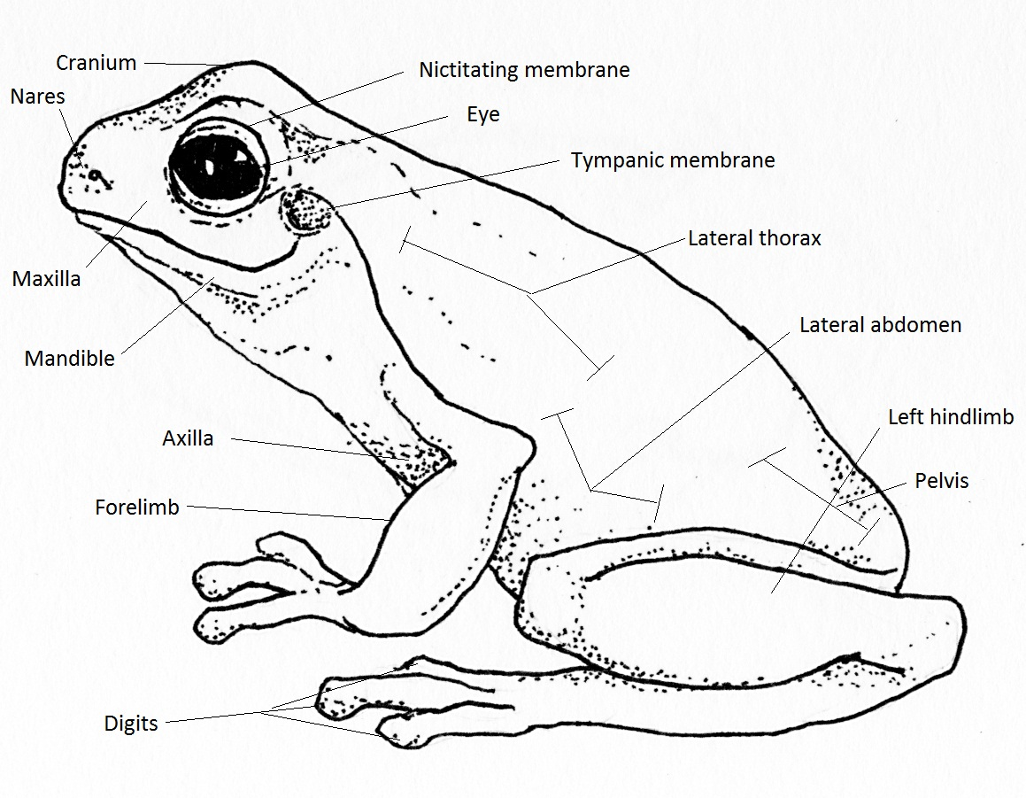

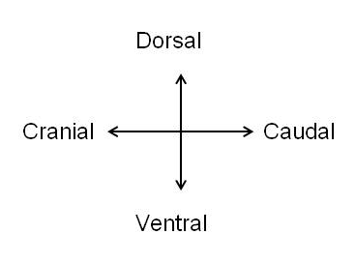
External anatomical descriptions for a frog: left lateral view
Source: Aquatic Animal Health Program, Animal Health Policy, Australian Government Department of Agriculture, Fisheries and Forestry

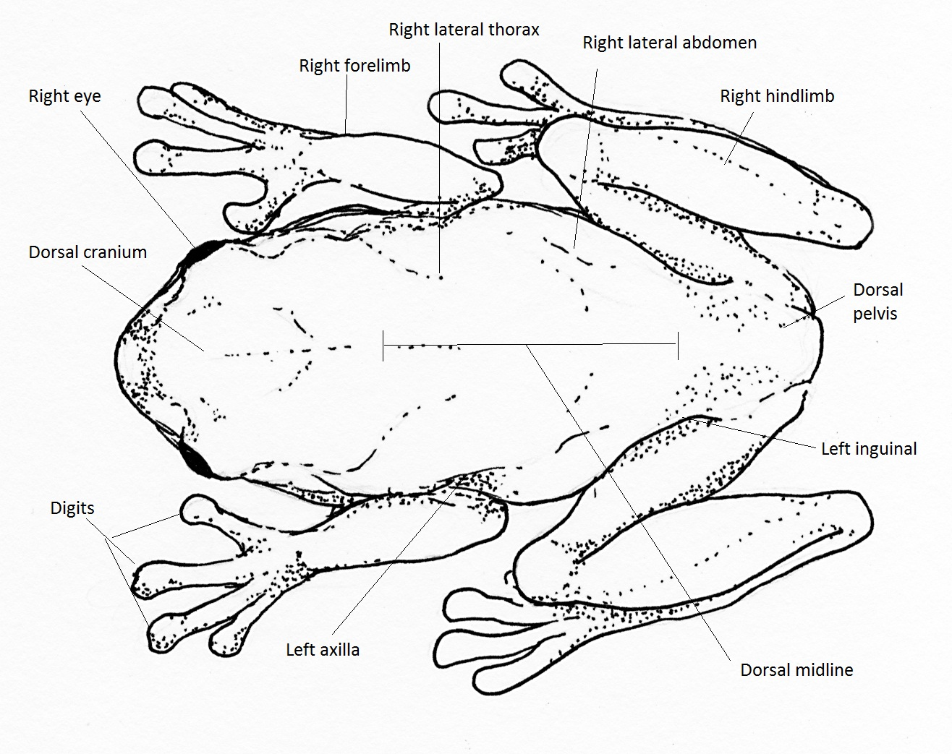


External anatomical descriptions for a frog: dorsal view
Source: Aquatic Animal Health Program, Animal Health Policy, Australian Government Department of Agriculture, Fisheries and Forestry

