Aquatic Animal Diseases Significant to Australia:
Identification Field Guide 4th Edition

Crayfish plague
(Also known as infection with Aphanomyces astaci)

EXOTIC DISEASE
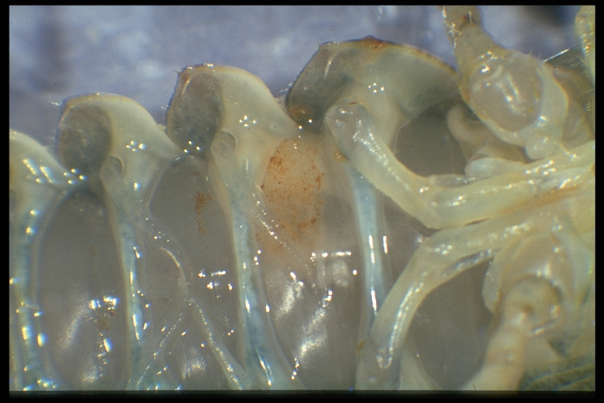  Crayfish plague, showing typical brown markings on a segment; healthy muscle tissue is present on either side of the affected segment  Source: D Alderman | 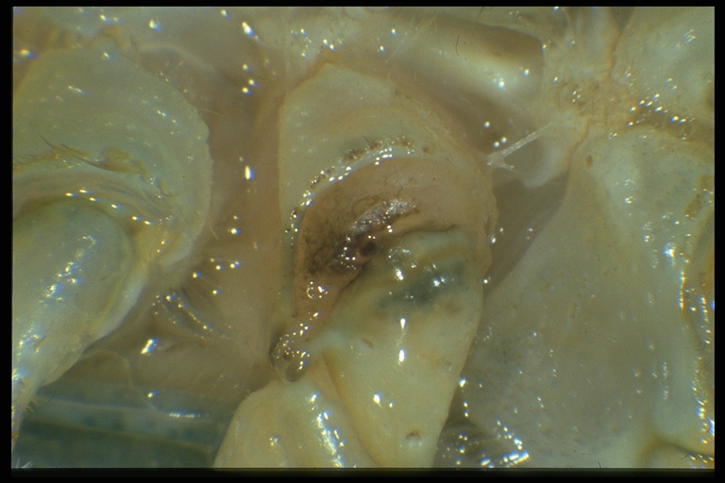  Crayfish plague, showing classic darkening at base of walking legs  Source: D Alderman

Signs of disease
Important: Animals with disease may show one or more of the signs below, but the pathogen may still be present in the absence of any signs.
Disease signs at the farm, tank or pond level are:
- high mortality at the time of the initial outbreak
- many dead or weak crayfish floating or lying in watercourses or ponds (mortalities may go unnoticed in the wild)
- crayfish in open water during daylight hours
- unsteady and raised gait (‘walking on stilts’)
- weakened, rapid tail escape response
- crayfish unable to remain upright (more evident when out of water)
- progressive paralysis
- crayfish trying to scratch or pinch themselves (occasionally seen).
Gross pathological signs are:
- growth on soft, non-calcified parts of the carapace
- brown or black spots on the carapace, where hyphae proliferate
- fine black lines on the soft shell underneath the tail
- melanised (black) shell in chronically infected individuals
- death occurring within weeks of the initial infection (particularly in European crayfish, Astacus sp.)
- white and necrotic musculature in the tail.
Microscopic pathological signs are:
- aseptate hyphae on the cuticle.

Disease agent
Crayfish plague is caused by infection with the oomycete Aphanomyces astaci. Although previously regarded as a fungus, the genus Aphanomyces is now classified with diatoms and brown algae in a group called Stramenopiles or Chromista.
This pathogen is known to occur in freshwater only.

Host range
It is believed that all species of freshwater crayfish are susceptible to crayfish plague. Species known to be susceptible are listed below.
Common name | Scientific name
Chinese mitten crab | Eriocheir sinensis
Crayfish (native to the eastern states of America) | Orconectes spp.
Freshwater crayfish | Cherax spp.
Giant Tasmanian crayfish | Astacopsis gouldi
Gippsland spiny crayfish | Euastacus kershawi
Japanese crayfishª | Cambaroides japonicus
Louisiana swamp crayfishª | Procambarus clarkii
Noble crayfishª | Astacus astacus
Signal crayfishª | Pacifastacus leniusculus
Stone crayfishª | Austropotamobius torrentium
Turkish crayfishª | Astacus leptodactylus
White-clawed crayfishª | Austropotamobius pallipes
a Naturally susceptible (other species have been shown to be experimentally susceptible)

Presence in Australia

EXOTIC DISEASE—not present in Australia.

Epidemiology
- Mortalities of up to 100% have occurred in Europe, with local loss of susceptible populations.
- North American crayfish (signal crayfish, Louisiana swamp crayfish, Orconectes sp.) can be infected without showing clinical signs or succumbing to the disease, but can become carriers of the disease agent and a source of transmission to less resistant species of crayfish.
- The disease was introduced into Europe in American freshwater crayfish and has decimated European crayfish stocks (both wild and cultured). There has been no evidence of developing resistance to the disease among European species since its introduction.
- Crayfish plague can occur at any time of year, but is more likely in the summer months.
- Death occurs between 5 and 50 days (or more) from initial infection, depending on water temperature and the initial number of zoospores.
- A. astaci releases motile zoospores directly to the water column when crayfish die. This is the primary transmission mechanism whereby motile zoospores of A. astaci are able to swim actively in the water column and show positive movement towards other crayfish.
- Translocation and migration of fish, birds and other wildlife can allow them to act as vectors, transporting the disease to previously unexposed waters.
- A. astaci can be introduced to a new susceptible population on contaminated ropes, traps, fishing gear, boots, nets and other equipment.
- Infection with A. astaci may be suspected when mortalities are observed to be limited to highly susceptible species of freshwater crayfish (where all other flora and fauna, particularly other crustaceans, are normal and healthy).

Differential diagnosis
The list of similar diseases below refers only to the diseases covered by this field guide. Gross pathological signs may be representative of a number of diseases not included in this guide, which therefore should not be used to provide a definitive diagnosis, but rather as a tool to help identify the listed diseases that most closely account for the gross signs.

Similar diseases
None of the other diseases in this field guide result in the rapid mortality or other gross signs of crayfish plague. In Australia, infection with the microbial parasite Thelohania (or porcelain disease) may cause similar gross signs.
Initial misdiagnosis has occurred when pollution has resulted in mortality of aquatic crustaceans where other species have survived.
In a few cases, examination by light microscopy can further define a diagnosis; however, further laboratory examination is always required for a definitive diagnosis.

Sample collection
Due to the uncertainty associated with differentiating diseases using only gross pathological signs, and because some aquatic animal disease agents might pose a risk to humans, only trained personnel should collect samples. You should phone your state or territory hotline number and report your observations if you are not appropriately trained. If samples have to be collected, the state or territory agency taking your call will provide advice on the appropriate course of action. Local or district fisheries or veterinary authorities may also provide advice regarding sampling.

Emergency disease hotline
The national disease hotline number is 1800 675 888. This number will put you in contact with the appropriate state or territory agency.

Further reading
The accepted procedures for a conclusive diagnosis of crayfish plague are summarised in the World Organisation for Animal Health Manual of diagnostic tests for aquatic animals 2011, available at www.oie.int/en/international-standard-setting/aquatic-manual/access-online.
Further information can be found on the Australian Government Department of Agriculture, Fisheries and Forestry website at www.daff.gov.au/animal-plant-health/aquatic/aquavetplan.
These hyperlinks were correct and functioning at the time of publication.

