Aquatic Animal Diseases Significant to Australia:
Identification Field Guide 4th Edition

Gill-associated virus disease
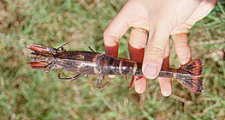
Black tiger prawn (Penaeus monodon) infected with gill-associated virus; note red colouration
Source: D Callinan

Signs of disease
Important: Animals with disease may show one or more of the signs below, but the pathogen may still be present in the absence of any signs.
Disease signs at the farm, tank or pond level are:
- high mortality (up to 80%)
- moribund prawns aggregating near the surface at pond edges
- initial increase in feeding at an abnormally high rate, followed by a sudden decline.
Gross pathological signs are:
- reddening of body and appendages
- biofouling with exoparasites
- emaciation
- pink to yellow colouration of the gills.
Microscopic pathological signs are:
- lymphoid organ necrosis (hypertrophied nuclei, marginated chromatin and vacuolation).

Disease agent
The causative agent is gill-associated virus (GAV), genotype 2 of six distinguished genotypes in the yellowhead complex of viruses. GAV is the type species of the genus okavirus in the family Roniviridae and order Nidovirales. Comparison of DNA sequences indicates that GAV and yellowhead virus are closely related, but have distinctly different genotypes, sharing 85% of their genetic material. Natural genetic recombination between GAV and other genotypes in the yellowhead complex has been reported outside Australia.

Host range
Species known to be susceptible to infection with GAV are listed below.
Common name | Scientific name
Black tiger prawnª | Penaeus monodon
Brown tiger prawn | Penaeus esculentus
Gulf banana prawn | Fenneropenaeus merguiensis
Kuruma prawn | Marsupenaeus japonicus
a Naturally susceptible (other species have been shown to be experimentally susceptible)

Presence in Australia
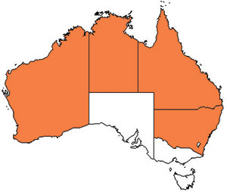
GAV has been officially reported from New South Wales, Queensland, the Northern Territory and Western Australia.

Epidemiology
The epidemiology of GAV is thought to be very similar to that of yellowhead virus:
- Transmission can be horizontal, directly from the water column and through ingestion of infected material.
- Vertical transmission can occur via surface contamination or infection of tissue surrounding the fertilised egg.
- Viral multiplication and disease appear to be induced by environmental stress.
- Mortality usually occurs among early to late juvenile stages in rearing ponds.
- Experimental infections with GAV indicate that larger (~20 g) kuruma prawns are less susceptible to disease than smaller (~6–13 g) prawns of the same species.
- GAV has been associated with mortalities of up to 80% in black tiger prawn ponds in Australia.
GAV occurs commonly as a chronic infection in healthy broodstock and farmed black tiger prawns in eastern Australia. It has also been associated with acute infections and disease outbreaks in ponds, causing high mortality, but produces gross signs and patterns of tissue tropism different from those for yellowhead virus.

Differential diagnosis
The list of similar diseases below refers only to the diseases covered by this field guide. Gross pathological signs may be representative of a number of diseases not included in this guide, which therefore should not be used to provide a definitive diagnosis, but rather as a tool to help identify the listed diseases that most closely account for the gross signs.

Similar diseases
Yellowhead disease
As GAV and yellowhead are closely related viruses, molecular testing is required to discriminate between the two diseases.

Sample collection
Due to the uncertainty associated with differentiating diseases using only gross pathological signs, and because some aquatic animal disease agents might pose a risk to humans, only trained personnel should collect samples. You should phone your state or territory hotline number and report your observations if you are not appropriately trained. If samples have to be collected, the state or territory agency taking your call will provide advice on the appropriate course of action. Local or district fisheries or veterinary authorities may also provide advice regarding sampling.

Emergency disease hotline
The national disease hotline number is 1800 675 888. This number will put you in contact with the appropriate state or territory agency.

Further reading
The accepted procedures for a conclusive diagnosis of GAV are summarised in the World Organisation for Animal Health Manual of diagnostic tests for aquatic animals 2011, available at www.oie.int/en/international-standard-setting/aquatic-manual/access-online.
This hyperlink was correct and functioning at the time of publication.

Further image
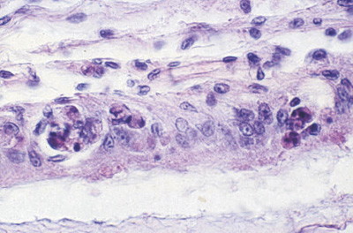
Histological changes present with gill-associated virus. Lymphoid necrosis includes signs such as hypertrophied nuclei, marginated chromatin and vacuolation
Source: L Owens

