Aquatic Animal Diseases Significant to Australia:
Identification Field Guide 4th Edition

Infectious hypodermal and
haematopoietic necrosis (IHHN)
(Also known as infection with Penaeus stylirostris densovirus
[PstDNV])
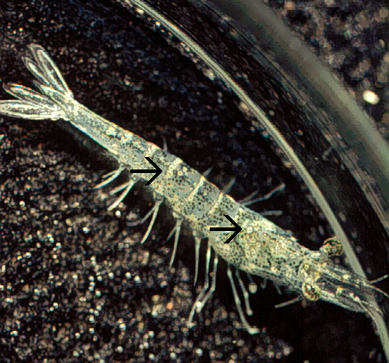  IHHN in juvenile Pacific blue shrimp (Litopenaeus stylirostris); note white to buff lesions under the shell (arrows)  Source: DV Lightner | 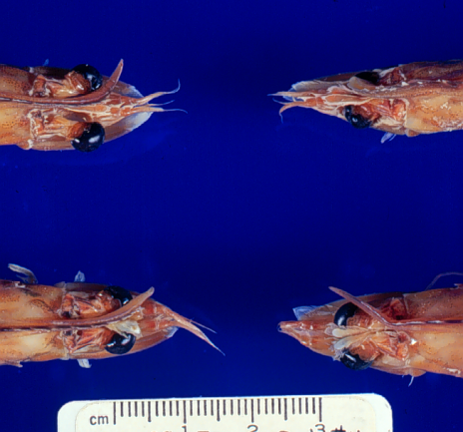  IHHN in juvenile Pacific blue shrimp (Litopenaeus stylirostris); note classic rostrum deformation  Source: DV Lightner
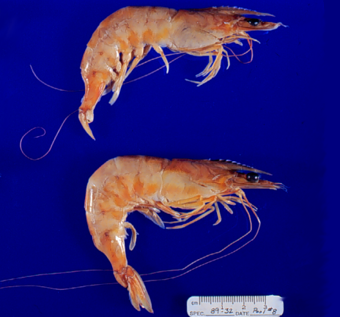 | Left: IHHN in juvenile Pacific blue shrimp (Litopenaeus stylirostris); note deformed tail fan and sixth abdominal segment  Source: DV Lightner

Signs of disease
Important: Animals with disease may show one or more of the signs below, but the pathogen may still be present in the absence of any signs.
Disease signs at the farm, tank or pond level are:
- reduced food consumption
- cannibalism
- repeatedly floating slowly to the water surface, rolling over and then sinking to the bottom
- morbidity or mortality
- poor hatching success of eggs
- poor survival of larvae and postlarvae.
Gross pathological signs are:
- opaque abdominal musculature.
In Pacific blue shrimp, additional gross pathological signs are:
- cuticular roughness
- cuticular deformities
- white to buff mottling of the shell, especially at the junction of abdominal shell plates.
In Pacific blue shrimp, Pacific white shrimp and black tiger prawns, additional gross pathological signs are:
- blue appearance of moribund prawns
- runt-deformity syndrome, the effects of which include
  - reduced and irregular growth in juveniles and subadults
  - deformed rostrums growing to one side
  - deformed sixth abdominal segment.
Microscopic pathological signs are:
- eosinophilic to pale basophilic intranuclear inclusion bodies (Cowdry type A inclusions) within tissues of ectodermal and mesodermal origin. Note that the inclusion bodies may be easily confused with developing intranuclear inclusion bodies caused by white spot disease.

Disease agent
IHHN and runt-deformity syndrome are caused by a Densovirus belonging to the family Parvoviridae (subfamily Densovirinae). At least three distinct genotypes of IHHN virus have been identified, but only two are known to be infectious to either Pacific white shrimp or black tiger prawns. Homologues of portions of the IHHN viral genome have been reported from the genomes of host prawns

Host range
Host species of IHHN are listed below.
Common name | Scientific name
Banana prawn | Fenneropenaeus merguiensis
Black tiger prawn^{ab} | Penaeus monodon
Pacific blue shrimpª | Litopenaeus stylirostris
Chinese white shrimp | Fenneropenaeus chinensis
Green tiger prawn or grooved tiger prawnª | Penaeus semisulcatus
Indian banana prawn | Fenneropenaeus indicus
Kuruma prawn | Marsupenaeus japonicus
Northern brown shrimp | Farfantepenaeus aztecus
Northern pink shrimp | Farfantepenaeus duorarum
Northern white shrimp | Litopenaeus setiferus
Pacific white shrimpª | Litopenaeus vannamei
Southern white shrimpª | Litopenaeus schmitti
Western white shrimpª | Litopenaeus occidentalis
Yellow-leg shrimpª | Fenneropenaeus californiensis
a Naturally susceptible (other species have been shown to be experimentally susceptible)
b Hybrids of the black tiger prawn and the brown tiger prawn (P. esculentus) are considered susceptible.

Presence in Australia
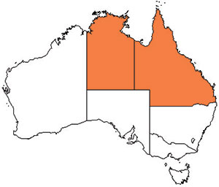
IHHN virus in the black tiger prawn has been officially reported from the Northern Territory and Queensland.

Epidemiology
- Gross signs of disease in an infected animal become evident from about 35 days of postlarval development.
- IHHN virus-resistant prawns and early life stages are carriers, and may transfer the virus to more susceptible species and life stages.
- The typical gross signs of runt-deformity syndrome may be observed in juveniles and subadults.
- Mortality events seldom occur in infected adult prawns.
- IHHN suppresses the prawns’ immune system, allowing infection by other disease agents.
- Infected tissue remains infectious after 5 years of storage at –20 °C, after 10 years at –80 °C, and after storage in 50% glycerine.
- IHHN infection can result in cumulative mortalities as high as 90% in postlarvae and juveniles.
- Transmission of IHHN virus can be via horizontal or vertical routes. Horizontal transmission has been demonstrated by cannibalism or through contaminated water, and vertical transmission has been demonstrated via infected eggs.

Differential diagnosis
The list of similar diseases below refers only to the diseases covered by this field guide. Gross pathological signs may be representative of a number of diseases not included in this guide, which therefore should not be used to provide a definitive diagnosis, but rather as a tool to help identify the listed diseases that most closely account for the gross signs.

Similar diseases
The microscopic signs of disease may also be similar to the early stages of white spot disease. Further laboratory examination is needed for a definitive diagnosis.

Sample collection
Due to the uncertainty associated with differentiating diseases using only gross pathological signs, and because some aquatic animal disease agents might pose a risk to humans, only trained personnel should collect samples. You should phone your state or territory hotline number and report your observations if you are not appropriately trained. If samples have to be collected, the state or territory agency taking your call will provide advice on the appropriate course of action. Local or district fisheries or veterinary authorities may also provide advice regarding sampling.

Emergency disease hotline
The national disease hotline number is 1800 675 888. This number will put you in contact with the appropriate state or territory agency.

Further reading
The accepted procedures for a conclusive diagnosis of IHHN are summarised in the World Organisation for Animal Health Manual of diagnostic tests for aquatic animals 2011, available at www.oie.int/en/international-standard-setting/aquatic-manual/access-online.
Further information can also be found on the disease pages of Fisheries and Oceans Canada: www.pac.dfo-mpo.gc.ca/science/species-especes/shellfish-coquillages/diseases-maladies/index-eng.htm.
These hyperlinks were correct and functioning at the time of publication.

Further images
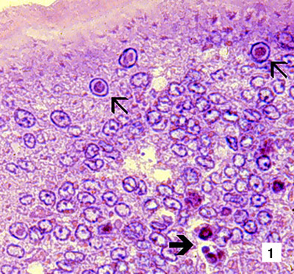
(1) Low magnification (830×) light micrograph of a haematoxylin and eosin stained section of a juvenile Pacific blue shrimp (Litopenaeus stylirostris) with severe acute IHHN disease. The section is through the cuticular epithelium and subcuticular connective tissues just dorsal and posterior to the heart. Numerous necrotic cells with pyknotic nuclei or with pathognomonic eosinophilic intranuclear inclusion bodies (Cowdry type A) are present (arrows).
Source: DV Lightner
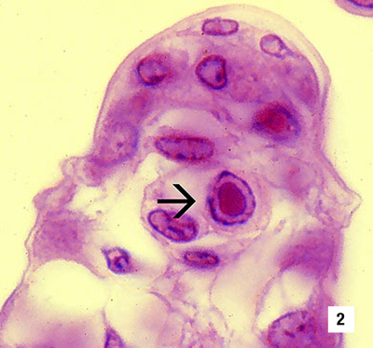
(2) High magnification (1800×) light micrograph of gills, showing eosinophilic intranuclear inclusions (Cowdry type A ) that are pathognomonic for IHHN virus infection
Source: DV Lightner
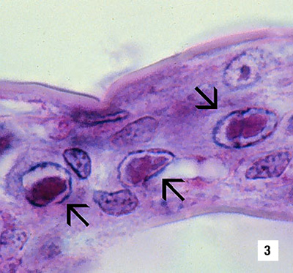
(3) A high magnification (1800×) light micrograph of a gill lamella, showing three adjacent cells with diagnostic IHHN virus Cowdry type A inclusions in their hypertrophied nuclei
Source: DV Lightner
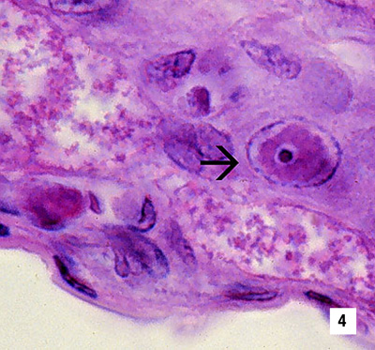
(4) An IHHN virus Cowdry type A inclusion in the nucleus of a gill epithelial cell, showing a chromatin process within the inclusion body (1800×)
Source: DV Lightner
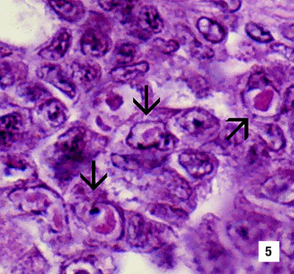
(5) Section through a haematopoietic nodule showing several cells with IHHN virus Cowdry type A inclusions (1800×)
Source: DV Lightner
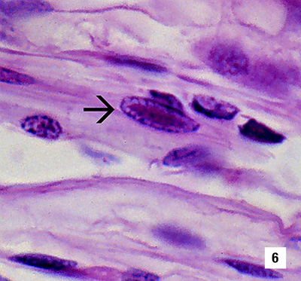
(6) Midsagittal section of the ventral nerve cord of a juvenile Pacific white shrimp (Litopenaeus vannamei) with runt-deformity syndrome. Note that Cowdry type A inclusions take the shape of the host cell nucleus, and so in the nerve cord they are often elliptical and appear slightly different from Cowdry type A inclusions in other tissues (1800×).
Source: DV Lightner
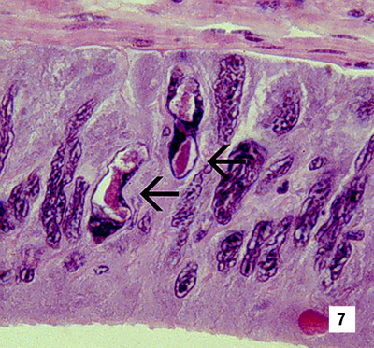
(7) Section of the vas deferens of an adult Pacific white shrimp (Litopenaeus vannamei) with IHHN. Bizarrely shaped Cowdry type A inclusions (which take the shape of the nuclei of this tissue) are illustrated (700×).
Source: DV Lightner
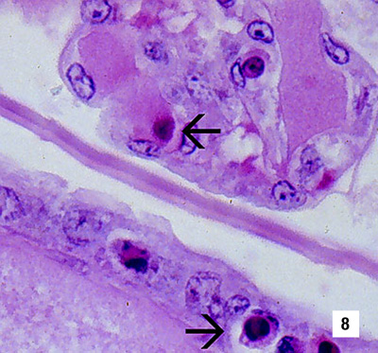
(8) Section of the gills of a juvenile Pacific blue shrimp (Litopenaeus stylirostris) with G4 IHHN. Although necrotic cells with pyknotic nuclei are numerous, no diagnostic Cowdry type A inclusions are apparent (700×).
Source: DV Lightner
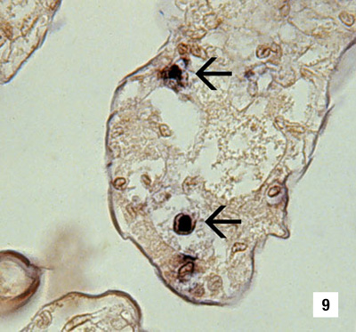
(9) A section of gills has reacted with a digoxygenin (DIG)-labelled DNA gene probe for IHHN virus. Several IHHN virus-infected cell nuclei have reacted with the probe. Viral DNA is stained dark blue to black by the detection reaction for DIG-labelled probe. DIG-labelled probe and Bismarck Brown (700×).
Source: DV Lightner
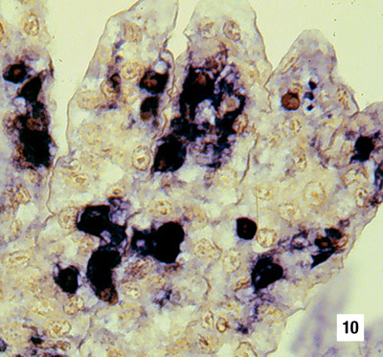
(10) Section of gills from a juvenile L.stylirostris with G4 IHHN. Probe positive IHHN virus-infected cells are abundant. DIG-labelled probe and Bismarck Brown (700×).
Source: DV Lightner
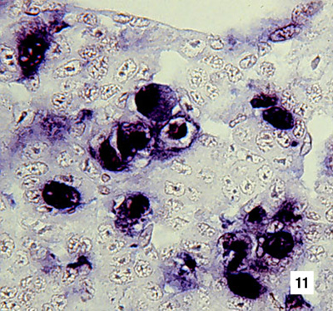
(11) Section of haematopoietic tissue from a juvenile blue shrimp with IHHN. Probe-positive cells are abundant. DIG-labelled probe and Bismarck Brown (700×).
Source: DV Lightner
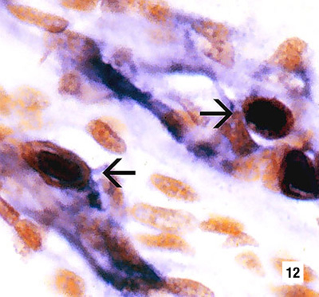
(12) Mid-sagittal section from a juvenile white shrimp with runt-deformity syndrome. The probe has reacted with several Cowdry type A inclusions and with cellular debris or haemolymph with a high content of IHHN virus. DIG-labelled probe and Bismarck Brown (600×).
Source: DV Lightner

