Aquatic Animal Diseases Significant to Australia:
Identification Field Guide 4th Edition

Infectious myonecrosis

EXOTIC DISEASE
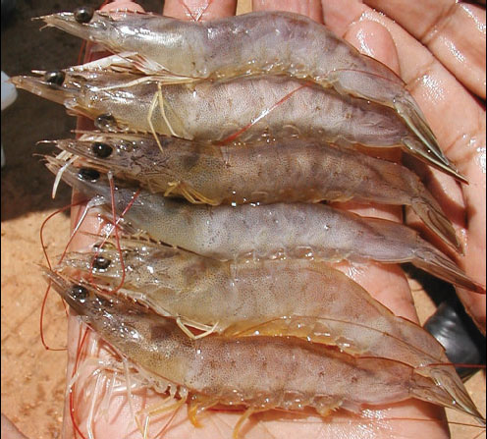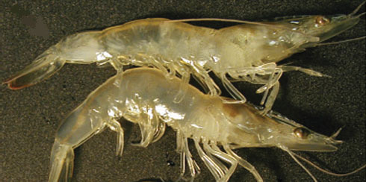
Gross signs of infectious myonecrosis in naturally infected farmed Pacific white prawns (Litopenaeus vannamei), exhibiting various degrees of skeletal muscle necrosis, visible as an opaque, whitish discolouration of the abdomen.
Source: DV Lightner

Signs of disease
Important: animals with disease may show one or more of the signs below, but the pathogen may still be present in the absence of any signs.

Disease signs at the farm, tank or pond level are:
- lethargy
- large numbers of moribund animals and significant mortalities (up to 70%), specifically during or following stressful events.
The acute form of the disease produces gross signs and elevated mortalities, but disease progresses to a chronic phase with persistent low-level mortalities
Gross pathological signs are:
- focal to extensive white necrotic areas in the striated muscle commonly observed in distal abdominal segments
- necrotic and reddened tail fan
- lymphoid organs increased to 3–4 times normal size
- moribund prawns with a full stomach as affected individuals may continue to feed until death.
Microscopic pathological signs are:
- coagulative necrosis of skeletal muscle by haemolytic infiltration and fibrosis.

Disease agent
The causative agent is infectious myonecrosis virus (IMNV), a putative Totivirus. Phylogenetic analysis based on its RNA-dependent RNA polymerase gene coding sequence groups IMNV most closely with Giardia lamblia virus, a member of the family Totiviridae.

Host range
Species known to be susceptible to IMNV are listed below.
Common name | Scientific name
Black tiger prawn | Penaeus monodon
Pacific shrimp | Litopenaeus stylirostris
Pacific white shrimpª | Litopenaeus vannamei
a Naturally susceptible (other species have been shown to be experimentally susceptible)

Presence in Australia

EXOTIC DISEASE—not present in Australia.

Epidemiology
- IMNV was originally identified in north-eastern Brazil in cultured L. vannamei; however, the virus has now been reported in South-East Asia, including the Indonesian provinces of West Nusa Tenggara, East Java and Bali.
- Clinical signs may have sudden onset following stressful events (e.g. capture by net, reduced feeding, sudden changes in temperature or salinity).
- Affected life stages include juveniles and subadults. Significant mortalities occur in juvenile and subadult pond-reared populations.
- Horizontal transmission has been demonstrated via cannibalism. Vertical transmission (direct passage from parents to offspring via eggs or sperm) is likely, but not confirmed.

Differential diagnosis
The list of similar diseases below refers only to the diseases covered by this field guide. Gross pathological signs may be representative of a number of diseases not included in this guide, which therefore should not be used to provide a definitive diagnosis, but rather as a tool to help identify the listed diseases that most closely account for the gross signs.

Similar diseases
White tail disease

Sample collection
Due to the uncertainty associated with differentiating diseases using only gross pathological signs, and because some aquatic animal disease agents might pose a risk to humans, only trained personnel should collect samples. You should phone your state or territory hotline number and report your observations if you are not appropriately trained. If samples have to be collected, the state or territory agency taking your call will provide advice on the appropriate course of action. Local or district fisheries or veterinary authorities may also provide advice regarding sampling.

Emergency disease hotline
The national disease hotline number is 1800 675 888. This number will put you in contact with the appropriate state or territory agency.

Further reading
The accepted procedures for a conclusive diagnosis of infectious myonecrosis are summarised in the World Organisation for Animal Health Manual of diagnostic tests for aquatic animals. The latest edition of the manual is available at www.oie.int/en/international-standard-setting/aquatic-manual/access-online.
This hyperlink was correct and functioning at the time of publication.

Further images
Myonecrosis due to infection of Litopenaeus vannamei with purified virions (1–3).
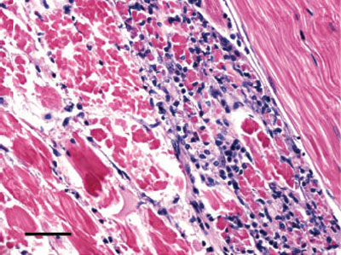
(1) Coagulative necrosis of skeletal muscle accompanied by haemocytic infiltration and fibrosis. Normal skeletal muscle can be observed in the upper right corner. Haematoxylin and eosin stain; bar, 50 μm.

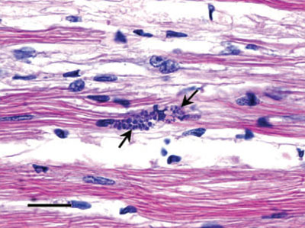
(2) Perinuclear pale basophilic to dark basophilic inclusion bodies are evident in this group of muscle cells (arrows point at some examples). Haematoxylin and eosin stain; bar, 20 μm.

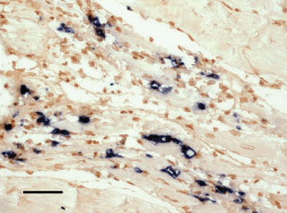
(3) In situ hybridisation of skeletal muscle tissue using a digoxigenin-labelled infectious myonecrosis virus probe. A black precipitate is present in areas where the probe has hybridised with target virus. Bismarck brown counterstain; bar, 50 μm.
Source: DV Lightner

