Aquatic Animal Diseases Significant to Australia:

Identification Field Guide 4th Edition

Monodon slow growth syndrome (MSGS)

EXOTIC DISEASE
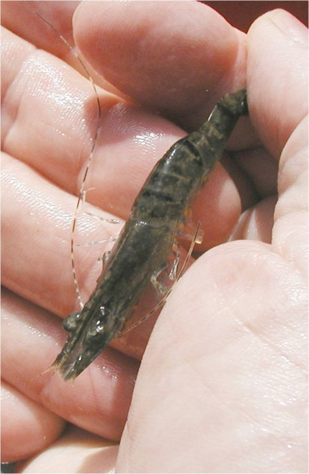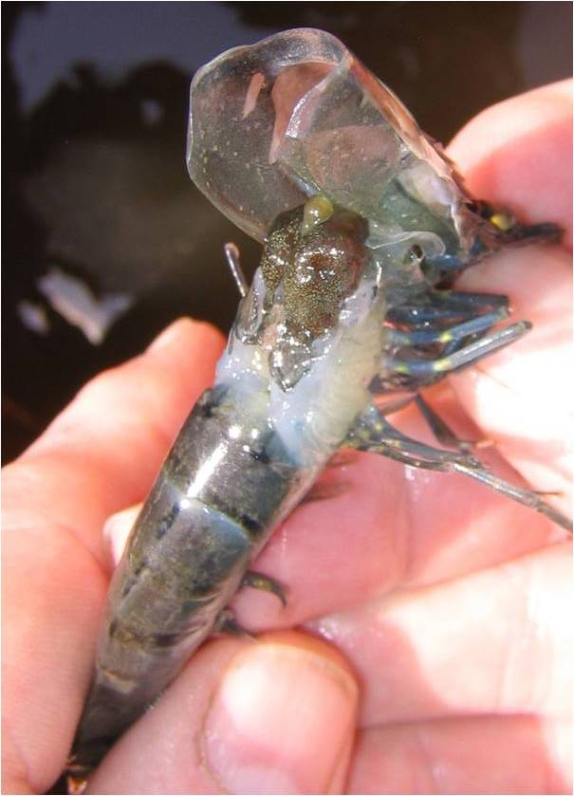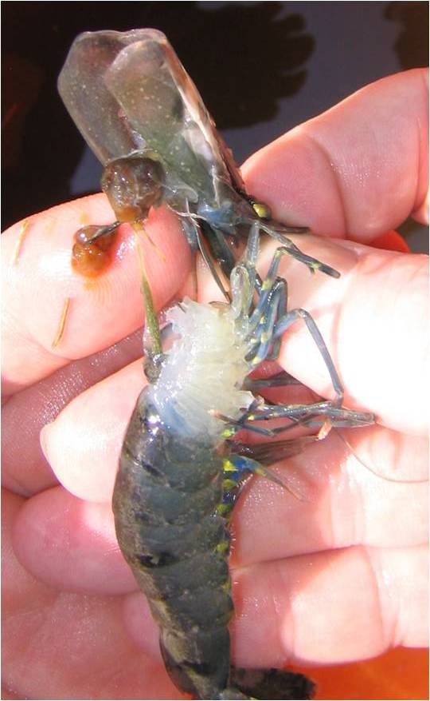
Penaeus monodon with monodon slow growth syndrome
Source: DV Lightner

Signs of disease
Important: Animals with disease may show one or more of the signs below, but the pathogen may still be present in the absence of any signs.
Disease signs at the farm, pond or tank level are:
- abnormally slow growth, resulting in irregularly sized prawns
- low average daily weight gain of less than 0.1 g/day at 4 months of age.
Gross pathological signs are:
- unusually dark colour
- unusually bright yellow markings
- brittle antennae
- bamboo-shaped abdominal segments

There are no definitive microscopic pathological signs.

Disease agent
The complete aetiology for MSGS is uncertain and there isn’t a clear case definition for this syndrome. A working case definition for surveillance and data gathering purposes is listed under epidemiology. A key component is the positive detection of Laem-Singh virus (LSNV) by RT-PCR (LSNV is considered a necessary but insufficient component cause). Known pathogens are unlikely to be the cause of MSGS and previous trials have indicated that a filterable infectious agent is involved.

Host range
Species known to be susceptible to MSGS are listed below.
Common name | Scientific name
Black tiger prawnª | Penaeus monodon
a Naturally susceptible

Presence in Australia

EXOTIC DISEASE—not present in Australia.

Epidemiology
- As the cause of MSGS is uncertain, a working case definition allows for suspected case data to be collected if the population:
  - test positive for Laem-Singh virus (LSNV)
  - has a coefficient of variation of more than 35% by weight
  - is free from hepatopancreatic parvovirus infection or any other hepatopancreatic infection
  - shows three of the signs of disease listed previously.
- In countries where the Pacific white shrimp (Litopenaeus vannamei) has already been introduced, Pacific white shrimp and black tiger prawns should be reared separately, particularly at the maturation and hatchery phase.

Differential diagnosis
The list of similar diseases below refers only to the diseases covered by this field guide. Gross pathological signs may be representative of a number of diseases not included in this guide, which therefore should not be used to provide a definitive diagnosis, but rather as a tool to help identify the listed diseases that most closely account for the gross signs.

Similar diseases
No diseases listed in this field guide are similar to monodon slow growth syndrome.

Sample collection
Due to the uncertainty associated with differentiating diseases using only gross pathological signs, and because some aquatic animal disease agents might pose a risk to humans, only trained personnel should collect samples. You should phone your state or territory hotline number and report your observations if you are not appropriately trained. If samples have to be collected, the state or territory agency taking your call will provide advice on the appropriate course of action. Local or district fisheries or veterinary authorities may also provide advice regarding sampling.

Emergency disease hotline
The national disease hotline number is 1800 675 888. This number will put you in contact with the appropriate state or territory agency.

Further reading
Further information can be found by searching ‘monodon slow growth syndrome’ on the Network of Aquaculture Centres in Asia–Pacific website at www.enaca.org.
This hyperlink was correct and functioning at the time of publication.

