Aquatic Animal Diseases Significant to Australia:

Identification Field Guide 4th Edition

Necrotising hepatopancreatitis (NHP)
(Also known as infection with necrotising hepatobacterium
or NHP bacterium)

EXOTIC DISEASE
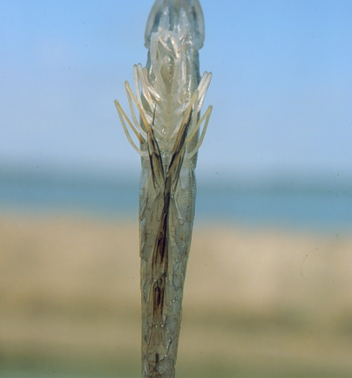  Pacific white shrimp (Litopenaeus vannamei) with NHP; note darkening at base of swimmerets, giving a fouled, ‘dirty’ appearance  Source: DV Lightner | 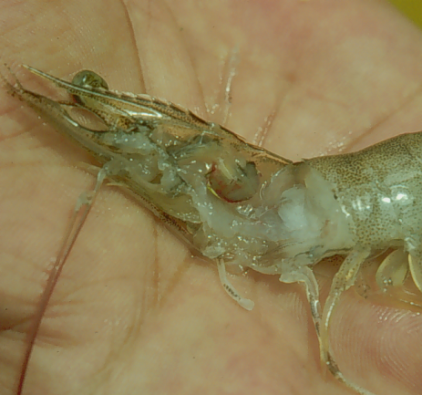  Pacific white shrimp (Litopenaeus vannamei) with NHP; note marked reduction in size of hepatopancreas  Source: DV Lightner

Signs of disease
Important: Animals with disease may show one or more of the signs below, but the pathogen may still be present in the absence of any signs.
Disease signs at the farm, tank or pond level are:
- lethargy
- emaciation
- heavy protozoan or bacterial fouling
- reduced growth rate.

Gross pathological signs are:
- soft shell
- flaccid body
- black gills
- empty intestinal tract
- degenerated or atrophied digestive gland (hepatopancreas), which appears pale to white
- black (melanised) streaks in the hepatopancreas.
Microscopic pathological signs are:
- multifocal granulomatous lesions in hepatopancreatic tubules, with atrophy of adjacent hepatopancreatic tubule epithelial cells
- tubular cells within the granulomatous lesions that can be hypertrophied and contain basophilic organisms within the cytoplasm
- sloughing of tubule epithelial cells
- severe haemocytic inflammation of the intratubular spaces.

Four distinct phases of infection have been described: initial, acute, transition and chronic. Acute and transition phases are identifiable by the presence of pathognomonic lesions in the hepatopancreas. Molecular techniques are required for positive diagnosis of NHP bacterium infected individuals in the initial or chronic phase of infection.

Disease agent
NHP is caused by infection with a Gram-negative, intracytoplasmic species of alpha-proteobacterium that infects the hepatopancreas of prawns, also referred to as NHP bacterium. The NHP bacterium exists in two morphological forms: a rod-shaped, non-flagellated, rickettsia-like organism; and a helical, flagellated form.

Host range
Species known to be susceptible to NHP are listed below.
Common name | Scientific name
Northern brown shrimpª | Farfantepenaeus aztecus
Northern white shrimpª | Litopenaeus setiferus
Pacific blue shrimpª | Litopenaeus stylirostris
Pacific white shrimpª | Litopenaeus vannamei
Yellow-leg shrimpª | Fenneropenaeus californiensis
a Naturally susceptible (other species have been shown to be experimentally susceptible)

Presence in Australia

EXOTIC DISEASE—not present in Australia.

Epidemiology
- NHP outbreaks are often preceded by lengthy periods of high water temperatures (29–31 °C) and elevated salinity (up to 40 parts per thousand).
- Mortality can be 90–95% within 30 days of an outbreak.
- Mortalities usually occur midway through the grow-out phase.
- NHP appears to be transmitted by direct ingestion of carrier prawns (survivors of NHP bacterial infection may carry the bacteria for life) and through contaminated water.
- NHP bacteria may also be shed in faeces and contribute to disease transmission.

Differential diagnosis
The list of similar diseases below refers only to the diseases covered by this field guide. Gross pathological signs may be representative of a number of diseases not included in this guide, which therefore should not be used to provide a definitive diagnosis, but rather as a tool to help identify the listed diseases that most closely account for the gross signs.

Similar diseases
No diseases listed in this field guide are similar to NHP. Any presumptive diagnosis requires further laboratory diagnosis for confirmation.

Sample collection
Due to the uncertainty associated with differentiating diseases using only gross pathological signs, and because some aquatic animal disease agents might pose a risk to humans, only trained personnel should collect samples. You should phone your state or territory hotline number and report your observations if you are not appropriately trained. If samples have to be collected, the state or territory agency taking your call will provide advice on the appropriate course of action. Local or district fisheries or veterinary authorities may also provide advice regarding sampling.

Emergency disease hotline
The national disease hotline number is 1800 675 888. This number will put you in contact with the appropriate state or territory agency.

Further reading
Further information can be found on the disease pages of Fisheries and Oceans Canada at www.pac.dfo-mpo.gc.ca/science/species-especes/shellfish-coquillages/diseases-maladies/index-eng.htm.
This hyperlink was correct and functioning at the time of publication.

Further images
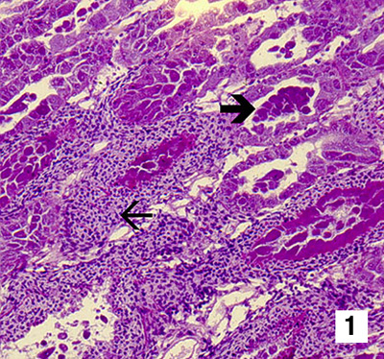
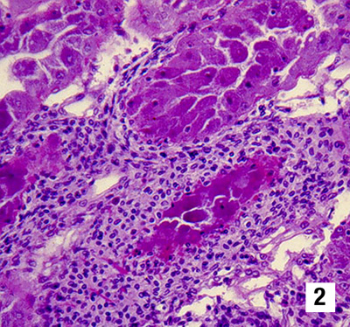 | (1 & 2) Low-magnification (Figure 1, 150×) and mid-magnification (Figure 2, 300×) photomicrographs of the hepatopancreas of a juvenile Pacific white shrimp (Litopenaeus vannamei) with severe, subacute (grade 3–4) NHP. Severe haemocytic inflammation (with some melanised foci) of the intratubular spaces (small arrow) in response to necrosis, cytolysis and sloughing of hepatopancreas tubule epithelial cells (large arrow) are among the principal histopathological changes due to the disease.  Source: DV Lightner

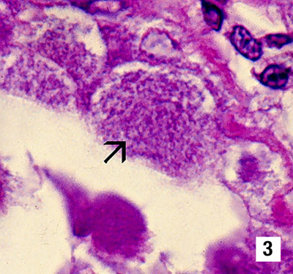
(3) A high-magnification (1700×) view of a portion of the hepatopancreas from Figures 1 and 2. The tubule epithelial cells show no cytoplasmic lipid droplets, but instead contain masses of the tiny, non–membrane bound, intracytoplasmic NHP bacteria (arrow).
Source: DV Lightner
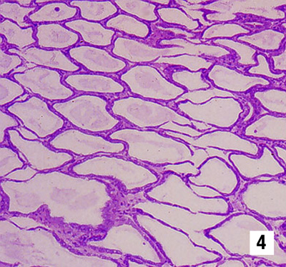
(4) Low-magnification (100×) view of the hepatopancreas of a juvenile Pacific white shrimp (Litopenaeus vannamei) with severe, chronic NHP. The hepatopancreas tubule epithelium is markedly atrophied, resulting in the formation of large oedematous (fluid filled or ‘watery’) areas.
Source: DV Lightner
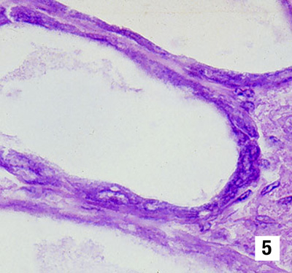
(5) A higher magnification (900×) photomicrograph of the atrophied hepatopancreas from a juvenile Pacific white shrimp (Litopenaeus vannamei) with chronic NHP. In contrast to the subacute phase of NHP, chronic-phase NHP shows no, or only occasional, foci of haemocytic inflammation of the necrotic or degenerating hepatopancreatic tubules. NHP bacteria may be found in the cytoplasm of an occasional hepatopancreatic cell.
Source: DV Lightner
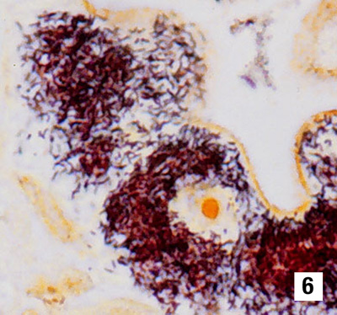
(6) Section of the hepatopancreas of a juvenile Pacific white shrimp (Litopenaeus vannamei) that is similar to that shown in Figure 3. Cytoplasmic masses of the NHP bacterium are silver stained and appear brown to black with the modified Steiner stain. Unaffected cells and nuclei are pale brown (1600×).
Source: DV Lightner
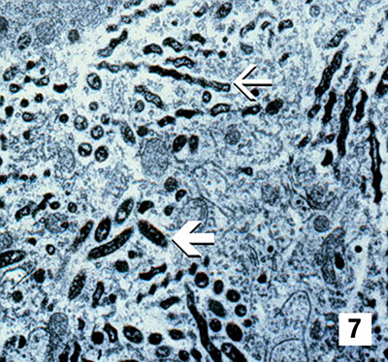
(7) TEM (10 000×) of a hepatopancreatocyte from a juvenile Pacific white shrimp (Litopenaeus vannamei) with NHP. Profiles of intracellular rod-shaped forms (large arrow) and helical forms (small arrow) of the NHP bacterium are abundant in the cytoplasm.
Source: DV Lightner
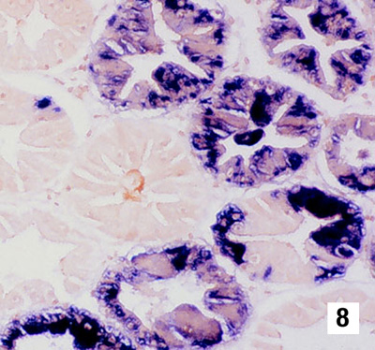 | 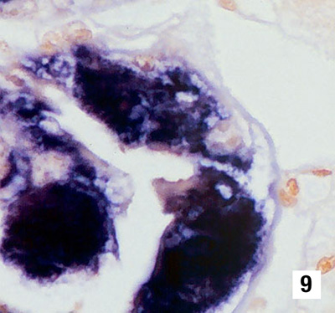
(8 & 9) Above and right: Low-magnification (Figure 8, 250×) and high-magnification (Figure 9, 1000×) views of sections of the hepatopancreas of a juvenile Pacific white shrimp with NHP. This section has been assayed for NHP using a digoxygenin (DIG)-labelled DNA probe. Cytoplasmic masses of the NHP bacterium are marked blue to blue-black by the probe. Unaffected cells and host cell nuclei take the brown counter stain. DIG-labelled NHP probe and Bismarck Brown.
Source: DV Lightner

