Aquatic Animal Diseases Significant to Australia:
Identification Field Guide 4th Edition

Milky haemolymph disease of spiny lobster (Panulirus spp.)
(Also known as milky haemolymph syndrome [MHS])

EXOTIC DISEASE
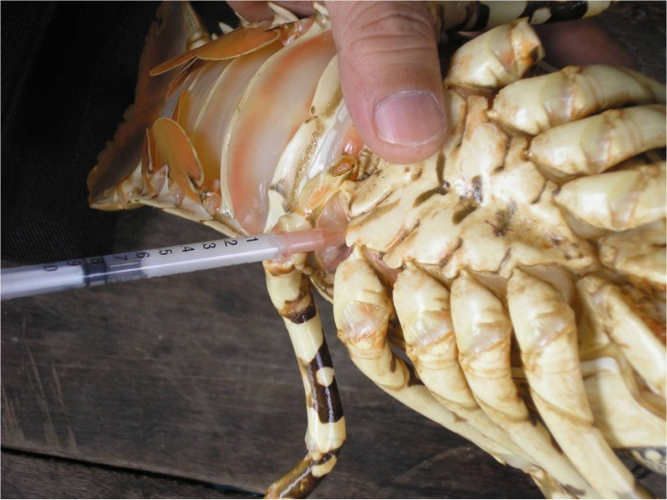  MHS in a Panulirus ornatus  Source: DV Lightner | 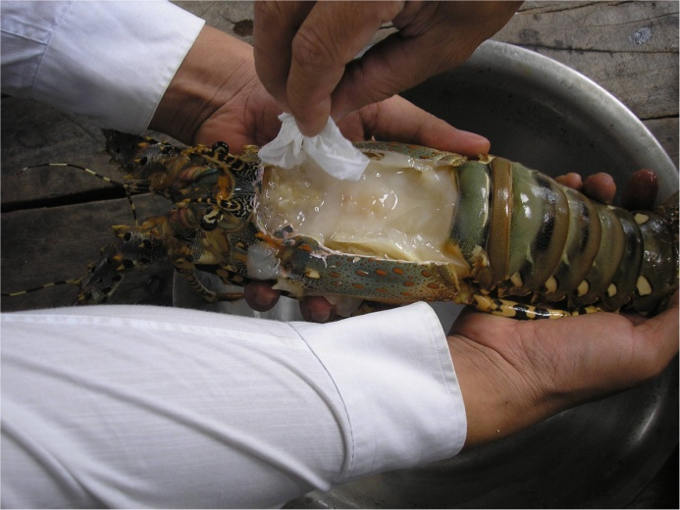  MHS in a Panulirus ornatus  Source: DV Lightner

Signs of disease
Important: Animals with disease may show one or more of the signs below, but the pathogen may still be present in the absence of any signs.
Disease signs at the farm, tank or pond level are:
- lethargy
- anorexia or cessation of feeding
- mortality soon after clinical and gross pathological signs appear.

Gross pathological signs are:
- milky haemolymph exuding from wounds or visible under swollen abdominal pleura of the exoskeleton (visible on the ventral side; if drawn into a syringe, may appear turbid or milky in severely affected specimens)
- white hypertrophied connective tissues of all major organs and tissues.
Microscopic pathological signs are:
- basophilic cytoplasmic masses of bacteria in haemocytes, fixed phagocytes and connective tissue cells.

Disease agent
Milky haemolymph disease of spiny lobster is caused by a rickettsia-like bacterium. Four distinct rickettsia-like bacteria have been found, one of which is known to be associated with the disease.

Host range
Species known to be susceptible to milky haemolymph disease of spiny lobster are listed below.
Common name | Scientific name
Black tiger prawnª | Penaeus monodon
European shore crabª | Carcinus maenas
Tropical spiny lobsters^{ab} | Panulirus spp.
a Naturally susceptible
b Species primarily susceptible to milky haemolymph disease of spiny lobster include the ornate rock lobster (P. ornatus), scalloped spiny lobster (P. homarus) and Chinese spiny lobster (P. stimpsoni).

Presence in Australia

EXOTIC DISEASE—not present in Australia.

Epidemiology
- It is suspected that horizontal transmission occurs by direct contact with infected lobsters in the same net-pens, or indirectly by contaminated water from adjacent net-pens.
- The disease has been experimentally transmitted among lobsters by cohabitation and by injection of unfiltered haemolymph from diseased lobsters into healthy lobsters.
- Haemolymph exuding from wounds or when drawn into a syringe is turbid, appearing milky in severely affected specimens.
- The haemolymph from severely affected individuals does not clot.
- The disease affects three-month-old or older juveniles and adult lobsters.
- It is suspected that fresh foods (fishery bycatch, molluscs and decapod crustaceans) fed to net-pen-reared lobsters in Vietnam are the source of the rickettsia-like bacterial agent of the disease.
- Injection of oxytetracycline has been effective in treating and preventing the disease.

Differential diagnosis
The list of similar diseases below refers only to the diseases covered by this field guide. Gross pathological signs may be representative of a number of diseases not included in this guide, which therefore should not be used to provide a definitive diagnosis, but rather as a tool to help identify the listed diseases that most closely account for the gross signs.

Similar diseases
No diseases listed in this field guide are similar to milky haemolymph disease of spiny lobster.

Sample collection
Due to the uncertainty associated with differentiating diseases using only gross pathological signs, and because some aquatic animal disease agents might pose a risk to humans, only trained personnel should collect samples. You should phone your state or territory hotline number and report your observations if you are not appropriately trained. If samples have to be collected, the state or territory agency taking your call will provide advice on the appropriate course of action. Local or district fisheries or veterinary authorities may also provide advice regarding sampling.

Emergency disease hotline
The national disease hotline number is 1800 675 888. This number will put you in contact with the appropriate state or territory agency.

Further reading
Further information (a disease information card) can be found on the World Organisation for Animal Health website at www.oie.int/en/international-standard-setting/specialists-commissions-groups/aquatic-animal-commission-reports/disease-information-cards.
This hyperlink was correct and functioning at the time of publication.

