Aquatic Animal Diseases Significant to Australia:

Identification Field Guide 4th Edition

Taura syndrome

EXOTIC DISEASE
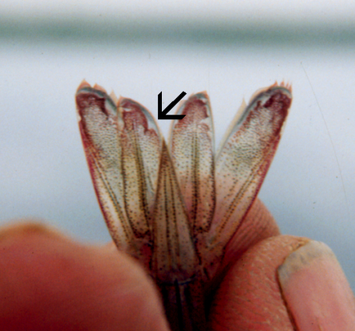  Taura syndrome in Pacific white shrimp (Litopenaeus vannamei); note distinctive red tail fan of Taura syndrome. Rough edges around tail fin are also common.  Source: DV Lightner | 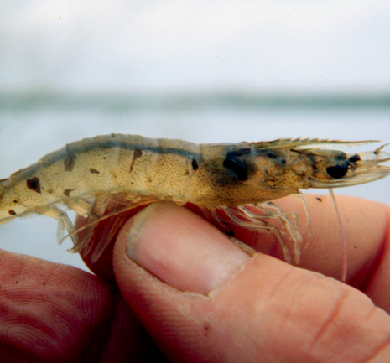  Taura syndrome in Pacific white shrimp (Litopenaeus vannamei); note darkening of body from infection  Source: DV Lightner

Signs of disease
Important: Animals with disease may show one or more of the signs below, but the pathogen may still be present in the absence of any signs.
Disease signs at the farm, tank or pond level are:
- lethargy
- cessation of feeding
- animals gathering at the pond edge when moribund
- sudden increase in presence of seabirds ‘fishing’ in ponds
- sudden onset of high mortalities in late postlarvae, juvenile or subadult prawns.
Taura syndrome has three distinguishable phases: acute, transition and chronic.
Gross pathological signs in the acute phase are:
- empty stomach and pale-red body surface and appendages
- red tail fan and pleopods due to the expansion of red chromatophores
- soft shell.
Gross pathological signs in the transition phase are:
- multiple, irregularly shaped and randomly distributed melanised (dark) cuticular lesions
- death, usually at moulting.
There are no obvious gross pathological signs of disease in the chronic phase.
Microscopic pathological signs are:
- necrosis of the cuticular epithelium of appendages
- multifocal lesions in the cuticular epithelium (evident during the transition phase).

Disease agent
Taura syndrome is caused by Taura syndrome virus, a small picorna-like RNA virus that belongs to the genus Aparavirus in the family Dicistroviridae.

Host range
Species known to be susceptible to Taura syndrome virus are listed below.
Common name | Scientific name
Black tiger prawn | Penaeus monodon
Chinese white shrimp | Fenneropenaeus chinensis
Kuruma prawn | Marsupenaeus japonicus
Northern brown shrimp | Farfantepenaeus aztecus
Northern pink shrimp | Farfantepenaeus duorarum
Northern white shrimpª | Litopenaeus setiferus
Pacific blue shrimpª | Litopenaeus stylirostris
Pacific white shrimpª | Litopenaeus vannamei
Red endeavour prawn | Metapenaeus ensis
Southern white shrimp | Litopenaeus schmitti
a Naturally susceptible (other species have been shown to be experimentally susceptible)

Presence in Australia

EXOTIC DISEASE—not present in Australia.

Epidemiology
- Taura syndrome is a disease of the nursery phase of the Pacific white shrimp. It usually occurs within 14–40 days of stocking postlarvae into grow-out ponds or tanks, with mortality from 40% to more than 90%.
- Taura syndrome virus has been documented in postlarvae, juvenile and adult life stages.
- Survivors of infection with Taura syndrome virus may become lifelong carriers.
- Transmission is horizontal through ingestion. Although vertical transmission is suspected, it has not been experimentally confirmed.
- Migratory birds, aquatic insects and humans are likely mechanical vectors of the disease. Individuals surviving the chronic phase of Taura syndrome are thought to be carriers of the virus.
- Resistance of the black tiger prawn and the kuruma prawn to Taura syndrome virus is unclear, but they appear to be more resistant than the Pacific white shrimp.
- Taura syndrome–resistant stocks of the Pacific white shrimp and Pacific blue shrimp are commercially available which have shown survival rates up to 100% following laboratory challenge.

Differential diagnosis
The list of similar diseases below refers only to the diseases covered by this field guide. Gross pathological signs may be representative of a number of diseases not included in this guide, which therefore should not be used to provide a definitive diagnosis, but rather as a tool to help identify the listed diseases that most closely account for the gross signs.

Similar diseases
White spot disease, yellowhead disease

Sample collection
Due to the uncertainty associated with differentiating diseases using only gross pathological signs, and because some aquatic animal disease agents might pose a risk to humans, only trained personnel should collect samples. You should phone your state or territory hotline number and report your observations if you are not appropriately trained. If samples have to be collected, the state or territory agency taking your call will provide advice on the appropriate course of action. Local or district fisheries or veterinary authorities may also provide advice regarding sampling.

Emergency disease hotline
The national disease hotline number is 1800 675 888. This number will put you in contact with the appropriate state or territory agency.

Further reading
The accepted procedures for a conclusive diagnosis of Taura syndrome are summarised in the World Organisation for Animal Health Manual of diagnostic tests for aquatic animals 2011, available at www.oie.int/en/international-standard-setting/aquatic-manual/access-online.
This hyperlink was correct and functioning at the time of publication.

Further images
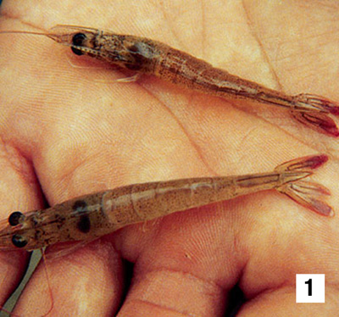  (1) Moribund, juvenile, pond-reared Pacific white shrimp (Litopenaeus vannamei) from Ecuador in the peracute phase of Taura syndrome. The shrimp are lethargic, and have soft shells and a distinct red tail fan.  Source: DV Lightner |  | 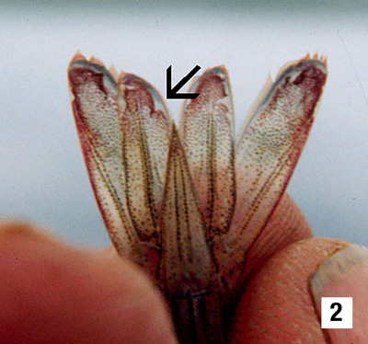  (2) A higher magnification (10×) view of the tail fan of one of the two shrimp shown in Figure 1. Use of a hand lens (or the close-up lens on a camera) shows rough edges of the cuticular epithelium in the uropods that are suggestive of focal necrosis of the epithelium at those sites (arrow).  Source: DV Lightner
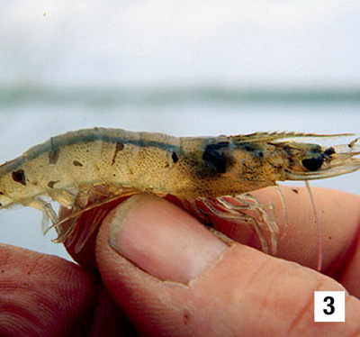  (3) Juvenile, pond-reared Pacific white shrimp (Litopenaeus vannamei) from Ecuador in the chronic or recovery phase of Taura syndrome. Multiple melanised foci mark sites of resolving cuticular epithelium necrosis due to Taura syndrome virus infection.  Source: DV Lightner | 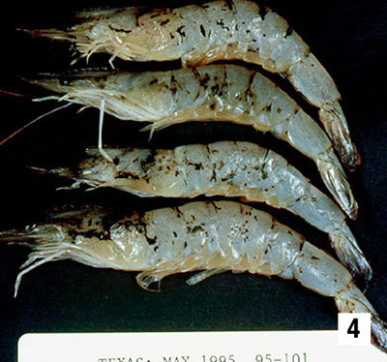  (4) Juvenile, pond-reared Pacific white shrimp (Litopenaeus vannamei) from Texas in the chronic or recovery phase of Taura syndrome. Multiple melanised foci mark sites of resolving cuticular epithelium necrosis due to Taura syndrome virus infection.  Source: DV Lightner
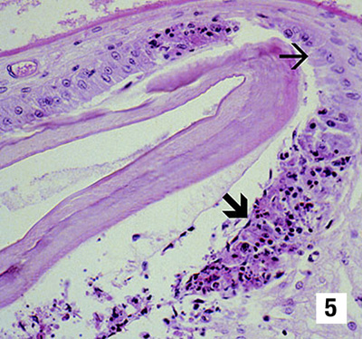
(5) A histological section through the stomach of a juvenile Pacific white shrimp (Litopenaeus vannamei) with peracute Taura syndrome. Prominent areas of necrosis in the cuticular epithelium (large arrow), which secretes the overlying acellular cuticle, are apparent. Adjacent to the focal lesions are normal-looking epithelial cells (small arrow). (300×)
Source: DV Lightner
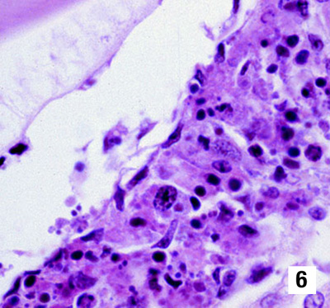
(6) A higher magnification (900×) of one of the classic peracute phase Taura syndrome lesions near the centre of Figure 5. Classic Taura syndrome lesions consist of necrotic cuticular epithelial and subcuticular connective tissue cells with pyknotic and karyorrhectic nuclei, a generally increased cytoplasmic eosinophilia and very numerous, variably staining, cytoplasmic inclusions. The cytoplasmic inclusions and pyknotic and karyorrhectic nuclei give the lesion a pathodiagnostic ‘peppered’ or ‘buckshot-riddled’ appearance. The peracute nature of the lesion is suggested by the absence of haemocytes in or near the lesion.
Source: DV Lightner
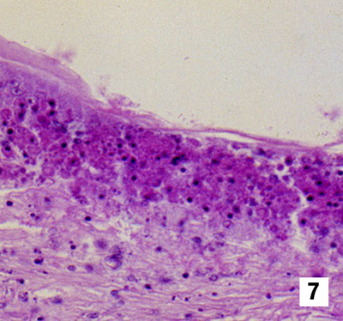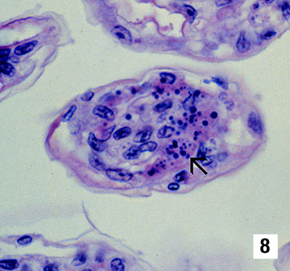
(7 & 8) Pathognomonic focal Taura syndrome virus lesions in other tissues (other than those shown in Figures 5 and 6) of a juvenile Pacific white shrimp (Litopenaeus vannamei) with peracute Taura syndrome. Figure 7 (450×) is a lesion in the cuticular epithelium and subcutis of the carapace; Figure 8 (900×) is in the gills (arrow). Nuclear pyknosis and karyorrhexis, increased cytoplasmic eosinophilia, and an abundance of variably staining, generally spherical cytoplasmic inclusions are distinguishing characteristics of the lesions.
Source: DV Lightner
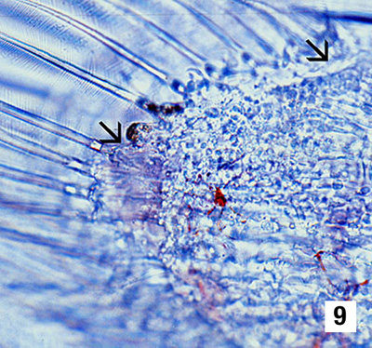
(9) Unstained wet mount of a uropod of an experimentally infected postlarval Pacific white shrimp (Litopenaeus vannamei) in the peracute phase of Taura syndrome. The postlarva was in the D4 stage of its moult cycle, as shown by the presence of the ‘old’ cuticle separated from the ‘new’ cuticle by a space. The arrows mark the approximate margins of a focal area of necrosis in the cuticular epithelium. The area of necrosis is evidenced by the presence of a vacant zone just under the cuticular epithelium (where the cuticular epithelium should be) and by the presence of refractile spheres (which are pyknotic and karyorrhectic nuclei) near the periphery of the lesion. A few expanded red chromatophores are also apparent in the subcuticular connective tissues of the uropod. (300×)
Source: DV Lightner
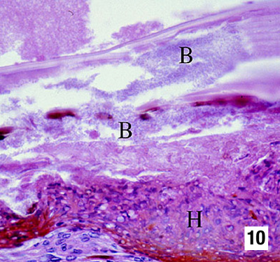
(10) Histological section (600×) of a resolving cuticular lesion in a juvenile Pacific white shrimp (Litopenaeus vannamei). A perforated cuticle that is heavily colonised with masses of bacteria (B) is at the top of the micrograph. A thick, melanised, haemocytic ‘plug’ (H) has formed basal to the cuticular epithelium to temporarily close the ‘wound’ from the outside. Basal to the haemocyte plug (H), connective tissue elements, and additional infiltrating haemocytes, provide the basal support for the regeneration of the cuticular epithelium. Pathognomonic Taura syndrome lesions in the recovery/chronic phase of Taura syndrome are usually few, relative to the resolving lesions shown here, and are often entirely absent.
Source: DV Lightner
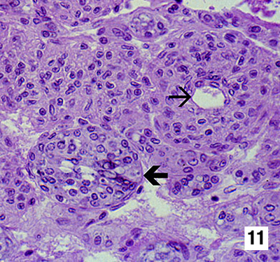
(11) Mid-sagittal section (450×) of the lymphoid organ (LO) of an experimentally infected juvenile Pacific white shrimp (Litopenaeus vannamei) in the chronic or recovery phase of Taura syndrome. Although pathognomonic Taura syndrome lesions of the type seen in the cuticular epithelium never occur in the LO, Taura syndrome virus does induce some significant lesions in this organ. Interspersed among normal-looking LO cords or tissue, which is characterised by multiple layers of sheath cells around a central haemolymph vessel (small arrow), are accumulations of disorganised LO cells that form LO ‘spheroids’ (LOS). LOS lack a central vessel and consist of cells that show karyomegaly and large, prominent cytoplasmic vacuoles and other cytoplasmic inclusions (large arrow).
Source: DV Lightner
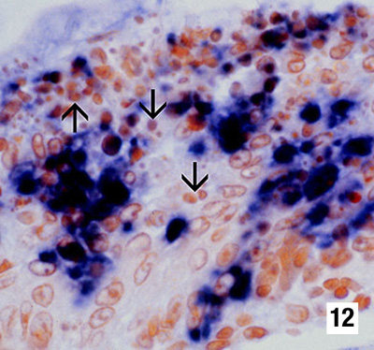
(12) Histological section (900×) of an appendage from a postlarval Pacific white shrimp (Litopenaeus vannamei) in the peracute phase of Taura syndrome that has been reacted with a digoxygenin (DIG)-labelled cDNA probe to Taura syndrome virus. The probe has reacted intensely with Taura syndrome virus–infected cells, staining the cytoplasm of infected cuticular epithelial cells and subcuticular connective tissue cells positive for the virus. The probe does not react with the pyknotic and karyorrhectic nuclei (arrows), because Taura syndrome virus is only cytoplasmic. These nuclear remnants contribute to the ‘peppered’ or ‘buckshot-riddled’ appearance of TS lesions.
Source: DV Lightner

