Aquatic Animal Diseases Significant to Australia:

Identification Field Guide 4th Edition

White spot disease
(Also known as infection with white spot syndrome virus)

EXOTIC DISEASE
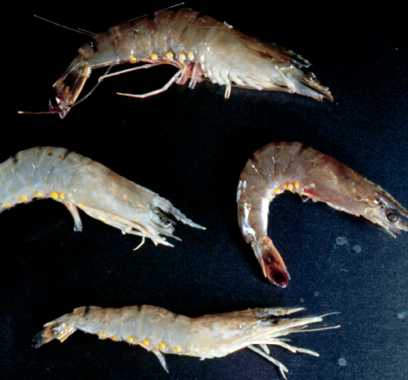  White spot disease in giant black tiger prawn (Penaeus monodon). Prawns at top and right of main photo show pink body colour typical of the acute phase of infection, while those at the bottom and to the left show classic white spots following the acute phase.  Source: DV Lightner | 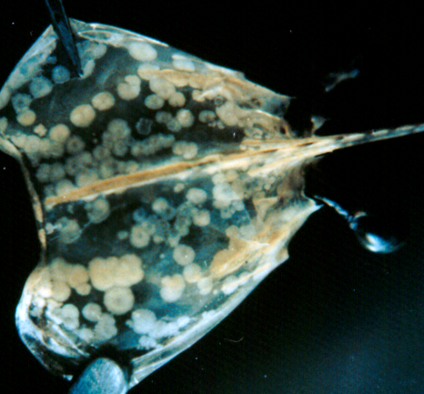  White spot disease in giant black tiger prawn (Penaeus monodon), showing classic white spots on the carapace  Source: DV Lightner

Signs of disease
Important: Animals with disease may show one or more of the signs below, but the pathogen may still be present in the absence of any signs.
Disease signs at the farm, tank and pond level are:
- rapid onset of mass mortality (80% or more) in farmed penaeid prawns during the grow-out period
- lethargy
- cessation of feeding
- aggregations of moribund prawns near the water surface at the edge of the rearing pond or tank.
Gross pathological signs are:
- loose carapace
- high degrees of colour variation, with a predominance of darkened (red-brown or pink) body surface and appendages
- heavy fouling of the surface and gills by external parasites
- white midgut line through the abdomen of severely affected larvae and postlarvae
- white calcium deposits embedded in the shell, causing white spots 0.5–3.0 mm in diameter
- delayed (or sometimes completely absent) clotting reaction of the haemolymph of infected shrimp.
Prawns with white spot disease may not show distinctive clinical signs. If present, shell lesions can range from minute spots to discs that are several millimetres in diameter, and may coalesce into larger plates. They are most easily observed by removing the cuticle over the cephalothorax, scraping away any attached tissue with the thumbnail and holding the cuticle up to the light. White spots in the cuticle are unreliable, even for preliminary diagnosis of white spot disease because similar spots can be produced by some bacteria, high alkalinity and other infectious or environmental conditions.
Microscopic pathological signs are:
- hypertrophied nuclei in gills and/or cuticular epithelium
- viral aggregates (shown as small reflective spots) in unstained smear preparations of the haemolymph by dark-field microscopy
- pathognomonic inclusion bodies in histological sections in target tissues.

Disease agent
The causative agent of white spot disease is white spot syndrome virus, a large DNA virus assigned as the only member of the genus Whispovirus (family Nimaviridae). The virus infects only crustaceans and appears not to be related to any other known viruses. It is not involved in the parasitic disease, common in finfish, also known as white spot. The virus is known to occur in fresh, brackish and marine water.

Host range
All decapod crustaceans (order Decapoda), including prawns, lobsters and crabs from marine, brackish or freshwater environments, are considered susceptible to infection. However, the disease has mainly been a problem in farmed penaeid (family Penaeidae) prawns.

Presence in Australia

EXOTIC DISEASE—not present in Australia.

Epidemiology
- Although many species of crustaceans are susceptible to infection, white spot syndrome virus is mainly a disease of farmed penaeid prawns.
- Rapid mortalities have been reported in many countries of up to 80% or more within 3–10 days.
- Experience has shown that prawn farm productivity falls to about 40% of normal for 2 years, and then recovers to about 70% over the long term.
- Resistance to white spot syndrome virus has not been reported for any of the penaeid species listed above.
- Infection may be low level and chronic (lifelong carriers are possible) in healthy crustaceans, or acute with disease and mortalities.
- Viral multiplication and disease appears to be induced by environmental and handling stress such as eye-stalk ablation, spawning, moulting, changes in salinity, temperature and pH and during plankton blooms. Imposing such stressors on suspect populations can a useful method to increase the probability of detecting virus.
- All life stages are potentially susceptible, from eggs to broodstock.
- Vertical transmission occurs from infected broodstock.
- Horizontal transmission of disease is usually via cannibalism of sick or dying prawns, or directly through contaminated water.
- Although not required for transmission, vectors of the virus include rotifers, marine molluscs, polychaete worms and non-decapodal crustaceans including Artemia salina, the copepods, non-crustacean arthropods and insect larvae.
- Birds can transmit the disease from pond to pond by releasing caught prawns over neighbouring ponds.
- White spot syndrome virus can persist and retain infectivity in seawater at 30ºC for at least 30 days (under laboratory conditions) and for at least 4 days in ponds.

Differential diagnosis
The list of similar diseases below refers only to the diseases covered by this field guide. Gross pathological signs may be representative of a number of diseases not included in this guide, which therefore should not be used to provide a definitive diagnosis, but rather as a tool to help identify the listed diseases that most closely account for the gross signs.

Similar diseases
Infectious hypodermal and haematopoietic necrosis virus, necrotising hepatopancreatitis, Taura syndrome, yellowhead disease
The microscopic signs described and shown here may also be symptomatic of infectious hypodermal haematopoietic necrosis. Further laboratory examination is needed for a definitive diagnosis.

Sample collection
Due to the uncertainty associated with differentiating diseases using only gross pathological signs, and because some aquatic animal disease agents might pose a risk to humans, only trained personnel should collect samples. You should phone your state or territory hotline number and report your observations if you are not appropriately trained. If samples have to be collected, the state or territory agency taking your call will provide advice on the appropriate course of action. Local or district fisheries or veterinary authorities may also provide advice regarding sampling.

Emergency disease hotline
The national disease hotline number is 1800 675 888. This number will put you in contact with the appropriate state or territory agency.

Further reading
The accepted procedures for a conclusive diagnosis of white spot syndrome virus are summarised in the World Organisation for Animal Health Manual of diagnostic tests for aquatic animals 2011, available at www.oie.int/en/international-standard-setting/aquatic-manual/access-online.
This hyperlink was correct and functioning at the time of publication.

Further images
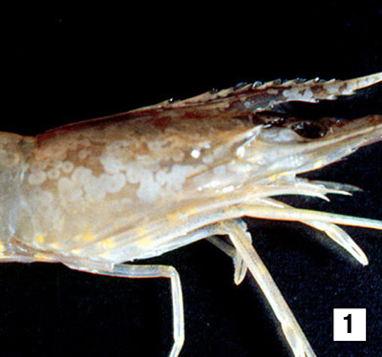
(1) A juvenile giant black tiger prawn (Penaeus monodon) that is displaying the distinctive white spots of white spot disease. White spots are especially visible on the carapace and the rostrum. Although providing a tentative diagnosis of white spot disease infection, white spots are not always visible in shrimp in the acute phase of the disease, and may develop in the subacute to chronic or recovery phases of the infection.
Source: DV Lightner
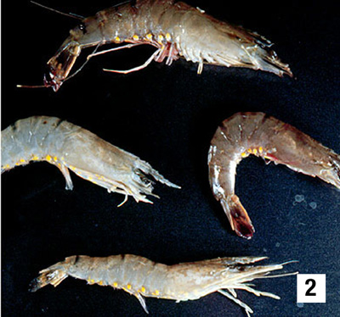
(2) Four juvenile black tiger prawns (Penaeus monodon), including the one shown in Figure 1 (at bottom), with different gross signs of white spot disease. The top and right shrimp show few, if any, white spots, but show a pink to red-brown discolouration due to expansion of the subcuticular chromatophores. This reddish appearance may be a gross sign that is more apparent in the acute phase of the disease. The shrimp on the left and bottom display diagnostic white spots that develop after the acute phase of the disease.
Source: DV Lightner
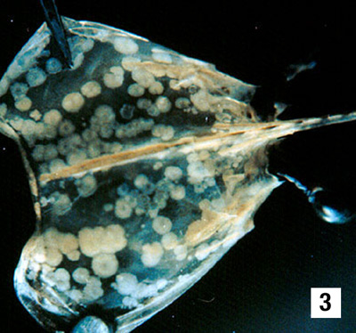
(3) The carapace from a juvenile black tiger prawn (Penaeus monodon) with white spot disease. White spots on the underside of the shell are caused by calcareous deposits. Photo: P Saibaba, SKBR College, Amalapuram, India
Source: DV Lightner
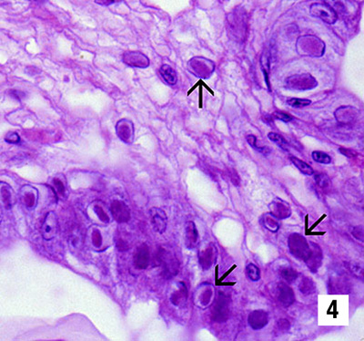
(4) Photomicrograph (900×) of a histological section from the stomach of a juvenile black tiger prawn (Penaeus monodon) infected with white spot disease. Prominent intranuclear inclusion bodies are abundant in the cuticular epithelium and subcuticular connective tissue of the organ (arrows). Cells in different phases of infection display intranuclear inclusion bodies. The early-phase inclusion bodies that predominate in this section are centronuclear and eosinophilic, and are separated from the nuclear membrane and marginated chromatin by an artifactual halo (resembling infectious hypodermal and haematopoietic necrosis inclusion bodies).
Source: DV Lightner
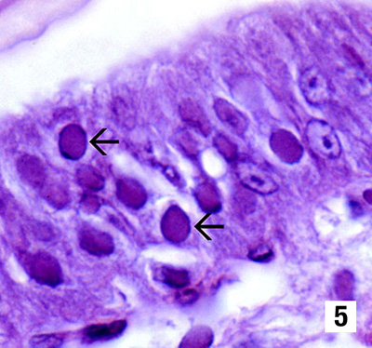
(5) Histological section (1300×) of the stomach of a juvenile Chinese white shrimp (Fenneropenaeus chinensis) with an advanced white spot disease infection. Fully developed white spot disease intranuclear inclusion bodies (arrows) are more basophilic, appear granular in texture and nearly fill the affected hypertrophied nucleus. Inclusion bodies are absent.
Source: DV Lightner
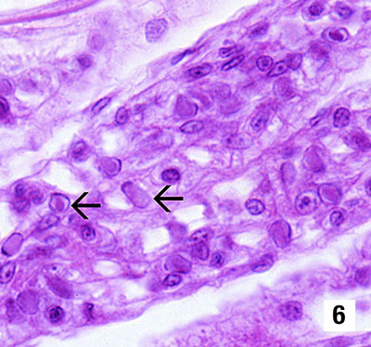
(6) Section of the gills from a juvenile Chinese white shrimp (Fenneropenaeus chinensis) with white spot disease (900×). Nearly one-quarter of the cells are infected, as indicated by the developing and fully developed intranuclear inclusion bodies of white spot disease (arrows).
Source: DV Lightner
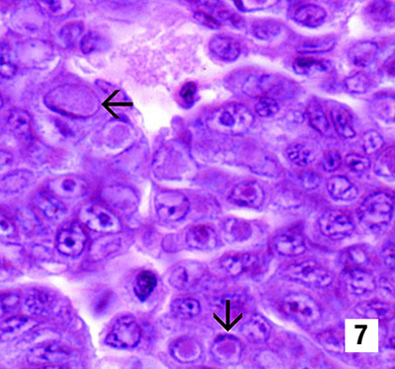
(7) Section of a white spot disease–infected haematopoietic nodule (1300×) from a juvenile Chinese white shrimp (Fenneropenaeus chinensis). As in Figure 6, nearly one-quarter of the cells in the section display intranuclear inclusions bodies of white spot disease (arrows) in various stages of development.
Source: DV Lightner
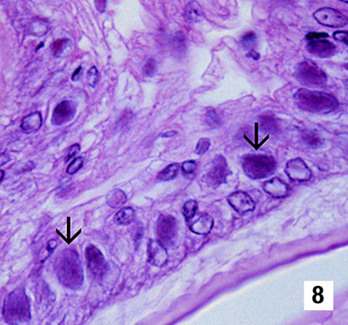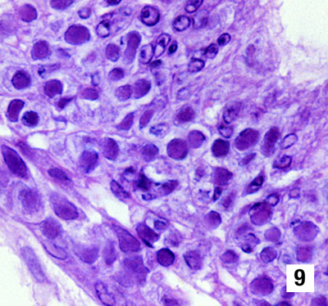
(8 & 9) Histological sections (900×) of the stomachs of Pacific blue shrimp (Litopenaeus stylirostris, Figure 8) and Pacific white shrimp (L. vannamei, Figure 9) experimentally infected with white spot disease. Both species display severe (grade 4) infections, with classic white spot disease intranuclear inclusion bodies (arrows) that are identical to those illustrated in Figures 3–7.
Source: DV Lightner

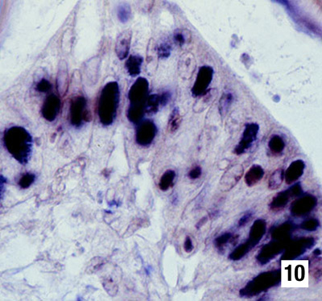 | 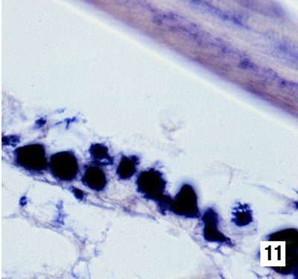
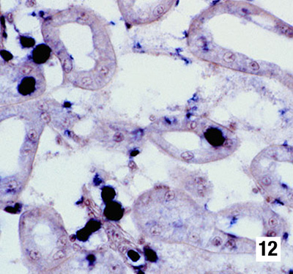 | (10, 11 & 12) Sections of various tissues from a white spot disease–infected juvenile Pacific white shrimp (Litopenaeus stylirostris) reacted by in situ hybridisation with a digoxygenin (DIG)-labelled DNA probe to the virus. The probe has reacted strongly with intranuclear inclusion bodies containing the disease in the various tissues of this shrimp, including the cuticular epithelium of the stomach (Figure 10, 900×), the cuticular epithelium and connective tissues of the carapace (Figure 11, 900×), and epithelial cells in the antennal gland (Figure 12, 450×).  Source: DV Lightner

