Aquatic Animal Diseases Significant to Australia:
Identification Field Guide 4th Edition

White tail disease
(Also known as white muscle disease [WMD])
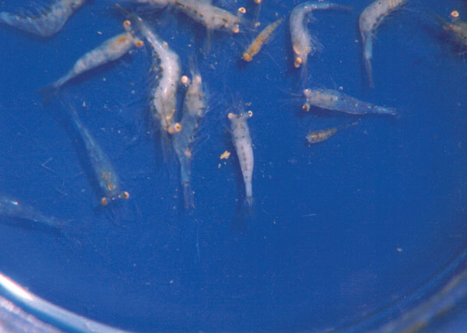
Giant freshwater prawn (Macrobrachium rosenbergii) postlarvae showing white tail disease
Source: AS Sahul Hameed

Signs of disease
Important: Animals with disease may show one or more of the signs below, but the pathogen may still be present in the absence of any signs.
Disease signs at the farm, tank or pond level are:
- presence of whitish postlarvae, followed by mortality 2–3 days after the conversion of first postlarva in larval rearing tanks
- lethargy
- mortality of up to 95% within 5 days after the appearance of the first gross signs.
Gross pathological signs are:
- particularly milky and opaque abdomen (tail), starting at the tail extremity (telson region) and gradually progressing towards the head
- abnormal appearance of floating moults in the tanks, which resemble ‘mica flakes’
- degeneration of telson and uropods (in severe cases)
- white colouration of abdominal muscle.
Microscopic pathological signs are:
- acute Zenker’s necrosis of striated muscles, characterised by severe hyaline degeneration, necrosis and muscular lysis
- pathognomonic basophilic intracytoplasmic inclusion bodies in infected muscle tissues.

Disease agent
The causative agent is Macrobrachium rosenbergii nodavirus (MrNV) and extra small virus (XSV).
Both these viruses are associated with the disease, but their respective roles are uncertain. These viruses are known to occur in fresh and brackish water.

Host range
Species known to be susceptible to white tail disease are listed below:
Common name | Scientific name
Giant freshwater prawnª | Macrobrachium rosenbergii
a Naturally susceptible

Presence in Australia
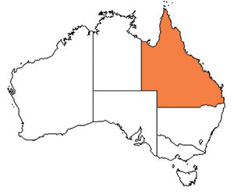
White tail disease has been officially reported from Queensland.

Epidemiology
- Very few postlarvae showing the clinical signs of white tail disease survive. Survivors seem to grow normally in grow-out ponds.
- Outbreaks most commonly occur in larvae, postlarvae and early juveniles. Adult life stages are resistant, and act as carriers.
- Transmission is both vertical (trans-ovum) and horizontal (from virus present in the water surrounding susceptible prawns or direct contact with an infected prawn).
- Mortality rates are variable and reach up to 95%.
- Some penaeid shrimp, Artemia and aquatic insects are vectors of white tail disease.

Differential diagnosis
The list of similar diseases below refers only to the diseases covered by this field guide. Gross pathological signs may be representative of a number of diseases not included in this guide, which therefore should not be used to provide a definitive diagnosis, but rather as a tool to help identify the listed diseases that most closely account for the gross signs.

Similar diseases
Infectious myonecrosis
The clinical signs described and shown here may also be symptomatic of other bacterial or viral infections, or poor water quality. Further laboratory examination is needed for a definitive diagnosis.

Sample collection
Due to the uncertainty associated with differentiating diseases using only gross pathological signs, and because some aquatic animal disease agents might pose a risk to humans, only trained personnel should collect samples. You should phone your state or territory hotline number and report your observations if you are not appropriately trained. If samples have to be collected, the state or territory agency taking your call will provide advice on the appropriate course of action. Local or district fisheries or veterinary authorities may also provide advice regarding sampling.

Emergency disease hotline
The national disease hotline number is 1800 675 888. This number will put you in contact with the appropriate state or territory agency.

Further reading
The currently accepted procedures for a conclusive diagnosis of white tail disease are summarised in the World Organisation for Animal Health Manual of diagnostic tests for aquatic animals 2011, available at www.oie.int/en/international-standard-setting/aquatic-manual/access-online.
This hyperlink was correct and functioning at the time of publication.

