Aquatic Animal Diseases Significant to Australia:
Identification Field Guide 4th Edition

Infection with infectious spleen and kidney
necrosis virus (ISKNV)-like viruses

EXOTIC DISEASE
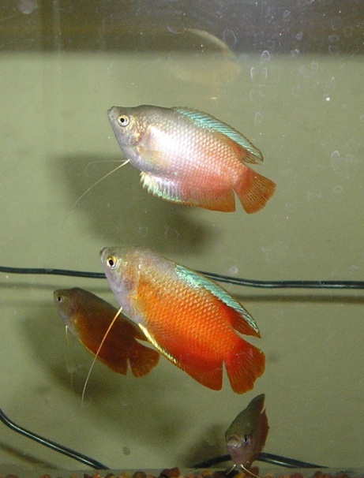  ISKNV in dwarf gourami: dwarf gourami naturally infected with an ISKNV-like iridovirus (top fish) showing pale colouration compared with unaffected fish (bottom fish)  Source: J Go | 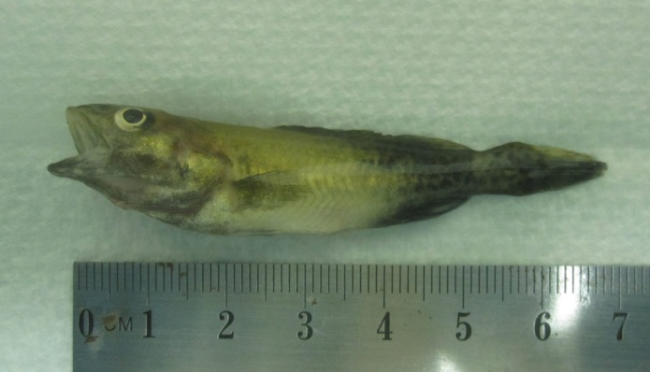  ISKNV in Murray cod fingerling: Murray cod fingerling experimentally infected with an ISKNV-like iridovirus showing discolouration around the front of the body (normal colouration evident near the tail) and signs of respiratory distress at time of death (flared opercula)  Source: J Go

Signs of disease
Important: Animals with disease may show one or more of the signs below, but the pathogen may still be present in the absence of any signs.
Disease signs at the farm, tank or pond level are:
- mortality between 50% and 100%
- fish remaining on bottom of tank and not feeding well
- lethargy
- respiratory distress (rapid movement of opercula).
Gross pathological signs are:
- changes in body colour (e.g. darkening or lightening of body colour)
- exophthalmos (popeye)
- abdominal distension (due to fluid or enlargement of organs).
Microscopic pathological signs are:
- basophilic hypertrophied cells throughout numerous body tissues, but especially the haematopoietic tissues of the kidney and spleen.

Disease agent
ISKNV-like viruses are a group of viral agents in the genus Megalocytivirus, family Iridoviridae. These viruses predominantly cause disease in freshwater fish (particularly cichlids, gouramis and poeciliids). The megalocytivirus agents included in this disease grouping are:
Cichlids:
- Angelfish iridovirus
- Cichlid iridovirus (includes ram cichlid and chromide cichlid)
- Iridovirus in Apistogramma spp.
- Iridovirus in oscars
- Iridovirus in rainbow krib
- Iridovirus in curviceps
Gouramis:
- Dwarf gourami iridovirus
- Pearl gourami iridovirus
- Iridovirus in thick-lipped gourami, three-spot gourami and silver gourami
- Iridovirus in paradise fish
Poeciliids:
- African lampeye iridovirus
- Swordtail iridovirus
- Iridovirus in mollies and platys
- Iridovirus in guppies.

Host range
Species known to be susceptible to ISKNV-like viruses are listed below. The list includes some native Australian fish species known to be highly susceptible to ISKNV-like viruses.
Common name | Scientific name
African lampeye killifishª | Aplocheilichthys normani
Angelfishª | Pterophyllum scalare
Banggai cardinalfishª | Pterapogon kauderni
Barramundiª | Lates calcarifer
Chinese perch or mandarin fishª | Siniperca chuatsi
Curvicepsª | Laetacara curviceps
Dwarf cichlidsª | Apistogramma spp.
Dwarf gouramiª | Colisa lalia
Flathead mulletª | Mugil cephalus
Grass carp | Ctenopharyngodon idellus
Grouperª | Epinephelus sp.
Guppyª | Poecilia reticulata (also known as Lebistes reticulatus)
Japanese parrotfish | Oplegnathus fasciatus
Largemouth bass | Micropterus salmoides
Marble gobyª | Oxyeleotris marmoratus
Mollyª | Poecilia sphenops
Murray codª | Maccullochella peelii peelii
Nile tilapiaª | Oreochromis niloticus
Orange chromideª | Etroplus maculatus
Oscarª | Astronotus ocellatus
Paradise fishª | Macropodus opercularis
Pearl gouramiª | Trichogaster leerii
Rainbow kribª | Pelvicachromis pulcher
Ram cichlidª | Mikrogeophagus ramirezi
Red drumª | Sciaenops ocellatus
Sailfin molliesª | Poecilia latipinna
Silver gouramiª | Trichogaster microlepis
Southern platyfish or red wagtail platyª | Xiphophorus maculatus
Swordtail or green swordtailª | Xiphophorus helleri
Thick-lipped gouramiª | Colisa labiosa
Three-spot gouramiª | Trichogaster trichopterus
Zebrafish | Danio rerio
a Naturally susceptible (other species have been shown to be experimentally susceptible)

Presence in Australia

EXOTIC DISEASE—not present in Australia.

Epidemiology
- ISKNV-like viruses are prone to inactivation by desiccation or heat at temperatures above 50 °C, but are stable in water at 4 °C for extended periods.
- ISKNV-like viruses have been found to cause disease in a wide variety of species (i.e. may lack strict host specificity).
- Based on experimental transmission studies, horizontal transmission via cohabitation, water, ingestion of excreta or cannibalism is likely.
- There is evidence that some species may be long-term asymptomatic carriers of ISKNV-like viruses, and that prevalence in infected populations may be high.

Differential diagnosis
The list of similar diseases below refers only to the diseases covered by this field guide. Gross pathological signs may be representative of a number of diseases not included in this guide, which therefore should not be used to provide a definitive diagnosis, but rather as a tool to help identify the listed diseases that most closely account for the gross signs.

Similar diseases
Epizootic haematopoietic necrosis, grouper iridoviral disease, red sea bream iridoviral disease

Sample collection
Due to the uncertainty in differentiating diseases using only gross pathological signs, and because some aquatic animal disease agents might pose a risk to humans, only trained personnel should collect samples. You should phone your state or territory hotline number and report your observations if you are not appropriately trained. If samples have to be collected, the agency taking your call will provide advice on the appropriate course of action. Local or district fisheries or veterinary authorities may also provide advice regarding sampling.

Emergency disease hotline
The national disease hotline number is 1800 675 888. This number will put you in contact with the appropriate state or territory agency.

Further reading
Biosecurity Australia 2010, Importation of freshwater ornamental fish: review of biosecurity risks associated with gourami iridovirus and related viruses—provisional final import risk analysis report, Biosecurity Australia, Canberra.

All fish belonging to the family Cichlidae.
Although currently uncharacterised, based on histopathology cichlid iridoviruses are considered to be megalocytiviruses.
Fish of the subfamilies Luciocephalinae and Macropodinae, family Osphronemidae.
All fish belonging to the family Poeciliidae.
All fish belonging to the subfamily Aplocheilichthyinae, family Poeciliidae.
Although currently uncharacterised, based on histopathology swordtail iridovirus and other iridoviruses identified under the family Poeciliidae are considered to be megalocytiviruses.

