Aquatic Animal Diseases Significant to Australia:
Identification Field Guide 4th Edition

Bacterial kidney disease

EXOTIC DISEASE
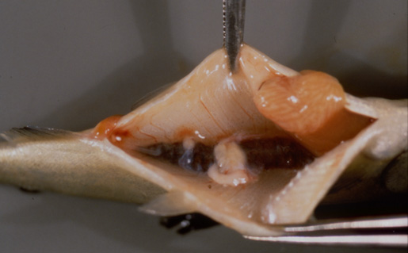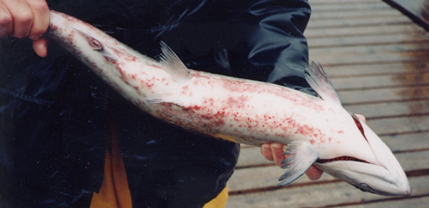
Left: Kidney lesions in a juvenile chinook salmon (Oncorhynchus tshawytscha) affected by bacterial kidney disease
Right: Ventral view of an adult chinook salmon (Oncorhynchus tshawytscha) with dermatitis (‘spawning rash’) caused by Renibacterium salmoninarum
Source: R Pascho and D Elliott

Signs of disease
Important: Animals with disease may show one or more of the signs below, but the pathogen may still be present in the absence of any signs.
Disease signs at the farm, tank or pond level are:
- lethargy
- increasing mortality.
Gross pathological signs are:
- exophthalmos (popeye)
- swollen abdomen and skin blisters or shallow ulcers (remnants of ruptured blisters)
- darkening of skin and pale gills
- haemorrhages at the base of the fins or at the vent
- creamy-white, granulomatous, nodular lesions in the kidney and sometimes in the liver and spleen, which may be encapsulated
- ascites (fluid in the abdominal cavity)
- haemorrhages on the abdominal wall and in the viscera
- diffuse, white membranous layer on one or more internal organs
- enlarged spleen
- cystic cavities in skeletal muscle.
Microscopic pathological signs are:
- focal or diffuse granulomatous reaction in the kidneys, liver and spleen
- small, rod-shaped bacteria (Renibacterium salmoninarum) in histological sections of skin lesions.

Disease agent
Bacterial kidney disease is caused by the bacterium Renibacterium salmoninarum. It is a slowly progressive and frequently fatal infection of cultured and wild salmonids in both fresh and marine waters.

Host range
Salmonid species known to be susceptible to bacterial kidney disease are listed below.
Common name | Scientific name
Arctic char | Salvelinus alpinus
Atlantic salmonª | Salmo salar
Black sea salmon | Salmo trutta labrax
Brook troutª | Salvelinus fontinalis
Brown troutª | Salmo trutta
Chinook salmonª | Oncorhynchus tshawytscha
Chum salmon | Oncorhynchus keta
Coho salmonª | Oncorhynchus kisutch
Cutthroat troutª | Salmo clarki
Dunube salmonª | Salmo hucho
Masu salmonª | Oncorhynchus masou
Pink salmonª | Oncorhynchus gorbuscha
Rainbow troutª | Oncorhynchus mykiss
a Naturally susceptible (other species have been shown to be experimentally susceptible)
Susceptible non-salmonid species include the following.
Common name | Scientific name
Ayuª | Plecoglossus altivelis
Burbot | Lota lota
Common shiner | Notropis cornutus
Fathead minnow | Pimephales promelas
Graylingª | Thymallus thymallus
Pacific herring | Clupea pallasii
Sablefish | Anoplopoma fimbria
Sea lampreyª | Petromyzon marinus
Shiner perch | Cymatogaster aggregata
a Naturally susceptible (other species have been shown to be experimentally susceptible)
Non-salmonid carriers include the following species.
Common name | Scientific name
Bartail flathead | Platycephalus indicus
Greenling | Hexagrammos otakii
Japanese scallop | Patinopecten yessoensis

Presence in Australia

EXOTIC DISEASE—not present in Australia.

Epidemiology
- The causative bacterium is likely to persist only within salmonids and not in the environment. However, as R. salmoninarum is often endemic in wild salmon populations, hatcheries can be constantly exposed to bacteria shed into the water by wild fish upstream.
- Other non-salmonid species have been demonstrated susceptible to infection with R. salmonarium, but only when raised in proximity to highly infected salmonids.
- The bacterium is transmitted both horizontally (between fish via the water) and vertically (parent to offspring via eggs). Surface disinfection of eggs does not prevent vertical transmission.
- Advanced infection becomes apparent only after the first year of the fish’s life.
- Coho (Oncorhynchus kisutch) and chinook (O. tshawytscha) salmon are the most important worldwide sources of infection.

Differential diagnosis
The list of similar diseases below refers only to the diseases covered by this field guide. Gross pathological signs may be representative of a number of diseases not included in this guide, which therefore should not be used to provide a definitive diagnosis, but rather as a tool to help identify the listed diseases that most closely account for the gross signs.

Similar diseases
No diseases listed in this field guide are similar to bacterial kidney disease.

Sample collection
Due to the uncertainty in differentiating diseases using only gross pathological signs, and because some aquatic animal disease agents might pose a risk to humans, only trained personnel should collect samples. You should phone your state or territory hotline number and report your observations if you are not appropriately trained. If samples have to be collected, the agency taking your call will provide advice on the appropriate course of action. Local or district fisheries or veterinary authorities may also provide advice regarding sampling.

Emergency disease hotline
The national disease hotline number is 1800 675 888. This number will put you in contact with the appropriate state or territory agency.

Further reading
Further information can be found on the Centre for Environment, Fisheries and Aquaculture Science (Cefas) International Database on Aquatic Animal Disease (IDAAD) website at www.cefas.defra.gov.uk/idaad/disocclist.aspx.
This hyperlink was correct and functioning at the time of publication.

Further images
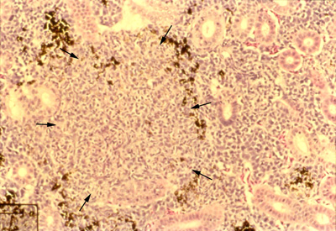
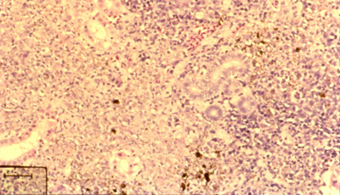
Focal (top photo, arrows) and diffuse (bottom photo) granulomas in the posterior kidney of juvenile chinook salmon (Oncorhynchus tshawytscha) with bacterial kidney disease. (Haematoxylin and eosin stain; scale bars = 50 µm)
Source: R Pascho and C O’Farrell

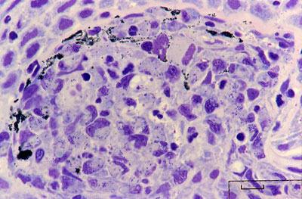
Histological section of a skin lesion of a juvenile chinook salmon (Oncorhynchus tshawytscha) infected with R. salmoninarum. Most of the small, rod-shaped R. salmoninarum are visible within the cytoplasm of macrophages. Note that the bacteria are purple-blue in this Giemsa-stained preparation, in contrast to the black melanin granules.
Source: R Pascho
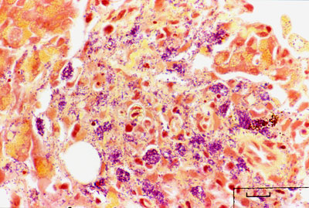
Gram-stained histological section of pancreatic tissue of a juvenile chinook salmon (Oncorhynchus tshawytscha) with systemic bacterial kidney disease. R. salmoninarum cells are present extracellularly and intracellularly within macrophages. Note the colour difference between the gram-positive (purple–blue) bacteria and the brown–black melanin granules.
Source: R Pascho

