Aquatic Animal Diseases Significant to Australia:
Identification Field Guide 4th Edition

Channel catfish virus disease (CCVD)

EXOTIC DISEASE
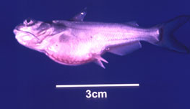  CCVD-affected channel catfish fingerling; note swollen stomach and ‘popeye’  Source: LA Hanson | 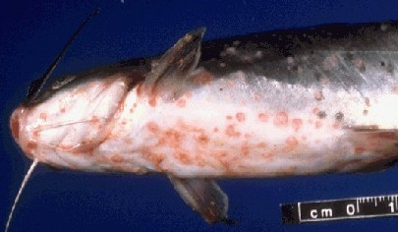  Haemorrhages present on the base of the body, gills and fins of channel catfish infected with CCV  Source: United States Department of Agriculture

Signs of disease
Important: Animals with disease may show one or more of the signs below, but the pathogen may still be present in the absence of any signs.
Disease signs at the farm, tank or pond level are:
- decreased feeding activity (usually the first sign)
- high mortality in fry and juvenile ictalurid catfish
- erratic swimming
- brief episodes of hyperactivity when fish are disturbed, followed by extended periods of lethargy
- large congregations of fish at the sides of hatching troughs or ponds, motionless in a head-up, tail-down position.
Gross pathological signs are:
- swollen abdomen
- exophthalmos (popeye)
- haemorrhaging of fins and ventral abdomen
- haemorrhaging of the musculature, liver and kidneys
- dark and enlarged spleen
- fluid in the abdominal cavity
- pale, enlarged kidneys, which may be the only internal indication of disease in infected fish.
Microscopic pathological signs are:
- extensive necrosis of renal tubules and interstitial tissues of the kidney.

Disease agent
CCVD is caused by a herpesvirus (ictalurid herpesvirus 1).

Host range
Ictalurid herpesvirus 1 has been isolated from crucian carp (Carassius carassius) and common carp (Cyprinus carpio) not exhibiting disease signs. It is currently unknown if they act as reservoirs for the virus.
Species known to be susceptible to CCVD are listed below.
Common nameª | Scientific name
Blue catfish | Ictalurus furcatus
Channel catfish | Ictalurus punctatus
a Both species listed are naturally susceptible (other species have been shown to be experimentally susceptible).

Presence in Australia

EXOTIC DISEASE—not present in Australia.

Epidemiology
- Horizontal transmission occurs directly from virus shed in water, and from virus carried by animal vectors and on fomites.
- Vertical transmission (from parent to offspring via eggs) is believed to be common.
- Mortality rates in exposed fish can increase to greater than 95%. Survivors of CCVD may experience short-term reductions in feed conversion (reduced weight gain). Generally, these fish appear normal but become carriers of the virus.
- Susceptibility appears to vary according to the strain of the virus.
- The disease occurs almost exclusively in fish that are less than 1 year old (fry and fingerlings) or smaller than 15 cm in length. The majority of occurrences are in fish less than 4 months old.
- Mortality rates are highest where water temperature exceeds 27 °C and declines with a reduction in temperature. Mortality rates are negligible at water temperatures lower than 18 °C.

Differential diagnosis
The list of similar diseases below refers only to the diseases covered by this field guide. Gross pathological signs may be representative of a number of diseases not included in this guide, which therefore should not be used to provide a definitive diagnosis, but rather as a tool to help identify the listed diseases that most closely account for the gross signs.

Similar diseases
Aeromonas salmonicida—atypical strains, enteric septicaemia of catfish

Sample collection
Due to the uncertainty in differentiating diseases using only gross pathological signs, and because some aquatic animal disease agents might pose a risk to humans, only trained personnel should collect samples. You should phone your state or territory hotline number and report your observations if you are not appropriately trained. If samples have to be collected, the agency taking your call will provide advice on the appropriate course of action. Local or district fisheries or veterinary authorities may also provide advice regarding sampling.

Emergency disease hotline
The national disease hotline number is 1800 675 888. This number will put you in contact with the appropriate state or territory agency.

Further reading
Further information can be found on the Centre for Environment, Fisheries and Aquaculture Science (Cefas) International Database on Aquatic Animal Disease (IDAAD) website at www.cefas.defra.gov.uk/idaad/disocclist.aspx.
This hyperlink was correct and functioning at the time of publication.

