Aquatic Animal Diseases Significant to Australia:
Identification Field Guide 4th Edition

Enteric red mouth disease

EXOTIC DISEASE
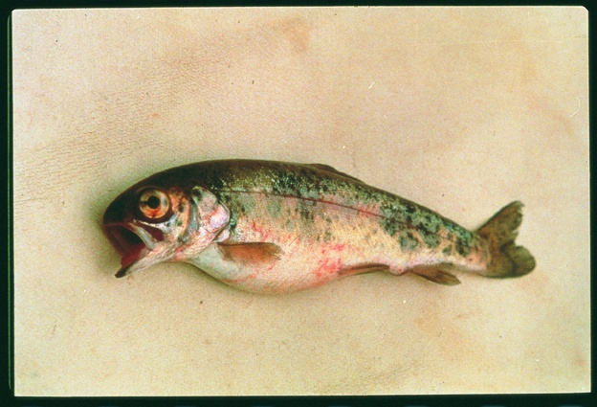  Enteric red mouth disease in rainbow trout; note skin and eye haemorrhages, and swollen abdomen  Source: HJ Schlotfeldt | 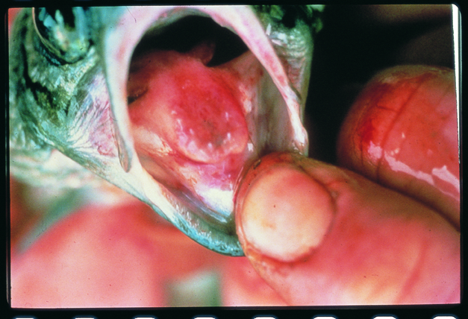  Enteric red mouth disease in rainbow trout; note reddened mouth and tongue  Source: HJ Schlotfeldt

Signs of disease
Important: Animals with disease may show one or more of the signs below, but the pathogen may still be present in the absence of any signs.
Disease signs at the farm, tank or pond level are:
- separation from other fish
- occasional nervous signs
- acute infections in fingerlings, although fish of all ages are affected usually with sustained low level mortalities observed
Gross pathological signs are:
- dark body colour (seen in atypical infections)
- haemorrhages at base of paired fins and vent
- reddening (subcutaneous haemorrhages) of the gill cover, corners of mouth, gums, palate and tongue
- exophthalmos (popeye) and orbital haemorrhages
- loss of appetite
- swollen abdomen
- ascites (fluid in the abdominal cavity)
- pinpoint haemorrhages on the liver, pancreas, pyloric caecae, swim bladder and lateral musculature surfaces
- enlarged, friable black spleen
- inflamed lower intestine containing thick yellow fluid.
Microscopic pathological signs are:
- generalised haemorrhagic septicaemic inflammatory response of all tissues
- bacterial colonisation of well-vascularised tissues (spleen, liver, heart, gills, kidney)
- necrosis of haematopoietic tissue in the kidney and spleen.

Disease agent
The causative agent of enteric red mouth disease is the bacterium Yersinia ruckeri. There are several serotypes of the bacterium, and classification systems can be based upon whole-cell typing as well as individual cell-wall antigen groupings. The serotype responsible for enteric red mouth disease is the Hagerman strain, serotype O1a, which is considered to be the most virulent.
Although the enteric red mouth strain (serotype O1a) is exotic to Australia, a virulent form of Y. ruckeri (serotype O1b) is endemic in Australia. It produces a septicaemic condition in Atlantic salmon (Salmo salar) known as yersiniosis. A characteristic of this form of the disease is exophthalmos (popeye) and the formation of pronounced haemorrhages in the eye that give rise to the description of 'blood spot' disease. The prominent reddening of the corners of the mouth, gums and palate typical of classical enteric red mouth disease does not normally occur in yersiniosis.

Host range
Species known to be susceptible to enteric red mouth disease are listed below.
Common name | Scientific name
Atlantic salmon | Salmo salar
Brown trout | Salmo trutta
Common carp | Cyprinus carpio
Goldfish | Carassius auratus
Rainbow trout | Oncorhynchus mykiss

Species not commonly found in Australia but known to be susceptible to infection are listed below.
Common name | Scientific name
Salmonid
Arctic char | Salvelinus alpinus
Brook trout | Salvelinus fontinalis
Chinook salmon | Oncorhynchus tschawytscha
Coho salmon | Oncorhynchus kisutch
Cutthroat trout | Salmo clarkii
Sockeye salmon | Oncorhynchus nerka
Non-salmonid
Bighead carp | Aristichthys nobilis
Burbot | Lota lota
Channel catfish | Ictalurus punctatus
Cisco | Coregonus artedi
Common sole | Solea solea
European eel | Anguilla anguilla
Emerald shiner | Notemigonus atherinoides
Fathead minnow | Pimephales promelas
Siberian sturgeon | Acipenser baeri
Silver carp | Hypophthalmichthys molitrix
Turbot | Scophthalmus maximus
Whitefish | Coregonus peled and C. muksun
It should be assumed that all species in the host range are naturally susceptible.

Presence in Australia

EXOTIC DISEASE—not present in Australia.
(A related disease known as ‘blood spot’ occurs in Australia).

Epidemiology
- Many other aquatic species are potential carriers but show no signs (e.g. some crustaceans, including freshwater crayfish).
- Transmission can be horizontal, via direct contact with infected fish or carriers. Carriers are particularly important sources of infection under stressful situations (e.g. increasing temperature).
- The organism can survive in the environment, with some strains able to form biofilms.
- Vertical transmission (fish to egg) is suspected but is yet to be proven.
- This disease causes septicaemia (bacteria are spread through the body via the blood).
- Fish of all ages are affected, and outbreaks usually begin with low mortalities that slowly escalate. The severity of the outbreak depends on the strain and presence of stressors.

Differential diagnosis
The list of similar diseases below refers only to the diseases covered by this field guide. Gross pathological signs may be representative of a number of diseases not included in this guide, which therefore should not be used to provide a definitive diagnosis, but rather as a tool to help identify the listed diseases that most closely account for the gross signs.

Similar diseases
Infectious haematopoietic necrosis, infectious salmon anaemia, spring viraemia of carp, viral haemorrhagic septicaemia

Sample collection
Due to the uncertainty in differentiating diseases using only gross pathological signs, and because some aquatic animal disease agents might pose a risk to humans, only trained personnel should collect samples. You should phone your state or territory hotline number and report your observations if you are not appropriately trained. If samples have to be collected, the agency taking your call will provide advice on the appropriate course of action. Local or district fisheries or veterinary authorities may also provide advice regarding sampling.

Emergency disease hotline
The national disease hotline number is 1800 675 888. This number will put you in contact with the appropriate state or territory agency.

Further reading
Further information can be found on the Centre for Environment, Fisheries and Aquaculture Science (Cefas) International Database on Aquatic Animal Disease (IDAAD) website at www.cefas.defra.gov.uk/idaad/disocclist.aspx.
This hyperlink was correct and functioning at the time of publication.
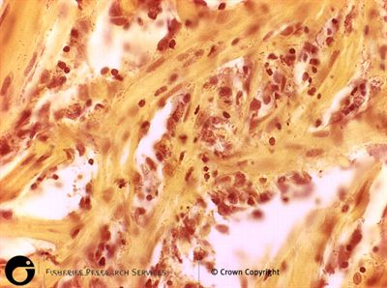  Diffuse haemorrhage evident on tissue section taken from a rainbow trout naturally infected with Yersinia ruckeri  Source: Scottish Government | 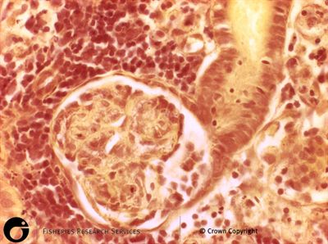  Cross section of a kidney nephron from a rainbow trout naturally infected with Yersinia ruckeri  Source: Scottish Government

