Aquatic Animal Diseases Significant to Australia:
Identification Field Guide 4th Edition

Enteric septicaemia of catfish
(Also known as edwardsiellosis or hole-in-the-head disease)
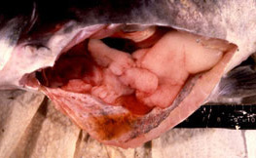 Fluid resulting from ascites in enteric septicaemia of catfish  Source: LA Hanson | 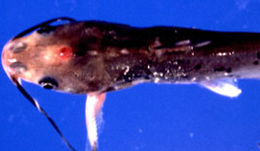 Cranial ulcers common in chronic enteric septicaemia of catfish  Source: LA Hanson
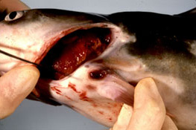
In chronic infections, lesions occasionally occur in the joints of the pectoral or dorsal spines.
Source: LA Hanson

Signs of disease
Important: Animals with disease may show one or more of the signs below, but the pathogen may still be present in the absence of any signs.
Disease signs at the farm, tank or pond level are:
- lethargic swimming
- abnormal behaviour—alternating listlessness and chaotic swimming
- disorientation and swimming in spirals
- loss of appetite
- ‘surfing’, with head protruding from water.
Gross pathological signs in the chronic encephalitic form are:
- swelling on top of the head, occasionally progressing to the erosion of connective tissue and exposure of the brain (a ‘hole in the head’)
- granulomatous inflammation of the brain.
Gross pathological signs in the acute septicaemic form are:
- pale gills
- darkening of the skin (observed in species other than channel catfish)
- multiple small white spots on the skin
- raised skin patches progressing to shallow ulcers on the flanks and head
- haemorrhage at the base of the fins, around the mouth, and on the throat, operculum (gill cover) and abdomen
- exophthalmos (popeye)
- swollen abdomen (‘pot-belly’)
- ascites (fluid in the abdominal cavity)
- lesions on the liver and other internal organs
- intestine frequently bloody, but may be transparent or clear yellow
- red, swollen anal region with trailing faecal casts (has been observed in infected barramundi)
- soft and pale spleen, anterior kidney or posterior kidney, with petechial (pinpoint) haemorrhages.
Microscopic pathological signs are:
- gram-negative rods in histological sections (muscle, kidney)
- locally extensive cellulitis in the head region
- necrotising myositis.

Disease agent
Enteric septicaemia of catfish is caused by the bacterium Edwardsiella ictaluri, which belongs to the family Enterobacteriaceae.

Host range
Enteric septicaemia of catfish is a highly infectious bacterial disease of the catfish families Ictaluridae, Plotosidae, Clariidae, Siluridae, Pangasiidae and Ariidae, but especially the ictalurids. Several non-catfish species are also susceptible and are listed below.
Common name | Scientific name
Ayuª | Plecoglossus altivelis
Barramundi or Asian seabass | Lates calcarifer
Berney’s catfish | Neoarius berneyi
Black bullheadª | Ameiurus melas
Black catfish | Neosilurus ater
Blue catfishª | Ictalurus furcatus
Brown bullheadª | Ameiurus nebulosus
Channel catfishª | Ictalurus punctatus
Chinook salmon | Oncorhynchus tshawytscha
Glass knifefishª | Eigenmannia virescens
Rainbow trout | Oncorhynchus mykiss
Rosy barbª | Puntius conchonius
Sind danioª | Danio devario
Sutchi catfishª | Pangasius hypophthalmus
Tadpole madtomª | Noturus gyrinus
Toothless catfish | Anodontiglanis dahlia
Walking catfishª | Clarias batrachus
White catfishª | Ameiurus catus
Yellow bullheadª | Ameiurus natalis
Yellow catfishª | Pelteobagrus fulvidraco
Zebrafishª | Danio rerio
a Naturally susceptible (other species have been shown to be experimentally susceptible)

Presence in Australia
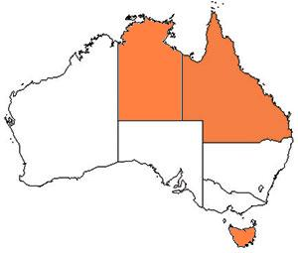
Enteric septicaemia of catfish has been officially reported in Australia from imported aquarium fish (danios, rosy barbs) held in contained facilities. In 2010 and 2011, native black catfish, toothless catfish and Berney’s catfish held in a facility also holding imported aquarium fish became infected, resulting in mortalities. Targeted surveillance and testing has not provided evidence of persistent infection with E. ictaluri in wild or farmed fish populations in Australia.

Epidemiology
- E. ictaluri has also been linked to disease outbreaks in barramundi (also known as Asian seabass) and Pangasius.
- Enteric septicaemia of catfish has primarily been a disease of channel catfish; however, it has been reported from other catfish and non-catfish species. Most of the epidemiological knowledge about the disease is based on its occurrence in channel catfish.
- Horizontal transmission is via the faecal–oral route, cannibalism, and contact with contaminated water and materials used in handling infected fish.
- Faeces are the main source of shedding and dissemination, although dead fish and equipment such as fishing nets and sorting devices may be contaminated and spread the disease.
- The intestinal tract is the primary site of infection for the acute septicaemic form. The chronic encephalitic form is thought to establish after entering fish via the olfactory sacs.
- Surviving catfish carry the bacterium, which also seems to be able to survive in the intestinal tracts of other fish species.
- Disease occurs primarily at water temperatures between 18 °C and 28 °C, making spring and autumn the most common times for outbreaks. Stress is often a predisposing factor.
- The bacterium can survive 3–4 months in pond water, mud and vegetation.
- Environmental stressors can influence the expression of clinical signs and extend the incubation period.
- Morbidity and mortality can be high in heavily stocked ponds.

Differential diagnosis
The list of similar diseases below refers only to the diseases covered by this field guide. Gross pathological signs may be representative of a number of diseases not included in this guide, which therefore should not be used to provide a definitive diagnosis, but rather as a tool to help identify the listed diseases that most closely account for the gross signs.

Similar diseases
Channel catfish virus disease, spring viraemia of carp

Sample collection
Due to the uncertainty in differentiating diseases using only gross pathological signs, and because some aquatic animal disease agents might pose a risk to humans, only trained personnel should collect samples. You should phone your state or territory hotline number and report your observations if you are not appropriately trained. If samples have to be collected, the agency taking your call will provide advice on the appropriate course of action. Local or district fisheries or veterinary authorities may also provide advice regarding sampling.

Emergency disease hotline
The national disease hotline number is 1800 675 888. This number will put you in contact with the appropriate state or territory agency.

Further reading
Further information can be found on the Centre for Environment, Fisheries and Aquaculture Science (Cefas) International Database on Aquatic Animal Disease (IDAAD) website at www.cefas.defra.gov.uk/idaad/disocclist.aspx.
This hyperlink was correct and functioning at the time of publication.

Further images
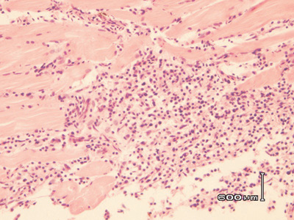
Necrotising myositis
Source: G Storie and H Prior

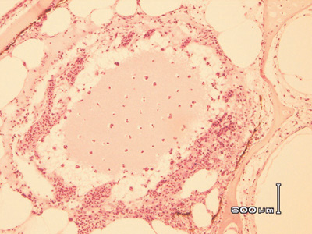  Locally extensive cellulitis in the head, involving connective tissue surrounding cranial bones and cartilage  Source: G Storie and H Prior | 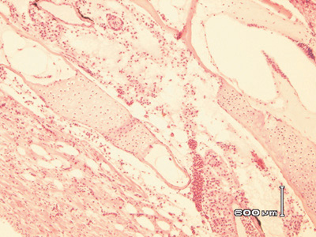  Locally extensive cellulitis in the head, involving connective tissue surrounding cranial bones and cartilage  Source: G Storie and H Prior

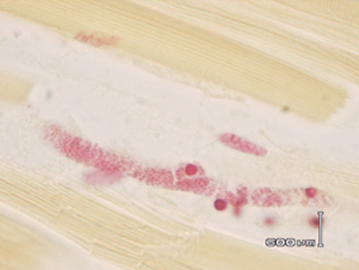  Gram-negative rods (Edwardsiella) in skeletal muscle  Source: G Storie and H Prior | 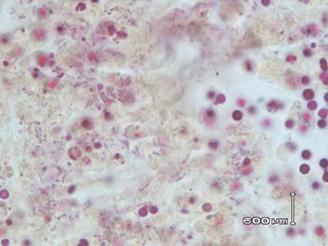  Gram-negative rods (Edwardsiella) in kidney  Source: G Storie and H Prior

