Aquatic Animal Diseases Significant to Australia:
Identification Field Guide 4th Edition

Furunculosis
(Also known as infection with Aeromonas salmonicida subsp.
salmonicida)

EXOTIC DISEASE
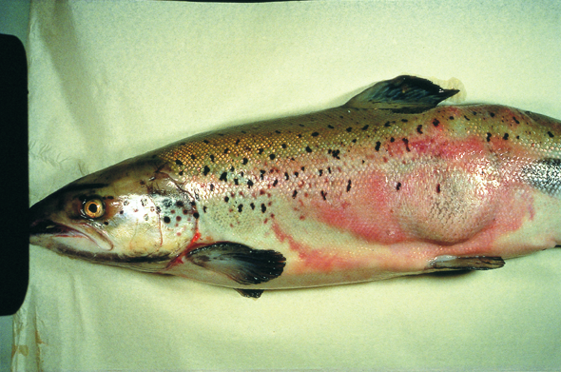  Furunculosis in Atlantic salmon (Salmo salar); note the large furuncle (boil) on the side of the fish  Source: T Håstein | 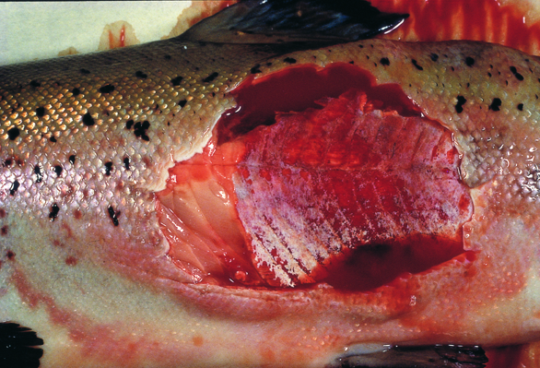  Furunculosis in Atlantic salmon (Salmo salar); note the furuncle cut away to show the underlying necrotic tissue  Source: T Håstein

Signs of disease
Important: Animals with disease may show one or more of the signs below, but the pathogen may still be present in the absence of any signs.
Disease signs at the farm, tank or pond level are:
- sudden death, perhaps with slight exophthalmos (popeye)
- often no clinical signs in young fish with a peracute form of the disease
- death in a matter of days following initial clinical signs of disease in growing fish with acute furunculosis
- high mortality
- lethargic swimming or swimming just below the surface
- loss of appetite
- respiratory distress and jumping from the water immediately before an outbreak.
Gross pathological signs are:
- furuncles (or boils) involving skin and/or muscle, progressing to crater lesions (usually restricted to the subacute or chronic phase in adult salmon)
- haemorrhages on the skin, mouth and fin bases (mainly of paired fins)
- darkening of body colour and pale gills
- bloody discharge from nares and/or vent
- exophthalmos (popeye)
- haemorrhages in muscle and internal organs
- enlarged spleen and focal necrosis of the liver
- stomach filled with mucus, blood and sloughed epithelial cells
- congested intestine
- death without any clinical signs other than darkening of the skin, which can occur in peracute infections in juvenile salmon.
Microscopic pathological signs are:
- fusion of gill lamellae, with necrosis of the epithelium
- eosinophilic inflammatory changes in gills
- bacterial colonies in many tissues
- sloughing of renal tubular cells into the renal tubular lumen
- sloughing of intestinal epithelial cells into the intestinal lumen.

Disease agent
Furunculosis is caused by the bacterium Aeromonas salmonicida subsp. salmonicida. This bacterium is intracellular and so may avoid some host immune defences after infection. During infection, the bacterium produces extracellular toxins that may play a significant role in the pathogenesis of the disease. There are four other subspecies of A. salmonicida; these ‘atypical’ strains are considered to cause a different disease syndrome, infection with Aeromonas salmonicida—atypical strains, which is also discussed in this guide.

Host range
All salmonids are believed to be susceptible to A. salmonicida subsp. salmonicida. Species known to be susceptible are listed below.
Common name | Scientific name
Atlantic codª | Gadus morhua
Atlantic salmonª | Salmo salar
Brook troutª | Salvelinus fontinalis (particularly susceptible)
Brown troutª | Salmo trutta (particularly susceptible)
Bullhead | Cottus gobio
Common shiner | Notropis cornutus
Eelª | Anguilla rostrata
Gilt-head seabreamª | Sparus aurata
Halibutª | Hippoglossus stenolepis
Minnows | Galaxiidae
Pike | Esox lucius
Pike perch | Sander lucioperca
Rainbow troutª | Oncorhynchus mykiss
Salmonids (all presumed susceptible) | Salmonidae
Sea lampreyª | Petromyzon marinus
Turbot | Psetta maxima (also known as Scophthalmus maximus)
Wolffishª | Anarhichas lupus
Wrasse | Labridae
a Naturally susceptible (other species have been shown to be experimentally susceptible)

Presence in Australia

EXOTIC DISEASE—not present in Australia.
The strain of Aeromonas causing furunculosis in salmonids overseas (i.e. the typical strain) is not present in Australia. However, atypical strains are present (see ‘Infection with Aeromonas salmonicida—atypical strains’).

Epidemiology
- Furunculosis is highly contagious and affects fish of all ages.
- The disease one of the most commercially significant salmonid diseases, occurring in freshwater and marine salmonid aquaculture in all countries except Australia and New Zealand.
- Overseas, this disease must be controlled on farms by medication or vaccination.
- Outbreaks typically occur at temperatures above 10 °C, however outbreaks can occur in very young fish and at temperatures as low as 2–4 °C. Disease may be precipitated by endogenous (e.g. smoltification, spawning) and exogenous (e.g. temperature fluctuations, poor water quality) stressors.
- Australia's relatively warm water temperatures may favour the establishment of A. salmonicida subsp. salmonicida.
- Rainbow trout are relatively resistant to the disease, but are still considered susceptible.
- Horizontal transmission occurs via the water column, but also through direct fish-to-fish contact and animal vectors (birds and invertebrates such as sea lice). A. salmonicida subsp. salmonicida has been detected on the surface of fertilised eggs; surface decontamination using iodine is effective in preventing vertical transmission (passage of infection from parent to offspring).
- A. salmonicida subsp. salmonicida can survive for months in some environments.
- Non-salmonids may become infected by ingesting tissue of infected salmonids. Similarly, transmission to non-salmonids can occur where fish caught for feed are taken from waters near an outbreak.
- Susceptibility to the disease increases with damaged mucous and skin, such as occurs when fish are handled with nets.
- Fish surviving disease outbreaks are recognised as carriers of the disease and may continue to infect the remaining population without themselves showing any outward signs of infection. Stress may precipitate disease in subclinical carriers.

Differential diagnosis
The list of similar diseases below refers only to the diseases covered by this field guide. Gross pathological signs may be representative of a number of diseases not included in this guide, which therefore should not be used to provide a definitive diagnosis, but rather as a tool to help identify the listed diseases that most closely account for the gross signs.

Similar diseases
Infection with Aeromonas salmonicida—atypical strains, epizootic haematopoietic necrosis, infectious haematopoietic necrosis

Sample collection
Due to the uncertainty in differentiating diseases using only gross pathological signs, and because some aquatic animal disease agents might pose a risk to humans, only trained personnel should collect samples. You should phone your state or territory hotline number and report your observations if you are not appropriately trained. If samples have to be collected, the agency taking your call will provide advice on the appropriate course of action. Local or district fisheries or veterinary authorities may also provide advice regarding sampling.

Emergency disease hotline
The national disease hotline number is 1800 675 888. This number will put you in contact with the appropriate state or territory agency.

Further reading
Further information can be found on the Australian Government Department of Agriculture, Fisheries and Forestry website at www.daff.gov.au/animal-plant-health/aquatic/aquavetplan/furunculosis.
This hyperlink was correct and functioning at the time of publication.

