Aquatic Animal Diseases Significant to Australia:
Identification Field Guide 4th Edition

Grouper iridoviral disease
(Also known as sleepy grouper disease)

EXOTIC DISEASE
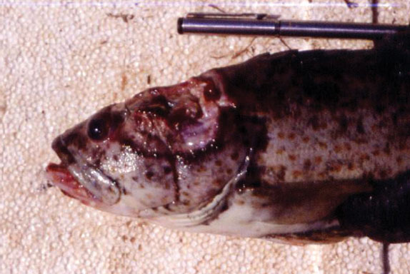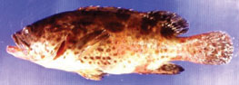
(a)
(b)
Gross signs of secondary infection in grouper infected by grouper iridovirus, showing (a) deep ulceration in muscular tissue and (b) red boils on the body surface
Source: S Kanchanakhan

Signs of disease
Important: Animals with disease may show one or more of the signs below, but the pathogen may still be present in the absence of any signs.
Disease signs at the farm, tank or pond level are:
- typically high mortalities, with many dead and moribund fish
- high mortality of young grouper
- innappetance
- lethargic swimming
- rapid opercular movements and dashing to the surface for air (in the terminal phase).
Gross pathological signs are:
- darkened body colour, pale gills and enlarged spleen
- signs of secondary infection such as deep ulceration or papular lesions.
Microscopic pathological signs are:
- necrosis of the splenic pulp and myocardium
- necrosis and reduction of haematopoietic tissue.

Disease agent
The infectious agent is grouper iridovirus (GIV). Synonyms include grouper iridovirus of Taiwan (TGIV) and Singapore grouper iridovirus (SGIV).

Host range
Fish known to be susceptible to GIV are listed below.
Common nameª | Scientific name
Estuarine rock cod | Epinephelus tauvina
Malabar grouper | Epinephelus malabaricus
Yellow grouper | Epinephelus awoara
a All the listed species are naturally susceptible (other species have been shown to be experimentally susceptible).

Presence in Australia

EXOTIC DISEASE—not present in Australia.

Epidemiology
- Grouper iridovirus disease causes losses not only in fry and juvenile grouper but also in 1–2-year-old, market-sized grouper, a highly priced product in tropical mariculture.
- Clinical disease and highest mortalities are usually seen in 3–4-month-old fish after stocking into sea cages.
- Older diseased fish typically appear lethargic or due to anaemia.
- Horizontal contact and waterborne transmission appear to be the principal mechanisms for virus spread.

Differential diagnosis
The list of similar diseases below refers only to the diseases covered by this field guide. Gross pathological signs may be representative of a number of diseases not included in this guide, which therefore should not be used to provide a definitive diagnosis, but rather as a tool to help identify the listed diseases that most closely account for the gross signs.

Similar diseases
Viral encephalopathy and retinopathy

Sample collection
Due to the uncertainty in differentiating diseases using only gross pathological signs, and because some aquatic animal disease agents might pose a risk to humans, only trained personnel should collect samples. You should phone your state or territory hotline number and report your observations if you are not appropriately trained. If samples have to be collected, the agency taking your call will provide advice on the appropriate course of action. Local or district fisheries or veterinary authorities may also provide advice regarding sampling.

Emergency disease hotline
The national disease hotline number is 1800 675 888. This number will put you in contact with the appropriate state or territory agency.

Further reading
Further information can be found on the Network of Aquaculture Centres in Asia–Pacific website: library.enaca.org/Health/DiseaseLibrary/Disease_card_GIV_Nakajima.pdf.
This hyperlink was correct and functioning at the time of publication.

