Aquatic Animal Diseases Significant to Australia:
Identification Field Guide 4th Edition

Gyrodactylosis

EXOTIC DISEASE
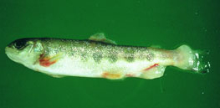
Gyrodactylosis in Atlantic salmon (Salmo salar); note excessive mucous and peeling of skin, especially around the tail
Source: T Håstein

Signs of disease
Important: Animals with disease may show one or more of the signs below, but the pathogen may still be present in the absence of any signs.
Disease signs at the farm, tank or pond level are:
- lethargy
- high mortality in Atlantic salmon (Salmo salar)
- scrubbing (rubbing against objects in response to skin irritation) and flashing (darting and twisting of fish and erratic swimming)
- gathering in low-current waters when heavily infected.

Gross pathological signs are:
- ulcers
- sloughing of the skin
- greyish appearance; as disease progresses, dorsal and pectoral fins may have a whitish appearance due to thickening of the epidermis
- excess mucus on skin
- frayed fins.

Disease agent
The causative agent for gyrodactylosis is an obligate freshwater ectoparasite, Gyrodactylus salaris, which is a flatworm (Platyhelminthes) belonging to the family Gyrodactylidae (class Monogenea). G. salaris occurs in Europe, mainly around the Baltic Sea and Norway.
Most waters have many types of flukes that are parasitic on fish gills and skin. Any evidence of infestation with these parasites beyond what is visible to the naked eye (as described above) requires identification by a parasitologist experienced in identifying Gyrodactylus species.

Host range
All species of salmonid should be considered potentially susceptible to G. salaris unless testing finds them to be not susceptible. Species which have been demonstrated susceptible to gyrodactylosis are listed below.
Common nameª | Scientific name
Arctic char | Salvelinus alpinus
Atlantic salmon | Salmo salar
Brook trout | Salvelinus fontinalis
Brown trout^{b} | Salmo trutta
Grayling | Thymallus thymallus
Lake trout | Salvelinus namaycush
Rainbow trout | Oncorhynchus mykiss
a All the species listed are naturally susceptible (other species have been shown to be experimentally susceptible).
b Susceptibility of brown trout is very low; G. salaris will usually only establish in a brown trout population that inhabits the same area as a population of infected salmonids.

Presence in Australia

EXOTIC DISEASE—not present in Australia.

Epidemiology
- G. salaris may be present for years in farmed salmonids, especially rainbow trout, without the fish showing any clinical signs of disease.
- G. salaris is a freshwater parasite that cannot survive in seawater; however, it can survive a few days at salinity of up to 20 parts per thousand.
- The parasite can survive 5–6 days detached from the host but cannot survive drying out.
- Transmission is horizontal (directly via the water column) by contact between infected and uninfected fish, or by contact between host fish and detached parasites on the substrate.
- Mortality in susceptible farmed Atlantic salmon can reach 100%.
- The parasite is readily spread between farms and countries through the transport of infected fish.

Differential diagnosis
The list of similar diseases below refers only to the diseases covered by this field guide. Gross pathological signs may be representative of a number of diseases not included in this guide, which therefore should not be used to provide a definitive diagnosis, but rather as a tool to help identify the listed diseases that most closely account for the gross signs.

Similar diseases
Many diseases listed in this field guide appear similar to gyrodactylosis. Further laboratory diagnosis is required for any presumptive diagnosis.

Sample collection
Due to the uncertainty in differentiating diseases using only gross pathological signs, and because some aquatic animal disease agents might pose a risk to humans, only trained personnel should collect samples. You should phone your state or territory hotline number and report your observations if you are not appropriately trained. If samples have to be collected, the agency taking your call will provide advice on the appropriate course of action. Local or district fisheries or veterinary authorities may also provide advice regarding sampling.

Emergency disease hotline
The national disease hotline number is 1800 675 888. This number will put you in contact with the appropriate state or territory agency.

Further reading
The accepted procedures for a conclusive diagnosis of gyrodactylosis are summarised in the World Organisation for Animal Health Manual of diagnostic tests for aquatic animals 2011, available at www.oie.int/en/international-standard-setting/aquatic-manual/access-online.
This hyperlink was correct and functioning at the time of publication.

Further image
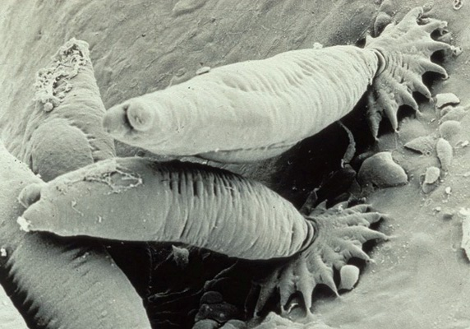
Scanning electron micrograph of G. salaris attached to the skin of an Atlantic salmon (Salmo salar) parr
Source: TA Mo

