Aquatic Animal Diseases Significant to Australia:
Identification Field Guide 4th Edition

Infection with Aeromonas

Salmonicida—atypical strains
(Disease resulting from infection with atypical strains of Aeromonas
salmonicida is known by such names as goldfish ulcer disease; carp
erythrodermatitis; ulcer disease of flounder, eel and salmon; or,
in Tasmania, marine aeromonas disease of salmonids [MAS])

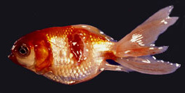 Goldfish ulcer disease in goldfish; note characteristic ulcers on the body  Source: J Carson | 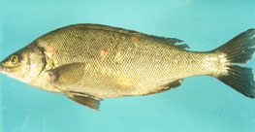  Atypical A. salmonicida in silver perch (Bidyanus bidyanus)  Source: M Landos
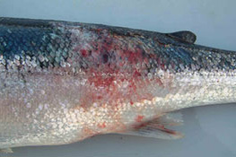 A. salmonicida biovar Acheron in Atlantic salmon (Salmo salar), known as marine aeromonid disease of salmonids  Source: K Ellard | 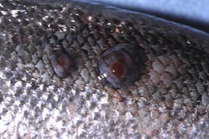 The blood-filled furuncles are specific to this condition, but are rarely noted because they rupture easily, resulting in ulcerations extending into the muscle  Source: K Ellard

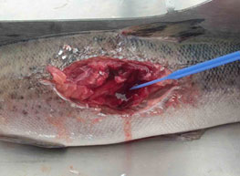 Ulcers develop below the surface of the skin, extending into muscle  Source: K Ellard | 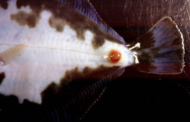 Ventral side of greenback flounder (Rhombosolea tapirina), with lesion caused by the greenback flounder strain of A. salmonicida  Source: J Carson
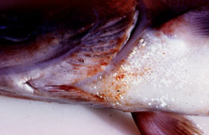 Atlantic salmon (Salmo salar) infected with the greenback flounder strain of atypical A. salmonicida after cohabitation with infected flounder
Source: J Carson

Signs of disease
Important: Animals with disease may show one or more of the signs below, but the pathogen may still be present in the absence of any signs.
Disease signs at the farm, tank or pond level are:
- lethargic swimming
- abnormal swimming and disorientation
- loss of appetite
- increased mortality.
Gross pathological signs are:
- white raised patches on the skin that progress to ragged-edged red ulcers
- haemorrhages on the skin and fin bases (usually the paired fins)
- fingernail-sized ulcers found anywhere on the fish but most often on the upper side of the lateral line behind the head or at the base of the tail fin
- pale gills with petechial (pinpoint) haemorrhages
- intestinal protrusion through the abdominal wall following severe ulceration
- haemorrhages in muscle and internal organs
- swollen kidneys and spleen.
Microscopic pathological signs are:
- hyperplasia of the gills, which may contain bacterial colonies
- ulcerated areas that show oedema, hyperaemia, leukocyte infiltration and considerable degenerative changes
- hyperaemia and haemorrhage in the spleen and kidneys
- fibroblast-like cells, which may produce granulomas in the dermis, spleen and kidney.

Disease agent
Atypical strains of the A. salmonicida bacterium differ from the typical strain causing furunculosis in salmonids. Atypical strains affect mainly non-salmonids (wild and cultured, marine and freshwater). Infection with atypical A. salmonicida does not necessarily result in the acute mortality and septicaemia that are characteristic of the typical furunculosis strain, but manifests more as external lesions and ulceration, often involving secondary infection. An exception to this is infection by MAS in Tasmania; in such cases, Atlantic salmon are most commonly affected, and clinical presentation is similar to furunculosis.
There are five subspecies of A. salmonicida, only one of which is known as a typical strain and causes furunculosis (A. salmonicida salmonicida). The other four subspecies (achromogenes, masoucida, smithia and pectinolytica) are referred to as atypical A. salmonicida and are recognised worldwide. Of these, all except A. salmonicida pectinolytica cause disease in fish. A new atypical strain that has recently been described in Australia, A. salmonicida biovar Acheron, causes MAS in Atlantic salmon.

Host range
Species known to be susceptible to atypical A. salmonicida are listed below.
Common name | Scientific name
American plaice | Hippoglossoides platessoides
Arctic char | Salvelinus alpinus
Atlantic codª | Gadus morhua
Atlantic herringª | Clupea harengus
Atlantic salmonª | Salmo salar
Black rockfishª | Sebastes schlegeli
Brook trout | Salvelinus fontinalis
Brown troutª | Salmo trutta
European carpª | Cyprinus carpio
Chubª | Leuciscus cephalus
Chum salmonª | Oncorhynchus keta
Common roachª | Rutilus rutilus
Crucian carpª | Carassius carassius
Dabª | Limanda limanda
Daceª | Leuciscus leuciscus
Eelª | Anguilla spp.
Flounderª | Platichthys flesus
Fourbeard rocklingª | Enchelyopus cimbrius
Freshwater breamª | Abramis brama
Goldfishª | Carassius auratus
Goldsinnyª | Ctenolabrus rupestris
Graylingª | Thymallus thymallus
Great sandeelª | Hyperoplus lanceolatus
Greenback flounderª | Rhombosolea tapirina
Haddockª | Melanogrammus aeglefinus
Halibutª | Hippoglossus stenolepis
Japanese flounderª | Paralichthys olivaceus
Lesser sand eel | Ammodytes lancea
Masu salmonª | Oncorhynchus masou
Minnowª | Phoxinus phoxinus
Pike | Esox lucius
Pink salmon | Oncorhynchus gorbuscha
Plaiceª | Pleuronectes platessa
Rainbow troutª | Oncorhynchus mykiss
Redfin perch or European perch | Perca fluviatilis
Ruddª | Scardinius erythrophthalmus
Sablefish | Anoplopoma fimbria
Shotted halibutª | Eopsetta grigorjewi
Shububkinª | Carassius sp.
Silver breamª | Blicca bjoerkna
Silver perchª | Bidyanus bidyanus
Smallmouth bassª | Micropterus dolomieui
Sockeye salmonª | Oncorhynchus nerka
Spotted wolffishª | Anarhichas minor
Striped trumpeter* | Latris lineata
Tomcodª | Gadus microgadus
Turbotª | Psetta maxima (also known as Scophthalmus maximus)
Viviparous blennyª | Zoarces viviparus
Whitefish | Coregonus spp.
Whitingª | Merlangius merlangus
Wrasseª | Labrus bergylta
Yellow bassª | Morone mississippiensis
a Naturally susceptible (other species have been shown to be experimentally susceptible)
Laboratory experiments indicate that all trout and salmon species, as well as many non-salmonids, are potentially susceptible to atypical strains of A. salmonicida. For example, Atlantic salmon and striped trumpeter can be infected by cohabitation with infected flounder. Rainbow trout are relatively resistant to atypical strains.

Presence in Australia
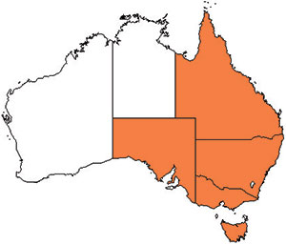
Atypical A. salmonicida has been officially reported from New South Wales, Queensland, South Australia, Victoria (goldfish ulcer disease) and Tasmania (greenback flounder biovar and Acheron biovar). Movement controls are in place to prevent the spread of goldfish ulcer disease to Western Australia and Tasmania. The Acheron biovar has been reported only from Tasmania and is limited to an isolated production area.

Epidemiology
- Transmission occurs horizontally (between fish via the water).
- Susceptibility to the disease increases with damaged mucus and skin, which occurs when fish are handled with nets.
- Outbreaks are expected to occur at water temperatures above 10 °C (i.e. summer months in southern waters of Australia) and may be precipitated by stress (i.e. handling, overpopulation and rapid temperature fluctuations).
- Secondary infection with other bacteria often results.
- Fish that survive disease outbreaks are recognised as carriers of the disease and may continue to infect the remaining population without themselves exhibiting signs of infection.
- Diagnosis based on clinical or external signs of disease is difficult because clinical signs vary and skin ulcers are often infected with opportunistic bacteria and fungi. A definitive diagnosis requires laboratory examination.

Differential diagnosis
The list of similar diseases below refers only to the diseases covered by this field guide. Gross pathological signs may be representative of a number of diseases not included in this guide, which therefore should not be used to provide a definitive diagnosis, but rather as a tool to help identify the listed diseases that most closely account for the gross signs.

Similar diseases
Channel catfish virus disease, epizootic ulcerative syndrome, furunculosis, spring viraemia of carp

Sample collection
Due to the uncertainty in differentiating diseases using only gross pathological signs, and because some aquatic animal disease agents might pose a risk to humans, only trained personnel should collect samples. You should phone your state or territory hotline number and report your observations if you are not appropriately trained. If samples have to be collected, the agency taking your call will provide advice on the appropriate course of action. Local or district fisheries or veterinary authorities may also provide advice regarding sampling.

Emergency disease hotline
The national disease hotline number is 1800 675 888. This number will put you in contact with the appropriate state or territory agency.

Further reading
BK Guðmundsdóttir (undated), The fish pathogen Aeromonas salmonicida subsp. achromogenes, available at www.nfmikro.net/Vintermotet04/Foredrag/Gudmundsdottir.htm.
This hyperlink was correct and functioning at the time of publication.

