Aquatic Animal Diseases Significant to Australia:
Identification Field Guide 4th Edition

Infectious salmon anaemia (ISA)

EXOTIC DISEASE
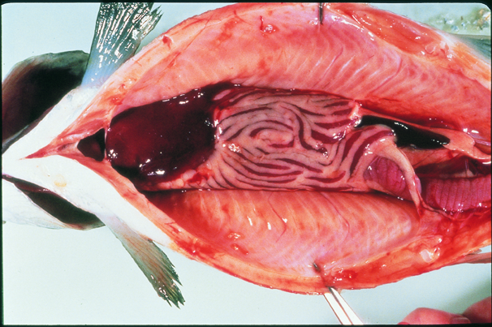

Atlantic salmon (Salmo salar) with ISA, showing gross lesions, dark liver, ascites and enlarged spleen
Source: T Poppe

Signs of disease
Important: Animals with disease may show one or more of the signs below, but the pathogen may still be present in the absence of any signs.
Disease signs at the farm, tank or pond level are:
- mortality rate up to 100%
- fish congregating near the surface
- fish gasping at the surface
- lethargy
- loss of appetite.

Gross pathological signs are:
- pale gills
- swollen abdomen
- exophthalmos (popeye)
- bleeding eyes and fin rot
- ecchymotic (bruise-like) skin haemorrhages
- scale-pocket oedema
- swollen and dark liver, kidney and spleen (early sign); liver may be almost black
- petechial (pinpoint) haemorrhages in internal fat, peritoneum and skeletal muscle
- dark red intestinal wall mucosa
- ascites (fluid in the abdominal cavity)
- surface haemorrhages on the liver
- pale heart.
Microscopic pathological signs are:
- renal interstitial haemorrhage and tubular necrosis
- branchial lamellar and filamental congestion
- congestion of the intestine and pyloric caecae
- perivascular inflammation and focal necrosis in the liver.

Disease agent
ISA virus is in the Orthomyxoviridae family of viruses.

Host range
The only species known to display clinical signs of ISA is the Atlantic salmon (Salmo salar).
Species known to be naturally asymptomatic carriers are listed below.
Common nameª | Scientific name
Brown trout | Salmo trutta
Coho trout | Oncorhynchus kisutch
Rainbow trout | Oncorhynchus mykiss
a All species listed are naturally susceptible to infection (other species have been shown to be experimentally susceptible)
Species shown experimentally to be asymptomatic carriers include the following.
Common name | Scientific name
Arctic char | Salvelinus alpinus
Atlantic cod | Gadus morhua
Atlantic herring | Clupea harengus
Coalfish or pollock | Pollachius virens
Salmon louse | Lepeophtheirus salmonis and Caligus elongatus

Presence in Australia

EXOTIC DISEASE—not present in Australia.

Epidemiology
- ISA occurs mainly in the Northern Hemisphere in spring and early winter at water temperatures from 3 °C to above 15 °C.
- The disease has caused major epizootics and severely impacted Atlantic salmon aquaculture production; most recently in Chile.
- Mortality rates vary from 15% to 100%; mortality may occur over a prolonged period, not necessarily as acute outbreaks.
- ISA is mainly transmitted horizontally through the water column but also by vectors (sea lice and populations of asymptomatic wild fish carriers).
- Experimental infection models demonstrated mortalities within 15 days of exposure to ISA.
- Spread of the disease has occurred with the movement of live juvenile salmonids from one fish farm to another, with the discharge of organic waste from fish processing plants into the marine environment and via water movement.
- The majority of natural outbreaks seem to occur in salmonid post-smolts.
- ISA has been the subject of extensive eradication campaigns in several countries, including Scotland. These can be successful and require vigilance to maintain ‘free’ status.
- It appears that stressors such as husbandry practices (e.g. treatment against salmon lice or infectious diseases), rising or falling temperatures, and poor water quality can predispose salmon to outbreaks of ISA.

Differential diagnosis
The list of similar diseases below refers only to the diseases covered by this field guide. Gross pathological signs may be representative of a number of diseases not included in this guide, which therefore should not be used to provide a definitive diagnosis, but rather as a tool to help identify the listed diseases that most closely account for the gross signs.

Similar diseases
Enteric red mouth disease, infectious haematopoietic necrosis, infectious pancreatic necrosis

Sample collection
Due to the uncertainty in differentiating diseases using only gross pathological signs, and because some aquatic animal disease agents might pose a risk to humans, only trained personnel should collect samples. You should phone your state or territory hotline number and report your observations if you are not appropriately trained. If samples have to be collected, the agency taking your call will provide advice on the appropriate course of action. Local or district fisheries or veterinary authorities may also provide advice regarding sampling.

Emergency disease hotline
The national disease hotline number is 1800 675 888. This number will put you in contact with the appropriate state or territory agency.

Further reading
The accepted procedures for a conclusive diagnosis of ISA are summarised in the World Organisation for Animal Health Manual of diagnostic tests for aquatic animals 2011, available at www.oie.int/en/international-standard-setting/aquatic-manual/access-online.
This hyperlink was correct and functioning at the time of publication.

Further images
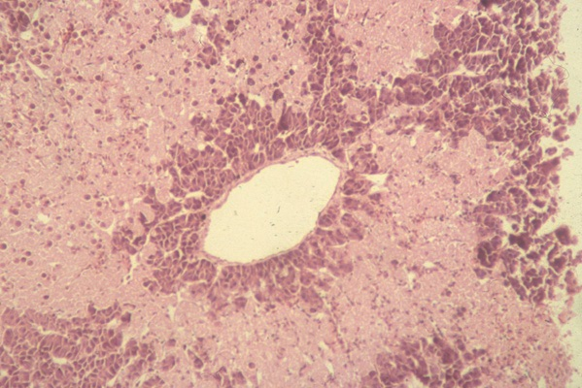
Liver from Atlantic salmon (Salmo salar) with ISA, showing multifocal bridging necrosis, leaving tissue around smaller veins viable
Source: T Poppe
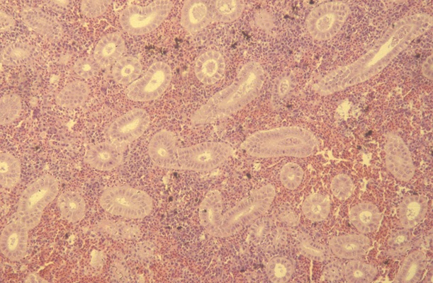
Kidney from Atlantic salmon (Salmo salar) with ISA, showing renal interstitial haemorrhage
Source: T Poppe

