Aquatic Animal Diseases Significant to Australia:
Identification Field Guide 4th Edition

Koi herpes virus disease (KHV)
(Also known as carp interstitial nephritis and gill necrosis virus)

EXOTIC DISEASE
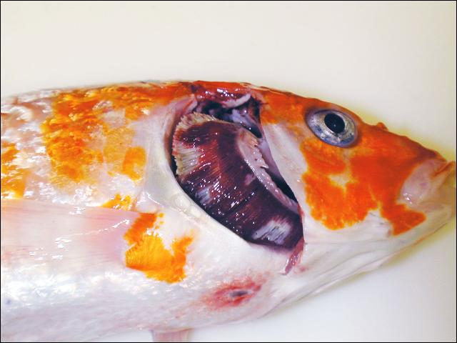
Koi carp (Cyprinus carpio) with gross lesions associated with KHV. Operculum is removed showing mottled red (haemorrhage) and white (necrosis) gill, sunken eyes and a single ulcer on the ventral skin.
Source: E Johnson

Signs of disease
Important: Animals with disease may show one or more of the signs below, but the pathogen may still be present in the absence of any signs.
Disease signs at the farm, tank or pond level are:
- mass mortalities, with many dead and moribund fish floating at the surface
- disorientation and erratic swimming behaviour (sometimes hyperactivity)
- fish coming to the surface and gasping
- fish separated from the shoal.

Gross pathological signs are:
- pale patches on the skin
- overproduction or underproduction of mucous on the skin and gills
- superficial branchial (gill) and skin haemorrhages
- enophthalmia (sunken eyes), erosion of the fins (occasionally), and blistering of the skin
- severe gill necrosis and/or erosion, seen as red and white patches
- focal or generalised loss of skin
- adhesions in the abdominal cavity and abnormal colouration of internal organs (lighter/darker or mottled)
- enlargement and surface haemorrhages of the kidney and liver.
Microscopic pathological signs are:
- inflammation and necrosis of gill tissues, and adhesion of gill filaments
- nuclear swelling, margination of chromatin and pale eosinophilic intranuclear inclusions of the epithelium
- non-specific inflammation and necrosis in other organs.

Disease agent
The causative agent of this disease is koi herpesvirus (KHV), also known as cyprinid herpesvirus 3 (CyHv3).

Host range
Species susceptible to KHV disease are listed below.
Common name | Scientific name
Common carp and koi carpª | Cyprinus carpio
a Naturally susceptible (other species have been shown to be experimentally susceptible)

Presence in Australia

EXOTIC DISEASE—not present in Australia.

Epidemiology
- An outbreak in Japan during the spring of 2004 occurred in wild carp populations in water temperatures of 15–16 °C. Most of the dead fish were adult. In the field, it appears that adult carp are more susceptible than juveniles.
- The virus may survive at low temperatures (5 °C), but the temperature range for disease outbreaks is primarily between 16 °C and 25 °C. Mortalities commonly appear between 22 °C and 25 °C, with few at temperatures above 30 °C.
- The disease affects all age classes of common and koi carp; the disease has occurred in fingerlings, juveniles and adults.
- Moving infected fish from cool (13 °C) to warm (23 °C) water results in rapid onset of mortality.
- Mortality rates can vary between 70% and 100%.
- Reservoirs of KHV are clinically infected fish and covert carriers. Virus is shed via faeces, urine, gills and skin mucus.
- Transmission of KHV is horizontal, mainly via water, but possibly via animal vectors and fomites.
- Vertical transmission cannot be excluded as a possible transmission route.
- Secondary gill infections (e.g. Flavobacterium columnare and Aeromonas spp.) are often associated with KHV infection.

Differential diagnosis
The list of similar diseases below refers only to the diseases covered by this field guide. Gross pathological signs may be representative of a number of diseases not included in this guide, which therefore should not be used to provide a definitive diagnosis, but rather as a tool to help identify the listed diseases that most closely account for the gross signs.

Similar diseases
Epizootic ulcerative syndrome, spring viraemia of carp

Sample collection
Due to the uncertainty in differentiating diseases using only gross pathological signs, and because some aquatic animal disease agents might pose a risk to humans, only trained personnel should collect samples. You should phone your state or territory hotline number and report your observations if you are not appropriately trained. If samples have to be collected, the agency taking your call will provide advice on the appropriate course of action. Local or district fisheries or veterinary authorities may also provide advice regarding sampling.

Emergency disease hotline
The national disease hotline number is 1800 675 888. This number will put you in contact with the appropriate state or territory agency.

Further reading
The accepted procedures for a conclusive diagnosis of KHV are summarised in the World Organisation for Animal Health Manual of diagnostic tests for aquatic animals 2011, available at www.oie.int/en/international-standard-setting/aquatic-manual/access-online.
This hyperlink was correct and functioning at the time of publication.

