Aquatic Animal Diseases Significant to Australia:
Identification Field Guide 4th Edition

Piscirickettsiosis

EXOTIC DISEASE
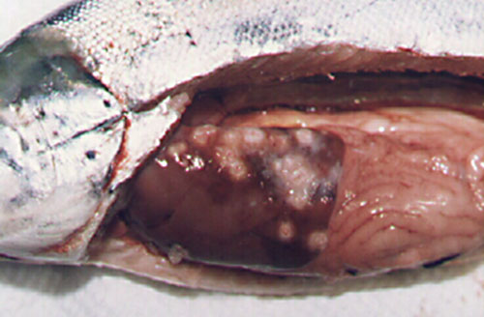
Piscirickettsiosis in Atlantic salmon (Salmo salar); note pale circular granulomas in liver and pinpoint haemorrhaging in pyloric caeca
Source: S Bravo

Signs of disease
Important: Animals with disease may show one or more of the signs below, but the pathogen may still be present in the absence of any signs.
Disease signs at the farm, tank or pond level are:
- increasing mortality
- loss of appetite
- emaciation
- lethargic swimming
- circling
- swimming near the surface or at the sides of the net or pens.
Gross pathological signs are:
- progressive skin lesions that range from areas of raised scales, to white raised plaques, to shallow ulcers on flanks and head
- darkening of skin and pale gills
- swollen abdomen
- grey, swollen spleen and kidney
- mottled liver (due to diffuse haemorrhages) or ring-shaped white to pale-yellow lesions (granulomas and areas of necrosis)
- ascites (fluid in the abdominal cavity)
- signs of peritonitis, including generalised diffuse inflammation of abdominal organs, adhesions and increased volume of free abdominal fluid
- petechial (pinpoint) haemorrhages of the gastrointestinal tract, swim bladder and visceral fat.
Microscopic pathological signs are:
- vasculitis and necrosis of the liver and kidney; inflammatory macrophage infiltration
- Rickettsia-like organisms in macrophages and epithelial cells.

Disease agent
Piscirickettsiosis is caused by the bacterium Piscirickettsia salmonis, which has recently been classified within the gammaproteobacteria, family Piscirickettsiaceae.

Host range
Fish known to be susceptible to piscirickettsiosis are listed below.
Common nameª | Scientific name
Atlantic salmon | Salmo salar
Chinook salmon | Oncorhynchus tshawytscha
Coho salmon | Oncorhynchus kisutch (most susceptible)
European seabass | Dicentrarchus labrax
Masu salmon | Oncorhynchus masou
Pink salmon | Oncorhynchus gorbuscha
Rainbow trout | Oncorhynchus mykiss
a All species listed are naturally susceptible (other species have been shown to be experimentally susceptible).
Piscirickettsiosis is only known to affect aquaculture stock and has not been recorded in fish from the wild.

Presence in Australia

EXOTIC DISEASE—not present in Australia.

Epidemiology
- Salmonid rickettsial septicaemia is a term used to describe diseases of salmonids caused by Rickettsia-like organisms, including P. salmonis. Piscirickettsiosis refers to the disease specifically caused by the bacterium P. salmonis.
- Outbreaks usually occur after fish are introduced to saltwater pens at water temperatures between 12 °C and 18 °C.
- Transmission is mainly horizontal (fish to fish). Although P. salmonis has been isolated in reproductive organs of salmonids, vertical transmission has not been definitively demonstrated.
- Bacteria are assumed to gain entry by breaching the physical barriers of the skin or gills. The invading bacteria then spread throughout the body via the blood (haematogenous spread), resulting in septicaemia.
- Mortality rates typically range between 10% and 30%, but have been recorded at 90% in seawater-raised coho salmon from Chile.

Differential diagnosis
The list of similar diseases below refers only to the diseases covered by this field guide. Gross pathological signs may be representative of a number of diseases not included in this guide, which therefore should not be used to provide a definitive diagnosis, but rather as a tool to help identify the listed diseases that most closely account for the gross signs.

Similar diseases
No diseases listed in this field guide are similar to piscirickettsiosis.

Sample collection
Due to the uncertainty in differentiating diseases using only gross pathological signs, and because some aquatic animal disease agents might pose a risk to humans, only trained personnel should collect samples. You should phone your state or territory hotline number and report your observations if you are not appropriately trained. If samples have to be collected, the agency taking your call will provide advice on the appropriate course of action. Local or district fisheries or veterinary authorities may also provide advice regarding sampling.

Emergency disease hotline
The national disease hotline number is 1800 675 888. This number will put you in contact with the appropriate state or territory agency.

Further reading
Further information can be found on the Centre for Environment, Fisheries and Aquaculture Science (Cefas) International Database on Aquatic Animal Disease (IDAAD) website at www.cefas.defra.gov.uk/idaad/disocclist.aspx.
This hyperlink was correct and functioning at the time of publication.

Further images
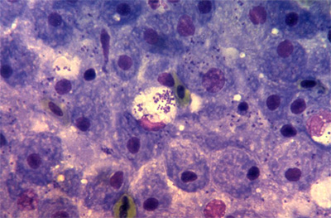
P. salmonis detected in tissue imprint
Source: European Association of Fish Pathologists
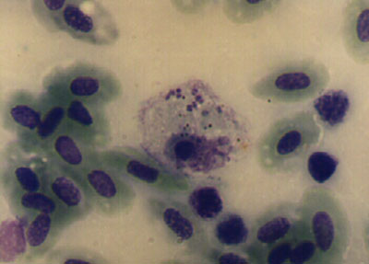  P. salmonis detected in tissue imprint  Source: S Bravo | 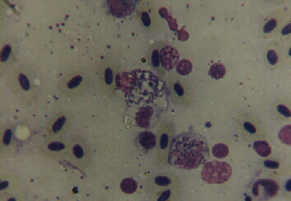  P. salmonis detected in tissue imprint  Source: S Bravo

