Aquatic Animal Diseases Significant to Australia:
Identification Field Guide 4th Edition

Viral encephalopathy and retinopathy
(Also known as viral nervous necrosis)
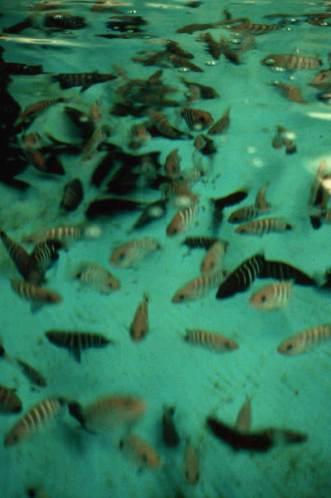
Viral encephalopathy and retinopathy in seven-band grouper (Epinephelus septemfasciatus); dark fish are affected, light fish are normal. A change in colouration is an important indicator of disease. Species differ in how they are affected (e.g. barramundi show lighter colouration when affected).
Source: B Munday

Signs of disease
Important: Animals with disease may show one or more of the signs below, but the pathogen may still be present in the absence of any signs.
Disease signs at the farm, tank or pond level are:
- 50–100% cumulative mortality over a period of 48 hours to several weeks
- higher mortalities in larvae and juvenile fish (9–28 days old) although older fish (>28 days) may also be affected
- anorexia
- abnormal swimming behaviours, including erratic, uncoordinated darting, spiral and/or looping swim pattern; corkscrew swimming
- fish resting belly-up (loss of equilibrium)
- hyperactivity
- sporadic protrusion of the head from the water.
Gross pathological signs are:
- colour change—larval barramundi become lighter, but groupers become darker
- blindness
- abrasions
- emaciation
- overinflated swim bladder (the only significant internal gross pathological sign).
Microscopic pathological signs are:
- vacuolation of central nervous tissues, including retina
- intracytoplasmic inclusions in brain tissues as crystalline arrays or aggregates.

Disease agent
Viral encephalopathy and retinopathy (VER) or Viral Nervous Necrosis (VNN) is a disease caused by a Betanodavirus, which is in the family Nodaviridae. VER was formerly referred to as barramundi picorna-like virus in Australia.

Host range
Species known to be susceptible to VER virus are listed below.
Common name | Scientific name
Atlantic halibutª | Hippoglossus hippoglossus
Atlantic salmon | Salmo salar
Australian bassª | Macquaria novemaculeata
Barcoo grunter | Scortum barcoo
Barfin flounderª | Verasper moseri
Barramundiª | Lates calcarifer
Brown-marbled grouperª | Epinephelus fuscoguttatus
Chinese catfishª | Silurus asotus
Cobiaª | Rachycentron canadum
Convict surgeonfish | Acanthurus triostegus
Common soleª | Solea solea
Dusky grouper | Epinephelus marginatus
Estuarine rockcodª | Epinephelus tauvina
Estuary catfish | Cnidoglanis macrocephalus
European eelª | Anguilla anguilla
European seabassª | Dicentrarchus labrax
Floundersª | Paralichthyidae
Gilt-head sea breamª | Sparus aurata
Golden grey mulletª | Liza auratus
Golden perch | Macquaria ambigua
Greater amberjackª | Seriola dumerili
Grouper and estuary codª | Epinephelus spp.
Haddockª | Melanogrammus aeglefinus
Humpback grouperª | Cromileptes altivelis
Japanese flounderª | Paralichthys olivaceus
Japanese tilefish | Branchiostegus japonicas
Japanese parrotfishª | Oplegnathus fasciatus
Japanese seabassª | Lateolabrax japonicus
Longtooth grouperª | Epinephelus bruneus
Macquarie perch | Macquaria australasica
Malabar grouperª | Epinephelus malabaricus
Mangrove Jack | Lutjanus argentimaculatus
Milkfish | Chanos chanos
Mulletª | Mugil cephalus
Murray cod | Maccullochella peelii peelii
Narrowstripe cardinalfish | Apogon exostigma
Orange-spotted grouperª | Epinephelus coioides
Red drumª | Sciaenops ocellatus
Red mullet | Mullus barbatus
Red snapper | Lutjanus erythropterus
Red-spotted grouperª or Hong Kong grouper | Epinephelus akaara
Russian sturgeonª | Acipenser gueldenstaedtii
Samson fish | Seriola hippos
Senegalese soleª | Solea senegalensis
Seven-band grouperª | Epinephelus septemfasciatus
Shi drumª | Umbrina cirrosa
Sleepy cod | Oxyeleotris lineolatus
Silver perch | Bidyanus bidyanus
Silver trevallyª | Pseudocaranx dentex
Snubnose dartª | Trachinotus blochii
Spotted coralgrouper | Plectropomus maculatus
Spotted knifejawª | Oplegnathus punctatus
Spotted wolffish | Anarhichas minor
Striped trumpeterª | Latris lineata
Thread-sail filefishª | Stephanolepis cirrhifer
Tiger pufferª | Takifugu rubripes
Tilapia | Oreochromis niloticus
Turbotª | Psetta maxima (also known as Scophthalmus maximus)
White grouperª | Epinephelus aeneus
White seabassª | Atractoscion nobilis
Winter flounderª | Pseudopleuronectes americanus
Yellow-wax pompanoª | Trachinotus falcatus
a Naturally susceptible (other species have been shown to be experimentally susceptible)

Presence in Australia
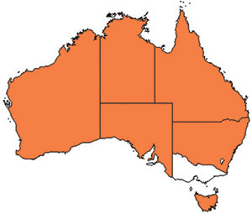
VER has been officially reported from New South Wales, the Northern Territory, Queensland, South Australia, Tasmania and Western Australia. It is primarily reported to affect larvae or fry.

Epidemiology
- VER is a disease which has been found in at least 40 species of marine fish from 16 families, and has been diagnosed in all inhabited continents.
- Most fish are affected as larvae or juveniles; however, in recent years, mortalities have occurred in older fish up to harvest size, particularly in European seabass, groupers (Epinephelus spp.) and Atlantic halibut. Disease incidence in the groupers and seabass has been associated with high water temperatures.
- Susceptibility and mortality are age dependent (onset of clinical disease in younger fish of some species results in higher mortality).
- Batches of barramundi larvae for aquaculture are now routinely screened for this disease in Australia.
- The incubation period for the disease in barramundi is 4 days, with typical disease onset 9–28 days after hatching, rarely occurring in older fish (50–60 days old). In silver trevally, disease onset is 1 day after hatching.
- Transmission is believed to occur horizontally, through the water column (i.e. via mouth, gills and skin), and vertically (parent to offspring). The rate of transmission may be influenced by stressors, including handling, repeated spawning, high stocking densities, high ambient temperature and virulence of the particular Betanodavirus strain. Sand worms of the family Nereidae, genus Nereis, collected in proximity to an infected farm have had positive detection of Betanodavirus.
- Virus can survive for 1 year in the right environmental conditions (pH 2–9 and 15 °C) and can persist subclinically in infected live fish. Therefore, fish products and byproducts may facilitate the spread of virus to unaffected areas.
- Cumulative mortality at 1 month is typically 50–100% in barramundi and 100% in silver trevally. In Australian hatcheries, 100% mortality in <3 days in larvae is typical.

Differential diagnosis
The list of similar diseases below refers only to the diseases covered by this field guide. Gross pathological signs may be representative of a number of diseases not included in this guide, which therefore should not be used to provide a definitive diagnosis, but rather as a tool to help identify the listed diseases that most closely account for the gross signs.

Similar diseases
Grouper iridoviral disease

Sample collection
Due to the uncertainty in differentiating diseases using only gross pathological signs, and because some aquatic animal disease agents might pose a risk to humans, only trained personnel should collect samples. You should phone your state or territory hotline number and report your observations if you are not appropriately trained. If samples have to be collected, the agency taking your call will provide advice on the appropriate course of action. Local or district fisheries or veterinary authorities may also provide advice regarding sampling.

Emergency disease hotline
The national disease hotline number is 1800 675 888. This number will put you in contact with the appropriate state or territory agency.

Further reading
Further information can be found at;
Sub-Committee on Animal Health Laboratory Standards (SCAHLS) website at www.scahls.org.au/procedures/anzsdps2
Centre for Environment, Fisheries and Aquaculture Science (Cefas) International Database on Aquatic Animal Disease (IDAAD) website at www.cefas.defra.gov.uk/idaad/disocclist.aspx.
These hyperlinks were correct and functioning at the time of publication.

Further images

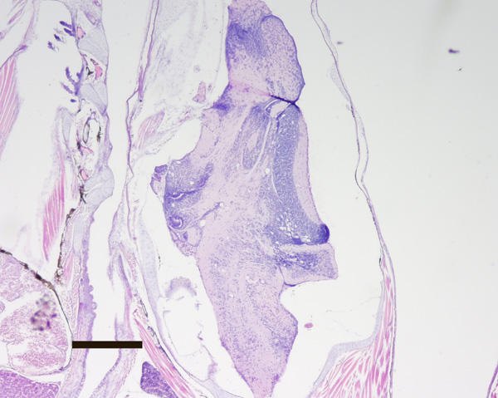
Barramundi (Lates calcarifer) 20 day old juvenile. Transverse section through larval head. Vacuoles associated with VER infection are readily visible in the brain even at 20x magnification. Haematoxylin and Eosin stain. Scale bar = 0.3 mm.
Source: B Jones
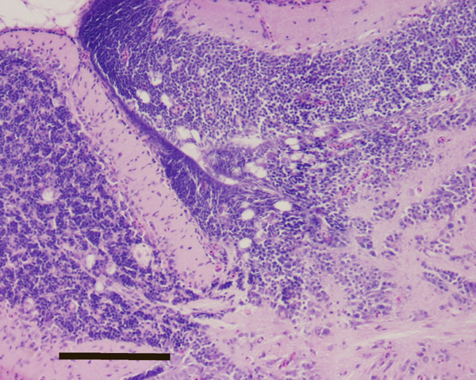
Barramundi (Lates calcarifer) 20 day old juvenile. Transverse section through brain. Juncture of optic lobe and mesencephalon. Vacuoles associated with VER infection are readily visible. Haematoxylin and Eosin stain. Scale bar = 0.1 mm.
Source: B Jones

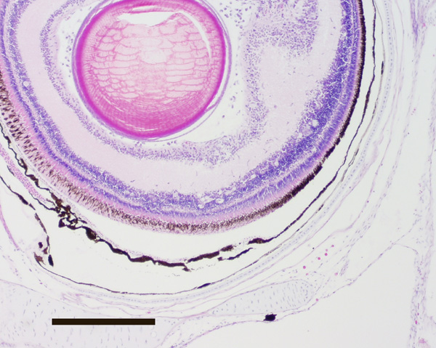
Barramundi (Lates calcarifer) 22 day old juvenile. Transverse section through retina. Vacuoles associated with VER infection are visible. Haematoxylin and Eosin stain. Scale bar = 0.2 mm.
Source: B Jones
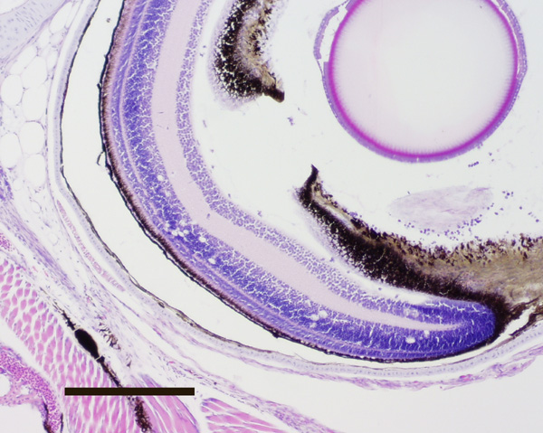
Barramundi (Lates calcarifer) 22 day old juvenile. Transverse section through retina. Vacuoles associated with VER infection are visible. Haematoxylin and Eosin stain. Scale bar = 0.2 mm.
Source: B Jones
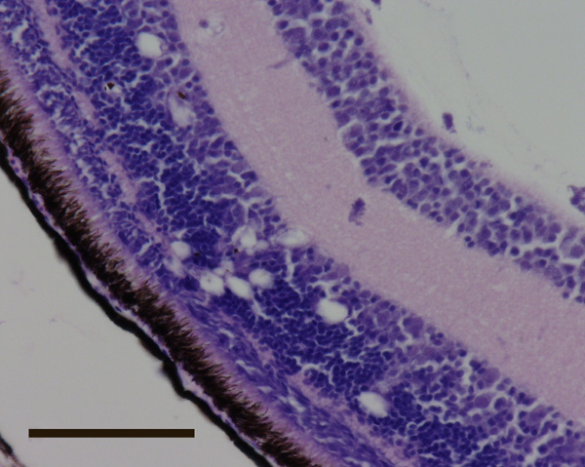
Barramundi (Lates calcarifer) 20 day old juvenile. Transverse section through retina. Vacuoles associated with VER infection are visible. Haematoxylin and Eosin stain. Scale bar = 0.05 mm.
Source: B Jones
Barramundi (Lates calcarifer) 20 day old juvenile. Transverse section through brain. Juncture of optic lobe and mesencephalon. Vacuoles associated with VER infection are readily visible. Haematoxylin and Eosin stain. Scale bar = 0.1 mm.
Source: B Jones

