Aquatic Animal Diseases Significant to Australia:
Identification Field Guide 4th Edition

Viral haemorrhagic septicaemia (VHS)

EXOTIC DISEASE
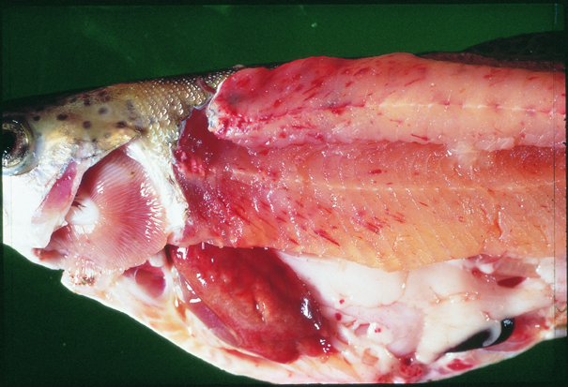  VHS in rainbow trout (Oncorhynchus mykiss); note pale colour of stomach region, pinpoint haemorrhages in fatty tissue and pale gills  Source: T Håstein | 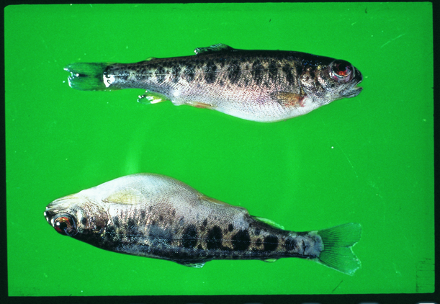  VHS in rainbow trout (Oncorhynchus mykiss); note swollen stomach and ‘popeye’  Source: T Håstein

Signs of disease
Important: Animals with disease may show one or more of the signs below, but the pathogen may still be present in the absence of any signs.
Disease outbreaks are seen in farmed trout and other salmonids, as well as in farmed turbot and Japanese flounder.

Disease signs of acute infection at the farm, tank or pond level are:
- rapid onset of high mortality
- lethargic swimming
- separation from shoal
- loss of appetite
- crowding at pond edges.
Disease signs of chronic infection at the farm, tank or pond level are:
- significant cumulative mortality (protracted)
- uncoordinated swimming (ataxia) with rotating movement around body axis (i.e. spinning).
Disease signs of the neurological form of the disease at the farm, tank or pond level are:
- low mortality
- severe abnormal swimming behaviour (flashing and spiralling).
General gross pathological signs are:
- exophthalmos (popeye)
- haemorrhaging under the skin, around the base of pectoral and pelvic fins and in the eyes
- swollen abdomen
- pale gills, with or without petechial (pinpoint) haemorrhages.
Gross pathological signs of acute infection are:
- slight darkening of the body colour
- exophthalmos (popeye)
- bleeding around the eyes
- bleeding under the skin around the base of the pectoral and pelvic fins
- skin ulceration
- swollen abdomen
- pale gills with pinpoint haemorrhages
- ascites (fluid in the abdominal cavity)
- petechial (pinpoint) haemorrhages in the fatty tissue, intestine, gonads, liver, swim bladder and muscle
- dark-red kidneys.
Gross pathological signs of chronic infection are:
- often an absence of external signs
- intense darkening of the skin
- exophthalmos (popeye)
- pale gills (anaemic)
- pale abdominal organs
- pale and mottled liver (evidence of haemorrhages on surface)
- pale gastrointestinal tract that is empty of food.
Microscopic pathological signs are:
- accumulation of erythrocytes in skeletal muscle fibres
- extensive focal necrosis in the liver, kidney and spleen
- VHS virus-positive endothelial cells in vascular system evident from immunohistochemistry.

Disease agent
VHS virus is a rhabdovirus of the genus Novirhabdovirus. Several genogroups or genotypes of the virus have been identified from different environments in different parts of the world:
- type I, continental Europe—freshwater group, trout farms (highly pathogenic to rainbow trout)
- type II, European marine strain (Baltic sea)—marine strain affecting wild and cultured marine and freshwater species (has low pathogenicity in rainbow trout)
- type III, north Atlantic marine group (North sea near the British Isles)
- type IVa, west coast of north America and east Asian group—marine group affecting a range of free-living marine and cultured species (highly pathogenic in Pacific herring; however, rainbow trout appear refractory to infection with this genotype)
- type IVb, Great lakes region—significant mortalities in wild freshwater species in the Great lakes.

Host range
VHS virus has been isolated from a broad range of marine and freshwater fish in Europe and the north Pacific (including cod, sprats, herring, haddock and turbot).
Species known to be susceptible to VHS are listed below.
Common name | Scientific name
Armoured weaselfish | Hoplobrotula armata
Atlantic cod | Gadus morhua
Atlantic halibut | Hippoglossus hippoglossus
Atlantic herring | Clupea harengus
Atlantic salmon | Salmo salar
Black crappie | Pomoxis nigromaculatus
Black sea bream or black porgy | Acanthopagrus schlegeli
Bluegill | Lepomis macrochirus
Blue whiting | Micromesistius poutassou
Bluntnose minnow | Pimephales notatus
Brook trout | Salvelinus fontinalis
Brown bullhead | Ictalurus nebulosus
Brown trout | Salmo trutta
Burbotª | Lota lota
Channel catfish | Ictalurus punctatus
Chinook salmon | Oncorhynchus tshawytscha
Chub mackerel | Scomber japonicus
Coho salmon | Oncorhynchus kisutch
Dab | Limanda limanda
Emerald shiner | Notropis atherinoides
English sole | Parophrys vetulus
Eulachonª | Thaleichthys pacificus
European eel | Anguilla anguilla
European seabass | Dicentrarchus labrax
European sprat | Sprattus sprattus
Flounder | Platichthys flesus
Fourbeard rockling | Enchelyopus cimbrius
Freshwater drumª | Aplodinotus grunniens
Gilt-head sea bream | Sparus aurata
Gizzard shad | Dorosoma cepedianum
Golden trout | Oncorhynchus aguabonita
Grayling | Thymallus thymallus
Greenland halibut | Reinhardtius hippoglossoides
Haddock | Melanogrammus aeglefinus
Hairtail | Trichiurus lepturus
Hybrid (rainbow trout × coho salmon) | Oncorhynchus mykiss × O. kisutch
Iberian nase | Pseudochondrostoma polylepis
Japanese flounderª | Paralichthys olivaceus
Japanese yellowtail | Seriola quinqueradiata
Korean flounder | Glyptocephalus stelleri
Lake trout | Salvelinus namaycush
Lake whitefish | Coregonus clupeaformis
Largemouth bass | Micropterus salmoides
Lesser argentine | Argentina sphyraena
Mullet | Mugil cephalus
Mummichogª | Fundulus heteroclitus
Muskellungeª | Esox masquinongy
Norway pout | Trisopterus esmarki
Pacific cod | Gadus macrocephalus
Pacific hakeª | Merluccius productus
Pacific herringª | Clupea pallasii
Pacific salmon | Oncorhynchus spp.
Pacific sand eel | Ammodytes personatus
Pacific sand lance | Ammodytes hexapterus
Pacific sardineª | Sardinops sagax
Pacific tomcod | Microgadus proximus
Pikeª | Esox lucius
Plaice | Pleuronectes platessa
Poor cod | Trisopterus minutus
Pumpkinseed | Lepomis gibbosus
Rainbow troutª | Oncorhynchus mykiss
Red-spotted grouper or Hong Kong grouper | Epinephelus akaara
River lamprey | Lampetra fluviatalis
Rock bass | Ambloplites rupestris
Rockfish | Sebastes spp.
Round gobyª | Neogobius melanostomus
Sablefishª | Anoplopoma fimbria
Sand eel | Ammodytes spp.
Sand goby | Pomatoschistus minutus
Senegalese sole | Solea senegalensis
Shiner perch | Cymatogaster aggregata
Shorthead redhorse | Moxostoma macrolepidotum
Silver pomfret | Pampus argenteus
Silver redhorse | Moxostoma anisurum
Smallmouth bassª | Micropterus dolomieui
Snapper | Pagrus auratus
Splake (lake trout × brook trout) | Salvelinus namaycush × S. fontinalis
Spottail shiner | Notropis hudsonius
Striped bass | Morone saxatilis
Surf smeltª | Hypomesus pretiosus
Three-spined stickleback | Gasterosteus aculeatus
Trout-perch | Percopsis omiscomaycus
Tubesnout | Aulorhynchus flavidus
Turbotª | Psetta maxima (also known as Scophthalmus maximus)
Walleye pollock or Alaska pollockª | Theragra chalcogramma
White bass | Morone chrysops
Whitefish | Coregonus spp.
White perch | Morone americanus
Whiting | Merlangius merlangus
Yellowback seabream | Evynnis tumifrons
Yellow perchª | Perca flavescens
a Naturally susceptible (other species have been shown to be experimentally susceptible)

Presence in Australia

EXOTIC DISEASE—not present in Australia.

Epidemiology
- Variant strains of the virus are responsible for disease in different geographical locations.
- Marine and freshwater species are susceptible to VHS virus infection. Younger fish are generally more susceptible to disease.
- Rainbow trout appear to be less susceptible to infection by marine strains of the virus.
- Water temperatures in an outbreak are generally near 10 °C. At water temperatures between 15 °C and 18 °C, the disease generally takes a shorter course with a modest accumulated mortality, but transmission can occur at water temperatures up to 22 °C. Mortality and morbidity have rarely been documented when water temperatures are above 18 °C, although VHS virus genotype IV has caused at least one fish kill at 20–22 °C, and some isolates can replicate in vitro at temperatures up to 25 °C.
- Transmission is horizontal directly through the water, from virus shed in faeces, urine (predominantly) and sexual fluids of clinically infected or carrier fish. The virus can also be spread by birds that have consumed infected fish, via blood-feeding vectors such as leeches, and on equipment that has been in contact with water from infected fish. The virus gains entry via the gills, skin wounds, oral exposure (predation) and possibly through the skin.
- Once infected, survivors are lifelong carriers of the virus; however, shedding is intermittent.
- Stressors including overcrowding, extreme temperatures and overfeeding will greatly reduce an animal’s resistance to infection.
- Mortality rate can range from 10% to 80%, depending on the VHS virus isolate, environmental variables (temperature), age, species, route of exposure and presence of additional stressors (highest mortality rates occur with acute infection, and lowest mortality rates in the neurological form).
- VHS virus is thought to have existed in the marine environment before its apparent transfer to fresh water, where it first became virulent in trout.
- It has been suggested that the European freshwater strains of VHS virus originated from fish in the northern Pacific and Atlantic oceans. The mechanism of transfer was possibly through the feeding of marine fish to cultured freshwater species.

Differential diagnosis
The list of similar diseases below refers only to the diseases covered by this field guide. Gross pathological signs may be representative of a number of diseases not included in this guide, which therefore should not be used to provide a definitive diagnosis, but rather as a tool to help identify the listed diseases that most closely account for the gross signs.

Similar diseases
Enteric red mouth disease, epizootic haematopoietic necrosis, epizootic ulcerative syndrome, infectious haematopoietic necrosis, infectious pancreatic necrosis, whirling disease

Sample collection
Due to the uncertainty in differentiating diseases using only gross pathological signs, and because some aquatic animal disease agents might pose a risk to humans, only trained personnel should collect samples. You should phone your state or territory hotline number and report your observations if you are not appropriately trained. If samples have to be collected, the agency taking your call will provide advice on the appropriate course of action. Local or district fisheries or veterinary authorities may also provide advice regarding sampling.

Emergency disease hotline
The national disease hotline number is 1800 675 888. This number will put you in contact with the appropriate state or territory agency.

Further reading
The accepted procedures for a conclusive diagnosis of VHS are summarised in the World Organisation for Animal Health Manual of diagnostic tests for aquatic animals 2011, available at www.oie.int/en/international-standard-setting/aquatic-manual/access-online.
For more information on VHS virus isolates, refer to the European Community Reference Laboratory for Fish Disease at www.fishpathogens.eu/vhsv.
These hyperlinks were correct and functioning at the time of publication

