Aquatic Animal Diseases Significant to Australia:
Identification Field Guide 4th Edition

Whirling disease

EXOTIC DISEASE
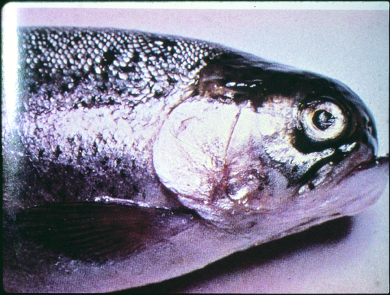  Whirling disease in trout; note deformed skull resulting from long-term infection  Source: T Håstein | 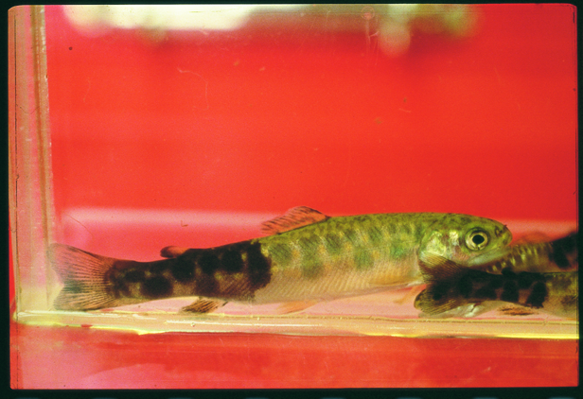  Whirling disease in trout; note classic darkening of the skin from vent to tail  Source: T Poppe

Signs of disease
Important: Animals with disease may show one or more of the signs below, but the pathogen may still be present in the absence of any signs.
Disease signs at the farm, tank or pond level are:
- mass mortalities in fry
- convulsive movements
- increased rate of breathing
- jerking backwards movements
- swimming with a whirling motion (‘tail chasing’)
- erratic, nervous darting movements until exhausted.
Gross pathological signs are:
- darkening of the skin from the vent to the tail (‘blacktail’)
- spinal curvature, skull deformation and shortened gill plates.

Disease agent
Whirling disease is caused by Myxobolus cerebralis, a parasitic protozoan that affects salmonids.

Life cycle
- M. cerebralis has a complex life cycle involving two hosts: ﬁsh (trout or salmon species) and an intermediate host, the tiny bottom-dwelling tubifex mud worm (Tubifex tubifex).
- Myxobolus spores (myxospores) develop in infected ﬁsh and are released into the environment when the fish dies. The myxospores are very persistent and can survive in moist environments for many years.
- Myxospores are ingested from the environment by tubifex mud worms. The spores then rapidly multiply in the worm’s intestine.
- A fragile waterborne spore stage of the parasite (triactinomyxon stage) is released from an infected intermediate host and attaches itself to a definitive host (i.e. fish). This must occur within a few days for survival of the spore stage. The parasite then migrates through the fish skin into the central nervous system, and ultimately into the cartilage.
- Following death and decomposition of infected fish, myxospores are released into the environment and the life cycle continues.
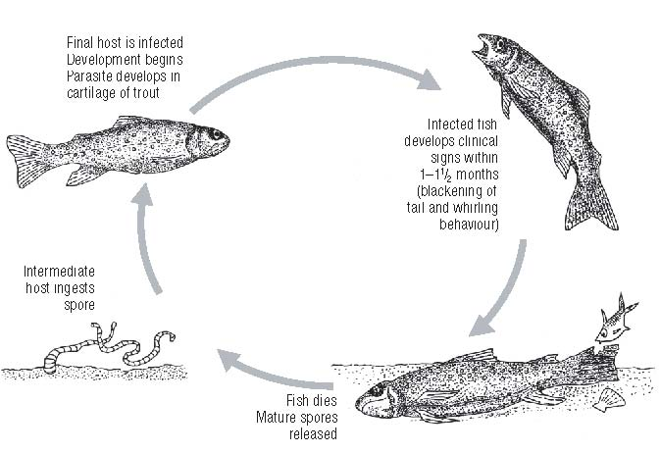
- Spores survive passing through the digestive tract of predators (e.g. birds) and can be transferred from place to place on muddy boots and equipment.

Life cycle of Myxobolus cerebralis
Source: Australian Government Department of Agriculture, Fisheries and Forestry

Host range
Species known to be susceptible to whirling disease are listed below.
Common nameª | Scientific name
Atlantic salmon | Salmo salar
Brook trout | Salvelinus fontinalis
Brown trout | Salmo trutta
Bull trout | Salvelinus confluentus
Chinook salmon | Oncorhynchus tshawytscha
Cutthroat trout | Oncorhynchus clarki
Golden trout | Oncorhynchus aguabonita
Rainbow trout | Oncorhynchus mykiss (most susceptible)
Sockeye salmon | Oncorhynchus nerka
a All species listed are naturally susceptible (other species have been shown to be experimentally susceptible).
The presence of clinical signs in all the species listed here can depend on many factors, particularly the age of the primary host of the initial infection. For example, infected rainbow trout older than 9 weeks will generally show no clinical signs; chinook salmon do not exhibit clinical signs of disease beyond the age of 3 weeks.

Presence in Australia

EXOTIC DISEASE—not present in Australia.

Epidemiology
- Whirling disease is chronic and primarily affects young ﬁsh.
- Susceptibility is influenced by water temperature, age and species.
- Young ﬁsh are highly susceptible because the parasite attacks their soft cartilage, resulting in nerve damage, skeletal deformities and sometimes death.
- Clinical signs of the disease are not evident until ﬁsh are approximately 7 cm long.
- When ﬁsh are 8–10 cm long, cartilage forms into bone and they are no longer susceptible to disease; however they remain carriers of the parasite.
- The intermediate host, the worm Tubifex tubifex, is found in Australia.
- Because tubifex worms live in mud, the disease can be partly controlled in trout farms by growing young ﬁsh in concrete raceways.
- The parasite spreads mainly through the stocking of infected ﬁsh and also through the alimentary tracts of ﬁsh-eating migratory birds.
- M. cerebralis is highly resistant in the myxospore stage. The myxospore released from the ﬁsh can withstand freezing and desiccation, and may survive in a stream for 20–30 years with appropriate environmental conditions. However, the spore stage released from the worm is short lived and susceptible to standard disinfection procedures.

Differential diagnosis
The list of similar diseases below refers only to the diseases covered by this field guide. Gross pathological signs may be representative of a number of diseases not included in this guide, which therefore should not be used to provide a definitive diagnosis, but rather as a tool to help identify the listed diseases that most closely account for the gross signs.

Similar diseases
Infectious haematopoietic necrosis, viral haemorrhagic septicaemia

Sample collection
Due to the uncertainty in differentiating diseases using only gross pathological signs, and because some aquatic animal disease agents might pose a risk to humans, only trained personnel should collect samples. You should phone your state or territory hotline number and report your observations if you are not appropriately trained. If samples have to be collected, the agency taking your call will provide advice on the appropriate course of action. Local or district fisheries or veterinary authorities may also provide advice regarding sampling.

Emergency disease hotline
The national disease hotline number is 1800 675 888. This number will put you in contact with the appropriate state or territory agency.

Further reading
Further information can be found on the Colorado Department of Natural Resources website at wildlife.state.co.us/Fishing/Management/Pages/WhirlingDisease.aspx.
This hyperlink was correct and functioning at the time of publication.

Further images

Phase micrograph of M. cerebralis myxospores extracted from infected rainbow trout cranial cartilage by the pepsin trypsin digest method. The spores measure approximately 10 μm in diameter
Source: J Bartholomew

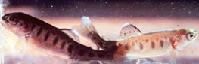  Whirling disease in trout (above and right); note classic darkening of the skin from anus to tail  Source: J Bartholomew | 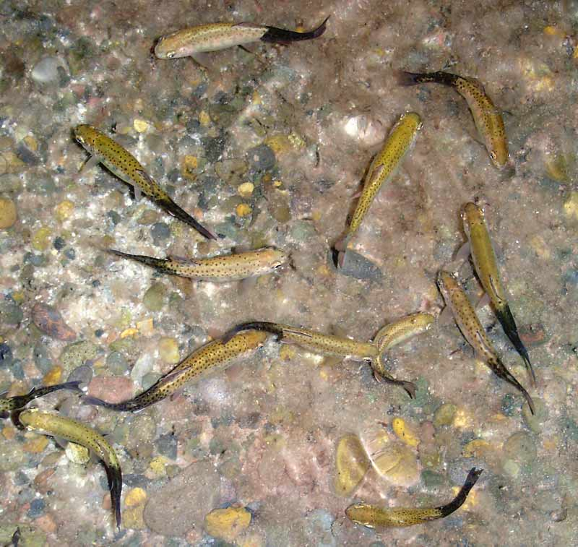

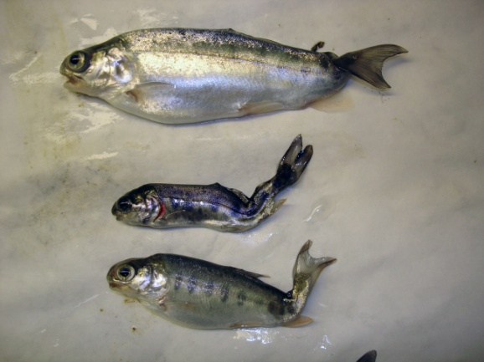
Trout infected with M. cerebralis displaying typical deformity
Source: J Bartholomew

