Aquatic Animal Diseases Significant to Australia:
Identification Field Guide 4th Edition

Abalone viral ganglioneuritis (AVG)
(Listed by the OIE as infection with abalone herpes virus [AbHV])
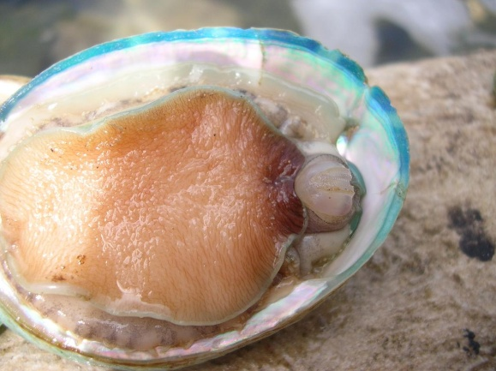  Abalone with AVG. Note the swollen and protruding mouth parts, particularly the prominent radula (toothed, chitinous, ribbon part of the mouth). Note also the retracted (curled) foot margins exposing bare shell beneath  Source: Victorian Department of Primary Industries | 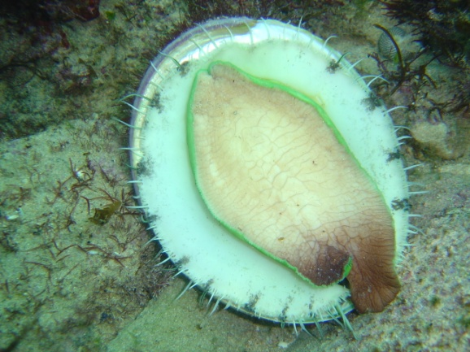  Healthy abalone; there is no evidence of any protruding mouth parts or foot curl  Source: Victorian Department of Primary Industries

Signs of disease
Important: Animals with disease may show one or more of the signs below, but the pathogen may still be present in the absence of any signs.
Disease signs at the farm, tank or pond level (or in the wild) are:
- rapid and high cumulative mortality of up to 90%
- clean (empty) shells on substrate due to predation of moribund and dead abalone
- inability to adhere to the substrate
- inability to right when placed upside down.

Gross pathological signs are:
- swollen and protruding mouth parts
- reduced activity of the pedal muscle
- edges of the foot curled inwards, leading to exposure of clean, shiny shell
- tetany or ‘hard foot’
- excessive mucous production
- abnormal spawning and bloating.
Microscopic pathological signs are:
- inflammation and necrosis of neural tissue.

Disease agent
AVG is caused by abalone herpes virus.

Host range
Species known to be susceptible to AVG are listed below.
Common name | Scientific name
Blacklip abaloneª | Haliotis rubra
Diversicolor or jiukong abaloneª | Haliotis diversicolor
Greenlip abaloneª | Haliotis laevigata
Tiger abaloneª | Haliotis rubra × Haliotis laevigata
a Naturally susceptible

Presence in Australia
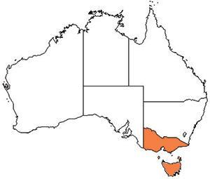
AVG has been officially reported from Victoria and Tasmania. In Victoria, AVG has been observed in farmed and wild abalone. In Tasmania, the disease has not been observed in wild abalone populations. However, AbHV has been detected in wild abalone and disease has been observed in abalone following capture.

Epidemiology
- AVG affects the nervous system of abalone.
- AVG affects all ages of abalone.
- Horizontal transmission has been demonstrated by:
  - exposing healthy abalone to water containing diseased abalone in the same tank without direct contact between the diseased and healthy abalone
  - placing healthy abalone in water that was previously inhabited by diseased abalone
  - intramuscular injection of healthy abalone with a filtered tissue homogenate from diseased abalone.
- Mortality can occur within 4 days of infection and within 1–2 days following the onset of clinical signs.
- It is unknown whether a carrier state exists.

Differential diagnosis
The list of similar diseases below refers only to the diseases covered by this field guide. Gross pathological signs may be representative of a number of diseases not included in this guide, which therefore should not be used to provide a definitive diagnosis, but rather as a tool to help identify the listed diseases that most closely account for the gross signs.

Similar diseases
No diseases listed in this field guide are similar to AVG.

Sample collection
Due to the uncertainty in differentiating diseases using only gross pathological signs, and because some aquatic animal disease agents might pose a risk to humans, only trained personnel should collect samples. You should phone your state or territory hotline number and report your observations if you are not appropriately trained. If samples have to be collected, the state or territory agency taking your call will provide advice on the appropriate course of action. Local or district fisheries or veterinary authorities may also provide advice regarding sampling.

Emergency disease hotline
The national disease hotline number is 1800 675 888. This number will put you in contact with the appropriate state or territory agency.

Further reading
The accepted procedures for a conclusive diagnosis of infection with abalone herpes virus are summarised in the World Organisation for Animal Health Manual of diagnostic tests for aquatic animals 2011, available at www.oie.int/en/international-standard-setting/aquatic-manual/access-online.
Further information can be found on the following websites:
- Tasmanian Department of Primary Industries, Parks, Water and Environment: www.dpiw.tas.gov.au
- Victorian Department of Primary Industries: www.dpi.vic.gov.au/fisheries/pests-weeds-diseases/abalone-disease
- Victorian Abalone Divers Association: www.vada.com.au.
These hyperlinks were correct and functioning at the time of publication.

Further images
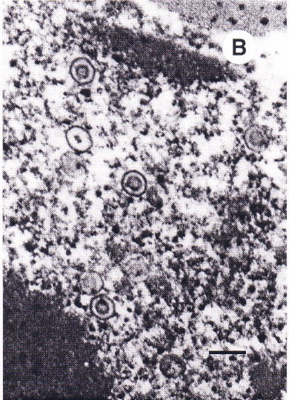
(1) Electron micrograph of the herpes virus responsible for causing AVG
Source: CSIRO Australian Animal Health Laboratory
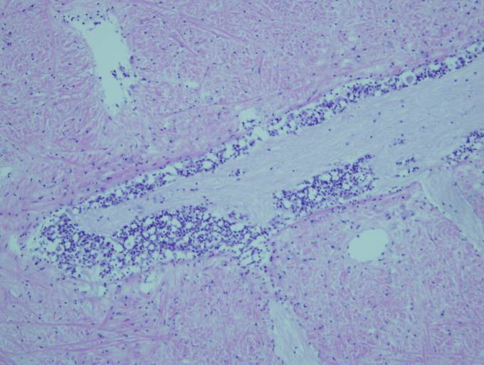
(2) Electron micrograph of the florid inflammatory response around the ganglia. The blue spots highlight the inflammatory cells typical of infection with AVG
Source: Victorian Department of Primary Industries
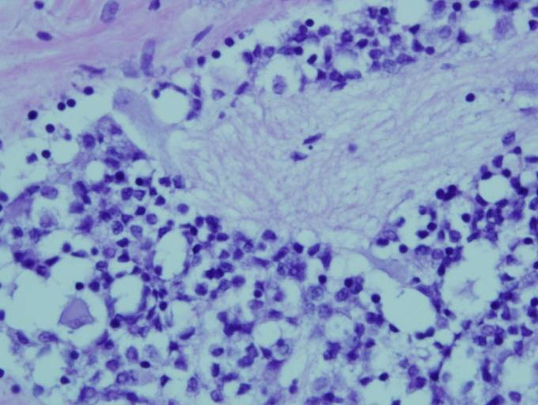
(3) Higher resolution image showing inflamed cells surrounding the ganglia
Source: Victorian Department of Primary Industries

