Aquatic Animal Diseases Significant to Australia:
Identification Field Guide 4th Edition

Infection with Bonamia exitiosa

EXOTIC DISEASE
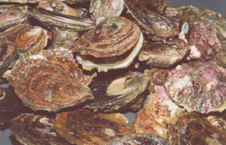  New Zealand flat oyster infected with Bonamia exitiosa; note typical gaping  Source: B Diggles | 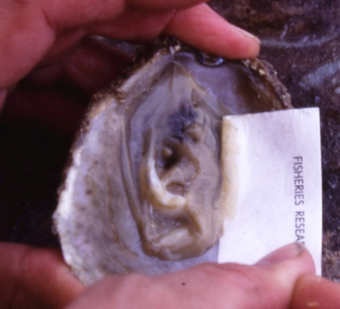  New Zealand dredge oyster (Ostrea chilensis) infected with Bonamia exitiosa  Source: B Jones

Signs of disease
Important: Animals with disease may show one or more of the signs below, but the pathogen may still be present in the absence of any signs.
Diseases caused by any of the microcell species are similar, with few or no clinical or gross signs present with light infection. Identification of the Bonamia or Mikrocytos species requires histological laboratory examination and molecular diagnostic techniques.

Disease signs at the farm, tank or pond level are:
- increased mortality.
Gross pathological signs are:
- stunted growth and poor condition
- weakened shell closure, leading to slight gaping
- watery flesh
- algae-covered shell lips after the mantle shrinks and no longer reaches the edges
- deformities of the gill margins.
Infection with species of Bonamia exitiosa rarely results in gross pathological signs of disease in oysters; often the only sign is increased mortality.
Microscopic pathological signs are:
- microcell parasites, usually found in or near epithelia
- microcell parasites within haemocytes and connective tissues (especially the gill and mantle)
- basophilic, spherical or ovoid parasites, 2–3 µm in diameter.

Disease agent
B. exitiosa is an intrahaemocytic protist in the phylum Haplosporidia that causes lethal infection of certain oysters. Some evidence suggests that B. exitiosa in New Zealand is similar but not identical to the species of Bonamia known to infect southern mud oysters in Australia. Based on current information they are considered to be separate species.

Host range
Species known to be susceptible to infection with B. exitiosa are listed below.
Common name | Scientific name
European flat oysterª | Ostrea edulis
New Zealand dredge oysterª | Ostrea chilensis
Southern mud oyster or Australian flat oysterª | Ostrea angasi
a Naturally susceptible (other species have been shown to be experimentally susceptible)

Presence in Australia

EXOTIC DISEASE—not present in Australia.

Epidemiology
- Mortalities can occur all year, with highest prevalence in mid to late summer.
- The disease dynamics of B. exitiosa in the New Zealand dredge oyster can be affected by exposure to temperature extremes (below 7 °C or above 26 °C), high salinity (40‰), starvation (prolonged holding in filtered seawater), handling (vigorous stirring four times per day) or heavy coinfection with apicomplexan protists.
- Cohabitation of infected and uninfected oysters in holding tanks appears to facilitate transmission of infection to the uninfected oysters.
- A seasonal pattern of disease has been observed in New Zealand since 1964, with separate epizootics in 1985–1991 and 1998–2003 resulting in cumulative mortality of wild populations of New Zealand dredge oysters of more than 90%.
- Transmission is thought to occur from host to host via infective stages being carried along water currents between oyster beds.

Differential diagnosis
The list of similar diseases below refers only to the diseases covered by this field guide. Gross pathological signs may be representative of a number of diseases not included in this guide, which therefore should not be used to provide a definitive diagnosis, but rather as a tool to help identify the listed diseases that most closely account for the gross signs.

Similar diseases
Infection with B. ostreae, Bonamia spp. and Mikrocytos mackini
There are few or no visual cues to the presence of this disease other than poor condition, shell gaping and increased mortality. Consequently, it is impossible to differentiate between Bonamia species based on gross signs alone; any presumptive diagnosis requires further laboratory examination.
Light microscopy can contribute diagnostic information, but further laboratory examination and molecular diagnostic techniques are required for a definitive diagnosis.

Sample collection
Due to the uncertainty in differentiating diseases using only gross pathological signs, and because some aquatic animal disease agents might pose a risk to humans, only trained personnel should collect samples. You should phone your state or territory hotline number and report your observations if you are not appropriately trained. If samples have to be collected, the state or territory agency taking your call will provide advice on the appropriate course of action. Local or district fisheries or veterinary authorities may also provide advice regarding sampling.

Emergency disease hotline
The national disease hotline number is 1800 675 888. This number will put you in contact with the appropriate state or territory agency.

Further reading
The accepted procedures for a conclusive diagnosis of infection with B. exitiosa are summarised in the World Organisation for Animal Health Manual of diagnostic tests for aquatic animals 2011, available at www.oie.int/en/international-standard-setting/aquatic-manual/access-online.
Further information can be found on the website of the Sub-Committee on Animal Health Laboratory Standards at www.scahls.org.au/procedures/anzsdps2.
These hyperlinks were correct and functioning at the time of publication.

Further images
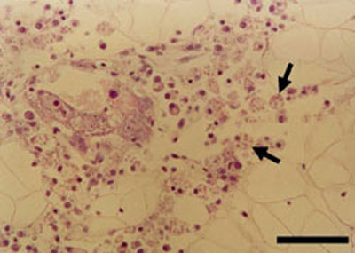
(1) Heavy B. exitiosa infection in New Zealand dredge oyster (Ostrea chilensis), by histology
Source: B Diggles
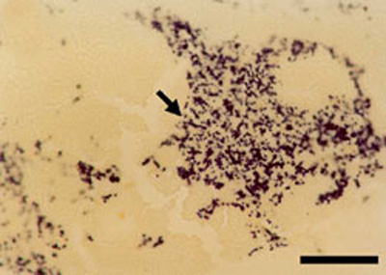
(2) Heavy B. exitiosa infection in New Zealand dredge oyster (Ostrea chilensis), by in situ hybridisation with a molecular probe
Source: B Diggles
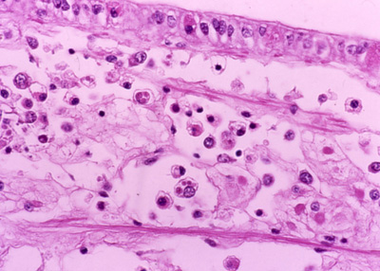
(3) Leydig tissue with circulating haemocytes, many of which have Bonamia exitiosa in them (the small pink spheres in the haemocyte cytoplasm, smaller than a nucleus)
Source: B Jones
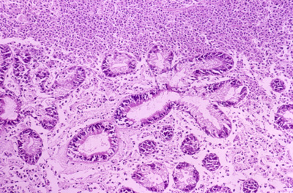
(4) Inflammatory response in a section through the digestive gland of New Zealand dredge oyster (Ostrea chilensis)
Source: B Jones

