Aquatic Animal Diseases Significant to Australia:
Identification Field Guide 4th Edition

Infection with Marteilia refringens
(Also known as Aber disease, digestive gland disease or marteiliosis)

EXOTIC DISEASE
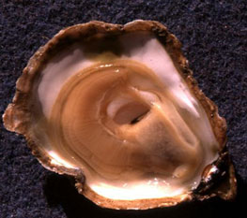  Healthy flat oyster  Source: French Research Institute for Exploration of the Sea—IFREMER | 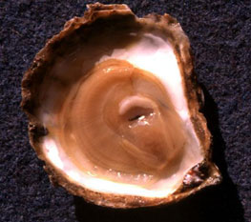  Flat oyster infected with Marteilia refringens  Source: French Research Institute for Exploration of the Sea—IFREMER

Signs of disease
Important: Animals with disease may show one or more of the signs below, but the pathogen may still be present in the absence of any signs.
Disease signs at the farm, tank or pond level are:
- high mortality
- reduced growth rate
- gaping.
Gross pathological signs are:
- poor condition and emaciation
- pale digestive gland
- inhibited gonad development.
Microscopic pathological signs are:
- tissue necrosis.

Disease agent
Marteilia refringens is a protozoan parasite (phylum Cercozoa, order Paramyxida) that affects the digestive system of multiple bivalve species, including oysters, mussels, cockles and clams.

Host range
Species known to be susceptible to infection with M. refringens are listed below.
Common name | Scientific name
American oysterª | Crassostrea virginica
Argentinian flat oyster | Ostrea puelchana
Asiatic oyster ª | Ostrea denselammellosa
Blue musselª | Mytilus edulis
Calico scallop | Argopecten gibbus
Common cockleª | Cardium edule
Dwarf oyster | Ostrea stentina
European flat oysterª | Ostrea edulis
European razor clamª | Solen marginatus
Mediterranean musselª | Mytilus galloprovincialis
New Zealand dredge oysterª | Ostrea chilensis
Olympia oysterª | Ostrea conchaphila
Pacific oyster | Crassostrea gigas
Rock oysterª | Saccostrea cucullata
Small brown mussel | Xenostrobus securis
Southern mud oyster or Australian flat oyster | Ostrea angasi
Striped venus clamª | Chamelea gallina
a Naturally susceptible (other species have been shown to be experimentally susceptible)

Presence in Australia

EXOTIC DISEASE—not present in Australia.

Epidemiology
- M. refringens infections result in high cumulative mortality (50–90%), associated with sporulation of the parasite in the epithelial cells of the digestive tubules. Highest cumulative mortalities usually occur during summer and autumn.
- Earlier stages of sporulation occur in epithelia of the digestive ducts and possibly the gills.
- Several intermediate hosts or a free-living stage are thought to be required during the lifecycle of M. refringens. The copepod Paracartia grani is one intermediate host and may be involved in transmission of M. refringens between bivalves.
- M. refringens can exist in a carrier state in some oysters, which can be potential reservoirs of infection.
- Factors triggering a pathogenic host response are not clearly established, but may include environmental stresses and differences in susceptibility to disease between stock.
- The temperature threshold for parasite sporulation and transmission is 17 °C; however, this is thought to vary with other environmental factors.

Differential diagnosis
The list of similar diseases below refers only to the diseases covered by this field guide. Gross pathological signs may be representative of a number of diseases not included in this guide, which therefore should not be used to provide a definitive diagnosis, but rather as a tool to help identify the listed diseases that most closely account for the gross signs.

Similar diseases
Infection with Marteilia sydneyi
The clinical signs of infection with M. refringens are almost identical to those of infection with other paramyxea (i.e. high mortalities associated with colourless and translucent tissues, poor condition, pale digestive gland and a shrunken body). Therefore, any presumptive diagnosis requires further laboratory examination.
Light microscopy can contribute diagnostic information, but further laboratory examination and molecular diagnostic techniques are required for a definitive diagnosis.

Sample collection
Due to the uncertainty in differentiating diseases using only gross pathological signs, and because some aquatic animal disease agents might pose a risk to humans, only trained personnel should collect samples. You should phone your state or territory hotline number and report your observations if you are not appropriately trained. If samples have to be collected, the state or territory agency taking your call will provide advice on the appropriate course of action. Local or district fisheries or veterinary authorities may also provide advice regarding sampling.

Emergency disease hotline
The national disease hotline number is 1800 675 888. This number will put you in contact with the appropriate state or territory agency.

Further reading
The accepted procedures for a conclusive diagnosis of infection with M. refringens are summarised in the World Organisation for Animal Health Manual of diagnostic tests for aquatic animals 2011, available at www.oie.int/en/international-standard-setting/aquatic-manual/access-online.
Further information is also available on the disease pages of Fisheries and Oceans Canada at www.pac.dfo-mpo.gc.ca/science/species-especes/shellfish-coquillages/diseases-maladies/index-eng.htm.
These hyperlinks were correct and functioning at the time of publication.

Further images
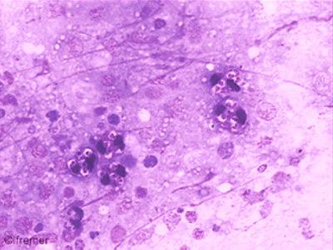
(1) Marteilia refringens tissue imprint (80×)
Source: French Research Institute for Exploration of the Sea—IFREMER
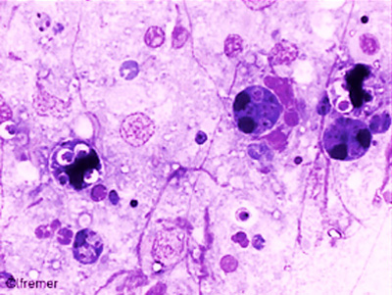
(2) Marteilia refringens tissue imprint (120×)
Source: French Research Institute for Exploration of the Sea—IFREMER

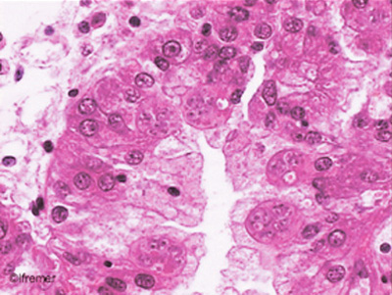
(3) Marteilia refringens tissue imprint (120×)
Source: French Research Institute for Exploration of the Sea—IFREMER
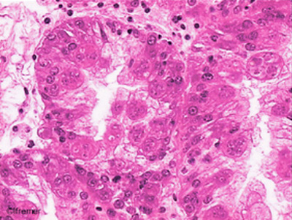
(4) Marteilia refringens tissue imprint (80×)
Source: French Research Institute for Exploration of the Sea—IFREMER

