Aquatic Animal Diseases Significant to Australia:
Identification Field Guide 4th Edition

Infection with Marteilia sydneyi
(Also known as QX disease and marteiliosis)
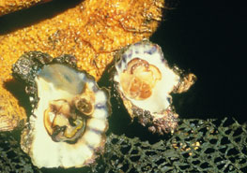
Infected Sydney rock oyster (Saccostrea glomerata) on right, showing a yellowish, watery body (‘pale sick’); Sydney rock oyster on left is normal
Source: R Adlard

Signs of disease
Important: Animals with disease may show one or more of the signs below, but the pathogen may still be present in the absence of any signs.
Disease signs at the farm, tank or pond level are:
- high cumulative mortalities of up to 100%.
Gross pathological signs are:
- shrunken body
- generally poor condition
- death within 60 days of infection
- colourless and translucent tissues because the gonad is completely resorbed
- digestive gland (usually a deep green or brown colour) becomes pale yellow–brown.
Microscopic pathological signs are:
- focal haemocytic inflammation of the gills
- epithelial and connective tissue hyperplasia of the gill epithelium, with fusion of gill filaments.

Disease agent
Marteilia sydneyi is a protozoan parasite of the phylum Paramyxea.

Host range
Species known to be susceptible to infection with M. sydneyi are listed below.
Common name | Scientific name
Sydney rock oyster | Saccostrea glomerata

Presence in Australia
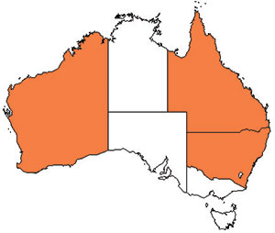
Infection with M. sydneyi is responsible for losses in the Sydney rock oyster industry on the east coast of Australia. The parasite and disease are present in Queensland and New South Wales. A related species of Marteilia has been associated with disease in the coral rock oyster (Saccostrea cucullata) in Western Australia and was officially reported in 1994. It has not been reported since.

Epidemiology
- Despite the presence of the pathogen, disease has not been observed in some eastern Australian estuaries.
- Oysters may be subjected to infection for a period of only 2 weeks per year.
- Outbreaks occur in summer and autumn. Warm temperatures favour parasite development, leading to greatest mortality at the end of summer.
- The disease is associated with low salinity and high water temperature.
- Transmission is horizontal; the pathogen passes from the environment into the epithelium of the palps and gills where it proliferates without forming spores.
- The life cycle of M. sydneyi is not fully understood. Intermediate hosts are required to complete the life cycle; most recent studies confirm that a benthic polychaete is an intermediate host.

Differential diagnosis
The list of similar diseases below refers only to the diseases covered by this field guide. Gross pathological signs may be representative of a number of diseases not included in this guide, which therefore should not be used to provide a definitive diagnosis, but rather as a tool to help identify the listed diseases that most closely account for the gross signs.

Similar diseases
Infection with Marteilia refringens
The clinical signs of infection with M. sydneyi are almost identical to those of infection with Haplosporidia (i.e. high mortalities associated with colourless and translucent tissues, poor condition, pale digestive gland and a shrunken body). Therefore, any presumptive diagnosis requires further laboratory examination.
Light microscopy can contribute diagnostic information, but further laboratory examination and molecular diagnostic techniques are required for a definitive diagnosis.

Sample collection
Due to the uncertainty in differentiating diseases using only gross pathological signs, and because some aquatic animal disease agents might pose a risk to humans, only trained personnel should collect samples. You should phone your state or territory hotline number and report your observations if you are not appropriately trained. If samples have to be collected, the state or territory agency taking your call will provide advice on the appropriate course of action. Local or district fisheries or veterinary authorities may also provide advice regarding sampling.

Emergency disease hotline
The national disease hotline number is 1800 675 888. This number will put you in contact with the appropriate state or territory agency.

Further reading
Further information can be found on the following websites:
- New South Wales Department of Primary Industries: www.dpi.nsw.gov.au/fisheries/pests-diseases/animal-health/aquaculture/qx-oyster-disease
- Department of Fisheries, Western Australia: www.fish.wa.gov.au/docs/pub/FHSlideofQuarter/200609.php?0408
- Disease pages of Fisheries and Oceans Canada: www.pac.dfo-mpo.gc.ca/science/species-especes/shellfish-coquillages/diseases-maladies/index-eng.htm.
These hyperlinks were correct and functioning at the time of publication.

Further images
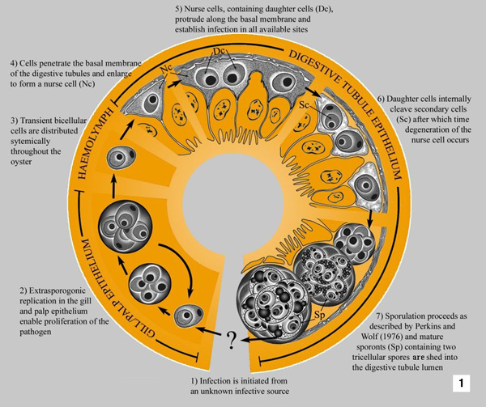
(1) Hypothetical development of Marteilia sydneyi in Sydney rock oyster (Saccostrea glomerata)
Source: S Kleeman
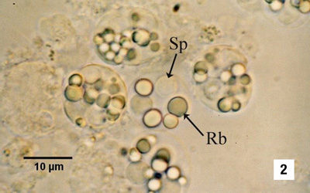
(2) Sporonts of Marteilia sydneyi containing refractile bodies (Rb) and spores (Sp)
Source: S Kleeman
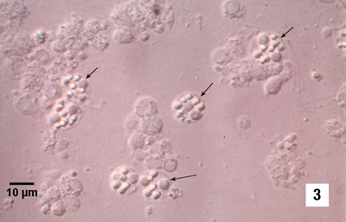
(3) Sporonts of Marteilia sydneyi (arrows) viewed under interference contrast optics
Source: S Kleeman

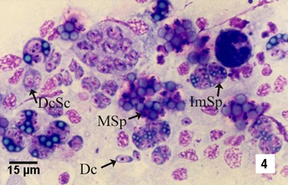
(4) Hemacolor (Merck)-stained tissue imprint of the digestive gland of Sydney rock oyster (Saccostrea glomerata) infected with Marteilia sydneyi, showing various life cycle stages, including daughter cells (Dc), daughter cells containing secondary cells (DcSc), immature sporonts (ImSp) and mature sporonts (MSp). Note that the various stages observed are often ruptured from their enclosing cells (i.e. the nurse cells or sporangiosori).
Source: S Kleeman
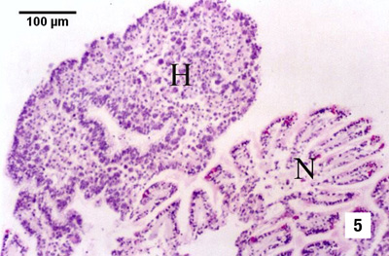
(5) Oyster reaction to the presence of numerous extrasporogonic stages in the epithelium of the gills consisting of epithelial and connective tissue hyperplasia (H), and fusion of filaments, in contrast with relatively normal-looking gill tissue (N)
Source: S Kleeman

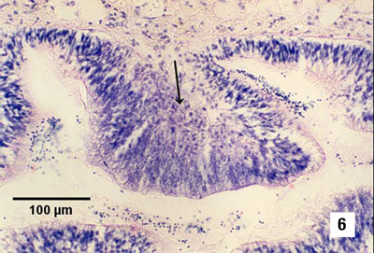
(6) Replicating stages in the palp epithelium; note the hypertrophy of the epithelial cells in the presence of proliferating parasites (arrow) in infected areas
Source: S Kleeman
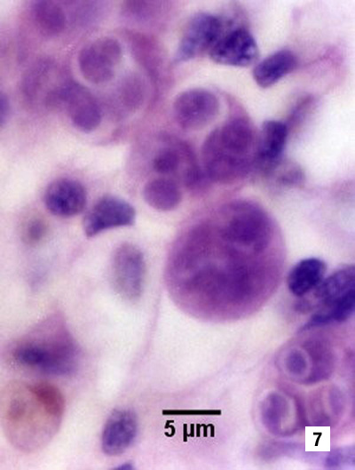  (7) Higher magnification of extrasporogonic stages in the epithelium of the gills (see phase 2 in Figure 1)  Source: S Kleeman | 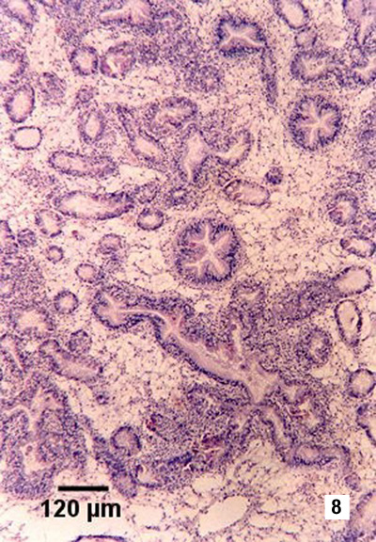  (8) Haematoxylin and eosin stained section, showing haemocytic infiltration of the connective tissue surrounding infected digestive gland tubules  Source: S Kleeman
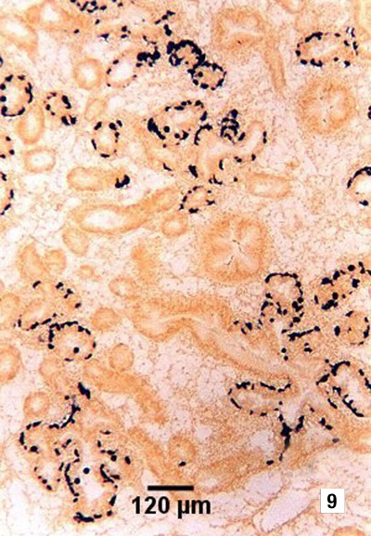  (9) Tissue section, showing the location of presporulating nurse cell stages (stained black) in digestive gland tubule epithelia  Source: S Kleeman | 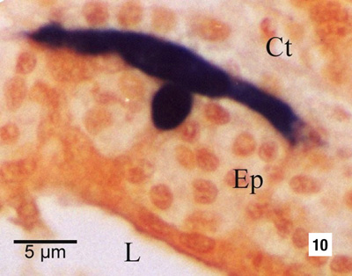  (10) Nurse cell (stained black by in situ hybridisation) demonstrating the extent of the pseudopodial extensions along the basal membrane of the digestive tubule epithelium (Ep). This feature is not evident with haematoxylin and eosin staining. Other labelled features are the connective tissue (Ct) that surrounds the tubule and the lumen (L) of the tubule.  Source: S Kleeman
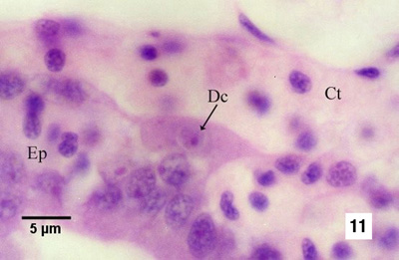
(11) Nurse cell containing one daughter cell (Dc) along the basal membrane of the tubule between the connective tissue (Ct) surrounding the tubules and the tubule epithelium (Ep)
Source: S Kleeman
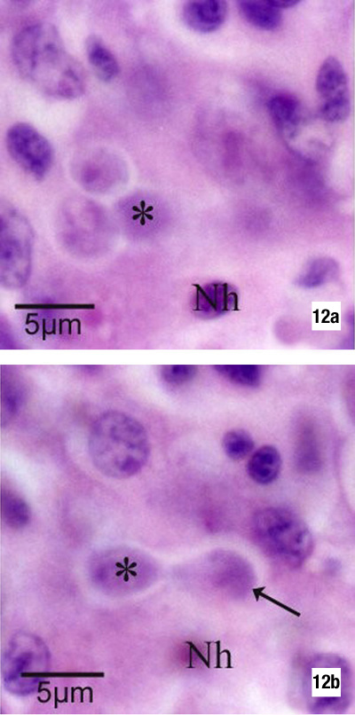 | (12a & b) The same tissue section but at different focal planes, demonstrating the budding of a daughter cell (arrow in Figure 12b) within the nurse cell. An asterisk marks the same daughter cell, and Nh denotes the same host cell nucleus in each figure. There are two additional daughter cells within the nurse cell (Figure 12a).  Source: S Kleeman

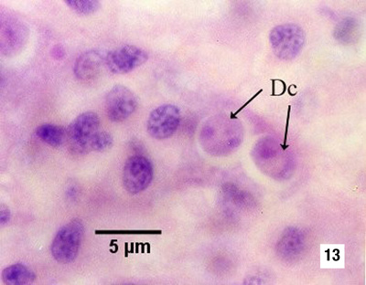  (13) Nurse cell containing two daughter cells (Dc, see phase 5 in Figure 1)  Source: S Kleeman | 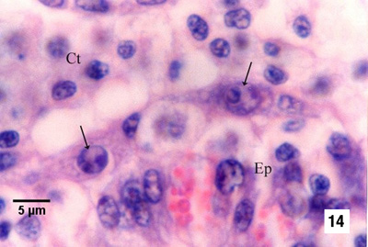  (14) Nurse cells containing bicellular daughter cells (arrows) along the basal membrane between the tubule epithelium (Ep) and the connective tissue that contains many infiltrating haemocytes (see phase 6 in Figure 1)  Source: S Kleeman
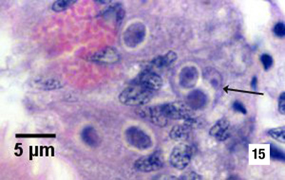  (15) Primary cell (arrow) containing two secondary cells (sporont primordia) just before sporulation (see initiation of phase 7 in Figure 1)  Source: S Kleeman | 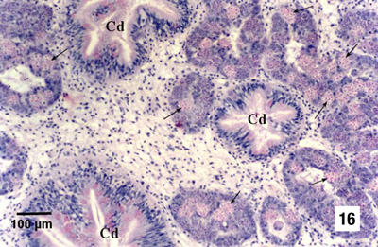  (16) Numerous sporulating stages (arrows) in the digestive gland tubules; note that sporulation does not occur in the ciliated ducts (Cd) of the digestive gland  Source: S Kleeman

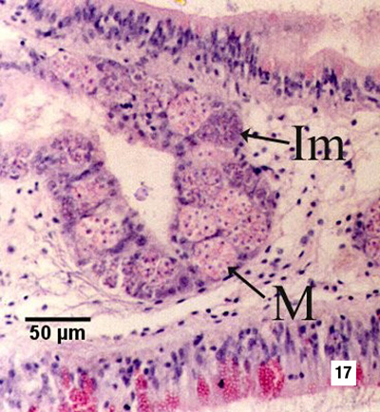
(17) Immature sporonts (Im) and mature sporonts (M) within sporangiosori in a digestive gland tubule; note that the epithelium of the tubule is almost completely replaced by Marteilia sydneyi
Source: S Kleeman

