Aquatic Animal Diseases Significant to Australia:
Identification Field Guide 4th Edition

Infection with Marteilioides chungmuensis
(Also known as marteilioidosis)

EXOTIC DISEASE
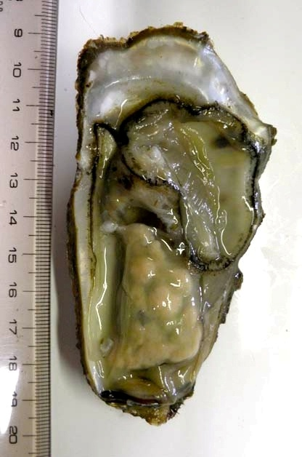  Pacific oyster (Crassostrea gigas) infected with Marteilioides chungmuensis  Source: N Itoh | 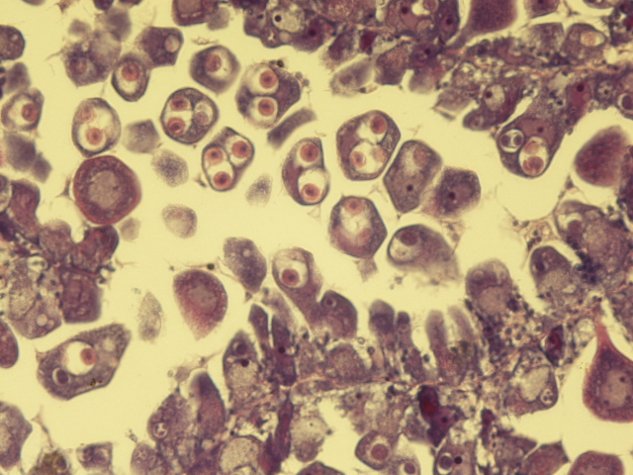  Histological section showing intracellular (within oocytes) Marteilioides chungmuensis  Source: N Itoh

Signs of disease
Important: Animals with disease may show one or more of the signs below, but the pathogen may still be present in the absence of any signs.
Disease signs at the farm, tank or pond level are:
- spawning failure
- high mortalities.
Gross pathological signs are:
- visible distension of the mantle surface due to infected eggs retained within the follicle
- nodule-like structures on the gonad surface.
Microscopic pathological signs are:
- parasites within oocytes.

Disease agent
Marteilioides chungmuensis is a protozoan parasite of the phylum Paramyxea, and is responsible for infection of Pacific oyster oocytes.

Host range
Species known to be susceptible to infection with M. chungmuensis are listed below.
Common name | Scientific name
Pacific oysterª | Crassostrea gigas
Iwagaki oyster | Crassostrea nippona
a Naturally susceptible

Presence in Australia

EXOTIC DISEASE—not present in Australia.

Epidemiology
- M. chungmuensis infects the cytoplasm of mature oocytes and can affect a substantial proportion of eggs.
- Prolonged spawning activity of infected oysters has been observed, resulting in nutritional wasting and mortality.
- Prevalence of infection increases during spawning in summer and decreases after spawning in winter.
- Infected oysters lose their marketability, due to their abnormal appearance.
- Mode of transmission is unknown; however, intermediate hosts may be involved in the life cycle of the disease.

Differential diagnosis
The list of similar diseases below refers only to the diseases covered by this field guide. Gross pathological signs may be representative of a number of diseases not included in this guide, which therefore should not be used to provide a definitive diagnosis, but rather as a tool to help identify the listed diseases that most closely account for the gross signs.

Similar diseases
No diseases listed in this field guide are similar to infection with M. chungmuensis.

Sample collection
Due to the uncertainty in differentiating diseases using only gross pathological signs, and because some aquatic animal disease agents might pose a risk to humans, only trained personnel should collect samples. You should phone your state or territory hotline number and report your observations if you are not appropriately trained. If samples have to be collected, the state or territory agency taking your call will provide advice on the appropriate course of action. Local or district fisheries or veterinary authorities may also provide advice regarding sampling.

Emergency disease hotline
The national disease hotline number is 1800 675 888. This number will put you in contact with the appropriate state or territory agency.

Further reading
Further information can be found on the disease pages of Fisheries and Oceans Canada at www.pac.dfo-mpo.gc.ca/science/species-especes/shellfish-coquillages/diseases-maladies/index-eng.htm.
This hyperlink was correct and functioning at the time of publication.

