Aquatic Animal Diseases Significant to Australia:
Identification Field Guide 4th Edition

Infection with Ostreid herpesvirus-1

microvariant (OsHV-1 µvar)

(Also known as Pacific oyster mortality syndrome [POMS])

Signs of disease
Important: Animals with disease may show one or more of the signs below, but the pathogen may still be present in the absence of any signs.
Disease signs at the farm, tank or pond level are:
- cumulative mortalities in Pacific oysters approaching 100% within 8–10 days of infection.
Gross pathological signs are:
- cessation of feeding and swimming by larvae, which exhibit velar lesions
- gaping in adults
- pale digestive gland in spat and older oysters.
Microscopic pathological signs are:
- ulcerative and erosive lesions in the connective tissue of mantle, gills, labial palps and digestive tissue
- nuclear hypertrophy, nuclear chromatin margination and pyknosis
- inflammatory changes ranging from mild and localised, to severe and extensive.

Disease agent
Ostreid herpesvirus-1 (OsHV-1) is the only member of the genus Ostreavirus (family Malacoherpesviridae, order Herpesvirales). OsHV-1 µvar is a genotype of this virus.

Host range
Species known to be susceptible to OsHV-1 µvar are listed below.
Common name | Scientific name
Pacific oysterª | Crassostrea gigas
a Naturally susceptible (other species have been shown to be experimentally susceptible)
Multiple bivalve species are known to be susceptible to other genotypes of OsHV-1.

Presence in Australia
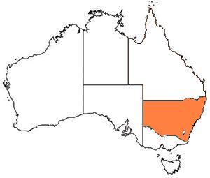
OsHV-1 µvar has been officially reported from only two estuaries in New South Wales.

Epidemiology
- The disease can affect all age groups of oysters, and there may be higher mortality in the younger life stages.
- Higher mortality appears to be associated with higher water temperature and crowding.
- Infected adults may be a source of infection for larvae or spat. However, it is not certain if true vertical transmission occurs. Horizontal transmission has been demonstrated.
- Some adults may survive with subclinical OsHV-1 infections, and act as carriers of the disease.

Differential diagnosis
The list of similar diseases below refers only to the diseases covered by this field guide. Gross pathological signs may be representative of a number of diseases not included in this guide, which therefore should not be used to provide a definitive diagnosis, but rather as a tool to help identify the listed diseases that most closely account for the gross signs.

Similar diseases
No diseases listed in this field guide are similar to infection with OsHV-1 µvar.

Sample collection
Due to the uncertainty in differentiating diseases using only gross pathological signs, and because some aquatic animal disease agents might pose a risk to humans, only trained personnel should collect samples. You should phone your state or territory hotline number and report your observations if you are not appropriately trained. If samples have to be collected, the state or territory agency taking your call will provide advice on the appropriate course of action. Local or district fisheries or veterinary authorities may also provide advice regarding sampling.

Emergency disease hotline
The national disease hotline number is 1800 675 888. This number will put you in contact with the appropriate state or territory agency.

Further reading
The accepted procedures for a conclusive diagnosis of infection with OsHV-1 µvar are summarised in the World Organisation for Animal Health Manual of diagnostic tests for aquatic animals 2011, available at www.oie.int/en/international-standard-setting/aquatic-manual/access-online.
Further information on OsHV-1 µvar can be found on the following websites:
- disease pages of Fisheries and Oceans Canada: www.pac.dfo-mpo.gc.ca/science/species-especes/shellfish-coquillages/diseases-maladies/index-eng.htm
- EUROPA, the European Commission: ec.europa.eu/food/animal/liveanimals/aquaculture/oyster_mortalities_en.htm.
These hyperlinks were correct and functioning at the time of publication.

Further image
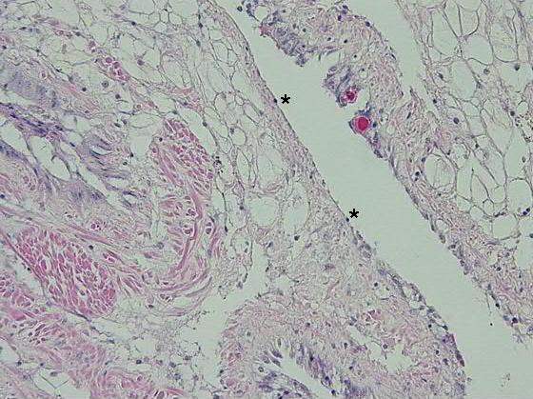
OsHV-1 µvar, 20×. High viral load causing multifocal to coalescing ulceration with attenuation of epithelium and pyknotic nuclei (*)
Source: M Gabor

