Aquatic Animal Diseases Significant to Australia:
Identification Field Guide 4th Edition

Infection with Perkinsus marinus

EXOTIC DISEASE
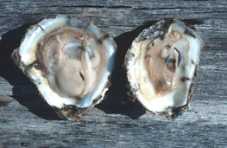
American oyster (Crassostrea virginica) on right, showing typical gross signs of infection with Perkinsus marinus; specimen on left is healthy
Source: E Burreson

Signs of disease
Important: Animals with disease may show one or more of the signs below, but the pathogen may still be present in the absence of any signs.
Disease signs at the farm, tank or pond level are:
- gaping
- retarded growth
- poor condition or emaciation.
Gross pathological signs are:
- shrinkage of mantle away from the outer edge of the shell
- occasional lesions in soft tissue
- pale digestive gland
- thin, watery tissues.
Microscopic pathological signs are:
- large, multifocal lesions in the gut epithelium or connective tissue of any organ containing P. marinus cells
- haemocyte infiltration and phagocytosis of P. marinus cells
- destruction of the gut epithelium.

Disease agent
P. marinus is an alveolate protist nominally in the Dinoflagellida, but there is ongoing scientific debate about its higher taxonomy.

Host range
Species known to be susceptible to infection with P. marinus are listed below.
Common name | Scientific name
American oysterª | Crassostrea virginica
Baltic macomª | Macoma balthica
Blue mussel | Mytilus edulis
Cortez oysterª | Crassostrea corteziensis
Mangrove oyster ª | Crassostrea rhizophorae
Pacific oyster ª | Crassostrea gigas
Sand gaper mussel | Mya arenaria
Suminoe oyster ª | Crassostrea ariakensis
a Naturally susceptible (other species have been shown to be experimentally susceptible)

Presence in Australia

EXOTIC DISEASE—not present in Australia.

Epidemiology
- Water temperatures above 20 °C encourage proliferation of the parasite, resulting in systemic disruption of connective tissue and epithelial cells, leading to high mortalities.
- Reduced salinity levels (below 9‰) can prevent clinical disease resulting from P. marinus infection, even in warm water (above 20 °C).
- Cumulative American oyster mortalities of up to 95% have been observed in the first summer following transfer of naive stock to an area where the disease is known to be present.
- Transmission is horizontal.
- Infection levels increase during spawning and under the stress of oxygen depletion.
- Prevalence and intensity of infection are greatest in oysters more than 1 year old and at depths greater than 90 cm.
- Exposure to pollutants will increase the prevalence of infection.

Differential diagnosis
The list of similar diseases below refers only to the diseases covered by this field guide. Gross pathological signs may be representative of a number of diseases not included in this guide, which therefore should not be used to provide a definitive diagnosis, but rather as a tool to help identify the listed diseases that most closely account for the gross signs.

Similar diseases
Infection with Perkinsus olseni
The clinical signs of infection with P. marinus are similar to those of infection with other species of Perkinsus (i.e. occasional pustules in soft tissue, pale digestive gland, poor condition, emaciation, shrinkage of mantle and retarded growth). It is therefore difficult to make a presumptive diagnosis based on gross signs alone; any presumptive diagnosis requires further laboratory examination.

Sample collection
Due to the uncertainty in differentiating diseases using only gross pathological signs, and because some aquatic animal disease agents might pose a risk to humans, only trained personnel should collect samples. You should phone your state or territory hotline number and report your observations if you are not appropriately trained. If samples have to be collected, the state or territory agency taking your call will provide advice on the appropriate course of action. Local or district fisheries or veterinary authorities may also provide advice regarding sampling.

Emergency disease hotline
The national disease hotline number is 1800 675 888. This number will put you in contact with the appropriate state or territory agency.

Further reading
The accepted procedures for a conclusive diagnosis of infection with P. marinus are summarised in the World Organisation for Animal Health Manual of diagnostic tests for aquatic animals 2011, available at www.oie.int/en/international-standard-setting/aquatic-manual/access-online.
Further information is available on the disease pages of Fisheries and Oceans Canada: www.pac.dfo-mpo.gc.ca/science/species-especes/shellfish-coquillages/diseases-maladies/index-eng.htm.
These hyperlinks were correct and functioning at the time of publication.

Further images
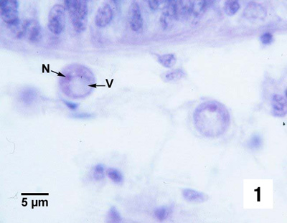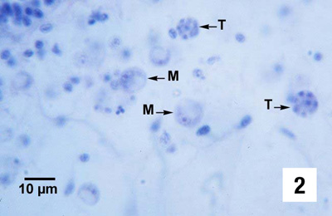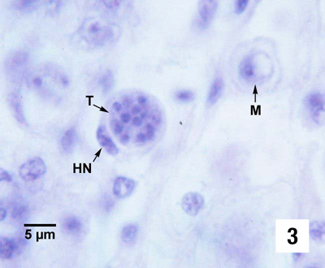
(1,2 & 3) A 16-cell tomont (T) containing developing trophozoites. This tomont is contained within a haemocyte (HN indicates the nucleus of the phagocytic cell), and a maturing trophozoite (M) is nearby.
Source: S Bower

