Aquatic Animal Diseases Significant to Australia:
Identification Field Guide 4th Edition

Infection with Xenohaliotis californiensis
(Also known as withering syndrome of abalone)

EXOTIC DISEASE
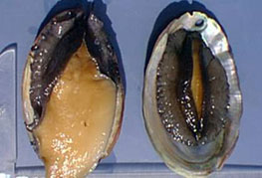
Abalone on right has withering syndrome. Note the severe atrophy (withering) of foot muscle. Specimen on left is healthy.
Source: J Moore

Signs of disease
Important: Animals with disease may show one or more of the signs below, but the pathogen may still be present in the absence of any signs.
Disease signs at the farm, tank or pond level are:
- reduced feeding
- inability of individuals to right themselves when upside down
- weakness and lethargy (clinging to horizontal surfaces rather than vertical or inverted)
- inability to adhere to the substrate.

Gross pathological signs are:
- wasting of body mass
- retraction of mantle
- atrophy of the foot muscle
- decreased response to tactile stimuli
- diminished reproductive output
- mottling of digestive gland (dark brown with small foci of tan-coloured tissue).
Microscopic pathological signs are:
- presence of intracellular bacteria in the cells of the digestive epithelia
- atrophy of digestive tubules
- increase in connective tissue, inflammation and metaplasia of the digestive gland.

Disease agent
Infection with Xenohaliotis californiensis is caused by the intracellular bacterium X. californiensis of the family Rickettsiaceae.

Host range
Five Haliotis species native to the Californian coast are susceptible to infection with X. californiensis. It is assumed that all species of Haliotis are susceptible. There have been no infection experiments on species of abalone that are wild or cultured in Australia, so susceptibility to X. californiensis is not confirmed in these species.
Species known to be susceptible to infection with X. californiensis are listed below.
Common name | Scientific name
Black abaloneª | Haliotis cracherodii
European abalone ª | Haliotis tuberculata
Flat abalone | Haliotis wallalensis
Green abaloneª | Haliotis fulgens
Japanese abalone | Haliotis discus hannai
Pink abaloneª | Haliotis corrugata
Red abaloneª | Haliotis rufescens
Small abaloneª | Haliotis diversicolor supertexta
White abaloneª | Haliotis sorenseni
a Naturally susceptible (other species have been shown to be experimentally susceptible)

Presence in Australia

EXOTIC DISEASE—not present in Australia.

Epidemiology
- The pathogen X. californiensis occurs in marine waters.
- The bacterium attacks the lining of the digestive tract, apparently obstructing the production of digestive enzymes. As a result, the abalone starve and expend their own body mass reserves, causing 'withering' of the foot, which impairs their ability to adhere to substrates and makes them vulnerable to predation.
- Abalone not eaten by predators usually die from starvation.
- Susceptibility varies between species of abalone (99% cumulative decline in black abalone and 30% in red abalone since the disease was first observed in 1986).
- Abalone can be infected with the bacterium without developing the disease.
- Transmission is known to occur horizontally, by cohabitation with infected abalone, and is via the faecal–oral route.
- Environmental stressors, such as elevated water temperature, may predispose carriers of the bacterium to disease. Survivors can remain carriers of the bacterium.

Differential diagnosis
The list of similar diseases below refers only to the diseases covered by this field guide. Gross pathological signs may be representative of a number of diseases not included in this guide, which therefore should not be used to provide a definitive diagnosis, but rather as a tool to help identify the listed diseases that most closely account for the gross signs.

Similar diseases
No diseases listed in this field guide are similar to infection with X. californiensis.

Sample collection
Due to the uncertainty in differentiating diseases using only gross pathological signs, and because some aquatic animal disease agents might pose a risk to humans, only trained personnel should collect samples. You should phone your state or territory hotline number and report your observations if you are not appropriately trained. If samples have to be collected, the state or territory agency taking your call will provide advice on the appropriate course of action. Local or district fisheries or veterinary authorities may also provide advice regarding sampling.

Emergency disease hotline
The national disease hotline number is 1800 675 888. This number will put you in contact with the appropriate state/territory agency.

Further reading
The accepted procedures for a conclusive diagnosis of infection with X. californiensis are summarised in the World Organisation for Animal Health Manual of diagnostic tests for aquatic animals 2011, available at www.oie.int/en/international-standard-setting/aquatic-manual/access-online.
Further information can be found on the Australian Government Department of Agriculture, Fisheries and Forestry website at www.daff.gov.au/animal-plant-health/aquatic/aquavetplan.
These hyperlinks were correct and functioning at the time of publication.

Further images
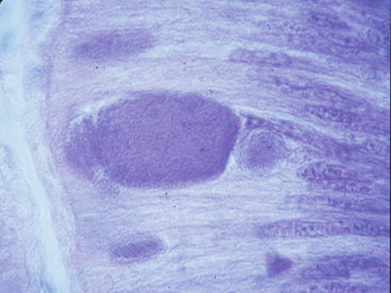
Close-up of an inclusion in the postoesophagus of a red abalone (Haliotis rufescens) positive for infection with X. californiensis
Source: J Moore
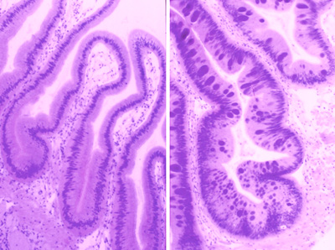
Postoesophagous tissue from healthy, farmed red abalone (Haliotis rufescens) on left; similar tissue on right from an abalone infected with X. californiensis, showing basophilic inclusions in epithelial cells, each containing thousands of individual bacteria
Source: J Moore

