Aquatic Animal Diseases Significant to Australia:
Identification Field Guide 4th Edition

Iridovirosis (gill necrosis virus)

EXOTIC DISEASE
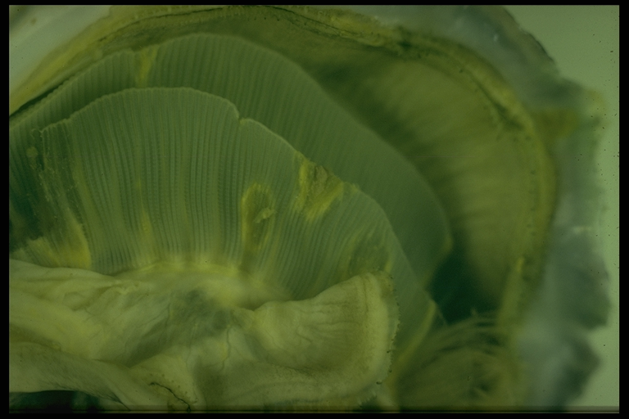
Iridovirosis (gill necrosis virus) in oysters. Note scarring of gill tissue.
Source: D Alderman

Signs of disease
Important: animals with disease may show one or more of the signs below, but the pathogen may still be present in the absence of any signs.

Disease signs at the farm, tank or pond level are:
- high mortality.

Gross pathological signs are:
- yellow or green pustules on mantle or adductor muscle
- yellow spots on gills and labial palps that spread as the disease progresses
- spots that increase in size and develop brown centres as the tissue dies, leaving a hole in the gill structure.

Microscopic pathological signs are:
- necrosis of gill or labial palp tissue
- massive haemocytic cellular infiltration around lesions
- basophilic, cytoplasmic inclusions found in most lesions.

Disease agent
Gill necrosis virus is an icosahedral DNA (deoxyribonucleic acid) virus.

Host range
Species known to be susceptible to iridovirosis are listed below.
Common nameª | Scientific name
European flat oyster | Ostrea edulis
Pacific oyster | Crassostrea gigas
Portuguese oyster | Crassostrea angulata
a All species above are considered naturally susceptible
It is not known if the Sydney rock oyster (Saccostrea glomerata) is susceptible.

Presence in Australia

EXOTIC DISEASE—not present in Australia.

Epidemiology
- A number of iridoviruses causing disease in oysters have been identified, but not all are associated with gill necrosis virus disease, and some affect oysters at different life stages.
- Horizontal transmission occurs directly via the water column through the surface of the gills.
- Little is known about the distribution of the organism responsible for this condition, but molluscan iridoviruses are generally considered to be distributed in oceans worldwide.
- A protist, Thankatostrea polymorpha in the phylum Sarcomastigophora, has also been associated with this disease.
- Outbreaks usually occur in spring and sometimes in summer.
- Surviving oysters do not repair perforated gill structures and are potential carriers of the virus.

Differential diagnosis
The list of similar diseases below refers only to the diseases covered by this field guide. Gross pathological signs may be representative of a number of diseases not included in this guide, which therefore should not be used to provide a definitive diagnosis, but rather as a tool to help identify the listed diseases that most closely account for the gross signs.

Similar diseases
No diseases listed in this field guide are similar to iridovirosis (gill necrosis virus) in oysters.

Sample collection
Due to the uncertainty in differentiating diseases using only gross pathological signs, and because some aquatic animal disease agents might pose a risk to humans, only trained personnel should collect samples. You should phone your state or territory hotline number and report your observations if you are not appropriately trained. If samples have to be collected, the state or territory agency taking your call will provide advice on the appropriate course of action. Local or district fisheries or veterinary authorities may also provide advice regarding sampling.

Emergency disease hotline
The national disease hotline number is 1800 675 888. This number will put you in contact with the appropriate state or territory agency.

Further reading
Further information can be found on the Fisheries and Oceans Canada website at www.pac.dfo-mpo.gc.ca/science/species-especes/shellfish-coquillages/diseases-maladies/index-eng.htm.
This hyperlink was correct and functioning at the time of publication.

