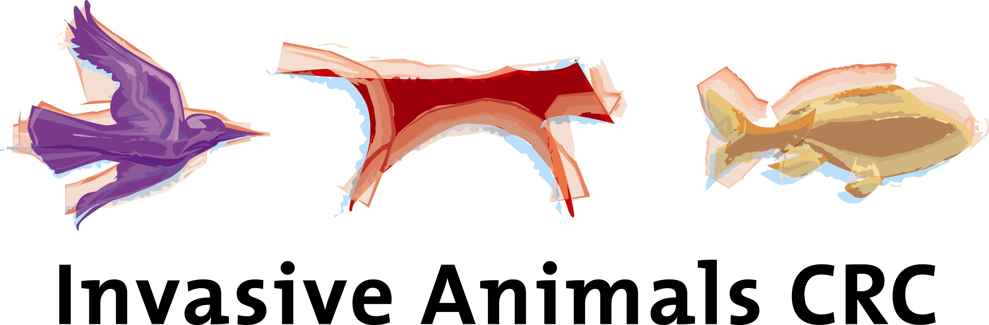



FERAL ANIMALS AS HOSTS OF EXOTIC DISEASE: IDENTIFICATION OF POTENTIAL DISEASE CONTACT BETWEEN FERAL ANIMALS AND SITES OF EXOTIC DISEASE INCURSION

Project leader: Peter West, I&I NSW and Invasive Animals CRC

Project Summary:

Feral and wild animals have been identified as a potential threat to the maintenance and transmission of many exotic diseases in Australia. A number of aspects regarding the extent of this threat remain unquantified, in particular, the level of possible contact between feral animal populations and points of exotic disease incursion. Such uncertainty may result in poor decision-making in the event of an exotic disease emergency, and may affect the size and severity of an exotic disease outbreak.

Objectives:

This project will identify where current populations of feral animals (namely feral pigs, feral goats, feral deer, foxes and wild dogs) throughout Australia may become exposed to exotic livestock diseases such as foot-and-mouth disease, if introduced to Australia. These species have been selected as feral pigs, feral goats and feral deer have been implicated in the transmission of FMD, and Canids have been implicated in the transmission of Leptospirosis. This project will identify sites of possible disease introduction at the national level, and utilise existing datasets for disease hosts, including feral animals (and livestock where available).

Building on the achievements of the WEDPP funded project (2002/03) “Risk analysis of feral and wild animals as a component of exotic and emergency disease preparedness planning” that identified possible disease incursion locations in NSW, this project will compile and collate datasets at the national scale for possible disease incursion sites. It will examine existing national-scale feral animal abundance data against possible incursion sites to quality areas of possible contact/disease transmission. This will be used to identify key risk areas for feral animal disease contact. Unlike the former project, this project will not undertake any epidemiology modelling.

Current national-level information on the range and abundance of feral animal disease hosts has recently been made available through a joint initiative between the Invasive Animals CRC and Australian, State and Territory governments. This project will review existing national datasets for feral animals relevant to diseases listed under AUSVETPLAN and OIE (Lists A and B), and identify areas of potential disease host exposure to disease incursions.

A desk-top exercise will be coordinated to review existing state and national feral animal datasets, review Importation Risk Analysis documents, and collate national datasets on disease incursion points to identify disease risk areas throughout Australia, as a means to support strategic disease surveillance and the management of potential feral animal disease hosts.

This project will directly address the goals of the WEDPP program, and will address recommendations of the WEDPP review workshop by delivering improved information on potential wild animal disease hosts and potential disease contact mechanisms.

