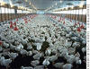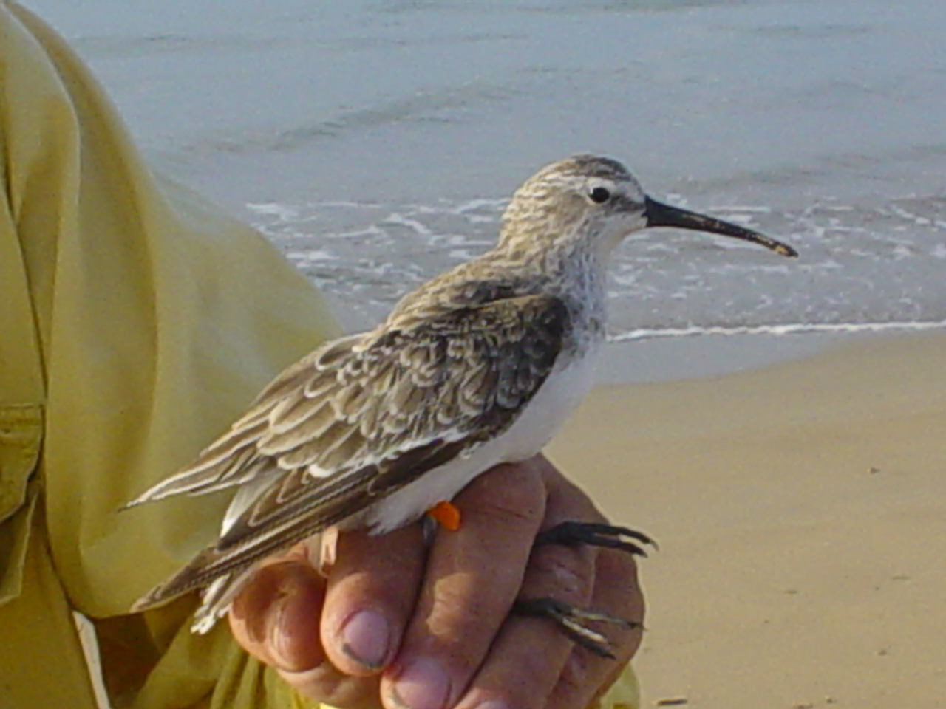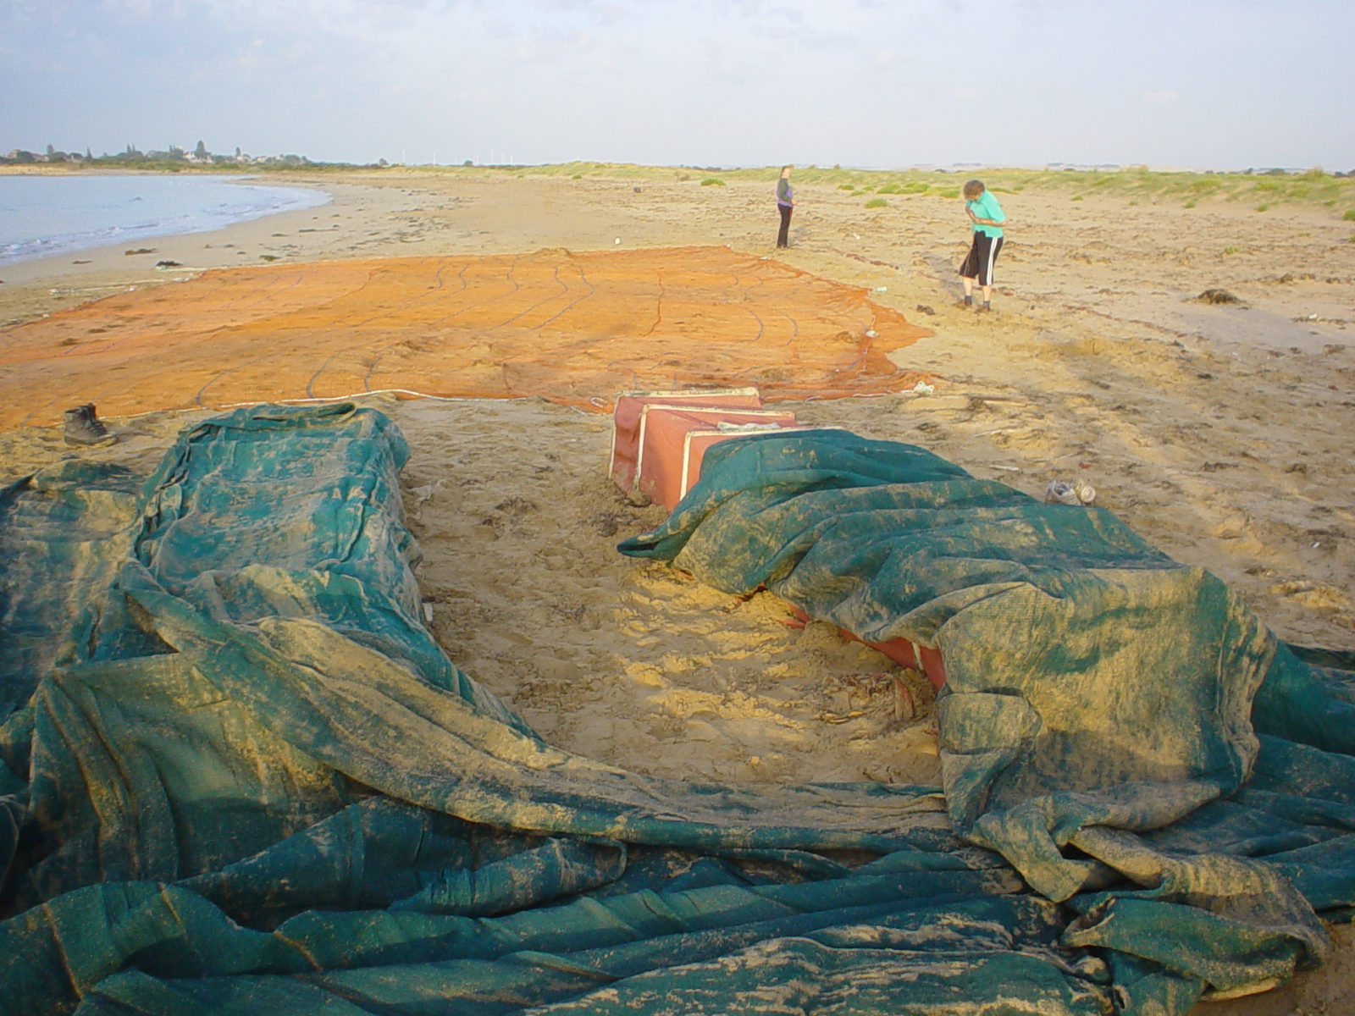

WEDPP

FINAL REPORT

June 2007

Simone Warner, Kim O’Riley, Amanda Welch &
Dennis Grix
Department of Primary Industries, Victoria
PROJECT DETAILS:

Project: Determination of optimal sampling and transport conditions for enhanced detection of Avian influenza and Newcastle disease viruses

Project Dates: 1st July 2006 to 30th June 2007

Project Leader: Simone Warner
Department of Primary Industries, Victoria
Attwood Centre
475 Mickleham Rd
Attwood, VIC, 3049

Phone: (03) 9217 4198
Fax: (03) 9217 4299
Email: Simone.Warner@dpi.vic.gov.au

1. Aims

1. To determine the optimal transport media and transport temperatures for increased detection of AIV and NDV by culture and molecular methods.

2. To determine if the time delays in transporting samples to the laboratory can reduce the chance of detecting viable virus or viral RNA.

2. Abbreviations

AAHL Australian Animal Health Laboratories
AIV Avian influenza virus
BHI Brain heart infusion medium
Ct Crossing threshold (Real Time PCR)
DPI Department of Primary Industries
H Haemagglutinin subtype
HA Hemagglutination assay
HPAI Highly pathogenic avian influenza
LPAI Low pathogenic avian influenza
M Matrix gene
N Neuraminidase subtype
NDV Newcastle Disease Virus
PCR Polymerase Chain Reaction
RLT QIAgen RNeasy kit lysis buffer for RNA extraction
RT-PCR Reverse Transcription Polymerase Chain Reaction
VTM Viral Transport Medium
WEDPP Wildlife and Exotic Disease Preparedness Program
WHO World Health Organisation Collaborating Centre for Reference and Research on Influenza

3. Background

Critical in the expeditious diagnosis of any disease is the ability to collect good clinical specimens and to transport them to the laboratory in a timely manner. This is particularly important in the diagnosis of an exotic or emerging disease, and when viable organisms are required for culture. Poor clinical specimens are often blamed for a delayed or incorrect diagnosis.

In recent years, standard PCR and Real time PCR has become a significant part of the disease investigation packages offered by diagnostic laboratories. The problem however, is that it can be difficult to definitively prove the cause of a disease by molecular methods alone when positive culture results cannot also be attained. In the case of avian influenza disease, it has been reported that as little as 20 per cent of viruses detected by sensitive PCR tests can actually be grown in egg culture (personal communication). This puts in doubt the accuracy of the PCR result for the other 80 per cent of samples that viruses cannot be grown from.

Interestingly, all five previous Australian avian influenza disease outbreaks could not be confirmed by sampling wild birds in the vicinity of the outbreak farms. It is possible that when the virus has mutated into a highly pathogenic form, that viral loads are substantially increased and consequent detection is relatively easy. However, when undertaking surveillance of birds prior to identification of the index case, it is likely that there is a lower viral load, consequently making detection of the viruses more difficult. It is in these cases in particular that there is a need to be satisfied that optimal sampling methods are used.

Previous WEDPP funded projects of this laboratory have focused on the enhanced detection of NDV and AIV by PCR once the samples have arrived at the laboratory. In contrast, this new project aims to build on the progress made by these other projects in determining the conditions required to provide samples of the highest quality to the laboratory for viral detection by both culture and Real Time PCR detection. The information generated will enhance current knowledge, and should once and for all settle the confusion that many field veterinarians and laboratories face with regards to recommending which sampling and transport methods should be followed.

4. Methods

Viral stocks of a low pathogenic AIV (subtype H4) and an avirulent NDV (V4 strain) will be used as the model viruses for each of the following experiments

Enhanced detection of AIV and NDV using optimised sampling conditions:

This study aimed to determine the best practice for obtaining high quality clinical samples for improved laboratory diagnosis of AIV and NDV. This was done by testing various viral transport media and transport temperatures on their ability to preserve live viruses for detection in egg culture and viral genetic material for use in PCR.

There are three primary viral transport media (VTM) that are widely used, one is glycerol-based (WHO web site recommendation), another is brain heart infusion (BHI) broth-based (used at DPI Attwood) and the other is Hanks salts based (used by CSIRO AAHL). All three buffers were inoculated separately with AIV and NDV in either high and low dilutions, and then assayed by culture and PCR to identify which VTM is superior in maintaining the integrity of the viral samples for a positive diagnostic outcome. The high virus concentration was based on 1.2x10⁻² HA units and the low virus concentration on 1.2x10⁻⁶ HA units.

The transport media had the following composition:
DPI – BHI broth base containing 2x10⁶IU/l penicillin; 0.2mg/ml streptomycin; 0.5mg/ml gentamicin; 500U/ml amphotericin B
AAHL – Hanks buffered salts base containing 0.5x10⁶IU/l penicillin; 0.2mg/ml streptomycin; 0.5mg/ml gentamicin; 5mg/ml BSA
WHO – 50% Glycerol base containing 2x10⁶IU/l penicillin; 0.2mg/ml streptomycin; 0.25mg/ml gentamicin

Another factor considered in this experiment was the effect of the sample’s storage temperature, therefore experiments were designed to determine the optimal temperature for maintaining sample integrity during transport. In order to test this, both concentrations of the two viruses were mock transported to the laboratory under various conditions such as room temperature (approx 20ºC), chilled with ice packs, submerged in ice/4⁰C, frozen at –20ºC, submerged in dry ice and submerged in liquid nitrogen. The outlined proposal shown below had a total of 72 samples that were tested in duplicate (total of 144) by both egg culture and Real time PCR. All inoculated VTM were held at the proposed experimental conditions for 48 hours prior to further testing.

VIRUS VTM TEMPERATURE DILUTIONS
Room Temp
AIV H4 BHI Chilled Low
NDV X Glycerol X Ice (4ºC) X High
Hanks -20ºC
Dry ice
Liquid Nitrogen

Culture (2) (3) (6) (2) =72

There were two additional factors considered in this study because they would be present in diagnostic cloacal samples; faecal material and the cotton swab. There is a chance that the presence of faeces or swab material could inhibit the growth of, or even kill, live viruses. Therefore, all VTM samples had fresh faecal material added (tested free of AI and ND viruses by PCR), as well as a wooden-stick swab. To determine the amount of faecal material that would be representative of that from a bird cloacal swab, the amount of faecal material from three chicken cloacal samples were weighed and averaged, giving an average of 0.1 gram faecal material per swab. Therefore, the equivalent of 0.1 gram of faecal material was added to each VTM tube prior to the addition of the AI or ND viruses.

PCR Experiments:

A small modification was incorporated for the PCR component of the testing. In addition to the methodology outlined for culture above, the same two viral samples were also added to an QIAgen RNeasy kit RNA extraction buffer (RLT) in addition to the VTMs to investigate if this would provide a superior yield and/or quality of RNA for use in PCR. Therefore, the same two dilutions of virus were inoculated in RNA extraction buffer and stored at three temperatures (room temperature, 4ºC and -80ºC) prior to nested Real time PCR testing. This added a total of 24 samples to the 144 samples in this study (2 viruses X 1 RNA extraction buffer X 3 temperatures X 2 virus concentrations = 12 X duplicate testing = 24)

The PCR test used were:
AIV DPI Type A Real Time PCR test
NDV AAHL NDV standard PCR test (F primers)

Field testing using the DPI Diagnostic van:

Field and control samples were assayed in duplicate by AIV Real time PCR to compare on-site versus laboratory processing. A total of 72 fresh faecal samples were collected at the Werribee Sanctuary/Sewerage farm into BHI VTM. One of the duplicate samples had RNA extraction performed in the field using the DPI Diagnostic van equipment, with the minimal delay possible after the sample is taken (Day 0). The other sample was stored in an esky with chill packs and transported back to the laboratory for testing as per the optimal conditions determined in Objective 1 of this project proposal (BHI VTM; Chill packs).

PCR was conducted on day 3 to represent the likely timing with which field samples would normally be processed. Control samples were included in the study and were set up as detailed below. In summary, allantoic fluid from eggs inoculated with low pathogenic H4N4 AIV was added to BHI VTM starting from 10⁻⁵ dilution of a 235 HA unit virus stock and with 10-fold dilutions to a final dilution of 10⁻¹³. Again, fresh faecal material and a swab were included in the VTM to represent that present in field samples.
RNA was extracted from a volume of 140µl VTM, where time 0 was performed in the DPI Diagnostic van and all subsequent times (day 1, 3, 5, 7 and 14) were performed at the laboratory. It was decided to perform all PCR work at the laboratory due to the PCR machines not being covered by warranty if they were taken in the DPI Diagnostic van.

CONTROLS
VIRUS DILUTIONS TIME

AIV H4 10⁻⁵ Day 0 (Van) X 10⁻⁶ X Day 1 (Lab) 10⁻⁷ Day 3 (Lab)
10⁻⁸ Day 7 (Lab)
10⁻⁹ Day 14 (Lab)
10⁻¹⁰
10⁻¹¹
10⁻¹²
10⁻¹³

Van (1) x (9) x (1) = 9
Lab (1) x (9) x (4) = 36

5. Results and Discussion

To determine the optimal transport media and transport temperatures for increased detection of AI and ND viruses by culture and molecular methods

This study aimed to determine the best practice for obtaining high quality clinical samples for improved laboratory diagnosis of AIV and NDV. Three viral transport media were tested at six different temperatures with two concentrations of low-pathogenic AIV and NDV. All work was performed in duplicate.

Viral Culture

In order to identify a viral transport medium (VTM) that is superior for maintaining the integrity of viral samples, three viral transport media were trialled: BHI, Hanks and Glycerol based media. All three of these buffers were inoculated with either high or low concentrations of low-pathogenic AIV or NDV and incubated at various temperatures for 48 hours. There were a total of six temperatures trialled including room temperature (approx 20ºC), chilled with ice packs, 4⁰C, frozen at minus 20ºC, dry ice/minus 80ºC and submerged in liquid nitrogen. Two viral concentrations were chosen to represent the range of titres that might occur in diagnostic samples. It might be expected that all VTM might suffice for detecting high concentrations of virus, whereas the differences in the ability of the various VTM to preserve virus viability may be highlighted when lower concentrations of virus are used.

Duplicate testing of three VTM across six temperatures for two concentrations of two viruses gave rise to a total of 144 samples (refer to methods section); these were cultured in eggs for the detection of live virus, as well as tested by Real time PCR for the detection of genetic material. Table 1 shows a summary of the duplicate culture results for the AIV experiments and Table 2 shows a summary of the duplicate NDV results (full results are shown in the A3 size spreadsheets attached in Appendices 1 and 2). Samples that had live virus detected after one or two passages in eggs are shaded in yellow. Since live virus was able to be cultured from many test samples, it appears that the presence of faecal material and wooden-stick swabs do not adversely affect the ability to detect live virus in diagnostic samples to any large extent.

At both high and low concentrations of AI virus, the BHI and Hanks VTM performed similarly and were superior to the glycerol VTM. The glycerol VTM generally had a reduced number of samples with recoverable virus for many of the temperatures tested (refer to Table 1). For example at 4ºC, which is probably one of the most common incubating temperatures, no AIV was recoverable from either of the duplicates incubated in the glycerol VTM, even for high virus concentrations. In contrast, even with low concentrations of AIV, where virtually no AIV was recoverable from any VTM at any temperature, AIV was recovered from 5 eggs inoculated from the Hanks VTM at the chilled temperature (from 3 eggs in duplicate 1 and from 2 eggs in duplicate 2). When all of the results are taken into consideration, either the BHI or Hanks VTM would be recommended for AIV culture.

All VTM performed well with high concentrations of NDV. Both the BHI and Hanks VTM were able to detect NDV at all temperatures for the high concentration of virus, whereas the glycerol VTM had detectable virus at all but one temperature (-80ºC) (refer to Table 2). This was not the case however for the low concentration of NDV where the BHI and glycerol VTM were superior to the Hanks VTM for the recovery of live NDV. For example, in the BHI VTM, all 6 temperatures had detectable NDV for at least one of the duplicates. In contrast, the Hanks VTM only had detectable NDV at 3 of the 6 temperatures and at 4 of the 6 temperatures for the glycerol VTM. In summary, based on these results, the BHI media appears superior to both Hanks and glycerol VTM for the recovery of live NDV.

Overall from the results obtained in this study, either the DPI BHI-based media or the AAHL Hanks-based media can be considered good transport media for use with diagnostic samples for AIV. Less AIV was recoverable from samples collected into the WHO glycerol-based VTM than both the DPI BHI and AAHL Hanks VTM for virtually all temperatures tested. For NDV culture however, this study showed the BHI VTM to be superior to both the Hanks and glycerol VTM. It is important to keep in mind however, that the incubation time in this study was only 48 hours. An incubation time of 48 hours may easily be exceeded with samples collected for surveillance. Therefore, it would also be interesting to perform this style of study where longer incubation periods are assessed. To that end, in addition to the work required to meet this project’s objectives, an additional experiment was undertaken to determine how long a VTM sample can be stored at 4ºC and still preserve live virus that can be detected by culture in eggs. BHI VTM containing faecal material was inoculated with live AIV and tested weekly in egg culture. At the time of writing this report, live virus was still detectable in eggs after incubation for four weeks (Refer to Appendix 1).

The exception to this was that the Hanks VTM out performed the other VTM just at the chilled temperature for the low concentration of NDV, interestingly this was also seen in the AIV experiments.

Table 1: Duplicate results for the number of eggs with detectable AIV per group of ten eggs (5 eggs for each of 2 passages) when inoculated with high or low concentrations of avian influenza virus. Single numbers represent egg deaths occurring within the first passage, whereas when egg deaths occurred in both first and second passages, the results are represented as two numbers (pass 1 + pass 2).

VTM | AIV  Conc | Temperature |  |  |  |  |  | Positive  ( /12)
VTM | AIV  Conc | Room Temp | Chill pack | 4ºC | -20 ºC | -80 ºC | Liquid Nitrogen | Positive  ( /12)
BHI | High | 1 | 4 | 3 | 1 | 2 | 1 | 12
BHI | High | 2 | 4 | 2 | 3 | 2 | 3 | 12
BHI | Low | 0 | 0 | 0 | 0 + 1 | 0 | 0 | 1
BHI | Low | 0 | 0 | 0 | 0 | 0 | 0 | 1
Hanks | High | 1 | 3 | 2 | 2 | 1 | 1 | 11
Hanks | High | 0 | 4 | 1 | 3 | 1 | 2 | 11
Hanks | Low | 0 | 3 | 0 | 0 | 0 | 0 | 2
Hanks | Low | 0 | 2 | 0 | 0 | 0 | 0 | 2
Glycerol | High | 2 | 2 | 0 | 1 | 1 | 1 | 9
Glycerol | High | 1 | 2 | 0 | 0 | 1 | 2 | 9
Glycerol | Low | 0 | 0 | 0 | 0 | 0 | 0 | 0
Glycerol | Low | 0 | 0 | 0 | 0 | 0 | 0 | 0

Table 2: Duplicate results for the number of eggs with detectable NDV per group of 7 eggs (see note below) when inoculated with high or low concentrations of Newcastle disease virus. Single numbers represent egg deaths occurring within the first passage, whereas when egg deaths occurred in both first and second passages, the results are represented as two numbers (pass 1 + pass 2).

VTM | NDV  Conc | Temperature |  |  |  |  |  | Positive  ( /12)
VTM | NDV  Conc | Room Temp | Chill pack | 4ºC | -20 ºC | -80 ºC | Liquid Nitrogen | Positive  ( /12)
BHI | High | 3 | 2 | 2 | 2 | 2 | 0 + 3 | 12
BHI | High | 2 | 2 | 2 | 1 | 2 | 1 | 12
BHI | Low | 1 | 0 + 1 | 1 | 0 | 1 | 1 | 10
BHI | Low | 0 + 2 | 2 | 0 | 1 | 2 | 2 | 10
Hanks | High | 0 + 4 | 1 | 0 + 3 | 1 | 1 | 1 | 12
Hanks | High | 0 + 2 | 0 + 3 | 1 | 1 | 1 | 1 | 12
Hanks | Low | 0 | 2 | 0 | 0 + 1 | 0 | 0 | 4
Hanks | Low | 0 | 0 + 4 | 0 | 0 | 1 | 0 | 4
Glycerol | High | 1 | 1 | 2 | 0 + 4 | 1 | 1 | 11
Glycerol | High | 1 | 0 + 4 | 1 | 0 + 4 | 0 | 0 + 4 | 11
Glycerol | Low | 0 | 0 | 0 | 0 + 1 | 0 + 1 | 0 + 1 | 6
Glycerol | Low | 0 + 2 | 0 | 0 | 1 | 1 | 0 | 6

Note: The egg supplier was unable to fulfil the requested order of NDV-antibody free eggs to allow 5 eggs per sample per passage. Therefore, the number of eggs had to be reduced to 3 eggs for each sample in passage 1, and 4 eggs for each sample in passage 2.
Molecular detection

This component of the objective was included to determine which combination of the various viral transport media and temperatures best suited downstream PCR testing. It is feasible that although some media/temperature combinations may suit the preservation of live virus, others may better suit the preservation of viral RNA. It is for that reason that RLT was used in addition to the three VTM used for the live virus study. RLT is the first buffer used in the RNA extraction process when using the QIAgen RNeasy kit and contains an RNase inhibitor specifically designed to prevent the degradation of RNA in samples.

The AIV PCR results show that there is no significant difference in the detection of genetic material based on the storage temperature.(refer to Table 3). This is evident in that Ct values obtained in the PCR were similar for all temperatures, where the Ct value represents the cycle where DNA amplification is detected – the lower the number, the stronger the positive result. The only sample that didn’t fit this pattern was the AAHL media/-80ºC sample where no virus was detected. Also, the warmer temperatures at which the VTM remains liquid(RT, chilled and 4⁰C) appear slightly superior for the BHI-based media. Based on these results, samples can be stored in liquid form and do not need to be frozen if PCR testing is to be performed within a few days.

Interestingly, there was a small difference in the PCR detection between the various media. Based on the Ct values of the DPI Real Time PCR test, the BHI and RLT buffers were superior in detecting AIV from the samples since Ct values of <12 were observed for all temperatures, which correspond to a strong positive PCR result. This contrasts the AAHL and WHO media where the Ct values ranged from 12 to 22, representing a weaker positive result.

In contrast to the AIV experiments, the storage temperature did influence the detection of NDV by PCR. Since the NDV PCR is a standard PCR not a Real Time test, the results are read manually off an agarose gel. Therefore, to aid the interpretation the intensity of the band was graded as a negative, strong positive (3+), positive (2+) or weak positive (1+) (refer to Table 4). It is also important to note that the NDV PCR test was designed for use on allantoic samples, not VTM from field samples. Therefore, when the samples were run, both dilutions tested negative for all samples (data not shown). The PCR was then repeated using a small aliquot of the first PCR as the seeding DNA in the second test. After the second PCR, positive results were detected from the high concentration of virus but not the low concentration of virus (refer to Table 4).

The lower concentration of virus was included to try and discriminate differences between the different media and the storage temperatures. Unfortunately, the dilution of virus used turned out to be slightly weaker than anticipated and all but one sample tested negative in the AIV PCR. Having said that, the BHI-based media was able to detect AIV when incubated at room temperature. Likewise, the NDV PCR was unable to detect any virus from any temperature for the low concentration of virus.

It is evident however, that the BHI-based VTM was superior in maintaining RNA/virus quality as all six temperatures gave a positive PCR result. The glycerol media also performed well with 5 of 6 temperatures giving a positive result, whereas the Hanks media was only positive at two of the temperatures. The BHI media also has the additional advantage of being able to use the sample for isolation work if required, unlike the RLT buffer which would inactivate live virus.
Table 3: Real time nested AIV PCR Ct results of positive AIV H4 (diluted 10⁻³ of neat) inoculated in three viral transport media’s (AAHL-Hanks, WHO-PBS/Glycerol and DPI-BHI) and a lysis buffer (QIAGEN RNeasy RLT buffer) and tested after 48 hours incubation at the temperatures described. All samples displayed dissociation peaks within the positive range (79.5-83.5). Ct threshold was 0.05.

VTM | AIV  Conc | Temperature |  |  |  |  |  | Positive
VTM | AIV  Conc | Room Temp | Chill pack | 4ºC | -20 ºC | -80 ºC | Liquid Nitrogen | Positive
BHI | High | 7.60 | 5.58 | 8.71 | 10.73 | 10.76 | 11.24 | 7 / 12
BHI | Low | 24.82 | Neg | Neg | Neg | Neg | Neg | 7 / 12
Hanks | High | 20.75 | 20.54 | 20.16 | 18.67 | Neg | 22.07 | 5 /12
Hanks | Low | Neg | Neg | Neg | Neg | Neg | Neg | 5 /12
Glycerol | High | 14.16 | 12.75 | 13.88 | 14.75 | 12.11 | 14.46 | 6 /12
Glycerol | Low | Neg | Neg | Neg | Neg | Neg | Neg | 6 /12
RLT | High | 8.52 | 6.94 | 9.01 | NP | NP | NP | 3 / 6
RLT | Low | Neg | Neg | Neg | NP | NP | NP | 3 / 6

Neg Negative - no Ct. value obtained in Real Time PCR test
NP Test not performed

Table 4: NDVPCR results of positive NDV (diluted 10⁻³ of neat) inoculated in three viral transport media’s (AAHL-Hanks, WHO-PBS/Glycerol and DPI-BHI) and a lysis buffer (QIAGEN RNeasy RLT buffer) and tested after 48 hours incubation at the temperatures described. Positive results were graded as 1+, 2+ or 3+ based on the intensity of the PCR product band in the agarose gel.

VTM | NDV  Conc | Temperature |  |  |  |  |  | Positive
VTM | NDV  Conc | Room Temp | Chill pack | 4ºC | -20 ºC | -80 ºC | Liquid Nitrogen | Positive
BHI | High | 3+ Pos | 2+ Pos | 2+ Pos | 2+ Pos | 1+ Pos | 3+ Pos | 6 / 12
BHI | Low | Neg | Neg | Neg | Neg | Neg | Neg | 6 / 12
Hanks | High | Neg | Neg | Neg | 2+ Pos | Neg | 1+ Pos | 2 / 12
Hanks | Low | Neg | Neg | Neg | Neg | Neg | Neg | 2 / 12
Glycerol | High | Neg | 1+ Pos | 3+ Pos | 1+ Pos | 2+ Pos | 3+ Pos | 5 / 12
Glycerol | Low | Neg | Neg | Neg | Neg | Neg | Neg | 5 / 12
RLT | High | 1+ Pos | 1+ Pos | 2+ Pos | NP | NP | NP | 3 / 6
RLT | Low | Neg | Neg | Neg | NP | NP | NP | 3 / 6

Neg Negative - no PCR product detected
1+ Pos Weak positive result
2+ Pos Positive result
3+ Pos Strong positive result
NP Test not performed

2. Use of the DPI Mobile Diagnostic Van to investigate the effect of time delays in transporting samples to the laboratory

The aim for this part of the project was to determine if time delays in transporting samples to the laboratory and processing them would have a deleterious effect on our ability to detect viral RNA. Our team is in the fortunate position of having access to the DPI Mobile Diagnostic van which is fitted with equipment to allow RNA extraction to be performed in the field. Samples were collected from the Werribee Sewerage farm and processed in replicate, one set in the mobile van and the other after transport back at the laboratory.

It was planned that in this second component of the study that the optimal storage conditions and VTM from the first component of this study would be used. There was not one particular VTM and temperature that was considerably superior to the others. The AAHL media did appear slightly better at the chill pack temperature, however when all temperatures were considered, the BHI-based media detected virus from slightly more samples overall (see the last column of tables 1 and 2). Therefore, with all things considered, the storage and transport conditions used for the diagnostic van experiments was BHI-based media incubated with chill packs.

Stock virus of 235 HA units was present in allantoic fluid from eggs inoculated with low pathogenic AIV H4N4 was diluted 10⁻⁵ to 10⁻¹³ from the stock virus solution. RNA from each viral dilution was extracted immediately following inoculation in VTM (T₀) in the DPI Diagnostic van. The RNA was re-extracted on each of days 1, 3, 7 and 14 (T_{1,} T₃, T₇, T₁₄) after storage at 4ºC. Table 5 shows the PCR results where all samples considered positive displayed dissociation peaks within the known positive range (79.5-83.5) and the Ct threshold used was 0.05.

The T₀ samples which were processed in the DPI Diagnostic van immediately after setup /collection did not detect more viral genetic material than the samples that were processed at a later time in the laboratory. RNA was detected in the day 1 and day 3 samples in the 10⁻⁸ viral dilution which is a staggering 2.4 x 10⁻⁶ HA units, compared with 10⁻⁷ dilution (2.4 x 10⁻⁵ HA units) at day 0, 7 and 14. These results indicate that the DPI nested Type A PCR is very sensitive in detecting low concentrations of AIV RNA even after storage at 4ºC for a period of 2 weeks. This is a very reassuring result for surveillance work where samples can often experience delays in processing prior to PCR testing due to the sheer volume of samples being tested. These results show that whilst there may be an advantage to processing samples immediately for viral culture, a delay in the setup time does not have a deleterious effect on PCR results. This was evident in that even samples that were stored for two weeks at 4ºC still had strongly detectable results at low dilutions of virus.

In addition to the control samples, 72 fresh faecal samples were collected on the day of the field experiment and RNA extracted in the DPI van and again in the laboratory 3 days later. All samples tested negative using the DPI Type A PCR test (refer to Table 6).

The information gained from this replicate testing of both the controls and field samples was designed to identify whether there is any deterioration in the stability of AIV RNA, when transported using the usual methods to the laboratory. This result gives confidence that the best methods possible are being used in future testing for detecting a virus by PCR. This is particularly important in the investigation of a possible exotic disease outbreak. These results were also encouraging in the fact that there was no significant degradation of results when performing a technique such as RNA extraction in the field, where although kits have greatly simplified this procedure, RNA is still highly susceptible to degradation by enzymes and great care is needed when processing samples. From these results, it could be recommended to use the diagnostic van in situations where rapid results are required and there is an advantage to performing the work on site, such as in the event of an exotic outbreak index case investigation.
Table 5. DPI Real time AIV PCR Ct results of positive control AIV H4 diluted 10⁻⁵ to 10⁻¹³ from neat virus stock (1:235 HA units). RNA from each viral dilution was extracted immediately following inoculation in VTM (T₀) in the DPI Mobile Diagnostic van. The RNA was re-extracted on each of days 1, 3, 7 and 14 after storage at 4ºC.

Time | Virus concentration
Time | 10⁻⁵ | 10⁻⁶ | 10⁻⁷ | 10⁻⁸ | 10⁻⁹ | 10⁻¹⁰ | 10⁻¹¹ | 10⁻¹² | 10⁻¹³
T₀ | 8.31 | 27.2 | 14.37 | Neg | Neg | Neg | Neg | Neg | Neg
T₁ | 7.10 | 11.82 | 16.30 | 17.31 | Neg | Neg | Neg | Neg | Neg
T₃ | 18.04 | 14.30 | 14.18 | 15.35 | Neg | Neg | Neg | Neg | Neg
T₇ | 6.92 | 10.88 | 13.12 | Neg | Neg | Neg | Neg | Neg | Neg
T₁₄ | 8.03 | 13.06 | 16.06 | Neg | Neg | Neg | Neg | Neg | Neg

Neg Negative – No detectable PCR product observed

Table 6: Real Time PCR results for 72 fresh faecal samples collected at Werribee and tested both in the DPI Diagnostic van and 3 days later at the PIRVic laboratories.

Sample  Number | Day 0 | Day 3 |  | Sample  Number | Day 0 | Day 3
1 | Neg | Neg |  | 37 | Neg | Neg
2 | Neg | Neg |  | 38 | Neg | Neg
3 | Neg | Neg |  | 39 | Neg | Neg
4 | Neg | Neg |  | 40 | Neg | Neg
5 | Neg | Neg |  | 41 | Neg | Neg
6 | Neg | Neg |  | 42 | Neg | Neg
7 | Neg | Neg |  | 43 | Neg | Neg
8 | Neg | Neg |  | 44 | Neg | Neg
9 | Neg | Neg |  | 45 | Neg | Neg
10 | Neg | Neg |  | 46 | Neg | Neg
11 | Neg | Neg |  | 47 | Neg | Neg
12 | Neg | Neg |  | 48 | Neg | Neg
13 | Neg | Neg |  | 49 | Neg | Neg
14 | Neg | Neg |  | 50 | Neg | Neg
15 | Neg | Neg |  | 51 | Neg | Neg
16 | Neg | Neg |  | 52 | Neg | Neg
17 | Neg | Neg |  | 53 | Neg | Neg
18 | Neg | Neg |  | 54 | Neg | Neg
19 | Neg | Neg |  | 55 | Neg | Neg
20 | Neg | Neg |  | 56 | Neg | Neg
21 | Neg | Neg |  | 57 | Neg | Neg
22 | Neg | Neg |  | 58 | Neg | Neg
23 | Neg | Neg |  | 59 | Neg | Neg
24 | Neg | Neg |  | 60 | Neg | Neg
25 | Neg | Neg |  | 61 | Neg | Neg
26 | Neg | Neg |  | 62 | Neg | Neg
27 | Neg | Neg |  | 63 | Neg | Neg
28 | Neg | Neg |  | 64 | Neg | Neg
29 | Neg | Neg |  | 65 | Neg | Neg
30 | Neg | Neg |  | 66 | Neg | Neg
31 | Neg | Neg |  | 67 | Neg | Neg
32 | Neg | Neg |  | 68 | Neg | Neg
33 | Neg | Neg |  | 69 | Neg | Neg
34 | Neg | Neg |  | 70 | Neg | Neg
35 | Neg | Neg |  | 71 | Neg | Neg
36 | Neg | Neg |  | 72 | Neg | Neg

6. Conclusions

This project had two major objectives. The first was to determine the optimal transport media and transport temperatures for increased detection of Avian influenza (AI) and Newcastle disease (ND) viruses, by both traditional culture techniques and Real Time PCR. Experiments were undertaken to assess three VTM at six different temperatures. For AIV, both the BHI VTM and the AAHL VTM performed well at the full range of temperatures, whereas the BHI VTM appeared superior to both Hanks and glycerol VTM for the recovery of live NDV. Overall then, since diagnostic samples are often being assessed for the presence of more than one virus, the BHI VTM would be the transport medium of choice for the detection of both AIV and NDV by either culture or PCR.

The second objective of the project was to determine if time delays in transporting samples to the laboratory can reduce the chance of detecting viral RNA. This study showed that whilst there may be an advantage to processing samples immediately for viral culture, a delay in the setup time does not have a deleterious effect on PCR results, and even samples that were stored for two weeks at 4ºC still had strongly detectable results at low dilutions of virus. These results were also encouraging in the fact that there was no significant degradation of results when performing a technique such as RNA extraction in the field. Therefore, it could be recommended to use the diagnostic van in situations where rapid results are required and there is an advantage to performing the work on site, such as in the event of an exotic outbreak index case investigation.

7. Appendix 1

Table 7: Culture of AIV in eggs over 4 weeks of storage in BHI VTM at 4ºC.

Time in weeks | Viral culture in eggs
1 | Positive
2 | Positive
3 | Positive
4 | Positive

