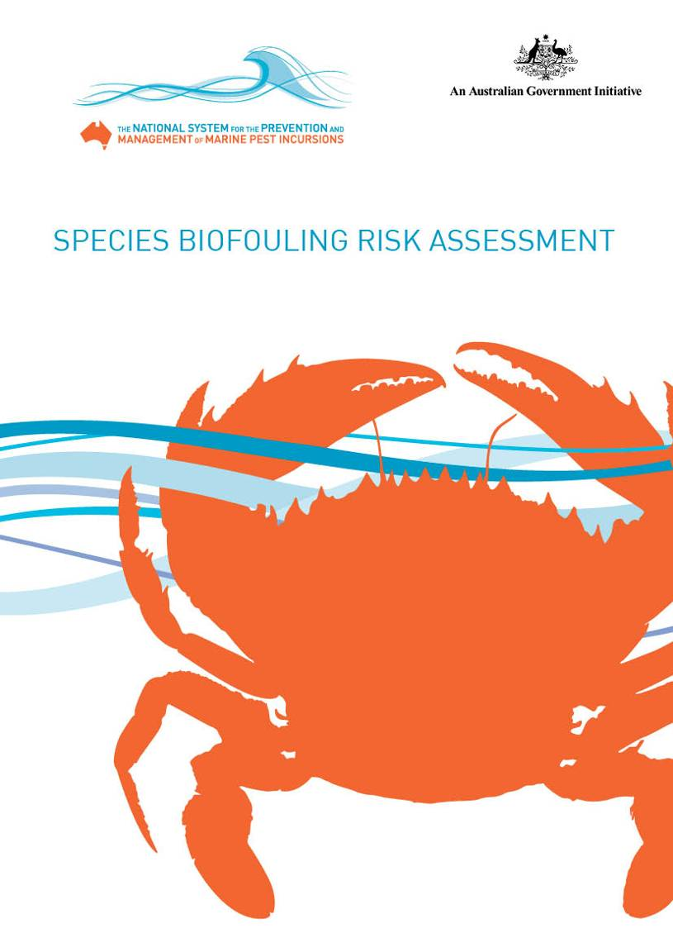

IMPORTANT
The Department of Agriculture, Fisheries and Forestry advises that the information contained in this report is based on scientific research and is intended to inform the development of public policy. Readers are advised and need to be aware that this information may be incomplete or unsuitable for use in any specific situation. Before taking any action or decision based on the information in this publication, readers should seek professional, scientific and technical advice.
To the extent permitted by law, the Australian Government and Department of Agriculture, Fisheries and Forestry (including its employees, consultants and advisers) disclaim all liability, including liability for negligence, for any direct or consequential loss, damage, death, injury, expense, liability or cost incurred or suffered by any person (including corporate entities or bodies politic) as a result of accessing, using or relying upon any of the information or data contained in this publication.
February 2011
ISBN: 978-1-921575-18-1 high res for print
978-1-921575-19-8 low res for web pdf
Copyright © Commonwealth of Australia 2009 (except where otherwise indicated)
This work is copyright. You may download, store in cache, display, print, reproduce, distribute or communicate these materials in an unaltered form only (retaining this notice) provided no monetary consideration is received in exchange and that the work is not dealt with in a manner that is misleading or deceptive. Apart from any use as permitted under the Copyright Act 1968, all other rights are reserved. Requests for further authorisation should be sent to: Commonwealth Copyright Administration, Attorney General’s Department, Robert Garran Offices, National Circuit, Barton ACT 2600 or posted at www.ag.gov.au/cca.

SPECIES BIOFOULING RISK ASSESSMENT

Commissioned by
The Department of Agriculture, Fisheries & Forestry (DAFF)

Prepared by
Chad Hewitt¹
Marnie Campbell¹
Ashley Coutts²
Alisha Dahlstrom¹
Derek Shields²
Joseph Valentine²

1 - National Centre for Marine Conservation and Resource Sustainability, University of Tasmania
2 - Aquenal Pty Ltd
CONTENTS

Summary 1
1.0 Introduction 3
1.1 Background 3
1.2 Assessment rationale 5
2.0 Methods and results 6
2.1 Identifying endpoints 7
2.2 Pest categorisation 8
2.2.1 Identifying hazards 8
2.2.2 Determining consequences 10
2.3 Determining likelihood 12
2.3.1 Inoculation 12
2.3.2 Establishment 30
2.3.3 Domestic spread 34
2.4 Calculating risk 42
2.4.1 Assessment and ranking of overall risk 43
2.5 Potential range of 56 pest species in Australia 48
3.0 Discussion and conclusions 50
Glossary 53
References 56
Appendices
Appendix A: Consequence matrices for the four core values. 66
Appendix B: Species likelihood, consequence and risk tables. 77
APPENDIX C: Vessel trading patterns from last port of call IUCN bioregions
to Australia between 2002 and 2007 over voyage duration
of 30 days to 365 days. 89
APPENDIX D: Graphs showing total and average residency periods of
vessels (by category) from 2002 to 2007 across IUCN bioregions
and Australian provinces (Lloyds MIU dataset). 95
APPENDIX E: Tables showing residency period (by category) across IUCN
bioregions and Australian provinces (Lloyds MIU dataset). 102
Appendix F: Datasheets for species ranked as moderate, high or extreme
risk species based on any voyage duration. 109
REFERENCES: APPENDIX F 167
LIST OF TABLES

Table 1: Results of global studies investigating the percentage of non-indigenous
marine species that can be associated with vessel biofouling. 4
Table 2: Core value subcategories for consideration in consequence matrices. 10
Table 3: Likelihood measures for marine biosecurity risk analysis. 12
Table 4: Matrix for ranking a species’ inoculation likelihood based on biofouling
association and transport pressure rank. 13
Table 5: Biofouling association rank with associated characteristics. 13
Table 6: Opportunity to infect settle weightings based on mean duration in port for all vessel
transits between 2002 and 2007. 19
Table 7: Summary of vessel arrivals between 2003 and 2007 classified by IUCN
bioregion of origin and vessel category. 29
Table 8: Percentage of species with transport pressure likelihood categories for
voyages of 30, 60, 90, 183 and 365 days. 30
Table 9: Trading relationships between and within the primary Australian provinces
based on percentage of international vessels entering Australia (first port)
and continuing to a second port. 38
Table 10: Risk calculation matrix. 42
Table 11: Species with risk rankings of moderate, high or extreme in at least one
core value and in at least one voyage duration. 44
Table 12: Minimum and maximum sea surface temperatures (SST) for each
Australian province derived from IMCRA bioregions. 50
LIST OF FIGURES

Figure 1: Conceptual model of the species invasion process and contributing factors. 6
Figure 2: The 18 IUCN bioregions. 8
Figure 3: Potential association for species to be transported by major vector categories
(average across the 18 IUCN bioregions). 9
Figure 4: Consequence information availability for species of concern across
environmental, economic, social/cultural and human health values. 11
Figure 5: Frequency of species of concern with consequence rankings in the
environmental, economic, social/cultural and human health values categories. 11
Figure 6: Likelihood ranks for biofouling association, transport pressure and inoculation. 16
Figure 7: Number of unique vessels (by vessel category) entering Australia between
2002 and 2007. 17
Figure 8: Major marine biogeographical provinces of Australia. 18
Figure 9: Cumulative and mean duration of vessels’ port stays in each of the 18 IUCN
bioregions from 2002 to 2007. 20
Figure 10: Number of IUCN bioregions transited by vessels on 30-day, 60-day, 90-day,
183-day and 365-day voyages. 21
Figure 11: Mean number of bioregions visited with increasing voyage duration. 21
Figure 12: Transport pressure and inoculation likelihoods for vessels that have been on
voyages of 30, 60, 90, 183 and 365 days prior to entering into Australia. 22
Figure 13: Number and percentage of vessels (all categories) that visited Australia from
2002 to 2007 which had traded with specific bioregions for 30, 60, 90, 183 or
365 days during that five-year period. 23
Figure 14: Mean number of recreational vessel visits per year to Australia and
apprehended IFFVs brought into Australian waters per year between
2002 and 2007. 24
Figure 15: Average number of recreational vessel arrivals into Australia for each month
between 2002 and 2007. 25
Figure 16: Reported speeds of vessels (by category) entering Australia between
2002 and 2007. 26
Figure 17: Vessels’ cumulative and mean duration in ports within the four Australian
provinces between 2002 and 2007. 28
Figure 18: Vessel arrivals from 2003 to 2007 categorised by trading region (based on
last port of call IUCN bioregion) and the province through which they entered
Australian waters. 31
Figure 19: Vessel arrivals to each Australian province between 2003 and 2007
categorised by vessel type and trading region (based on last port of call
IUCN bioregion). 32
Figure 20: Comparison of species’ physiological tolerances versus native province
sea surface temperature range; and comparison of sea surface temperature
for the eastern Pacific provinces. 33
Figure 21: Major currents and circulation patterns around Australia. 35
Figure 22: Duration of stay in second port of call by international vessels entering
Australia between 2002 and 2007. 36
Figure 23: Risk categorisation for environmental, economic, social/cultural and human
health values for voyage durations of 30, 60, 90, 183 and 365 days. 46
Figure 24: Comparison of species’ physiological temperature tolerances versus inferred
temperature tolerance; and sea surface temperature ranges for Australian
provinces. 49

SUMMARY

Summary
Marine biological invasions have increased throughout the world’s oceans to the extent that no region is considered ‘pristine’. At least 1781 species have been identified as introduced in marine or estuarine systems somewhere in the world. Many of these species have been introduced to several regions, inferring an ease of transport by human-mediated mechanisms. A substantial number of these species have either demonstrable or inferred impacts.
Marine species have been transported around the world in many ways, both intentionally and accidentally. Concern has typically focused on vessel traffic, specifically the transport of species in ballast water, which is used for trim and stability of commercial vessels. This led to the development of the International Maritime Organization’s International convention for the control and management of ship's ballast water and sediments that was adopted in 2004.
More recently, attention has shifted to species that attach to the external surfaces of vessels, including commercial, fishing, and non-trading vessels such as barges, dredges, tugs and recreational yachts. Such species are collectively known as biofouling.
Science-based risk assessment is a key element of Australia’s biosecurity system and underpins the nation’s biosecurity policies. However, there are currently no Australian regulatory measures for preventing the introduction of invasive marine species through biofouling.
The objective of this project was to conduct a risk assessment to identify and assess the biosecurity risk to Australia associated with the entry, establishment and spread of marine pest species as biofouling. This risk assessment is therefore intended to inform Australian Government policy development for continued management of marine pest risks as biofouling.
The risk assessment followed a five-step process:
- identifying endpoints
- identifying hazards
- determining consequences
- determining likelihood
- calculating risk.
Risk was evaluated across three identified endpoints: inoculation, establishment and spread. International voyages to Australia were assessed for the risk they pose in relation to inoculation and establishment. Likelihood of domestic spread was assessed through analysis of domestic movement of international shipping, other domestic vessel movements/traffic and through natural means.
Key hazards for Australia were deemed to be those species with a recognised invasion history, but not currently known to be present in Australian waters. More than 1781 species that have been identified as being introduced to some region of the world were evaluated for their association with biofouling and transport pressure. Species association with biofouling was assessed on the basis of life history characteristics. Transport pressure was calculated as a function of the intersection between a species’ global distribution and the opportunities for transport calculated as a combination of the number of vessels arriving in Australia from regions where a species is present.
The consequence (or impact) was assessed for each species on four core values of environment, economic, social/cultural and human health, based on information derived from the literature. The vast majority of species had neither demonstrable nor inferred impacts stated in the published literature, significantly decreasing the ability to assess risk. For those species with available information about their consequence, risk was calculated as the product of likelihood and consequence. The result of this analysis was a restricted suite of 56 species that have a high probability of arrival into Australian waters and the potential to cause moderate to extreme impacts across one or more of the four core values if successfully introduced.

INTRODUCTION

1.0 Introduction

1.1 Background
The expansion of species ranges in geological and ecological time is a result of both natural and human-mediated processes, collectively referred to as biological invasions (Carlton 2001). Natural processes, typically referred to as range expansions, occur over long timeframes and generally result from the breakdown of biogeographic barriers between adjoining biogeographic provinces. In contrast, human-mediated movements of species, known specifically as biological introductions, occur in ecological timeframes of weeks to years and transcend the geographies of natural species’ range expansions. The human-mediated movements of non-indigenous marine species have occurred intentionally and accidentally for thousands of years (diCastri 1989). Intentional movements of species have occurred for both agricultural and cultural reasons (Elton 1958; Crosby 1986; Diamond 1998). Intentional and accidental movements have increased through time, largely tracking European expansion (Crosby 1986; diCastri 1989) and resulting in significant alterations to modern ecosystems (e.g. Vitousek et al. 1996).
The early recognition of human-mediated transport by Ostenfeld (1908) and Elton (1958), allowed for development of an understanding of patterns and process in recent decades (e.g. Carlton 1985, 1996, 2001; Williams et al. 1988; Ruiz et al. 2000; Hewitt 2002; Castilla et al. 2005; Minchin 2006).
Marine species can be transported via a variety of mechanisms including:
- boring into wooden-hulled vessels (e.g. Turner 1966; Carlton & Hodder 1995)
- biofouling of organisms on vessel hulls and in niche areas including sea-chests and internal pipe work (e.g. Ribera & Boudouresque 1995; James & Hayden 2000; Gollasch 2002; Coutts et al. 2003; Fofonoff et al. 2003; Coutts & Taylor 2004; Coutts & Dodgshun 2007; Davidson et al. 2009)
- the historic use of dry and semi-dry ballast (e.g. Ruiz et al. 2000; Carlton 2001)
- ballast water transport of planktonic and pelagic organisms, including species fragments (e.g. Ostenfeld 1908; Carlton 1985; Carlton & Geller 1993; Fofonoff et al. 2003)
- intentional transfers of aquaculture organisms, specifically oysters (e.g. Elton 1958; Carlton 1989; Cook et al. 2008)
- unintentional movement of associated organisms including pathogens, parasites, epifaunal and infaunal organisms (e.g. Elton 1958; Carlton 1989, 1996; Hewitt et al. 2006, 2007, 2009c; Cook et al. 2008)
- deliberate transfers of aquaculture food products such as live, fresh or frozen materials (e.g. Hewitt et al. 2006; Cook et al. 2008)
- biofouling of aquaculture gear (e.g. Hewitt et al. 2006; Cook et al. 2008)
- transfer of live, fresh, frozen and dried food products and live aquarium products (e.g. Weigle et al. 2005)
- use of biological material for packing (e.g. Ribera Siguan 2002, 2003; Miller et al. 2004)
- transport of species for scientific research (e.g. Carlton 2001).
In many cases, these transport mechanisms, often referred to as vectors in marine biosecurity, have facilitated the translocation of multiple species and often entire assemblages of tens to hundreds of species between disparate bioregions. They frequently continued over long periods, inoculating receiving environments with propagules or new individuals over multiple generations (e.g. Carlton & Geller 1993; Ruiz et al. 2000; Hewitt et al. 2004).
While it is difficult to establish a firm link between an already established non-indigenous marine species and the vector by which it arrived in the new location, attempts have been made to do so. Inferences, based on reasoned argument, have largely been based on life history modes, timing of invasions, and association between location of incursion and vectors. Table 1 presents results of several studies from around the globe that have estimated the proportion of non-indigenous marine species that may have been translocated as biofouling.
INTRODUCTION

Hewitt et al. (1999, 2004) conducted an evaluation of introduced species to Port Phillip Bay in Victoria (Australia) and identified the most probable vector(s) of transport for individual species based on the biology of each species' life history phase (e.g. planktonic larvae for ballast water, attached benthic phase for vessel biofouling) and the timing of invasions (e.g. before or after the advent of ballast water use). In that study, the assignment of species to vectors was not exclusive and where life history or evidence indicated, species were assigned to multiple vectors. Any vector by which a life history phase could be transported (see expert chapters in Hewitt et al. 1999) and was operating at the time of first collection, was given equal weighting. The generated summary was based on a percentage of all species components contributing to each vector.
Hewitt and Campbell (2010) provided an assessment of the current state of knowledge of marine and estuarine invasions on a global scale, using techniques similar to the evaluation of Port Phillip Bay described above. The 2008 study of available literature found 1781 species worldwide had been introduced into bioregions outside their native range. Species associated with biofouling of commercial merchant and fishing vessels, and aquaculture biofouling represented 55.5% (±9.4% SD) of the total species. It is these 1781 species that form the basis of this risk assessment.

Table 1: Results of global studies investigating the percentage of
non-indigenous marine species that can be associated with vessel biofouling.

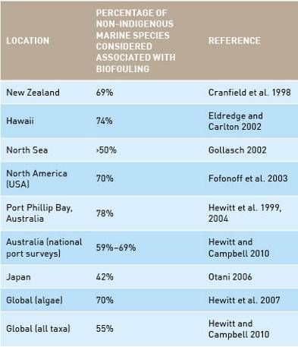

INTRODUCTION

1.2 Assessment rationale
Recent agreement on international and national management approaches to issues associated with ballast water vectors, and increased concern over biofouling species, has led to development of this project to assess marine pest biofouling risks into Australian waters.
Global marine biosecurity efforts for the past several decades have focused on ballast water- (and sediment) mediated species transfers, with several nations developing independent management arrangements. Meanwhile, the international community has moved towards a binding agreement (e.g. Gollasch et al. 2007; Hewitt et al. 2009b).
Ballast water has been implicated as the vector most likely to be responsible for several high profile marine species invasions (e.g. Carlton 1985, 2001; Carlton & Geller 1993). Examples include:
- global increase in toxic dinoflagellate blooms (Hallegraeff 1993)
- introduction of the comb-jelly, Mnemiopsis leidyi into the Black, Azov and Caspian Seas, contributing to the collapse of the regions’ anchovy fishery (e.g. Kideys 2002)
- dominance of the Asian clam, Corbula (Potamocorbula) amurensis in San Francisco Bay, California (Nichols et al. 1990)
- invasion of the northern Pacific seastar, Asterias amurensis into Hobart, Tasmania and Port Phillip Bay, Victoria (Ross et al. 2003).
The finalisation of a ballast water convention (BWM 2004) through the United Nation’s International Maritime Organization, which followed more than 14 years of negotiations (Gollasch et al. 2007; Hewitt et al. 2009a, b), has resulted in a refocus on the potential for biofouling to transport species (e.g. Hewitt et al. 2009b, c).
Biofouling has long been recognised as an introduction mechanism for marine and estuarine organisms (e.g. Carlton 1979; Carlton & Hodder 1995) and is increasingly being identified as an equal, if not greater, risk than ballast water during the past decade (e.g. Hewitt et al. 1999, 2004; Thresher 2000; Gollasch 2002; Hewitt 2002, 2003; Lewis et al. 2003, 2004; Minchin 2006, 2007; Schaffelke et al. 2006; Schaffelke & Hewitt 2007; Hewitt & Campbell 2010).
The introduction of Mytilopsis sallei into Darwin Harbour in 1999, followed by Perna viridis and Hydroides sanctaecrucis in Cairns (Trinity Inlet), drew attention to the fact that Australia was exposed to marine pests through biofouling. This was despite the fact that five years earlier Clapin and Evans (1995) had clearly identified that Sabella spallanzanii’s entry into Australia was linked to biofouling. Furthermore, the evaluation of Port Phillip Bay (Hewitt et al. 1999, 2004) had determined that more than 78% of species were likely to have been introduced with biofouling.
Despite increasing awareness of these transport mechanisms, our knowledge base is limited, resulting in the need for decision support tools that provide consistency and transparency during decision-making.
Risk-based decision frameworks for the management of ballast water-mediated introductions have been under development since the mid-1990s. The implementation of these Decision Support Systems (DSS) has demonstrated the utility of risk analysis in the field of marine biosecurity. Application to biofouling, however, has been slow.
Risk analysis is commonly used for management of such issues because pragmatic decisions can be made that provide a balance between competing environmental and socio-economic interests, despite limited availability of information (e.g. Hayes & Hewitt 1998; Campbell 2005, 2007, 2008, 2009; Hayes et al. 2005; Hewitt et al. 2006; Barry et al. 2008; Campbell & Hewitt 2008a).
In a marine biosecurity context, conventional risk assessment methodology consists of five steps: identifying endpoints, identifying hazards, determining likelihood, determining consequences and calculating risk. This process is similar (following the five-step process) to the official risk management standard (AS/NZ4360:2004) used in Australia and New Zealand (Standards Australia 2000, 2004). Here we present an evaluation of the species-level risks associated with biofouling on vessels entering Australian waters, with a view to determining risk of entry, establishment and subsequent domestic spread.

METHODS AND RESULTS

2.0 Methods and results
This risk assessment followed a five-step process: identify endpoints, identify hazards, determine consequences, determine likelihood and calculate risk (sensu Standards Australia 2000, 2004). It evaluated risk across three identified endpoints: inoculation, establishment and spread (see Figure 1).
This risk assessment focused on international vessels entering Australia, examining their international voyages prior to entry into Australia between 2002 and 2007 to determine the species likely to be transported. This data range was the most recently available when the analysis was undertaken and the period for which information on the majority of vessel types was available. Earlier records were unable to be used due to inconsistencies and cost constraints. In addition, the continuing domestic movements were assessed to determine the potential for further spread within Australia (see Section 2.3.3). Data about non-indigenous marine and estuarine species world-wide from the Hewitt & Campbell (2010) report was used as a starting point to identify hazards (i.e. species associated with biofouling). Other vectors, such as ballast water, aquaculture and aquarium trade, exist, which can facilitate transport of non-native species. Such vectors have been examined elsewhere (e.g. Hayes et al. 2005); this report specifically focuses on those hazards likely to be associated with biofouling.
Global non-indigenous marine and estuarine species were categorised as hazards based on their: association with biofouling, potential to arrive and establish in Australia and potential to cause impact.

Figure 1: Conceptual model of the species invasion process and contributing factors
(adapted from Lewis & Coutts 2010).
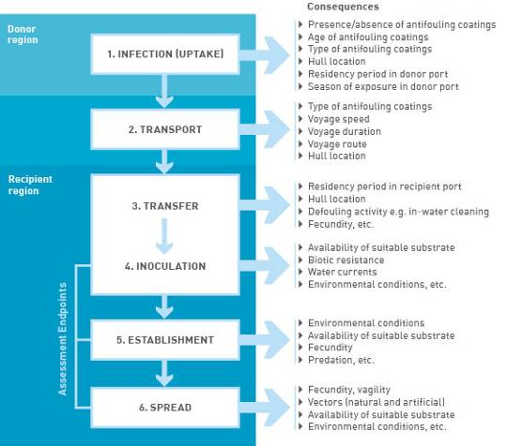
METHODS AND RESULTS
Consequences (impacts) were assessed against the following four core values (modified from Campbell 2008) and a number of subcategories.
- Environmental–biological and physical characteristics of an ecosystem being assessed, excluding extractive use and aesthetic value. In this report, we have assessed consequences against impacts on habitat, biodiversity, trophic interactions, nationally important and ecologically valuable species, and assets of environmental significance.
- Economic–components within an ecosystem that provide a current or potential economic gain or loss.
- Social and cultural–values placed on a location in relation to human use for pleasure, aesthetic and generational values. This value category also takes into account iconic or spiritual value, including locations that create a sense of local, regional or national identity. In this report, we have assessed consequences against impacts to social, cultural, aesthetic and national image.
- Human health–value of a safe and healthy society shared equally across generations and socio-economic groups.
To ensure a consistent approach, consequences were assessed using a number of different consequence matrices (see Appendix A) that gauge impact against: duration of impact (days/months/years); resilience (ability to recover); and scale/extent of impact (local, national and/or international). Threshold values within each consequence matrix were established via a number of expert workshops held in New Zealand, Australia and South America during previous research (e.g. Campbell 2005, 2008; Campbell & Gallagher 2007). The basis for the threshold values was derived from legislative and policy obligations in the first instance and subsequently adjusted through expert consultation (see Campbell 2005, 2007, 2008). Threshold values are based on consensus and represent a perceived value rather than a fixed value.
The likelihood (probability) of inoculation, establishment and spread of non-indigenous marine species was assessed using a likelihood matrix (see Table 3). Further descriptions of these stages are illustrated with examples within Section 2.3 of this document. A species risk can be derived once hazards are identified, and consequence and likelihood determined. A risk matrix (see Table 9) is used for this calculation. For example, a species that has a very low consequence ranking and a moderate likelihood of occurrence will result in a moderate risk ranking.

2.1 Identifying endpoints
The endpoint of the risk analysis is a critical stage in scoping the context of the assessment and determines the detail of consequence analysis to be applied (e.g. Campbell et al. 2007; Campbell 2008). For example, unintentional introductions of non-indigenous marine species associated with the movements of species, feed stocks and equipment would typically consider quarantine endpoints–that is, any unpermitted breach of the border (e.g. Hewitt & Hayes 2001, 2002; Hayes 2002; Campbell et al. 2007; Campbell 2009). Marine biosecurity risk can be evaluated across three endpoints:
- inoculation (or entry)
- establishment
- spread.
This risk assessment focuses primarily on the international entry of vessels (inoculation endpoint) with less extensive evaluations of establishment and spread.
METHODS AND RESULTS

2.2 Pest categorisation

2.2.1 Identifying hazards
Hazards have been defined in this context as non-indigenous marine species that:
- are associated with biofouling
- have potential to transcend the Australian quarantine border
- have demonstrated or inferred potential to cause a negative impact.
The identification of species-level hazards is based on the comprehensive assessment of recognised world-wide marine and estuarine invasions undertaken by Hewitt & Campbell (2010), which built on previous work by Hayes et al. (2004a).
Hewitt & Campbell (2010) compiled information from over 700 data sources, including:
- primary literature (i.e. peer-reviewed journals and books)
- secondary literature (i.e. ‘grey’ literature such as websites, policy documents, online databases and reports)
- information derived from a number of researchers.
The global species distribution data was recorded using the 18 large-scale World Conservation Union (IUCN) marine bioregions (Kelleher et al. [1995] identified in Hewitt & Campbell [2010]). These are considered closer representatives of widely accepted biological provinces and offer a more conservative approach to estimating distributions than the finer scale ecoregions of Spalding et al. (2007), which do not represent provincial boundaries.
The designation and use of biogeographic boundaries has engendered significant debate in the literature, however, the use of provinces with recognition of overlapping boundaries provides the basis for the

Figure 2: The 18 IUCN bioregions (as defined by Kelleher et al. [1995] and modified following Hewitt et al. [2002]).
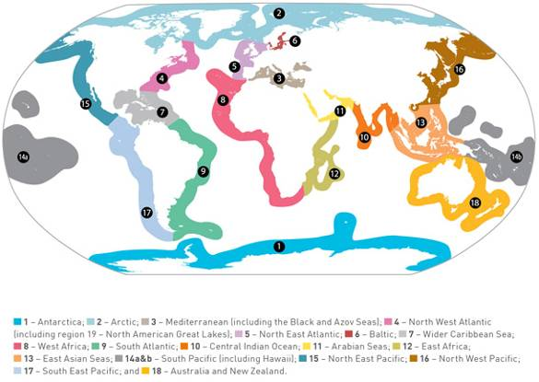
METHODS AND RESULTS
Kelleher et al. (1995) designation (Figure 2). This system creates a sequence of ‘core’ and ‘transitional’ areas, which are roughly equivalent to the Spalding et al. (2007) ‘ecoregions’ used by Molnar et al. (2008). Hayes et al. (2004a) used these ‘core’ and ‘transitional’ areas described by Kelleher et al. (1995) in their identification of ‘next pests’.
By recording species at the bioregion level, it is assumed that the species is present in all ports in the bioregion. Due to limitations of the data available from many parts of the world, and the rapidity with which species can be transported within a region, this assumption avoids an overly restrictive data collection exercise.
The database of global marine and estuarine introductions developed in Hewitt & Campbell (2010) includes 1781 species–43 of which are restricted to lower salinities (<5 ppt). More than 98% of the 1781 species were allocated to possible transport vectors. This followed the criteria and methods proposed by Hewitt & Campbell (2010) which was similar to the evaluation of Port Phillip Bay in Hewitt et al. (1999, 2004) and was based on:
- examination of life history characteristics (at the species-level where available)
- morphological characteristics
- habitat associations.
Where species-level information was not readily available, genus-level characteristics were used to classify morphological characteristics and habitat associations.
The global dataset indicates that more species have life history characteristics associated with vessel biofouling than any other vector (Figure 3), with vessel biofouling representing 42.6% (±2.2% SD) and total biofouling (vessel, aquaculture and fisheries) 55.5% (±9.4% SD). This represents a total of 793 species that have:
- a demonstrable invasion history at some location
- life history characteristics that infer an association with biofouling.
This species dataset was restricted further on the basis of records of species in Australia, resulting in a reduction to 657 species that:
- have an invasive history
- have an association with biofouling based on life history characteristics or statements in the literature
- are not currently known to be present in Australia.

Figure 3: Potential association for
species to be transported by major

vector categories (average across
the 18 IUCN bioregions).

METHODS AND RESULTS

2.2.2 Determining consequences
Consequence rankings reflect the likely severity of impacts a hazardous event can create. In this context, it reflects the impact that a non-indigenous marine species can potentially have on the wide range of values the biosecurity system is attempting to protect. This section of the report evaluates consequences for four core values:
- environmental • social and cultural
- economic • human health.
In marine biosecurity, a semi-quantitative approach is typically used to capture stakeholder and expert perceptions, which are combined with available quantitative data. Quantitative (numerical) risk assessments are not common in a management context (although see Hayes & Hewitt 1998, 2000; Hewitt & Hayes 2001, 2002; Barry et al. 2008) because the data requirements are onerous, especially considering that little information is available about the impacts of many introduced marine species. Also, numerical risk produces numbers that are often treated as absolute judgements, which may lead to socio-political alterations in risk perception (Byrd & Cothern 2005).
Hayes et al. (2004a) states that there is currently no universally accepted way to measure the potential impact of non-native species. A variety of methods have been employed to develop more objective means of determining potential impact, including the heuristic assessment of expert opinions (Hayes & Sliwa 2003; Hayes et al. 2004a; Campbell 2008), stakeholder perceptions (Campbell 2008, 2009), and assessment of direct empirical evaluations from other regions (International Council for the Exploration of the Seas [ICES] 1984, 1988, 2005; Hayes & Hewitt 1998, 2000; Campbell 2008).
In order to improve consistency and aid stakeholder and expert discussion, consequence matrices have been developed across core values (i.e. environmental, economic, social/cultural, and human health) that explicitly delineate rankings of impact (consequence) from negligible to extreme (Campbell et al. 2007; Campbell 2008; Hewitt et al. 2006; Campbell & Hewitt 2008a; see Appendix A). These matrices provide exemplars of impact at the various ranks to provide guidance in predicting level of impact. Each primary category (environmental, economic, social/cultural, and human health) is divided into subcategories for more detailed consideration (see Table 2).
The readily accessible primary and secondary literature was evaluated for the 657 species. Using the consequence exemplars in the matrices (see Appendix A) the literature was assessed for records to identify demonstrable or inferred impacts across the four core values.
A total of 162 species (see Appendix B) had either inferred or demonstrated impacts, with environmental impacts the most frequently cited, followed by economic consequences. A large proportion of species with identified environmental impacts also had economic, social/cultural or human health effects (see Figure 4).
Table 2: Core value sub-categories for consideration in consequence matrices.
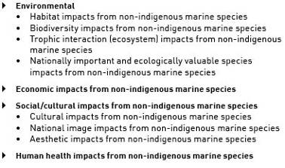

For the remaining 495 species, there was no information available about their impacts–these are not assessed further in this report as explained below.
Based on the outcome of the literature evaluation, 162 species were deemed to be species of concern requiring a more thorough evaluation to categorise consequence using the agreed consequence matrices. The categorisation of consequence for the 162 species relied on the information from the literature, however, an indication of the severity of impact was often lacking. This resulted in use of the consequence matrices (see Appendix A) as guides to assign consequence ranks based on the severity of impact described in the literature, coupled with information about the spatial and temporal scale of impact.

METHODS AND RESULTS

Within the literature, impacts were either demonstrated, inferred, or ‘missing’. Species for which no information relating to their impact could be found, were unable to be assessed further and were assigned a rank of ‘negligible’. Demonstrated impacts ranged from negligible to extreme, whereas inferred impacts were generally restricted to ranks up to moderate to reflect the uncertainty involved. Exceptions included inferred impacts that have significant national and international implications. Such inferred impacts were categorised as high and this was relevant for impacts on:
- international and national obligations, including protected, threatened or endangered species or habitats (e.g. designated wetlands, habitat-forming species, cetaceans, mangroves, seagrasses, corals, sea fans)
- economic interests of national concern (e.g. high profile or migratory fisheries stocks, aquaculture stocks, tourism-related species)
- human mortality or morbidity.
Figure 5 illustrates the distribution of species’ consequence rankings across environmental, economic, social/cultural and human health values. For the 495 species where no information on impact was found, an assignation of negligible was made. As a consequence, the lack of information for these 495 species resulted in these species not being considered further in this report. Regardless, a watching brief should be kept on these species in case significant impacts of species are documented.
Figure 4: Consequence information availability for species of concern across environmental, economic, social/cultural and human health values.

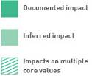

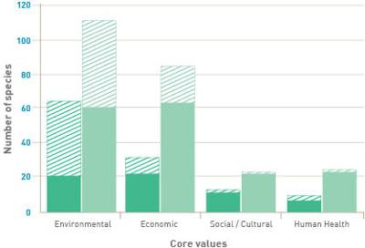

Figure 5: Frequency of species of concern with consequence rankings in the environmental (A), economic (B), social/cultural (C) and human health (D) values categories.
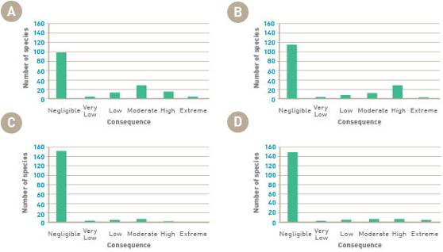
METHODS AND RESULTS

2.3 Determining likelihood
The likelihood (or probability) of an event occurring was determined using a likelihood matrix developed a priori (Table 3). This is an expansion (to include probabilities) on the standard likelihood matrix that has been used in marine biosecurity assessments in New Zealand (Campbell 2005, 2008, Campbell et al. accepted), Australia (Campbell & Hewitt 2008b) and the Mediterranean (Campbell et al. 2007). Three significant likelihood endpoints have been identified for evaluation of international biofouling species:
- inoculation
- establishment
- spread.
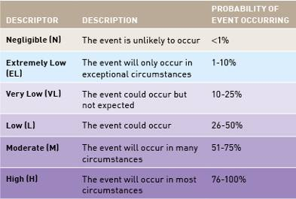
Table 3: Likelihood measures for marine biosecurity risk analysis (modified from Campbell & Gallagher 2007).

2.3.1 Inoculation
The likelihood of inoculation was evaluated using a matrix of likelihood rankings (see Table 4) that combines:
- association with biofouling (ranked negligible to high)
- transport pressure for each species (also ranked negligible to high) derived from:
- settlement opportunity to colonise the vessel based on duration in overseas ports
- the number of vessels arriving from regions where the species is present based on extended voyage characteristics
- transport survival based on physical and physiological stress during the voyage
- inoculation opportunity based on duration in an Australian port.
Table 4 provides a mechanism to combine the two elements of inoculation likelihood in a consistent and transparent fashion.
Several assumptions were made in this analysis, including:
- species were assumed to be able to attach or ‘recruit’ to a vessel at any time of year (equivalent to assuming reproductive activity throughout the year)
- species detected in a bioregion and reported in the literature were assumed to have established there (Note that data collection for species distributions ceased in May 2009)
- species detected in one location within a bioregion were assumed to be present in all areas (ports) of a bioregion
- vessels were assumed to have some areas without fully active antifouling coatings
- vessels were assumed to have some areas protected from the hydrodynamic forces created by vessel speed
- inoculum pressure was calculated for all of Australia, or for a particular province of Australia, rather than for a specific port
- all vessel categories were assumed to be equally able to transport all species
- all pathways from various bioregions to Australia were assumed equally ‘stressful’ (e.g. no influence of trans-equatorial transit).
METHODS AND RESULTS

Table 4: Matrix for ranking a species’ inoculation likelihood based on biofouling association and transport pressure rank.
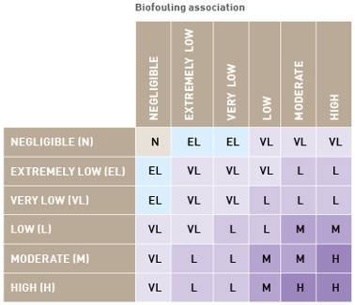

2.3.1.1 Association with biofouling
The metrics used for ranking species’ association with biofouling were based on life history characteristics and a literature review based on demonstration of association (see Table 5). Ranks were assigned to individual species by two of the authors (Coutts & Hewitt) and differences were reconciled by mutual agreement.
Of the 657 species considered, information about impact was available for only 162 species. Of the 162 species with available impact information:
- 10 species were identified as having a negligible biofouling association based on life histories
- 11 species were rated as having an extremely low biofouling association due to being planktonic but with benthic resting stages
- 18 were identified as having a very low biofouling association
- 123 were ranked as having a biofouling association ranking equal to or greater than low, i.e. low, moderate or high (see Figure 6a)

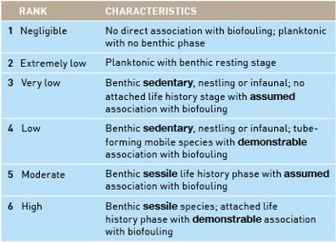
Table 5: Biofouling association rank with associated characteristics.
METHODS AND RESULTS

2.3.1.2 Transport pressure
Transport pressure was assessed on the following factors:
- opportunity for biofouling-associated species to settle on the vessel in the donor port
- transport frequency (number of opportunities for transport)
- a species’ ability to survive the transport process
- inoculation opportunity for a species to depart the vessel and settle in the receiving port.
Similar to the analysis by Hayes et al. (2004a), this assessment assumes that the opportunity for biofouling organisms to be transported is directly correlated with the number of vessel visits from a region. In keeping with previous assessments (Hayes & Hewitt 1998, 2000; Hayes & Sliwa 2003; Hayes et al. 2004a; Barry et al. 2008) it also assumes that a species record in a bioregion is considered a demonstration of establishment throughout the bioregion, and that all ports in that bioregion are infected.
For the purposes of transport pressure the element of assessment is the vessel. Therefore, the demonstration of a species’ likely presence on a vessel is the focus, rather than the abundance of a species on any individual vessel.
Analysis of vessel activity was initially based on the Australian Quarantine and Inspection Service (AQIS) pratique dataset for vessel arrivals from 2003 to 2007. This information provided patterns for last port of call for vessels travelling to Australian ports, however, it did not differentiate petroleum vessels within the commercial vessel category and nor did it include illegal foreign fishing vessels (IFFVs). Subsequently, these patterns were investigated in greater detail using additional datasets to cover all vessel categories: the Australian Fisheries Management Authority (AFMA) dataset for IFFV apprehensions during the period of 2002 to 2007; and the Lloyds Maritime Intelligence Unit dataset (hereafter Lloyds MIU dataset) representing commercial vessels, petroleum vessels, non-trading vessels, naval vessels, commercial fishing vessels and recreational vessels (>25 m) entering Australia from 2002 to 2007 and including the previous 10 ports of call and next 10 ports of call. This practically means that for some vessels, voyage histories could extend earlier than 1999 (e.g. for vessels entering Australia in January 2002) or into 2008 (when the Lloyds MIU reported data to the authors). The Lloyds MIU dataset allowed a further differentiation of vessel categories, including separating petroleum vessels from commercial (merchant) vessels, and identifying subcategories of non-trading vessels.
The Lloyds MIU dataset represents an accumulation of Port State reports and consequently required significant error-checking for overlapping voyage statistics. To reduce the overlapping voyage statistics in which individual vessels were represented in multiple records (i.e. locations) at the same time, records from earlier than 1999 were removed because consistency of reporting could not be verified. Negative values for transit duration between ports were also removed. In addition, poor spatial resolution such as designation of ports as ‘Pacific Ocean’, ‘Australasia’, and ‘Southeast Asia’ were assigned to IUCN bioregions where unequivocal, or removed from the dataset. These changes resulted in <5% removal rate for the entire dataset.
Vessels are not of a consistent size, nor do they ‘behave’ in an identical fashion (e.g. Carlton 1985, 1996, 2001; Hewitt et al. 1999, 2004; Ruiz et al. 2000; Gollasch 2002; Fofonoff et al. 2003; Minchin 2006). As a consequence, vessels were divided into a number of categories (and further subcategories where appropriate) to reflect the various management regimes and previously recognised differences in vessel activity (e.g. Ribera & Bouderesque 1995; Ruiz et al. 2000; Carlton 2001; Lewis et al. 2004; Floerl & Inglis 2005; Floerl et al. 2005; Minchin 2006; Hulme 2009). These classifications are assumed to approximately correspond to vessel behaviours (e.g. maintenance history, voyage characteristics, speed [see Figure 16]), however, it has been assumed here that no particular vessel characteristic is more or less likely to transport a species.
METHODS AND RESULTS
Vessel categories used in this report include (also see glossary):
- commercial vessels, including merchant vessels and cruise ships
- petroleum production and exploratory industry vessels, including offshore anchor handling/support/supply; pipe laying vessels; drilling platforms/ships and floating production; storage and offloading (FPSO), given they are solely employed within the sector
- naval vessels (both foreign and domestic), including naval auxiliary tankers
- non-trading vessels which encompass a wide variety of vessel types, including the subcategories of tugs, research vessels, dredges, barges and yachts >25 m or superyachts (differentiated based on differing behaviours including speed, duration in port, and voyage characteristics)
- fishing vessels, including commercial vessels engaged in capturing wild stocks of living marine resources, such as fishing (general), trawler (all types), whaler, fish carrier and fish factory vessels
- illegal foreign fishing vessels (IFFVs) which are differentiated from commercial fishing vessels due to behaviours and different regulatory controls
- recreational vessels which incorporate yachts <25 m length due to regulatory controls in Australia.
As stated above, petroleum industry vessels represent a significant class of commercial (merchant) vessel with widely varying characteristics, including long residence times and slow speeds for some vessel types. Original analysis of the AQIS pratique dataset found that it provided insufficient information to differentiate petroleum vessels from other vessels within the commercial vessel category. Subsequently, obtaining the Lloyds MIU dataset allowed further differentiation of vessel categories, including separating petroleum vessels from commercial (merchant) vessels, and identifying subcategories of non-trading vessels.
The three datasets (Lloyds MIU; AQIS pratique; AFMA) were interrogated to identify the number of unique vessel entries into Australia based on the vessel categories (see Figure 7). The Lloyds MIU dataset was interrogated to determine the relative contribution across vessel categories for all of Australia and for each of the four primary Australian provinces (see Figure 8).
Elements of transport pressure are further analysed below.
Opportunity to infect the vessel in the donor port
The opportunity for a species to infect (i.e. settle on or recruit to) a vessel depends on a combination of factors, including: the stage of biofouling currently present; maintenance history (including antifouling paint condition); whether the timing of the opportunity coincides with an active reproduction period for sessile and sedentary species; and the amount of time available for a species to settle or colonise.
Biofouling community development begins as soon as materials are placed in the water (e.g. Sutherland & Karlson 1977; Floerl 2002). As a consequence, shortly after vessels are cleaned–in dry-dock or in the water–the settlement of marine organisms and development of a biofouling community begins (see Hayes et al. 2004b; Lewis et al. 2004). The rate of this development can be reset or delayed through various means, including in-water cleaning and appropriate application of antifouling paints. However, when the vessel is considered as a whole, the ‘niche’ biofouling areas including sea-chests, bow and stern thrusters, propellers, propeller shafts and rudder areas are likely to have secondary or tertiary levels of biofouling shortly after (three to six months) cleaning or antifouling paint application (e.g. James & Hayden 2000; Floerl 2002; Hayes 2002; Coutts et al. 2003; Coutts & Taylor 2004; Hayes et al. 2004b; Lewis et al. 2004; Piola et al. 2009). Therefore, few limitations to settlement exist for any individual species when considering the vessel as a whole, hence all vessels can be colonised.
Settlement opportunities for some species also involve an element of timing. Mobile species associated with biofouling have the ability to swim to the vessel hull or into niche areas; therefore, no restriction on the timing of settlement occurs. For species that are sessile or sedentary, typical means of establishing in a new location are either by accidentally getting ‘swept’ to another location by hydrodynamic forces (e.g. waves, propeller wash, currents), or by reproduction. Many sessile or sedentary marine species spawn gametes (reproductive elements) into the water column where fertilisation and development occurs, or hatch larvae directly into the water column–these species are known as meroplankton since they spend a portion of their life cycle in the water column. Once development has progressed sufficiently–ranging from minutes to months for different species–the larval form is able to settle onto hard substrate by metamorphosing into an adult.
METHODS AND RESULTS

Figure 6: Likelihood ranks for (A) biofouling association, (B) transport pressure and (C) inoculation likelihood using the matrix in Table 4. Transport pressure here, is based on last port of call only. Data from Lloyds MIU dataset.

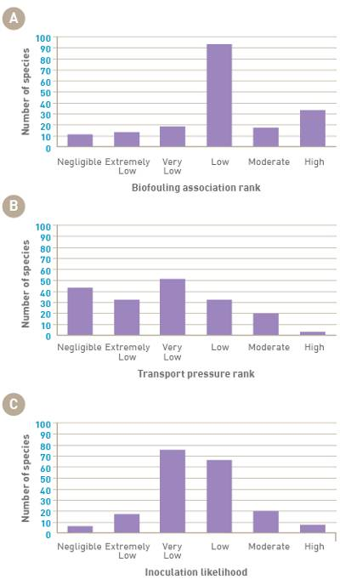

In order for a meroplanktonic species to settle on a vessel, it is necessary that the species’ timing of reproduction (reproductive phenology) and settling periods for planktonic phases to coincide with the duration in port. Assessing settlement opportunity would require a significant increase in our current state of knowledge–there is limited data on the timing or triggers (cues) of reproduction for many non-indigenous marine species, particularly in introduced regions. This is particularly important as non-indigenous marine species expand on their realised niche to utilise their fundamental niche and hence they often behave in ways that are not recorded within the literature. For example, Mytilopsis sallei in Darwin Harbour produced two, potentially three, cohorts in a seven-month period (Campbell & Hewitt, unpubl. manuscript). In Hong Kong Harbour, where M. sallei is also introduced, it produces two cohorts per 12 months (Morton 1989); however, in its native environment M. sallei reproduces once every 12 to 18 months (Kalyanasundaram 1975). Similarly, the larval durations and metamorphosis requirements have yet to be determined for many introduced species.
METHODS AND RESULTS

Given that settlement opportunity acts to reduce risk, it is more conservative to assume that all species reproduce year-round and therefore, have the ability to inoculate any vessel that comes to port. As more information emerges, or when the focus is reduced to a smaller subset of species, better life history information can be obtained and applied in a management context.
In order to estimate the amount of time a species has to settle on an individual vessel, the mean (± SD) and cumulative duration in port were calculated for each IUCN bioregion based on vessel port visits between 2002 and 2007 (Lloyds MIU dataset), noting that this captures neither recreational vessels <25 m nor IFFVs.
As stated above, most vessels will already have secondary or tertiary levels of biofouling in some area, therefore port duration will represent an increased opportunity of settlement. In order to account for greater likelihood of species settling on the hull of vessels with longer duration in ports, a weighting function (‘opportunity to infect’) was developed and applied to the number of vessel visits for each vessel category within a bioregion (see Table 6).

Figure 7: Number of unique vessels (by vessel category) entering Australia between 2002 and 2007. (Lloyds MIU dataset, AQIS pratique dataset and Australian Fisheries Management Authority [AFMA] IFFV dataset).

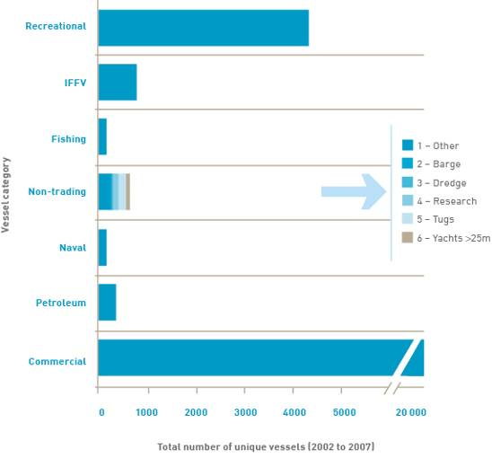
METHODS AND RESULTS

Figure 8: Major marine bioregeographical provinces of Australia.
Solanderian – tropical
Peronian (includes Lord Howe and Norfolk Islands)- warm temperate
Flindersian – cold temperate
Dampierian (includes Cocos, Keeling and Thursday Islands and Ashmore Reff)- tropical. Provinces adjusted from Bennet and Pope (Knox 1963; Poore 1995).

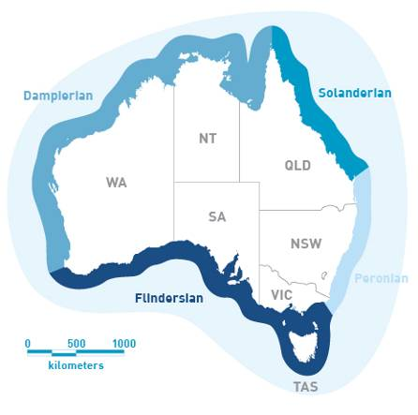
‘Opportunity to infect’ weightings were based on literature evaluations of biofouling accumulation (e.g. Sutherland & Karlson 1977; Carlton & Hodder 1995; Lewis 2002). Port stays greater than 20 days are likely to develop primary levels of biofouling and create enhanced opportunities for settlement and growth of individual secondary biofouling organisms. Port stays of greater duration (~30 days) increase the settlement and growth of secondary biofoulers; and port stays of >60 days increase the opportunities for tertiary biofouling (Carlton & Hodder 1995; Floerl 2002; Lewis et al. 2004; Floerl & Inglis 2005). Growth rates are contingent on ambient temperature and other factors (e.g. Sutherland & Karlson 1977). The weighting was calculated from the mean vessel duration in port, based on an assumption that greater numbers of days represent increased opportunity for species to infect. The weighting was arbitrarily constrained between one and two. However, this could readily be adjusted to increase the influence of port duration in the assessment.
Bioregions with greatest number of vessels clearly exhibit a greater accumulated time in port (see Figure 9a; see also Appendices D and E). The mean duration in port by vessel visit (see Figure 9b; see also Appendices D and E), however, demonstrates that vessel turnaround is comparable across most trading regions, with the obvious exception of the Antarctic (see Figure 9a and 9b).
As previously stated, recreational vessels <25 m and IFFVs are not captured by the Lloyds MIU dataset, but previous evaluations (e.g. Floerl 2002; Floerl & Inglis 2005; Floerl et al. 2005, 2009; Hayes et al. 2004a, b; Forrest et al. 2009) suggest that these categories of vessels will, on average, have longer port durations with stays reaching several years in extreme instances.
METHODS AND RESULTS

Table 6: Opportunity to infect settle weightings based on mean duration in port for all vessel transits between 2002 and 2007 (Lloyds MIU dataset).
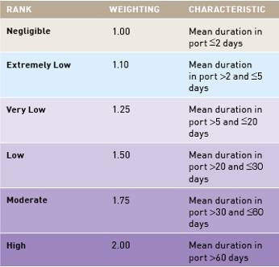
Transport frequency
The number of vessel entries arriving from each bioregion (last port of call) from 2002 to 2007 was calculated as a total across all vessel categories and for each individual vessel category. For each of the 162 species, the number of vessels arriving from bioregions in which the species was known to be present–either as a native, cryptogenic or a non-indigenous marine species based on the Hewitt & Campbell (2010) database–was calculated to represent the raw transport frequency of each species. This figure represents the potential opportunities that the given species had to be transported into Australian waters over the five-year period based on last port of call.
Vessels are likely to accumulate species since their last cleaning (including in-water cleaning, dry-docking or antifouling paint application), however, this data is infrequently available for evaluation. Most commercial vessels have dry-docking rotations of greater than three years and up to five years (Lewis 2002; Davidson et al. 2009). With a number of Australian states banning in-water cleaning for larger vessels (ANZECC 1997), the period between cleaning is likely to exceed several years. The influence of voyage duration on species accumulation was assessed by creating voyages into classes of 30, 60, 90, 183 and 365 days prior to entry into Australia.
During shorter ‘voyages’, the majority of vessels transited between one or two bioregions. Only a few vessels visited three or more bioregions during a 30-day period (see Figure 10a). As voyage time increased, however, a greater number of bioregions were visited by vessels. After 90 days, a relatively large number of vessels were visiting three bioregions (illustrated by the ‘hump’ in Figure 10c); and after 183 days, a second ‘hump’ was evident in the graph, showing a significant number of vessels visiting six bioregions (see Figure 10d). This accumulation of bioregions over voyages of longer duration is demonstrated by an increase in the mean number of bioregions visited on voyages of longer duration (see Figure 11). On average, vessels visited at least two bioregions within a six-month period (183 days). These voyage durations were used to evaluate the changing transport pressure and subsequent inoculation likelihood (see Figure 12a and b, respectively).
Between 2002 and 2007, Australia had approximately 15 000 international vessel (including recreational vessels <25 m and apprehended IFFVs) entries per year and the fleet traded with all global bioregions at some point (during that period).
Transport patterns differed between bioregions (see Figure 13) and changed over time (see Appendix C: Figures C1 to C6), showing an increase in trade from the North West Pacific and East Asian Seas and moderate decreases in other regions. The increase in transport frequency from bioregions as voyage durations increased from 30 days to 365 days can be seen with the addition of lighter shades of grey. As would be expected, more distant bioregions such as the Arctic, North West and North East Atlantic, Baltic and the Mediterranean are largely represented in voyage lengths greater than 60 days.
METHODS AND RESULTS

The influence of recreational vessels <25 m and apprehended IFFVs is more restricted due to the lower numbers of vessel visits (see Figure 14) and the more seasonal nature of recreational vessel arrivals (see Figure 15). Both recreational vessels and IFFVs arrive from a differing suite of bioregions, creating a different risk profile from other vessel categories (see Figure 14).
Recreational vessels largely arrive from the South Pacific or East Asian Seas, although this represents their last port of call rather than their home port. Little information is available concerning the previous ports of call (or bioregions), however many recreational vessels (<25 m) transit through the South Pacific from North East Pacific, Wider Caribbean, and either North East Atlantic or North West Atlantic. This category of vessels is also likely to spend lengthy amounts of time in port at a variety of locations given that it is associated with recreational activities. The seasonal nature of arrivals in Australia is largely driven by cyclonic activity, resulting in an arrival prior to storm season (e.g. cyclone and monsoon) and possibly increased port stays in Australia immediately after having arrived from overseas.
IFFVs largely arrive from the East Asian Seas and South Pacific and are apprehended by AFMA and impounded at one of several nearshore (or port) locations. While the numbers of vessel apprehensions have been consistent through time, a similar level cannot be assumed into the future.

Figure 9: Cumulative (A) and mean duration (B) of vessels’ port stays in each of the 18 IUCN bioregions from 2002 to 2007 (Lloyds MIU dataset). Bars represent the mean number of days per year with one standard deviation (lines).
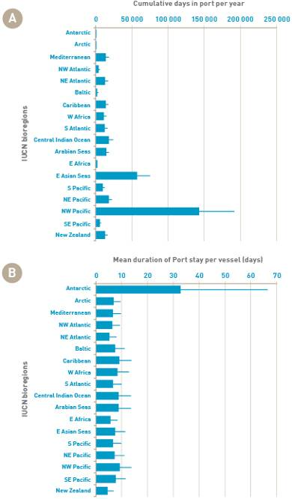
METHODS AND RESULTS

Figure 10: Number of IUCN bioregions transited by vessels for (A) 30-day, (B) 60-day, (C) 90-day, (D) 183-day and (E) 365-day voyages (derived from subsampling 2007 voyage data, Lloyds MIU dataset).
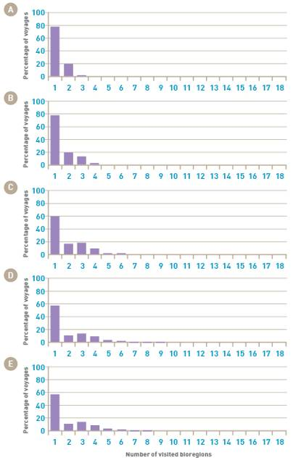
Figure 11: Mean number of bioregions visited with increasing voyage duration. Data from Lloyds MIU dataset.
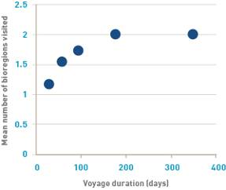
METHODS AND RESULTS

Figure 12: Transport pressure rank (A) and inoculation likelihood (B) for vessels that have been on voyages of 30, 60, 90, 183 and 365 days prior to entering into Australia. Data from Lloyds MIU dataset.
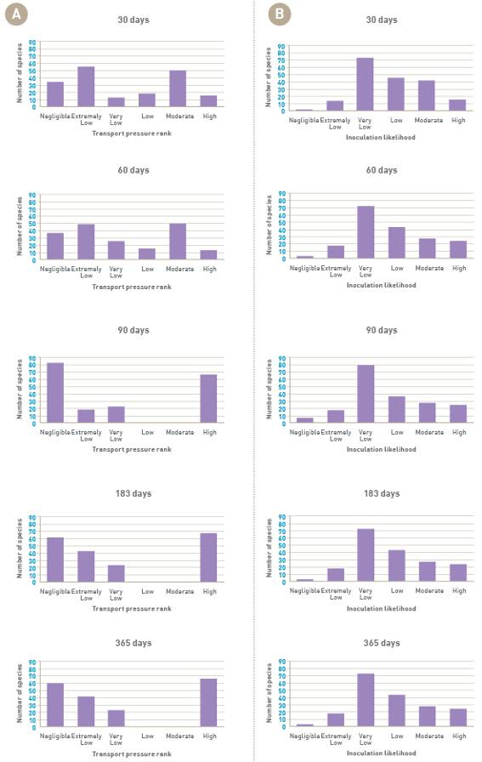
METHODS AND RESULTS

Figure 13: Number (A) and percentage (B) of vessels (all categories) that visited Australia from 2002 to 2007 which had traded with specific bioregions for 30, 60, 90, 183 or 365 days during that five-year period. Note that recreational vessels <25 m and IFFVs are presented only in the 30-day voyage period due to data constraints (Lloyds MIU dataset, AQIS pratique dataset and AFMA IFFV dataset).
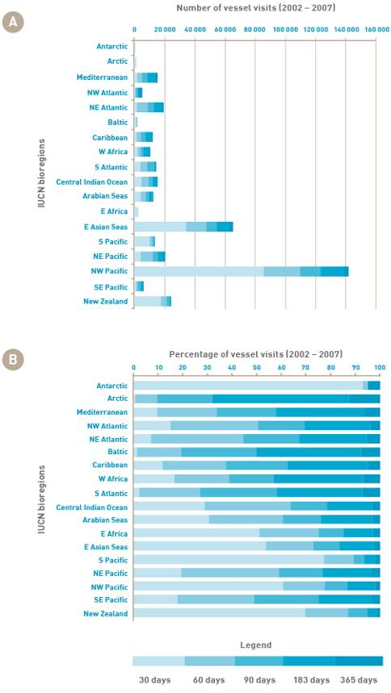
METHODS AND RESULTS

Figure 14: Mean number of recreational vessel visits per year (A) to Australia and apprehended IFFVs brought into Australian waters per year (B) between 2002 and 2007 (AQIS pratique dataset and AFMA IFFV dataset, respectively). Bars represent the mean number of days per year with one standard deviation (lines).
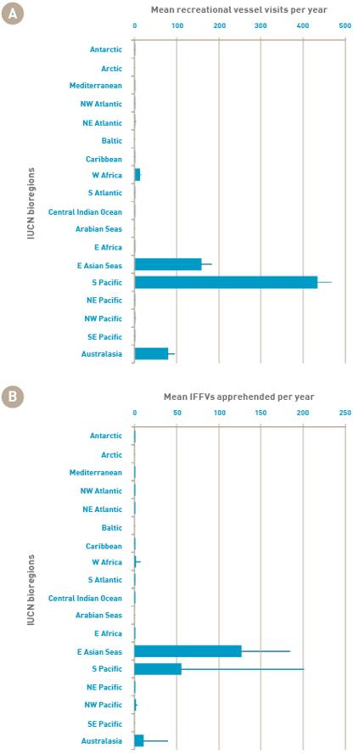
METHODS AND RESULTS

Figure 15: Average number of recreational vessel arrivals into Australia for each month between 2002 and 2007 (AQIS pratique dataset).
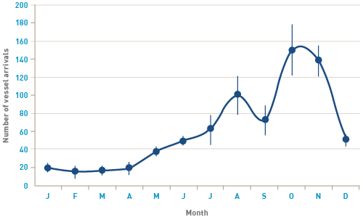
Transport survival
The transport process can create significant physical and physiological stresses on species that impacts their ability to survive a voyage.
Physical stress on species is primarily caused by vessel speed. Several studies have demonstrated the relationship between speed and shear stress on species survival (e.g. Coutts 1999; Davidson et al. 2009; Coutts et al. 2010). Analysing the Lloyds MIU dataset for vessel speeds across vessel categories (see Figure 16) revealed no significant differences across the broad vessel categories (excluding recreational vessels <25 m and IFFVs), despite significant differences between individual vessels within categories. Vessels in the categories of commercial, petroleum, non-trading (specifically tugs, barges and dredges), IFFVs and recreational vessels are known to travel at slow speeds–significantly increasing a species’ likelihood of survival (e.g. Floerl & Inglis 2005; Floerl et al 2005; Davidson et al. 2009; Coutts et al. 2010).
Additionally, while vessel speed is correlated with species presence on exposed hull surfaces (e.g. Coutts et al. 2010), numerous protected niche areas such as sea-chests (e.g. Coutts et al. 2003; Coutts & Taylor 2004; Coutts & Dodgshun 2007), bow and stern thrusters, propellers and propeller shafts, will allow species to survive despite high vessel speeds (e.g. James & Hayden 2000; Hayes 2002; Coutts & Taylor 2004; Hayes et al. 2004b). As a consequence, speed may not provide differentiation between vessel types nor significantly reduce risk.
Physiological stress on species can be created by the type and condition of antifouling paints used on a vessel (e.g. Piola & Johnston 2006) as well as the voyage route. Antifouling paints are explicitly designed to minimise and delay the settlement of epibenthic species on the hull surface. There is extensive research detailing the efficacy and various failings of antifouling paints (e.g. Minchin 2006; Dafforn et al. 2008; see also various publications in the journal Biofouling). Most recently, the ban on organotin paints, specifically tributyltins (TBTs) has prompted investigations into viable alternatives and resurrected the concerns over biofouling-mediated invasions. Antifouling paints differ significantly in their effectiveness, as well as their method and location of application (Lewis 2002; Lewis et al. 2004; Piola et al. 2009). From a management perspective, information on antifouling paint type, application procedures and timing of application is difficult to obtain. As a result, the use of antifouling paint was not studied in this risk assessment.
METHODS AND RESULTS

Figure 16: Reported speeds of vessels (by category) entering Australia between 2002 and 2007. Maximum/minimum reported range indicated by line, 90% confidence intervals around the mean represented by blocks. Slow moving drill rigs and drill ships have been estimated to have a vessel speed of 5 knots and are included in with petroleum vessels; recreational vessels >25 m are included in non-trading vessels. Vessel speeds for IFFVs and recreational vessels <25 m could not be obtained. Data from the Lloyds MIU dataset for 2002 to 2007.

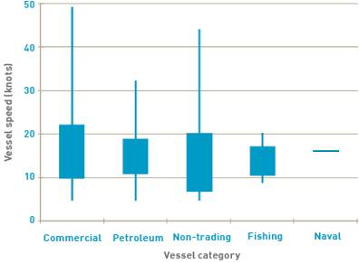

Physiological stress associated with exposure to changing environmental conditions is likely for biofouling species associated with the external hulls of vessels. Transport between high or mid-latitude regions on either side of the equator will expose species to the physiological stresses of increased water temperature during transit. Similarly, freshwater species in transit across oceanic barriers (e.g. between the North American Great Lakes and the inland waters of Europe) will fully experience marine waters during transit across the North Atlantic. Most trade routes to Australia entail a crossing of the equator, several of which may also be accompanied by a freshwater transit through the Panama Canal or a high salinity transit of the Suez Canal. Quantifying the effect of these transits is difficult without laboratory analyses of individual species’ physiological tolerance and exposure. As this factor only acts to decrease the likelihood, leaving it out of the current assessment until definitive information is available, provides a conservative result. Therefore, we have assumed that all voyage pathways are equally stressful.
Inoculation opportunity
Similar to the opportunity for species to settle in the donor port, attached biofouling species need to either reproduce (sexually or asexually) or be scraped off the hull to inoculate a receiving port. Any sedentary, infaunal and mobile fauna associated with biofouling assemblages (e.g. gastropods, crabs and other mobile crustaceans, small fishes such as blennies and gobies, seastars), including those occurring in sea-chests, will have increased opportunity to leave the vessel either by being dislodged or by swimming or dropping off the vessel. Inoculation opportunity is typically believed to be a function of port duration and the reproductive maturity or vagility (ease of movement) of individual species.
As with the previous discussion, reproductive activity can be influenced by many factors including the intrinsic maturation rate of individuals, and extrinsic factors such as temperature and day length (Minchin & Gollasch 2003). These influences on reproduction can be as difficult to ascertain as in the donor ports (see ‘Opportunity to settle on the vessel in the donor port’ in Section 2.3.1). The action of being scraped off a hull is a stochastic process and depends on a number of elements, including the species’ location on the hull, its attachment mode, type of antifouling coating on the vessel, and the handling of the vessel; in port. The vagility of sedentary and mobile fauna associated with biofouling is, by definition, high. These species are capable of moving and will therefore have the opportunity to leave the vessel at any time once in port. As a consequence, biofouling and biofouling-associated species were assumed to have the ability to reproduce (sexually or asexually), escape and/or swim away or be scraped off, all year-round.
METHODS AND RESULTS

Identifying the time available to inoculate a recipient port was calculated as the mean (± SD) and cumulative duration in Australian ports within each of the four biogeographic provinces (see Figure 17; see also Appendices D and E). Cumulative days in port inform the overall opportunity of species entry, but are indicative of species transport only, being heavily influenced by vessel traffic. Arguably, an individual attached to the hull of a single vessel that remains in port for the year is likely to have a greater opportunity to reproduce, be dislodged, or depart that vessel, than individuals on 365 different vessels arriving throughout the year for one day only. An individual attached to the hull of a single vessel for an entire year will experience the entire seasonal change in a new region, leading to the likelihood of reaching sexual maturity and attaining a size that would be susceptible to wave action or damage. In contrast, the mean (± SD) of individual vessel visits provides a more realistic indication of inoculation opportunity of individual species.
The Dampierian province (Cape Leeuwin, Western Australia to Cape York, Queensland) has the highest average for port duration, followed by the Solanderian (Eastern Queensland), however, the absence of data concerning oil rigs, IFFVs and recreational vessels <25 m is of concern. Such vessel types are known to have long residence periods and are able to transport non-indigenous marine species (Floerl 2002; Floerl & Inglis 2005; Floerl et al. 2005).
More than 89% of vessel arrivals in Australia are in the commercial category (see Table 7). For Australia as a whole, the North West Pacific followed by East Asian Seas and South Pacific were the highest vessel origins between 2002 and 2007 (see Figure 13; Appendix C), although recreational vessels <25 m and apprehended IFFVs (Figure 14) are largely derived from the South Pacific and East Asian Seas, respectively.
Significant differences in arrival patterns exist between Australian provinces in vessel number and origin (see Figures 18 and 19a-d; Table 7). The Dampierian province had the greatest number of vessel arrivals, followed by the Peronian, Solanderian and Flindersian provinces. The highest proportion of vessel arrivals in all four Australian provinces was from the North West Pacific IUCN bioregion in comparison to all other IUCN bioregions. The South Pacific had the highest representation of recreational vessels to all four regions, with the greatest number to the Solanderian province followed by the Peronian and Flindersian provinces. The East Asian Seas had the greatest contribution of all vessel types to the Dampierian province.
METHODS AND RESULTS

Figure 17: Vessels’ cumulative (A) and mean duration (B) in ports within the four Australian provinces between 2002 and 2007 (+SD). Note that oil rigs, IFFVs and recreational vessels <25 m are not represented here (Lloyds MIU dataset).

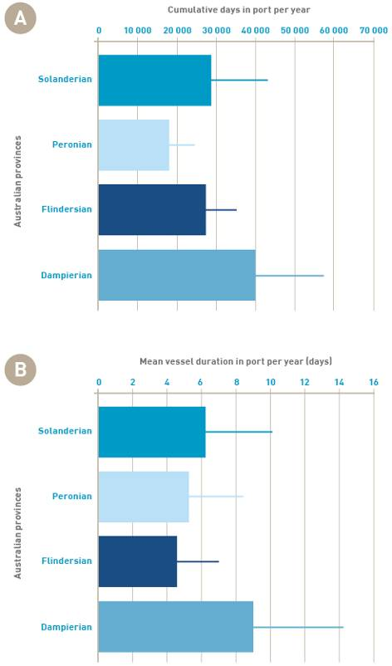
METHODS AND RESULTS

Table 7: Summary of vessel arrivals between 2003 and 2007 classified by IUCN bioregion of origin and vessel category (AQIS pratique dataset).
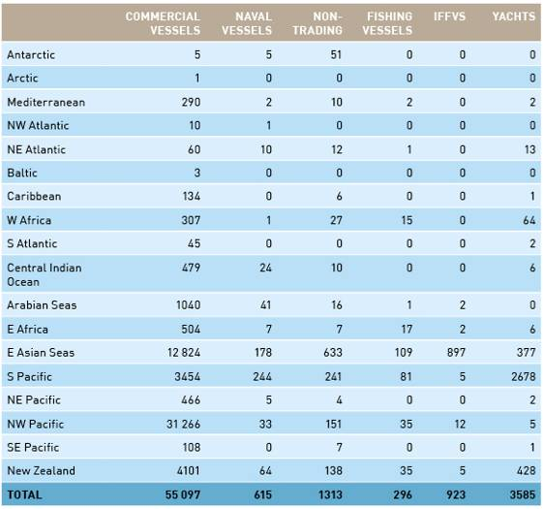
Summary of transport pressure
To reiterate the various assumptions made when assessing transport pressure:
- species were assumed to be present in all areas (ports) of bioregions to which they had been introduced or were native
- all vessels were deemed to have an equal opportunity of a species settling, regardless of time of year or the period since dry-docking, in-water cleaning or antifouling paint application
- all transport pathways were considered to be equally stressful.
To determine a species’ transport pressure, a series of calculation steps were undertaken. First, the numbers of arriving vessels in each category were calculated for each bioregion and multiplied by the port duration weighting (to take into account the opportunity for settlement). This number was then summed within each of the 18 bioregions. Then for each species, the weighted number of vessels arriving from all bioregions where the species was present (as a native, cryptogenic or non-indigenous population) was summed–providing a cumulative number of vessel opportunities for that species to be transported into Australia. This value was then divided by the unweighted number of vessels entering Australia to provide the percentage of total opportunities for entry. In order to account for effect of voyage duration, these steps were repeated for vessels visiting bioregions over 30-, 60-, 90-, 183- and 365-day voyage windows (see Figure 12).
METHODS AND RESULTS

These vessel numbers were then ranked according to likelihood probabilities in Table 3 to provide a categorical rank for each of the voyage periods as a function of percentage of total visits. As a result, a large number of species were identified as having a negligible transport pressure (ranging from 19% in 30 days to 32% in 365 days). In contrast, more than 35% of species were ranked as having low, moderate or high transport pressure across all voyage lengths (see Table 8).

Table 8: Percentage of species with transport pressure likelihood ranks for voyages of 30, 60, 90, 183 and 365 days (Lloyds MIU dataset).
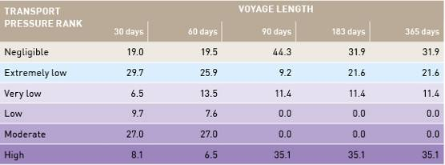

2.3.1.3 Summary of inoculation likelihoods
Based on the biofouling association ranks (see Figure 6a) and transport pressure ranks (see Figure 6b), inoculation likelihood (see Figure 6c) was calculated using the matrix in Table 4.
More than a third (35%) of all species were identified as having an inoculation likelihood ranking of low, moderate or high (see Figure 6c), with an increasing percentage of species ranked in the high category for longer voyage timeframes (see Figure 12). As would be expected, increasing voyage duration captures a greater number of bioregions (see Figures 11, 12, 13), resulting in an increase in the pool of species and an increased capture of vessels with longer port stays.

2.3.2 Establishment
Establishment represents the survival and development of a self-sustaining population once a species has been inoculated into a new (receiving) environment (e.g. Occipinti-Ambrogi & Galil 2004). There is a common theory amongst researchers (e.g. Carlton 1985; Lodge 1993; Ruiz et al. 2000; Hewitt & Huxel 2002; Lockwood et al. 2007) that a species’ likelihood of establishment is related to its invasion and inoculation characteristics as well as the traits of the receiving environment.
Species characteristics which influence establishment likelihood include physiological tolerance to the new (receiving) environment sufficient for reproduction to occur and all life history stages to survive. These are typically based on empirical evaluations of species’ tolerances to a suite of environmental factors, such as temperature, salinity, light and dissolved oxygen. However, these empirical evaluations have been carried out for a relatively small number of species (e.g. Hayes & Hewitt 1998, 2000; Campbell 2009).
Given these constraints, a second method of estimating a species’ probable survival in a new region is to match the environmental characteristics of the donor region where it is known to exist, with a recipient region–a process known as environmental matching (e.g. Hilliard & Raaymakers 1997; Kilroy et al. 2008; see also Hewitt & Hayes 2001, 2002). As Barry et al. (2008) suggest, evidence to support the utility of environmental matching in the marine environment is limited, largely due to the inappropriate selection of environmental characteristics and scale by various authors. The ability for environmental matching to provide realistic risk evaluations becomes increasingly limited as nonsensical or irrelevant environmental factors are included in the analysis (Barry et al. 2008).
METHODS AND RESULTS

One of the greatest errors in environmental matching assessments is the inappropriate use of scale. As Hewitt & Hayes (2002) demonstrate, environmental matching is meant to create a surrogate measure for the species of concern’s tolerance range. This is done by selecting a location where a species is known to exist (the donor location), and using a range of environmental values to compare with a potential recipient location. If the donor location is restricted to a port, rather than the entire province or bioregion in which the species resides, then an artificial limit to the range of environmental values will be derived. To illustrate this, Hewitt and Hayes (2002) demonstrated that the temperature ranges of the Port of Sydney and the Port of Hobart differ and hence, based on a simple environmental match, species would not be expected to survive in both. Regardless, Sydney and Hobart are located within a single large-scale province and share many species. For example, when the two ports’ temperature ranges are compared with the temperature tolerances of the introduced seastar, Asterias amurensis, they both fall well within the range of its survival (Hewitt & Hayes 2002).

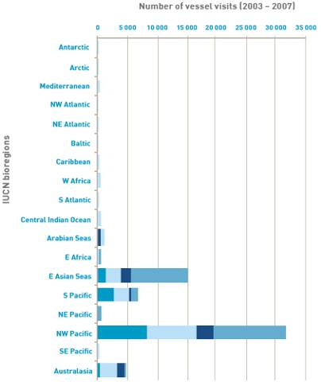
Figure 18: Vessel arrivals from 2003 to 2007 categorised by trading region (based on last port of call IUCN bioregion) and the province through which they entered Australian waters (see Figure 8; AQIS pratique dataset).

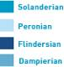
METHODS AND RESULTS

Figure 19: Vessel arrivals to each Australian province between 2003 and 2007 categorised by vessel type and trading region (based on last port of call IUCN bioregion). The four Australian provinces are: (A) Solanderian province, (B) Peronian province, (C) Flindersian province, and (D) Dampierian province. Note that petroleum vessels are included in commercial vessels due to the constraints of the AQIS pratique dataset.

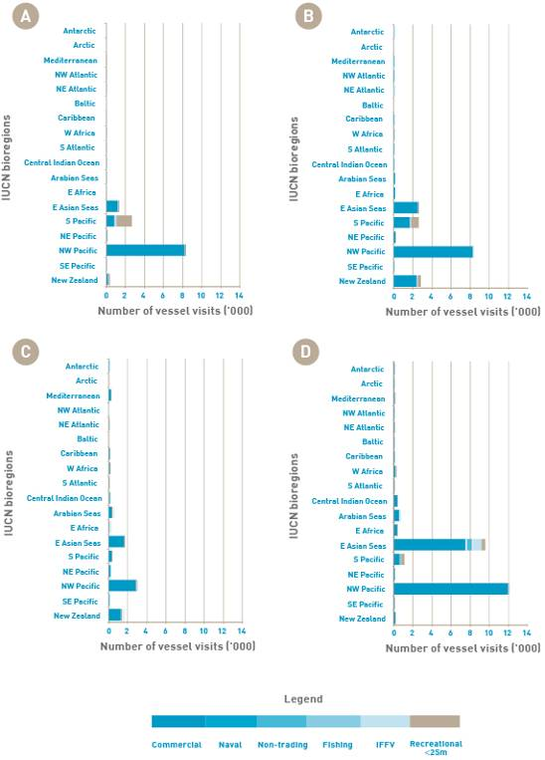
METHODS AND RESULTS

Non-indigenous marine species have been shown to fully realise their fundamental niche (sensu Hutchinson 1957), suggesting that their physiological tolerances are conservatively represented by the wide ranging environmental conditions (e.g. salinities and water temperatures) in their native distribution. In a previous evaluation (Hewitt & Campbell, unpubl. manuscript), the known temperature tolerances of several introduced marine pests in Australian waters were compared with the sea surface temperature maxima and minima (over a 10-year period) for their native provinces (see Figure 20a). The environmental range of temperatures in a species’ native provinces conservatively describes the temperature tolerances of the species, suggesting that the environmental ranges of provinces can be used as conservative surrogates of species’ tolerance levels.
As a consequence, the ‘overlap’ of environmental characteristics of different provinces may indicate the likelihood of species’ survival in various regions. Significant provincial overlap occurs from the Arctic to the Antarctic along the eastern Pacific basin (see Figure 20b), suggesting that many species could survive in a wide range of provinces across the eastern basin, and that their restricted distributions may be constrained more by other factors (e.g. transport opportunity, receiving community resistance including predation and competition) than significant physiological ‘resistance’. The northern and southern distribution of the large brown kelp, Macrocystis integrifolia is a case in point (Graham et al. 2007).
For the purposes of this report, the evaluation is to determine whether a species poses a risk for Australia as a nation. Australia covers a latitudinal range from 12° S to 43.5° S and has four biogeograhic provincial boundaries, with waters ranging from tropical to cool temperate (see Figure 8). Australia therefore has overlapping environmental conditions with much of the globe, suggesting that arriving species could probably survive in at least one location of Australia. A finer spatial scale would be required to determine a reduction in establishment due to environmental constraints alone.

Figure 20: Comparison of species’ physiological tolerances versus native province sea surface temperature range (A); and comparison of sea surface temperature for the eastern Pacific provinces (B) (from Hewitt & Campbell, unpubl. manuscript).

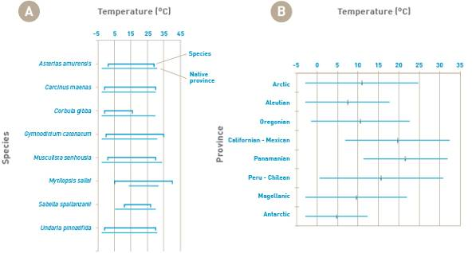
METHODS AND RESULTS

Species requirements are not limited to physiological tolerances and can include habitat requirements, such as substratum type, exposure gradients and nutrient availability. For all species considered in this analysis, the occupation of hard substrate–either directly as biofouling or in association with biofouling–is a key habitat requirement. Many of these species occupy both natural and man-made hard substrates in other regions of the world, specifically the port and marina structures including rocky breakwalls and protection groynes (e.g. Glasby et al. 2007; Dafforn et al. 2008; see also references in Campbell et al. 2007). These structures coincide with points of entry into Australia and are likely to represent the first substrate a new species will encounter once inoculated. As a consequence, no limitations to establishment based on habitat requirements are considered further here.
A second factor that contributes to a species’ establishment success is the frequency and timing of its propagule (e.g. larvae or individuals) arrival into a new location (e.g. Ruiz et al. 2000; Fofonoff et al. 2003). This concept of ‘propagule pressure’ identifies that if several inoculation events of a single species occurred over time into a single location, then the opportunity for establishment is more likely to occur. Similarly, the hypothesis of propagule pressure suggests that a higher number of propagules arriving in a single location at the same time will increase establishment likelihood. The reasoning revolves around creating a population with increased ability to overcome ‘founder effects’, such as reduced reproductive success due to an inability to find a mate (e.g. Lockwood et al. 2007).
In this report, propagule pressure based on a higher number of propagules has been incorporated into the assessment of transport pressure. This had been done through the calculation of the number of opportunities for a species to arrive into Australia (i.e. vessel entries from regions where a species is found either as a native, cryptogenic or introduced population). Propagule pressure based on the arrival of a species through time has not been explicitly evaluated here, although the period of evaluation (2002 to 2007) and the consistency of vessel arrivals for most categories (excluding recreational vessels <25 m; see Figure 15) suggests that for Australia as a whole, species arrivals occur throughout the year.
Establishment can, however, be influenced by the residence time of a vessel in the receiving port. Residence time relates to the opportunity that a species has to reproduce, dislodge (for species capable of surviving and establishing once dislodged from a substrate) or depart (for mobile or sedentary species). The longer the duration of port stay, the greater likelihood a species has of inoculating the port. Information about how vessels’ residence time in ports influences inoculation opportunity is also discussed in Section 2.3.1.
Additional hypothesised influences on establishment success include the influence of the recipient community on invasion success. This can occur by causing biotic resistance to new invasions through well established, species-rich communities leading to increased predation and/or competition by native species (e.g. Elton 1958; Hewitt & Huxel 2002; Dunstan & Johnson 2006). The empirical evidence suggests that biotic resistance does occur in some systems. In marine systems, small scale manipulations have also demonstrated negative relationships, with species-rich communities having low numbers of invasions (e.g. Stachowicz et al. 1999, 2002; Dunstan & Johnson 2006).
Alternatively, recipient communities can influence invasions through heightened susceptibility as a consequence of increased disturbance, including habitat replacement (e.g. Glasby et al. 2007; Dafforn et al. 2008) or invasional meltdown (e.g. Simberloff & von Holle 1999), whereby the effect of one invasion leads to the facilitation of subsequent invasions.
Given the location and community-specific factors leading to either biotic resistance or invasional meltdown it is impossible to incorporate these into this risk analysis as all have the potential to be operating in some location of Australia. Indeed, several of the previously cited studies are from Australian systems (e.g. Dunstan & Johnson 2006; Glasby et al. 2007; Dafforn et al. 2008) demonstrating that both biotic resistance and invasion susceptibility are occurring in the Australian marine environment.

2.3.3 Domestic spread
Domestic spread refers to progressive expansion and establishment of species in locations beyond the first site of establishment in the receiving country. This can be facilitated either by natural or human-mediated means. The likelihood of spread within Australia following an initial incursion has been evaluated based on species’: life history characteristics, mechanisms and barriers to natural spread, opportunities to settle on transport vectors, frequency of transport opportunities, and the distal extent of transport opportunities.

METHODS AND RESULTS

Life history characteristics include a species’ mobility (able to move by themselves), vagility (ease of movement, e.g. unattached) and/or reproduction strategy (asexual, sexual with planktonic gametes and/or larvae, larval period). Natural mechanisms and barriers to species spread in Australia include coastal currents and the north/south division of the continent into tropical and temperate climatic zones.
In contrast, human-mediated mechanisms of spread relate to the chances of transport that mirror the discussion of international transport patterns above. These include the potential to settle on a vessel, the frequency of vessel movements between domestic regions and the opportunity to depart a vessel in the receiving port. The opportunity to settle and depart a vessel relate to the time spent in ports by the various transport vectors including international vessels on voyages with domestic components, recreational vessels such as cruising yachts and fishing fleets.

2.3.3.1 Natural spread
The natural spread of organisms relies on a combination of species’ life history traits and local environmental characteristics, including coastal current strength and direction, and the presence of accumulation zones for larval retention and entrainment (e.g. Grosholz & Ruiz 1995; Inglis et al. 2006; Bax & Dunstan 2007; DeRivera et al. 2007). These details will necessarily vary according to the species concerned and local port environmental characteristics (Inglis et al. 2006). For example, biofouling species typically have either a planktonic larval phase or alternative capacity for long distance spread. It can be expected that patterns of natural spread are in accordance with prevailing currents (see Figure 21), with those species with longer larval periods having greater capacity for spread via this mechanism.
The main pattern of natural spread via ocean currents can be expected: down the east coast from the Solanderian to the Peronian and Flindersian province; and down the west coast from the Damperian to the Flindersian province. Minimal natural spread can be expected against these main patterns. The connections between the Solanderian and Dampierian provinces are minimal and restricted to the throughflow in the Torres Strait region (see Figure 8 for explanation of provinces). While spread is likely to follow these patterns, local circulation patterns can be very complex and there is also potential for species to spread against the prevailing currents (Byers & Pringle 2006).

Figure 21: Major currents and circulation patterns around Australia. The continent is bounded by the Pacific Ocean to the east, the Indian Ocean to the west and the Southern Ocean to the south–from Hobday et al. (2007). Dashed lines represent variable currents.

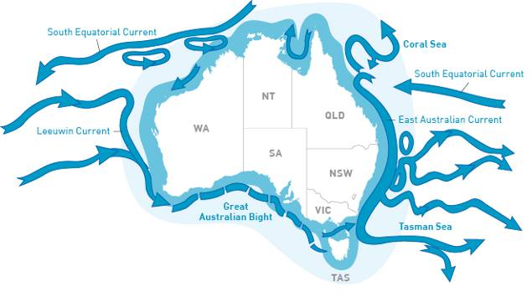
METHODS AND RESULTS

2.3.3.2 Human-mediated spread: Spread via international traffic trading domestically
Calculating the likelihood of an established species attaching to a new vessel in an Australian port is the same as that for an international port. Therefore, the previous risk assessments for inoculation (entry) and establishment of species can provide insights to domestic spread.
The likelihood of spread can initially be assessed as high based on: a species already having demonstrated an invasion history and an association with an active transport vector (biofouling); and a species having been assessed as highly likely to be able to become established in at least one Australian province. Given that more than 41% (±4.8%) of international vessels entering Australia will transit from the primary port of entry to additional Australian ports (see Figure 22), the possibility of species only inoculating the first port of arrival and not subsequent ports is low. This represents an annual average of 5595 (±796) international vessels which will act to spread species that are already associated with international vessels.
Time spent in port is likely to influence the opportunity for species to settle on a vessel as well as for species to depart an already infected vessel. The majority of international vessels entering Australia (average of 82.4% across years) will spend five or fewer days in the second port, however, an average of 121 (±23) vessels per year will spend greater than 30 days in the second Australian port (see Figure 22).

Figure 22: Duration of stay in second port of call by international vessels entering Australia between 2002 and 2007. Vessel visits represent the mean across years (Lloyds MIU dataset).

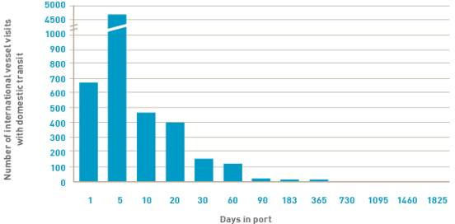

As identified above, more than 41% (±4.8%) of international vessel visits continue on to a second Australian port. The frequency of transport between the four Australian provinces provides an indication of the extent of probable spread. The majority of these vessels will visit a second port in a different province (see Table 9):
- 73.7% (±4.9%) of vessels entering a port in the Peronian province continued to another province
- 61.4% (±4.1%) of vessels entering a port in the Flindersian province continued to another province
- 58.8% (±6.3%) of vessels entering a port in the Solanderian province continued to another province
- 45.6% (±12.8%) of vessels entering a port in the Dampierian province continued to another province.
METHODS AND RESULTS

2.3.3.3 Human-mediated spread: Spread via domestic traffic
Domestic transfer of species is also likely to occur via domestic vessels, including commercial, petroleum, fishing, naval, non-trading vessels and recreational vessels, based on the reasoning used to assess likelihood of inoculation. Species arriving on an international vessel may therefore be transported to additional ports as part of this domestic reticulate web.
Detailed information about domestic vessels’ movement patterns in Australian waters is limited. However, available data from Australia, combined with overseas work, provides compelling evidence that domestic traffic has the potential to be a significant vector for further spread of pest species (e.g. Floerl 2002; Kinloch et al. 2003; Floerl et al. 2009; Forrest et al. 2009; Acosta & Forrest 2009).
A review of the risk of spread for marine pests around Australia posed by domestic vessels from 23 sectors (e.g. cruise ships, customs launches, commercial fishing vessels) provides insight into the importance of these vectors (Kinloch et al. 2003). This review was not a quantitative analysis of specific movement patterns, but involved ranking domestic vessels on the basis of their characteristics and the nature and intensity of their activity in each sector. It was concluded from this analysis that commercial fishing vessels, dredges and offshore (petroleum) support vessels were likely to be the highest risk vectors for domestic spread of species (Kinloch et al. 2003). The high ranking of commercial fishing vessels in this study was on the basis of them: having a high likelihood of entraining marine pests due to them spending prolonged periods in commercial ports; being wide-ranging, regular and frequent users of the marine environment; and being highly mobile, often operating in different fishing grounds and from different ports. As is the case for most non-trading vessels, specific movement patterns of commercial fishing vessels are difficult to quantify and map because no records are kept of vessel movements or port visits, except in the case of a small proportion of the Australian Government-managed fleet that use vessel monitoring systems (Kinloch et al. 2003).
Particular vessel types, such as dredges, are believed to pose a high risk due to their unique behaviours relative to other vessel types–they move slowly and/or have long periods of port residency (>30 days). Many of these vessel types have been associated with a number of non-indigenous marine species detections (e.g. Carlton & Hodder 1995; Carlton 2001; Stafford et al. 2007; Davidson et al. 2009). Furthermore, slow-moving barges, dredges, research vessels and tugs that have been shown to transport intact communities (e.g. Coutts 2002) have also been implicated in transfers into and within Australia (e.g. Clapin & Evans 1995; Sabella transfers in Western Australia by a dredge that moved between Cockburn Sound, Bunbury, Albany and Esperance).
Another key vector for domestic spread is recreational vessels (e.g. Floerl & Inglis 2003; Ashton et al. 2006; Minchin et al. 2006; Acosta & Forrest 2009; Floerl et al. 2009). Surveys conducted along the Queensland coastline clearly highlight the importance of this vector (Floerl 2002). This study used multiple lines of evidence to demonstrate the potential role of this vector for spread of marine pests and involved biofouling sampling of yachts and marinas, along with questionnaire surveys to determine vessel movements. The work showed that these vessels can harbour a range of biofouling taxa, typically resembling the biofouling taxa in their home port. Furthermore, the work also showed that vessel movements have the potential to transfer pest organisms along the coastline. For 2192 trips recorded over the two-year survey period, most trips (46.5%) were relatively short (<20 km). However, 35.2% of trips covered 20 km to 100 km, 13.6% of trips covered 100 km to 300 km, 3.9% had travelled interstate, and 0.8% had travelled to overseas destinations. Importantly, the work showed that there was considerable exchange of vessels between widely separated marinas (encompassing more than 1000 km of coastline). Overall, the results of this study provide strong evidence that recreational vessel movements are able to facilitate the spread of marine pests along the Queensland coastline at a rate that greatly exceeds natural dispersal (Floerl 2002).
METHODS AND RESULTS

Table 9: Trading relationships between and within the primary Australian provinces based on percentage of international vessels entering Australia (first port) and continuing to a second port. The average percentage for: (A) 2002 to 2007; (B) 2002; (C) 2003; (D) 2004; (E) 2005; (F) 2006; (G) 2007.

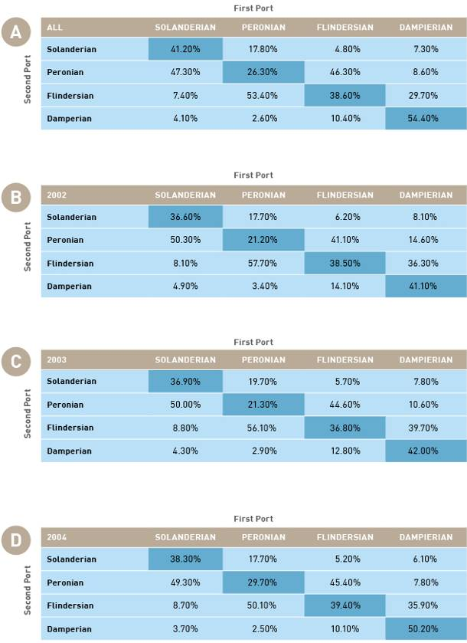
METHODS AND RESULTS

Table 9: (continued)

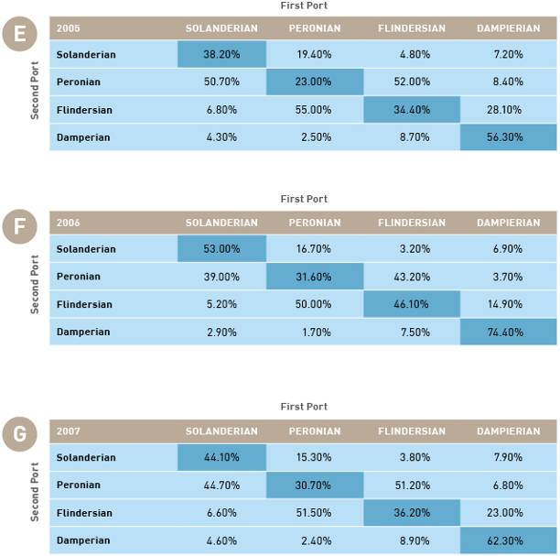
METHODS AND RESULTS

Similar quantitative studies examining species spread via this vector are lacking for other regions of Australia, but there is a strong likelihood that the patterns observed in Queensland would also apply elsewhere. This is supported by anecdotal information, such as the influx of international and interstate cruising vessels arriving in Tasmania during the summer cruising season (D Shields, pers. obs.). International cruising yachts arriving in Australia typically cross the Pacific during the trade-wind season to arrive in Bundaberg or Cairns in October before heading south to escape the cyclone season. Many of these cruising yachts sail as far south as Sydney and some continue to Tasmania. Iconic events such as the annual Sydney–Mooloolaba–Cairns, Sydney–Hobart and Melbourne–Hobart yacht races, the biennial Tasmanian Wooden Boat Festival and the tall ships’ circumnavigations involve both participants and followers conducting long coastal voyages between widely separated ports and anchorages. Each autumn a fleet of cruising yachts heads from temperate ports to warmer tropical waters and returns the following spring (D Shields, pers. obs.).
Previous work has ranked the commercial fishing sector as posing the highest risk of all marine transport sectors of domestically translocating marine pests (Kinloch et al. 2003). Approximately 12 000 fishing vessels ranging in size from 5 m dinghies to 80 m deep sea trawlers work from ports all around Australia (Kinloch et al. 2003). The largest Australian-managed commercial fishery is the Eastern Tuna and Billfish Fishery which employs 40% of Australian-managed commercial fishing vessels (Kinloch et al. 2003) and extends from Cape York, Queensland, around Tasmania to the South Australian/Victorian border. Fishing occurs in both the Australian fishing zone and adjacent high seas (AFMA 2009). Major ports used by the fleet include Cairns, Mooloolaba, Coffs Harbour, various south coast New South Wales ports and Hobart. Another important fishery, targeting Southern Bluefin Tuna, extends completely around Australia. The Northern Prawn Fishery is located off Australia’s northern coast and extends from the low water mark to the outer edge of the Australian fishing zone in the area between Cape York in Queensland and Cape Londonderry in Western Australia (AFMA 2009). These three large fishing fleets alone have the capacity to translocate biofouling species between ports around Australia.
A survey in 2007 of a variety of commercial fishing vessels in ports around Australia found biofouling on all but one of the 14 vessels inspected. In that survey, 190 biofouling species were identified, including 30 non-indigenous marine species (Aquenal, unpubl. report). This survey inspected vessels after they had been hauled out of the water, so it may have missed mobile species associated with biofouling. The home ports of many fishing vessels are man-made harbours within commercial trading ports. Fishing fleets routinely spend extended periods laid up in harbour waiting on weather conditions or the opening of fishing seasons. Many fishing vessels follow the fish and unload their catch and reprovision far from their home ports. Fishing harbours are often crowded with vessels from different fleets and widely distributed home ports–providing ample opportunity for biofouling organisms carried on fishing vessels to inoculate the harbours and other fishing vessels in the vicinity.
Ultimately, once a species has become established in a high traffic port, or ‘transport hub’, there is a strong probability that domestic vessels will be colonised by pest species and translocated to more locations across Australia. As successive hubs colonise, the number of populations from which natural spread can occur increases via natural dispersal (Floerl 2002). This pattern of spread, termed the ‘hub and spoke’ dispersal (sensu Cartlon 1996) is typical of marine pest species (Carlton 1996; Cranfield et al. 1998). Recent modelling analysis indicates that spread of invasive organisms not only occurs from hubs, but also from seemingly unimportant transport nodes (Floerl et al. 2009). Nonetheless, transport hubs were consistently more likely to become infested by an invader species and to accelerate spread to secondary locations faster when compared with low traffic nodes (Floerl et al. 2009).
METHODS AND RESULTS

2.3.3.4 Domestic spread: Evidence from previous pest incursions in Australia
Patterns of spread following incursions of marine pest species in Australia provide additional evidence that domestic spread is likely following initial establishment. A number of examples are cited below.
- Asterias amurensis: The Northern Pacific seastar was first detected in the Derwent Estuary, Tasmania in 1986 (Buttermore et al. 1994) and has since spread throughout sheltered south-east Tasmanian bays. It has also spread to the north-east coast of Tasmania (A Morton, pers. comm.) and across Bass Strait to Port Phillip Bay (Cohen et al. 2000). While long-distance dispersal is possible (Dunstan & Bax 2007) given that this species has a long larval period (120 days–Bruce et al. 1995), A. amurensis was almost certainly transported across Bass Strait by vessel traffic between Tasmania and the mainland (Kinloch et al. 2003).
- Undaria pinnatifida: Following invasion of the east coast of Tasmania in 1988 (Sanderson 1990), the Japanese seaweed spread via natural dispersal at a rate of five to 10 km per year (Sanderson 1997). Subsequently, range expansions up to 50 km were observed. While not proven, these larger dispersal events are considered to be attributable to spread via domestic vessels (Sanderson 1997). Similarly, the colonisation of Port Phillip Bay in 1996 (Campbell & Burridge 1998) was likely to be due to domestic transfer.
- Sabella spallanzanii: The spread of the European fan worm down the Western Australian coastline is believed to be due to movement of dredges in the region (Clapin & Evans 1995). The species is known to occur in South Australia, Victoria and Tasmania and is likely to have spread through natural dispersal and association with fishing industry operations and as biofouling (NIMPIS 2002a).
- Carcinus maenas: The European green shore crab was originally introduced to mainland Australia (Victoria) around 1900 (Fulton & Grant 1900). In the 1970s it was identified in New South Wales (Hutchings et al 1989), South Australia (Zeidler 1978) and in 1993 in Tasmania (Gardner et al. 1994). A single record in the Swan River, Western Australia was found in 1965, but has not been detected since. Thresher et al. (2003) described the spread of C. maenas in Australia from its initial invasion in Victoria into New South Wales and Tasmania.

2.3.3.5 Summary of domestic spread
The subsequent spread of non-indigenous marine species once introduced into a new region will occur through the natural spread of organisms and through human-mediated movements. Natural spread is typically associated with currents, including drift, wind-driven movement and mobility for some species (e.g. salmonids). As discussed previously, the large-scale pattern of spread via ocean currents in Australia would be down the east coast (from the Solanderian to the Peronian and to the Flindersian province) and down the west coast (from the Damperian to the Flindersian province); (see Figure 21). At smaller scales, prevailing currents coupled with wind-driven circulation would determine spread.
In contrast to natural spread, human-mediated spread of non-indigenous marine species is similar to the calculations for international spread. For species attached to entering international vessels, more than 41% of international vessels entering Australia continue to a second (or more) domestic port. Many of these subsequent visits are for periods greater than 30 days (121±23 vessels per year; see Figure 22). In addition to international traffic transiting between domestic ports, domestic traffic will provide opportunities for secondary spread of non-indigenous marine species. The vessel groupings of recreational, fishing, domestic trading, domestic non-trading, domestic petroleum (specifically the service vessels) and naval vessels all provide opportunities for the translocation of species from primary points of entry to subsequent locations. Commercial fishing vessels were identified by Kinloch et al (2003) as the highest domestic risk based on: having a high likelihood of entraining marine pests due to them spending prolonged periods in commercial ports; being wide-ranging, regular and frequent users of the marine environment; and being highly mobile, often operating in different fishing grounds and from different ports. Similarly, dredges and slow moving barges may pose a high level of risk due to similar behaviour patterns.
Several previous pest incursions into Australia have experienced subsequent spread. The high profile invasions of Asterias amurensis, Undaria pinnatifida, Sabella spallanzanii and Carcinus maenas have all exhibited secondary spread following initial invasions. These secondary spread events have been through combinations of natural and human-mediated vectors, with large-scale movements being facilitated by human activity.
The likelihood of human-mediated domestic spread of these species is high–in accordance with the species’ likelihood of initial inoculation and establishment. Numerous suitable vectors exist, including foreign vessels transiting between domestic ports, domestic trading vessels, domestic non-trading vessels such as fishing fleets, petroleum industry vessels and dredges, and recreational vessels. The only natural barrier to spread identified in this analysis applies to the small number of freshwater pest species. For these species, the presence of elevated salinities in coastal waters provides a barrier to further spread.

METHODS AND RESULTS

2.4 Calculating risk
Estimated risk has been assessed for each core value (i.e. environmental, economic, social/cultural, and human health) against a standard risk matrix using the inoculation likelihood multiplied by the consequence rank for each core value. Risk is then described in qualitative terms, ranging from negligible to extreme (see Table 10).

Table 10: Risk calculation matrix (modified from Campbell 2008).

N = negligible
VL = very low
L = low
M = moderate
H = high
E = extreme
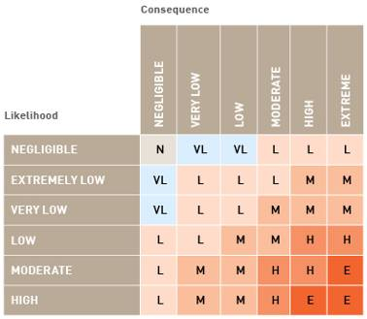

The outcomes of the risk assessments indicate that 56 of the remaining 162 species are identified as having extreme, high or moderate risk in at least one core value category when evaluated for all vessel categories between 2002 and 2007 and for all voyage durations (see Table 11). Eighty-four percent of these 56 species pose a moderate, high or extreme risk to environmental values. Sixty-nine percent of the species pose a moderate, high or extreme risk to economic values. Seventeen percent pose a moderate, high or extreme risk to both social and cultural, and human health core values. A large proportion (43.1%) of species represent a moderate, high or extreme risk to only one core value with 31% of species representing a risk to two core values; 20.7% (Balanus eburneus, Balanus improvisus, Charybdis japonica, Didemnum vexillum, Dreissena bugensis, Dreissena polymorpha, Cliona thoosina, Crassostrea virginica, Mytilopsis sallei, Limnoperna fortunei, Sargassum muticum and Ulva pertusa) are a risk to three core values; and 5.2% (Eriocheir sinensis, Perna perna and Perna viridis) are a risk to four core values. Several of these species, including E. sinensis, P. viridis, P. perna, and M. sallei, have previously been identified as species of concern by Australia.
Several biofouling-associated species not present in Australia that are currently listed by State jurisdictions as species of biosecurity concern are not recorded on this list of biofouling risk species (e.g. the bivalves Ensis directus, Perna canaliculus and the crab Hemigrapsus penicillatus). This outcome is due to a number of reasons–P. canaliculus is not considered to have successfully established as an invader anywhere in the world, despite the previous detection of a small population in South Australia (V. neverauskas, pers. comm.). In contrast, both E. directus and H. penicillatus have a moderate biofouling association, limited recognised global distributions and a poor demonstration of impacts, resulting in risk rankings less than moderate for any individual core value (see Appendix B).
For voyage durations of increasing length, more species are deemed to have a significant and quantifiable risk according to this assessment methodology; Figure 23 illustrates the change in risk categorisation for the four core values. Increasing voyage duration slightly increases the risk categorisation for individual species due to the vessel’s passage through a higher number of bioregions (see Figures 11, 12, 13). However, this assessment found no consequent increase in the identified risk species (see Figure 23). This may be due to the levelling off of the mean number of bioregions entered after 183-day (six months) voyages (see Figure 11).

METHODS AND RESULTS

2.4.1 Assessment and ranking of overall risk
In order to assess and rank overall risk for the 56 identified species, a ranking scheme was devised. This involved assigning a rating for each risk level (1=moderate, 3=high, 5=extreme) and then summing the ratings across the four core values to provide an overall risk value. The ratings used to determine overall risk rankings were as follows:
- moderate: sum of risk ratings = < 3
- high: sum of risk ratings = 3-4
- extreme: sum of risk ratings = ≥ 5
- As can be seen in Table 11, when the risk ratings were summed across the four core values:
- 21 species were in the moderate risk category
- 14 species were in the high risk category
- 21 species were identified in the extreme risk category.
Six species that have overall risk values ≥ 10 (double the extreme value) are B. improvisus, C. japonica, E. sinensis, S. muticum, P. perna and P. viridis. These species represent a suite of global invaders, with documented impacts across a range of values.
METHODS AND RESULTS

Table 11: Species with risk rankings of moderate (M), high (H) or extreme (E) in at least one core value and in at least one voyage duration. Moderate, high and extreme ranks were given scores of 1, 3 and 5 respectively to determine overall risk ratings and overall risk ranks.
Table 11: (continued): Species with risk rankings of moderate (M), high (H) or extreme (E) in at least one core value and in at least one voyage duration. Moderate, high and extreme ranks were given scores of 1, 3 and 5 respectively to determine overall risk ratings and overall risk ranks.

METHODS AND RESULTS

Figure 23: Risk categorisation for environmental (A), economic (B), social/cultural (C) and human health (D) values for voyage durations of 30, 60, 90, 183 and 365 days.
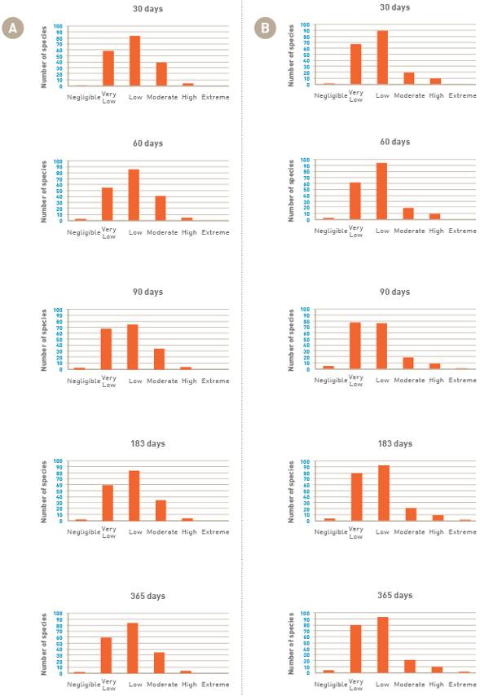
METHODS AND RESULTS

Figure 23: (continued)
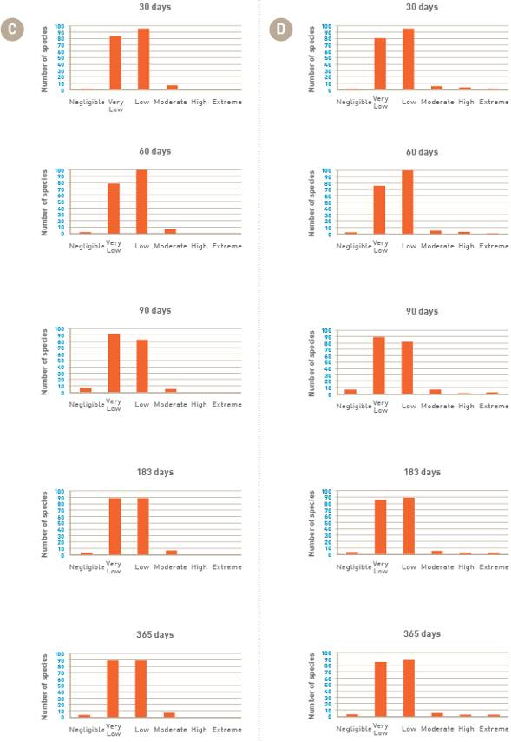
METHODS AND RESULTS

2.5 Potential range of 56 pest species in Australia
An analysis was conducted to determine the potential Australian geographic range for each of 56 selected high risk species (i.e. those ranked in at least one core value as a moderate, high or extreme risk; see Table 11) based on environmental (temperature tolerance) overlap. The aim of this analysis was to determine whether water temperature may be a barrier to domestic spread for any of the 56 species.
The main environmental factor that could be reasonably investigated was water temperature. Sea surface temperature range derived from each species’ current world-wide distribution (hereafter referred to as inferred temperature range) was firstly determined using IUCN bioregion data taken over a 10-year period (Hobday & Hewitt, unpubl. data). (Appendix F describes the bioregions in which each species is found.) Physiological temperature tolerance information was also compiled for those species where such detailed information was available. For each Australian province (see Figure 8), maximum and minimum values for sea surface temperature were then calculated (see Table 12) by combining Australia’s bioregionalisation (Interim Marine Coastal Regionalisation of Australia [IMCRA] 4.0 and the Australian Meso-scale regionalisation) data across these provinces (Hobday & Hewitt, unpubl. data). Temperature tolerance of the various life stages of particular species could then be compared to the sea surface temperature range of each province within Australia (see Figure 24).
The overlap of the species’ combined inferred and physiological temperature tolerance with Australian provinces’ temperature ranges (see Figure 24a) predicts that all of the species are able to survive and reproduce within each of the four provinces. The approach used in this analysis–applying a large-scale distributional temperature range for each species using IUCN boundaries–provides a broader estimate than the known physiological temperature tolerance for most species (see Figure 24b) and a conservative estimate of environmental niche matching. Analysis at a finer spatial scale was not possible as detailed distributional information was largely unavailable for most species. The assumption that species found in an IUCN bioregion are able to exist within all areas of that bioregion is consistent with the approach used in the preceding risk analysis. Large-scale provinces in Australia were used to provide a comparable scale to the IUCN boundaries. Where there was information available for physiological temperature tolerance of particular species (see Figure 24a), this confirmed that these high risk species are likely to survive and be able to reproduce in a wide range of temperatures and in all of Australia’s provinces.
An important factor which influences the establishment of a species at a new location is the temperature tolerance of its larvae, which is often more restricted than the adults’ temperature tolerance (Turoboyski 1973; Romero & Moreira 1980). For example, the metamorphosis of larvae of Rhithropanopeus harrisii is limited to temperatures between 18 ˚C and 30 ˚C (Turoboyski 1973). This may restrict this species’ survival in the Flindersian province to the higher latitudes and summer months. However, this is still in accordance with the prediction that this species can survive in the Flindersian province.
Salinity tolerance was also considered in relation to the potential range of pest species in Australia. Several of the selected species are freshwater species that are not tolerant of salinities greater than 25 ppt. These species include Crangonyx floridanus, Dikerogammarus villosus, Gammarus tigrinus, Gmelinoides fasciatus, Corbicula fluminea, Dreissena bugensis and Dreissena polymorpha. There are only a limited number of Australian ports where freshwater conditions are evident and these conditions are usually only seasonal. Therefore, survival of such freshwater species is unlikely in most Australian ports. In the unlikely event of such freshwater species establishing, there would be extremely limited capacity for domestic spread. Salinities typical of marine environments would prevent natural dispersal around the coast, so domestic spread would be restricted to translocation via anthropogenic vectors.
Factors such as nutrient requirements, habitat specificity and pH tolerance could not be included in the analysis of species’ potential ranges due to the lack of information in the literature and the complexity of the broad provinces considered in this study. For parasitic barnacle species (Briarosaccus callosus, Loxothylacus panopaei and Sylon hippolytes), availability of host species may be a limiting factor, however, insufficient knowledge of potential hosts and their distributions is available to draw conclusions.
METHODS AND RESULTS

Figure 24: Comparison of species’ physiological temperature tolerance versus their inferred temperature tolerance (A); and sea surface temperature ranges for Australian provinces (B).

DISCUSSIONS AND CONCLUSIONS

Table 12: Minimum and maximum sea surface temperatures (SST) for each Australian province derived from IMCRA bioregions.
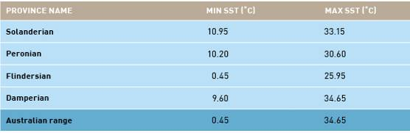

3.0 Discussion and conclusions
It is becoming widely recognised at public and policy levels that invasions of marine species present a clear and significant threat to the environmental, economic, social/cultural and human health values represented by the marine environment (e.g. Lubchenco et al. 1991; Pimentel et al. 2000a; Carlton 2001; Pimentel 2002; Hewitt et al. 2004, 2009a, b). This focus on the protection of the marine environment as well as the goods and service benefits it provides has been termed marine biosecurity (Hewitt et al. 2004, 2009a, b).
Marine biosecurity, specifically in its quarantine phase, relies on the management of risks through identification of hazards and assessment of the likelihood and consequences of those hazards (e.g. Hayes 1997; Hayes & Hewitt 1998, 2000; Hewitt & Hayes 2001; Hayes & Sliwa 2003; Campbell 2005, 2008, 2009; Campbell et al. 2007; Barry et al. 2008). Most marine biosecurity risk assessments focus on minimising the entry of unwanted or potentially harmful species (e.g. Hayes & Sliwa 2003; Campbell 2005, 2008) as evidenced by numerous ‘black lists’ of restricted organisms (e.g. Hayes & Sliwa 2003; Hewitt et al. 2004, 2009a, b). The identification of species for inclusion on ‘black lists’, or for the explicit development of regulations, requires the use of risk assessment.
Several vectors or mechanisms of transport have been implicated in the world-wide transfer of non-indigenous marine species (e.g. Carlton 1979, 1985, 2001; Ribera & Bouderesque 1995; Hewitt et al. 1999, 2004a, b). The global focus on ballast water-mediated marine invasions has dominated marine biosecurity efforts in the past several decades (e.g. Carlton 1985), despite recent work indicating that biofouling represents an equally significant threat (e.g. Hewitt et al. 1999, 2004; Thresher 2000; Gollasch 2002; Hewitt 2002, 2003; Fofonoff et al. 2003; Lewis et al. 2003, 2004; Ribera-Siguan 2003; Floerl & Inglis 2005; Minchin 2006, 2007; Schaffelke et al 2006; Schaffelke & Hewitt 2007; Hewitt & Campbell 2010).
This study clearly demonstrates that a number of exotic species associated with biofouling represent a risk to Australia. Out of the global suite of 1781 marine species with recognised invasion history, 793 were deemed to have some likely association with biofouling of vessels, fisheries or aquaculture gear by Hewitt and Campbell (2010).
Australia has a significant taxonomic knowledge base, with high endemicity (Poore 1995), and has invested in evaluations of its current state of marine introductions through literature and museum collection evaluations (Pollard & Hutchings 1990a, b; Hewitt et al. 1999, 2004) and a series of baseline port surveys (see Campbell et al. 2007; Hewitt & Campbell 2010). The present assessment interrogated this knowledge base and identified 657 of the 793 species as not being present in Australia.
Predicting impact of potential invasive marine species is problematic. Consequently, the predictions made in this report necessarily relied on work from overseas locations and for many species this was not readily available. Impact analyses have been recognised as a critical area of research largely lacking in the literature about invasive species (Carlton 1996; Vermeij 1996; Williamson 1996; Byers et al. 2002).
DISCUSSIONS AND CONCLUSIONS

Consequence was evaluated across the four primary values: environmental, economic, social/cultural and human health. These core values were further divided using a suite of consequence matrices providing explicit exemplars of levels of impact (see Appendix A), including duration of impact (days/months/years), resilience (ability to recover) and scale/extent of impact (local/national/international).
Investigation of the literature found that only 162 species of the 657 not found in Australia had inferred or demonstrable impacts. As discussed previously, no investigations were found in the literature for 495 species to suggest that they were of insufficient interest to warrant investigation (and therefore were unlikely to have any inferred impact). An alternative reason for the lack of information in the literature may be that investigations had been undertaken which resulted in negative results, but details of these examinations remained unpublished (Jennions & Møller 2002; Dickersin & Min 2006). Additionally, a number of species for which investigations had been undertaken were found to have no impact (e.g. Forrest & Taylor 2002).
Furthermore, the evaluation relied on readily available literature, but was largely drawn from publications supplied in English and heavily weighted to North American, European and Australasian (Australia and New Zealand) regions. Regardless, only 162 species were found to have any discernable impact, resulting in a restricted set of species for analyses. Clearly some of the unstudied species could pose a threat to Australia across the four core values and would therefore be a priority for further investigation. For the purposes of this report, however, species with no inferred or demonstrated impact were excluded from further consideration.
For the 162 species, a further assessment of association with biofouling was coupled with an evaluation of transport pressure based on global distribution of the species (in both native and introduced bioregions). This enabled identification of the number of vessels arriving in Australia that could have transported the species to the continent’s waters. This required a number of critical assumptions, including:
- a species’ presence in a bioregion represents an established population throughout the bioregion
- all vessel categories are equally able to transport all species
- all trade routes from bioregions to Australia are equally ‘stressful’.
These assumptions represent conservative approaches to the information available. The ability to discern a non-indigenous marine species’ presence in overseas ports can be problematic (e.g. Hayes & Hewitt 1998, 2000; Hewitt & Hayes 2001, 2002; Barry et al. 2008). While there have been numerous efforts to provide current information on invasions into various global regions (see Campbell et al. 2007 for review), the information is typically out-of-date by the time it is in the peer-reviewed literature. Assuming that a report of a species in a bioregion represents an established population, this allows a risk manager to use the information in making an assessment. Similarly, assuming that a species is spread throughout the bioregion, when it may have only been reported from one location, addresses the significant lag time between incursion, detection and reporting. During this period, which can span more than a decade, the opportunity for the species to have spread through natural and human-mediated means creates the high likelihood that nearby regions and ports will have been infected.
Vessel category has been clearly recognised elsewhere as having characteristics that could influence inoculation pressure (e.g. Carlton 1985, 2001; Carlton & Hodder 1995; Coutts 1999; Wonham et al. 2000; Floerl 2002; Coutts & Dodgshun 2007; Piola et al. 2008). Vessel behaviours differ significantly both individually and across vessel categories. These behavioural differences include, but are not limited to, vessel speed, time spent in port, and maintenance history.
An evaluation of vessel speed based on the Lloyds MIU dataset indicated that no clear differentiation could be discerned by using the gross scale of vessel categories applied in this assessment. Clearly, some vessel types move at much slower speeds than others, and recent reports suggest that slower moving and sedentary vessels, including barges, dredges, drilling rigs and FPSOs, may harbour larger quantities and diversity of species than other vessels (e.g. Coutts 2002; Floerl 2002; Floerl & Inglis 2005; Davidson et al. 2009; Coutts et al. 2010). The relationship, however, between a vessel’s maximum, or even mean, speed (representing sheer forces) and the successful transport of species to new regions remains unclear.
The presence of hydrodynamically protected or niche areas on a vessel’s hull, such as sea-chests, rudders and propeller shafts (e.g. Clapin & Evans 1995; Gollasch 2002; Hayes 2002; Coutts et al. 2003; Coutts & Taylor 2004; Hayes et al. 2004b; Coutts & Dodgshun 2007) nevertheless, suggests that speed alone will not preclude a species’ presence on a vessel, but may significantly reduce its abundance. Coutts (1999) evaluated commercial (merchant) vessels entering Bell Bay in Tasmania, Australia, and found that speed was a good correlate of species abundance and a moderate correlate for diversity. However, this study concentrated on the uniform areas of the hull surface and did not explore niche or protected areas of a vessel's hull.

DISCUSSIONS AND CONCLUSIONS

Time spent in port by various vessel categories provides a clear indication of differences in opportunity for species to settle on the vessel (assumed to correlate with time in port). This factor has been used as a multiplier of vessel visits from a bioregion in this assessment to account for the increased likelihood that a species would be transported. The accumulation of biofouling in a small area of a vessel is unlikely to be a linear process; however, across the entire wettable surface area of a vessel, a species’ accumulation may be assumed to be linear as described by the weighting function used here. Indeed the accumulation of species onto settlement panels often follows an exponential increase in diversity as the habitat increases in complexity (Sutherland & Karlson 1977). At some point, however, an asymptote (a levelling off) of the species’ accumulation is expected to occur in the local patch, or more broadly once the community accumulates the entire species pool from a bioregion (Rosenzweig 2001). How rapidly the community is assembled varies widely across regions and time of year (Sutherland & Karlson 1977; Lewis 2002; Lewis et al. 2004; Dunstan & Johnson 2006).
As voyage duration increases, the number of bioregions visited was found to rise in a step-wise pattern with a mode after 90 days around three bioregions. Taking into account the expected operational cycle of vessels between dry-docking and antifouling paint applications, coupled with the restrictions placed on in-water cleaning in many jurisdictions, most vessels will be expected to have significant communities of species. Based on the assessment of voyage duration, multiple bioregions are visited by half of the vessels travelling for periods of less than one year. This in turn increases the opportunity for species from disparate regions to attach to the hull and also increases the total likelihood for individual species to be transported. Given that some vessels entering Australia in the study period (2002 to 2007) had participated in voyages of at least 183 days (six months), all 18 bioregions had been visited by at least one vessel entering Australia.
A number of vessel characteristics could not be evaluated and did not contribute to the final evaluation. As previously noted, vessel speed did not differentiate between vessel categories, but varied widely within several categories. Antifouling paint history, coupled with more generic hull husbandry information, could potentially provide significant information on the likely state of biofouling. However, this information could not be obtained at the scale required, and therefore could not be included in this assessment.
Of the 162 species for which inferred or demonstratable impacts across one or more of the core values (environmental, economic, social/cultural and human health) were recovered in the literature, and for which inoculation likelihood was assessed, a restricted suite of 56 species were deemed to have a risk equal to or greater than moderate. This outcome represents a similar level of risk as identified by previous evaluations for ballast water-vectored species (Hayes & Sliwa 2003; Hayes et al. 2004a).
Several of these species exhibit risk across multiple values. For example, the Asian green mussel (P. viridis), brown mussel (P. perna) and Chinese mitten crab (E. sinensis) are ranked as moderate to extreme risk across all four values. The use of multiple values, against which risk is assessed, provides a broader understanding of the threats to Australia’s marine environment and its maritime economy. By presenting risk in this manner, managers can better represent the threats to those elements that stakeholders find most relevant.
The 56 species identified as representing an increased risk to Australia include species that impact aquaculture activities, coastal industries, wild fisheries and other living marine resources, protected and habitat-forming species, social/cultural values and human health (see Table 11 and Appendix F). Several have already been identified as ‘next pests’ by marine researchers (e.g. Hayes & Sliwa 2003; Hayes et al. 2004a). The 56 species listed in Table 11 are all likely to arrive (inoculate) and establish in at least two major provinces of Australia. Subsequent spread is likely as the same methods for international inoculation and establishment will be used to facilitate domestic spread.
In conclusion, a total of 56 species were found to pose a risk greater than moderate when assessed across all vessel entries to Australia. This assessment explicitly analysed these species for establishment and spread endpoints and found that all species had the likelihood to establish in some location of Australia and subsequently spread.

GLOSSARY

AFMA dataset An internal database maintained by the Australian Fisheries Management Authority (AFMA) of illegal foreign fishing vessels.
Antifouling paint Any coating (generally applied as a paint) specifically designed to prevent or deter the settlement and growth of biofouling organisms on a submerged surface (e.g. vessel hull), including biocidal coatings and fouling-release coatings.
AQIS pratique dataset Australian Quarantine and Inspection Service (AQIS) vessel monitoring system dataset; an internal electronic system maintained by AQIS.
Australian waters Includes State and Territory coastal waters, territorial seas, contiguous zones and Australia’s exclusive economic zone which extends 200 nautical miles (370 km) out from Australia’s coastline. This term also covers the joint petroleum development area–an area of the Timor Sea with overlapping territorial claims between Australia and Timor Leste.
Ballast water Any water (including associated sediments) taken on board a vessel for the express purpose of maintaining its trim and stability during a voyage.
Benthic species Flora and fauna found on, or associated with, the ocean floor.
Biofouling Marine organisms attached to: any submerged artificial structure, including wharves, jetties and any part of a vessel hull (including the rudders, propellers and other hull appendages); internal seawater systems (including sea-chests and pipe work); or equipment or equipment spaces attached to or onboard the vessel (including mooring devices, anchor wells, cable lockers, cargo spaces, bilges, etc).
Bioregion An area constituting a natural ecological community with characteristic flora, fauna and environmental conditions, and bounded by natural rather than artificial borders.
Biosecurity Managing the risks associated with pests and diseases which could potentially cause harm to human, animal or plant health, as well as the environment or economy, from entering, emerging, establishing or spreading in a given area.
Biotic resistance The hypothetical resistance to new species entering a community by the existing members. Elton (1957) suggested that well connected, species-rich communities would naturally resist new species entering by predation, parasitism, and direct and indirect competition.
Colonise Larvae or propagules that successfully settle and establish on a submerged substrate.
Commercial vessel Vessel that carries or exchanges commodities or people. This vessel category includes: asphalt tankers; bulk carriers; bulk carriers with container capacity; bulk cement carriers; bulk ore carriers; bunkering tankers; chemical tankers; combined bulk and oil tankers; combined chemical and oil tankers; combined LNG and LPG gas carriers; combined ore and oil carriers; crude oil tankers; fully cellular containerships; general cargo ships; general cargo ships with container capacity; liquid natural
gas carriers; liquid petroleum gas carriers; livestock carriers; passenger (cruise) ships; passenger roll-on roll-offs; reefers; roll-on roll-offs; roll-on roll-offs with container capacity; tankers (unspecified); vehicle carriers; and wood-chip carriers.
Consequence The likely impact or magnitude of an adverse event or hazard.
Demonstrable impact An impact that has been scientifically demonstrated through observation and/or empirical evaluation.
Donor port The port from which a species is likely to be transported to a receiving port or region.
Dry and semi-dry ballast The largely historic use of rocks, cobble, sand and other dry substances to help maintain the trim and stability of a vessel. Semi-dry refers to the wet nature of the bilge, providing a humid environment.
Endpoint An expression of the thing(s) that you are trying to prevent, achieve, protect or manage through risk analysis. Endpoints in a marine biosecurity context are generally either quarantine-based (prevention of entry) or impact-based (prevention of impact).
Epibenthic species Living on the surface of the benthic substrate on the bottom of the ocean or estuary.
Epifauna An animal growing on top of the substrate.
Established species A non-indigenous species that produces a self-sustaining population which reproduce and recruit individuals to replace loss from the population.
Establishment A non-indigenous species that is inoculated into the new (introduced) environment and recruits, settles or attaches and subsequently survives in the new environment. Establishment also includes survival and development of a self-sustaining population.
Event In risk assessment, an event (often referred to as a hazard) is an activity that may lead to an undesirable outcome.
Fecundity The number of offspring produced, usually by an individual.
Fishing vessel Legal commercial vessels engaged in the industry of capturing wild stocks, including: fishing (general); trawler (all types); whaler; fish carrier; and fish factory.
Freshwater species For the purposes of this report, freshwater species are defined as species restricted to water of less than 3 ppt salinity.
Hazard A situation or event that could lead to harm.
Hull The wetted (submerged) surfaces of a vessel, including its propulsion and steering gear, internal cooling circuits, sea strainers, bow and stern thrusters, transducers, log probes, anchors, anchor chains, anchor lockers and bilge spaces.
Illegal foreign fishing vessel (IFFV) Foreign vessel apprehended for fishing illegally in Australia.
Indigenous or native Species that are naturally occurring in a region, having evolved or migrated into a region without human intervention.

GLOSSARY

Infauna An animal growing inside a substrate.
Infect Transfer of a species to a transport vector (vessel), such as the settlement of benthic organisms onto a vessel hull.
Inferred impact An impact that is identified by an expert as possible or probable, however, has not been empirically demonstrated.
Inoculate/inoculation Release of a non-indigenous marine species into the surrounding environment. Includes release of offspring, fragments and/or direct transfer of individuals, but does not infer successful establishment.
Inoculation likelihood The probability of a species arriving in a new location. For the purposes of this report it is a categorical ranking of the probability of arrival in Australia for individual species combining a species, biofouling association rank with the transport likelihood (the proportion of vessels arriving from regions where the species is known to be present).
Introduced, non-indigenous, exotic marine species Species that have been transported by human activities–intentionally or unintentionally–into a region in which they did not historically occur.
Introduction The human-mediated movement of an animal to an area outside its natural range.
Invasional meltdown The hypothetical situation where one invading species can facilitate subsequent invasions thereby creating a positive feedback loop.
Invasive species A species (or organisms) that cause, or is likely to cause, damage to the environment, economy (e.g. agricultural or aquaculture activities, wild fisheries stocks) or human health.
Last port of call The last official port visited by a vessel prior to entering another port jurisdiction.
Likelihood The probability or frequency of an adverse event or hazard occurring.
Lloyds MIU Lloyds Maritime Intelligence Unit.
Marine pest Any exotic marine species that poses a threat to the marine environment, economy (industry), societal values or human health if introduced, established or translocated.
Meroplankton Category of organisms that spend a part of their life cycle in the water column as plankton. For invertebrates and many fishes, the planktonic stage is usually the larval stage.
Naval vessels Naval vessels and auxiliary tankers.
Next port of call The next official port to be visited by a vessel after leaving a port jurisdiction.
Non-trading vessel Vessel category that includes: barge; cable ship; crane ship; cutter suction dredger; dredger; ferry; fire fighting tug; fire fighting tug supply; fishery protection; grab dredger; hopper barge; hopper dredger; icebreaker; landing craft; lighthouse/tender; meteorological research;
oceanographic research; patrol ship; pollution control vessel; pontoon; pusher tug; research; research/supply ship; salvage tug; seismographic research; semi-submersible heavy lift vessel; suction dredger; tank barge; trailing suction hopper dredger; training; tug; tug/supply; and yachts >25 m or super-yachts.
Petroleum vessel Vessel category that includes: anchor handling fire fighting tug/supply; anchor handling tug/supply; diving support; drill platform; drill ship; floating gas production; floating production tanker; floating storage tanker; offshore safety; pipe layer; product tanker; supply; and support.
Plankton Collective name for all the forms of drifting or floating organic life found in the ocean or in fresh water.
Primary biofouling First stage or level of biofouling and includes the biochemical and bacterial conditioning of a submerged surface and the accumulation of microalgae (<1 mm) and filamentous algae (<5 mm).
Primary literature Peer reviewed journals and books, generally presenting original findings.
Propagules Reproductive offspring of aquatic invertebrates (larvae) and algae (propagules) and/or individuals.
Qualitative A subjective assessment that does not necessarily involve any measurements and often uses non-quantifiable information.
Qualitative risk assessment Risk assessment that relies on subjective assessments, including heuristic assessments of expert or stakeholder opinion.
Quantitative An objective assessment in which measurements will be, or have been, made (e.g. mean number of organisms per sampling unit).
Quantitative risk assessment Also known as probabilistic risk assessment, it involves assessors describing the elements of risk (i.e. likelihood and consequence) numerically. However, this is often replaced with qualitative descriptors representing categories or bands of numerical risk (this is often referred to as semi-quantitative risk assessment).
Recreational vessel Non-commercial vessel designed for non-commercial use, intended to be operated by, and carry, at least one person within the confines of a hull. For the purposes of this report, recreational vessels are restricted to vessels <25 m, and recreational vessels >25 m are reported as ’non-trading vessels‘, due to variations in regulatory controls across Australia. Windsurfers, surfboards, rafts and tubes are not considered recreational vessels.
Recruitment The post-settlement survival of an individual or species within a defined time period.
Reproductive phenology The timing and period (duration) of reproductive activity for an individual species.
Risk The product of likelihood (frequency) and magnitude (consequence) of an event or hazard.

GLOSSARY

Risk analysis Risk analysis is made up of three components: risk assessment, risk management and risk communication. The process seeks to identify the relevant risks associated with a proposed introduction and to assess each of those risks.
Risk assessment The method used to determine the likelihood (frequency) of a particular event (risk) occurring and its possible consequences (magnitude). In a marine biosecurity context, risk assessment consists of five steps: identifying endpoints, identifying hazards, determining likelihood, determining consequences and calculating risk.
Sea-chests Recesses built into a vessel’s hull below the waterline that house the seawater intake pipes used for ballast uptake, engine cooling, fire-fighting and other onboard functions.
Secondary biofouling Second stage of biofouling which can take the form of acorn and gooseneck barnacles, bryozoans, hydroids, serpulid worms, spirorbid worms, algal tufts, coralline algae, or amphipods.
Secondary literature Generally non-peer reviewed literature, including ‘grey’ literature such as websites, policy documents, databases, reports; also includes encyclopaedias and dictionaries.
Sedentary Species that are unattached or weakly attached to the substratum, but generally do not significantly move around (e.g. seastars, anemones, some clams).
Semi-quantitative risk assessment The replacement of continuous numerical values describing the elements of risk (likelihood and consequence) with qualitative descriptors representing categories or bands of numerical risk.
Sessile Species such as sponges, corals and barnacles that are firmly attached to the hard substratum.
Settlement In a marine ecology context, it is the process of a species transferring from the water column to the benthic substrate, usually associated with metamorphosis from larvae (juvenile phase) to adult. Settlement represents the act of settling, whereas recruitment is a term that infers survival after some period of time post-settlement.
Spread The movement and establishment of a species, either by natural or human-mediated means into new locations beyond their first site of establishment.
Tertiary biofouling Third and final stage of biofouling that is characterised by the presence of sponges, ascidians, mussels, oysters, clams, gastropods, crabs, shrimp, seastars, sabellid worms, sea anemones and macroalgae.
Translocation The movement of an organism from one place to another.
Transport pressure Number of vessels arriving from a particular bioregion multiplied by a port duration weighting.
This number is then summed within each of the 18 bioregions. For each species, the weighted number of vessels arriving from all bioregions where the species is present is summed, providing a cumulative number of vessel opportunities for that species to be transported into Australia. This value is then divided by the unweighted number of vessels entering Australia to provide the percentage of total opportunities for entry.
Vagility The distance moved by an organism; the ease with which an organism moves away from its place of birth.
Vector The physical means, agent or mechanism which facilitates the transfer of organisms or their propagules from one place to another. In a marine biosecurity context, this includes ships’ ballast water, ships’ hulls, movements of commercial oysters, and live seafood.
Vessel Any ship, barge, mobile drilling unit, work boat, craft, launch, submersible, etc

REFERENCES

Acosta H & Forrest BM 2009, ‘The spread of marine non-indigenous species via recreational boating: A conceptual model for risk assessment based on fault tree analysis’, Ecological Modelling, vol. 220, pp. 1586-1598.
Australian Fisheries Management Authority (AFMA) 2009, viewed 10 July 2009, <http://www.afma.gov.au/fisheries/tuna/etbf/default.html>.
Ammons D, Rampersad J & Poli MA 2001, Toxicon, vol. 39, pp. 889-892.
Australian and New Zealand Environment and Conservation Council 1997, Working together to reduce the impacts from shipping operations: ANZECC strategy to protect the marine environment, Code of Practice for antifouling and in-water hull cleaning and maintenance, p. 12.
Aquenal Pty Ltd, ‘Identifying Biofouling on Commercial Fishing Vessels (DAFF 05/2007)’, unpublished report to the Australian Government Department of Agriculture, Fisheries and Forestry.
Ashton G, Boos K, Shucksmith R & Cook E 2006, ‘Risk assessment of hull fouling as a vector for marine non-natives in Scotland’, Aquatic Invasions, vol. 1, pp. 214–218.
Australian Greenhouse Office, Canberra, Australia.
Bailey-Brock JH 1990, Pacific Science, vol. 44, pp. 81–87.
Balcom NC 1994, ‘Aquatic Immigrants of the Northeast, No. 4: Asian Clam, Corbicula fluminea’, Connecticut Sea Grant College Program, viewed 8 March 2010, <http://www.sgnis.org/publicat/nespp_4.htm>.
Barry S, Hayes KR, Hewitt CL, Behrens HL, Dragsund E & Bakke SM 2008, ‘Ballast water risk assessment: principles, processes and methods’, ICES Journal of Marine Science, vol. 65, pp. 121–131.
Bayne BL 1965, ‘Growth and the delay of metamorphosis of the larvae of Mytilus edulis L. (Mollusca) Ophelia, vol. 2, pp. 1–47.
Bergstrom P 2004, ‘An introduction to dark false mussels’, NOAA Chesapeake Bay Office, viewed 29 May 2009, <http://www.chesapeakebay.net/pubs/calendar/LRSC_09-30-04_Presentation_1_5352.pdf>.
Bishop MWH 1951, ‘Distribution of barnacles by ships’, Nature, vol. 167, p. 531.
Boudreaux ML, Walters LJ & Rittschof D 2009, ‘Interactions between native barnacles, non-native barnacles, and the eastern oyster Crassostrea virginica,’ Bulletin of Marine Science, vol. 84, pp. 43–57.
Bower SM & Boutillier JA 1990, ‘Sylon (Crustacea: Rhizocephala) infections on the shrimp in British Columbia’, in Perkins FO & Cheng TC (eds), Pathology in Marine Science, Academic Press, pp. 267–275.
Britton-Simmons KH 2004, ‘Direct and indirect effects of the introduced alga Sargassum muticum on benthic, subtidal communities of Washington State, USA’, Marine Ecology Progress Series, vol. 277, pp. 61–78.
Britton-Simmons KH & Abbott KC 2008, ‘Short- and long-term effects of disturbance and propagule pressure on a biological invasion’, Journal of Ecology, vol. 96, pp. 68–77.
Bruce BD, Sutton CA & Lyne V 1995, Final report to the Fisheries Research and Development Corporation, CSIRO.
Bullard SG, Lambert G, Carman MR, Byrnes J, Whitlatch RB, Ruiz G, Miller RJ, Harris L, Valentine PC, Collie JS, Pederson J, McNaught DC, Cohen AN, Asch RG, Dijkstra J & Heinonen K 2007, The Colonial ascidian Didemnum sp. : current distribution, basic biology and potential threat to marine communities of the northeast and west coasts of North America. Journal of Experimental Marine Biology and Ecology, vol. 342, pp. 99–108.
Buttermore RE, Turner E & Morrice MG 1994, ‘The introduced northern Pacific seastar Asterias amurensis in Tasmania’, Memoirs of the Queensland Museum, vol. 36, pp. 21–25.
BWM 2005, International Convention on the Control and Management of Ship’s Ballast Water and Sediments, International Maritime Organization, London, United Kingdom, viewed 20 May 2009, <http://www.imo.org>.
Byers JE & Pringle JM 2006, ‘Going against the flow: retention, range limits and invasions in advective environments’, Marine Ecology Progress Series, vol. 313, pp. 27–41.
Byers JE, Reichard S, Randall JM, Parker IM, Smith CS, Lonsdale WM, Atkinson IAE, Seastedt TR, Williamson M, Chornesky E & Hayes D 2002, ‘Directing research to reduce the impacts of nonindigenous species’, Conservation Biology, vol. 16, pp. 630–640.
Byrd DM & Cothern CR 2005, Introduction to risk analysis. A systematic approach to science-based decision making, Government Institutes, Maryland, United States.
Campbell ML 2005, ‘Organism Impact Assessment (OIA) for potential impacts of Didymosphenia geminata’, technical report prepared for Biosecurity New Zealand, viewed 24 October 2007, <http://www.biosecurity.govt.nz/files/pests-diseases/plants/didymo/didymo-org-ia-oct-05.pdf>.
Campbell ML, Galil B, Gollasch S & Occhipinti-Ambrogi A 2007, ‘Guidelines for controlling the vectors of introduction into the Mediterranean of non-indigenous species and invasive marine species’, Regional Activities Center for Specially Protected Areas (RAC/SPA, UNEP), Tunisia, 24pp, viewed 17 March 2010, <http://www-3.unipv.it/det/ecologia/GuidelinesMED.pdf>.
Campbell ML 2008, ‘Organism impact assessment: Risk analysis for post-incursion management’, ICES Journal of Marine Science, vol. 65, pp. 795–804.
Campbell ML 2009, ‘An overview of risk assessment in a marine biosecurity context’, in Rilov G & Crooks J (eds), Marine bioinvasions. Ecology, conservation, and management perspectives, Springer-Verlag, Berlin, ch. 20, pp. 353–374.
Campbell ML & Gallagher C 2007, ‘Assessing the relative effects of fishing on the New Zealand marine environment through risk analysis’, ICES Journal of Marine Science, vol. 64, pp. 256–270.
Campbell ML, Gould B & Hewitt CL 2007, ‘Baseline survey evaluations and surveillance techniques to assess marine bioinvasions’, Marine Pollution Bulletin, vol. 55, pp. 360–378.
Campbell ML & Hewitt CL 2008a, ‘Introduced marine species risk assessment – aquaculture’, technical report in ‘Proceedings of the risks in aquaculture workshop’ (held in Rayong, Thailand), FAO, Rome.
Campbell ML & Hewitt CL 2008b, Risk analysis–MV Leonardo da Vinci dredge vessel domestic transfers between Port Hedland and Botany Bay return, technical report prepared for National Centre for Marine and Coastal Conservation.
Campbell ML, Grage A, Mabin C & Hewitt CL 2009, ‘Conflict between international treaties: failing to mitigate the effects of introduced marine species’, Dialogue, vol. 28, no. 1, pp. 46–56.

REFERENCES

Campbell ML, Cassidy, M, Gould, B & Hewitt, C.L. (accepted), ‘Marine biosecurity risk evaluation to protect high-value areas of New Zealand’, Conservation Biology.
Campbell SJ & Burridge TR 1998, ‘Occurrence of Undaria pinnatifida (Phaeophyta, Laminariales) in Port Phillip Bay, Victoria, Australia’, Marine and Freshwater Research, vol. 49, pp. 379-381.
Carlton JT 1979, ‘History, biogeography and ecology of the introduced marine and estuarine invertebrates of the Pacific Coast of North America’, PhD dissertation, University of California, United States.
Carlton JT 1985, ‘Transoceanic and interoceanic dispersal of coastal marine organisms: the biology of ballast water’, Oceanography and Marine Biology Annual Review, vol. 23, pp. 313–371.
Carlton JT 1989, ‘Man’s role in changing the face of the ocean: Biological invasions and implications for conservation of nearshore environments’, Conservation Biology 3, pp. 265–273.
Carlton JT 1996, ‘Pattern, process, and prediction in marine invasion ecology’, Biological Conservation, vol. 78, pp. 97–106.
Carlton JT & Geller JB 1993, ‘Ecological roulette: the global transport of nonindigenous marine organisms’, Science, vol. 261, pp. 78–82.
Carlton JT & Hodder J 1995, ‘Biogeography and dispersal of coastal marine organisms: experimental studies on a replica of a 16th-century sailing vessel’, Marine Biology, vol. 121, pp. 721–730.
Carlton JT 2001, Introduced Species in U.S. Coastal Waters: Environmental Impacts and Management Priorities, Pew Oceans Commission, Virginia, United States, 28 pp.
Castilla JC, Uribe M, Bahamonde N, Clarke M, Desqueyroux-Faúndez R, Kong I, Moyano H, Rozbaczylo N, Santilices B, Valdovinos C & Zavala P 2005, ‘Down under the southeastern Pacific: marine non-indigenous species in Chile,’ Biological Invasions, vol. 7, pp. 213–232.
Clapin G & Evans DR 1995, The status of the introduced marine fanworm Sabella spallanzanii in Western Australia: a preliminary investigation, Centre of Research on Introduced Marine Pests, technical report no. 2, CSIRO Division of Fisheries, Hobart, Australia, p. 34.
Cohen AN 2005a, ‘Guide to the exotic species of San Francisco Bay’, San Francisco Estuary Institute, Oakland, California, United States, viewed 18 October 2009, <http://www.exoticsguide.org>.
Cohen, AN 2005b, ‘Guide to the exotic species of San Francisco Bay’, San Francisco Estuary Institute, Oakland, California, United States, viewed 30 November 2009, <http://www.exoticsguide.org/species_pages/c_amurensis.html>.
Cohen AN 2005c, ‘Guide to the exotic species of San Francisco Bay’, San Francisco Estuary Institute, Oakland, California, United States, viewed 30 November 2009, <http://www.exoticsguide.org/species_pages/m_arenaria.html>.
Cohen AN 2007, ‘Potential distribution of zebra mussels (Dreissena polymorpha) and quagga mussels (Dreissena bugensis) in California: Phase 1 report’, report prepared for the California Department of Fish and Game, viewed 16 October 2009, <http://www.sfei.org/staffpubs_pages/pubs_cohen.htm>.
Cohen AN & Weinstein A 2001, ‘The potential distribution of Chinese mitten crabs (Eriocheir sinensis) in selected waters of the western United States with U.S. Bureau of Reclamation facilities’, Tracy Fish Collection Facilities Studies, vol. 21, p. 61.
Cohen BF, Currie DR & McArthur MA 2000, ‘Epibenthic community structure in Port Phillip Bay, Victoria, Australia’, Marine and Freshwater Research, vol. 51, pp.689–702.
Cohen BF, Heislers S, Parry G, Asplin M, Werner G & Restall J 2002, Exotic marine pests in the outer harbour of the Port of Adelaide, South Australia, report for Marine and Freshwater Resources Institute, Queenscliff, Victoria, Australia, no. 40.
Cook EJ, Arsenault G, Ashton G, Barnette P, Campbell M, Clark P, Coutts A, Gollasch S, Hewitt C, Liu H, Minchin D, Ruiz G & Shucksmith R 2008, ‘Non-native aquaculture species releases: implications for aquatic ecosystems’, in Holmer M, Black K, Duarte C, Karakassis Y & Marbà N (eds), Aquaculture in the Ecosystem, Springer, Heidelberg, Germany, ch. 5, pp. 155–184.
Costlow JD & Bookhout CG 1957, ‘Larval development of Balanus eburneus in the laboratory’, Biological Bulletin, vol. 112, pp. 313–324.
Coutts ADM 1999, ‘Hull fouling as a modern vector for marine biological invasions: investigation of merchant vessels visiting northern Tasmania’, unpublished MSc. thesis, Australian Maritime College, Launceston, Tasmania, Australia.
Coutts ADM 2002, ‘A biosecurity investigation of a barge in the Marlborough Sounds’, Cawthron Report, no. 744.
Coutts ADM, Moore KM & Hewitt CL 2003, ‘Ships’ sea-chests: an overlooked transfer mechanism for non-indigenous marine species?’, Marine Pollution Bulletin, vol. 46, no. 11, pp. 1510–1512.
Coutts ADM & Taylor MD 2004, ‘A preliminary investigation of biosecurity risks associated with biofouling on merchant vessels in New Zealand’, New Zealand Journal of Marine and Freshwater Research, vol. 38, pp. 215–219.
Coutts ADM & Dodgshun T 2007, ‘The nature and extent of organisms in vessel sea-chests: a protected mechanism for marine bioinvasions’, Marine Pollution Bulletin, vol. 54, pp. 875–886.
Coutts ADM, Piola RF, Hewitt CL, Connell SD & Gardner JPA 2010, ‘Effect of vessel voyage speed on the survival and translocation of hull fouling organisms’, Biofouling, vol. 26, pp. 1–13.
Cranfield HJ, Gordon DP, Willan RC, Marshall BA, Battershill CN, Francis MP, Nelson WA, Glasby CJ & Read GB 1998, Adventive Marine Species in New Zealand, technical report prepared for National Institute of Water and Atmospheric Research, Wellington, New Zealand, no. 34.
Critchley AT, Farnham WF & Morrell SL 1986, ‘An account of the attempted control of an introduced marine alga Sargassum muticum in Southern England UK’, Biological Conservation, vol. 35, pp. 313–332.
Crosby AW 1986, Ecological Imperialism: The Biological Expansion of Europe, 900-1900, Cambridge University Press, Cambridge.
Crosier DM & Molloy DP 2008, ‘Killer shrimp–Dikerogammarus villosus’, viewed 16 October 2009, <http://el.erdc.usace.army.mil/ansrp/dikerogammarus_villosus.pdf>.
Dafforn KA, Glasby TM & Johnston EL 2008, ‘Differential effects of tributyltin and copper antifoulants on recruitment of non-indigenous species’, Biofouling, vol. 24, pp. 23–33.

REFERENCES

Darrigan G & de Drago IE 2000, ‘Invasion of Limnoperna fortunei in America’, Nautilus, vol. 2, pp. 69–74.
Davison DM 1996, Sargassum muticum in Strangford Lough, 1995–1998: A review of the introduction and colonisation of Strangford Lough MNR and cSAC by the invasive brown algae Sargassum muticum, report to the Environment and Heritage Service, Department of Environment, Northern Ireland.
Davidson IC, McCann LD, Fofonoff PW, Sytsma MD & Ruiz GM 2009, ‘The potential for hull-mediated species transfers by obsolete ships on their final voyages’, Diversity and Distributions, vol. 14, pp. 518–529.
Day RL & Blake JA 1979, ‘Reproduction and larval development of Polydora giardi Mesnil (Polychaeta: Spionidae)’, Biological Bulletin, vol. 156, pp. 20–30.
Den-Hartog C 1997, Is Sargassum muticum a threat to eelgrass beds?, Aquatic-Botany, vol. 58, pp. 37–41.
Department of Climate Change, Australian Government, Canberra, www.greenhouse.com.au/impacts/publications/marinelife.html>.
DeRivera CE, Hitchcock NG, Teck SJ, Steves BP, Hines AH & Ruiz GM 2007, ‘Larval development rate predicts range expansion of an introduced crab’, Marine Biology, vol. 150, pp. 1275–1288.
Deysher L & Norton TA 1982, ‘Dispersal and colonisation in Sargassum muticum (Yendo) Fensholt’, Journal of Experimental Marine Biology and Ecology, vol. 56, pp. 179–195.
di Castri F 1989, ‘History of biological invasions with special emphasis on the Old World’, in Drake JA, Mooney HA, di Castri F, Groves RH, Kruger FJ, Rejmánek M & Williamson M (eds), Biological Invasions: A Global Perspective, SCOPE 37, John Wiley and Sons, New York, pp. 1–30.
Diamond J 1998, Guns, germs and steel: the fates of human societies, W.W. Norton & Company, New York.
Dickersin K & Min Y-I 2006, ‘Publication bias: the problem that won’t go away’, Annals of the New York Academy of Sciences, vol. 703, pp. 135–148.
Dineen JF & Hines AH 1991, ‘Interactive effect of salinity and adult extract upon settlement of estuarine barnacle Balanus improvisus (Darwin, 1854)’, Journal of Experimental Marine Biology and Ecology, vol. 156, pp. 239–252.
Dineen JF, Clark PE, Hines AH, Reed SA & Walton HP 2001, ‘Life history, larval description, and natural history of Charybdis hellerii (decapoda, Brachyura, Portunidae), an invasive crab in the western Atlantic’, Journal of Crustacean Biology, vol. 21, pp. 774–805.
Dunstan PK & Bax NJ 2007, ‘How far can marine species go? Influence of population biology and larval movement on future range limits’, Marine Ecology Progress Series, vol. 344, pp. 15–28.
Dunstan PK & Johnson CR 2006, ‘Linking richness, community variability, and invasion resistance with patch size’, Ecology, vol. 87, pp. 2842–2850.
Eldredge L G & Carlton JT 2002, ‘Hawaii marine bioinvasions: a preliminary assessment’, Pacific Science, vol. 56, pp. 211–212
Elton C 1958, The Ecology of Invasions by Plants and Animals, Methuen and Co., London, p. 181.
Fiala M & Oriol L 1990, ‘Light-temperature interactions on the growth of Antarctic diatoms’, Polar Biology, vol. 10, pp. 629–636.
Floerl O 2002, ‘Intracoastal spread of fouling organisms by recreational vessels’, PhD thesis, James Cook University, Townsville, p. 283.
Floerl O & Inglis GJ 2003, ‘Boat harbour design can exacerbate hull fouling’, Austral Ecology, vol. 28, pp. 116–127.
Floerl O & Inglis GJ 2005, ‘Starting the invasion pathway: The interaction between source populations and human transport vectors’, Biological Invasions, vol. 7, pp. 589–606.
Floerl O, Inglis GJ & Hayden BJ 2005, ‘A risk-based predictive tool to prevent accidental introductions of nonindigenous marine species’, Environmental Management, vol. 35, pp. 765–778.
Floerl O, Inglis GJ, Dey K & Smith A 2009, ‘The importance of transport hubs in stepping-stone invasions’, Journal of Applied Ecology, vol. 46, pp. 37–45.
Fofonoff PW, Ruiz GM, Stevens B, & Carlton JT 2003, ‘In ships or on ships? Mechanisms of transfer and invasion for non-native species to the coasts of North America’, in Ruiz GM & Carlton JT (eds), Invasive species: vectors and management strategies, Island Press, Boca Raton, pp. 152–182.
Forrest BM & Taylor MD 2002, ‘Assessing invasion impact: survey design considerations and implications for management of an invasive marine plant’, Biological Invasions, vol. 4, pp. 375–386.
Forrest BM, Gardner JPA & Taylor MD 2009, ‘Internal borders for managing invasive marine species’, Journal of Applied Ecology, vol. 46, pp. 46–54.
Fulton SW & Grant FE 1900, ‘Note on the occurrence of the European crab, Carcinus maenas, Leach, in Port Phillip’, Victorian Naturalist, vol. 17, pp. 145-146.
Galil BS 2006, ‘Brachidontes pharaonis. Delivering Alien Species Inventories for Europe’, viewed 16 October 2009, <http://www.europe-aliens.org/pdf/Brachidontes_pharaonis.pdf>.
Gardner NC, Kwa S & Paturusi A 1994, ‘First recording of the European shore crab Carcinus maenas in Tasmania’, Tasman Naturalist, vol. 116, pp. 26-28.
Glasby TM, Connell SD, Holloway MG & Hewitt CL 2007, ‘Nonindigenous biota on artificial structures: could habitat creation facilitate biological invasions?’, Marine Biology, vol. 151, pp. 887–895.
Gollasch S 2002, ‘The importance of ship hull fouling as a vector of species introductions into the North Sea’, Biofouling, vol. 18, pp. 105–121.
Gollasch S, Minchin D, Rosenthal H & Voigt M 1999, Exotics across the ocean: Case histories on introduced species, report prepared by members of the European Union concerted action on testing monitoring systems for risk assessment of harmful introductions by ships to European waters, Department of Fishery Biology, Institut for Marine Science, University of Kiel, Germany.
Gollasch S, David M, Dragsund E, Hewitt CL & Fukuyo Y 2007, ‘Critical review of the IMO International Convention on the management of ships’ ballast water and sediments’, Harmful Algae, vol. 6, pp. 585–600.
Graham MH, Vásquez JA & Buschmann AH 2007, ‘Global ecology of the giant kelp Macrocystis: From ecotypes to ecosystems’, Oceanography and Marine Biology, vol. 45, pp. 39–88.

REFERENCES

Grosholz ED & Ruiz GM 1995, ‘Spread and potential impact of the recently introduced European green crab, Carcinus maenas, in central California’, Marine Biology, vol. 122. no. 2, pp. 239–247.
Hales JM & Fletcher RL 1989, ‘Studies on the recently introduced brown alga Sargassum muticum (Yendo) Fensholt. IV. The effect of temperature, irradiance and salinity on germling growth’, Botanica marina, vol. 32, pp. 167–176.
Hallegraeff GM 1993, ‘Review of harmful algal blooms and their apparent global increase’, Phycologia, vol. 32, pp. 79–99.
Hayes KR 1997, A review of ecological risk assessment methodologies, Centre of Research on Introduced Marine Pests, technical report no. 13, CSIRO Marine Research, Hobart, Australia, p. 113.
Hayes KR 2002, ‘Identifying hazards in complex ecological systems. Part 2: Infections modes and effects analysis for biological invasions’, Biological Invasions, vol. 4, no. 3, pp. 251–261.
Hayes KR & Hewitt CL 1998, A risk assessment framework for ballast water introductions, Centre for Research on Introduced Marine Pests, technical report no. 14 prepared by CSIRO Marine Research, CSIRO, Hobart, Australia.
Hayes KR & Hewitt CL 2000, Risk assessment framework for ballast water introductions, Centre for Research on Introduced Marine Pests, vol. 2, technical report no. 21 prepared by CSIRO Marine Research, CSIRO, Hobart, Australia.
Hayes KR & Sliwa C 2003, ‘Identifying potential marine pests—a deductive approach applied to Australia’, Marine Pollution Bulletin, vol. 46, pp. 91–98.
Hayes KR, Sliwa C, Migus S, McEnnulty F & Dunstan P 2004a, National priority pests: Part II ranking of Australian marine pests, report for the Department of the Environment, Water, Heritage and the Arts (formerly the Department of the Environment and Heritage), CSIRO Marine Research, CSIRO, Hobart, Australia.
Hayes KR, Sutton C, Gunasekera R, Sliwa C, Migus S, McEnnulty F, Dunstan P, Green M & Patil J 2004b, Empirical validation: Small vessel translocation of key threatening species–Stage I–Asterias amurensis, report prepared for the Australian Department of Environment and Heritage.
Hayes KR, Connon R, Neil K & Inglis G 2005, ‘Sensitivity and cost considerations for the detection and eradication of marine pests in ports’, Marine Pollution Bulletin, vol. 50, pp. 823–834.
Hewitt CL 2002, ‘The distribution and diversity of Australian tropical marine bio-invasions’, Pacific Science, vol. 56, pp. 213–222.
Hewitt CL 2003, ‘Marine Biosecurity Issues in the World Oceans: Global activities and Australian directions’, Ocean Yearbook, vol. 17, pp. 193-212.
Hewitt CL, Campbell ML, Thresher RE & Martin RB 1999, Marine Biological Invasions of Port Phillip Bay, Victoria, technical report no. 2 prepared by Centre for Research on Introduced Marine Pests, CSIRO Marine Research, CSIRO, Hobart, Australia.
Hewitt CL, Campbell ML, Moore KM, Murfet NB & McEnnulty F 2000, Introduced Species Survey of Fremantle, Western Australia, report prepared for the Fremantle Port Authority by Centre for Research on Introduced Marine Pests, CSIRO Marine Research, Hobart, Australia.
Hewitt CL & Hayes KR 2001, ‘Marine biosecurity and risk assessment’, Quarantine and Market Access Conference October 2001 Proceedings, Biosecurity Australia, Canberra, Australia, pp. 176–182.
Hewitt CL & Hayes KR 2002, ‘Risk assessment of marine biological invasions’, in Leppäkoski E, Gollasch S & Olenin S (eds), Invasive Aquatic Species of Europe Distribution, Impact and Management, Kluwer Academic Publishers, Dordrecht, The Netherlands.
Hewitt CL & Huxel GR 2002, ‘Community assembly dynamics and invasion resistance’, Biological Invasions, vol. 4, pp. 263–271.
Hewitt CL, Campbell ML, Thresher RE, Martin RB, Boyd S, Cohen BF, Currie DR, Gomon MF, Keogh MJ, Lewis JA, Lockett MM, Mays N, McArthur MA, O’Hara TD, Poore GCB, Ross DJ, Storey MJ, Watson JE & Wilson RS 2004, ‘Introduced and cryptogenic species in Port Phillip Bay, Victoria, Australia’, Marine Biology, vol. 144, pp. 182–202.
Hewitt CL, Campbell ML & Gollasch S 2006, Alien Species in Aquaculture. Considerations for responsible use, IUCN, Gland, Switzerland and Cambridge, United Kingdom, pp. viii, 32.
Hewitt CL, Campbell ML & Schaffelke B 2007, ‘Introductions of marine macroalgae–accidental transfer pathways and mechanisms’, Botanica Marina, vol. 50, pp. 326–337.
Hewitt CL & Campbell ML in press, Assessment of relative contribution of vectors to the introduction and translocation of marine invasive species, report for the Department of Agriculture, Fisheries and Forestry, National Centre for Marine Conservation and Resource Sustainability Australian Maritime College, University of Tasmania, Australia, p. 45.
Hewitt CL, Everett RA, Parker N & Campbell ML 2009a, ‘Marine bioinvasion management: structural frameworks’, in Rilov G & Crooks J (eds), Biological Invasions in Marine Ecosystems: Ecology, Conservation and Management Perspectives, Springer, Heidelberg, Germany, ch. 18, pp. 327–333.
Hewitt CL, Everett RA & Parker N 2009b, ‘Examples of current international, regional and national regulatory frameworks for preventing and managing marine bioinvasions’ in Rilov G & Crooks J (eds), Biological Invasions in Marine Ecosystems: Ecology, Conservation and Management Perspectives. Springer, Heidelberg, Germany.
Hewitt CL, Gollasch S, Minchin D 2009c, ‘Ballast water, sediments and hull fouling’, in Rilov G & Crooks J (eds), Marine Bioinvasions. Ecology, Conservation, and Management Perspectives, Springer-Verlag, Berlin, ch. 6, pp. 117–132.
Hewitt CL, Martin RB, Sliwa C, McEnnulty FR, Murphy NE, Jones T & Cooper S (eds), National Introduced Marine Pest Information System, web publication, viewed 8 July 2009, <http://crimp.marine.csiro.au/nimpis>.
Hewitt CL, Willing J, Bauckham A, Cassidy AM, CoxcmS, Jones L & Wotton DM 2004, ‘New Zealand marine biosecurity: delivering outcomes in a fluid environment’, New Zealand Journal of Marine and Freshwater Research, vol. 38, pp. 429–438.
Hicks DW & McMahon RF 2002, ‘Temperature acclimation of upper and lower thermal limits and freeze resistance in the nonindigenous brown mussel, Perna perna (L.), from the Gulf of Mexico’, Marine Biology, vol. 140, pp. 1167–1179.

REFERENCES

Hicks DW & Tunnell JW 1993, ‘Invasion of the south Texas coast by the edible brown mussel Perna perna (Linneaus 1758)’, Veliger, vol. 36, pp. 92–94.
Hicks DW, Tunnell JW & McMahon RF 2001, ‘Population dynamics of the nonindigenous brown mussel Perna perna in the Gulf of Mexico compared to other world-wide populations’, Marine Ecology Progress Series, vol. 211, pp. 181–192.
Hill K 2004, Callineces sapidus, Smithsonian Marine Station, viewed 8 October 2009, <http://www.sms.si.edu/IRLspec/Callin_sapidu.htm>.
Hilliard RW & Raaymakers S 1997, Ballast water risk assessment for twelve Queensland ports. Stage 5: Executive summary and synthesis of Stages 1–4, EcoPorts monograph series no. 14, Ports Corporation of Queensland, Brisbane, Australia.
Hobday A J, Okey TA, Poloczanska ES, Kunz TJ & Richardson AJ 2007, Impacts of climate change on Australian marine life, CSIRO Marine and Atmospheric Research, report to the Australian Greenhouse Office, Canberra, Australia, viewed 19 September 2009, <www.greenhouse.gov.au/impacts/publications/marinelife.html>.
Hulme PE 2009, ‘Trade, transport and trouble: Managing invasive species pathways in an era of globalization’, Journal of Applied Ecology, vol. 46, pp. 10–18.
Hutchings P, Vander-Velde J & Keable S 1989, ‘Baseline survey of the benthic macrofauna of Twofold Bay, NSW, with a discussion of the marine species introduced to the bay’, Proceedings of the Linnean Society of New South Wales, vol. 110, pp. 339-367.
Hutchinson RE 1957, Cold Spring Harbor symposium on quantitative biology, vol. 22, pp. 415–427.
International Centre for the Exploration of the Seas 1984, Guidelines for Implementing the ICES Code of Practice Concerning Introductions and Transfers of Marine Species, cooperative research report no. 130, International Council for the Exploration of the Seas Secretariat, Copenhagen, Denmark.
International Centre for the Exploration of the Seas 1988, Codes of Practice and Manual of Procedures for Consideration of Introductions and Transfers of Marine and Freshwater Organisms, cooperative research report no. 159, International Council for the Exploration of the Seas Secretariat, Copenhagen, Denmark.
International Centre for the Exploration of the Seas 2005, ICES Code of Practice on the Introductions and Transfers of Marine Organisms, International Council for the Exploration of the Seas, Copenhagen, Denmark.
Inglis GJ, Hurren H, Oldman J & Haskew R 2006, ‘Using habitat suitability index and particle dispersion models for early detection of marine invaders’, Ecological Applications, vol. 16, pp. 1377–1390.
James P & Hayden B 2000, ‘The potential for the introduction of exotic species by vessel hull fouling: A preliminary study’, NIWA Technical Report, no. 16.
Jegla TC & Costlow JD 1982, ‘Temperature and salinity effects on developmental and early posthatch stages of Limulus’, in Bonaventura J, Bonaventura C & Tesh S (eds), Physiology and Biology of Horseshoe Crabs: Studies on Normal and Environmentally Stressed Animals, Alan R. Liss, New York, United States.
Jennions MD & Møller AP 2002, ‘Publication bias in ecology and evolution: An empirical assessment using the ‘trim and fill’ method’, Biological Reviews of the Cambridge Philosophical Society, vol. 77, pp. 211–222.
Kalyanasundaram N 1975, ‘Studies on the biology of Mytilopsis sallei (Recluz), an important marine fouling mollusc’. Bulletin of the Department of Marine Science, University of Cochin, vol. 4, pp. 685-693.
Kelleher G, Bleakeley C & Wells S 1995, A global representative system of marine protected areas. Volumes 1–4, The Great Barrier Reef Marine Park Authority, The World Bank, and The World Conservation Union, Washington DC, United States.
Kideys AE 2002, ‘The comb jelly Mnemiopsis leidyi in the Black Sea’, in Leppäkoski E, Gollasch S & Olenin S (eds), Invasive aquatic species of Europe. Distribution, impacts and management, Kluwer Academic Publishers, Dordrecht, pp. 56–61.
Kilroy C, Snelder TH, Floerl O, Vieglais CC & Dey KL 2008, ‘A rapid technique for assessing the suitability of areas for invasive species applied to New Zealand’s rivers’, Diversity and Distributions, vol. 14, pp. 262–272.
Kinloch M, Summerson R & Curran D 2003, Domestic vessel movements and the spread of marine pests. Risks and management approaches, Bureau of Rural Sciences, Australian Government Department of Agriculture, Fisheries and Forestry.
Knox GA 1963, ‘The biogeography and intertidal ecology of the Australasian coasts’, Oceanography and Marine Biology, An Annual Review, vol. 1, pp. 341–404.
Korn OM & Elfimov AS 1999, ‘Larval development of a warm-water immigrant barnacle, Solidobalanus fallax (Cirripedia: Archaeobalanidae) reared in the laboratory‘, Journal of the Marine Biological Association of the United Kingdom. vol. 79, pp. 1039–1044.
Lee T, Yame WC, Tama TY, Hob BSW, Ng MH & Broomb MJ 1997, ‘Occurrence of hepatitis A virus in green-lipped mussels Perna viridis’, Water Research, vol. 33, pp. 885–889.
Leppäkoski E & Gollasch S (eds) 1999, Initial risk assessment of alien species in Nordic coastal waters, project funded by the Nordic Council of Ministers.
Lewis JA & Coutts ADM 2010, ‘Biofouling invasions’, in Dürr S & Thomason JC (eds), Biofouling, Blackwell Publishing.
Lewis JA 2002, Hull fouling as a vector for the translocation of marine organisms. Phase I Study: Hull fouling research, report no. 1 prepared by Strategic Ballast Water Research and Development Program, Australian Government Department of Agriculture, Fisheries and Forestry, Canberra.
Lewis PN, Hewitt CL, Riddle M & McMinn A 2003, ‘Marine Introductions in the Southern Ocean: an unrecognised hazard to biodiversity’, Marine Pollution Bulletin, vol. 46, pp. 213–223.
Lewis PN, Riddle M & Hewitt CL 2004, ‘Management of exogenous threats to Antarctica and the sub-Antarctic Islands: balancing risks from TBT and non-indigenous marine organisms’, Marine Pollution Bulletin, vol. 49, pp. 999–1005.
Lockwood JL, Hoopes MF & Marchetti MP 2007, Invasion Ecology, Blackwell Scientific Press, United Kingdom.
Lodge DM 1993, ‘Biological invasions: lessons for ecology’, Trends in Ecology and Evolution, vol. 8, pp. 133–37.

REFERENCES

Lohse DP 2002, ‘Relative strengths of competition for space and food in a sessile filter feeder’, Biological Bulletin, vol. 203, pp. 173–180.
Lubchenco JA, Olson M, Brubaker LB, Carpenter SR, Holland MM, Hubbell SP, Levin SA, MacMahon JA, Matson PA, Melillo JM, Mooney HA, Peterson CH, Pulliam HR, Real LA, Regal PJ & Risser PG 1991, ‘The sustainable biosphere initiative: an ecological research agenda’, Ecology, vol. 72, pp. 371–412.
Lützen J 1981, ‘Observations on the rhizocephalan barnacle Sylon hippolytes M. Sars parasitic on the prawn Spirontocaris lilljeborgi (Danielssen)’, Journal of Experimental Biology and Ecology, vol. 50, pp. 334–347.
Maeda M, Itami T, Furumoto A, Hennig O, Imamura T, Kondo M, Hirono I, Aoki T & Takahashi Y 1998, ‘Detection of penaeid rod-shaped DNA virus (PRDV) in wild-caught shrimp and other crustaceans’, Fish Pathology, vol. 33, pp. 381–387.
Ministry of Agriculture and Forestry Biosecurity New Zealand 2009, viewed 17 June 2009, <http://www.biosecurity.govt.nz/pests/perna-perna>.
McDermott JJ 1998, ‘The western Pacific brachyuran (Hemigrapsus sanguineus: Grapsidae), in its new habitat along the Atlantic coast of the United States: geographic distribution and ecology’, ICES Journal of Marine Science, vol. 55, pp. 289–298.
Miller WA, Chang AL, Cosentino-Manning N & Ruiz GM 2004, ‘A new record and eradication of the northern Atlantic alga Ascophyllum nodosum (Phaeophyceae) from San Francisco Bay, California, USA’, Journal of Phycology, vol. 40, pp. 1028–1031.
Mikhail SK 2007, ‘First monospecific bloom of the harmful raphidophyte Chattonella antiqua (Hada) Ono in Alexandria waters related to water quality and copepod grazing’, Chemistry and Ecology, vol. 23, pp. 393-407.
Minchin D 2008, Crepidula fornicata, Delivering Alien Invasive Species Inventories for Europe, viewed 18 October 2009, <http://www.europe-aliens.org/pdf/Crepidula_fornicata.pdf>.
Minchin D & Gollasch S 2003, ‘Fouling and ships’ hulls: How changing circumstances and spawning events may result in the spread of exotic species’, Biofouling, vol. 19, pp. 111–122.
Minchin D, Floerl O, Savini D & Occhipinti A 2006, ‘Small craft and the spread of exotic species’, in Davenport JL & Davenport J (eds), Ecology of transportation: Managing mobility for the environment, Springer-Verlag, Berlin, vol. 10, pp. 99–118.
Minchin D 2006, ‘The transport and the spread of living aquatic species’, in Davenport J & Davenport JL (eds), The ecology of transportation: managing mobility for the environment, Springer-Verlag, Berlin, pp. 77–97.
Minchin D 2007, ‘Aquaculture and transport in a changing environment: overlap and links in the spread of alien biota’, Marine Pollution Bulletin, vol. 55, pp. 302–313.
Molnar JL, Gamboa RL, Revenga C & Spalding MD 2008, ‘Assessing the global threat of invasive species to marine biodiversity’, Frontiers in Ecology and Evolution, vol. 6, pp. 485–492.
Morton B 1973, ‘Some aspects of the biology and functional morphology of the organs of feeding and digestion of Limnoperna fortunei (Dunker) (Bivalvia: Mytilacea)’, Malacologia, vol. 12, pp. 265–281.
Morton B 1989, ‘Life-history characteristics and sexual strategy of Mytilopsis sallei (Bivalvia: Dreissenacea), introduced into Hong Kong’, Journal of Zoology, vol. 219, pp. 469-485.
National Estuarine and Marine Exotic Species Information System (NEMESIS) 2005a, Loxothylacus panopaei, Chesapeake Bay introduced species database, viewed 14 October 2009, <http://invasions.si.edu/nemesis/CH-ECO.jsp?Species_name=Loxothylacus+panopaei>.
National Estuarine and Marine Exotic Species Information System (NEMESIS) 2005b, Anguillicola crassus, Chesapeake Bay introduced species database, viewed 15 October 2009, <http://invasions.si.edu/nemesis/CH-IMP.jsp?Species_name=Anguillicola+crassus>.
Nichols FH, Thompson JK & Schemel LE 1990, ‘Remarkable invasion of San Francisco Bay (California, USA) by the Asian clam Potamocorbula amurensis. II. Displacement of a former community’, Marine Ecology Progress Series, vol. 66, pp. 95–101.
National Introduced Marine Pests Information System (NIMPIS) 2002a, ‘Sabella spallanzanii species summary’, in Hewitt CL, Martin RB, Sliwa C, McEnnulty FR, Murphy NE, Jones T & Cooper S (eds), National Introduced Marine Pest Information System, web publication, viewed 11 November 2006, <http://crimp.marine.csiro.au/nimpis>.
NIMPIS 2002b, ‘Perna viridis species summary’ in Hewitt CL, Martin RB, Sliwa C, McEnnulty FR, Murphy NE, Jones T & Cooper S (eds), National Introduced Marine Pest Information System, web publication, viewed 8 July 2009, <http://crimp.marine.csiro.au/nimpis>.
NIMPIS 2002c, ‘Mytilopsis sallei species summary’ in Hewitt CL, Martin RB, Sliwa C, McEnnulty FR, Murphy NE, Jones T, Cooper S (eds), National Introduced Marine Pest Information System, web publication, <http://crimp.marine.csiro.au/nimpis>.
North E, Schlag Z, Hood R, Zhong L, Li M & Gross T 2006, ‘Modeling dispersal of Crassostrea ariakensis oyster larvae in Chesapeake Bay’, report to Maryland Department of Natural Resources, p. 55.
Occhipinti-Ambrogi A & Galil B 2004, ‘A uniform terminology on bioinvasions: a chimera or an operative tool?’, Marine Pollution Bulletin. vol. 49, pp. 688–694.
Oikawa H, Fujita T, Saito K, Watabe S, Satomi M & Yano Y 2004, ‘Comparison of paralytic shellfish poisoning toxin between carnivorous crabs (Telmessus acutidens and Charybdis japonica) and their prey mussel (Mytilus galloprovincialis)’, Toxicon, vol. 43, pp. 713–719.
Ostenfeld CH 1908, On the immigration of Biddulphia sinensis Grev. and its occurrence in the North Sea during 1903-1907 and on its use for the study of the direction and rate of flow of the currents. Meddelelser fra Kommissionen for Danmarks Fiskeri- og Havundersøgelser: Serie Plankton 1 (6): pp. 1-44.
Otani M 2006, ‘Important vectors for marine organisms unintentionally introduced to Japanese waters’, in Koike F, Clout MN, Kawamichi M, De Poorter M & Iwatsuki K (eds), Assessment and Control of Biological Invasion Risks, Shoukadoh Book Sellers, Kyoto, Japan and IUCN, Gland, Switzerland, pp. 92–103.
Paffenhofer G-A & Stearns DE 1988, ‘Why is Acartia tonsa (Copepoda: Calanoida) restricted to nearshore environments?’ Marine Ecology Progress Series, vol. 42, pp. 33–38.

REFERENCES

Pimentel D, Lach L, Zuniga R & Morrison D 2000a, ‘Environmental and economic costs of nonindigenous species in the United States’, BioScience, vol. 50, pp. 53–65.
Pimentel D, McNair S, Janecka J, Wightman J, Simmonds C, O’Connell C, Wong E, Russell L, Zern J, Aquino T & Tsomondo T 2000b, ‘Economic and environmental threats of alien plant, animal, and microbe invasions’, Agricultural Ecosystems and Environment, vol. 84, pp. 1–20.
Pimentel D 2002, Biological invasions: economic and environmental costs of alien plant, animal, and microbe species, CRC Press, Boca Raton, United States.
Piola RF & Johnston EL 2006, ‘Differential resistance to extended copper exposure in four introduced bryozoans’, Marine Ecology Progress Series, vol. 311, pp. 103–114.
Piola RF & Johnston EL 2008, ‘The potential for translocation of marine species via small-scale disruptions to antifouling surfaces’, Biofouling, vol. 24, pp. 145–155.
Piola RF, Dafforn KA & Johnston EL 2009, ‘The influence of antifouling practices on marine invasions’, Biofouling, vol. 25, pp. 633–644.
Pollard DA & Hutching PA 1990a, ‘A review of exotic marine organisms introduced to the Australian Region. I. Fishes.’, Asian Fisheries Science, vol. 3, pp. 205–221.
Pollard DA & Hutching PA 1990b, ‘A review of exotic marine organisms introduced to the Australian Region. II. Invertebrates and algae’, Asian Fisheries Science, vol. 3, pp. 223–250.
Poore GCB 1995, ‘Biogeography and diversity of Australia’s marine biota’, in Zann LP & Kailola P (eds), State of the Marine Environment Report for Australia, Technical Annex 1: The Marine Environment, Department of the Environment, Sport and Territories, Canberra, pp. 75–84.
Qvarfordt S, Kautsky H & Malm T 2006, ‘Development of fouling communities on vertical structures in the Baltic Sea’, Estuarine, Coastal and Shelf Science, vol. 67, pp. 618–628.
Rajagopal S, Nair KVK, van der Velde G & Jenner HA 1996, ‘Seasonal settlement and succession of fouling communities in Kalpakkam, east coast of India’, Netherlands Journal of Aquatic Ecology, vol. 30, pp. 309–325.
Rajagopal S, van der Gaag B, Van der Veble G & Jenner HA 2002, ‘Control of brackish water fouling mussel, Mytilopsis leucophaeata, with sodium hypochlorite’, Archives of Environmental Contamination and Toxicology, vol. 43, p. 3.
Rajagopal S, Van der Gaag B, Van der Veble G & Jenner HA 2005 ‘Upper temperature tolerances of exotic brackish-water mussel, Mytilopsis leucophaeata: An experimental study’, Marine Environmental Research vol. 60, no. 4, pp. 512–530.
Rajagopal S, Velde G, Gaag M & Jenner HA 2003, ‘How effective is intermittent chlorination to control adult mussel fouling in cooling water systems?’, Water Research, vol. 37, pp. 329–338.
Rajagopal S, Venugopalan VP, Nair KVK, van der Velde G & Jenner HA 1998, ‘Settlement and growth of the green mussel Perna viridis (L.) in coastal waters: influence of water velocity’, Aquatic Ecology, vol. 32, pp. 313–322.
Rajagopal S, Venugopalan VP, van der Velde G & Jenner HA 2006, ‘Greening of the coasts: a review of the Perna viridis success story,’Aquatic Ecology, vol. 40, pp. 273–297.
Reed DP, Herod JJ & Sickel JB 1998, ‘Variations in Zebra Mussel (Dreissena polymorpha) veliger densities throughout 1996 at dam 52 on the lower Ohio River’, Journal of Freshwater Ecology, vol. 13, pp. 255–261.
Ribera MA & Boudouresque CF 1995, ‘Introduced marine plants with special reference to macroalgae: mechanisms and impact’, Progress in Phycological Research, vol. 11, pp. 187–268.
Ribera Siguan MA 2002, ‘Review of non-native marine plants in the Mediterranean Sea’, in Leppäkoski E, Gollasch S & Olenin S (eds), Invasive Aquatic Species of Europe Distribution, Impact and Management, Kluwer Academic Publishers, The Netherlands, pp. 291–310.
Ribera Siguan MA 2003, ‘Pathways of biological invasions of marine plants’, in Ruiz GM & Carlton JT (eds), Invasive species: Vectors and management strategies, Island Press, Washington DC, United States, pp. 182–226.
Ricciardi A 1998, ‘Global range expansion of the Asian mussel Limnoperna fortunei (Mytilidae): another fouling threat to freshwater systems’, Biofouling, vol. 13, pp. 97–106.
Romero SMB & Moreira GS 1980, ‘The combined effects of salinity and temperature on the survival of embryos and veliger larvae of Perna perna (Linneaus, 1758) (Molluska: Bivalvia)’, Bol. Fisiol, Animal, University of San Paulo, vol. 5, pp. 45–58.
Rosenzweig ML 2001, ‘Loss of speciation rate will impoverish future diversity’, Proceedings of the National Academy of Sciences of the United States of America, vol. 98, pp. 5404–5410.
Ross DJ, Johnson CR & Hewitt CL 2003, ‘Assessing the ecological impacts of an introduced seastar: the importance of multiple methods’, Biological Invasions, vol. 5, pp. 3–21.
Ruiz GM, Fofonoff PW, Carlton JT, Wonham MJ & Hines AH 2000, ‘Invasion of coastal marine communities in North America: apparent patterns, processes, and biases’, Annual Review of Ecology and Systematics, vol. 31, pp. 481–531.
Sanderson JC 1990, ‘A preliminary survey of the distribution of the introduced macroalga’, Undaria pinnatifida (Harvey) Suringer on the east coast of Tasmania, Australia’, Botanica Marina, vol. 33, pp. 153–157.
Sanderson JC. 1997, Survey of Undaria pinnatifida in Tasmanian coastal waters, January-February 1997 (draft report), report to the Tasmanian Department of Marine Resources, Hobart, Australia.
Schaffelke B & Hewitt CL 2007, ‘Impacts of introduced macroalgae’, Botanica Marina, vol. 50, pp. 397–417.
Schaffelke B, Smith J &Hewitt CL 2006, ‘Introduced macroalgae–growing problems’, Journal of Applied Phycology, vol. 18, pp. 529–541.
Segnini de Bravo MI, Chung KS & Perez JE 1998, ‘Salinity and temperature tolerances of the green and brown mussels, Perna viridis and Perna perna (Bivalvia, Mytilidae),’ Revista de Biologia Tropical, suppl. 46, no. 5, pp. 121–126.
Siddall SE 1978, ‘Temporal changes in the salinity and temperature requirements of tropical mussel larvae’, Proceedings of the World Mariculture Society, vol. 9, pp. 549–566.
Simberloff, D & Von Holle B 1999, ‘Positive interactions of nonindigenous species: invasional meltdown’, Biological Invasions, vol. 1, pp. 21–32.

REFERENCES

Smith DG & Boss KJ 1996, ‘The occurrence of Mytilopsis leucophaeata (Conrad, 1821) (Veneroida: Dreissenidae) in Southern New England’, Veliger, vol. 39, pp. 359–360.
Southward AJ, Hiscock K, Moyse J & Elfimov AS 2004, ‘Habitat and distribution of the warm-water barnacle Solidobalanus fallax (Crustacea: Cirripedia)’, Journal of the Marine Biological Association of the UK, vol. 84, pp. 1169–1177.
Spalding MD, Fox HE, Allen GR, Davidson N, Ferdaña ZA, Finlayson M, Halpern BS, Jorge MA, Lombana A, Lourie SA, Martin KD, McManus E, Molnar J, Recchia CA & Robertson J 2007, ‘Marine ecoregions of the world: A bioregionalization of coastal and shelf areas’, Bioscience, vol. 57, pp. 573-583.
Stachowicz JJ, Whitlatch RB & Osman RW 1999, ‘Species diversity and invasion resistance in a marine ecosystem’, Science, vol. 286, pp. 1577–1579.
Stachowicz JJ, Fried H, Osman RW & Whitlatch RB 2002, ‘Biodiversity, invasion resistance, and marine ecosystem function: Reconciling pattern and process’, Ecology, vol. 83, pp. 2575–2590.
Stafford H, Willan RC & Neil KM 2007, ‘The invasive Asian Green Mussel, Perna viridis (Linnaeus, 1758) (Bivalvia: Mytilidae), breeds in Trinity Inlet, tropical northern Australia’, Molluscan Research, vol. 27, pp. 105–109.
Standards Australia 2000, Australian and New Zealand Standard. Risk Management, Standards Australia, Sydney.
Standards Australia 2004, Australian and New Zealand Standard. Risk Management, Standards Australia, Sydney.
Sutherland JP & Karlson RH 1977, ‘Development and stability of the fouling community at Beaufort, North Carolina’, Ecological Monographs, vol. 47, pp. 425–446.
Swedish Environmental Protection Agency (SEPA) 2005, ‘Gammarus tigrinus factsheet’, web publication, viewed 8 October 2009, <http://www.frammandearter.se:16080/0/2english/pdf/Gammarus_tigrinus.pdf>.
Thresher RE 2000, ‘Key threats from marine bioinvasions: a review of current and future issues’, in Pederson J (ed.), Marine Bioinvasions, Proceedings of the First National Conference, January 24–27, 1999, Massachusetts Institute of Technology, Sea Grant College Program, Boston, pp. 24–36.
Thresher R, Proctor C, Ruiz G, Gurney R, MacKinnon C, Walton W, Rodriguez L & Bax N 2003, ‘Invasion dynamics of the European shore crab, Carcinus maenas, in Australia’, Marine Biology, vol. 142, pp. 867–876.
Turner R 1966, A survey and illustrated catalogue of the Teredinidae (Mollusca: Bivalvia), Museum of Comparative Zoology, Harvard University, Cambridge, Massachusetts, United States.
Turoboyski K 1973, ‘Biology and Ecology of Rhithropanopeus harrisii’, Marine Biology, vol. 23, pp. 303–313.
U.S. Army Corps of Engineers 2006, ‘Species profiles - Limnoperna fortunei,’ web publication, viewed 10 July 2009, <http://el.erdc.usace.army.mil/ansrp/limnoperna_fortunei.pdf>.
Verlaque M, Belsher T & Deslous-Paoli JM 2002, ‘Morphology and reproduction of Asiatic Ulva pertusa (Ulvales, Chlorophyta) in Thau Lagoon (France, Mediterranean Sea),’ Cryptogamie, Algol, vol. 23, no. 4, pp. 301–310.
Vermeij GJ 1996, ‘An agenda for invasion biology’, Biological Conservation, vol. 78, pp. 3–9.
Vitousek PM, D’Antoniocm, Loope LL & Westbrooks R 1996, ‘Biological invasions as global environmental change’, American Scientist, vol. 84, pp. 468–477.
Weigle SM, Smith LD, Carlton JT & Pederson J 2005, ‘Assessing the risk of introducing exotic species via the live marine species trade’, Conservation Biology, vol. 19, pp. 213–223.
Williams RJ, Griffiths FB, Van der Wal EJ & Kelly J 1988, ‘Cargo vessel ballast water as a vector for the transport of non-indigenous marine species’, Estuarine, Coastal and Shelf Science, vol. 26, pp. 409–420.
Williamson M 1996, Biological Invasions, Chapman and Hall, London.
Wonham MJ, Carlton JT, Ruiz GM & Smith LD 2000, ‘Fish and ships: Relating dispersal frequency to success in biological invasions’, Marine Biology, vol. 136, pp. 1111–1121.
Zabin CJ 2005, ‘Community ecology of the invasive intertidal barnacle Chthamalus proteus in Hawaii’, unpublished PhD dissertation, University of Hawaii.
Zaiko A 2005, ‘Balanus improvisus’ in Olenin S, Leppakoski E & Daunys D (eds), Baltic Sea alien species database.
Zeidler W 1978, ‘Note on the occurrence of the European shore crab Carcinus maenas (Linn. 1758) in Australia’, South Australian Naturalist, vol. 52, pp. 11–12.
Additional references of general interest:
APEC MRC-WG 2001, Final Report: Development of a Regional Risk Management Framework for APEC Economies for Use in the Control and Prevention of Introduced Marine Pests.
Environmental Protection Authority 2007, State of the Environment Report: Western Australia 2007, web publication, <http://www.soe.wa.gov.au/glossary.html>.
Hawaiian Ecosystems at Risk project (HEAR), ‘Galapagos invasive species glossary’, web publication, <http://www.hear.org/galapagos/invasives/glossary.htm>.
Kingsford M & Battershill C (eds) 1998, Studying Temperate Marine Environments A handbook for ecologists, Canterbury University Press, New Zealand.
Levinton J, Marine Biology: Function, Biodiversity, Ecology, Oxford University Press, New York.
The National System for the Prevention and Management of Marine Pest Incursions 2009, ‘National biofouling management guidance for commercial vessels’, Commonwealth of Australia, <http://www.marinepests.gov.au/__data/assets/pdf_file/0011/1109594/Biofouling_guidelines_commercial_vessels.pdf>.
International Councils of Marine Industry Associations 2006, ‘Recreational boating definitions’, web survey publication, <http://www.icomia.com/technical-info/docs/Rec%20Boat%20definition%20May%2007.pdf>.

LIST OF APPENDICES

Appendix A: Consequence matrices for the four core values. 66
Appendix B: Species likelihood, consequence and risk tables. 77
Appendix C: Vessel trading patterns from last port of call IUCN bioregions
to Australia between 2002 and 2007 over voyage duration of
30 days to 365 days. 89
Appendix D: Graphs showing total and average residency periods of vessels
(by category) from 2002 to 2007 across IUCN bioregions and
Australian Provinces (Lloyds MIU dataset). 95
Appendix E: Tables showing residency period (by category) across IUCN
bioregions and Australian provinces (Lloyds MIU dataset). 102
Appendix F: Datasheets for species ranked as moderate, high or extreme
risk species based on any voyage duration. 109
References–(Appendix F) 165

APPENDIX A
Table A1: Habitat impacts from non-indigenous marine species.
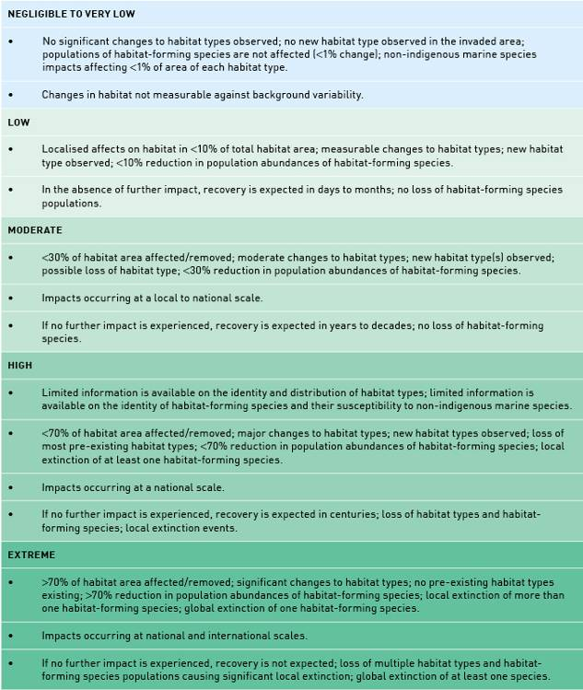
APPENDIX A
Table A2: Biodiversity impacts from non-indigenous marine species.
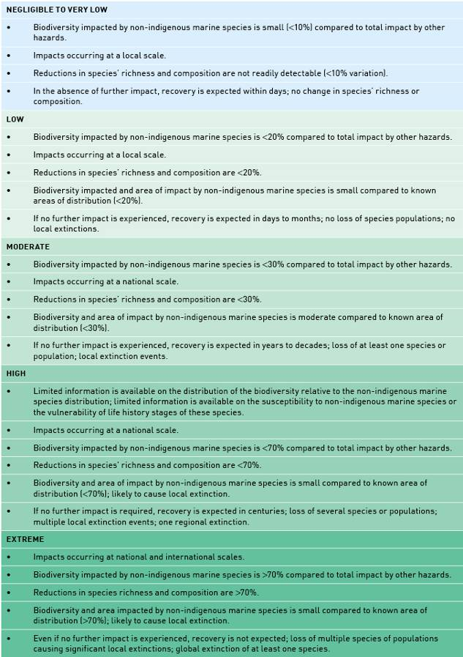
APPENDIX A
Table A3: Trophic interactions (ecosystem) impacts from non-indigenous marine species.
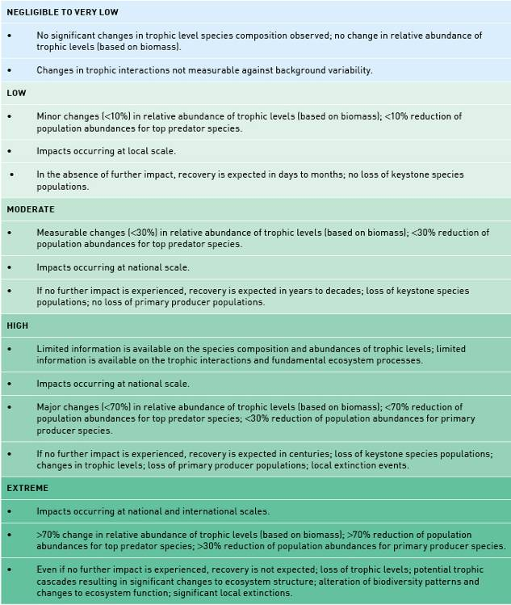
APPENDIX A
Table A4: Nationally important and ecologically valuable species impacts from non-indigenous marine species.
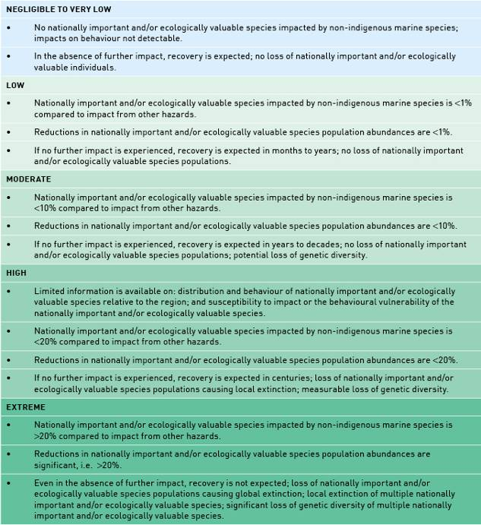
APPENDIX A
Table A5: Assets of environmental significance impacts from non-indigenous marine species.
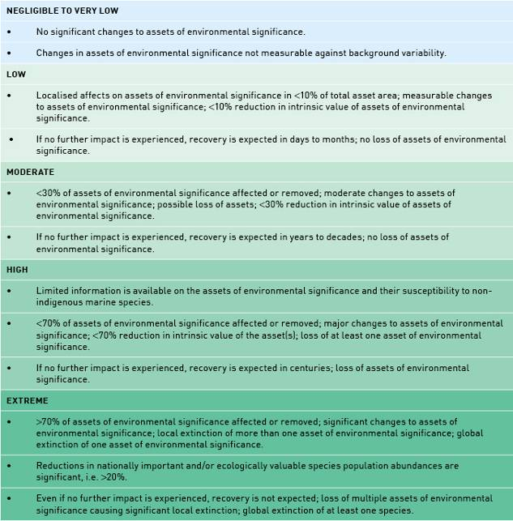
APPENDIX A
Table A6: Economic impacts from non-indigenous marine species.
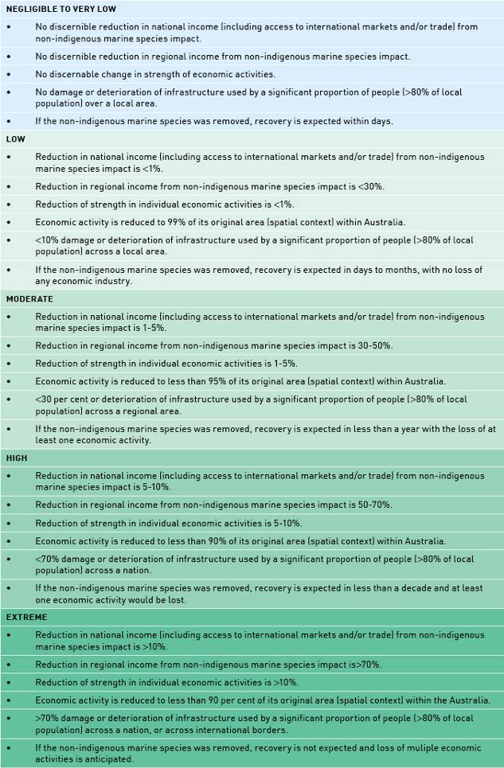
APPENDIX A
Table A7: Social impacts from non-indigenous marine species.
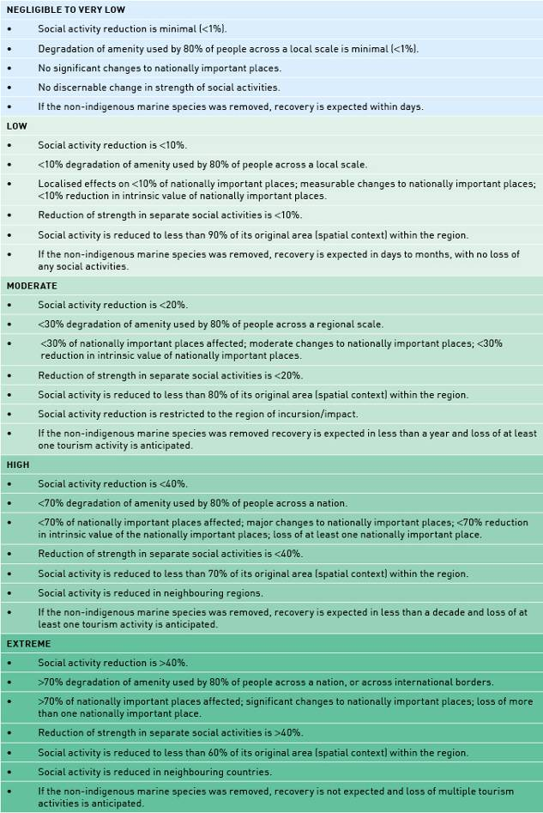
APPENDIX A
Table A8: Cultural impacts from non-indigenous marine species.
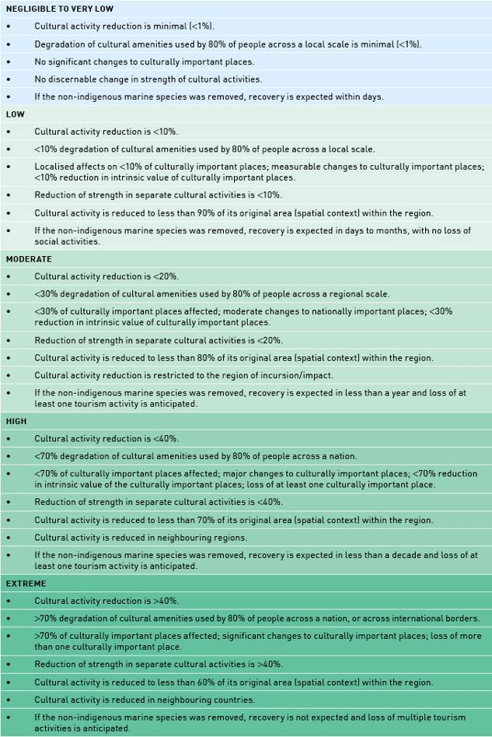
APPENDIX A
Table A9: National image impacts from non-indigenous marine species.
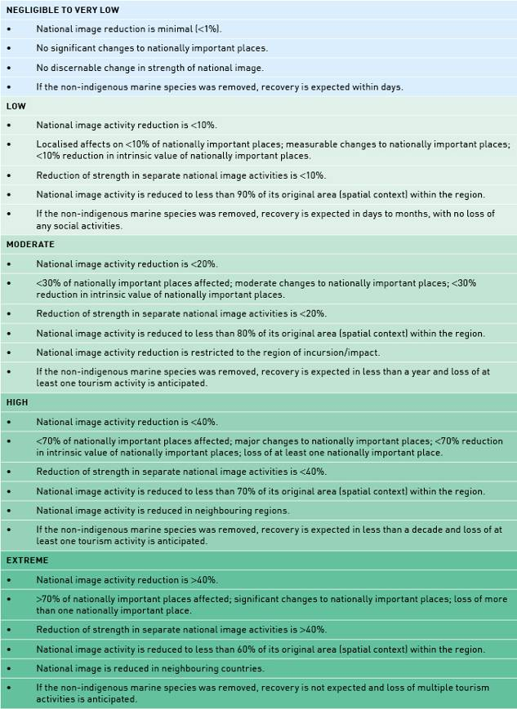
APPENDIX A
Table A10: Aesthetic impacts from non-indigenous marine species.
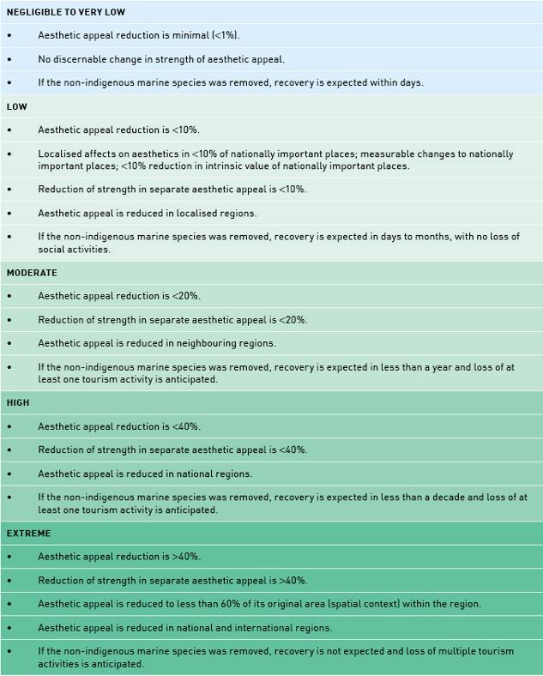
APPENDIX A
Table A11: Human health impacts from non-indigenous marine species.
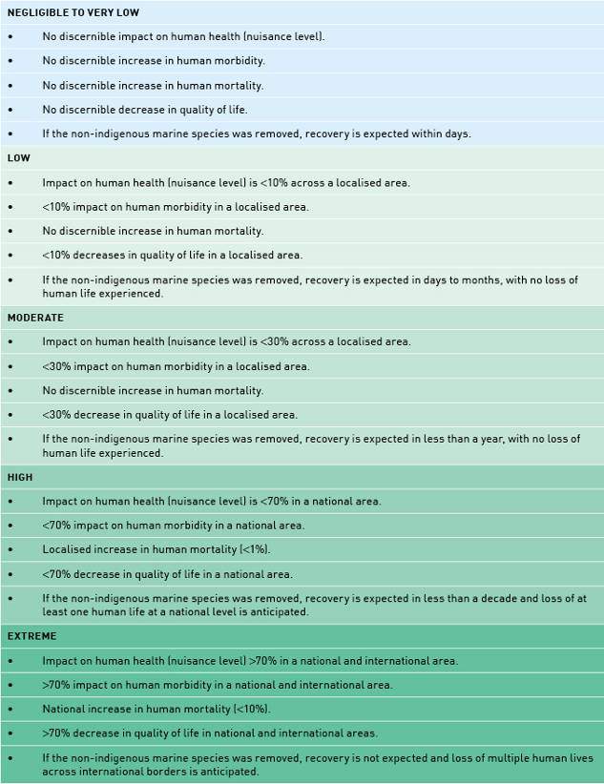

Appendix B
(TABLE B1: 1/6)

Table B1: Species list with likelihood ranks for biofouling association and transport pressure based on all voyage durations (LPOC, 30d, 60d, 90d, 183d, or 365d) between 2002 and 2007.
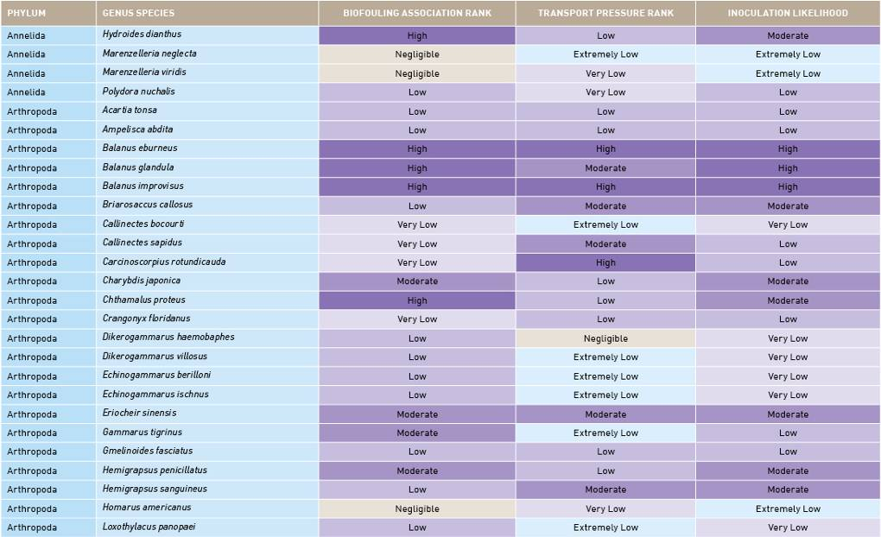
APPENDIX B: (TABLE B1: 2/6)
Table B1: Species list with likelihood ranks for biofouling association and transport pressure based on all voyage durations (LPOC, 30d, 60d, 90d, 183d, or 365d) between 2002 and 2007.
APPENDIX B: (TABLE B1: 3/6)
Table B1: Species list with likelihood ranks for biofouling association and transport pressure based on all voyage durations (LPOC, 30d, 60d, 90d, 183d, or 365d) between 2002 and 2007.
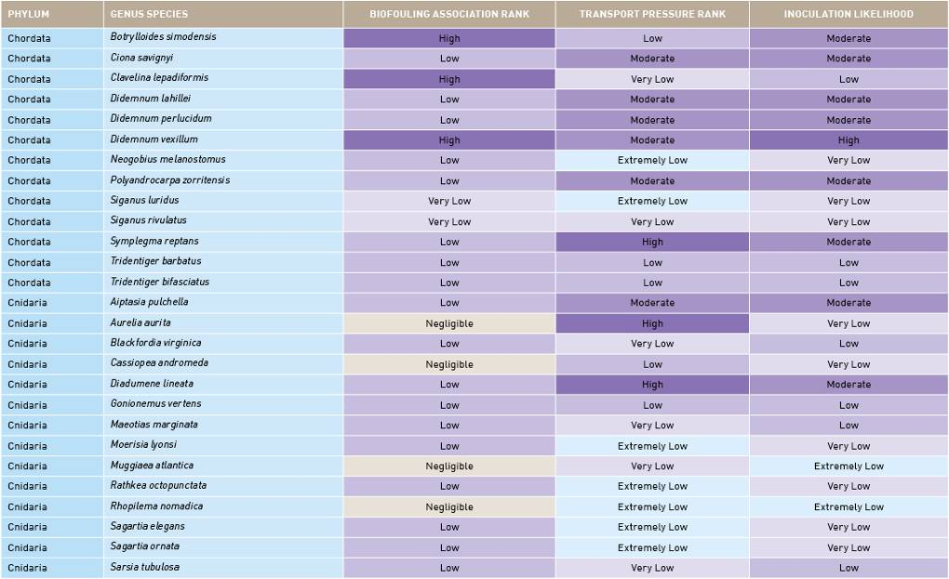
APPENDIX B: (TABLE B1: 4/6)
Table B1: Species list with likelihood ranks for biofouling association and transport pressure based on all voyage durations (LPOC, 30d, 60d, 90d, 183d, or 365d) between 2002 and 2007.
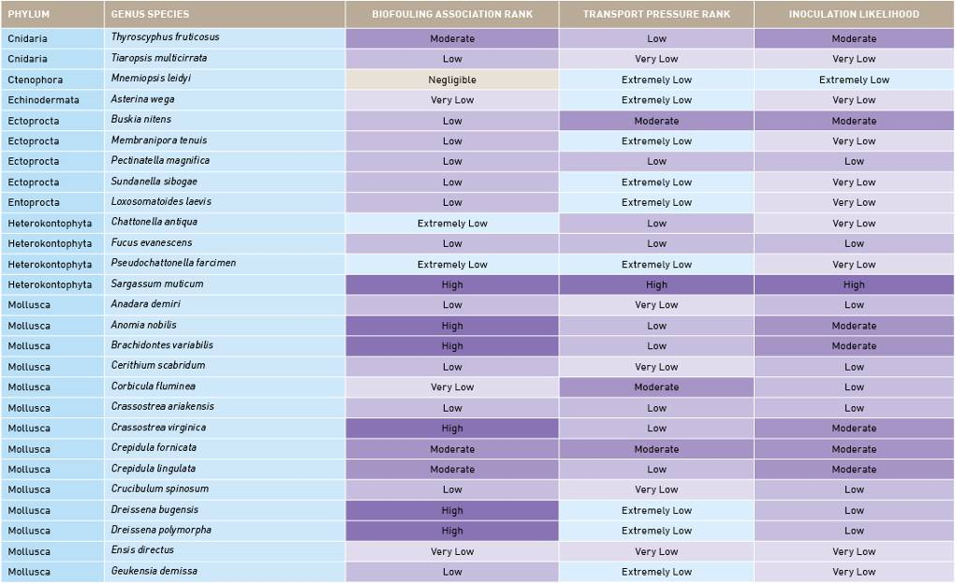
APPENDIX B: (TABLE B1: 5/6)
Table B1: Species list with likelihood ranks for biofouling association and transport pressure based on all voyage durations (LPOC, 30d, 60d, 90d, 183d, or 365d) between 2002 and 2007.
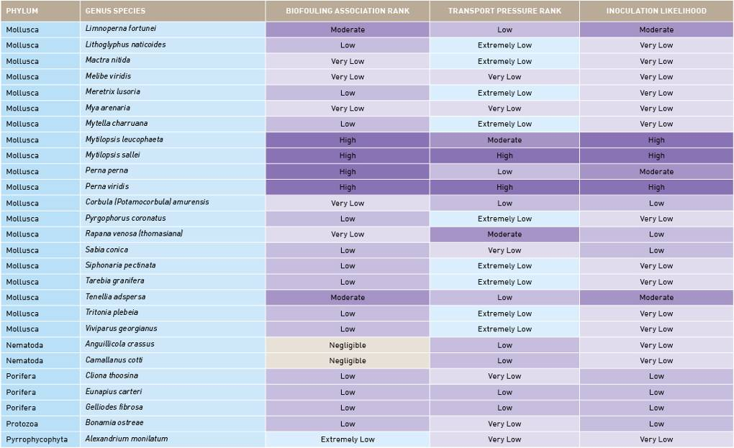
APPENDIX B: (TABLE B1: 6/6)
Table B1: Species list with likelihood ranks for biofouling association and transport pressure based on all voyage durations (LPOC, 30d, 60d, 90d, 183d, or 365d) between 2002 and 2007.
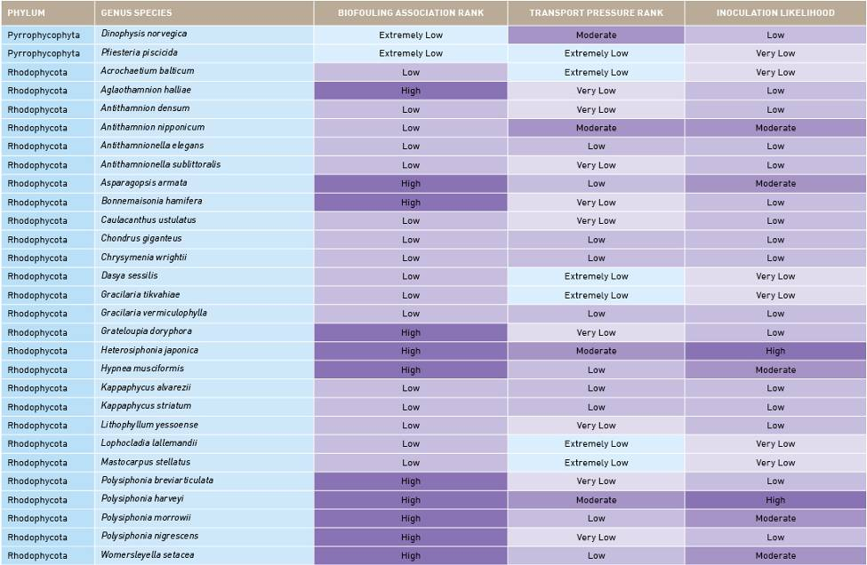
APPENDIX B: (TABLE B2: 1/6)
Table B2: Species list with consequence ranks and risks for Environmental (ENV), Economic (ECON), Social/Cultural (S/C) and Human health (HH) based on all voyage durations (LPOC, 30d, 60d, 90d, 183d, or 365d) between 2002 and 2007.
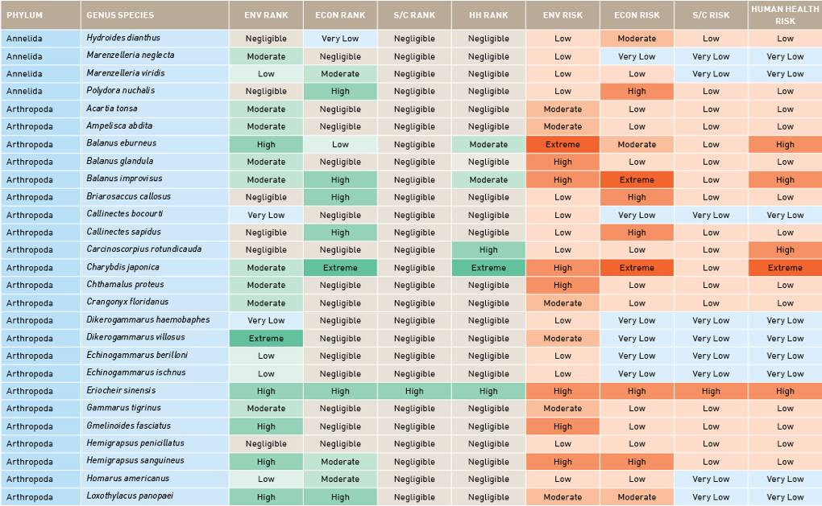
APPENDIX B: (TABLE B2: 2/6)
Table B2: Species list with consequence ranks and risks for Environmental (ENV), Economic (ECON), Social/Cultural (S/C) and Human health (HH) based on all voyage durations (LPOC, 30d, 60d, 90d, 183d, or 365d) between 2002 and 2007.

APPENDIX B: (TABLE B2: 3/6)
Table B2: Species list with consequence ranks and risks for Environmental (ENV), Economic (ECON), Social/Cultural (S/C) and Human health (HH) based on all voyage durations (LPOC, 30d, 60d, 90d, 183d, or 365d) between 2002 and 2007.
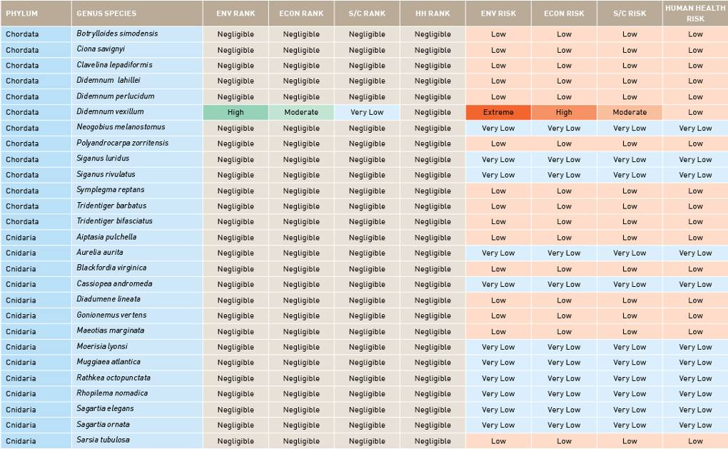
APPENDIX B: (TABLE B2: 4/6)
Table B2: Species list with consequence ranks and risks for Environmental (ENV), Economic (ECON), Social/Cultural (S/C) and Human health (HH) based on all voyage durations (LPOC, 30d, 60d, 90d, 183d, or 365d) between 2002 and 2007.
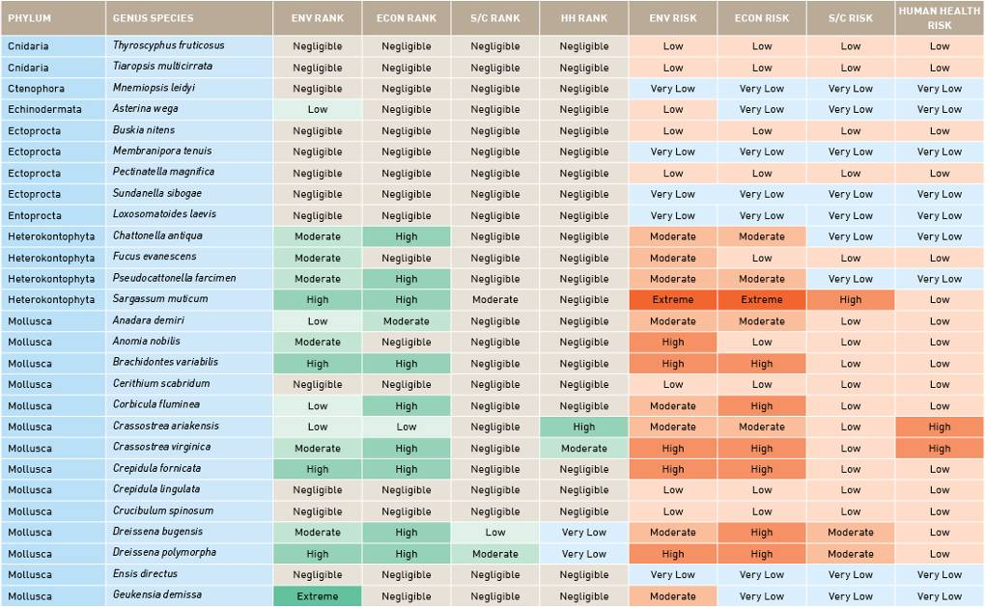
APPENDIX B: (TABLE B2: 5/6)
Table B2: Species list with consequence ranks and risks for Environmental (ENV), Economic (ECON), Social/Cultural (S/C) and Human health (HH) based on all voyage durations (LPOC, 30d, 60d, 90d, 183d, or 365d) between 2002 and 2007.
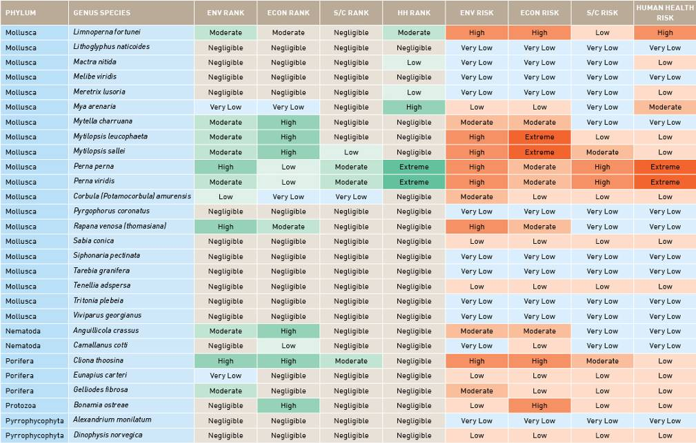
APPENDIX B: (TABLE B2: 6/6)
Table B2: Species list with consequence ranks and risks for Environmental (ENV), Economic (ECON), Social/Cultural (S/C) and Human health (HH) based on all voyage durations (LPOC, 30d, 60d, 90d, 183d, or 365d) between 2002 and 2007.
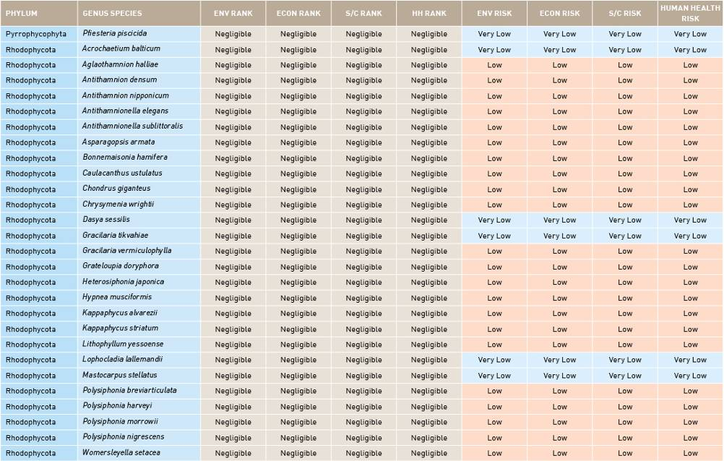

APPENDIX C
Figure C1: Number and percentage of vessel visits to Australia in 2002 that traded with specific bioregions over voyages of 30, 60, 90, 183 and 365 days.

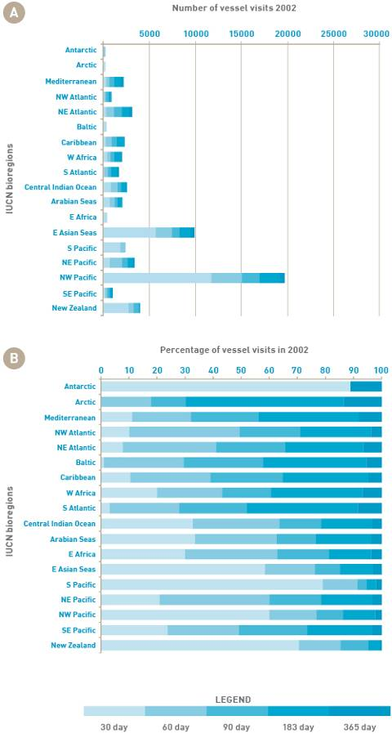
APPENDIX C
Figure C2: Number and percentage of vessel visits to Australia in 2003 that traded with specific bioregions over voyages of 30, 60, 90, 183 and 365 days.

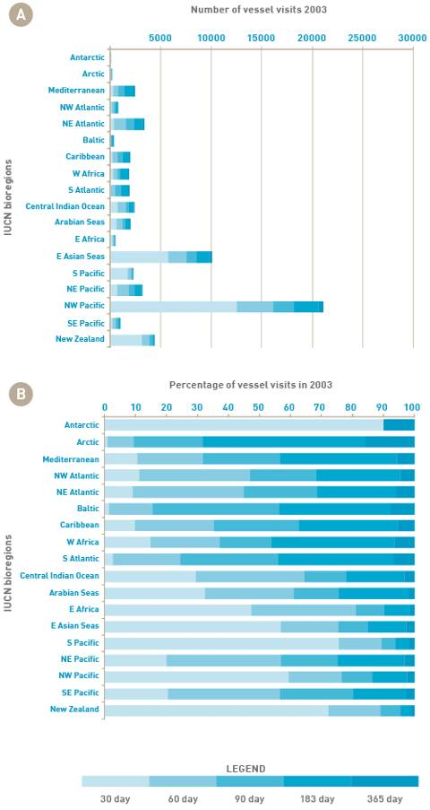
APPENDIX C
Figure C3: Number and percentage of vessel visits to Australia in 2004 that traded with specific bioregions over voyages of 30, 60, 90, 183 and 365 days.

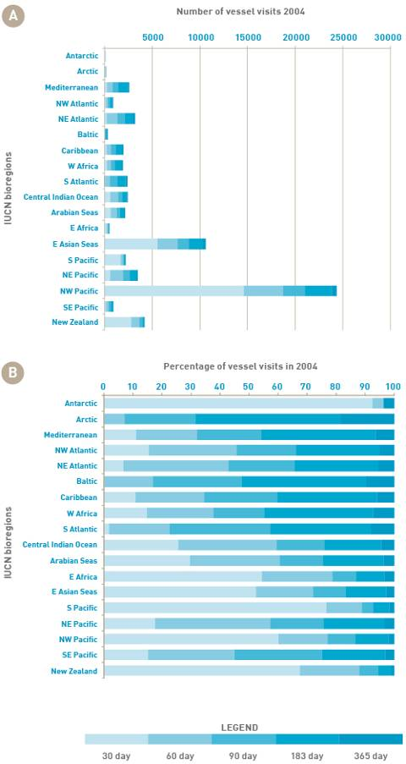
APPENDIX C
Figure C4: Number and percentage of vessel visits to Australia in 2005 that traded with specific bioregions over voyages of 30, 60, 90, 183 and 365 days.

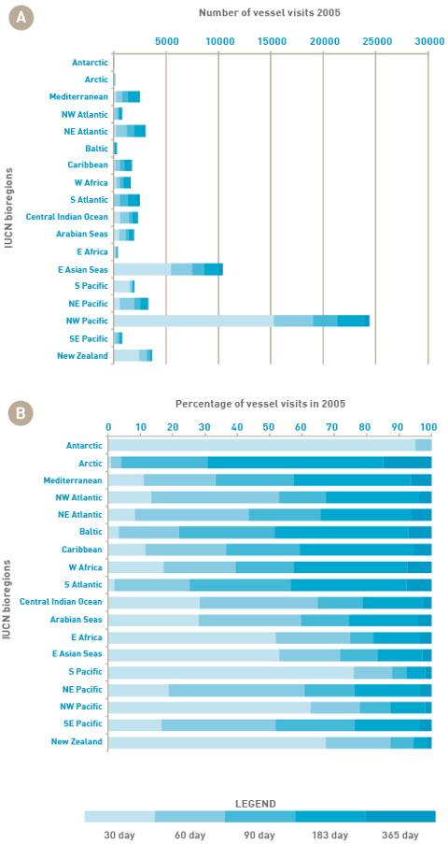
APPENDIX C
Figure C5: Number and percentage of vessel visits to Australia in 2006 that traded with specific bioregions over voyages of 30, 60, 90, 183 and 365 days.

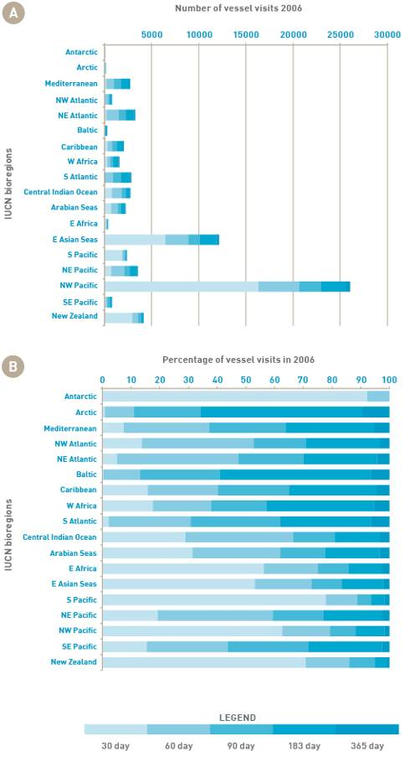
APPENDIX C
Figure C6: Number and percentage of vessel visits to Australia in 2007 that traded with specific bioregions over voyages of 30, 60, 90, 183 and 365 days.

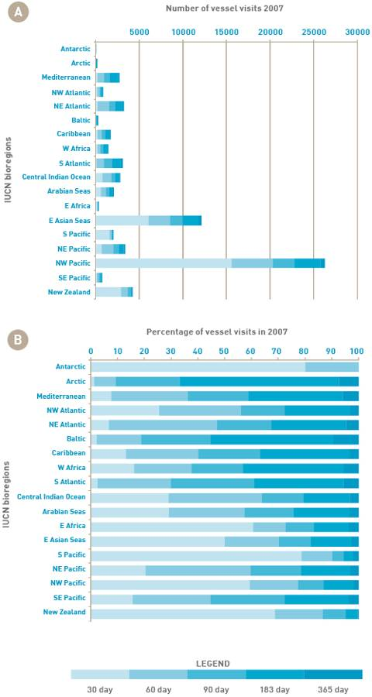

APPENDIX D
Graphs showing total and average residency periods of vessels (by category) from 2002 to 2007 across IUCN bioregions and Australian Provinces (Lloyds MIU dataset).

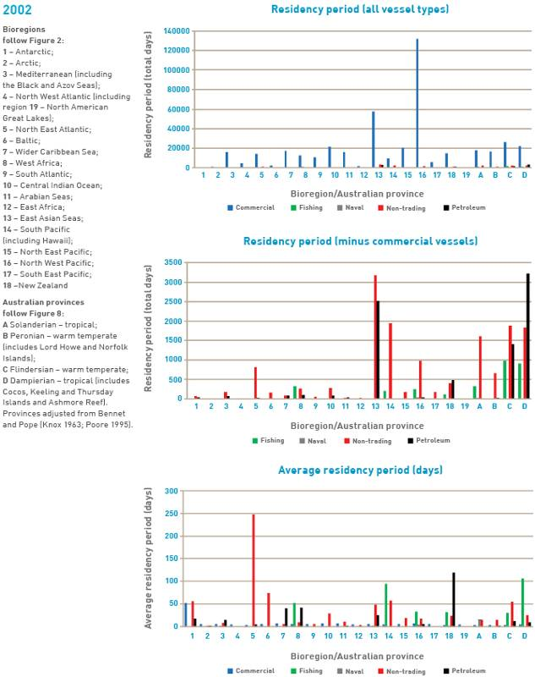
APPENDIX D
Graphs showing total and average residency periods of vessels (by category) from 2002 to 2007 across IUCN bioregions and Australian Provinces (Lloyds MIU dataset).

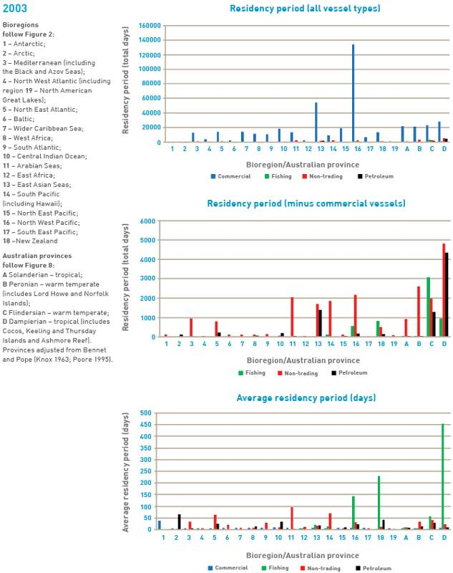
APPENDIX D
Graphs showing total and average residency periods of vessels (by category) from 2002 to 2007 across IUCN bioregions and Australian Provinces (Lloyds MIU dataset).

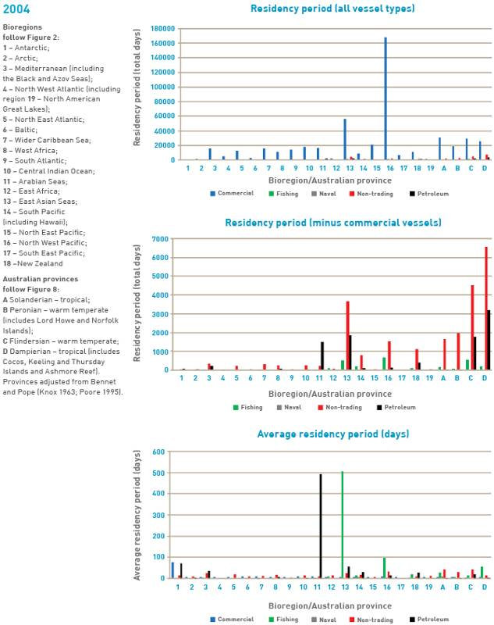
APPENDIX D
Graphs showing total and average residency periods of vessels (by category) from 2002 to 2007 across IUCN bioregions and Australian Provinces (Lloyds MIU dataset).

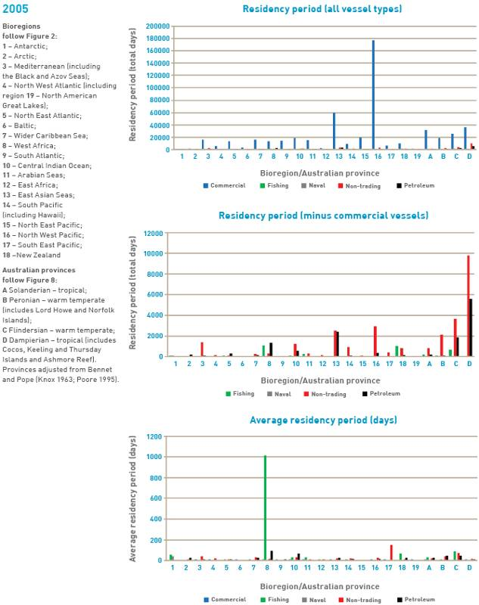
APPENDIX D
Graphs showing total and average residency periods of vessels (by category) from 2002 to 2007 across IUCN bioregions and Australian Provinces (Lloyds MIU dataset).

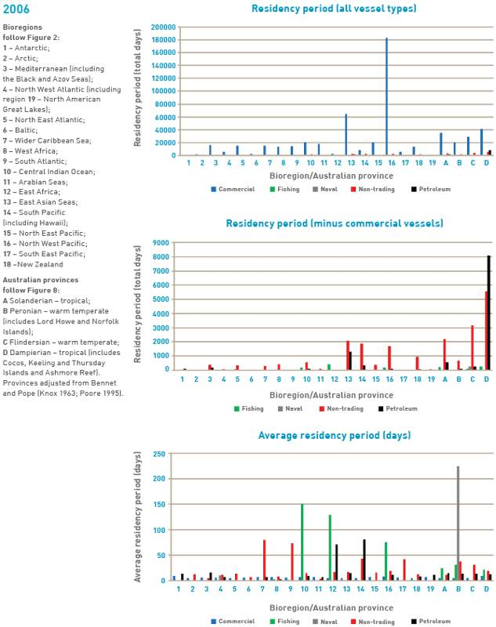
APPENDIX D
Graphs showing total and average residency periods of vessels (by category) from 2002 to 2007 across IUCN bioregions and Australian Provinces (Lloyds MIU dataset).

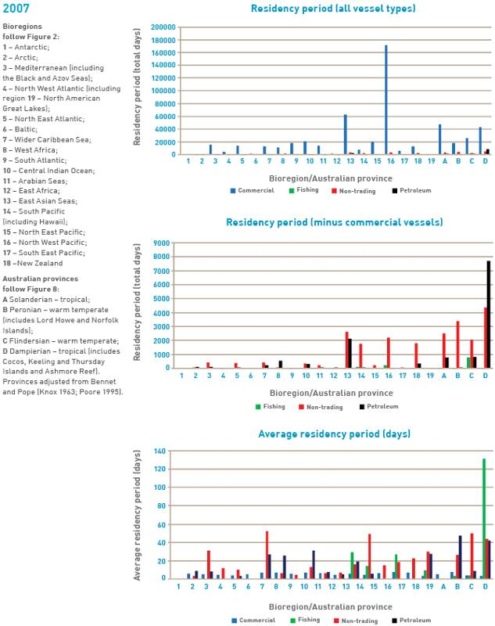
APPENDIX D
Graphs showing total and average residency periods of vessels (by category) from 2002 to 2007 across IUCN bioregions and Australian Provinces (Lloyds MIU dataset).

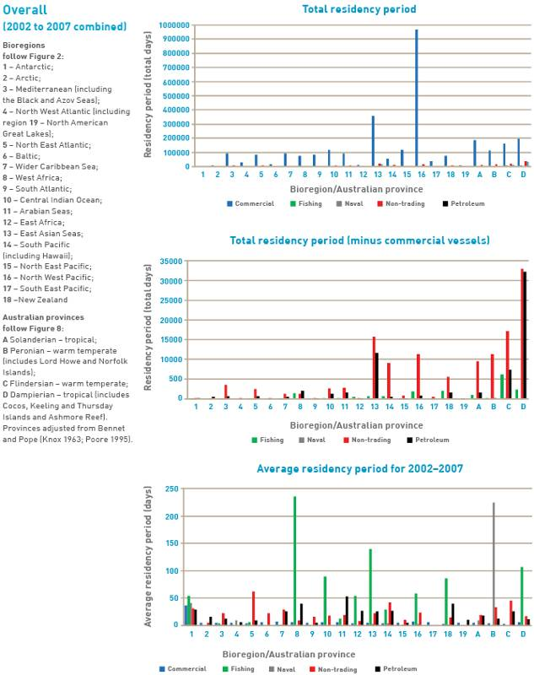

APPENDIX E
Table E1: 2002 residency periods in port for commercial, petroleum, fishing, naval, and non-trading vessels.
Note: recreational vessels >25 m are included in non-trading; recreational vessels <25 m and IFFVs are not included (Lloyds MIU dataset).
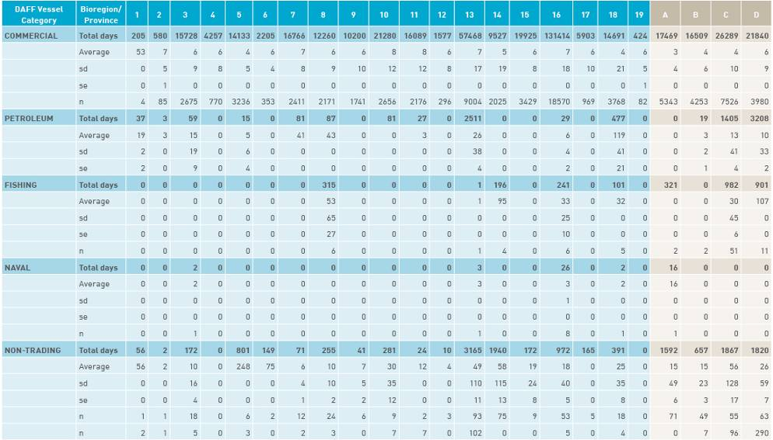
Bioregions follow Figure 2: 1 – Antarctica; 2 – Arctic; 3 – Mediterranean (including the Black and Azov Seas); 4 – North West Atlantic (including region 19 – North American Great Lakes); 5 – North East Atlantic; 6 – Baltic; 7 – Wider Caribbean Sea; 8 – West Africa; 9 – South Atlantic; 10 – Central Indian Ocean; 11 – Arabian Seas; 12 – East Africa; 13 – East Asian Seas; 14 – South Pacific (including Hawaii); 15 – North East Pacific; 16 – North West Pacific; 17 – South East Pacific; 18 –New Zealand
Australian Provinces follow Figure 8: A Solanderian – Tropical; B Peronian – Warm Temperate (includes Lord Howe and Norfolk Islands); C Flindersian – Warm Temperate; D Dampierian – Tropical (includes Cocos, Keeling and Thursday Islands and Ashmore Reef). Provinces adjusted from Bennet and Pope (Knox 1963; Poore 1995)
APPENDIX E
Table E2: 2003 residency periods in port for commercial, petroleum, fishing and non-trading vessels.
Note: recreational vessels >25 m are included in non-trading; no naval vessels were recorded, recreational vessels <25 m and IFFVs are not included (Lloyds MIU dataset).
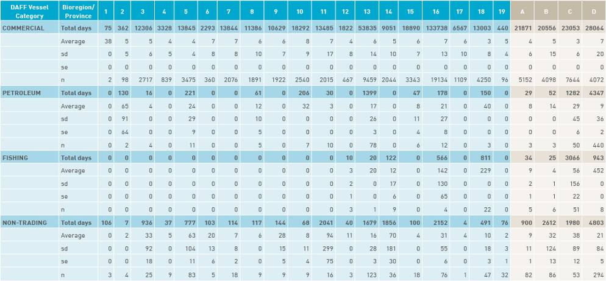

Bioregions follow Figure 2: 1 – Antarctica; 2 – Arctic; 3 – Mediterranean (including the Black and Azov Seas); 4 – North West Atlantic (including region 19 – North American Great Lakes); 5 – North East Atlantic; 6 – Baltic; 7 – Wider Caribbean Sea; 8 – West Africa; 9 – South Atlantic; 10 – Central Indian Ocean; 11 – Arabian Seas; 12 – East Africa; 13 – East Asian Seas; 14 – South Pacific (including Hawaii); 15 – North East Pacific; 16 – North West Pacific; 17 – South East Pacific; 18 –New Zealand
Australian Provinces follow Figure 8: A Solanderian – Tropical; B Peronian – Warm Temperate (includes Lord Howe and Norfolk Islands); C Flindersian – Warm Temperate; D Dampierian – Tropical (includes Cocos, Keeling and Thursday Islands and Ashmore Reef). Provinces adjusted from Bennet and Pope (Knox 1963; Poore 1995)
APPENDIX E
Table E3: 2004 residency periods in port for commercial, petroleum, fishing, naval, and non-trading vessels.
Note: recreational vessels >25 m are included in non-trading; recreational vessels <25 m and IFFVs are not included (Lloyds MIU dataset).
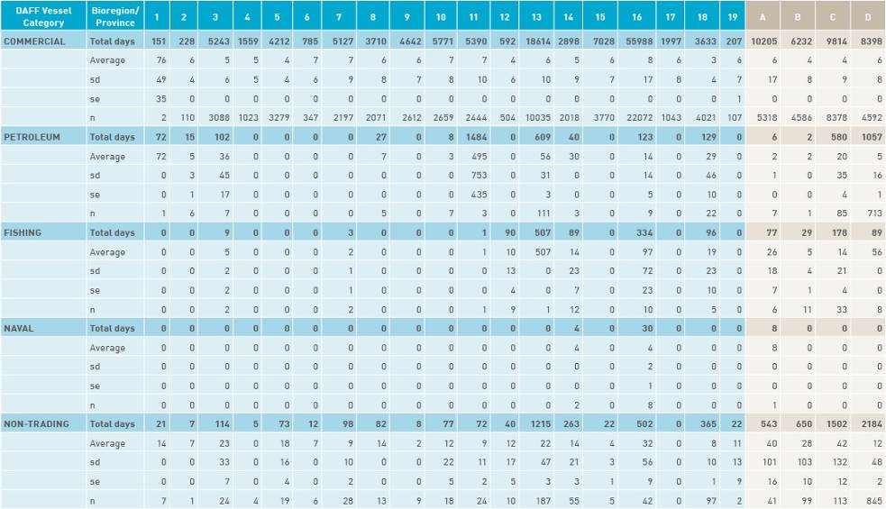
Bioregions follow Figure 2: 1 – Antarctica; 2 – Arctic; 3 – Mediterranean (including the Black and Azov Seas); 4 – North West Atlantic (including region 19 – North American Great Lakes); 5 – North East Atlantic; 6 – Baltic; 7 – Wider Caribbean Sea; 8 – West Africa; 9 – South Atlantic; 10 – Central Indian Ocean; 11 – Arabian Seas; 12 – East Africa; 13 – East Asian Seas; 14 – South Pacific (including Hawaii); 15 – North East Pacific; 16 – North West Pacific; 17 – South East Pacific; 18 –New Zealand
Australian Provinces follow Figure 8: A Solanderian – Tropical; B Peronian – Warm Temperate (includes Lord Howe and Norfolk Islands); C Flindersian – Warm Temperate; D Dampierian – Tropical (includes Cocos, Keeling and Thursday Islands and Ashmore Reef). Provinces adjusted from Bennet and Pope (Knox 1963; Poore 1995)
APPENDIX E
Table E4: 2005 residency periods in port for commercial, petroleum, fishing, naval, and non-trading vessels.
Note: recreational vessels >25 m are included in non-trading; recreational vessels <25 m and IFFVs are not included (Lloyds MIU dataset).
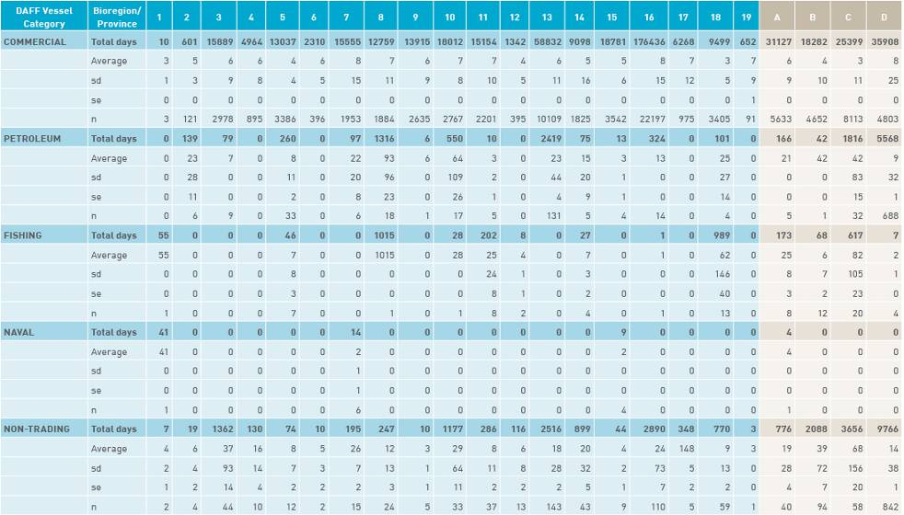
Bioregions follow Figure 2: 1 – Antarctica; 2 – Arctic; 3 – Mediterranean (including the Black and Azov Seas); 4 – North West Atlantic (including region 19 – North American Great Lakes); 5 – North East Atlantic; 6 – Baltic; 7 – Wider Caribbean Sea; 8 – West Africa; 9 – South Atlantic; 10 – Central Indian Ocean; 11 – Arabian Seas; 12 – East Africa; 13 – East Asian Seas; 14 – South Pacific (including Hawaii); 15 – North East Pacific; 16 – North West Pacific; 17 – South East Pacific; 18 –New Zealand
Australian Provinces follow Figure 8: A Solanderian – Tropical; B Peronian – Warm Temperate (includes Lord Howe and Norfolk Islands); C Flindersian – Warm Temperate; D Dampierian – Tropical (includes Cocos, Keeling and Thursday Islands and Ashmore Reef). Provinces adjusted from Bennet and Pope (Knox 1963; Poore 1995)
APPENDIX E
Table E5: 2006 residency periods in port for commercial, petroleum, fishing, naval, and non-trading vessels.
Note: recreational vessels >25 m are included in non-trading; recreational vessels <25 m and IFFVs are not included (Lloyds MIU dataset).
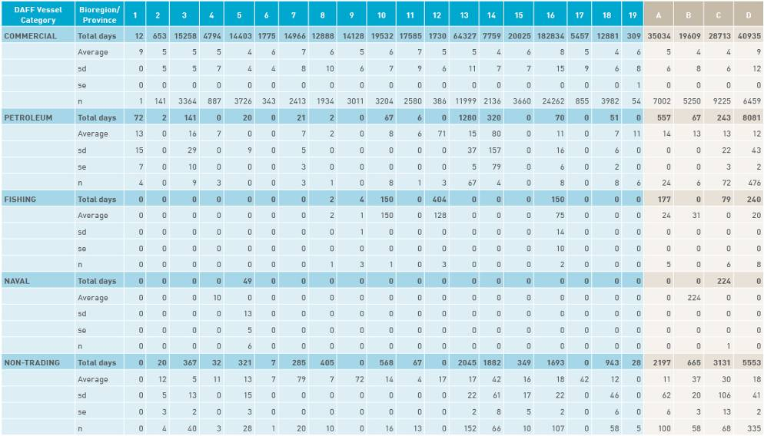
Bioregions follow Figure 2: 1 – Antarctica; 2 – Arctic; 3 – Mediterranean (including the Black and Azov Seas); 4 – North West Atlantic (including region 19 – North American Great Lakes); 5 – North East Atlantic; 6 – Baltic; 7 – Wider Caribbean Sea; 8 – West Africa; 9 – South Atlantic; 10 – Central Indian Ocean; 11 – Arabian Seas; 12 – East Africa; 13 – East Asian Seas; 14 – South Pacific (including Hawaii); 15 – North East Pacific; 16 – North West Pacific; 17 – South East Pacific; 18 –New Zealand
Australian Provinces follow Figure 8: A Solanderian – Tropical; B Peronian – Warm Temperate (includes Lord Howe and Norfolk Islands); C Flindersian – Warm Temperate; D Dampierian – Tropical (includes Cocos, Keeling and Thursday Islands and Ashmore Reef). Provinces adjusted from Bennet and Pope (Knox 1963; Poore 1995)
APPENDIX E
Table E6: 2007 residency periods in port for commercial, petroleum, fishing and non-trading vessels.
Note: recreational vessels >25 m are included in non-trading; no naval vessels were recorded; recreational vessels <25 m and IFFVs are not included (Lloyds MIU dataset).
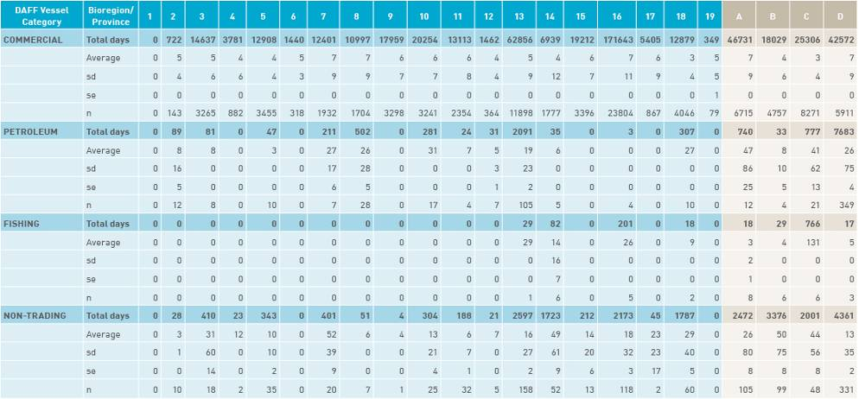

Bioregions follow Figure 2: 1 – Antarctica; 2 – Arctic; 3 – Mediterranean (including the Black and Azov Seas); 4 – North West Atlantic (including region 19 – North American Great Lakes); 5 – North East Atlantic; 6 – Baltic; 7 – Wider Caribbean Sea; 8 – West Africa; 9 – South Atlantic; 10 – Central Indian Ocean; 11 – Arabian Seas; 12 – East Africa; 13 – East Asian Seas; 14 – South Pacific (including Hawaii); 15 – North East Pacific; 16 – North West Pacific; 17 – South East Pacific; 18 –New Zealand
Australian Provinces follow Figure 8: A Solanderian – Tropical; B Peronian – Warm Temperate (includes Lord Howe and Norfolk Islands); C Flindersian – Warm Temperate; D Dampierian – Tropical (includes Cocos, Keeling and Thursday Islands and Ashmore Reef). Provinces adjusted from Bennet and Pope (Knox 1963; Poore 1995)
APPENDIX E
Table E7: Residency periods in port between 2002 and 2007 (combined) for commercial, petroleum, fishing, naval, and non-trading vessels.
Note: recreational vessels >25 m are included in non-trading; recreational vessels <25 m and IFFVs are not included (Lloyds MIU dataset).
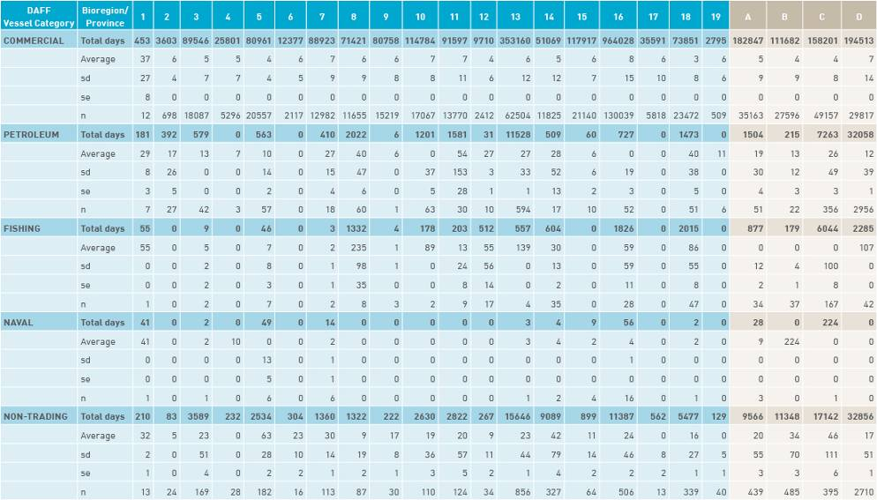
Bioregions follow Figure 2: 1 – Antarctica; 2 – Arctic; 3 – Mediterranean (including the Black and Azov Seas); 4 – North West Atlantic (including region 19 – North American Great Lakes); 5 – North East Atlantic; 6 – Baltic; 7 – Wider Caribbean Sea; 8 – West Africa; 9 – South Atlantic; 10 – Central Indian Ocean; 11 – Arabian Seas; 12 – East Africa; 13 – East Asian Seas; 14 – South Pacific (including Hawaii); 15 – North East Pacific; 16 – North West Pacific; 17 – South East Pacific; 18 –New Zealand
Australian Provinces follow Figure 8: A Solanderian – Tropical; B Peronian – Warm Temperate (includes Lord Howe and Norfolk Islands); C Flindersian – Warm Temperate; D Dampierian – Tropical (includes Cocos, Keeling and Thursday Islands and Ashmore Reef). Provinces adjusted from Bennet and Pope (Knox 1963; Poore 1995)

Appendix F

Species datasheet

Hydroides dianthus
Hydroides dianthus is a calcareous tube-building polychaete that is widely distributed in a variety of habitats, including open coasts, partly brackish waters of bays, lagoons and ports (Link et al. 2009). This polychaete species provides numerous microhabitats for other species by means of its tubes and sediment enriched with tube fragments (Haines & Maurer 1980).

Common names:
Serpulid tube worm, limy tube worm.
Distribution:
Found in five of the 18 IUCN bioregions (see Figure 2).
Native: North West Atlantic (Eno et al. 1997).
Introduced: Mediterranean, North East Atlantic, Caribbean, West Africa, North East Pacific, South Atlantic and North West Pacific.
Larval period:
Planktonic for up to two weeks (citations in Link et al. 2009).
Temperature tolerance:
Inferred: -2.9 °C to 31.8 °C.
Physiological: No information available.

Inoculation likelihood: HIGH
Biofouling association rank – HIGH
H. dianthus is most likely to be introduced via vessel biofouling, but its planktonic larvae can also be transported in ballast water (Link et al. 2009). There was a possible additional introduction associated with the American oyster Crassostrea virginica (citations in Eno et al. 1997).
Transport pressure rank – MODERATE
Australian trade with the IUCN bioregions where H. dianthus is found represents 21.8% of the nation’s total trade. Once the additional weighting is applied to the different vessel types to account for the mean duration in port in various bioregions, the average increases to the equivalent of 25.5% representing a moderate likelihood of transport.

Consequence:
Consequence was evaluated based on literature assessments.
Environmental impacts – NEGLIGIBLE
No information available.
Economic impacts – VERY LOW
H. dianthus may kill young oysters (C. virginica) by overgrowing them in its native range of eastern North America (Eno et al. 1997). It is also the host of certain nematode stages in eastern North America (Eno et al. 1997).
Social impacts/cultural impacts – NEGLIGIBLE
No information available.
Human health impacts – NEGLIGIBLE
No information available.

Risks:
Multiplying the inoculation likelihood (i.e. moderate) by consequence for each value category (i.e. negligible, very low, negligible, negligible) results in the following risk categorisations across all vessel types and in at least one voyage duration.
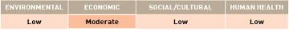

APPENDIX F
Species datasheet

Polydora nuchalis
Polydora nuchalis is a spionid polychaete, native to the eastern Pacific (Mexico). It is common to nearshore environments and is specifically known from aquaculture ponds. It feeds on detritus and other organic particulate matter.

Common names:
Spionid polychaete worm.
Distribution:
Found in two of the 18 IUCN bioregions (see Figure 2).
Native: North East Pacific.
Introduced: South Pacific (Hawaii).
Larval period:
Details about the larval period could not be found for this species, but the larval period for a closely related species, P. giardi, is 20 to 32 days (Day & Blake 1979).
Temperature tolerance:
Inferred: -1.5 °C to 32.1 °C.
Physiological: No information available.

Inoculation likelihood: LOW
Biofouling association rank – LOW
P. nuchalis is a sedentary infaunal species and not directly associated with biofouling, however, it has the potential to survive in sea-chests of vessels (Coutts & Dodgshun 2007).
Transport pressure rank – VERY LOW
Australian trade with the IUCN bioregions where P. nuchalis is found represents 10.0% of the nation’s total trade. Once the additional weighting is applied to the different vessel types to account for the mean duration in port in various bioregions, the average increases to the equivalent of 12.8% representing a very low likelihood of transport.

Consequence:
Consequence was evaluated based on literature assessments.
Environmental impacts – NEGLIGIBLE
No information available.
Economic impacts – HIGH
P. nuchalis is inferred to have environmental impacts on other organisms due to competition for space and resources and through habitat modification (Bailey-Brock 1990).
Social impacts/cultural impacts – NEGLIGIBLE
No information available.
Human health impacts – NEGLIGIBLE
No information available.

Risks:
Multiplying the inoculation likelihood (i.e. low) by consequence for each value category (i.e. negligible, high, negligible, negligible) results in the following risk categorisations across all vessel types and in at least one voyage duration.

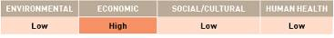

APPENDIX F
Species datasheet

Acartia tonsa
Acartia tonsa is a calanoid copepod with a body length of 1–1.5 mm. This species is found throughout the water column, predominantly in surface layers. In the Baltic Sea, this species is dominant in summer and autumn in the upper layers at 0–20 m depth (Zaiko 2004). It is known to develop in mass abundance and has very high reproductive potential (Zaiko 2004).

Common names:
None.
Distribution:
Found in eight of the 18 IUCN bioregions (see Figure 2).
Native: North East Pacific.
Introduced: Arctic, Mediterranean, North West Atlantic, North East Atlantic, Baltic, East Asian Seas and South East Pacific (Kurashova 2002).
Larval period:
Duration of the full developmental cycle from egg to mature adult is 30 to 33 days (Kurashova 2002).
Temperature tolerance:
Inferred: -2.9 °C to 31.8 °C.
Physiological: -1 °C to 32 °C (citations in Paffenhofer & Stearns 1988). Reproductive rate is low–under 10 °C (Zaiko 2004).

Inoculation likelihood: LOW
Biofouling association rank – LOW
A. tonsa was possibly introduced through transport on vessels hulls and/or in ballast water (Remy 1927; NOBANIS 2005). As it is a zooplankton species which produces diapause eggs, transport via ballast water is likely (Eno et al. 1997).
Transport pressure rank – LOW
Australian trade with the IUCN bioregions where A. tonsa is found represents 36.8% of the nation’s total trade. Once the additional weighting is applied to the different vessel types to account for the mean duration in port in various bioregions, the average increases to the equivalent of 44.7% representing a low likelihood of transport.

Consequence:
Consequence was evaluated based on literature assessments.
Environmental impacts – MODERATE
A.tonsa has a tendency to become numerically dominant and may outcompete native planktonic copepods (citations in Zaiko 2004). It also can change energy/matter flows between pelagic and benthic compartments and modify trophic structure of invaded ecosystems (citations in Zaiko 2004). Some experimental studies have found that high levels of PSP toxin can be accumulated in copepod grazers such as A. tonsa, supporting the hypothesis that zooplankton may serve as PSP toxin vectors to higher trophic levels (citations in Zaiko 2004). A. tonsa may also have potential positive environmental impacts due to its high abundances and grazing abilities, which can serve as a potential biological control of algal blooms (citations in Zaiko 2004).
Economic impacts – NEGLIGIBLE
No information available.
Social impacts/cultural impacts – NEGLIGIBLE
No information available.
Human health impacts – NEGLIGIBLE
No information available.

Risks:
Multiplying the inoculation likelihood (i.e. low) by consequence for each value category (i.e. moderate, negligible, negligible, negligible) results in the following risk categorisations across all vessel types and in at least one voyage duration.

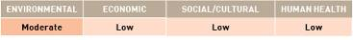

APPENDIX F
Species datasheet

Ampelisca abdita
Ampelisca abdita is a tube-dwelling suspension/deposit feeding amphipod. It grows to about 6 mm long and forms a narrow tube of 34 mm. In the Atlantic, A. abdita is commonly found amongst oyster beds and forms extensive mats within the sediments of protected bays (Hayes & Sliwa 2003).

Common names:
None.
Distribution:
Found in six of the 18 IUCN bioregions (see Figure 2).
Native: North West Atlantic, Wider Caribbean and the South Atlantic.
Introduced: North East Pacific, East Asian Seas and Central Indian Ocean.
Larval period:
No information available.
Temperature tolerance:
Inferred: -2.9 °C to 31.8 °C.
Physiological: Unknown.

Inoculation likelihood: LOW
Biofouling association rank – LOW
The invasion history of A. abdita is presumably linked with oyster movements and there is also the potential for the species to be transported via ballast water (Hayes & Sliwa 2003).
Transport pressure rank – LOW
Australian trade with the IUCN bioregions where A. abdita is found represents 35.7% of the nation’s total trade. Once the additional weighting is applied to the different vessel types to account for the mean duration in port in various bioregions, the average increases to the equivalent of 44.8% representing a low likelihood of transport.

Consequence:
Consequence was evaluated based on literature assessments.
Environmental impacts – MODERATE
In San Francisco Bay, the high abundance of A. abdita allows it to interfere with the native mollusc Macoma balthica through predation, physical processes or competition for food (citations in Hayes & Sliwa 2003). It has also been suggested that A. abdita may limit recruitment and disrupt the feeding of established organisms (citations in Hayes & Sliwa 2003).
Economic impacts – NEGLIGIBLE
No information available.
Social impacts/cultural impacts – NEGLIGIBLE
No information available.
Human health impacts – NEGLIGIBLE
No information available.

Risks:
Multiplying the inoculation likelihood (i.e. low) by consequence for each value category (i.e. moderate, negligible, negligible, negligible) results in the following risk categorisations across all vessel types and in at least one voyage duration.

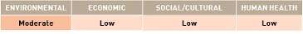

APPENDIX F
Species datasheet

Balanus eburneus
Balanus eburneus is a hermaphroditic (both sexes in one individual) sessile barnacle, reaching 2cm in size. It is found in fully saline to brackish waters of bays and estuaries. It occupies a variety of shallow marine substrates, including rocks and cobbles, man-made habitats (jetties, wharves, groynes, plastic debris) and also on biogenic (living) substrates such as mangroves, other crustaceans and shells of molluscs.

Common names:
Ivory barnacle.
Distribution:
Found in nine of the 18 IUCN bioregions (see figure 2).
Native: North West Atlantic and Wider Caribbean Sea.
Introduced: North East Atlantic, West Africa, Central Indian Ocean, South Pacific, North East Pacific, North West Pacific and South East Pacific.
Larval period:
Planktonic duration of seven to 13 days (Costlow & Bookhout 1957).
Temperature tolerance:
Inferred:-2.9 °C to 32.4 °C.
Physiological: 8 °C to 26 °C (Costlow & Bookhout 1957).

Inoculation likelihood: HIGH
Biofouling association rank – HIGH
B. eburneus is recognised as a primary benthic fouler, demonstrably associated with biofouling on hulls of vessels (Bishop 1951).
Transport pressure rank – HIGH
Australian trade with the IUCN bioregions where B. eburneus is found represents 61.2% of the nation’s total trade. Once the additional weighting is applied to the different vessel types to account for the mean duration in port in various bioregions, the average increases to the equivalent of 76.9% representing a high likelihood of transport.

Consequence:
Consequence was evaluated based on literature assessments.
Environmental impacts – HIGH
B. eburneus was inferred to have environmental impacts on other organisms due to competition for space in its native and introduced ranges, and through habitat modification by creating a monoculture (e.g. Boudreaux et al 2009)
Economic impacts – LOW
B. eburneus is a nuisance fouler on commercial structures, including wharves, jetties and buoys, as well as biofouling on vessel hulls. As a biofouling barnacle, it is inferred to block seawater intakes for industrial (e.g. power station, factory) cooling systems and to foul mussels and oysters interfering with aquaculture production (e.g. Leppakoski & Gollasch 1999).
Social impacts/cultural impacts – NEGLIGIBLE
No information available.
Human health impacts – MODERATE
In recreational areas sharp shells may pose laceration risks (Leppakoski & Gollasch 1999).

Risks:
Multiplying the inoculation likelihood (i.e. high) by consequence in each value category (i.e. high, low, negligible, moderate) results in the following risk categorisations across all vessel types and in at least one voyage duration.

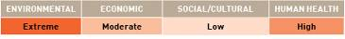

APPENDIX F
Species datasheet

Balanus glandula
Balanus glandula is predominantly an open coast species which can also inhabit estuaries. The species is found from the middle to upper intertidal area. Adults are about 1cm wide and are generally as tall as they are wide, but will grow into tall columnar shapes if crowded. The animals grow on rocks, pilings and sometimes other organisms. B. glandula is often the most abundant barnacle in the upper half of the intertidal zone (reaching densities of up to 70 000 individuals per square metre), and the most ubiquitous barnacle species on the Pacific coast. An individual can produce up to six broods of 1000 to 30 000 young per year.

Common names:
Acorn barnacle, white acorn barnacle, white buckshot barnacle.
Distribution:
Found in four of the 18 IUCN bioregions (see Figure 2).
Native: North East Pacific.
Introduced: West Africa, South Atlantic and North West Pacific.
Larval period:
Eggs are incubated in the mantle cavity for a period of approximately two months. Nauplii hatch and are planktonic for about one month (Barnes & Barnes 1956).
Temperature tolerance:
Inferred: -2.9 °C to 32.4 °C.
Physiological: Exact limits are unknown. Reproduction is thought to be restricted to sea temperatures below 17 °C (Barnes & Barnes 1956). In Argentina, B. glandula inhabit coastlines where mean temperature ranges between 4.3 °C and 21 °C. The species has been observed to survive high temperatures in laboratory and field conditions (e.g. 34 °C for 8.5 hours), without showing evidence of irreversible protein damage (Berger & Emlet 2007).

Inoculation likelihood: HIGH
Biofouling association rank – HIGH
Hulls and fenders of barges and tugboats have been found to be fouled with B. glandula. When scraped from fenders, egg masses have been found inside B. glandula, and when immersed in seawater, larvae have been observed to hatch from such egg masses (Kado & Nanba 2006). Larvae from biofouling organisms on cargo vessels from the United States are thought to be responsible for the establishment of this species at Japanese ports (Kado 2003).
Transport pressure rank – MODERATE
Australian trade with the IUCN bioregions where B. glandula is found represents 43.9% of the nation’s total trade. Once the additional weighting is applied to the different vessel types to account for the mean duration in port in various bioregions, the average increases to the equivalent of 55.7% representing a moderate likelihood of transport.

Consequence:
Consequence was evaluated based on literature assessments.
Environmental impacts – MODERATE
This barnacle is a successful invader and has changed community structure of Argentinean intertidal communities, forming monospecific dense belts and displacing native barnacle species (Schwindt 2007).
Economic impacts – NEGLIGIBLE
No information available.
Social impacts/cultural impacts – NEGLIGIBLE
No information available.
Human health impacts – NEGLIGIBLE
No information available.

Risks:
Multiplying the inoculation likelihood (i.e. high) by consequence in each value category (i.e. moderate, negligible, negligible, negligible) results in the following risk categorisations across all vessel types and in at least one voyage duration.

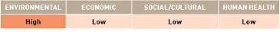

APPENDIX F
Species datasheet

Balanus improvisus
Balanus improvisus is a hermaphroditic (both sexes in one individual) sessile barnacle, reaching 8–10mm in size. Found in fully saline to brackish water. In California, B. improvisus invades freshwater aqueducts as larvae, but adults cannot reproduce in freshwater. It occupies a variety of shallow marine substrates including rocks and cobbles, man-made habitats (jetties, wharves, groynes, plastic debris) and also on biogenic (living) substrates such as macro-algae, other crustaceans and shells of molluscs.

Common names:
Bay barnacle, acorn barnacle.
Distribution:
Found in 10 of the 18 IUCN bioregions (see Figure 2).
Native: North West Atlantic.
Introduced: Arctic, North East Atlantic, Baltic, South Atlantic, Arabian Seas, East Asian Seas, North East Pacific, North West Pacific and New Zealand.
The species has previously been identified in Western Australia, however, a subsequent survey of the region (Hewitt et al. 2000) did not detect its establishment in Australian waters.
Larval period:
Larval duration is between six to eight days at 25 °C (Dineen & Hines 1994).
Temperature tolerance:
Inferred:-2.9 °C to 35.3 °C.
Physiological: 1.8 °C to 22.7 °C (Zaiko, 2005).

Inoculation likelihood: HIGH
Biofouling association rank – HIGH
B. improvisus is recognised as a primary benthic fouler, demonstrably associated with biofouling on hulls of vessels (Bishop 1951; Gollasch et al. 1999; Gollasch 2002).
Transport pressure rank – HIGH
Australian trade with the IUCN bioregions where B. improvisus is found represents 76.8% of the nation’s total trade. Once the additional weighting is applied to the different vessel types to account for the mean duration in port in various bioregions, the average increases to the equivalent of 95.6% representing a high likelihood of transport.

Consequence:
Consequence was evaluated based on literature assessments.
Environmental impacts – MODERATE
B. improvisus was inferred to have environmental impacts on other organisms through competition for space in its native and introduced ranges, and to create habitat modification by creating a monoculture (e.g. Lohse 2002; Qvarfordt et al 2006).
Economic impacts – HIGH
B. improvisus has been inferred to block seawater intakes for industrial (e.g. power station, factory) cooling systems in the Baltic Sea and to foul mussels and oysters interfering with aquaculture production (Gollasch et al. 1999; Leppakoski & Gollasch 1999).
Social impacts/cultural impacts – NEGLIGIBLE
No information available.
Human health impacts – MODERATE
In recreational areas sharp shells may pose laceration risks (Leppakoski & Gollasch 1999).

Risks:
Multiplying the inoculation likelihood (i.e. high) by consequence in each value category (i.e. moderate, high, negligible, moderate) results in the following risk categorisations across all vessel types and in at least one voyage duration.

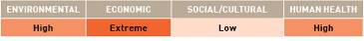

APPENDIX F
Species datasheet

Briarosaccus callosus
Briarosaccus callosus is a cosmopolitan rhizocephalan barnacle that parasitises decapod crustaceans. Due to its very high reproductive potential, this species can rapidly infest decapod crustacean populations (Isaeva et al. 2005).

Common names:
Parasitic barnacle.
Distribution:
Found in four of the 18 IUCN bioregions (see Figure 2).
North East Atlantic, Baltic, North East Pacific and North West Pacific. All regions are considered cryptogenic given the native region is unknown.
Larval period:
Larvae swim freely for around a month before settling and parasitising an appropriate host (Isaeva et al. 2005).
Temperature tolerance:
Inferred: -2.9 °C to 32.4 °C.
Physiological: Development of larvae ceases and no metamorphosis at 4 °C. Larvae can develop at temperatures of 6 ˚C to 8 °C (Kashenko & Korn 2002). Upper temperature range unknown.
Inoculation likelihood: MODERATE
Biofouling association rank – LOW
No information available. Vessel would need to carry a crustacean host infected with B. callosus in order for this species to be introduced via biofouling.
Transport pressure rank – MODERATE
Australian trade with the IUCN bioregions where B. callosus is found represents 42.3% of the nation’s total trade. Once the additional weighting is applied to the different vessel types to account for the mean duration in port in various bioregions, the average increases to the equivalent of 52.7% representing a low likelihood of transport.

Consequence:
Consequence was evaluated based on literature assessments.
Environmental impacts – MODERATE
No information available.
Economic impacts – HIGH
This species parasitises various species of commercially important crabs, including species of Lithodes, Paralithodes and Paralomis (Isaeva et al. 2005). A high prevalence of infection can conceivably reduce commercial stocks (Bower & Meyer 1999).
Social impacts/cultural impacts – NEGLIGIBLE
No information available.
Human health impacts – NEGLIGIBLE
No information available.

Risks:
Multiplying the inoculation likelihood (i.e. moderate) by consequence for each value category (i.e. moderate, high, negligible, negligible) results in the following risk categorisations across all vessel types and in at least one voyage duration.

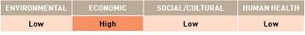

APPENDIX F
Species datasheet

Callinectes sapidus
Callinectes sapidus lives in estuaries and on the coast from low tide down to a depth of 35 m on muddy and sandy sea floors. Females mate in the upper reaches of estuaries, then move to the mouth of the estuary or nearshore coastal waters to spawn. In its native habitat on the Atlantic Coast from Nova Scotia to Uruguay, it serves as an important commercial and recreational fishery for human consumption (Nehring et al. 2008). C. sapidus produce huge numbers of offspring (about one to two million, but up to eight million eggs per female) that grow quickly and rapidly become sexually mature. C. sapidus can live under a wide range of chemical and physical environmental conditions and are omnivores and good swimmers–usually necessary prerequisites to become a successful invader (Nehring et al. 2008).

Common names:
Blue crab.
Distribution:
Found in eight of the 18 IUCN bioregions (see Figure 2).
Native: North West Atlantic, Wider Caribbean Sea and South Atlantic.
Introduced: Mediterranean, North East Atlantic, Baltic, South Pacific and North West Pacific.
Larval period:
Typical time for development through the seven zoeal stages is between 30 and 50 days before metamorphosis to the megalopal stage. The megalopa then persists between six and 58 days (Hill 2004).
Temperature tolerance:
Inferred: -2.9 °C to 31.8 °C
Physiological: 15 °C to 30 °C (Hill 2004). Growth occurs between 15 °C and 30 °C, but is prevented at temperatures below 10 °C. Low temperatures (<10 °C) prevent moulting and decrease growth rates in C. sapidus (Hill 2004), while a state of hibernation is induced in C. sapidus at temperatures below 5 °C. Generally, growth occurs at temperatures over 15 °C, and is mostly unaffected by salinity conditions (Hill 2004). Hatching of C. sapidus eggs requires water temperatures higher than 19 °C (citations in Nehring et al. 2008).

Inoculation likelihood: LOW
Biofouling association rank – VERY LOW
Ballast water was suspected as the main vector for introducing this species into European waters because C. sapidus were predominantly found in port regions where ballast water discharges frequently occur (citations in Nehring et al. 2008). However, the recent record of C. sapidus in the Weser estuary (Germany) has been attributed to translocation via biofouling (Nehring et al. 2008). C. sapidus is also thought to have been introduced to Japan in sea-chests (Otani 2004).
Transport pressure rank – MODERATE
Australian trade with the IUCN bioregions where C. sapidus is found represents 55.7% of the nation’s total trade. Once the additional weighting is applied to the different vessel types to account for the mean duration in port in various bioregions, the average increases to the equivalent of 69.1% representing a moderate likelihood of transport.

Consequence:
Consequence was evaluated based on literature assessments.
Environmental impacts – NEGLIGIBLE
No information available.
Economic impacts – HIGH
Juvenile populations of clams, mussels and oysters are the preferred foods of C. sapidus (Hill 2004) and this species has the potential to impact on commercial populations of these organisms. C. sapidus is nominated as one of the 100 ‘worst invasive alien species in the Mediterranean’ based on its impacts on biodiversity and fisheries (citations in Nehring et al. 2008).
Social impacts/cultural impacts – NEGLIGIBLE
No information available.
Human health impacts – NEGLIGIBLE
No information available.

Risks:
Multiplying the inoculation likelihood (i.e. low) by consequence for each value category (i.e. negligible, high, negligible, negligible) results in the following risk categorisations across all vessel types and in at least one voyage duration.

APPENDIX F
Species datasheet

Carcinoscorpius rotundicauda
Carcinoscorpius rotundicauda is found in shallow waters on soft sandy substrates. It typically occupies marine habitats, but it has also been found in rivers with low salinities. C. rotundicauda is predominantly a scavenger species and feeds on mollusca, arthropoda and detritus. Females can lay 60 000 to 120 000 eggs in batches of a few thousand at a time, with eggs taking up to two weeks to hatch. Individuals take 11 years to reach sexual maturity, after which they can live up to 14 more years.

Common names:
Bangladesh horseshoe crab, mangrove horseshoe crab.
Distribution:
Found in three of 18 the IUCN bioregions (see Figure 2).
Native: Central Indian Ocean, East Asian Seas and North West Pacific.
Introduced: No information available.
Larval period:
After hatching, trilobite larvae remain in the water column for around 21 days before settling onto soft sediments (Lee & Morton 2005).
Temperature tolerance:
Inferred: -2.9 °C to 32.7 °C.
Physiological: Minimum 22 °C, maximum 35 °C. Moulting continues when temperatures remain >28 °C, and are halted at <22 °C. Low temperatures have also been found to reduce moulting hormone levels to a critical degree in a closely related species, Limulus polyphemus and hence, suspend the moulting process at temperatures of <20 °C. The optimal temperature for development of L. polyphemus larvae ranges from 25 °C to 30 °C (Jegla & Costlow 1982), while the maximum survival temperature is 35 °C (Ehlinger & Tankersley 2004).

Inoculation likelihood: LOW
Biofouling association rank – VERY LOW
No information available.
Transport pressure rank – HIGH
Australian trade with the IUCN bioregions where C. rotundicauda is found represents 61.8% of the nation’s total trade. Once the additional weighting is applied to the different vessel types to account for the mean duration in port in various bioregions, the average increases to the equivalent of 77.7% representing a high likelihood of transport.

Consequence:
Consequence was evaluated based on literature assessments.
Environmental impacts – NEGLIGIBLE
No information available.
Economic impacts – NEGLIGIBLE
No information available.
Social impacts/cultural impacts – NEGLIGIBLE
No information available.
Human health impacts – NEGLIGIBLE
The eggs and flesh of C. rotundicauda in parts of South East Asia have been found to contain tetrodotoxin (TTX) which is not suitable for human consumption. The eggs of the cooked animal have been traditionally eaten, which has caused food poisoning of people in Thailand (Tanu & Noguchi 1999).

Risks:
Multiplying the inoculation likelihood (i.e. low) by consequence in each value category (i.e. negligible, negligible, negligible, high) results in the following risk categorisations across all vessel types and in at least one voyage duration.

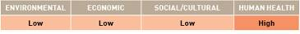

APPENDIX F
Species datasheet

Charybdis japonica
Charybdis japonica is a dioecious (two sexes), commercially important crab species in its native region of the North West Pacific that reach 12cm in size. C. japonica is found primarily in bays and estuaries, but can also survive on the open coast. Juvenile C. japonica have been associated with seagrass meadows (Huh & An 1998, cited in Smith et al. 2003) and soft mud, sand and shell habitats in New Zealand (Gust & Inglis 2006).

Common names:
Lady crab, Asian paddle crab, Asian crab, swimming crab.
Distribution:
Found in two of the 18 IUCN bioregions (see Figure 2).
Native: North West Pacific, particularly coastal regions of China, Japan, Korea, Taiwan and Malaysia (Smith et al. 2003).
Introduced: New Zealand.In 2000, a single male specimen was identified in Adelaide (Gilliland, Primary Industries and Resources, South Australia, pers. comm.; Hayes & Sliwa 2003), but subsequent surveys did not detect any additional specimens (Cohen et al. 2002).
Larval period:
Information about this species’ larval period could not be found, but the closely related species, C. hellerii, has a larval duration of 44 days (Dineen et al. 2001).
Temperature tolerance:
Inferred: -1.5 °C to 31.5 °C.
Physiological: No information available.

Inoculation likelihood: MODERATE
Biofouling association rank – MODERATE
C. japonica is not a sessile or sedentary species, but is associated with biofouling, and the genus has been identified in sea-chests of vessels (Coutts & Dodgshun 2007).
Transport pressure rank – LOW
Australian trade with the IUCN bioregions where C. japonica is found represents 39.1% of the nation’s total trade. Once the additional weighting is applied to the different vessel types to account for the mean duration in port in various bioregions, the average increases to the equivalent of 49% representing a low likelihood of transport.
Consequence:
Consequence was evaluated based on literature assessments.
Environmental impacts – MODERATE
C. japonica is a predatory species demonstrated to cause direct impacts on benthic species living in or on soft and hard substrates. Additionally, C. japonica is a known carrier of the White Spot Syndrome Virus (WSSV) (Maeda et al. 1998; Hayes & Sliwa 2003), which may affect a wide range of native crustaceans including shrimps and crabs.
Economic impacts – EXTREME
C. japonica is a known carrier of a World Organisation for Animal Health (OIE) listed species, WSSV (Maeda et al. 1998; Hayes & Sliwa 2003) which has the potential to affect several commercially important Australian wild stocks and aquaculture shrimp, lobster and crab species. C. japonica is also a predator of aquaculture species, such as the blue mussel, Mytilus galloprovincialis (Oikawa et al. 2004).
Social/cultural impacts – NEGLIGIBLE
No information available.
Human health impacts – EXTREME
C. japonica has been demonstrated to bioaccumulate toxins (e.g. paralytic shellfish poisoning) through predation on filter feeding molluscs (Oikawa et al. 2004). As a consequence, human consumption of C. japonica during or immediately following a toxic algal bloom event could transmit the toxins in sufficient quantities to cause human illness.

Risks:
Multiplying the inoculation likelihood (i.e. moderate) by consequence for each value category (i.e. moderate, extreme, negligible, extreme) results in the following risk categorisations across all vessel types and in at least one voyage duration.

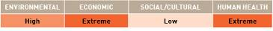

APPENDIX F
Species datasheet

Chthamalus proteus
A small barnacle about 1cm in diameter that inhabits the high or supra-tidal zones of protected harbours and embayments growing on pilings and other surfaces (Southward et al. 1998).

Common names:
Atlantic barnacle, Caribbean barnacle.
Distribution:
Found in four of the 18 IUCN bioregions (see Figure 2).
Native: South Atlantic and Wider Caribbean.
Introduced: East Asian Seas and South Pacific.
Larval period:
The larval period is short and varies with temperature and diet. There are six naupliar stages followed by a cyprid. At 28 °C, the earliest cyprids could develop was within 10 days (Zabin 2005).
Temperature tolerance:
Inferred: -0.6 °C to 32.1 °C.
Physiological: 16 °C to 38 °C (Zabin 2005).

Inoculation likelihood: MODERATE
Biofouling association rank – HIGH
This biofouling organism is thought to have been introduced to Hawaii from the Caribbean and then distributed throughout the island chain on the hulls of vessels and boats (DeFelice et al. 1998). It is now commonly seen growing above the water line on vessel hulls in Hawaii. It is thought to be only a matter of time before the species is introduced via this vector to other areas in the Pacific (Southward et al. 1998).
Transport pressure rank – LOW
Australian trade with the IUCN bioregions where C. proteus is found represents 29.9% of the nation’s total trade. Once the additional weighting is applied to the different vessel types to account for the mean duration in port in various bioregions, the average increases to the equivalent of 38.0% representing a low likelihood of transport.

Consequence:
Consequence was evaluated based on literature assessments.
Environmental impacts – MODERATE
This species is potentially a nuisance biofouling organism. It may cause competition for space with native and non-indigenous invertebrates in the high intertidal zone (Southward et al. 1998). In Hawaii this barnacle has established itself by exploiting a largely vacant niche (i.e. supratidal zone). Although impacts in Hawaii appear relatively benign (Southward et al. 1998), at high densities the barnacle may negatively impact the limpet Siphonaria normalis (Zabin 2005).
Economic impacts – NEGLIGIBLE
No information available.
Social/cultural impacts – NEGLIGIBLE
No information available.
Human health impacts – NEGLIGIBLE
No information available.

Risks:
Multiplying the inoculation likelihood (i.e. moderate) by consequence for each value category (i.e. moderate, negligible, negligible, negligible) results in the following risk categorisations across all vessel types and in at least one voyage duration.

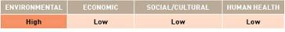

APPENDIX F
Species datasheet

Crangonyx floridanus
Crangonyx floridanus is a freshwater amphipod that can tolerate low salinities.

Common name:
Florida crangonyctid.
Distribution:
Found in three of the 18 IUCN bioregions (see Figure 2).
Native: Wider Caribbean.
Introduced: North East Pacific and North West Pacific.
Larval period:
Unknown.
Temperature tolerance:
Inferred: -2.9 °C to 32.4 °C.
Physiological: No information available.

Inoculation likelihood: LOW
Biofouling association rank – VERY LOW
The introduction of C. floridanus into Japan and Oregon has been attributed to ballast water (Zhang 1997). C. floridanus has not been recorded as a biofouling species.
Transport pressure rank – LOW
Australian trade with the IUCN bioregions where C. floridanus is found represents 38.3% of the nation’s total trade. Once the additional weighting is applied to the different vessel types to account for the mean duration in port in various bioregions, the average increases to the equivalent of 48.2% representing a low likelihood of transport.

Consequence:
Consequence was evaluated based on literature assessments.
Environmental impacts – MODERATE
Widely invasive species in Japan (Kanada et al. 2007).
Economic impacts – NEGLIGIBLE
No information available.
Social/cultural impacts – NEGLIGIBLE
No information available.
Human health impacts – NEGLIGIBLE
No information available.

Risks:
Multiplying the inoculation likelihood (i.e. low) by consequence for each value category (i.e. moderate, negligible, negligible, negligible) results in the following risk categorisations across all vessel types and in at least one voyage duration.

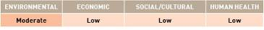

APPENDIX F
Species datasheet

Dikerogammarus villosus
Dikerogammarus villosus is a predatory freshwater amphipod. Its preferred environment is freshwater and brackish waters of lakes, rivers, estuaries and canals. D. villosus can tolerate salinities up to 24 ppt.

Common name:
Killer shrimp.
Distribution:
Found in two of the 18 IUCN bioregions (see Figure 2).
Native: Mediterranean.
Introduced: Baltic.
Larval period:
No larval stage–eggs are developed in the ventral brood chamber of the female. The species’ young resemble adults and reach sexual maturity rapidly.
Temperature tolerance:
Inferred: -2.9 °C to 29.7 °C.
Physiological: 20 °C to 35°C.

Inoculation likelihood: VERY LOW
Biofouling association rank – LOW
Invasion into North America predicted via ballast tanks (Crosier & Molloy 2008). This species lives on solid surfaces of all kinds.
Transport pressure rank – EXTREMELY LOW
Australian trade with the IUCN bioregions where D. villosus is found represents 5.4% of the nation’s total trade. Once the additional weighting is applied to the different vessel types to account for the mean duration in port in various bioregions, the average increases to the equivalent of 6.2% representing an extremely low likelihood of transport.

Consequence:
Consequence was evaluated based on literature assessments.
Environmental impacts – EXTREME
D. villosus colonises a wide variety of substrates and is capable of adapting to a wide range of habitats. It is able to survive fluctuations in temperature, salinity and oxygen levels (Crosier & Molloy 2008). D. villosus is a voracious predator of other macroinvertebrates, including other gammarids, which can result in displacement or local extinction of native species, thereby reducing biodiversity (Crosier & Molloy 2008). D. villosus has been observed attacking small fish, which raises concern over whether vulnerable life stages (eggs, larvae and juveniles) of vertebrates may also be at risk (Crosier & Molloy 2008). D. villosus may also be an intermediate host of acanthocephalan worms (a parasite of birds and fish) (Crosier & Molloy 2008).
Economic impacts – NEGLIGIBLE
No information available.
Social/cultural impacts – NEGLIGIBLE
No information available.
Human health impacts – NEGLIGIBLE
No information available.

Risks:
Multiplying the inoculation likelihood (i.e. very low) by consequence for each value category (i.e. extreme, negligible, negligible, negligible) results in the following risk categorisations across all vessel types and in at least one voyage duration.

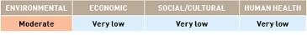

APPENDIX F
Species datasheet
Eriocheir sinensis
Eriocheir sinensis is a migrating species of crab found in rivers, estuaries and marine habitats of cold-temperate to tropical areas. E. sinensis is tolerant to highly polluted water and typically occupies lower shorelines to about 10 m in depth. E. sinensis is a culinary delicacy in Asia and supports a US$1.25 billion per annum aquaculture industry in China (Gollasch 2006). It has been used as bait for eel fishing and to produce fish meal and cosmetic products. The species has also been used as fertilizer in agriculture. This species has been nominated as among 100 of the ‘world’s worst’ invaders.

Common name:
Chinese mitten crab.
Distribution:
Found in seven of the 18 IUCN bioregions (see Figure 2).
Native: North West Pacific.
Introduced: Mediterranean, North West Atlantic, North East Atlantic, Baltic, Wider Caribbean Sea and North East Pacific.
Larval period:
The larval duration for E. sinensis is 43 to 90 days (Herborg et al. 2007). The species is catadromous–its free living planktonic larvae develop predominantly in saline water and require salinity greater than 15 ppt, although they spend much of the remainder of their lifecycle in freshwater (Herborg et al. 2007).
Temperature tolerance:
Inferred: -2.9 °C to 32.4 °C.
Physiological: Adult survival: 4 °C to 32 °C (Cohen & Weinstein 2001). Successful development of larvae occurs only at temperatures > 12 °C. No survival of first zoea has been observed below 9 °C (Anger 1991). Juvenile growth rates stops below 7 °C and above 30 °C (Cohen & Weinstein 2001).

Inoculation likelihood: MODERATE
Biofouling association rank – MODERATE
Some specimens in empty ‘shells’ of cirripeds have been reported on a vessel’s hull (Gollasch 2006). Two adult mitten crabs (4–5cm) were found in the sea-chest of a vessel that travelled from Bremen, China, to Hamburg, Germany (citations in Herborg et al 2003).
Transport pressure rank – MODERATE
Australian trade with the IUCN bioregions where E. sinensis is found represents 52.2% of the nation’s total trade. Once the additional weighting is applied to the different vessel types to account for the mean duration in port in various bioregions, the average increases to the equivalent of 64.4% representing a moderate likelihood of transport.

Consequence:
Consequence was evaluated based on literature assessments.
Environmental impacts – HIGH
E. sinensis impacts freshwater and estuarine ecosystems on a number of levels. It has an opportunistic diet including algae, detritus, and a variety of macroinvertebrates (citations in Gollasch 2006). Juvenile E. sinensis form dense colonies and create burrows in the intertidal portions of streams, a process which has caused erosion of stream banks in both Europe and the United States (citations in Gollasch 2006).
Economic impacts – HIGH
The monetary impact caused by E. sinensis in German waters since 1912 totals to approximately 80 million (Gollasch 2006). This species steals bait and damages fishing gear which hinders commercial and recreational fishing (citations in Gollasch 2006). Crabs may also feed on trapped fish in commercial aquaculture ponds. E. sinensis may also block water intakes in irrigation and water supply schemes (Gollasch 2006). In California, E. sinensis has disrupted water diversion plants with large numbers of downstream-migrating crabs becoming trapped in holding tanks meant to keep fish out of turbines. This has caused fish mortality; and high costs are spent to prevent the crab’s entry (citations in Gollasch 2006).
Social/cultural impacts – HIGH
In California, adult E. sinensis have become a major nuisance to anglers, taking a variety of baits including ghost shrimp and shad (Washington Sea Grant Program 2000).
Human health impacts – HIGH
E. sinensis is an intermittent host for the Oriental lung fluke. Mammals, including humans, can become infested by eating raw or poorly cooked mitten crabs (Gollasch 2006).

Risks:
Multiplying the inoculation likelihood (i.e. moderate) by consequence for each value category (i.e. high, high, high, high) results in the following risk categorisations across all vessel types and in at least one voyage duration.
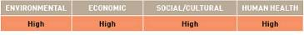

APPENDIX F
Species datasheet

Gammarus tigrinus
Gammarus tigrinus is an amphipod that is 4–11 mm in length. It is a benthic species which inhabits a range of environments, including sand and coarse stone substrates. G. tigrinus is typically found in rivers, with salinities ranging from freshwater to 25 ppt.

Common names:
Amphipod, freshwater shrimp.
Distribution:
Found in three of the 18 IUCN bioregions (see Figure 2).
Native: North West Atlantic.
Introduced: Baltic and North East Atlantic.
Larval period:
No larval stage–eggs are developed in the ventral brood chamber of the female. Egg incubation period is about 10 days and females are sexually mature after four weeks (Chambers 1977).
Temperature tolerance:
Inferred: -2.9 °C to 29.6 °C.
Physiological: 0 °C to 35 °C (SEPA 2005).

Inoculation likelihood: LOW
Biofouling association rank – MODERATE
This species is thought to have been introduced to the United Kingdom through ballast water (Swedish Environmental Protection Agency [SEPA] 2005) and to Germany as fish food. No information was available in relation to biofouling association.
Transport pressure rank – EXTREMELY LOW
Australian trade with the IUCN bioregions where G. tigrinus is found represents 7.0% of the nation’s total trade. Once the additional weighting is applied to the different vessel types to account for the mean duration in port in various bioregions, the average increases to the equivalent of 7.9% representing an extremely low likelihood of transport.
Consequence:
Consequence was evaluated based on literature assessments.
Environmental impacts – MODERATE
G. tigrinus has become widespread where it has been introduced to rivers in Germany, Netherlands and other countries in the Baltic and North East Atlantic regions. G. tigrinus is an omnivore and has been shown to outcompete and displace native amphipods (SEPA 2005). Since its introduction, it has become the most common amphipod in German rivers, however, following the introduction of D. villosus, it has become less dominant.
Economic impacts – NEGLIGIBLE
No information available.
Social/cultural impacts – NEGLIGIBLE
No information available.
Human health impacts – NEGLIGIBLE
No information available.
Risks:
Multiplying the inoculation likelihood (i.e. low) by consequence for each value category (i.e. moderate, negligible, negligible, negligible) results in the following risk categorisations across all vessel types and in at least one voyage duration.

APPENDIX F
Species datasheet

Gmelinoides fasciatus
Gmelinoides fasciatus is able to survive a wide range of temperatures and oxygen concentrations (Berezina 2007). It is a freshwater amphipod, with a salinity tolerance of 4 ppt in males and 6 ppt in females. G. fasciatus cannot reproduce in salinities higher than 2 ppt (Berezina & Panov 2004). It is widespread in different aquatic ecosystems from low salinity lakes to estuaries (Berezina 2007). G. fasciatus inhabits silt, sandy, stony and woody substrates and concentrates in macrophyte and macroalgae beds (Berezina 2007). G. fasciatus is one of the most successful invaders in eastern Europe and Siberia (Berezina et al. 2009). It consumes detritus, algae and aquatic plants as well as small benthic and zooplankton organisms (Berezina 2007). The species can tolerate severe eutrophication (Berezina 2007). In some regions, G. fasciatus was intentionally introduced to enrich fish production (Berezina 2007). G. fasciatus has a short life cycle and high fecundity which means it can reach high densities in a short period (Berezina 2007; Berezina et al. 2009).

Common name:
Baikalian amphipod.
Distribution:
Found in two of the 18 IUCN bioregions (see Figure 2).
Native: Inland waters of Asia and Serbia (CORPI 2008).
Introduced: Baltic and North West Pacific bioregions as well as freshwaters of eastern Europe and Siberia (Berezina et al. 2009).
Larval period:
No information.
Temperature tolerance:
Inferred: -2.9 °C to 22.5 °C (Baltic bioregion)
Physiological: Female G. fasciatus were found with fecund eggs in the Neva Estuary (Baltic Sea basin) at a water temperature of 27 °C (Berezina 2007).

Inoculation likelihood: LOW
Biofouling association rank – LOW
G. fasciatus was intentionally introduced to some regions to enrich fish production (Berezina 2007). No information available on the likelihood of this species occurring as biofouling.
Transport pressure rank – LOW
Australian trade with the IUCN bioregions where G. fasciatus is found represents 32.6% of the nation’s total trade. Once the additional weighting is applied to the different vessel types to account for the mean duration in port in various bioregions, the average increases to the equivalent of 41.3% representing a low likelihood of transport.

Consequence:
Consequence was evaluated based on literature assessments.
Environmental impacts – HIGH
G. fasciatus has had a high ecological impact in the aquatic ecosystems of Russia where its spread has led to changes in pre-existing biota, loss of species diversity and alterations to food webs (Berezina 2007). It causes alterations in community structures and a decrease in the native macroinvertebrate populations (Berezina et al. 2009). G. fasciatus is also able to transfer a parasite that can cause disease in ducks (Sidorov, cited in Berezina 2007).
Economic impacts – NEGLIGIBLE
No information available.
Social/cultural impacts – NEGLIGIBLE
No information available.
Human health impacts – NEGLIGIBLE
No information available.

Risks:
Multiplying the inoculation likelihood (i.e. low) by consequence for each value category (i.e. high, negligible, negligible, negligible) results in the following risk categorisations across all vessel types and in at least one voyage duration.

APPENDIX F
Species datasheet

Hemigrapsus sanguineus
Hemigrapsus sanguineus inhabits hard-bottom intertidal habitats and sometimes shallow subtidal habitats, with highest densities occurring at the middle and lower intertidal elevations (Benson 2005). This species is an opportunistic omnivore, feeding on macroalgae, salt marsh grass, larval and juvenile fish, and small invertebrates such as amphipods, gastropods, bivalves, barnacles and polychaetes. H. sanguineus has a high fecundity and females are capable of producing 50 000 eggs per clutch with three to four clutches per breeding season.

Common names:
Asian shore crab, Japanese shore crab.
Distribution:
Found in four of the 18 IUCN bioregions (see Figure 2).
Native: North West Pacific.
Introduced: North West Atlantic, Mediterranean and North East Atlantic.
Larval period:
Larval planktonic stage lasts for one month under optimal temperature and salinity conditions (Epifanio et al. 1998).
Temperature tolerance:
Inferred: -2.9 ˚C to 31.5 °C.
Physiological: Minimum temperature required for development of larvae into juvenile stage is 15 °C (Epifanio et al. 1998). In its native and introduced range, this species is not reported at locations where average summer sea surface temperatures are below 12.6 °C. The adults are recorded as surviving in temperatures from 0.8 °C to 26.7 °C in New Jersey (McDermott 1998).

Inoculation likelihood: MODERATE
Biofouling association rank – LOW
There is potential for H. sanguineus to be transported in niche areas such as sea-chests, but no specific information is available.
Transport pressure rank – MODERATE
Australian trade with the IUCN bioregions where H. sanguineus is found represents 43.4% of the nation’s total trade. Once the additional weighting is applied to the different vessel types to account for the mean duration in port in various bioregions, the average increases to the equivalent of 53.4% representing a moderate likelihood of transport.

Consequence:
Consequence was evaluated based on literature assessments.
Environmental impacts – HIGH
The very broad diet of H. sanguineus suggests it has the potential to affect populations of native species such as crabs, fish and shellfish by disrupting the food web (Benson 2005). It is also a competitor with native crabs for habitat and food. Recent trends in the United States show numbers of H. sanguineus are steadily increasing, while native crab populations are declining (Benson 2005). Since its introduction to the United States in 1988, it has become the dominant crab species in rocky intertidal habitats at many locations.
Economic impacts – MODERATE
Predates on commercial species, such as blue mussels Mytilus edulis, soft-shell clams Mya arenaria and oysters Crassostrea virginica (Benson 2005), as well as juvenile lobsters Homarus americanus.
Social/cultural impacts – NEGLIGIBLE
No information available.
Human health impacts – NEGLIGIBLE
No information available.

Risks:
Multiplying the inoculation likelihood (i.e. moderate) by consequence for each value category (i.e. high, moderate, negligible, negligible) results in the following risk categorisations across all vessel types and in at least one voyage duration.

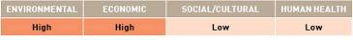

APPENDIX F
Species datasheet

Loxothylacus panopaei
Loxothylacus panopaei is a rhizocephalan barnacle that is a parasite of decapod crustaceans. The host range of L. panopaei includes at least nine species of xanthid crabs, including commercially important Callinectes species.

Common name:
Parasitic barnacle.
Distribution:
Found in two of the 18 IUCN bioregions (see Figure 2).
Native: Wider Caribbean Sea.
Introduced: North West Atlantic
Larval period:
Larval development is completed in 84 hours.
Temperature tolerance:
Inferred: 10.5 ˚C to 31.8 °C.
Physiological: For reproduction: 11 ˚C to 26 °C (National Estuarine and Marine Exotic Species Information System [NEMESIS] 2005). For survival: unknown.

Inoculation likelihood: VERY LOW
Biofouling association rank – LOW
Introduced to Chesapeake Bay in association with aquaculture transfers (oysters) from the Gulf of Mexico (citations in NEMESIS 2005a).
Transport pressure rank – EXTREMELY LOW
Australian trade with the IUCN bioregions where L. panopaei is found represents 4.5% of the nation’s total trade. Once the additional weighting is applied to the different vessel types to account for the mean duration in port in various bioregions, the average increases to the equivalent of 5.5% representing an extremely low likelihood of transport.

Consequence:
Consequence was evaluated based on literature assessments.
Environmental impacts – HIGH
As a parasite on decapod crustaceans, L. panopaei usually destroys the gonads of the host and inhibits moulting. L. panopaei may cause indirect effects on other trophic levels, such as the predators and prey of its host species (NEMESIS 2005a).
Economic impacts – HIGH
As a parasite of the commercially important blue crab (C. sapidus), L. panopaei is believed to cause significant economic loss in the Gulf of Mexico (Vasquez-Lopez et al. 2006).
Social/cultural impacts – NEGLIGIBLE
No information available.
Human health impacts – NEGLIGIBLE
No information available.

Risks:
Multiplying the inoculation likelihood (i.e. very low) by consequence for each value category (i.e. high, high, negligible, negligible) results in the following risk categorisations across all vessel types and in at least one voyage duration.

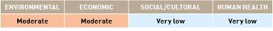

APPENDIX F
Species datasheet

Pachygrapsus fakaravensis
Pachygrapsus fakaravensis is a medium-sized intertidal crab that inhabits rocky shores. P. fakaravensis is a scavenger that feeds on plant and animal debris in the intertidal zone (Eldredge & Smith 2001).

Common name:
Polynesian grapsid crab.
Distribution:
Found in one of the 18 IUCN bioregions (see Figure 2).
Native: South Pacific (French Polynesia).
Introduced: South Pacific (Hawaii).
Larval period:
Has a planktonic larval stage, but larval duration is unknown.
Temperature tolerance:
Inferred: -2.9 °C to 32.1 °C.
Physiological: No information available.

Inoculation likelihood: LOW
Biofouling association rank – MODERATE
This species is thought to have been introduced to Hawaii via ballast water (Eldredge & Smith 2001). No references are available with respect to the species’ biofouling association.
Transport pressure rank – EXTREMELY LOW
Australian trade with the IUCN bioregions where P. fakaravensis is found represents 5% of the nation’s total trade. Once the additional weighting is applied to the different vessel types to account for the mean duration in port in various bioregions, the average increases to the equivalent of 6.6% representing an extremely low likelihood of transport.

Consequence:
Consequence was evaluated based on literature assessments.
Environmental impacts – MODERATE
Environmental impact is unknown, but species may compete with native intertidal grapsid crabs for food and shelter (Eldredge & Smith 2001).
Economic impacts – NEGLIGIBLE
No information available.
Social/cultural impacts – NEGLIGIBLE
No information available.
Human health impacts – NEGLIGIBLE
No information available.

Risks:
Multiplying the inoculation likelihood (i.e. low) by consequence for each value category (i.e. moderate, negligible, negligible, negligible) results in the following risk categorisations across all vessel types and in at least one voyage duration.

APPENDIX F
Species datasheet

Rhithropanopeus harrisii
Rhithropanopeus harrisii is a dioecious (two sexes) crab species, reaching 12cm in size. This species is found in estuaries and salt marshes in both native and introduced regions, tolerating a wide range of salinities, including freshwater. It is commonly associated with oyster beds and areas of man-made disturbance such as canals and waterways (Gollasch et al. 1999; Leppakoski & Gollasch 1999).

Common names:
Harris mud crab, white-fingered mud crab, Zuiderzee crab.
Distribution:
Found in eight of the 18 IUCN bioregions (see Figure 2).
Native: North West Atlantic and Wider Caribbean Sea.
Introduced:Mediterranean, North East Atlantic, Baltic, South Atlantic, North East Pacific and North West Pacific.
Larval period:
14 to 50 days (Turoboyski 1973).
Temperature tolerance:
Inferred: -2.9 °C to 32.4 °C.
Physiological: -2.9 °C to 35 °C (Turoboyski, 1973). Larvae can survive between 18 °C and 30 °C (Turoboyski 1973).

Inoculation likelihood: MODERATE
Biofouling association rank – MODERATE
R. harrisii is not a sessile or sedentary species, but is associated with biofouling of oysters and mussels, and has the potential to survive in sea-chests of vessels (Coutts & Dodgshun 2007).
Transport pressure rank – MODERATE
Australian trade with the IUCN bioregions where R. harrisii is found represents 55.7% of the nation’s total trade. Once the additional weighting is applied to the different vessel types to account for the mean duration in port in various bioregions, the average increases to the equivalent of 68.7% representing a moderate likelihood of transport.

Consequence:
Consequence was evaluated based on literature assessments.
Environmental impacts – MODERATE
R. harrisii is a small predatory species that is inferred to cause direct impacts on other crabs, as well as predation on benthic species living in or on soft and hard substrates (Gollasch et al. 1999).
Economic impacts – HIGH
R. harrisi may prey upon newly settled spat of commercially important oysters and mussels (Leppakoski & Gollasch 1999). Reports of crabs clogging water intakes have been documented in northern Europe (Gollasch et al. 1999; Leppakoski & Gollasch 1999).
Social/cultural impacts – NEGLIGIBLE
No information available.
Human health impacts – NEGLIGIBLE
No information available.

Risks:
Multiplying the inoculation likelihood (i.e. moderate) by consequence for each value category (i.e. moderate, high, negligible, negligible) results in the following risk categorisations across all vessel types and in at least one voyage duration.

APPENDIX F
Species datasheet

Solidobalanus fallax
Solidobalanus fallax is a hermaphroditic (both sexes in one individual) sessile, warm-water barnacle. It is found primarily in bays and estuaries, but can also persist on the open coast. In Europe, the species is primarily found on biological substrata such as algae, cnidarians, molluscs and crustaceans (Southward et al. 2004), but also settles on plastic bags and nets, and objects such as crab and lobster pots.

Common name:
Warm-water barnacle.
Distribution:
Found in two of the 18 IUCN bioregions (see Figure 2).
Native: West Africa.
Introduced: North East Atlantic.
Larval period:
Eight-day planktonic period before reaching the cyprid stage (Korn & Elfimov 1999).
Temperature tolerance:
Inferred: -1.5 ˚C to 31.7 °C.
Physiological: Unknown.

Inoculation likelihood: LOW
Biofouling association rank – LOW
S. fallax is a sessile species, but has a preferential association with biological substrates making its association with biofouling reliant on well established biofouling assemblages.
Transport pressure rank – VERY LOW
Australian trade with the IUCN bioregions where S. fallax is found represents 8.6% of the nation’s total trade. Once the additional weighting is applied to the different vessel types to account for the mean duration in port in various bioregions, the average increases to the equivalent of 10.4% representing a very low likelihood of transport.

Consequence:
Consequence was evaluated based on literature assessments.
Environmental impacts – EXTREME
S. fallax settles on biogenic substrate including algae, molluscs, crustaceans and the habitat-forming sea-fan Eunicella verrucosa where its presence is inferred to cause negative impacts by overgrowth and smothering (Southward et al. 2004).
Economic impacts – MODERATE
S. fallax is a nuisance fouler on commercial maritime structures including wharves, jetties and buoys, as well as biofouling on vessel hulls. As a biofouling barnacle, it is inferred to block seawater intakes for industrial (e.g. power station, factory) cooling systems and to foul mussels and oysters–interfering with aquaculture production (Leppakoski & Gollasch 1999; Southward et al. 2004).
Social/cultural impacts – NEGLIGIBLE
No information available.
Human health impacts – NEGLIGIBLE
No information available.

Risks:
Multiplying the inoculation likelihood (i.e. low) by consequence for each value category (i.e. extreme, moderate, negligible, negligible) results in the following risk categorisations across all vessel types and in at least one voyage duration.

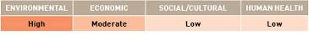

APPENDIX F
Species datasheet

Sphaeroma annandalei
Sphaeroma annandalei is an isopod crustacean that is a specialised marine wood borer. S. annandalei prefers mesohaline conditions (citations in Menon et al. 2000).

Common name:
Isopod.
Distribution:
Found in two of the 18 IUCN bioregions (see Figure 2).
Native: Central Indian Ocean.
Introduced: South Atlantic.
Larval period:
No information available.
Temperature tolerance:
Inferred: 20.9 °C to 32.4 °C.
Physiological: No information available.

Inoculation likelihood: LOW
Biofouling association rank – LOW
This species may bore into wooden boats (Sanagoudra & Neelakanton 2008).
Transport pressure rank – VERY LOW
Australian trade with the IUCN bioregions where S. annandalei is found represents 8.0% of the nation’s total trade. Once the additional weighting is applied to the different vessel types to account for the mean duration in port in various bioregions, the average increases to the equivalent of 10.1% representing a very low likelihood of transport.

Consequence:
Consequence was evaluated based on literature assessments.
Environmental impacts – EXTREME
S. annandalei is a prolific wood borer and causes biodeterioration of mangroves (Venkatakrishnan & Balakrishnan Nair 1973).
Economic impacts – MODERATE
S. annandalei can cause biodeterioration of underwater timber construction, including marine structures and fishing craft (Sanagoudra & Neelakanton 2008).
Social/cultural impacts – NEGLIGIBLE
No information available.
Human health impacts – NEGLIGIBLE
No information available.

Risks:
Multiplying the inoculation likelihood (i.e. very low) by consequence for each value category (i.e. extreme, moderate, negligible, negligible) results in the following risk categorisations across all vessel types and in at least one voyage duration.

APPENDIX F
Species datasheet

Sylon hippolytes
Sylon hippolytes is a parasitic castrating barnacle, affecting a wide range of Caridean shrimp species throughout the coastal areas of the North Pacific. Its externa, the portion of the barnacle external to the host, can reach 1–1.5cm in diameter, usually underneath the abdomen.

Common name:
Parasitic barnacle.
Distribution:
Found in four of the 18 IUCN bioregions (see Figure 2).
Native: North West Pacific.
Introduced: Wider Caribbean Sea, Central Indian Ocean and East Asian Seas.
Larval period:
Larvae are discharged as cyprids. The period of time that cyprids spend in the plankton is unknown.
Temperature tolerance:
Inferred: -2.9 °C to 32.7 °C.
Physiological: Unknown.

Inoculation likelihood: MODERATE
Biofouling association rank – LOW
S. hippolytes is not a sessile or sedentary species, but is associated with secondary mobile species found in biofouling assemblages, including those organisms common in sea-chests of vessels (Coutts & Dodgshun 2007).
Transport pressure rank – MODERATE
Australian trade with the IUCN bioregions where S. hippolytes is found represents 58.1% of the nation’s total trade. Once the additional weighting is applied to the different vessel types to account for the mean duration in port in various bioregions, the average increases to the equivalent of 73.4% representing a moderate likelihood of transport.

Consequence:
Consequence was evaluated based on literature assessments.
Environmental impacts – NEGLIGIBLE
S. hippolytes is a parasitic castrator infecting at least 21 Caridean shrimp species. This species can cause a stunting of growth and alteration of sexual characteristics, with potential to sterilise males (Bower & Boutillier 1990; Lützen 1981). It usually occurs in a small percentage of wild populations (<5%).
Economic impacts – HIGH
S. hippolytes affects several species of commercial interest, including wild and aquaculture-farmed stocks (see Bower & Boutillier 1990). Infected prawns usually die when the parasite has completed its life cycle. Prawns that survive infection often exhibit brown or black scars, making them less desirable for market.
Social/cultural impacts – NEGLIGIBLE
No information available.
Human health impacts – NEGLIGIBLE
No information available.

Risks:
Multiplying the inoculation likelihood (i.e. moderate) by consequence for each value category (i.e. negligible, high, negligible, negligible) results in the following risk categorisations across all vessel types and in at least one voyage duration.

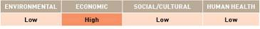

APPENDIX F
Species datasheet

Corethron criophilum
Corethron criophilum is a non-toxic cold water diatom.

Common name:
Diatom.
Distribution:
Found in one of the 18 IUCN bioregions (see Figure 2). New Zealand—considered to be cryptogenic as native region unknown.
Larval period:
Planktonic species.
Temperature tolerance:
Inferred: -2.85 ˚C to 31.7 °C.
Physiological: Maximum is 6 ˚C to 9 °C, but minimum is unknown. Maximum growth occurs between 3 °C and 5 °C (Fiala & Oriol 1990).

Inoculation likelihood: EXTREMELY LOW
Biofouling association rank – NEGLIGIBLE
Planktonic species for entire life cycle; occurrence in biofouling assemblages is not recorded.
Transport pressure rank – EXTREMELY LOW
Australian trade with the IUCN bioregions where C. criophilum is found represents 7.0% of the nation’s total trade. Once the additional weighting is applied to the different vessel types to account for the mean duration in port in various bioregions, the average increases to the equivalent of 8.4% representing an extremely low likelihood of transport.

Consequence:
Consequence was evaluated based on literature assessments.
Environmental impacts – MODERATE
This species is one of the best competitors in cold-water phytoplankton communities for nitrate (Sommer 1991).
Economic impacts – HIGH
C. criophilum blooms can cause mortality of farmed coho salmon (Speare et al. 1989). The spines of C. criophilum cause the epithelium of the gills of fish to become physically irritated, which forms lesions and produces excessive mucus that leads to asphyxiation (Speare et al. 1989).
Social/cultural impacts – NEGLIGIBLE
No information available.
Human health impacts – NEGLIGIBLE
No information available.

Risks:
Multiplying the inoculation likelihood (i.e. extremely low) by consequence for each value category (i.e. moderate, high, negligible, negligible) results in the following risk categorisations across all vessel types and in at least one voyage duration.

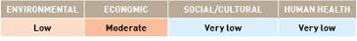

APPENDIX F
Species datasheet

Avrainvillea amadelpha
Avrainvillea amadelpha is a green macroalgae which is most abundant in shallow, sandy habitats with low water motion. A. amadelpha forms dense clumps often covered with silt/sand and can also grow on rock or coral rubble (Hawaiian Biological Society [HBS] 2009). Its success as an invader has been attributed to its lack of predators and rapid growth rate (HBS 2009).

Common name:
Leather mudweed.
Distribution:
Found in four of the 18 IUCN bioregions (see Figure 2).
Native: Central Indian Ocean.
Introduced: East Africa, East Asian Seas and South Pacific.
Larval period
No information available.
Temperature tolerance:
Inferred: 14.6 °C to 35.3 °C.
Physiological: No information available.

Inoculation likelihood: LOW
Biofouling association rank – LOW
This species is able to attach and grow on hard substrates such as rock or coral rubble (HBS 2009).
Transport pressure rank – LOW
Australian trade with the IUCN bioregions where A. amadelpha is found represents 28.5% of the nation’s total trade. Once the additional weighting is applied to the different vessel types to account for the mean duration in port in various bioregions, the average increases to the equivalent of 36.2% representing a low likelihood of transport.

Consequence:
Consequence was evaluated based on literature assessments.
Environmental impacts – MODERATE
In Hawaii where it was recently introduced, A. amadelpha has out-competed native macrophytes, resulting in the reduction of native seagrass beds (University of Hawaii 2001). The closely packed blades of A. amadelpha trap sediments and provide habitat for filter feeders such as worms and molluscs. Trapped sediments eventually create a layer of mud, thus changing the nature of the substrate. A. amadelpha also decreases the heterogeneity of rocky reefs by covering holes and cracks, thus affecting recruitment of other species (HBS 2009).
Economic impacts – LOW
A. amadelpha decreases the heterogeneity of reef substrate by covering holes and cracks, which in turn may affect recruitment rates of species of commercial interest, such as octopus, lobsters and aquarium fisheries (HBS 2009). Loss of seagrass habitat may also impact on commercial and recreational fisheries (University of Hawaii 2010).
Social/cultural impacts – NEGLIGIBLE
No information available.
Human health impacts – NEGLIGIBLE
No information available.

Risks:
Multiplying the inoculation likelihood (i.e. low) by consequence for each value category (i.e. moderate, low, negligible, negligible) results in the following risk categorisations across all vessel types and in at least one voyage duration.

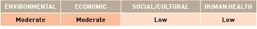

APPENDIX F
Species datasheet

APPENDIX F
Species datasheet

Codium fragile atlanticum
Codium fragile atlanticum is a siphonous green seaweed. There are reportedly two subspecies found in Britain (C. f. atlanticum and C. f. tomentosoides), but as they are only distinguishable microscopically, there is much uncertainty as to when they were introduced and how they have spread (Joint Nature Conservation Committee [JNCC] undated; Guiry 2008). A third subspecies, C. f. scandinavicum, was introduced to Denmark and Norway from Asiatic coasts of the Pacific (JNCC undated). There has been much debate about how many distinct subspecies of C. fragile exist and which ones have invasive tendencies (Provan et al. 2008). Recent genetic studies have shown that in Britain, C. f. atlanticum is probably native; and C. f. tomentosoides, whilst introduced and invasive, is synonymous with C. f. atlanticum (Provan et al. 2008). Furthermore, the small genotypic variation reported, and the large phenotypic variation described, makes the described subspecies and varieties unsustainable. Therefore, for all practical purposes, it may be best to recognise one variable species of C. fragile (Guiry 2008). The Global Invasive Species Database states that C. f. tomentosoides: has been introduced around the world through shellfish aquaculture, recreational boating and transport on vessel hulls; and it fouls shellfish beds, accumulates and rots on beaches, and alters benthic communities and habitats (Invasive Species Specialists Group [ISSG] 2005b).

Common name:
Green sea fingers.
Distribution:
Found in three of the 18 IUCN bioregions (see Figure 2).
Native: North West Pacific (JNCC undated; Eno et al. 1997).
Introduced: North East Atlantic and West Africa for C. f. atlanticum (JNCC undated; Eno et al. 1997).
Larval period:
No information available.
Temperature tolerance:
Inferred: -2.9 °C to 31.5 °C.
Physiological: No information available.

Inoculation likelihood: LOW
Biofouling association rank – VERY LOW
C. f. atlanticum was intentionally introduced to Ireland with shellfish and may have spread around Britain through rafting or floating (Eno et al. 1997).
Transport pressure rank – MODERATE
Australian trade with the IUCN bioregions where C. f. atlanticum is found represents 40.7% of the nation’s total trade. Once the additional weighting is applied to the different vessel types to account for the mean duration in port in various bioregions, the average increases to the equivalent of 51% representing a moderate likelihood of transport.
Consequence:
Consequence was evaluated based on literature assessments.
Environmental impacts – MODERATE
In Britain, C. f. atlanticum displaces the native species C. tomentosum (Farnham, cited in Eno et al. 1997).
Economic impacts – NEGLIGIBLE
No information available.
Social/cultural impacts – NEGLIGIBLE
No information available.
Human health impacts – NEGLIGIBLE
No information available.

Risks:
Multiplying the inoculation likelihood (i.e. low) by consequence for each value category (i.e. moderate, negligible, negligible, negligible) results in the following risk categorisations across all vessel types and in at least one voyage duration.

APPENDIX F
Species datasheet

Ulva pertusa
Ulva pertusa is a thin, green macroalgae that grows between the surface and 1 m depth on rocky substrates and hard structures (Verlaque et al. 2002). This species tolerates a wide range of salinities from marine conditions to salinities as low as 17–18 ppt, but is most common in coastal lagoons.

Common name:
Sea lettuce.
Distribution:
Found in two of the 18 IUCN bioregions (see Figure 2).
Native: North West Pacific.
Introduced: Mediterranean.
Larval period:
Information unavailable.
Temperature tolerance:
Inferred: -2.9 °C to 32.4 °C.
Physiological: Exact limits are unknown. Growth rate is highest at low temperatures, i.e. 15 °C (citations in Verlaque et al. 2002). On the Izu Peninsula, the species’ optimum temperature for photosynthesis is 25 °C to 30 °C (citations in Verlaque et al. 2002). In the Thau Lagoon, U. pertusa is able to survive temperatures between 4 °C and 27 °C.

Inoculation likelihood: MODERATE
Biofouling association rank – HIGH
This is a biofouling species that grows on hard structures (Verlaque et al. 2002).
Transport pressure rank – LOW
Australian trade with the IUCN bioregions where U. pertusa is found represents 36.9% of the nation’s total trade. Once the additional weighting is applied to the different vessel types to account for the mean duration in port in various bioregions, the average increases to the equivalent of 46.1% representing a low likelihood of transport.

Consequence:
Consequence was evaluated based on literature assessments.
Environmental impacts – MODERATE
At certain times of the year, with the addition of nutrients to its habitat, U. pertusa forms dense blooms in inner bays of Japan and Korea, termed ‘green tides’ (Yabe et al. 2009). These blooms can affect seagrass beds mainly through shading (citations in Yabe et al. 2009). Decomposing U. pertusa typically wash up on beaches, resulting in decreased infaunal abundance and diversity (citations in Yabe et al. 2009).
Economic impacts – MODERATE
Washed up decomposing Ulva spp. can cause major economic impacts to tourism, as well as the costs involved with clean up activities (Charlier et al. 2007).
Social/cultural impacts – MODERATE
Washed up decomposing Ulva spp. produce noxious odours, which prevent people from utilising the waterfront areas (citations in Yabe et al. 2009).
Human health impacts – NEGLIGIBLE
The noxious odours produced by the decomposing Ulva spp. have the potential to cause damage to human health (Charlier et al. 2007).

Risks:
Multiplying the inoculation likelihood (i.e. moderate) by consequence for each value category (i.e. moderate, moderate, moderate, negligible) results in the following risk categorisations across all vessel types and in at least one voyage duration.

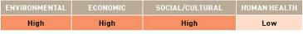

APPENDIX F
Species datasheet
Didemnum vexillum
Didemnum vexillum is an aggressive and rapidly spreading colonial ascidian (Bullard et al. 2007; Coutts & Forrest 2007). Colonies exhibit a wide range of morphological variation and can be pinkish, tan, or pale orange in colour (Valentine 2009). D. vexillum colonies can be long and rope-like (up to about 1 m in length) or can form extensive encrusting mats and can grow on a wide variety of hard substrata (Valentine 2009). Growth form appears to be related to habitat type, current velocities and space availability, as rope-like forms are common in low energy habitats, whereas mat-like colonies are common where tidal flows are strong (Valentine 2009). D. vexillum has been observed in nearshore and offshore sites and can grow at depths ranging from < 1 m to at least 81 m (Bullard et al. 2007).

Common names:
Colonial sea squirt, drooping sea squirt, ascidian, colonial tunicate.
Distribution:
Found in five of the 18 IUCN bioregions (see Figure 2).
Native: There is some uncertainty surrounding its native range, but recent genetic analysis suggests D. vexillum may be native to the North West Pacific bioregion (Japan; Lambert 2009).
Introduced: North West Atlantic (Bullard et al. 2007), North East Atlantic (Valentine 2009), North East Pacific (Daniel & Therriault 2007) and New Zealand (Kott 2009).
Larval period:
D. vexillum has pelagic larvae with a short larval period, generally less than one day (Osman & Whitlatch 2007). Fragments of D. vexillum colonies can also reattach and grow, facilitating spread to new locations (Valentine et al. 2009).
Temperature tolerance
Inferred: -2.9 °C to 32.4 °C.
Physiological: -2 °C to > 24 °C.

Inoculation likelihood: HIGH
Biofouling association rank – HIGH
D. vexillum readily fouls boat hulls, aquaculture structures and cultured shellfish (Coutts & Forrest 2007). Consequently, human-mediated transport via biofouling is the most important vector for long-distance dispersal (Svane & Young 1991; Osman & Whitlatch 2007).
Transport pressure rank – MODERATE
Australian trade with the IUCN bioregions where D. vexillum is found represents 50.5% of the nation’s total trade. Once the additional weighting is applied to the different vessel types to account for the mean duration in port in various bioregions, the average increases to the equivalent of 62.4% representing a moderate likelihood of transport.

Consequence:
Consequence was evaluated based on literature assessments.
Environmental impacts – HIGH
D. vexillum commonly overgrows other ascidian species (both colonial and solitary) as well as sponges, macroalgae, hydroids, anemones, bryozoans, scallops, mussels, polychaetes and crustaceans that have completed their terminal moult (Bullard et al. 2007).
Economic impacts – MODERATE
D. vexillum is considered a threat to aquaculture industries because of its demonstrated invasiveness and ability to over-settle and smother mussels (Coutts & Forrest 2007). Recent experimental studies have shown that widespread colonisation of substrata by D. vexillum could affect scallop fisheries, lowering recruitment through reduction of the area of quality habitats available for settlement (Morris et al. 2009). In addition, the Canadian aquaculture industry has reported that heavy infestations of non-indigenous ascidians result in increased handling and processing costs. Offshore fisheries may also suffer where high densities of D. vexillum may alter the access of commercially important fish species to critical spawning grounds, prey items and refugia (Daly & Scavia 2008).
Social/cultural impacts – VERY LOW
Large infestations of D. vexillum have the potential to causes loss of aesthetic value to a region, including loss of recreational value.
Human health impacts – NEGLIGIBLE
No information available.

Risks:
Multiplying the inoculation likelihood (i.e. moderate) by consequence for each value category (i.e. high, moderate, very low, negligible) results in the following risk categorisations across all vessel types and in at least one voyage duration.
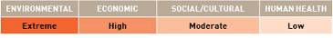

APPENDIX F
Species datasheet

Pseudochattonella farcimen (previously Chattonella aff. verruculosa)
Pseudochattonella farcimen is a cold water heterokont phytoflagellate. This is a new species based on a description of material from Skagerack sampled in 2001 (Eikrem et al 2009). The species is planktonic and is present in fjords, open water and open coastal area in the North Sea, Skagerrak and Kattegat (Naustvoll 2006).

Common name:
Raphidophyte.
Distribution:
Found in one of the 18 IUCN bioregions (Figure 2). North East Atlantic—where it is considered to be cryptogenic as its native region is unknown.
Larval period:
As this is a ‘new’ species, there is limited information available. The life history characteristics of P. farcimen are presently uncertain. Some preliminary experiments indicate that the species may form resting stages (cysts) under certain conditions. However, it is uncertain if such resting stages are part of a sexual reproduction. Vegetative growth is by ordinary cell division (citations in Naustvoll 2006).
Temperature tolerance:
Inferred: -1.5 °C to 27 °C.
Physiological: P. farcimen is a cold water species with optimal growth between 2 °C and 10 °C (citations in Naustvoll 2006). All blooms have occurred when the water temperature was below 10 °C (Naustvoll 2006).

Inoculation likelihood: VERY LOW
Biofouling association rank – EXTREMELY LOW
No information available.
Transport pressure rank – EXTREMELY LOW
Australian trade with the IUCN bioregions where P. farcimen is found represents 5.3% of the nation’s total trade. Once the additional weighting is applied to the different vessel types to account for the mean duration in port in various bioregions, the average increases to the equivalent of 5.9% representing an extremely low likelihood of transport.

Consequence:
Consequence was evaluated based on literature assessments.
Environmental impacts – MODERATE
From April to May 1998, P. farcimen formed a massive bloom in the North Sea and off the coasts of Germany, Denmark, Sweden and Norway, which reportedly caused mortality among wild fish stocks (Naustvoll 2006).
Economic impacts – HIGH
The 1998 bloom of P. farcimen killed 350 tonnes of farmed salmon (citations in Edvardsen et al. 2007). This species also formed a bloom in April and May 2000 in the German Bight and off the Danish Jutland coast (citations in Edvardsen et al. 2007). In 2001, P. farcimen again caused fish mortalities in Norway, and 1100 tonnes of reared salmon were killed (Edvardsen et al. 2007). During the 2001 bloom, toxin analyses of seawater containing high density of P. farcimen were performed (citations in Edvardsen et al. 2007). No known algal toxins were detected in this seawater. The mechanism behind the fish mortality is still unknown.
Social/cultural impacts – NEGLIGIBLE
No information available.
Human health impacts – NEGLIGIBLE
No information available.

Risks:
Multiplying the inoculation likelihood (i.e. very low) by consequence for each value category (i.e. moderate, high, negligible, negligible) results in the following risk categorisations across all vessel types and in at least one voyage duration.

APPENDIX F
Species datasheet

Chattonella antiqua
Chattonella antiqua is a harmful red tide-forming phytoplankton species.

Common name:
Raphidophyte.
Distribution:
Found in one of the 18 IUCN bioregions (see Figure 2), North West Pacific where it is considered to be cryptogenic as its native region is unknown.
Larval period:
Chattonella spp are dormant between autumn and spring, in the form of cells on the sea floor. Vegetative planktonic cells are then present in the water column for approximately four months (Imai & Itoh 1987).
Temperature tolerance:
Inferred: -2.9 °C to 31.5 °C.
Physiological: 15 °C to 32.5 °C for total growth range (citations in Mikhail 2007). Dormant period under low temperatures (11 °C) is required for maturation. Germination of dormant resting stages for C. antiqua requires a minimum of 12 °C and maximum of 25 °C. Germination is at a maximum at 22 °C (Imai & Itoh 1987).

Inoculation likelihood: VERY LOW
Biofouling association rank – EXTREMELY LOW
No information available.
Transport pressure rank – LOW
Australian trade with the IUCN bioregions where C. antiqua is found represents 32.1% of the nation’s total trade. Once the additional weighting is applied to the different vessel types to account for the mean duration in port in various bioregions, the average increases to the equivalent of 40.6% representing a low likelihood of transport.

Consequence:
Consequence was evaluated based on literature assessments.
Environmental impacts – MODERATE
C. antiqua is one of the most noxious red tide phytoplankton species. Blooms of C. antiqua in Japan have caused massive mortality of fish, crabs and other marine organisms (Hosoi-Tanabe et al. 2006).
Economic impacts – HIGH
Blooms produced by C. antiqua have caused serious damage to the fishery industry in Japan (Hosoi-Tanabe et al. 2006), especially to farming of the yellowtail, with damage costs reaching US$30 million during the red tides of 1972 (citations in Nakamura et al. 1989).
Social/cultural impacts – NEGLIGIBLE
No information available.
Human health impacts – NEGLIGIBLE
No information available.

Risks:
Multiplying the inoculation likelihood (i.e. very low) by consequence for each value category (i.e. moderate, high, negligible, negligible) results in the following risk categorisations across all vessel types and in at least one voyage duration.

APPENDIX F
Species datasheet
Fucus evanescens
Fucus evanescens is perennial brown seaweed which can reach up to 40cm in length. It is a common and often dominant species in its native range, forming a belt in the lower littoral (citations in Wikstrom 2004). The species is monoecious and will self-fertilise and has a maximum life-span of two to three years.
In areas where it has been introduced, F. evanescens has primarily established itself at sites where there are no native macroalgae, or where such species are rare, e.g. in harbours and other environments affected by human disturbance. F. evanescens contains high concentrations of defence chemicals, which cause grazer species to avoid it (although some grazing does occur). These substances are also an effective defence against epiphytic organisms (Wikstrom & Kautsky 2004).

Common name:
None.
Distribution:
Found in five of the 18 IUCN bioregions (see Figure 2).
Native: Arctic and North West Atlantic.
Introduced: North East Atlantic, Baltic and North West Pacific.
Larval period:
Larval period unknown, however, seaweeds generally have a short planktonic duration and effective dispersal shadows in the order of metres (citations in Wikstrom 2004).
Temperature tolerance:
Inferred: -2.9 °C to 32.4 °C.
Physiological: Information unknown.

Inoculation likelihood: LOW
Biofouling association rank – LOW
The primarily occurrence of F. evanescens in harbours and marinas between 1966 and 1972 suggests that the main mechanism for long distance dispersal was transport of reproductive plants associated with boats or fishing equipment (Wikstrom 2004). Since F. evanescens is monoecious and will self-fertilise, one fertile plant is enough to found a new population.
Transport pressure rank – LOW
Australian trade with the IUCN bioregions where F. evanescens is found represents 39.3% of the nation’s total trade. Once the additional weighting is applied to the different vessel types to account for the mean duration in port in various bioregions, the average increases to the equivalent of 48.8% representing a low likelihood of transport.

Consequence:
Consequence was evaluated based on literature assessments.
Environmental impacts – MODERATE
During the first 20 years following establishment, this species spread quickly in the Oslofjord and has become the most common fucoid (citations in Wikstrom 2004). The increase in F. evanescens coincided with a general decline in native fucoid species, which was probably due to eutrophication (citations in Wikstrom 2004). It is thought that disturbance to native seaweed populations has facilitated the establishment of this species (Wikstrom 2004). F. evanescens has been found to support less biomass and fewer species of epiphytes than the native species of F. vesiculosus in Sweden (Wikstrom & Kautsky 2004). This implies that the invasion of this species may alter biodiversity and productivity at higher trophic levels. Up until now, however, it does not appear to have encroached on the habitats of other macroalgae, but seems rather to establish itself in areas where no other seaweed is present (Wikstrom & Kautsky 2004). Since the invader does not appear to competitively exclude native seaweeds, the effect of the invasion on Swedish coastal ecosystems is probably small (Wikstrom 2004).
Economic impacts – NEGLIGIBLE
No information available.
Social/cultural impacts – NEGLIGIBLE
No information available.
Human health impacts – NEGLIGIBLE
No information available.

Risks:
Multiplying the inoculation likelihood (i.e. low) by consequence for each value category (i.e. moderate, negligible, negligible, negligible) results in the following risk categorisations across all vessel types and in at least one voyage duration.
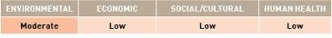

APPENDIX F
Species datasheet

Sargassum muticum
Sargassum muticum is a large brown macroalga that can attain lengths of several metres in shallow, sheltered waters. It is found primarily in bays and estuaries, but can also persist on the open coast. S. muticum often forms dense, monospecific stands. It occupies most hard substrates, however, rarely settles on small rocks or cobble.

Common names:
Japanese seaweed, Japweed, wire weed, strangle weed.
Distribution:
Found in eight of the 18 IUCN bioregions (see Figure 2).
Native: North West Pacific.
Introduced: Arctic, Mediterranean, North West Atlantic, North East Atlantic, Baltic, East Asian Seas and North East Pacific.
Larval period:
Planktonic period less than 48 hours (Deysher & Norton 1982). However, long distance dispersal (up to 900 km) can also occur via mature plants or branches drifting in ocean currents (Davison 1996).
Temperature tolerance:
Inferred: -2.9 °C to 32.7 °C.
Physiological: -1.4 °C to 30 °C (Hales & Fletcher 1989).

Inoculation likelihood: HIGH
Biofouling association rank – HIGH
S. muticum is a sessile species, directly attached to the primary substrate and with demonstrable association with vessel biofouling.
Transport pressure rank – HIGH
Australian trade with the IUCN bioregions where S. muticum is found represents 67.4% of the nation’s total trade. Once the additional weighting is applied to the different vessel types to account for the mean duration in port in various bioregions, the average increases to the equivalent of 83.5% representing a high likelihood of transport.

Consequence:
Consequence was evaluated based on literature assessments.
Environmental impacts – HIGH
S. muticum is a large brown alga that forms dense mats that out-compete other macroalgae and invertebrates through shading, whipping and smothering (Britton-Simmons 2004; Britton-Simmons & Abbott 2008). S. muticum is inferred to impact on seagrass species (den Hartog 1997), an important and often protected nursery habitat.
Economic impacts – HIGH
S. muticum is a nuisance biofouling species–it fouls all structures placed in the water, including wharves, jetties, boats, buoys and other navigation aids. The species causes: physical obstructions to navigation; specifically of small vessels; clogging of water intake pipes of boats and industrial installations; and smothering and interference with aquaculture operations, specifically oysters and mussels (Critchley et al. 1986).
Social/cultural impacts – MODERATE
Large dense stands of S. muticum cause loss of aesthetic value to a region, including loss of recreational value (Critchley et al. 1986).
Human health impacts – NEGLIGIBLE
No information available.

Risks:
Multiplying the inoculation likelihood (i.e. high) by consequence for each value category (i.e. high, high, moderate, negligible) results in the following risk categorisations across all vessel types and in at least one voyage duration.

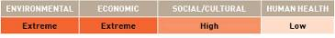

APPENDIX F
Species datasheet

Anadara demiri
Anadara demiri is a bivalve that typically lives buried within the sediment on muddy and sandy substrates. However, the species may also inhabit hard substrata (e.g. rocks, mollusc shells, artificial substrates), attaching by means of byssus threads (Morello et al. 2004). A. demiri is considered one of the 100 ‘worst invasive’ alien species in the Mediterranean Sea (citations in Albano et al. 2009).

Common name:
Arc shell.
Distribution:
Found in two of the 18 IUCN bioregions (see Figure 2).
Native: Origin unknown (Albano et al. 2009).
Introduced: Mediterranean and Central Indian Ocean.
Larval period:
Information about the species’ larval period is unknown, however, larvae of a closely related species, A. broughtoni, begin to settle 30 days after fertilisation.
Temperature tolerance:
Inferred: -1.2 ˚C to 29.7 °C.
Physiological: Unknown.

Inoculation likelihood: LOW
Biofouling association rank – LOW
A. demiri is thought to have been introduced into the Mediterranean Sea either as planktonic larvae carried in vessels’ ballast water or as benthic stages associated with aquaculture transfers of bivalves (citations in Morello et al. 2004). However, as this species is able to attach to hard substrates via byssus threads, it can potentially attach to the hulls of vessels.
Transport pressure rank – VERY LOW
Australian trade with the IUCN bioregions where A. demiri is found represents 9.4% of the nation’s total trade. Once the additional weighting is applied to the different vessel types to account for the mean duration in port in various bioregions, the average increases to the equivalent of 11.3% representing a very low likelihood of transport.

Consequence:
Consequence was evaluated based on literature assessments.
Environmental impacts – LOW
A. demiri possesses a number of traits that make it a strong competitor–especially with respect to autochthonous bivalves. A. demiri is able to withstand intense environmental pollution and is capable of attaching to all kinds of hard substrata by means of byssus threads (Morello et al. 2004). The species is a very rapid coloniser and quickly becomes dominant in certain areas (Morello et al. 2004).
Economic impacts – MODERATE
The establishment of A. demiri could result in a loss of habitat occupied by commercially important species, such as Chamelea gallina in Italy (Morello et al. 2004). Furthermore, A. demiri may impact aquaculture operations–A. demiri juveniles have been observed attached to ropes used for mussel culture (citations in Morello et al. 2004).
Social/cultural impacts – NEGLIGIBLE
No information available.
Human health impacts – NEGLIGIBLE
No information available.

Risks:
Multiplying the inoculation likelihood (i.e. low) by consequence for each value category (i.e. low, moderate, negligible, negligible) results in the following risk categorisations across all vessel types and in at least one voyage duration.

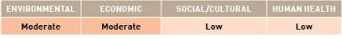

APPENDIX F
Species datasheet

Anomia nobilis
Anomia nobilis is a bivalve which superficially resembles true oysters. However, they differ in relation to their mode of attachment (i.e. a byssal plug passing through an opening in the right valve) and their delicate translucent shells (Eldredge & Smith 2001). A. nobilis individuals are commonly found piled one on top of the other in the biofouling community. They are a very common biofouling organism, typically found on pier pilings and floating docks in harbours. They are also found intertidally on the under surface of flat stones.

Common names:
Jingle shell, saddle oyster.
Distribution:
Found in five of the 18 IUCN bioregions (see Figure 2).
Native: Central Indian Ocean, Arabian Seas and East Asian Seas.
Introduced: South Pacific (Hawaii).
Larval period:
No information available.
Temperature tolerance:
Inferred: 17.6 ˚C to 32.7 °C.
Physiological: No information available.

Inoculation likelihood: MODERATE
Biofouling association rank – HIGH
Species thought to have been introduced to Hawaii most likely as biofouling on vessels’ hulls (Eldredge & Smith 2001).
Transport pressure rank – LOW
Australian trade with the IUCN bioregions where A. nobilis is found represents 31.5% of the nation’s total trade. Once the additional weighting is applied to the different vessel types to account for the mean duration in port in various bioregions, the average increases to the equivalent of 40.2% representing a low likelihood of transport.

Consequence:
Consequence was evaluated based on literature assessments.
Environmental impacts – MODERATE
The ecological impact of A. nobilis is largely unstudied, but observations suggest competition with other biofouling invertebrates for space (Eldredge & Smith 2001).
Economic impacts – NEGLIGIBLE
In Hawaii, where this species has been introduced, A. nobilis is a common biofouling organism found on hard structures such as floating docks and pier pilings. When abundant, it forms dense stacks that are difficult to remove (Eldredge & Smith 2001). The cleaning of this nuisance biofouling species may cause economic impacts.
Social/cultural impacts – NEGLIGIBLE
No information available.
Human health impacts – NEGLIGIBLE
No information available.
Risks:
Multiplying the inoculation likelihood (i.e. moderate) by consequence for each value category (i.e. moderate, negligible, negligible, negligible) results in the following risk categorisations across all vessel types and in at least one voyage duration.

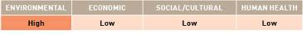

APPENDIX F
Species datasheet

Brachidontes variabilis (pharaonis)
Brachidontes variabilis is a small gregarious intertidal bivalve that is dark in colour and reaches 4cm in width. It is found attached to gravel and rocks, often in association with oysters. It also attaches to mangrove roots (Galil 2006).

Common name:
Variable mussel.
Distribution:
Found in three of the 18 IUCN bioregions (see Figure 2).
Native: East Asian Seas and Arabian Seas.
Introduced: Mediterranean.
Larval period:
Planktonic larvae period is unknown.
Temperature tolerance:
Inferred: - 1.2 ˚C to 35.3 °C.
Physiological: In the Mediterranean B. variabilis show wide temperature tolerances (9 °C to 31 °C), and occurs at salinities from 35 ppt to 53 ppt (Galil 2006).

Inoculation likelihood: MODERATE
Biofouling association rank – HIGH
B. variabilis has probably been spread by vessel biofouling in the Mediterranean (Dogan et al. 2007).
Transport pressure rank – LOW
Australian trade with the IUCN bioregions where B. variabilis is found represents 26.8% of the nation’s total trade. Once the additional weighting is applied to the different vessel types to account for the mean duration in port in various bioregions, the average increases to the equivalent of 33.4% representing a low likelihood of transport.

Consequence:
Consequence was evaluated based on literature assessments.
Environmental impacts – HIGH
In the Mediterranean, B. variabilis locally displaces the native mytilid, Mytilaster minimus. B. variabilis interferes with recruitment of M. minimus, and detrimentally affects its survival and growth. Surveys have shown that B. variabilis populations in the Mediterranean now reach densities up to 300 specimens per square metre, while M. minimus is now only rarely encountered (Galil 2006).
Economic impacts – HIGH
B. variabilis is a common biofouling mussel species in cooling water systems of tropical coastal power stations (Rajagopal et al. 2005).
Social/cultural impacts – NEGLIGIBLE
No information available.
Human health impacts – NEGLIGIBLE
No information available.

Risks:
Multiplying the inoculation likelihood (i.e. moderate) by consequence for each value category (i.e. high, high, negligible, negligible) results in the following risk categorisations across all vessel types and in at least one voyage duration.

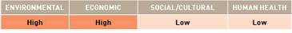

APPENDIX F
Species datasheet

Corbicula fluminea
Corbicula fluminea is a freshwater clam which is usually less than 2.5cm in length, but can grow up to 6.5cm (Invasive Species Specialists Group [ISSG] 2005a). C. fluminea is found in lakes and streams with silt, mud, sand, and gravel substrates (Institute of Natural Resource Sustainability [INHS] 2010). C. fluminea can tolerate salinities of up to 13 ppt for short periods (Aguirre & Poss 2010). It feeds on plankton, requires high levels of dissolved oxygen and is intolerant of pollution (Balcom 1994). The clam is hermaphroditic and is able to self-fertilise, capable of releasing hundreds or even thousands of juveniles per day and up to 70 000 per year (Balcom 1994).

Common names:
Asian clam, Asiatic clam.
Distribution:
Found in four of the 18 IUCN bioregions (see Figure 2).
Native: North West Pacific.
Introduced: North West Atlantic, North East Atlantic and North East Pacific.
Larval period:
Larvae spawned late in spring and early summer can reach sexual maturity by the next autumn (citations in ISSG 2005a). The juveniles are weak swimmers and are usually found near the bottom of the water column.
Temperature tolerance:
Inferred: -2.9 ˚C to 32.4 °C.
Physiological: 2 ˚C to 30 °C (Balcom 1994). Spawning can continue all year-round in water temperatures higher than 16 °C (ISSG 2005a).

Inoculation likelihood: LOW
Biofouling association rank – VERY LOW
The source of introduction of C. fluminea to North America is unknown. It is suspected that this species was brought from China by immigrants as a food source and subsequently released (Balcom 1994). This species cannot tolerate open sea salinities, so it is unlikely to survive transit across marine waters.
Transport pressure rank – MODERATE
Australian trade with the IUCN bioregions where C. fluminea is found represents 43.6% of the nation’s total trade. Once the additional weighting is applied to the different vessel types to account for the mean duration in port in various bioregions, the average increases to the equivalent of 54.1% representing a moderate likelihood of transport.

Consequence:
Consequence was evaluated based on literature assessments.
Environmental impacts – LOW
Ecologically, C. fluminea alters benthic substrates (citations in Foster et al. 2009) and can out-compete many native clam species for limited resources (citations in ISSG 2005a).
Economic impacts – HIGH
The introduction of C. fluminea into the United States has resulted in the clogging of water intake pipes, affecting power, water and other industries. Nuclear service water systems (for fire protection) are very vulnerable, jeopardising fire protection. In 1980, the costs of correcting this problem were estimated at US$1 billion annually. C. fluminea causes such problems because its juveniles are weak swimmers, and consequently, they are pushed to the bottom of the water column where intake pipes are usually placed. They are drawn inside the intakes, where they attach, breed and die. The intake pipes become clogged with live clams, empty shells and dead body tissues. Buoyant dead clams can also clog intake screens (ISSG 2005a).
Social/cultural impacts – NEGLIGIBLE
No information available.
Human health impacts – NEGLIGIBLE
No information available.

Risks:
Multiplying the inoculation likelihood (i.e. low) by consequence for each value category (i.e. low, high, negligible, negligible) results in the following risk categorisations across all vessel types and in at least one voyage duration.

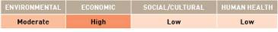

APPENDIX F
Species datasheet
Corbula (Potamocorbula) amurensis
Corbula amurensis is an infaunal bivalve that grows to around 2–3cm in length. It is usually white, tan or yellow, with no markings on the external valves. C. amurensis buries into sediments on the sea floor, exposing half to two-thirds of its shell above this sediment in order to feed (citations in Invasive Species Specialists Group [ISSG] 2005c). It occurs in a range of sediment types including mud, peat, clay and sand, but is most abundant on mixed mud-sand substrates (citations in ISSG 2005c). C. amurensis is tolerant of a wide range of environmental conditions and is found across a broad range of salinities, ranging from 0–35 ppt (Nicolini & Penry 2000). C. amurensis exists from tropical to cold temperate waters, mostly subtidally, but it has been found in the intertidal zone (citations in ISSG 2005c).

Common names:
Amur river clam, Amur river corbula, brackish-water corbula, Chinese clam.
Distribution:
Found in two of the 18 IUCN bioregions (see Figure 2).
Native: North West Pacific.
Introduced: North East Pacific.
Larval period:
Larvae settle 17 to 19 days after fertilisation (Nicolini & Penry 2000).
Temperature tolerance:
Inferred: -2.9 ˚C to 32.4 °C.
Physiological: 8 ˚C to 23 °C (Cohen 2005b).

Inoculation likelihood: LOW
Biofouling association rank – VERY LOW
The most likely vector for the introduction of C. amurensis to San Francisco Bay is via larvae in association with vessels’ ballast water. The species does not attach directly to hard substrates, but has the potential to occur as biofouling in vessels’ sea-chests.
Transport pressure rank – LOW
Australian trade with the IUCN bioregions where C. amurensis is found represents 37.1% of the nation’s total trade. Once the additional weighting is applied to the different vessel types to account for the mean duration in port in various bioregions, the average increases to the equivalent of 46.8% representing a low likelihood of transport.

Consequence:
Consequence was evaluated based on literature assessments.
Environmental impacts – LOW
C. amurensis has the ability to form dense populations with densities exceeding 10 000 individuals per square metre in its invaded range in San Francisco Bay. Establishment of such dense populations causes changes to sediment structure (Carlton et al. 1990). The capacity of dense C. amurensis populations to filter large volumes of phytoplankton and bacterioplankton also has the potential to permanently depress primary productivity and biomass of these organisms (Werner & Hollibaugh 1993). Establishment of C. amurensis in San Francisco Bay has also been demonstrated to result in displacement of native benthic communities, which were presumably excluded by C. amurensis’ consumption of their food or larvae (Nichols et al. 1990).
Economic impacts – VERY LOW
It is thought to be responsible for the collapse of some commercial fisheries in addition to the decline in the diversity and abundance of many benthic species in the area (ISSG 2005c).
Social/cultural impacts – VERY LOW
There may be negative impacts on birds and fish populations as a result from feeding on C. amurensis (Cohen 2005b), potentially impacting on aesthetic values.
Human health impacts – NEGLIGIBLE
No information available.

Risks:
Multiplying the inoculation likelihood (i.e. low) by consequence for each value category (i.e. low, very low, very low, negligible) results in the following risk categorisations across all vessel types and in at least one voyage duration.
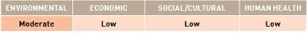

APPENDIX F
Species datasheet

Crassostrea ariakensis
Crassostrea ariakensis is a dioecious (two sexes), commercially important oyster species reaching 12cm in size. It is found primarily in bays and estuaries, but can also survive on the open coast. It is currently the focus of debate in the Chesapeake Bay (United States) as an introduced replacement for the declining native oyster, C. virginica.

Common names:
Suminoe oyster, Asian oyster.
Distribution
Found in three of the 18 IUCN bioregions (see Figure 2).
Native: North West Pacific.
Introduced: North West Atlantic and North East Pacific.
Larval period:
21 days (North et al. 2006).
Temperature tolerance:
Inferred: -2.9 ˚C to 32.4 °C.
Physiological: No information available.

Inoculation likelihood: LOW
Biofouling association rank – LOW
C. ariakensis is a sessile species, attaching directly to primary substrate, but its association with vessel biofouling is assumed because the genus is a known biofouling species.
Transport pressure rank – LOW
Australian trade with the IUCN bioregions where C. ariakensis is found represents 38.3% of the nation’s total trade. Once the additional weighting is applied to the different vessel types to account for the mean duration in port in various bioregions, the average increases to the equivalent of 48.2% representing a low likelihood of transport.

Consequence:
Consequence was evaluated based on literature assessments.
Environmental impacts – LOW
C. ariakensis is a filter feeding oyster, with gregarious settlement leading to the establishment of high densities, out-competing native species for space and potentially causing larval depletion through filter feeding. It can cause habitat alteration by forming biogenic reefs and is known to interbreed with other oyster species, causing introgression into native populations and the species may harbour disease.
Economic impacts – LOW
C. ariakensis can interbreed with other commercial oyster species, causing outbreeding depression. The species is known to be affected by several OIE-listed molluscan diseases.
Social/cultural impacts – NEGLIGIBLE
No information available.
Human health impacts – HIGH
C. ariakensis has been demonstrated to bioaccumulate toxins (e.g. paralytic shellfish poisoning, diarrhetic shellfish poisoning) through filter feeding. As a consequence, human consumption of C. ariakensis during or immediately following a toxic algal bloom event could transmit the toxins in sufficient quantities to cause human illness.

Risks:
Multiplying the inoculation likelihood (i.e. low) by consequence for each value category (i.e. low, low, negligible, high) results in the following risk categorisations across all vessel types and in at least one voyage duration.

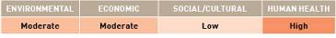

APPENDIX F
Species datasheet

Crassostrea virginica
The oyster Crassostrea virginica has a thick oval shell and grows to about 10cm—15cm in length. This species favours estuaries and bays and can also grow in marine environments. C. virginica are found in shallow waters of tidal to subtidal depth and are able to withstand a wide range of temperatures. In the United States, C. virginica is a commercially important fisheries species.

Common names:
Eastern oyster, American oyster.
Distribution:
Found in seven of the 18 IUCN bioregions (see Figure 2).
Native: North West Atlantic, Wider Caribbean Sea and South Atlantic.
Introduced: North East Pacific, Baltic and South Pacific.
Larval period:
Larvae take approximately two to three weeks to settle onto a substrate (CASIP 2009).
Temperature tolerance:
Inferred: -2.9 ˚C to 32.4 °C.
Physiological: Adult oysters are eurythermal and can withstand a wide range of temperatures, including freezing temperatures (Osborne 1999). Northern oysters spawn at temperatures between 15.5 ˚C and 20 °C, while southern oysters spawn at temperatures above 20 °C (Wallace 2001).

Inoculation likelihood: MODERATE
Biofouling association rank – HIGH
Introduction of this oyster species to Hawaii was intentional, for commercial oyster fishery. First plantings were in 1866 in Pearl Harbor (Bishop Museum and University of Hawaii [BMUH] 2002).
Transport pressure rank – LOW
Australian trade with the IUCN bioregions where C. virginica is found represents 23.8% of the nation’s total trade. Once the additional weighting is applied to the different vessel types to account for the mean duration in port in various bioregions, the average increases to the equivalent of 29.2% representing a low likelihood of transport.

Consequence:
Consequence was evaluated based on literature assessments.
Environmental impacts – MODERATE
The ecological impact of C. virginica in Hawaii remains unstudied. Before a die-off in the early 1970s, these oysters formed extensive dense beds in the estuarine areas of Pearl Harbor, which undoubtedly affected the native benthic communities there (BMUH 2002). C. virginica is a key structural component of estuaries, playing a major role in the function of estuary ecosystems (citations in Puglisi 2008).
Economic impacts – HIGH
A major problem caused by the oyster is nuisance biofouling, often to boats (Osborne 1999).
Social/cultural impacts – NEGLIGIBLE
No information available.
Human health impacts – MODERATE
The human pathogen Vibrio vulnificus is found in the tissues of some populations of C. virginica. Vibrio vulnificus causes primary septicaemia in patients with weakened immune systems. The infection occurs when the oyster are eaten raw (citations in Puglisi 2008).

Risks:
Multiplying the inoculation likelihood (i.e. moderate) by consequence for each value category (i.e. moderate, high, negligible, moderate) results in the following risk categorisations across all vessel types and in at least one voyage duration.

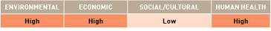

APPENDIX F
Species datasheet

Crepidula fornicata
Crepidula fornicata is a protandrous hermaphrodite mollusc–beginning life as a male, then changing sex and developing into a female. C. fornicata can grow to 5cm and is a filter feeder, occurring within sheltered coastal bays and estuaries and sometimes in deeper water. It attaches firmly to objects with its muscular foot. Individuals may attach to each other to form ‘chains’.

Common names:
Slipper limpet, Atlantic slipper limpet.
Distribution:
Found in seven of the 18 IUCN bioregions (Figure 2).
Native: North West Atlantic, Wider Caribbean Sea and South Atlantic.
Introduced: Mediterranean, North East Atlantic, North East Pacific and North West Pacific.
Larval period:
The planktotrophic larval duration is approximately three weeks (Minchin 2008).
Temperature tolerance:
Inferred: -2.85 °C to 31.8 °C.
Physiological: This species can survive light frosts and in temperatures up to ~30 °C (Minchin 2008).

Inoculation likelihood: MODERATE
Biofouling association rank – MODERATE
This species may be transported on vessels’ hulls and in ballast water in the pelagic larval phase (Joint Nature Conservation Committee [JNCC] 2002).
Transport pressure rank – MODERATE
Australian trade with the IUCN bioregions where C. fornicata is found represents 55.2% of the nation’s total trade. Once the additional weighting is applied to the different vessel types to account for the mean duration in port in various bioregions, the average increases to the equivalent of 68.1% representing a moderate likelihood of transport.

Consequence:
Consequence was evaluated based on literature assessments.
Environmental impacts – HIGH
C. fornicata may occur at densities exceeding 1700 individuals per square metre attaining a wet biomass of 10 kg per square metre. High C. fornicata densities result in competition with endemic species in coastal regions. Their abundance can change sediments to mud deposits of faeces, pseudofaeces and shell drifts. Such accumulating sediments on maerl beds reduce diversity and abundance of living plants (JNCC 2002). Shells may also provide a refuge for predators.
Economic impacts – HIGH
C. fornicata is considered a pest on commercial oyster beds, competing for space and food, while depositing mud on them that renders the substratum unsuitable for the settlement of spat (Viard & Dupont 2005). C. fornicata causes reduced growth of commercial bivalves in some enclosed bays and also need to be removed before marketing oysters. This species also fouls artificial structures in port regions and may reduce recruitment of some commercially important fishes (Minchin 2008).
Social/cultural impacts – NEGLIGIBLE
No information available.
Human health impacts – NEGLIGIBLE
No information available.

Risks:
Multiplying the inoculation likelihood (i.e. moderate) by consequence in each value category (i.e. high, high, negligible, negligible) results in the following risk categorisations across all vessel types and in at least one voyage duration:

APPENDIX F
Species datasheet

Dreissena bugensis
Dreissena bugensis is a freshwater mussel that reaches a maximum size of 6cm. The embryos and larvae of D. bugensis are less tolerant of salinity than those of zebra mussels (D. polymorpha) and have upper salinity limits of about 5 ppt (citations in Cohen 2007). Cohen (2007) concluded that the limiting maximum salinity for zebra mussels was 4 ppt, although it would be less in waters with rapidly fluctuating salinities (estuaries). Juvenile and adult D. bugensis attach to hard surfaces using byssal threads and also have the ability to build up populations on soft substrates (Cohen 2007). D. bugensis individuals byssally attach to the shells of other mussels and can form thick mats several layers thick (Invasive Species Specialists Group [ISSG] 2006). D. bugensis was introduced to the Great Lake system following the introduction of the zebra mussel (D. polymorpha). D. bugensis has begun to replace the zebra mussel as the most dominant invasive Dreissena species and it is able to colonise at much deeper depths (ISSG 2006).

Common name:
Quagga mussel.
Distribution:
Found in three of the 18 IUCN bioregions (see Figure 2).
Native: Ponto-Caspian Basin (Cohen 2007, Benson et al. 2009) (Note that this is not IUCN bioregion).
Introduced: North West Atlantic (including the North American Great Lakes), North East Atlantic and Baltic (Benson et al. 2009).
Larval period:
D. bugensis spawn from spring to autumn and produce large numbers of planktonic larvae (veligers) that typically spend one to several weeks drifting in the water column before attachment (citations in Cohen 2007). Planktonic periods are longer at lower temperatures and veligers may remain in the plankton over winter (citations in Cohen 2007).
Temperature tolerance:
Inferred: -2.9 ˚C to 32.4 °C.
Physiological: Upper temperature limit may be as low as 25 °C, although there is evidence indicating that they can survive temperatures as high as 30 °C (citations in Cohen 2007). There is some evidence of spawning in Lake Erie in North America at temperatures as low as 4.8 °C (citations in Cohen 2007).

Inoculation likelihood: LOW
Biofouling association rank – HIGH
The introduction of D. bugensis to the Great Lakes appears to have been through ballast water discharge from transoceanic vessels that were carrying veligers, juveniles or adult mussels (Benson et al. 2009).
Transport pressure rank – EXTREMELY LOW
Australian trade with the IUCN bioregions where D. bugensis is found represents 7.0% of the nation’s total trade. Once the additional weighting is applied to the different vessel types to account for the mean duration in port in various bioregions, the average increases to the equivalent of 7.9% representing an extremely low likelihood of transport.

Consequence:
Consequence was evaluated based on literature assessments.
Environmental impacts – MODERATE
D. bugensis are efficient filter feeders and can remove phytoplankton resources from the water column, potentially altering trophic dynamics (Cohen et al. 2007; Benson et al. 2009).
Economic impacts – HIGH
D. bugensis cause massive nuisance biofouling of submerged objects and water pipes (Cohen et al. 2007). They rapidly colonise hard surfaces causing serious economic problems–clogging water intake structures and causing massive biofouling on docks, breakwalls, buoys, boats and beaches (Benson et al. 2009).
Social/cultural impacts – LOW
Major detrimental impact on recreational boating due to biofouling (ISSG 2006).
Human health impacts – VERY LOW
No information available.

Risks:
Multiplying the inoculation likelihood (i.e. low) by consequence for each value category (i.e. moderate, high, low, very low) results in the following risk categorisations across all vessel types and in at least one voyage duration.

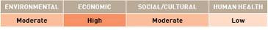

APPENDIX F
Species datasheet
Dreissena polymorpha
Dreissena polymorpha (zebra mussel) is a freshwater mussel that reaches a maximum size of 5cm. Salinity tolerances reported for zebra mussels vary widely and may be dependent on both the rate of changes in salinity and water chemistry (Cohen 2007). The species’ upper salinity limit appears to be about 10 ppt–zebra mussels were abundant throughout the Aral Sea at salinities of 10 ppt (citations in Cohen 2007). Cohen (2007) concluded that the limiting maximum salinity for zebra mussels was 6 ppt, although it would be less in waters with rapidly fluctuating salinities (estuaries). Juveniles and adults of the species attach to hard surfaces using byssal threads and also have the ability to build-up populations on soft substrates (Cohen 2007).

Common names:
Zebra mussel, European zebra mussel.
Distribution:
Found in three of the 18 IUCN bioregions (see Figure 2).
Native: Ponto-Caspian Basin (Cohen 2007).
Introduced: North West Atlantic including the North American Great Lakes in southern Canada and the United States (Cohen 2007), North East Atlantic and Baltic.
Larval period:
Larval duration is 10 to 90 days (Reed et al. 1998). Planktonic larvae (veligers) typically spend one to several weeks drifting in the water column before attachment (citations in Cohen 2007). Planktonic periods are longer at lower temperatures and veligers may remain in the plankton over winter (citations in Cohen 2007).
Temperature tolerance:
Inferred: -2.85 ˚C to 31.8 °C.
Physiological: D. polymorpha can tolerate water temperatures as low as 6 °C in winter, but summer water temperatures above 6 °C to 12 °C are needed to support adult growth (citations in Cohen 2007). In general, temperatures above 12 °C are needed for D. polymorpha spawning and it is considered that mean summer temperatures of 9 ˚C to 15 °C are the lower limiting temperatures for potential distribution (citations in Cohen 2007). The upper limit for D. polymorpha survival is thought to be approximately 30 °C (citations in Cohen 2007).

Inoculation likelihood: LOW
Biofouling association rank – HIGH
D. polymorpha is probably dispersed through human activities e.g. artificial waterways, vessels, fishing activities, amphibious planes and recreational equipment (Gulf States Marine Fisheries Commission [GSMFC] 2005). D. polymorpha may be naturally dispersed after being attached to aquatic plants that break off and move downstream, or to other organisms (e.g. mud stuck to birds or crayfish) (Cohen 2007). D. polymorpha cannot tolerate open sea salinities, so it is unlikely to survive voyages that involve transit across marine waters.
Transport pressure rank – EXTREMELY LOW
Australian trade with the IUCN bioregions where D. polymorpha is found represents 7.0% of the nation’s total trade. Once the additional weighting is applied to the different vessel types to account for the mean duration in port in various bioregions, the average increases to the equivalent of 7.9% representing an extremely low likelihood of transport.

Consequence:
Consequence was evaluated based on literature assessments.
Environmental impacts – HIGH
In the Great Lakes in the United States, D. polymorpha can disrupt existing food webs by consuming phytoplankton and altering physical conditions (increased light levels). They may also threaten biodiversity via competition with native organisms (Cohen 1998).
Economic impacts – HIGH
In the Great Lakes, D. polymorpha have blocked pipes that deliver water to cities and factories, and cooling water to nuclear and fossil fuel-fired power plants. D. polymorpha cause massive nuisance biofouling to vessel and boat hulls, marine structures and navigational buoys (Cohen 1998).
Social/cultural impacts – MODERATE
D. polymorpha cover the beaches of the Great Lakes with sharp-edged shells and rotting mussel flesh (Cohen 1998).
Human health impacts – VERY LOW
There are indications that D. polymorpha promoted blooms of the toxic planktonic colonial cyanobacterium, Microcystis aeruginosa in Lake Huron through selection rejection in pseudofaeces (Vanderploeg et al. 2001). Microcystis spp. produce a potent class of hepatotoxins that can poison aquatic organisms, wildlife and humans (Carmichael, in Vanderploeg et al. 2001).

Risks:
Multiplying the inoculation likelihood (i.e. low) by consequence for each value category (i.e. high, high, moderate, very low) results in the following risk categorisations across all vessel types and in at least one voyage duration.
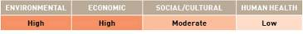

APPENDIX F
Species datasheet
Geukensia demissa
Geukensia demissa is a mussel with an olive-brown periostracum (thin, glossy tissue covering the shell) that generally grows to about 10cm in length (Cohen 2005a). It is mainly a subtidal species (on oyster reefs), but can be found in the intertidal zone in salt marshes (Cohen 2005a). G. demissa sometimes occurs above the mud surface attaching to pilings, concrete walls or rocks; and occasionally in the biofouling community on floating docks (Cohen 2005a).

Common names:
Ribbed mussel, ribbed horse mussel.
Distribution:
Found in two of the 18 IUCN bioregions (see Figure 2).
Native: North West Atlantic.
Introduced: North East Pacific.
Larval period:
The planktonic larvae are present in the water from early summer to early autumn (Cohen 2005a).
Temperature tolerance:
Inferred: -2.9 ˚C to 32.4 °C.
Physiological: In California, G. demissa has been collected in water temperatures of 13 ˚C to 22 °C and can tolerate short-term exposures to water temperatures up to 56 °C (Cohen 2005a).

Inoculation likelihood: VERY LOW
Biofouling association rank – LOW
On the Atlantic Coast, G. demissa frequently occurs on reefs dominated by the Virginia oyster (Crassostrea virginica). Its introduction to San Francisco Bay probably resulted from shipments of these oysters (Cohen 2005a). G. demissa may also have been transported from San Francisco Bay to other locations in California through hull biofouling (Cohen 2005a).
Transport pressure rank – EXTREMELY LOW
Australian trade with the IUCN bioregions where G. demissa is found represents 6.2% of the nation’s total trade. Once the additional weighting is applied to the different vessel types to account for the mean duration in port in various bioregions, the average increases to the equivalent of 7.6% representing an extremely low likelihood of transport.
Consequence:
Consequence was evaluated based on literature assessments.
Environmental impacts – EXTREME
G. demissa can affect the cycling of nutrients in Atlantic salt marshes by removing a third of the particulate phosphorus from suspension and depositing it on the mud surface (Kuenzler 1961 in Cohen 2005a). In San Francisco Bay, G. demissa are consumed by the endangered California Clapper Rail (Rallus longirostris obsoletus), but the toes and probing beaks of Clapper Rails are frequently caught and clamped between the gaping shells of the mussel that protrude from the mud (de Groot 1927 in Cohen 2005a). Clapper Rails can lose their toes to ribbed mussels or have their beaks clamped shut and die of starvation, or chicks can be caught by mussels and drown by the incoming tide (Cohen 2005a). There are reports of nearly every Clapper Rail in San Francisco Bay missing one or more toes as well as reports of Clapper Rails with ribbed mussels clamped to their toes or bills (Cohen 2005a). In Newport Bay, California, United States, the Light-footed Clapper Rail (R. longirostris levipes) are also thought to lose their toes after being caught by G. demissa (Zembal & Fancher, cited in Cohen 2005a).
Economic impacts – NEGLIGIBLE
No information available.
Social/cultural impacts – NEGLIGIBLE
No information available.
Human health impacts – NEGLIGIBLE
No information available.

Risks:
Multiplying the inoculation likelihood (i.e. very low) by consequence for each value category (i.e. extreme, negligible, negligible, negligible) results in the following risk categorisations across all vessel types and in at least one voyage duration.

APPENDIX F
Species datasheet

Limnoperna fortunei
Limnoperna fortunei is a dioecious (two sexes) bivalve, found primarily in lower salinities of estuaries and rivers, however, it is capable of persisting in higher salinities and is found in fully saline harbours (Morton 1973; Darrigan & de Drego 2000). L. fortunei is a filter feeder that attaches to a wide variety of hard substrates using byssal threads.

Common name:
Golden mussel.
Distribution:
Found in two of 18 the IUCN bioregions (see Figure 2).
Native: East Asian Seas.
Introduced: South Atlantic.
Larval period:
30 to 70 days (United States Army Corps of Engineers 2006).
Temperature tolerance:
Inferred: -2.9 ˚C to 32.7 °C.
Physiological: 8 ˚C to 35 °C (Ricciardi, 1998).

Inoculation likelihood: MODERATE
Biofouling association rank – MODERATE
L. fortunei is a sessile species that directly attaches to primary substrate and is known to be associated with biofouling.
Transport pressure rank – LOW
Australian trade with the IUCN bioregions where L. fortunei is found represents 21.7% of the nation’s total trade. Once the additional weighting is applied to the different vessel types to account for the mean duration in port in various bioregions, the average increases to the equivalent of 27.3% representing a low likelihood of transport.

Consequence:
Consequence was evaluated based on literature assessments.
Environmental impacts – MODERATE
L. fortunei has been demonstrated to bioaccumulate microcystin toxins, which cause mortalities in birds that prey on them. L. fortunei has been recorded at densities of up to 150 000 individuals per square metre and out-competes other species for space and food. Darrigan & de Drago (2000) identified the displacement of native gastropods in South America by L. fortunei.
Economic impacts – MODERATE
L. fortunei is a nuisance fouler of any structures placed in the water, including wharves, jetties, boats, buoys and other navigation aids. L. fortunei also has been inferred to reach sufficiently high densities to clog water intake systems (Ricciardi 1998).
Social/cultural impacts – NEGLIGIBLE
No information available.
Human health impacts – MODERATE
L. fortunei has been demonstrated to bioaccumulate microcystin toxins. As a consequence, human consumption of L. fortunei during or immediately following a toxic blue-green algal bloom event could transmit the toxins in sufficient quantities to cause human illness.

Risks:
Multiplying the inoculation likelihood (i.e. moderate) by consequence for each value category (i.e. moderate, moderate, negligible, moderate) results in the following risk categorisations across all vessel types and in at least one voyage duration.

APPENDIX F
Species datasheet

Mya arenaria
Mya arenaria is an infaunal bivalve that lives buried up to 30cm below the surface in sand, mud and clays, often in mixtures with coarse gravel (Cohen 2005c). M. arenaria typically occurs in bays and estuaries in the upper intertidal zone. It also occurs in the low intertidal and shallow subtidal zones, and is also occasionally reported from deeper water. M. arenaria adults are tolerant of low salinities (down to 5 ppt) and low oxygen conditions (survival observed in anoxic conditions after eight days) (Cohen 2005c).

Common names:
Soft-shell clam, sandgaper, steamer clam.
Distribution:
Found in seven of the 18 IUCN bioregions (see Figure 2).
Native: Arctic, North West Atlantic (eastern North America) and North East Pacific. M. arenaria has been reported as native to the North West Pacific (Korea and Japan), but this record is now thought to be M. japonica.
Introduced: Mediterranean, North East Atlantic, Baltic and North West Pacific.
Larval period:
Typically two to three weeks, but can be up to six weeks (Cohen 2005c).
Temperature tolerance:
Inferred: -2.9 ˚C to 32.4 °C.
Physiological: -2 ˚C to 28 °C.

Inoculation likelihood: VERY LOW
Biofouling association rank – VERY LOW
Historically, M. arenaria have been deliberately introduced in the past, but they are also thought to have been accidentally translocated in association with transfer of oysters. The species does not attach directly to hard substrates. It has the potential to occur as biofouling in vessels’ sea-chests.
Transport pressure rank – VERY LOW
Australian trade with the IUCN bioregions where M. arenaria is found represents 17.1% of the nation’s total trade. Once the additional weighting is applied to the different vessel types to account for the mean duration in port in various bioregions, the average increases to the equivalent of 20% representing a very low likelihood of transport.

Consequence:
Consequence was evaluated based on literature assessments.
Environmental impacts – VERY LOW
M. arenaria has the ability to reach high population densities, up to 1000 individuals per square metre, and 19th century workers reported that it replaced populations of the native bent-nosed clam Macoma nasuta (Cohen 2005c). M. arenaria has also been demonstrated to alter nutrient cycling in soft sediments (Hansen et al. 1996). Other ecological impacts of M. arenaria include benthic-pelagic interaction, bioaccumulation, community dominance and habitat change (Baltic Sea Alien Species Database 2007).
Economic impacts – VERY LOW
No information available.
Social/cultural impacts – NEGLIGIBLE
No information available.
Human health impacts – HIGH
M. arenaria has been demonstrated to bioaccumulate toxins (e.g. paralytic shellfish poisoning, diarrhetic shellfish poisoning) through filter feeding (MacQuarrie & Bricelj 2008). As a consequence, human consumption of M. arenaria during or immediately following a toxic algal bloom event could transmit the toxins in sufficient quantities to cause human illness.

Risks:
Multiplying the inoculation likelihood (i.e. very low) by consequence for each value category (i.e. very low, very low, negligible, high) results in the following risk categorisations across all vessel types and in at least one voyage duration.

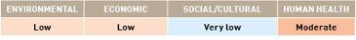

APPENDIX F
Species datasheet

Mytella charruana
Mytella charruana is a tropical bivalve whose native distribution extends from South and Central America northward through Mexico (Masterson 2007). M. charruana are usually less than 2cm in length, but can be larger than 4cm (The Nature Conservancy undated). Similar to other mussel species, it attaches to hard substrates such as oyster shells as well as man-made structures, e.g. water intake pipes, wood pilings, driftwood (Masterson 2007).

Common name:
Charru mussel.
Distribution:
Found in two of the 18 IUCN bioregions (see Figure 2).
Native: South Atlantic.
Introduced: Wider Caribbean Sea (Florida, Benson 2008; Georgia, Masterson 2007).
Larval period:
No information available.
Temperature tolerance:
Inferred: -2.9 ˚C to 31.5 °C, although stated to be ‘tropical’.
Physiological: The die-off in mussels found at the Jacksonville, Florida, power plant is thought to have been due to colder winter temperatures (Boudreaux & Walters, cited in Masterson 2007).

Inoculation likelihood: VERY LOW
Biofouling association rank – LOW
Probably introduced to North America through ballast water (Benson 2008).
Transport pressure rank – EXTREMELY LOW
Australian trade with the IUCN bioregions where M. charruana is found represents 6.7% of the nation’s total trade. Once the additional weighting is applied to the different vessel types to account for the mean duration in port in various bioregions, the average increases to the equivalent of 8.5% representing an extremely low likelihood of transport.

Consequence:
Consequence was evaluated based on literature assessments.
Environmental impacts – MODERATE
M. charruana has the potential to greatly increase and compete with native organisms (The Nature Conservancy undated). M. charruana individuals in Mosquito Lagoon (near the Kennedy Space Center, Florida) were observed on a reef where they could compete with native organisms for food and habitat (Benson 2008).
Economic impacts – HIGH
M. charruana has caused nuisance biofouling of intake pipe filters at a power plant in Jacksonville, Florida, showing its potential to decrease efficiency and increase costs at industrial plants and power utilities (Benson 2008). It also has the potential to compete with commercially important native oysters (The Nature Conservancy undated).
Social/cultural impacts – NEGLIGIBLE
No information available.
Human health impacts – NEGLIGIBLE
No information available.

Risks:
Multiplying the inoculation likelihood (i.e. very low) by consequence for each value category (i.e. moderate, high, negligible, negligible) results in the following risk categorisations across all vessel types and in at least one voyage duration.

APPENDIX F
Species datasheet

Mytilopsis leucophaeata
Mytilopsis leucophaeata is a dioecious (two sexes) bivalve. It is found primarily in bays and estuaries, but capable of withstanding a wide range of salinities, resulting in its presence in open coastal waters and waters <1 ppt (Rajagopal et al. 2003). M. leucophaeata settles on any hard substrate placed in the water.

Common names:
Dark false mussel, Conrad’s false mussel.
Distribution:
Found in five of the 18 IUCN bioregions (see Figure 2).
Native: North West Atlantic and Wider Caribbean Sea.
Introduced: North East Atlantic, Baltic and North West Pacific.
Larval period:
Information about larval duration for this species was not available, but for a closely related species–Dreissena polymorpha–the period is 10 to 90 days (Reed et al. 1998).
Temperature tolerance:
Inferred: -2.9 ˚C to 31.8 °C.
Physiological: 5 ˚C to 35 °C (Rajagopal et al 2002; Rajagopal et al 2005).

Inoculation likelihood: HIGH
Biofouling association rank – HIGH
M. leucophaeata is a sedentary species with a direct association with biofouling.
Transport pressure rank – MODERATE
Australian trade with the IUCN bioregions where M. leucophaeata is found represents 42.4% of the nation’s total trade. Once the additional weighting is applied to the different vessel types to account for the mean duration in port in various bioregions, the average increases to the equivalent of 52.6% representing a moderate likelihood of transport.

Consequence:
Consequence was evaluated based on literature assessments.
Environmental impacts – MODERATE
M. leucophaeata competes with other fouling organisms and causes competitive displacement, reaching densities of up to 28 000 individuals per square metre (Bergstrom 2004).
Economic impacts – HIGH
M. leucophaeata is a nuisance biofouling species, fouling all structures placed in the water including wharves, jetties, boats, buoys and other navigation aids (Bergstrom 2004; Smith & Boss 1996). Similarly, M. leucophaeata is inferred to cause clogging of water intake systems (Rajagopal et al. 2003).
Social/cultural impacts – NEGLIGIBLE
No information available.
Human health impacts – NEGLIGIBLE
No information available.

Risks:
Multiplying the inoculation likelihood (i.e. high) by consequence for each value category (i.e. moderate, high, negligible, negligible) results in the following risk categorisations across all vessel types and in at least one voyage duration.

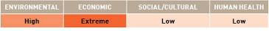

APPENDIX F
Species datasheet
Mytilopsis sallei
Mytilopsis sallei is a small mussel that grows to an average size of 2.5cm (National Introduced Marine Pests Information System [NIMPIS] 2002c). It is a colonial surface dweller of sheltered, shallow waters and has high fecundity, rapid growth and a fast maturity rate (NIMPIS 2002c). During their lifespan, M. sallei individuals change sex so that a proportion of mussels in any population are hermaphrodites (NIMPIS 2002c). Spawning appears to be triggered by salinity changes, and eggs and sperm are spawned into the water column where external fertilisation takes place (NIMPIS 2002c). In its introduced habitat, M. sallei is found at a range of salinities (0–27 ppt) (NIMPIS 2002c). In 1999, this species was found on three marinas and on vessels in Darwin Harbour. Following a rapid response to the incursion, the species was subsequently eradicated (Coles & Eldredge 2002; Bax et al. 2002).

Common names:
Black striped mussel.
Distribution:
Found in eight (eradicated from one) of the 18 IUCN bioregions (see Figure 2).
Native: North West Atlantic, Wider Caribbean Sea and South Atlantic.
Introduced: Central Indian Ocean (India, NIMPIS 2002c), East Asian Seas (Singapore, Sin et al. 1991; Malaysia, Tan & Norton 2006), South Pacific, North West Pacific (Japan, Taiwan, Hong Kong; NIMPIS 2002c, Bax et al. 2002), and Australia (introduced to Darwin Harbour and subsequently eradicated).
Larval period:
Pelagic larvae develop within a day of fertilisation and then settle within a few days (NIMPIS 2002c). M. sallei is extremely prolific and fecund (Commonwealth Scientific and Industrial Research Organisation 2001).
Temperature tolerance:
Inferred: -2.9 ˚C to 32.7 °C.
Physiological: In its introduced habitat, M. sallei is found at a range of temperatures from 10 ˚C to 30 °C (NIMPIS 2002c).

Inoculation likelihood: HIGH
Biofouling association rank – HIGH
M. sallei was found in Darwin Harbour in 1999 and believed to have entered marinas as biofouling on the hulls of yachts (Coles & Eldredge 2002). In 2000, it was found on hulls of two Indonesian fishing boats quarantined in Darwin Harbour (Willan et al. 2000). M. sallei is thought to have been introduced to Hong Kong via a Vietnamese refugee boat (Huang & Morton 1983).
Transport pressure rank – HIGH
Australian trade with the IUCN bioregions where M. sallei is found represents 74.8% of the nation’s Australia’s total trade. Once the additional weighting is applied to the different vessel types to account for the mean duration in port in various bioregions, the average increases to the equivalent of 94.1% representing a high likelihood of transport.

Consequence:
Consequence was evaluated based on literature assessments.
Environmental impacts – MODERATE
M. sallei forms dense monospecific aggregations that exclude most other species, leading to decreased biodiversity (NIMPIS 2002c). The discovery of this species in Darwin Harbour was considered a threat to the environment (Bax et al. 2002).
Economic impacts – HIGH
M. sallei causes massive nuisance biofouling on wharves and marinas, seawater systems (pumping stations, vessel ballast and cooling systems), marine farms (NIMPIS 2002c) and vessel hulls (Huang & Morton 1983). When discovered in Darwin Harbour, M. sallei was considered a threat to water-dependent marine infrastructure around northern Australia and to the local A$40 million pearl fishery industry (Bax et al. 2002). In Singapore, this mussel has formed a broad, extensive, densely populated strip on the vertical and sloping concrete walls of monsoon canals that reach up to several kilometres inland from the sea (Tan & Morton 2006).
Social/cultural impacts – LOW
Biofouling can cause losses to public or tourist amenities. Vessel biofouling reduces efficiency and can impact on transport systems.
Human health impacts – NEGLIGIBLE
No information available.

Risks:
Multiplying the inoculation likelihood (i.e. high) by consequence for each value category (i.e. moderate, high, low, negligible) results in the following risk categorisations across all vessel types and in at least one voyage duration.

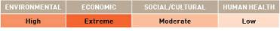

APPENDIX F
Species datasheet

Perna perna
Perna perna is a dioecious (two sexes), mytilid bivalve, reaching 12cm in size. It is found in bays and estuaries as well as the open coast. P. perna creates extensive biofouling, settling on a variety of substrates including exposed rocky intertidal and protected man-made structures (Hicks et al. 2001). P. perna has a wide salinity tolerance, but has a low freeze resistance (Hicks & McMahon 2002) and is found in tropical to sub-temperate waters.

Common name:
Brown mussel.
Distribution:
Found in seven of the 18 IUCN bioregions (see Figure 2).
Native: This remains equivocal, however, is believed to be both sides of the South Atlantic, representing IUCN bioregions of the South Atlantic and West Africa.
Introduced: Mediterranean, Wider Caribbean Sea, Central Indian Ocean, Arabian Seas, and East Africa. Recently, P. perna was detected in New Zealand.
Larval period:
Larval period is 15 to 20 days, but settlement can be delayed for up to three months when food availability and temperatures are low, as has been shown for other species of the Mytilidae family (Bayne 1965).
Temperature tolerance:
Inferred: -1.2 ˚C to 35.3 °C.
Physiological: 10 ˚C to 30 °C (Romero & Moreira 1980; Siddall 1978). Metamorphosis of larvae is limited to temperatures between 18 °C and 30 °C (Siddall 1978). Temperature tolerance for veliger stages is 10 °C to 30 °C (Romero & Moreira 1980).

Inoculation likelihood: MODERATE
Biofouling association rank – HIGH
P. perna is a sedentary species, with known associations with vessel biofouling, and the genus has been identified in sea-chests of vessels (Coutts & Dodgshun 2007).
Transport pressure rank – LOW
Australian trade with the IUCN bioregions where P. perna is found represents 30.9% of the nation’s total trade. Once the additional weighting is applied to the different vessel types to account for the mean duration in port in various bioregions, the average increases to the equivalent of 38.4% representing a low likelihood of transport.

Consequence:
Consequence was evaluated based on literature assessments.
Environmental impacts – HIGH
P. perna is a large and successful biofouling species which can out-compete other native epibenthic species.
Economic impacts – LOW
P. perna is a nuisance biofouling species, fouling all structures placed in the water including wharves, jetties, boats, buoys and other navigation aids. In extreme situations, the species can cause navigational buoys to submerge due to high biomass (Hicks & Tunnell 1993).
Social/cultural impacts – MODERATE
Potential for P. perna to impact on aesthetic and recreational values.
Human health impacts – EXTREME
P. perna has been demonstrated to bioaccumulate toxins (e.g. paralytic shellfish poisoning) through filter feeding (Barbera-Sanchez et al. 2004). As a consequence, human consumption of P. perna during or immediately following a toxic algal bloom event could transmit the toxins in sufficient quantities to cause human illness.

Risks:
Multiplying the inoculation likelihood (i.e. moderate) by consequence for each value category (i.e. high, low, moderate, extreme) results in the following risk categorisations across all vessel types and in at least one voyage duration.

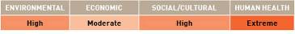

APPENDIX F
Species datasheet

Perna viridis
Perna viridis is a dioecious (two sexes), commercially important bivalve species in its native region of the East Asian Seas, reaching >16cm in size. It is found primarily in bays and estuaries, but can also survive on the open coast. It can withstand a wide range of salinities and reaches high densities—up to 35 000 individuals per square metre (National Introduced Marine Pests Information System 2002).

Common name:
Asian green mussel.
Distribution:
Found in seven of the 18 IUCN bioregions (see Figure 2).
Native: East Asian Seas and North West Pacific.
Introduced: Wider Caribbean Sea, South Atlantic, Central Indian Ocean, Arabian Seas and South Pacific
Note that in August 2001, P. viridis was detected in Trinity Inlet, Cairns, Australia, and subsequent removal and evaluation has not detected an established population (Hayes et al. 2005).
Larval period:
26 to 33 days (Rajagopal et al. 1998).
Temperature tolerance:
Inferred: -2.9 °C to 35.3 °C.
Physiological: 7 °C to 37.5 °C (Segnini de Bravo et al. 1998).

Inoculation likelihood: HIGH
Biofouling association rank – HIGH
P. viridis is a sedentary species, with known associations with vessel biofouling. The genus has been identified in sea-chests of vessels (Coutts & Dodgshun 2007). It was detected as vessel fouling in Trinity Inlet, Cairns, Australia, and was subsequently removed (Hayes et al. 2005).
Transport pressure rank – HIGH
Australian trade with the IUCN bioregions where P. viridis is found represents 77.3% of the nation’s total trade. Once the additional weighting is applied to the different vessel types to account for the mean duration in port in various bioregions, the average increases to the equivalent of 97.6% representing a high likelihood of transport.

Consequence:
Consequence was evaluated based on literature assessments.
Environmental impacts – MODERATE
P. viridis is a large and successful biofouling species which can out-compete other native epibenthic species causing changes in community structure and trophic interactions.
Economic impacts – LOW
P. viridis is a nuisance biofouling species, fouling all structures placed in the water including wharves, jetties, boats, mariculture equipments, buoys and other navigation aids. In India, it causes significant harm, clogging water intakes for industrial cooling systems (Rajagopal et al. 1996, 1998).
Social/cultural impacts – MODERATE
Potential for P. viridis to impact on aesthetic and recreational values.
Human health impacts – EXTREME
P. viridis has been demonstrated to bioaccumulate toxins (e.g. paralytic shellfish poisoning, amnesic shellfish poisoning, diarrhetic shellfish poisoning and hepatitis A virus) through filter feeding (Ammons et al. 2001; Lee et al. 1997). As a consequence, human consumption of P. viridis during or immediately following a toxic algal bloom event could transmit the toxins in sufficient quantities to cause human illness. Human deaths have been recorded.

Risks:
Multiplying the inoculation likelihood (i.e. high) by consequence for each value category (i.e. moderate, low, moderate, extreme) results in the following risk categorisations across all vessel types and in at least one voyage duration.

APPENDIX F
Species datasheet

Rapana venosa (thomasiana)
Rapana venosa originated in the Japanese Sea. This species has been introduced to the Black Sea (first recorded in 1946) and Azov Sea where it has become widespread, except in low salinity areas (Uyan & Aral 2003). Due to the demand for Rapana spp. meat on the international market, R. venosa has become an important economic species in the Black Sea (Uyan & Aral 2003). This species is an active carnivore, preferring habitats occupied by both bivalve and crustacean species and can be found in soft substratum as well as rocky areas (Sahin et al. 2009). R. venosa occurs in depths of 1–90 m in the Black Sea and seasonally migrates from shallow waters (< 15 m) in the summer to deeper waters in the winter (> 15 m) (Sahin et al. 2009).

Common names:
Rapa whelk, Japanese sea snail, veined rapa whelk.
Distribution:
Found in five of the 18 IUCN bioregions (see Figure 2).
Native: North West Pacific (Japanese Sea; Uyan & Aral 2003).
Introduced: Mediterranean (Black Sea and Azov Sea, Uyan & Aral 2003; Aegean and Adriatic Seas, Sahin et al. 2009), North West Atlantic, North East Atlantic and South Atlantic.
Larval period:
Based on a study in the Black Sea, after the completion of the early larval development stage in the egg capsule, the larvae hatched from the capsule as a veliger on day 20 (Uyan & Aral 2003). The larvae were then pelagic for the following five days and settled to the bottom on day 25 (Uyan & Aral 2003).
Temperature tolerance:
Inferred: -2.9 °C to 31.5 °C.
Physiological: Information unknown.

Inoculation likelihood: LOW
Biofouling association rank – VERY LOW
R. venosa is thought to have been introduced into the Black Sea by a vessel carrying its eggs attached to the hull (Uyan & Aral 2003). R. venosa is also possibly transported through ballast water (citations in Sahin et al. 2009).
Transport pressure rank – MODERATE
Australian trade with the IUCN bioregions where R. venosa is found represents 46.9% of the nation’s total trade. Once the additional weighting is applied to the different vessel types to account for the mean duration in port in various bioregions, the average increases to the equivalent of 57.7% representing a moderate likelihood of transport.

Consequence:
Consequence was evaluated based on literature assessments.
Environmental impacts – HIGH
R. venosa is a carnivorous gastropod that impacts on bivalve species, reducing local biodiversity (Uyan & Aral 2003). Rapid distribution and increased biomass of R. venosa in the Black Sea caused severe damage to the benthic ecosystem (Sahin et al. 2009). In the 1950s, R. venosa depleted oyster and mussel populations living near the southern shores of the Cremea and near the Bulgarian coast (Uyan & Aral 2003).
Economic impacts – MODERATE
There have been positive economic benefits of the R. venosa introduction in the Black Sea. In the 1980s, the demand for Rapana spp. meat on the international market led to massive commercial catches of the R. venosa off Turkey and Bulgaria (Uyan & Aral 2003).
Social/cultural impacts – NEGLIGIBLE
No information available.
Human health impacts – NEGLIGIBLE
No information available.

Risks:
Multiplying the inoculation likelihood (i.e. low) by consequence for each value category (i.e. high, moderate, negligible, negligible) results in the following risk categorisations across all vessel types and in at least one voyage duration.

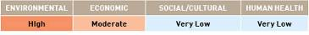

APPENDIX F
Species datasheet
Anguillicola crassus
Anguillicola crassus appears to have relatively little impact on its native host, Anguilla japonica (Japanese eel) (National Estuarine and Marine Exotic Species Information System [NEMESIS 2005b]). However, its introduction to Europe has had severe effects on the culture of European eels, A. anguilla (NEMESIS 2005b). Anguillicola infection occurs when eels ingest an infected copepod or a paratenic host fish and the nematodes move from the digestive tract into the swimbladder (NEMESIS 2005b). They develop in the swimbladder wall, then mature nematodes move into the swimbladder lumen (NEMESIS 2005b). Anguillicola infection can result in inflammation and connective tissue formation in the swimbladder wall which causes decreased swimbladder function (NEMESIS 2005b). After introduction to Europe, this nematode successfully colonised most European countries throughout the 1980s, especially in freshwater environments (Didziulis 2006). A. crassus has also been introduced to the United States where its introduced host is the American eel, A. rostrata (NEMESIS 2005b).

Common names:
Eel swimbladder nematode, parasitic nematode.
Distribution:
Found in five of the 18 IUCN bioregions (see Figure 2).
Native: Inland waters of Asia and East Asian Seas (Vietnam).
Introduced: North West Atlantic, North East Atlantic, Baltic and Wider Caribbean Sea.
Larval period:
Planktonic larval stage is about 11 days (NEMESIS 2005b). Larvae survival rates highest in freshwater, but can occur in salinities of up to 30 ppt (NEMESIS 2005b).
Temperature tolerance:
Inferred: -2.9 °C to 32.7 °C.
Physiological: 10 °C to 30 °C for reproduction (NEMESIS 2005b).

Inoculation likelihood: VERY LOW
Biofouling association rank – NEGLIGIBLE
A. crassus is thought to have arrived in Europe with eels imported from south-eastern Asia (Didziulis 2006). The main dispersal vector is thought to be the uncontrolled intercontinental transfer of live eels (Didziulis 2006).
Transport pressure rank – LOW
Australian trade with the IUCN bioregions where A. crassus is found represents 28.5% of the nation’s total trade. Once the additional weighting is applied to the different vessel types to account for the mean duration in port in various bioregions, the average increases to the equivalent of 35% representing a low likelihood of transport.

Consequence:
Consequence was evaluated based on literature assessments.
Environmental impacts – MODERATE
A. crassus can have significant negative effects on wild European eels (A. anguilla). High rates of infection of wild A. anguilla resulted in a slight reduction in length-weight ratios, decreased oxygen content in swimbladder gas and slower swimming speed (citations within NEMESIS 2005b). The nematode is expected to have serious impacts on American eel (A. rostrata) populations, but these will be difficult to differentiate from pollution, habitat destruction and other human-caused environmental changes (NEMESIS 2005b).
Economic impacts – HIGH
A. crassus causes mortality, decreased growth and reduced swimming speed on cultured European eels (A. anguilla) that have been raised in ponds from wild-caught elvers (NEMESIS 2005b). Infection rates as high as 90% have been observed on A. rostrata in some regions of Chesapeake Bay, however, the impact of this nematode on eel populations in this region is unknown (NEMESIS 2005b). The nematode has caused extensive mortality of cultured A. rostrata (Ooi et al. in NEMESIS 2005b) and is expected to adversely impact wild populations (NEMESIS 2005b).
Social/cultural impacts – NEGLIGIBLE
No information available.
Human health impacts – NEGLIGIBLE
No information available.

Risks:
Multiplying the inoculation likelihood (i.e. very low) by consequence for each value category (i.e. moderate, high, negligible, negligible) results in the following risk categorisations across all vessel types and in at least one voyage duration.
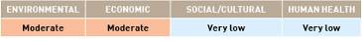

APPENDIX F
Species datasheet

Cliona thoosina
Cliona thoosina is a boring sponge found on rocks and shells on the sea floor. It commonly bores holes in the objects on which it lives (Prince William Sound Regional Advisory Council 2005). It can reproduce clonally (asexually) and sexually with fragmentation, mainly resulting from current or wave action (Prince William Sound Regional Advisory Council 2005). C. thoosina is an oviparous species. Sexual reproduction is achieved by the release of sperm into the water, internal fertilisation occurs in the receiving sponge and zygotes are released into the water where they complete their development (Prince William Sound Regional Advisory Council 2005).

Common name:
Boring sponge.
Distribution:
Found in two of the 18 IUCN bioregions (see Figure 2). The current native distribution is unknown with the taxonomy unresolved (proposed synonymy with species in the Mediterranean, Chile and Japan but its origin and present distribution are unknown [Ruiz et al. 2006]).
Cryptogenic: Mediterranean.
Introduced: North East Pacific (Alaska; Prince William Sound Regional Advisory Council 2005).
Larval period:
C. thoosina larvae are short-lived (one to two days) and are normally released at dawn in response to a light cue (Prince William Sound Regional Advisory Council 2005).
Temperature tolerance:
Inferred: -2.9°C to 32.4 °C.
Physiological: No information available.

Inoculation likelihood: LOW
Biofouling association rank – LOW
C. thoosina was most likely introduced into Alaska in association with aquaculture transfers of oyster spat (Prince William Sound Regional Advisory Council 2005). It may also have been introduced via ballast water (Ray 2005).
Transport pressure rank – VERY LOW
Australian trade with the IUCN bioregions where C. thoosina is found represents 9.8% of the nation’s total trade. Once the additional weighting is applied to the different vessel types to account for the mean duration in port in various bioregions, the average increases to the equivalent of 11.8% representing a very low likelihood of transport.

Consequence:
Consequence was evaluated based on literature assessments.
Environmental impacts – HIGH
C. thoosina encrusts the surface of mollusc shells–particularly oysters and clams–and secretes enzymes that etch the shell (Ray 2005; Ruiz et al. 2006). The weakening of the shell makes the mollusc more vulnerable to predators such as crabs and birds (Prince William Sound Regional Advisory Council 2005). In severe cases C. thoosina can kill the host mollusc (Prince William Sound Regional Advisory Council 2005).
Economic impacts – HIGH
C. thoosina infestations can be harmful to commercial oysters and clams by eroding and sometimes dissolving the shells, thereby increasing the vulnerability of the shellfish to predators (Ruiz et al. 2006). The infestations can also reduce the appeal of the mollusc to human consumers (Prince William Sound Regional Advisory Council 2005; Ruiz et al. 2006).
Social/cultural impacts – MODERATE
C. thoosina infestations can reduce the appeal of the host shellfish to human consumers (Prince William Sound Regional Advisory Council 2005; Ruiz et al. 2006).
Human health impacts – NEGLIGIBLE
No information available.

Risks:
Multiplying the inoculation likelihood (i.e. low) by consequence for each value category (i.e. high, high, moderate, negligible) results in the following risk categorisations across all vessel types and in at least one voyage duration.

APPENDIX F
Species datasheet

Gelliodes fibrosa
The encrusting sponge Gelliodes fibrosa is a shallow water species found in biofouling communities (i.e. pier pilings, floating docks) of the major island harbours of Hawaii (Bishop Museum & University of Hawaii 2005; O’Connor et al. 2008). It is also found on shallow reef patches and may be a threat to coral reef patches in protected habitats (O’Connor et al. 2008). G. fibrosa most commonly occurs as a thick encrusting blue-grey mat with anastomosing and meandering branches (Bishop Museum & University of Hawaii 2005). Like most sponges, G. fibrosa is probably capable of asexual reproduction by fragmentation, but details regarding sexual reproduction of this species are unknown (Eldredge & Smith 2001).

Common name:
Grey encrusting sponge.
Distribution:
Found in two of the 18 IUCN Bioregions (see Figure 2).
Native: East Asian Seas (Phillipines; Bishop Museum & University of Hawaii 2005).
Introduced: South Pacific (Hawaii and possibly Guam; Bishop Museum & University of Hawaii 2005).
Larval period:
No information available.
Temperature tolerance:
Inferred: 17.6 °C to 32.7 °C.
Physiological: No information available.

Inoculation likelihood: LOW
Biofouling association rank – LOW
G. fibrosa was introduced to Hawaii through biofouling on vessels’ hulls (Bishop Museum & University of Hawaii 2005). G. fibrosa was found on the hull of a floating dry-dock brought to Pearl Harbor, Hawaii from the Philippines in 1992 (Godwin 2003).
Transport pressure rank – LOW
Australian trade with the IUCN bioregions where G. fibrosa is found represents 23.2% of the nation’s total trade. Once the additional weighting is applied to the different vessel types to account for the mean duration in port in various bioregions, the average increases to the equivalent of 29.6% representing a low likelihood of transport.

Consequence:
Consequence was evaluated based on literature assessments.
Environmental impacts – MODERATE
In Hawaii, G. fibrosa is found encrusting the shaded underside of plate corals on patch reefs (Bishop Museum & University of Hawaii 2005). It may be a possible threat to corals in protected habitats, competing for space with native invertebrates (Bishop Museum & University of Hawaii 2005).
Economic impacts – NEGLIGIBLE
No information available.
Social impacts – NEGLIGIBLE
No information available.
Human health impacts – NEGLIGIBLE
No information available.

Risks:
Multiplying the inoculation likelihood (i.e. low) by consequence for each value category (i.e. moderate, negligible, negligible, negligible) results in the following risk categorisations across all vessel types and in at least one voyage duration.

APPENDIX F
Species datasheet

Bonamia ostreae
Bonamia ostreae is an intrahaemocytic protistan parasite of the European flat oyster, Ostrea edulis. It parasitises the blood cells (haemocytes) and the cells of oyster gills (Culloty & Mulcahy 2007) causing bonamiosis (Arzul et al. 2009). Bonamiosis is a disease of oysters caused by parasites of the genus Bonamia (Culloty & Mulcahy 2007). B. ostreae has been described in various ecosystems from estuaries to open sea (Arzul et al. 2009). The complete life cycle of B. ostreae is uncertain (Culloty & Mulcahy 2007). Based on the presence of haplosporosomes and molecular analysis, B. ostreae is in the taxonomic group Haplosporidia, although a spore stage has never been observed (Culloty & Mulcahy 2007).

Common names:
Bonamia, Haplosporidian parasite.
Distribution:
Found in three of the 18 IUCN bioregions (see Figure 2).
Native: Mediterranean.
Introduced: North West Atlantic and North East Atlantic.
Larval period:
No information available.
Temperature tolerance:
Inferred: -2.9 °C to 32.4 °C.
Physiological: Arzul et al. (2009) investigated the effect of temperature (4 °C, 15 °C and 25 °C) on the survival of parasites maintained in vitro in seawater and showed that B. ostreae had lower survival at 25 °C compared to 4 °C and 15 °C.

Inoculation likelihood: LOW
Biofouling association rank – LOW
B. ostreae is believed to be spread by movements of infected oysters (Culloty & Mulcahy 2007). It is not a biofouling organism although its host (O. edulis) may be spread through biofouling.
Transport pressure rank – VERY LOW
Australian trade with the IUCN bioregions where B. ostreae is found represents 11.4% of the nation’s total trade. Once the additional weighting is applied to the different vessel types to account for the mean duration in port in various bioregions, the average increases to the equivalent of 12.8% representing a very low likelihood of transport.

Consequence:
Consequence was evaluated based on literature assessments.
Environmental impacts – NEGLIGIBLE
No information available.
Economic impacts – HIGH
B. ostreae is responsible for a serious decline in the aquaculture production of the European flat oyster, O. edulis (Naciri-Graven et al. 1998; Launey et al. 2001; Lallias et al. 2008). Prophylactic measures were taken to sustain oyster farming, but the continuing presence of B. ostreae and another parasite (Marteilia refringens) led to the initiation of a program to select for resistant oysters (Naciri-Graven et al. 1998). The program was based on mass selection of oysters and parasite inoculation or natural infections (Naciri-Graven et al. 1998). Naciri-Graven et al. (1998) reported no measurable natural resistance of O. edulis to B. ostreae in the wild.
Social impacts – NEGLIGIBLE
No information available.
Human health impacts – NEGLIGIBLE
No information available.

Risks:
Multiplying the inoculation likelihood (i.e. low) by consequence for each value category (i.e. negligible, high, negligible, negligible) results in the following risk categorisations across all vessel types and in at least one voyage duration.

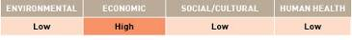

REFERENCES: APPENDIX F

Aguirre W & Poss SG 1999, Non-Indigenous Species In the Gulf of Mexico Ecosystem: Corbicula fluminea (Muller, 1774), Gulf States Marine Fisheries Commission (GSMFC).
Albano PG, Rinaldi E, Evangelisti F, Kuan M & Sabelli B 2009, ‘On the identity and origin of Anadara demiri (Bivalvia: Arcidae)’, Journal of the Marine Biological Association of the United Kingdom, vol. 89, pp. 1289–1298.
Anger K 1991, ‘Effects of temperature and salinity on the larval development of the Chinese mitten crab Eriocheir sinensis (Decapoda: Grapsidae)’, Marine Ecology Progress Series vol. 72, pp. 103–110.
Ammons D, Rampersad J & Poli MA 2001, ‘Evidence for PSP in mussels in Trinidad’, Toxicon, vol. 39, pp. 889–892.
Arzul I, Gagnaire B, Bond C, Chollet B, Morga B, Ferrand S, Robert M & Renault T 2009, ‘Effects of temperature and salinity on the survival of Bonamia ostreae, a parasite infecting flat oysters Ostrea edulis’, Diseases of Aquatic Organisms, vol. 85, pp. 67–75.
Bailey-Brock JH 1990, ‘Polydora nuchalis (Polychaeta: Spionidae), a New Hawaiian Record from Aquaculture Ponds’, Pacific Science, vol. 44, pp. 81–87.
Balcom NC 1994, ‘Aquatic Immigrants of the Northeast, no. 4: Asian clam, Corbicula fluminea’, Connecticut Sea Grant College Program.
Baltic Sea Alien Species Database 2007, Olenin S, Daunys D, Leppäkoski E & Zaiko A (eds), viewed 30 November 2009, <http://www.corpi.ku.lt/nemo/>.
Barbera-Sánchez A, Soler JF, Rojas De Astudillo L, Chang-Yen I 2004, ‘Paralytic Shellfish Poisoning (PSP) in Margarita Island, Venezuela’, Revista de Biologia Tropical vol. 52, pp. 89–98.
Barnes H and Barnes M 1956, ‘The General Biology of Balanus glandula Darwin’, Pacific Science, vol. 10, no. 4, pp. 415–422.
Bax N, Hayes K, Marshall A, Parry D & Thresher R 2002, ‘Man-made marinas as sheltered islands for alien marine organisms: Establishment and eradication of an alien invasive marine species’, in Veitch CR & Clout MN (eds), Turning the tide: the eradication of invasive species, IUCN SSC Invasive Species Specialist Group, IUCN, Gland, Switzerland and Cambridge, United Kingdom, pp. 26–39.
Bayne BL 1965, ‘Growth and the delay of metamorphosis of the larvae of Mytilus edulis L. (Mollusca)’, Ophelia, vol. 2, pp. 1–47.
Benson A 2005, ‘Asian shore crab, Japanese shore crab, Pacific crab, Hemigrapsus sanguineus (De Haan)’, USGS Nonindigenous Aquatic Species Information Database, viewed 11 October 2009, <http://fl.biology.usgs.gov/Nonindigenous_Species/Asian_shore_crab/asian_shore_crab.html>.
Benson A 2008, ‘Mytella charruana’, USGS Nonindigenous Aquatic Species Database, viewed 15 October 2009, <http://nas.er.usgs.gov/queries/FactSheet.asp?speciesID=106>.
Benson AJ, Richerson MM & Maynard E 2009, ‘Dreissena rostriformis bugensis’, USGS Nonindigenous Aquatic Species Database, Gainesville, Florida, United States, viewed 16 October 2009, <http://nas.er.usgs.gov/queries/FactSheet.asp?speciesID=95>.
Berezina NA 2007, ‘Invasions of alien amphipods (Amphipoda: Gammaridea) in aquatic ecosystems of North-Western Russia: pathways and consequences’, Hydrobiologia, vol. 590, pp. 15–29.
Berger MS & Emlet RB 2007, ‘Heat-shock response of the upper intertidal barnacle Balanus glandula: Thermal stress and acclimation’, Biological Bulletin, vol. 212, pp. 232–241.
Berezina NA & Panov PE 2004, ‘Distribution, population structure and salinity tolerance of the invasive amphipod Gmelinoides fasciatus (Stebbing) in the Neva Estuary’, Hydrobiologia, vol. 514, pp. 199–206.
Berezina NA, Zhakova LV, Zaporozhets NV & Panov VE 2009, ‘Key role of the amphipod Gmelinoides fasciatus in reed beds of Lake Ladoga’, Boreal Environment Research, vol. 14, pp. 404–414.
Bergstrom P 2004, ‘An Introduction to Dark False mussels’, NOAA Chesapeake Bay Office, viewed 29 May 2009, <http://www.chesapeakebay.net/pubs/calendar/LRSC_09-30-04_Presentation_1_5352.pdf>.
Bishop Museum & University of Hawaii 2002, ‘Introduced marine species of Hawaii–Crassostrea virginica fact sheet’, viewed 18 October 2009, <http://www2.bishopmuseum.org/HBS/invertguide/species/crassostrea_virginica.htm>.
Bishop MWH 1951, ‘Distribution of barnacles by vessels’, Nature, vol. 167, p. 531.
Boudreaux ML, Walters LJ & Rittschof D 2009, ‘Interactions between native barnacles, non-native barnacles, and the eastern oyster Crassostrea virginica’, Bulletin of Marine Science, vol. 84, pp. 43–57.
Bower SM & Boutillier JA 1990, ‘Sylon (Crustacea: Rhizocephala) infections on the shrimp in British Columbia’, in Perkins FO and Cheng TC (eds), Pathology in Marine Science, Academic Press, pp. 267–275.
Bower SM & Meyer GR 1999, ‘Synopsis of Infectious Diseases and Parasites of Commercially Exploited Shellfish: Rhizocephalan Parasites of Crabs’, viewed 18 October 2009, <http://www.pac.dfompo.gc.ca/sci/shelldis/pages/rhizocb_e.htm>.
Britton-Simmons KH 2004, ‘Direct and indirect effects of the introduced alga Sargassum muticum on benthic, subtidal communities of Washington State, USA’, Marine Ecology Progress Series, vol. 277, pp. 61–78.
Britton-Simmons KH & Abbott KC 2008, ‘Short and long-term effects of disturbance and propagule pressure on a biological invasion’, Journal of Ecology, vol. 96, pp. 68–77.
Bullard SG, Lambert G, Carman MR, Byrnes J, Whitlatch RB, Ruiz G, Miller RJ, Harris L, Valentine PC, Collie JS, Pederson J, McNaught DC, Cohen AN, Asch RG, Dijkstra J & Heinonen K 2007, ‘The colonial ascidian Didemnum sp.: current distribution, basic biology and potential threat to marine communities of the northeast and west coasts of North America’, Journal of Experimental Marine Biology and Ecology, vol. 342, pp. 99–108.
Carlton JT, Thompson JK, Schemel LE & Nichols FH 1990, ‘Remarkable invasion of San Francisco Bay (California, USA) by the Asian clam Potamocorbula amurensis. I. Introduction and dispersal’, Marine Ecology Progress Series, vol. 66, pp. 81–95.
Chambers MR 1977, ‘The population ecology of Gammarus tigrinus (sexton) in the reed beds of the Tjeukemeer’, Hydrobiologia, vol. 53, pp. 155–164.

REFERENCES: APPENDIX F

Charlier RH, Morand P, Finkl CW & Thys A 2007, ‘Green tides on the Brittany Coasts’, Environmental Research, Engineering and Management, vol. 3, pp. 52–59.
Coastal Research and Planning Institute 2008, ‘Gmelinoides fasciatus’, CORPI database, viewed 16 June 2010, <http://www.corpi.ku.lt/nemo/directory_details.php?sp_name=Gmelinoides+fasciatus>.
Cohen AN 1998, ‘Vessels’ ballast water and the introduction of exotic organisms into the San Francisco Estuary: current status of the problem and options for management’, San Francisco Estuary Institute, Richmond, California, United States, viewed 16 October 2009, <http://www.sfei.org/staffpubs_pages/pubs_cohen.htm>.
Cohen AN 2005a, ‘Guide to the exotic species of San Francisco Bay’, San Francisco Estuary Institute, Oakland, California, United States, viewed 18 October 2009, <http://www.exoticsguide.org>.
Cohen AN 2005b, ‘Guide to the exotic species of San Francisco Bay. Corbula amurensis’, San Francisco Estuary Institute, Oakland, California, United States, viewed 30 November 2009, <http://www.exoticsguide.org/species_pages/c_amurensis.html>.
Cohen AN 2005c, ‘Guide to the exotic species of San Francisco Bay’, San Francisco Estuary Institute, Oakland, California, United States, viewed 30 November 2009, <http://www.exoticsguide.org/species_pages/m_arenaria.html>.
Cohen AN 2007, ‘Potential distribution of zebra mussels (Dreissena polymorpha) and quagga mussels (Dreissena bugensis) in California: Phase 1 report’, report for the California Department of Fish and Game, viewed 16 October 2009, <http://www.sfei.org/staffpubs_pages/pubs_cohen.htm>.
Cohen AN, Moll R, Carlton JT, O’Neill Jr CR, Anderson L & Moyle PB 2007 ‘California’s response to the zebra/quagga mussel invasion in the west’, recommendations of the California Science Advisory Panel prepared for the California Incident Command, viewed 16 October 2009, <http://www.sfei.org/staffpubs_pages/pubs_cohen.htm>.
Cohen AN & Weinstein A 2001, ‘The potential distribution of Chinese mitten crabs (Eriocheir sinensis) in selected waters of the western United States with U.S. Bureau of Reclamation facilities’, Tracy Fish Collection Facilities Studies, vol. 21, p. 61.
Cohen BF, Heislers S, Parry G, Asplin M, Werner G & Restall J 2002, ‘Exotic marine pests in the outer harbour of the Port of Adelaide, South Australia’, Marine and Freshwater Resources Institute Report No. 40, Marine and Freshwater Resources Institute, Queenscliff, Victoria, Australia.
Coles SL & Elredge LG 2002, ‘Nonindigenous Species Introductions on Coral Reefs: A Need for Information’, Pacific Science, vol. 56, pp. 191–209.
Commonwealth Science and Industrial Research Organisation (CSIRO) 2001, ‘CSIRO Marine Science Marine Pest Information Sheet: Mytilopsis sallei CRIMP (Centre for Research on Introduced Marine Pests) Infosheet 10’, viewed 25 October 2009, <http://www.marine.csiro.au/crimp/Reports/Infosht10_Mytil0201S3.pdf>.
CORPI 2008, ‘Alien Species Directory’, Baltic Sea Alien Species Database, viewed 17 November 2008, <http://www.corpi.ku.lt/nemo/alien_species_directory.html>.
Costlow JD & Bookhout CG 1957, ‘Larval development of Balanus eburneus in the laboratory’, Biological Bulletin, vol. 112, pp. 313–324.
Coutts ADM & Dodgshun T 2007, ‘The nature and extent of organisms in vessel sea-chests: a protected mechanism for marine bioinvasions’, Marine Pollution Bulletin, vol. 54, pp. 875–886.
Coutts ADM & Forrest BM 2007, ‘Development and application of tools for incursion response: Lessons learned from the management of the fouling pest Didemnum vexillum’, Journal of Experimental Marine Biology and Ecology, vol. 342, pp. 154–162.
Critchley AT, Farnham WF & Morrell SL 1986, ‘An account of the attempted control of an introduced marine alga Sargssum muticum in Southern England UK’, Biological Conservation, vol. 35, pp. 313–332.
Crosier DM & Molloy DP 2008, ‘Killer Shrimp - Dikerogammarus villosus’, viewed 16 October 2009, <http://el.erdc.usace.army.mil/ansrp/dikerogammarus_
villosus.pdf>.

Culloty SC & Mulcahy MF 2007, ‘Bonamia ostreae in the native oyster, Ostrea edulis: a review’, Marine and Environment Heath Series, Marine Institute, Galway, Ireland, no. 29, <http://www.marine.ie/NR/rdonlyres/F8A9A859-BEA9-4D31-B1B6-C19850388777/0/Bonamia.pdf>.
Cultured Aquatic Species Information Programme (CASIP) 2009, ‘Crassostrea virginica’, Food and Agriculture Oraganization (FAO) of the United Nations, Fisheries and Aquaculture Department, viewed 18 October 2009, <http://www.fao.org/fishery/culturedspecies/Crassostrea_virginica/en>.
Daley BA & Scavia D 2008, ‘An integrated assessment of the continued spread and potential impacts of the colonial ascidian, Didemnum sp. A in U.S. waters’, National Oceanic and Atmospheric Administration (NOAA) technical memorandum, National Centers for Coastal Ocean Science (NCCOS), pp. 61, 78.
Daniel KS & Therriault TW 2007, ‘Biological synopsis of the invasive tunicate Didemnum sp,’ Canadian Manuscript Report of Fisheries and Aquatic Sciences, Pacific Biological Station, Nanaimo, British Columbia, Canada, pp. 1–53.
Darrigan G & de Drago IE 2000, ‘Invasion of Limnoperna fortunei (Dunker, 1857) (Bivalvia: Mytilidae) in America’, Nautilus, vol.2, pp. 69–74.
Davison DM 1996, ‘Sargassum muticum in Strangford Lough, 1995–1998; A review of the introduction and colonisation of Strangford Lough MNR and cSAC by the invasive brown algae Sargassum muticum’, report to the Environment & Heritage Service, Department of Environment, Northern Ireland, pp. 91.
Day RL & Blake JA 1979, ‘Reproduction and larval development of Polydora giardi Mesnil (Polychaeta: Spionidae)’, Biological Bulletin, vol. 156, pp. 20–30.
DeFelice RC, Coles SL, Muir D & Eldredge LG 1998, ‘Investigation of marine communities of midway beach harbour and adjacent lagoon, Midway Atoll, NW Hawaiian Islands’, Hawaii Biological Survey.
Den-Hartog C 1997, ‘Is Sargassum muticum a threat to eelgrass beds?’, Aquatic-Botany, vol. 58, pp. 37–41.
Deysher L & Norton TA 1982, ‘Dispersal and colonisation in Sargassum muticum (Yendo) Fensholt’, Journal of Experimental Marine Biology and Ecology, vol. 56, pp. 179–195.
Didziulis V 2006, ‘Invasive alien species fact sheet- Anguillicola crassus’, online database of the North European and Baltic Network on Invasive Alien Species (NOBANIS), viewed 28 October 2009, <http://www.nobanis.org/files/factsheets/Anguilicola_crassus.pdf>.

REFERENCES: APPENDIX F

Dineen JF & Hines AH 1994, ‘Larval settlement of the polyhaline barnacle I (Gould): Cue interactions and comparisons with two estuarine congeners’, Journal of Experimental Marine Biology and Ecology, vol. 179, pp. 223-234.
Dineen JF, Clark PE, Hines AH, Reed SA & Walton HP 2001, ‘Life history, larval description, and natural history of Charybdis hellerii (decapoda, Brachyura, Portunidae), an invasive crab in the western Atlantic’, Journal of Crustacean Biology, vol. 21, pp. 774–805.
Dogan A, Onen M & Ozturk B 2007, ‘A new record of the invasive Red Sea mussel Brachidontes pharaonis (Fischer P 1870) (Bivalvia: Mytilidae) from the Turkish coasts’, Aquatic Invasions, vol. 2, pp. 461–463.
Edvardsen B, Eikrem W, Shalchian-Tabrizi K, Riisberg I, Johnsen G, Naustvoll L & Throndsen J 2007, ‘Verrucophora farcimen gen. et sp. nov. (Dictyochophyceae, Heterokonta)—a bloom-forming ichthyotoxic flagellate from the Skagerrak, Norway’, Journal of Phycology, vol. 43, pp. 1054–1070.
Ehlinger GS & Tankersley RA 2004, ‘Survival and Development of Horseshoe Crab (Limulus polyphemus) Embryos and Larvae in Hypersaline Conditions’, Biological Bulletin, vol. 206, pp. 87–94.
Eikrem W, Edvardsen B & Throndsen J 2009, ‘Research note: Renaming Verrucophora farcimen Eikrem, Edvardsen et Throndsen,’ Phycological Research, vol 57, p. 170.
Eldredge LG & Smith CM (eds) 2001, ‘A guidebook of introduced marine species in Hawaii’, in Bishop Museum Technical Report 21, Bishop Museum and the University of Hawaii.
Eno NC, Clark RA & Sanderson WC (eds) 1997, Non-native marine species in British waters: a review and directory, Joint Nature Conservation Committee, Great Britain, p. 152.
Epifanio CE, Dittel AI, Park S, Schwalm S, Fouts A 1998, ‘Early life history of Hemigrapsus sanguineus, a non-indigenous crab in the Middle Atlantic Bight’, Marine Ecology Progress Series, vol. 170, pp. 231–238.
Foster AM, Fuller P, Benson A, Constant S & Raikow D 2009, ‘Corbicula fluminea’, United States Geological Survey nonindigenous aquatic species database, Gainesville, Florida, United States, viewed 17 October 2009, <http://nas.er.usgs.gov/queries/FactSheet.asp?speciesID=92>.
Galil BS 2006, ‘Brachidontes pharaonis, Delivering Alien Species Inventories for Europe’, viewed 16 October 2009, <http://www.europe-aliens.org/pdf/Brachidontes_pharaonis.pdf>.
Galil BS & Bogi C 2008, ‘Mytilopsis sallei (Mollusca: Bivalvia: Dreissenidae) established on the Mediterranean coast of Israel’, Journal of the Marine Biological Association biodiversity records, viewed 16 October 2009, <http://www.mba.ac.uk/jmba/pdf/6415.pdf>.
Godwin LS 2003, ‘Hull fouling of maritime vessels as a pathway for marine species invasions to the Hawaiian Islands’, Biofouling, vol. 19, no. 1 (supplement), pp. 123–131.
Gollasch S 2006, ‘Global invasive species database Eriocheir sinensis fact sheet’, Invasive Species Specialist Group (ISSG), viewed 17 October 2009, <http://www.issg.org/database/species/ecology.asp?si=38&fr=1&sts=sss&lang=EN>.
Gollasch S, Minchin D, Rosenthal H & Voigt M 1999, Exotics across the ocean: Case histories on introduced species, report prepared by members of the European Union concerted action on testing monitoring systems for risk assessment of harmful introductions by vessels to European waters, Department of Fishery Biology, Institut for Marine Science, University of Kiel, Germany.
Grosholz ED & Ruiz GM 1995, ‘Spread and potential impact of the recently introduced European green crab, Carcinus maenas, in central California’, Marine Biology, vol. 122, no. 2, pp. 239–247.
Guiry MD 2008, ‘Species: Codium fragile var. atlanticum’, AlgaeBase, web publication, National University of Ireland, Galway, viewed 2 November 2009, <http://www.algaebase.org/search/species/detail/?species_ id=245>.
Guiry MD & Guiry GM 2009, ‘Species: Codium fragile subsp tomentosoides’, AlgaeBase, web publication, National University of Ireland, Galway, viewed 23 October 2009, <http://www.algaebase.org/search/species/detail/?
species_id=46>.

Gulf States Marine Fisheries Commission (GSMFC) 2005, ‘Dreissena polymorpha fact sheet’, viewed 16 October 2009, <http://nis.gsmfc.org/nis_factsheet.php?toc_id=131>.
Gust N & Inglis GJ 2006, ‘Adaptive multi-scale sampling to determine an invasive crab’s habitat usage and range in New Zealand’, Biological Invasions, vol. 8, pp. 339–353.
Haines JL & Maurer D 1980, ‘Quantitative faunal associates of the serpulid polychaete hydroides dianthus’, Marine Biology, vol. 56, pp. 43–47.
Hales JM, Fletcher RL 1989, ‘Studies on the recently introduced brown alga Sargassum muticum (Yendo) Fensholt. IV. The effect of temperature, irradiance and salinity on germling growth’, Botanica Marina, vol. 32, pp. 167–176.
Hansen K, King GM & Kristensen E 1996, ‘Impact of the soft-shell clam Mya arenaria on sulphate reduction in an intertidal sediment’, Marine Ecology Progress Series, vol. 10, pp. 181–194.
Hawaiian Biological Survey (HBS) 2009, ‘Avrainvillea amadelpha’, Bishop Museum, viewed 19 October 2009, <http://www2.bishopmuseum.org/algae/results3.asp?search=Avrainvillea_amadelpha>.
Hayes KR & Sliwa C 2003, ‘Identifying potential marine pests—a deductive approach applied to Australia’, Marine Pollution Bulletin, vol. 46, pp. 91–98.
Hayes KR, Connon R, Neil K & Inglis G 2005, ‘Sensitivity and cost considerations for the detection and eradication of marine pests in ports’, Marine Pollution Bulletin, vol. 50, pp. 823–834.
Herborg LM, Rushton SP, Clare AS & Bentley MG 2003, ‘Spread of the Chinese mitten crab (Eriocheir sinensis H. Milne Edwards) in Continental Europe: analysis of a historical data set’, Hydrobiologia, vol. 503, pp. 21–28.
Herborg LM, Jerde CL, Lodge DM, Ruiz GM &MacIsaac HJ 2007, ‘Predicting the North American distribution of Chinese mitten crabs (Eriocheir sinensis) using measures of propagule pressure and environmental niche models’, Ecological Applications, vol. 17, pp. 663–674.
Hewitt CL & Campbell ML 2010, The relative contribution of vectors to the introduction and translocation of invasive marine species, report prepared for the Department of Primary Industries, Fisheries and Forestry, <http://www.marinepests.gov.au.marine_pests/publications>.

REFERENCES: APPENDIX F

Hewitt CL, Campbell ML, Moore KM, Murfet NB & McEnnulty F 2000, Introduced Species Survey of Fremantle, Western Australia, report for the Fremantle Port Authority, CRIMP, CSIRO Marine Research, Hobart, Tasmania, Australia.
Hicks DW & McMahon RF 2002, ‘Temperature acclimation of upper and lower thermal limits and freeze resistance in the nonindigenous brown mussel, Perna perna (L.), from the Gulf of Mexico’, Marine Biology, vol. 140, pp. 1167–1179.
Hicks DW & Tunnell JW 1993, ‘Invasion of the south Texas coast by the edible brown mussel Perna perna (Linneaus 1758)’, Veliger, vol. 36, pp. 92–94.
Hicks DW, Tunnell JW & McMahon RF 2001, ‘Population dynamics of the nonindigenous brown mussel Perna perna in the Gulf of Mexico compared to other world-wide populations’, Marine Ecology Progress Series, vol. 211, pp. 181–192.
Hill K 2004, ‘Callineces sapidus’, Smithsonian Marine Station, viewed 8 October 2009, <http://www.sms.si.edu/IRLspec/Callin_sapidu.htm>.
Hosoi-Tanabe S, Otake I & Sako Y 2006, ‘Phylogenetic analysis of noxious red tide flagellates Chattonella antiqua, C. marina, C. ovata, and C. verruculosa (Raphidophyceae) based on the rRNA gene family’, Fisheries Science vol. 72, pp. 1200–1208.
Huang ZG & Morton B 1983, ‘Mytilopsis sallei (Bivalvia: Dreissenoidea) established in Victoria Harbour, Hong Kong,’ Malacological Review, vol. 16, pp. 99–100.
Imai I & Itoh K 1987, ‘Annual life cycle of Chattonella spp., causative flagellates of noxious red tides in the Inland Sea of Japan’, Marine Biology, vol. 94, pp. 287 –292.
Inglis GJ, Hurren H, Oldman J & Haskew R 2006, ‘Using habitat suitability index and particle dispersion models for early detection of marine invaders’, Ecological Applications, vol. 16, pp. 1377–1390.
Institute of Natural Resource Sustainability 2009, ‘Corbicula fluminea’, viewed 16 June 2010, <http://www.inhs.illinois.edu/animals_plants/mollusk/musselmanual/page174_5.html>.
Invasive Species Specialist Group (ISSG) 2005a, ‘Global invasive species database Corbicula fluminea fact sheet’, viewed 17 October 2009, <http://www.issg.org/database/species/ecology.asp?si=537&fr=1&sts=sss&lang=EN>.
Invasive Species Specialist Group (ISSG) 2005b, ‘Global invasive species database: Codium fragile spp tomentosoides fact sheet’, viewed 4 November 2009, <http://www.issg.org/database/species/ecology.asp?si=796&fr=1&sts=sss&lang=EN>.
Invasive Species Specialist Group (ISSG) 2005c, ‘Global invasive Species Database Corbula amurensis fact sheet’, viewed 30 November 2009, <http://www.issg.org/database/species/impact_info.asp?si=136&fr=1&sts=&lang=EN>.
Invasive Species Specialist Group (ISSG) 2006, ‘Global invasive species database Dreissena bugensis fact sheet’, viewed 16 October 2009, <http://www.issg.org/database/species/ecology.asp?si=918&fr=1&sts>.
Invasive Species Specialist Group (ISSG) 2008, ‘Global invasive species database Geukensia demissa fact sheet’, <http://www.issg.org/database/species/search.asp?sts=sss&st=sss&fr=1&x=0&y=0&sn=Geukensia+demissa&rn=&hci=-1&ei=-1&lang=EN>
Isaeva VV, Dolganov SM & Shukalyuk AI 2005, ‘Rhizocephalan barnacles - parasites of commercially important crabs and other decapods’, Russian Journal of Marine Biology, vol. 31, pp. 215–220.
Jegla TC & Costlow JD 1982, ‘Temperature and salinity effects on developmental and early posthatch stages of Limulus’, in Bonaventura J, Bonaventura C & Tesh S (eds), Physiology and Biology of Horseshoe Crabs: Studies on Normal and Environmentally Stressed Animals, Alan R. Liss, New York, United States, pp. 103–113.
Joint Nature Conservation Committee (JNCC) 2002, ‘Crepidula fornicata fact sheet’, Advisors of United Kingdom Government, viewed 18 October 2009, <http://www.jncc.gov.uk/default.aspx?page=1711>.
Joint Nature Conservation Committee (JNCC) undated, ‘Codium fragile fact sheet’, viewed 2 November 2009, <http://www.jncc.gov.uk/page-1678>.
Kado R 2003, ‘Invasion of Japanese shores by the NE Pacific barnacle Balanus glandula and its ecological and biogeographical impact’, Marine Biology, vol. 249, pp. 199–206.
Kado R & Nanba N 2006, ‘Balanus glandula : a new alien barnacle from the west coast of North America, established on the northeast coast of Japan’, in Koike F, Clout MN, Kawamichi M, De Poorter M & Iwatsuki K (eds), Assessment and Control of Biological Invasion Risks, Shoukadoh Book Sellers, Kyoto, Japan and IUCN, Gland, Switzerland, pp. 210–211.
Kanada S, Kuranishi RB, Ishiwata S, Tojo K, Shimizu T, Taira H & Satake K 2007, ‘Distribution of an alien species, Crangonyx floridanus Bousfield (Crustacea: Amphipoda: Crangonyctidae) in Japan’, Japanese Journal of Limnology, vol. 68, pp. 449 –460.
Kashenko SD & Korn OM 2002, ‘Adaptive responses of the larvae of cirripede barnacle Peltogasterella gracilis to changes in seawater temperature and salinity’, Russian Journal of Marine Biology, vol. 28, pp. 317–323.
Korn OM & Elfimov AS 1999, ‘Larval development of a warm-water immigrant barnacle, Solidobalanus fallax (Cirripedia: Archaeobalanidae) reared in the laboratory’, Journal of the Marine Biological Association of the United Kingdom, vol. 79, pp. 1039–1044.
Kott P 2009, ‘Taxonomic revision of Ascidiacea (Tunicata) from the upper continental slope off north-western Australia’, Journal of Natural History, vol. 43, pp. 1947-1986.
Kurashova EK 2002, ‘Acartia tonsa’, Caspian Environment Programme, viewed 6 October 2009, <http://www.caspianenvironment.org/biodb/eng/zooplankton/Acartia%20tonsa/main.htm>.
Lallias D, Arzul I, Heurtebise S, Ferrand S, Chollet B, Robert M, Beaumont AR, Boudry P, Morga B & Lapègue S 2008, ‘Bonamia ostreae-induced mortalities in one-year old European flat oysters Ostrea edulis: Experimental infection by cohabitation challenge’, Aquatic Living Resources, vol. 21, pp. 423–439.
Lambert G 2009, ‘Adventures of a sea squirt sleuth: unraveling the identity of Didemnum vexillum, a global ascidian invader’, Aquatic Invasions, vol. 4, no. 1, pp. 5–28.
Launey S, Barre M, Gerard A & Naciri-Graven Y 2001, ‘Population bottleneck and effective size in Bonamia ostreae-resistant populations of Ostrea edulis as inferred by microsatellite markers’, Genetical Research, vol. 78, pp. 259–270.

REFERENCES: APPENDIX F

Lee CN & Morton B 2005, ‘Experimentally derived estimates of growth by juvenile Tachypleus tridentatus and Carcinoscorpius rotundicauda (Xiphosura) from nursery beaches in Hong Kong’, Journal of Experimental Marine Biology and Ecology, vol. 318, pp. 39–49.
Lee T, Yame WC, Tama TY, Hob BSW, Ng MH & Broomb MJ 1997, ‘Occurrence of hepatitis A virus in green-lipped mussels Perna viridis’, Water Research, vol. 33, pp. 885–889.
Leppäkoski E & Gollasch S (eds) 1999, Initial risk assessment of alien species in Nordic coastal waters, project funded by the Nordic Council of Ministers, p. 244.
Link H, Nishi E, Tanaka K, Bastida-Zavala R, Kupriyanova EK & Yamakita T 2009, ‘Hydroides dianthus, an alien species introduced into Tokyo Bay, Japan’, Marine Biodiversity Records, vol. 2, no. 87.
Lohse DP 2002, ‘Relative strengths of competition for space and food in a sessile filter feeder’, Biological Bulletin, vol. 203, pp. 173–180.
Lützen J 1981, ‘Observations on the rhizocephalan barnacle Sylon hippolytes M. Sars parasitic on the prawn Spirontocaris lilljeborgi (Danielssen)’, Journal of Experimental Biology and Ecology, vol. 50, pp. 334–347.
Maeda M, Itami T, Furumoto A, Hennig O, Imamura T, Kondo M, Hirono I, Aoki T & Takahashi Y 1998, ‘Detection of penaeid rod-shaped DNA virus (PRDV) in wild-caught shrimp and other crustaceans’, Fish Pathology, vol. 33, pp. 381–387.
McDermott JJ 1998, ‘The western Pacific brachyuran (Hemigrapsus sanguineus: Grapsidae), in its new habitat along the Atlantic coast of the United States: geographic distribution and ecology’, ICES Journal of Marine Science, vol. 55, pp. 289–298.
MacQuarrie SP & Bricelj VM 2008, ‘Behavioral and physiological responses to PSP toxins in Mya arenaria populations in relation to previous exposure to red tides’, Marine Ecology Progress Series, vol. 366, pp. 59–74.
Masterson J 2007, ‘Mytella charruana’, Smithsonian Marine Station, viewed 15 October 2009, <http://www.sms.si.edu/IRLspec/Mytella_charruana.htm>.
Menon NN, Balchand AN & Menon NR 2000, ‘Hydrobiology of the Cochin backwater system–a review’, Hydrobiologia, vol. 430, pp. 149–183.
Mikhail SK 2007, ‘First monospecific bloom of the harmful raphidophyte Chattonella antiqua (Hada) Ono in Alexandria waters related to water quality and copepod grazing’, Chemistry and Ecology, vol. 23, pp. 393–407.
Minchin D 2008, ‘Crepidula fornicata’, Delivering Alien Invasive Species Inventories for Europe, viewed 18 October 2009, <http://www.europe-aliens.org/pdf/Crepidula_fornicata.pdf>.
Morello EB, Solustri C & Froglia C 2004, ‘The alien bivalve Anadara demiri (Arcidae): a new invader of the Adriatic Sea, Italy’, Journal of the Marine Biological Association of the United Kingdom, vol. 84, pp. 1057–1064.
Morris JA, Carman MR, Hoagland KE, Green-Beach ERM & Karney RC 2009, ‘Impact of the invasive colonial tunicate Didemnum vexillum on the recruitment of the bay scallop (Argopecten irradians irradians) and implications for recruitment of the sea scallop (Placopecten magellanicus) on Georges Bank’, Aquatic Invasions, vol. 4, no. 1, pp. 207–211.
Morton B 1973, ‘Some aspects of the biology and functional morphology of the organs of feeding and digestion of Limnoperna fortunei (Dunker) (Bivalvia: Mytilacea)’, Malacologia, vol. 12, pp. 265–281.
Naciri-Graven Y, Martin AG, Baud JP, Renault T & Gerard A 1998, ‘Selecting flat oyster Ostrea edulis for survival when infected with the parasite Bonamia ostreae’, Journal of Experimental Marine Biology and Ecology, vol. 224, pp. 91–107.
Nakamura Y, Takashima J & Watanabe M 1989, ‘Chemical environment for red tides due to C. antiqua in the Seto Inland Sea, Japan’, Journal of the Oceanographical Society of Japan, vol. 44, pp. 113–124.
Naustvoll LJ 2006, ‘Chattonella aff. Verruculosa fact sheet’, online database of the North European and Baltic Network on Invasive Alien Species (NOBANIS), viewed 17 October 2009, <http://www.nobanis.org/files/factsheets/Chattonella_verruculosa.pdf>.
Nehring S, Speckels G & Albersmeyer J 2008, ‘The American blue crab Callinectes sapidus RATHBUN on the German North Sea coast: status quo and further perspectives’, Senckenbergiana maritima, vol. 38, pp. 39–44.
NEMESIS 2005a, ‘Loxothylacus panopaei’, Chesapeake Bay introduced species database, viewed 14 October 2009, <http://invasions.si.edu/nemesis/CH-ECO.jsp?Species_name=Loxothylacus+panopaei>.
NEMESIS 2005b, ‘Anguillicola crassus,’ Chesapeake Bay introduced species database, viewed 15 October 2009, <http://invasions.si.edu/nemesis/CH-IMP.jsp?Species_name=Anguillicola+crassus>.
Nichols FH, Thompson JK & Schemel L 1990, ‘Remarkable invasion of San Francisco Bay (California, USA) by the Asian clam Potamocorbula amurensis. II. Displacement of a former community’, Marine Ecology Progress Series, vol. 66, pp. 95–101.
Nicolini MH & Penry DL 2000, ‘Spawning, fertization, and larval development of Potamocorbula amurensis (Mollusca: Bivalvia) from San Francisco Bay, California’, Pacific Science, vol. 54, no. 4, pp. 377–388.
NIMPIS 2002c, ‘Mytilopsis sallei species summary’, viewed 23 October 2009, <http://adl.brs.gov.au/marinepests/index.cfm?fa=main.spDetailsDB&sp=6000009583>.
NOBANIS 2005, ‘Acartia tonsa (Acartiidae) in Lithuania’, viewed 6 October 2009, <http://www.nobanis.org/NationalInfo.asp?countryID=LT&taxaID=1624>.
North E, Schlag Z, Hood R, Zhong L, Li M & Gross T 2006, Modeling dispersal of Crassostrea ariakensis oyster larvae in Chesapeake Bay, p. 77.

REFERENCES: APPENDIX F

O’Connor M, Hawkins C & Loomis D 2008, ‘A manual of previously recorded non-indigenous invasive and native transplanted animal species of the Laurentian Great Lakes and coastal United States’, NOAA technical memorandum NOS NCCOS, no. 77, viewed 8 October 2009, <http://coastalscience.noaa.gov/documents/techmemo77.pdf>.
Oikawa H, Fujita T, Saito K, Watabe S, Satomi M & Yano Y 2004, ‘Comparison of paralytic shellfish poisoning toxin between carnivorous crabs (Telmessus acutidens and Charybdis japonica) and their prey mussel (Mytilus galloprovincialis)’, Toxicon, vol. 43, pp. 713–719.
Osborne P 1999, ‘Crassostrea virginica fact sheet’, Animal Diversity Web, viewed 18 October 2009, <http://animaldiversity.ummz.umich.edu/site/accounts/information/Crassostrea_virginica.html>.
Osman RW & Whitlatch RB 2007, ‘Variation in the ability of Didemnum sp. to invade established communities’, Journal of Experimental Marine Biology and Ecology, vol. 342, pp. 40–53.
Otani M 2004, ‘Introduced marine organisms in Japanese coastal waters and the processes involved in their entry’, Japanese Journal of Benthology, vol. 59, pp. 45–57.
Prince William Sound Regional Advisory Council (PWSRAC) 2005, ‘Nonindigenous aquatic species of concern for Alaska fact sheet 7: Boring sponge: Cliona thoosina’, viewed 10 October 2009, <http://www.pwsrcac.org/docs/d0015500.pdf>.
Provan J, Booth D, Todd NP, Beatty GE & Maggs CA 2008, ‘Tracking biological invasions in space and time: elucidating the invasive history of the green alga Codium fragile using old DNA’, Diversity and Distributions, vol. 14, pp. 343–354.
Puglisi MP 2008, ‘Crassostrea virginica’, Smithsonian Marine Station, viewed 18 October 2009, <http://www.sms.si.edu/IRLspec/Crassostrea_virginica.htm>.
Qvarfordt S, Kautsky H & Malm T 2006, ‘Development of fouling communities on vertical structures in the Baltic Sea’, Estuarine, Coastal and Shelf Science, vol. 67, pp. 618–628.
Rajagopal S, Nair KVK, Van der Velde G & Jenner HA 1996, ‘Seasonal settlement and succession of fouling communities in Kalpakkam, east coast of India’, Netherlands Journal of Aquatic Ecology, vol. 30, pp. 309–325.
Rajagopal S, van der Gaag B, Van der Veble G & Jenner HA 2002, ‘Control of brackish water fouling mussel, Mytilopsis leucophaeta, with sodium hypochlorite’, Archives of environmental contamination and toxicology, vol. 43, pp. 296–300.
Rajagopal S, Van der Gaag B, Van der Veble G & Jenner HA 2005, ‘Upper temperature tolerances of exotic brackish-water mussel, Mytilopsis leucophaeta: An experimental study’, Marine Environmental Research, vol. 60, pp. 512–530.
Rajagopal S, Velde G, Gaag M & Jenner HA 2003, ‘How effective is intermittent chlorination to control adult mussel fouling in cooling water systems?’, Water Research, vol. 37, pp. 329–338.
Rajagopal S, Venugopalan VP, Nair KVK, van der Velde G & Jenner HA 1998, ‘Settlement and growth of the green mussel Perna viridis (L.) in coastal waters: influence of water velocity’, Aquatic Ecology, vol. 32, pp. 313–322.
Rajagopal S, Venugopalan VP, Van der Velde G & Jenner HA 2005, ‘Response of mussel Brachidontes variabilis to chlorination,’ Chemistry and ecology, vol. 21, no. 2, pp. 119–132.
Rajagopal S, Venugopalan VP, van der Velde G & Jenner HA 2006, ‘Greening of the coasts: a review of the Perna viridis success story’, Aquatic Ecology vol. 40, pp. 273–297.
Ray GL 2005, ‘Invasive estuarine and marine animals of the Pacific Northwest and Alaska’, ANSRP Technical Notes Collection (ERDC TN-ANSRP-05-6), U.S. Army Engineer Research and Development Center, Vicksburg, Mississippi, United States, viewed 16 October 2009, <http://el.erdc.usace.army.mil/ansrp>.
Reed DP, Herod JJ & Sickel JB 1998, ‘Variations in zebra mussel (Dreissena polymorpha) veliger densities throughout 1996 at dam 52 on the lower Ohio River‘, Journal of Freshwater Ecology, vol. 13, pp. 255–261.
Ricciardi A 1998, ‘Global range expansion of the Asian mussel Limnoperna fortunei (Mytilidae): another fouling threat to freshwater systems’, Biofouling, vol. 13, pp. 97–106.
Romero SMB & Moreira GS 1980, ‘The combined effects of salinity and temperature on the survival of embryos and veliger larvae of Perna perna (Linneaus, 1758) (Molluska: Bivalvia)’, Bol. Fisiol. Animal, University of San Paulo, Brazil, vol. 5, pp. 45–58.
Ruiz GM, Huber T, Larson K, McCann L, Steves B, Fofonoff P & Hines AH 2006, ‘Biological Invasions in Alaska’s Coastal Marine Ecosystems: Establishing a Baseline, Final report submitted to Prince William Sound Regional Citizens’ Advisory Council & U.S. Fish & Wildlife Service, Smithsonian Environmental Research Center, Edgewater, Maryland, United States.
Sanagoudra SN & Neelakanton KB 2008, Studies on marine wood-borers of Kali Estuary, Karwar, Karnataka, India. American Geophysical Union Fall Meeting 2007. American Geophysical Union.
Sahin C, Emiral H, Okumus I, Gozler AM, Kalayci F, Hacimurtezaoglu N 2009, ‘The Benthic exotic species of the Black Sea: Blood cockle (Anadara inaequivalvis, Bruguiere, 1789: Bivalve) and Rapa whelk (Rapana thomasiana, Crosse, 1861: Mollusc)’, Journal of Animal and Veterinary Advances, vol. 8, pp. 240-245.
Schwindt E 2007, ‘The invasion of the acorn barnacle Balanus glandula in the south western Atlantic 40 years later’, Journal of the Marine Biological Association UK, vol. 87, pp. 1219–1225.
Segnini de Bravo MI, Chung KS & Perez JE 1998, ‘Salinity and temperature tolerances of the green and brown mussels, Perna viridis and Perna perna (Bivalvia, Mytilidae)’, Revista de Biologia Tropical, supplement vol. 46, no. 5, pp. 121–126.
Shukalyuk AI, Isaeva VV, Pushchin II & Dolganov SM 2005, ‘Effects of the Briarosaccus callosus Infestation on the Commercial Golden King Crab Lithodes aequispina’, Journal of Parasitology, vol. 91, pp. 1502 –1504.

REFERENCES: APPENDIX F

Siddall SE 1978, ‘Temporal changes in the salinity and temperature requirements of tropical mussel larvae’, Proceedings of the World Mariculture Society, vol. 9, pp. 549–566.
Sin YM, Wong MK, Chou LM & Alias NB 1991, ‘A study of the heavy metal concentrations of the Singapore River’, Environmental Monitoring and Assessment, vol. 19, pp. 481–494.
Smith DG & Boss KJ 1996, ‘The occurrence of Mytilopsis leucophaeata (Conrad, 1821) (Veneroida: Dreissenidae) in Southern New England’, Veliger, vol. 39, pp. 359–360.
Smith PJ, Webber WR, McVeagh SM, Inglis GJ, Gust N 2003, ‘DNA and morphological identification of an invasive swimming crab, Charybdis japonica, in New Zealand waters’, New Zealand Journal of Marine and Freshwater Research, vol. 37, pp. 753-762.
Sommer U 1991, ‘Comparative nutrient status and competitive interactions of two Antarctic diatoms (Corethron criophilum and Thalassiosira antarctica)’, Journal of Planktonic Research, vol. 13, pp. 61–75.
Southward AJ, Burton RS, Coles SL, Dando PR, DeFelice R, Hoover J, Parnell PE, Yamaguchi T & Newman WA 1998, ‘Invasion of Hawaiian shores by an Atlantic barnacle’, Marine Ecology Progress Series, vol. 165, pp. 119–126.
Southward AJ, Hiscock K, Moyse J & Elfimov AS 2004, ‘Habitat and distribution of the warm-water barnacle Solidobalanus fallax (Crustacea: Cirripedia)’, Journal of the Marine Biological Association of the UK, vol. 84, no. 6, pp. 1169–1177.
Speare DJ, Brackett J & Ferguson HW 1989, ‘Sequential pathology of the gills of Coho salmon with a combined diatom and microsporidian gill infection’, Canadian Veterinary Journal, vol. 30, pp. 571–575.
Svane I & Young CM 1991, ‘Sensory structures in tadpole larvae of the ascidians Microcosmus exasperatus Heller and Herdmania momus (Savigny)’, Acta Zoologica, vol. 72, pp. 129-135.
Swedish Environmental Protection Agency (SEPA) 2005, ‘Gammarus tigrinus fact sheet’, viewed 18 October 2009, <http://www.frammandearter.se/0/2english/pdf/Gammarus_tigrinus.pdf>.
Tan KS & Morton B 2006, ‘The invasive Caribbean bivalve Mytilopsis sallei (Dreissenidae) introduced to Singapore and Johor Bahru, Malaysia’, Raffles Bulletin of Zoology, vol. 54, no. 2, pp. 429 –434.
Tanu MB & Noguchi T 1999, ‘Tetrodotoxin as a toxic principle in the Horseshoe Crab Carcinoscorpius rotundicauda collected from Bangladesh’, Journal of Food Hygiene Society Japan, vol. 40, no. 6.
The Nature Conservancy undated, ‘Invasive mussel alert: Mytella charruana found in Indian River Lagoon’, viewed 15 October 2009, <http://www.iswgfla.org/files/Mytella%20fact%20sheet-final.pdf>.
Turoboyski K 1973, ‘Biology and Ecology of Rhithropanopeus harrisii,’ Marine Biology, vol. 23, pp. 303–313.
United States Army Corps of Engineers 2006, ‘Species profiles - Limnoperna fortunei,’ viewed 10 July 2009, <http://el.erdc.usace.army.mil/ansrp/limnoperna_fortunei.pdf>.
University of Hawaii 2010, ‘Avrainvillea amadelpha’, viewed 16 June 2010, <http://www.hawaii.edu/reefalgae/invasive_algae/
chloro/avrainvillea_amadelpha.htm.>.
University of Hawaii Botany Department undated, ‘Avrainvillea amadelpha’, viewed 16 June 2010, <http://www.hawaii.edu/
reefalgae/invasive_algae/chloro/avrainvillea_amadelpha.htm>.
Uyan O & Aral O 2003, ‘The larval development stages of the Japanese snail, Rapana thomasiana, Gross 1861, in the egg capsule’, Turkish Journal of Zoology, vol. 27, pp. 331–337, viewed 16 October 2009, <http://journals.tubitak.gov.tr/zoology/issues/zoo-03-27-4/zoo-27-4-9-0204-4.pdf>.
Valentine PC, Carman MR, Dijkstra J & Blackwood DS 2009, ‘Larval recruitment of the invasive colonial ascidian Didemnum vexillum, seasonal water temperatures in New England coastal and offshore waters, and implications for spread of the species,’ Aquatic Invasions, vol. 4, no. 1, pp. 153–168.
Valentine PC 2009, ‘USGS national geologic studies of benthic habitats, Northeastern United States, marine nuisance species, species Didemnum vexillum’, viewed 30 November 2009, <http://woodshole.er.usgs.gov/project-pages/stellwagen/didemnum/images/pdf/index.pdf>.
Vanderploeg HA, Nalepa TF, Jude DJ, Mills EL, Holeck KT, Liebig JR, Grigorovich IA & Ojaveer H 2002, ‘Dispersal and emerging ecological impacts of Ponto-Caspian species in the Laurentian Great Lakes,’ Canadian Journal of Fisheries and Aquatic Sciences, vol. 59, pp. 1209–1228.
Vasquez-Lopez H, Alvarez-Noguera F & Franco-Lopez J 2006, ‘First record on larval development of the cirrepedian parasite Loxothylacus texanus (Cirripedia-Rhizocephala) under laboratory conditions in Mexico,’ International Journal of Zoological Research, vol. 2, no. 1, pp. 91–99.
Venkatakrishnan R, Balakrishnan Nair N 1973, ‘ Observations on the sex characters of the timber-boring sphaeromids (Isopoda) of the Indian waters’, Hydrobiologia, vol. 42, pp. 413–427.
Verlaque M, Belsher T & Deslous-Paoli JM 2002, ‘Morphology and reproduction of Asiatic Ulva pertusa (Ulvales, Chlorophyta) in Thau Lagoon (France, Mediterranean Sea),’ Cryptogamie, Algol, vol. 23, no. 4, pp. 301 –310.
Viard F & Dupont L 2005, ‘Crepidula fornicata (mollusc),’ global invasive species database, viewed 18 October 2009, <http://www.issg.org/database/species/ecology.asp?fr=1& si=600>.
Wallace RK 2001, ‘Cultivating the eastern oyster Crassostrea virginica’, Southern Regional Aquatic Centre publication, no. 432, viewed 18 October 2009, <http://aquanic.org/publicat/usda_rac/efs/srac/432fs.pdf>.
Washington Sea Grant Program 2000, ‘Non-indigenous species facts: Chinese mitten crab’, viewed 11 October 2009, <http://www.wsg.washington.edu/outreach/mas/nis/mittencrab. html>.
Werner I & Hollibaugh JT 1993, ‘Potamocorbula amurensis: comparison of clearance rates and assimilation efficiencies for phytoplankton and bacterioplankton,’ Limnology and Oceanography, vol. 38, no. 5, pp. 949–964.
Wikstrom SA 2004, ‘Marine Seaweed Invasions–the ecology of the introduced Fucus evanescens’, Doctoral dissertation, Department of Botany, Stockholm University, Sweden.

REFERENCES: APPENDIX F
Wikstrom SA & Kautsky L 2004, ‘Invasion of a habitat-forming seaweed: effects on associated biota,’ Biological Invasions, vol. 6, pp. 141–150.
Willan RC, Russel BC, Murfet NB, Moore KL, McEnnulty FR, Horner SK, Hewitt CL, Dally GM, Campbell ML & Bourke ST 2000, ‘Outbreak of Mytilopsis sallei (Recluz, 1849) (Bivalvia: Dreissenidae) in Australia,’ Molluscan Research, vol. 20, pp. 25–30.
Yabe T, Ishiii Y, Amano Y, Koga T, Hayashi S, Nohara S & Tatsumoto H 2009, ‘Green tide formed by free-floating Ulva spp. at Yatsu tidal flat, Japan,’ Journal of Limnology, vol. 10, pp. 239–245.
Zabin CJ 2005, ‘Community ecology of the invasive intertidal barnacle Chthamalus proteus in Hawaii,’ University of Hawaii, Manoa, Hawaii, p. 210.
Zaiko A 2004, ‘Acartia tonsa’, in Olenin S, Leppakoski E & Daunys D (eds), Baltic Sea alien species database, viewed 6 October 2009, <http://www.corpi.ku.lt/nemo/a_tonsa.html>.
Zaiko A 2005, ‘Balanus improvisus’, in Olenin S, Leppakoski E & Daunys D (eds), Baltic Sea alien species database, viewed 6 October 2009, <http://www.corpi.ku.lt/nemo/balanus.html>.
Zhang J 1997, ‘Systematics of the freshwater amphipod genus Crangonyx (Crangonyctidae) in North America’, Dissertation, Old Dominion University, Virginia, United States.

This publication may be referenced elsewhere in this document as Hewitt and Campbell (2008).
See <www.marinepests.gov.au> for further information.
Average percentage of species in each of the 18 IUCN bioregions with potential to be transported by major vector categories. Standard deviations of the mean for each vector are presented by error bars and numbers above the line (Hewitt & Campbell 2010).
Based on previous studies: Costlow & Bookhout 1957; Turoboyski 1973; Siddall 1978; Romero & Moreira 1980; Jegla & Costlow 1982; Paffenhofer & Stearns 1988; Hales & Fletcher 1989; Fiala & Oriol 1990; Balcom 1994; McDermott 1998; Ricciardi 1998; Segnini de Bravo et. al. 1998; Cohen & Weinstein 2001; National Introduced Marine Pests Information System (NIMPIS) 2002c; Rajagopal et al. 2002; Verlaque et al 2002; Verlaque et al. 2003; Hill 2004; Cohen 2005a,b,c; National Estuarine and Marine Exotic Species Information System (NEMESIS) 2005a; NEMESIS 2005b; Rajagopal et. al. 2005; Swedish Environmental Protection Agency (SEPA) 2005; Zabin 2005; Zaiko 2005; Galil 2006; Bullard et al. 2007; Cohen 2007; Mikhail 2007; Crosier & Molloy 2008; Minchin 2008. *Physiological tolerance information is unavailable for these species.

