Biosecurity Emergency Management
Biosecurity Incident Management System
V1.0 – 29 October 2012
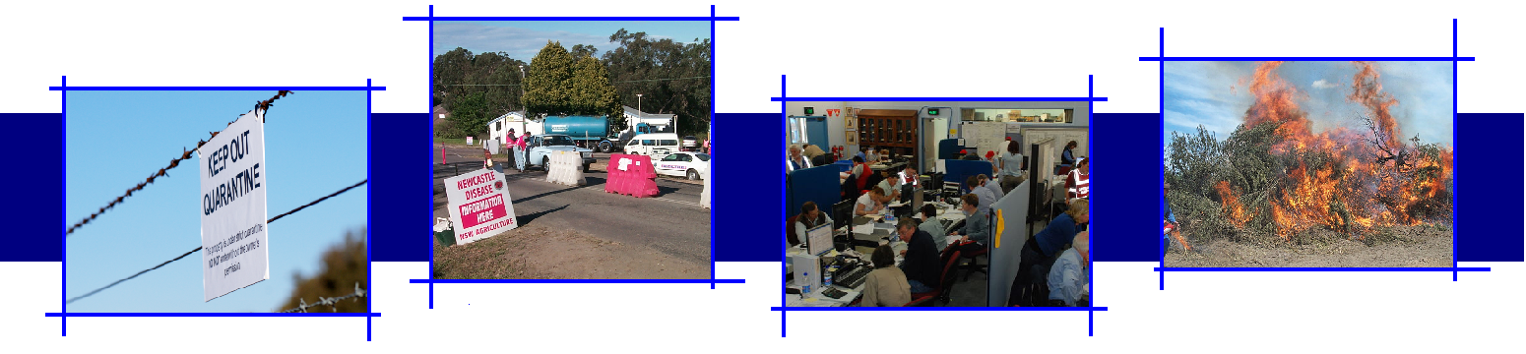

Version Control
Version | Date of issue | Author | Comments
V1.0 | 29/10/2012 | BEPWG – BIMS Working Group | National Biosecurity Committee endorsed version
Biosecurity Emergency Preparedness Working Group
BEPWG@daff.gov.au
C/- Australian Government Department of Agriculture, Fisheries and Forestry
PO Box 858
Canberra ACT 2600
Cover: photographs courtesy of New South Wales Department of Primary Industry and Fisheries and Australian Government Department of Agriculture, Fisheries and Forestry.

ACKNOWLEDGEMENTS
Significant contributions have been made by organisations in the development of the Biosecurity Incident Management System. The Biosecurity Emergency Preparedness Working Group would like to acknowledge the following:
Australian Government Department of Agriculture, Fisheries and Forestry
Department of Primary Industries and Water, Tasmania
Turning Point Crisis Management
Animal Health Australia
Biosecurity Queensland
Primary Industries and Resources, South Australia

CONTENTS
INTRODUCTION 7
1.1 Authority 7
1.2 Purpose 7
1.3 Scope and Application 8
1.4 Existing Incident Management Arrangements 8
1.5 Review 9
CONTEXT 11
2.1 Biosecurity Incidents 11
2.2 Preparing for Biosecurity Incidents 12
2.3 Managing Response to Biosecurity Incidents 12
2.4 Phases of a Biosecurity Response 14
2.5 Application of the Biosecurity Incident Management System 16
2.6 Classification of Biosecurity Incidents 20
THE BIOSECURITY INCIDENT MANAGEMENT SYSTEM 25
3.1 Features of the Biosecurity Incident Management System 25
3.2 Incident Management Principles 28
3.3 The Incident Management Team 31
Glossary 47
Appendices 51
Appendix 1: Associated National Documents 53
Appendix 2: Relief and Recovery Roles in a Biosecurity Response Context 57

This page has been left blank
Biosecurity Incident Management System

INTRODUCTION

1.1 Authority
This document has been prepared by a working group, established by the Biosecurity Emergency Preparedness Working Group and endorsed by the National Biosecurity Committee, 29 October 2012.

1.2 Purpose
The purpose of this document is to provide guidance in contemporary practices for the management of biosecurity incident response and initial recovery operations in Australia.
The Biosecurity Incident Management System is a uniform approach for managing the response to biosecurity incidents and can be applied to all biosecurity sectors. It is based on established incident management systems, which are widely recognised and used throughout Australia.
The development and articulation of the Biosecurity Incident Management System is directly linked to the Inter-governmental Agreement on Biosecurity (IGAB), Schedule 7 outcome of:
‘An enhanced level of preparedness and consistent response arrangements across jurisdictions to assist in the effective and timely management of biosecurity incidents and emergencies.’
Further, the Biosecurity Incident Management System contributes significantly towards achieving one of the priority reform areas of IGAB Schedule 7, namely:
‘Maintain clearly defined and consistent emergency response arrangements that are recognised and practiced by all jurisdictions across each level of government.’
Adoption of the Biosecurity Incident Management System will lead to efficiencies in preparedness activities, such as planning, training, exercising, as well as enhancing the existing pool of human resources available from other agencies that may be able to assist in emergency responses.

1.3 Scope and Application
The scope of this document is primarily focused at using the Biosecurity Incident Management System for managing the response to (which includes initial recovery from) biosecurity incidents.

The Biosecurity Incident Management System is an ‘all hazards’ approach, which:
- represents the most contemporary approach to incident management.
- co-exists with and complements current, sector specific and jurisdictional response arrangements
- is contextualised to a biosecurity environment
- can be applied to all biosecurity incidents, irrespective of sector or scale of response
- provides a guide for personnel working within operations centres established at national, state/territory, local and field levels
- is consistent with contemporary incident management systems employed by other emergency response agencies across Australia and in other countries, including:
- Australasian Inter Services Incident Management System (AIIMS)
- Australia Emergency Coordination System (AECS)
- Critical Incident Management System (CIMS) – NZ
- National Incident Management System (NIMS) – US.

1.4 Existing Incident Management Arrangements
A range of state, territory and Commonwealth legislation, as well as sector-specific policy and plans may be relevant in a biosecurity response, with applicability dependent upon the nature of the incident. Legislation may impose certain obligations and/or provide powers enabling certain response actions. The Biosecurity Incident Management System is intended to complement these established arrangements.
An illustration of the documentation framework, applicable in biosecurity responses is at Figure 01.
Details of the relevant national documents referred to in Figure 01 are provided at Appendix 1.

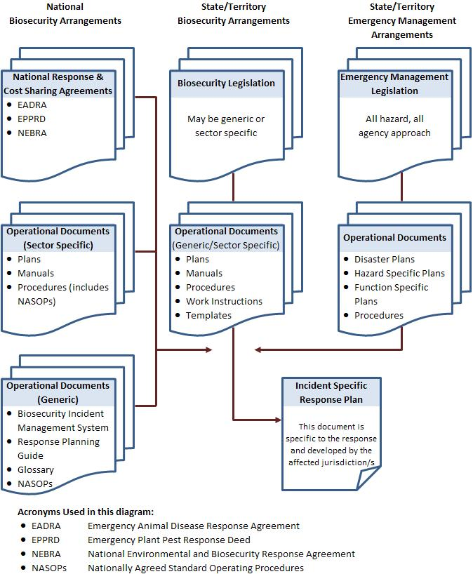

Figure 01. Documentation framework applicable to biosecurity responses

1.5 Review
This document will be reviewed regularly by the Biosecurity Emergency Preparedness Working Group.

This page has been left blank

Biosecurity Incident Management System

CONTEXT

2.1 Biosecurity Incidents
Biosecurity is defined as ‘mitigating the risks and impacts to the economy, the environment, social amenity or human health associated with pests and diseases’ entering, emerging, establishing or spreading. Biosecurity incidents therefore are ‘events which increase the likelihood of biosecurity risks being realised’.
Biosecurity incidents range in impact and duration. More severe incidents can have significant impacts on the economy, environment and/or affected communities, and take several months to resolve.
Biosecurity is generally managed within the appropriate biosecurity sectors, namely:
- animal health (terrestrial and aquatic)
- plant health
- introduced marine pests
- vertebrate pests
- weeds
- environmental pests and disease.
Typically, states and territories have primary responsibility for preparing for and responding to biosecurity incidents within their borders. The Australian Government also has a role in providing national leadership and coordination in preparing for and responding to biosecurity incidents.
A unique feature of biosecurity emergency management is that potentially affected industries play a significant role in preparing for and responding to biosecurity incidents. To this extent industry bodies have committed to support preparedness and response to incidents through maintaining national plans and sector specific response agreements.

2.2 Preparing for Biosecurity Incidents
Preparing for biosecurity incidents includes developing arrangements to ensure that, should a pest or disease outbreak occur, all those resources and services needed to respond can be efficiently mobilised and deployed. Typical preparedness activities include:
- identifying and assessing the risk
- developing policy, arrangements and plans
- establishing resources, systems and processes
- training response personnel and educating stakeholders and potentially affected industries and communities
- conducting exercises
- evaluating preparedness and response activities.

2.3 Managing Response to Biosecurity Incidents
When detected, the usual response to biosecurity incidents is to firstly contain and then eradicate the causative agent or species. This may include surveillance to determine the extent of the problem and likely success of any eradication program, followed by further surveillance, to ensure return to a pest/disease free status has been achieved.
The response to any biosecurity incident will necessitate the establishment of an organisational structure, specific to the management of that incident. This structure will have two functions:
- provision of strategic policy and direction, and
- planning and implementation of operational activities.
2.3.1 Strategic policy and direction
The initial report of the occurrence of a suspected pest or disease will be received by the relevant chief technical officer (i.e. Chief Veterinary Officer or Chief Plant Protection Officer or equivalent) within a jurisdiction. In consultation with senior management of the responsible state/territory agency, the jurisdiction’s strategic intentions will be formulated.
Early notification will also be made to the relevant national principal specialist (i.e. Australian Chief Veterinary Officer or Australian Chief Plant Protection Officer or equivalent), who may convene the relevant national consultative committee to provide technical assessment of the proposed response. That incident specific national consultative committee will in turn advise the national management group on how the biosecurity incident should be managed.
Typically the chief technical officers (i.e. Chief Veterinary Officer or Chief Plant Health Officer or equivalent) from each state, territory and Australian Government, together with representatives from affected industries will form the membership of the relevant consultative committee. (This membership may vary slightly under the different sectoral response arrangements, which are detailed in the respective national response agreements)
The national management group, established for an incident, will be made up of the heads of agency of the relevant state, territory and Australian Government agencies, together with representation from industry bodies that are contributing financially towards the cost of the response to the particular incident.
Further information on national consultative committees and national management groups can be found in the relevant national agreements:
- Emergency Animal Disease Response Agreement
- Emergency Plant Pest Response Deed
- National Environmental and Biosecurity Response Agreement.
Where the response to a biosecurity incident does not warrant the establishment of a national consultative committee or national management group, strategic policy and direction for the management of the response to an incident is provided by the affected jurisdiction’s agency executive.
2.3.2 Operational policy and implementation
Operational policy and implementation is coordinated through the establishment of operations centres at levels appropriate for the particular incident. The key consideration is that the management of activities and relevant decisions are made at the lowest practical level.
In the case of a biosecurity incident of national significance, the response will require a coordinated approach, across multiple government agencies and affected industries. Consequently, response activities will occur and be managed at multiple levels, these may include:
- national
- state/territory
- local
- field.
These levels and their respective responsibilities are further described in section 2.5.1.

2.4 Phases of a Biosecurity Response
The response to a biosecurity incident can be broken down into three phases: the investigation and alert phase, the operational phase and the stand-down phase.
2.4.1 Investigation and alert phase
The investigation and alert phase begins when a notifying party declares that, based on an initial analysis of the pest or disease, an outbreak of a pest or disease exists or has the potential to exist. The investigation and alert phase exists while accurate confirmation of the diagnosis is made and the likely extent of the pest or disease outbreak is scoped. If requested, a response plan is prepared by the affected jurisdiction/s.
During the investigation and alert phase:
- investigation and related activities are usually managed using ‘normal business’ arrangements, with staff and operations centre/s being placed on standby in anticipation of initiating an operational response
- a national consultative committee may be established
- a national management group may be established.
NOTE: Specific actions taken by national consultative committees and national management groups during the investigation and alert phase are described in national response agreement/s and supporting documentation.
2.4.2 Operational phase
The operational phase commences when the presence of the pest or disease is confirmed and activities under a response plan are implemented. Typically the aim of the operational phase is to contain and/or eradicate the pest or disease.
During the Operational Phase:
- operations centres will be established at the appropriate levels (i.e. national, state and/or local), to manage strategic and operational aspects of the response.
- a national consultative committee may be established
- a national management group may be established.
NOTE: Specific actions taken by appropriate national consultative committees and national management groups during the operational phase are described in national response agreement/s and supporting documentation.
Upon initial containment or eradication of the pest or disease, further work may be required to determine proof of freedom. Proof of freedom may include a period of research and/or surveillance activities and will end when the national management group determines (on advice from the national consultative committee) that the response has been effective.
If it is determined that the pest or disease cannot be eradicated a transition to managing the pest or disease outbreak may take place. This would occur outside the current national cost sharing agreements.
    - Stand-down phase
The stand-down phase commences when:
- the investigation and alert phase fails to confirm the presence of a pest or disease, or
- the response strategy has been effective, or
- eradication of a pest or disease is not considered feasible, cost effective or beneficial, or
- the relevant national management group formally declares that the pest or disease outbreak is over.
During the stand-down phase:
- operations centres will:
  - develop and implement an on-going management program, if required
  - recover, decommission and dispose of stores and equipment
  - arrange appropriate archiving of all records
  - finalise accounts
  - conduct debriefings and record all learnings
  - develop an action plan to address learnings.
- the national consultative committee, if established for the response, will conclude its activities and stand down
- the national management group, if established for the response, will conclude its activities and stand down.
NOTE: Specific actions taken by national consultative committees and national management groups during the stand down phase are described in national response agreement/s and supporting documentation.
2.4.4 Relief and recovery
Recovery is the coordinated process of supporting emergency-affected individuals and communities in the reconstruction of the physical infrastructure and restoration of emotional, social, economic and physical well-being and the environment. In relation to biosecurity emergencies, restoration of environmental values may be of particular concern and a significant component of the recovery effort.
Relief and recovery is likely to include coordination of support and the provision of information to affected communities to mitigate the impacts of a pest or disease.
Appendix 2 provides guidance on relief and recovery roles in the context of biosecurity incidents.

2.5 Application of the Biosecurity Incident Management System
The Biosecurity Incident Management System has application at the national, state/territory, local and field levels. While it is acknowledged that the focus and structure will be different at each of these levels the key principles that underpin the Biosecurity Incident Management System are equally applicable to each.
The Biosecurity Incident Management System is reliant on interaction with broader biosecurity response arrangements, including national consultative committees and national management groups, as well as interaction with the whole of government emergency management arrangements. The relationship that exists between the national consultative committees, national management groups and the operational aspects of the Biosecurity Incident Management System are illustrated in Figure 02.
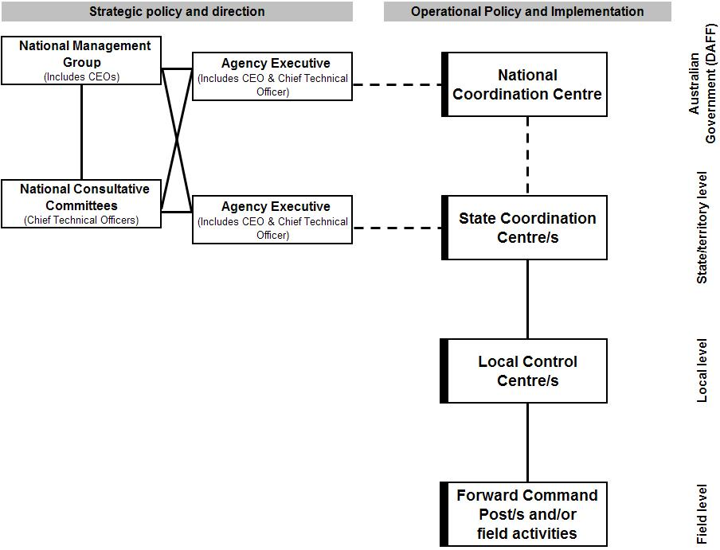

Figure 02. Responding to biosecurity incidents
This diagram recognises that the ‘Agency Executive’ has an integral role in the management of a biosecurity incident and they form a vital link between their jurisdiction and the national aspects of the response. In this role the Agency Executive have responsibility for the higher level policy direction, that is put into effect through national, state, local and field level activities.
This Biosecurity Incident Management System also recognises that state, territory and national emergency management arrangements apply (or have relevance) to biosecurity incidents. In cases where an effective response requires resources beyond the capacity of the state/territory biosecurity agency additional resources will be sought in accordance with state/territory whole-of-government and/or national arrangements. This requires effective liaison with the relevant state/territory emergency management agency.
2.5.1 Responsibilities at national, state/territory, local and field levels
The way in which the Biosecurity Incident Management System is implemented and relevant responsibilities at the national, state/territory, local and field levels are described below.
National responsibilities
The Australian Government Department of Agriculture Fisheries and Forestry has developed arrangements for managing its responsibilities during the response to biosecurity incidents. These arrangements include an Incident Management Framework which is consistent with the Biosecurity Incident Management System and complementary to arrangements described in sector specific arrangements, such as AUSVETPLAN, PLANTPLAN etc.
When established, the centre from which the Australian Government Department of Agriculture, Fisheries and Forestry manages its responsibilities is known as the National Coordination Centre.
The Australian Government Department of Sustainability, Environment, Water People and Communities has arrangements in place to manage its statutory responsibilities during the response
In applying these arrangements the responsible Australian Government agency ensures a nationally coordinated and consistent approach to the management of biosecurity incidents.
In some circumstances the Australian Government may have responsibility for the overall control of response activities, however these situations are rare and usually occur where there is little or no state/territory involvement in the response (such as Commonwealth land or off-shore incidents).

State/territory responsibilities
During the response to a biosecurity incident, the affected state/territory biosecurity agency will manage its responsibilities in accordance with the relevant national, state and/or territory biosecurity arrangements and state/territory emergency management arrangements. This may include the establishment of a State Coordination Centre.
When established, the State Coordination Centre will have primary responsibility for the coordination of activities across the state and generally should not become involved in the management of on ground activities. In some circumstances it may be appropriate to combine state and local operations in one centre. If this occurs staff need to be able to separate strategic, state wide activities, from operational activities, being conducted at a local or field level.
Local responsibilities
During the response to a biosecurity incident, the responsible state/territory biosecurity agency may choose to establish Local Control Centres to manage certain operational aspects of the response.
When established, the Local Control Centre will have primary responsibility for planning, conducting and supporting all operational activities in its geographical area of responsibility.
Depending on the complexity or extent of the response it may be necessary to establish more than one Local Control Centre. In any case the focus of each Local Control Centre’s activities will be guided by the objectives established at the state level. The Local Control Centre’s Incident Management Team will identify what needs to be achieved by the Local Control Centre, how this will be achieved and allocate responsibilities. These arrangements will normally be documented in an Incident Action Plan which is approved by the Incident Manager at the local level and disseminated (either in writing or verbally) to those with responsibility for implementing activities.
At the local level all major incident management functions will normally be applied, namely Incident Management, Operations, Planning, Public Information, Logistics and Finance and Administration.
In the case of a level one or level two incident (as described in section 2.6 Classification of Incidents), the Local Control Centre may be the highest level of control applied to the response. In this case the state/territory’s Agency Executive will provide the required policy and strategic direction for the management of the incident.

Field responsibilities
At this level, teams will be deployed by the Local Control Centre to undertake tasks in the field including:
      - investigation – sample collection to enable diagnosis or identification of a pest or disease and/or surveillance tasks to determine the extent of a pest or disease spread
      - area movement and security – enforcement of quarantine, possibly including checkpoint operations
      - infected/infested premises operations – tasks associated with managing containment and treatment or eradication of a pest or disease at an infected/infested property or place.
If required, one or more Forward Command Posts may be established to manage field activities in a finite geographic location with a focus on achieving an identified task or range of tasks, allocated by higher level command.
Reasons for establishing a Forward Command Post include to:
- Manage activities associated with a number of premises in a small geographic area.
- Act as an assembly point for activities associated with remotely located premises.
- Manage specific operational tasks that need to be undertaken within a specified area, such as vaccination, trapping, aerial spraying etc.
When established the Forward Command Post/s will report directly to the Operations Manager in the Local Control Centre.

2.6 Classification of Biosecurity Incidents
Not all incidents and responses are the same. Therefore there is a need to identify and communicate the classification or level of incident, to ensure that the appropriate level of coordination, resources and support are provided in order to achieve a successful resolution. The following provides guidance on the levels of incident response and their application.
2.6.1 Level one incident
A level one incident is a localised response, being managed by local resources with little or no external support. Facilities for managing the response are small scale.
Examples of organisational structures that may be applicable to a level one incident are illustrated in Figures 03, 04 and 05 below.
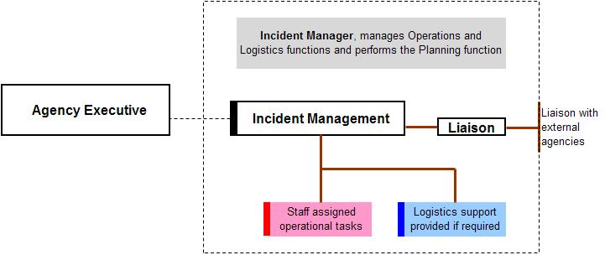

Figure 03. Example of possible level 1 incident organisational structure
NOTE: In this example:
- the Incident Manager manages all functions
- the Agency Executive provides appropriate strategic policy and direction.
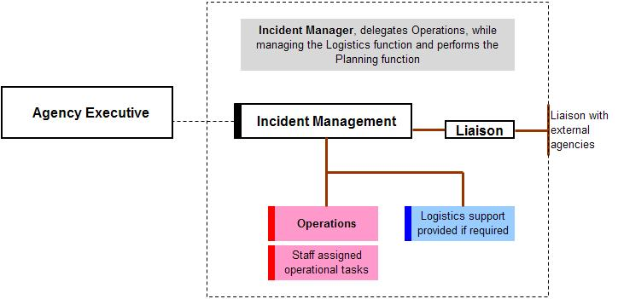

Figure 04. Example of possible level 1 incident organisational structure
NOTE: In this example:
- the Incident Manager delegates the Operations function, while managing the Logistics function and performing the Planning function
- the Agency Executive provides appropriate strategic policy and direction.
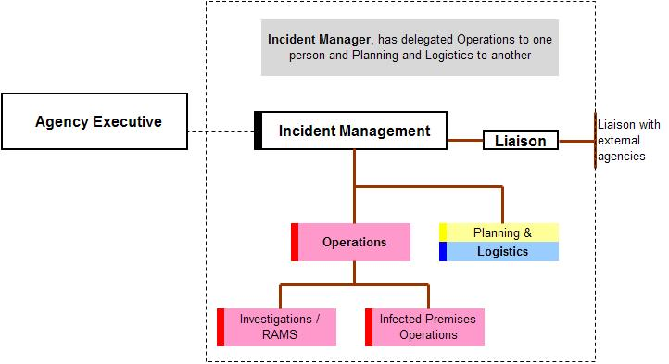

Figure 05. Example of possible level 1 incident organisational structure
NOTE: In this example:
- the Incident Manager has delegated the Operations function to one person and the Planning and Logistics functions to another
- the Agency Executive provides appropriate strategic policy and direction.
In these three examples, all activities are managed by the Incident Manager, utilising the organisations’ normal facilities and infrastructure, without the need for the establishment of a dedicated State Coordination Centre.
2.6.2 Level two incident
A level two incident is a local or regional response, being managed primarily at the local level, with some support being coordinated by the state. A dedicated Local Control Centre and perhaps small scale State Coordination Centre may be required to manage the response.
An example of the organisational structure that may be applicable to a level two incident is illustrated in Figures 06 below.

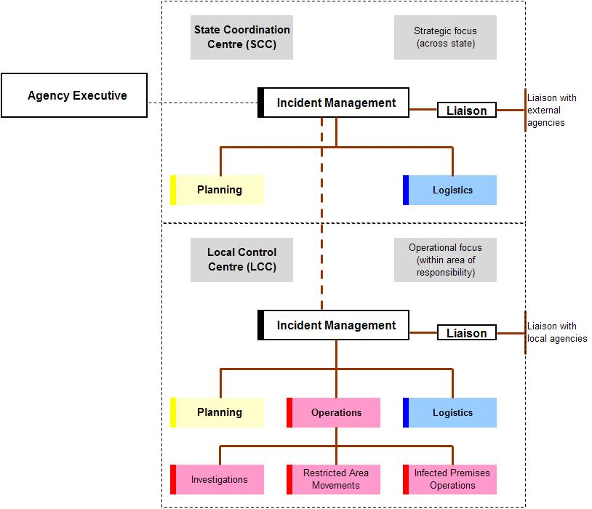

Figure 06. Example of possible level 2 incident organisational structure
NOTE: In this example:
- a Local Control Centre has been established, in which the Incident Manager has delegated the Operations, Logistics and Planning functions
- the Local Control Centre manages all activities within its (geographic) area of responsibility
- a small State Coordination Centre has been established from which strategic planning is undertaken and some logistical support coordinated
- the Agency Executive provides strategic policy and direction to the Incident Manager, within the State Coordination Centre.
- a strong link exists between state and local levels to ensure operational activities are managed in line with the strategic policy and direction.
2.6.3 Level three incident
A level three incident is a state wide response, being managed primarily at a state/territory level. This may include the establishment of one or more Local Control Centres and a fully operational State Coordination Centre. Some resource support may be provided from outside the responsible agency or state.
An example of the organisational structure that may be applicable to a level three incident is illustrated in Figure 07 below.

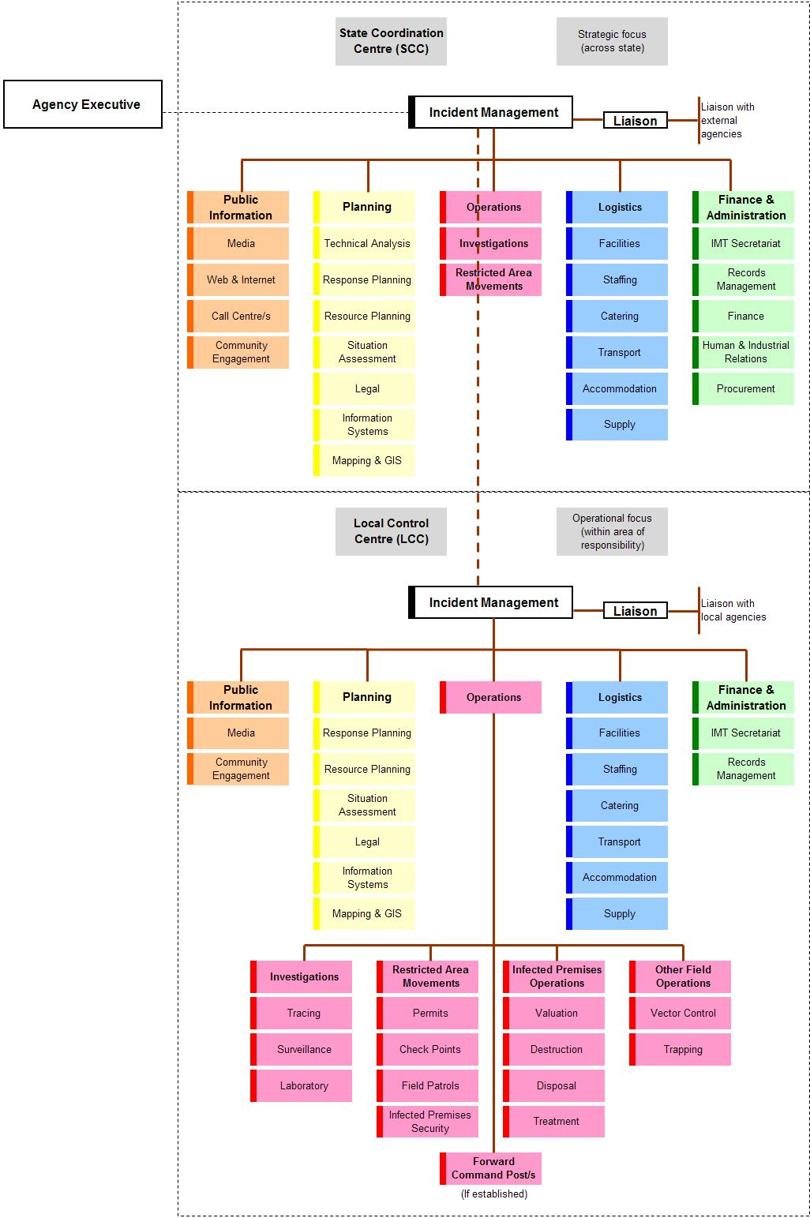

Figure 07: Example of possible level 3 incident organisational structure
In this example some operations functions have been identified at a state level. This would only occur if the State Coordination Centre has taken responsibility for operational activities outside the Local Control Centre/s area/s of responsibility.

2.6.4 Level four incident
A level four incident is where one or more jurisdictions are involved in managing the response to a biosecurity incident. One or more of the involved jurisdiction’s resources or established arrangements are insufficient for the response and the National Coordination Centre is required to coordinate nationally available support to the affected jurisdiction/s.
2.6.5 Level five incident
A level five incident is where one or more jurisdictions are involved in managing the response to a biosecurity incident. The national resources are insufficient for the response and the National Coordination Centre is required to coordinate international support to affected jurisdiction/s.
NOTE: Irrespective of the level of incident response within a jurisdiction the National Coordination Centre may be operating to deal with national issues, such as quarantine and/or international trade issues, which have little or no immediate impact on the level of response applied by a state/territory.

Biosecurity Incident Management System

THE BIOSECURITY INCIDENT MANAGEMENT SYSTEM
The initial response to any incident or emergency is usually reactive in nature, in that available resources are dispatched to the site of an incident and upon arrival, decisions are made as to how resources are employed and actions are adjusted based on available resources and immediate operational needs.
Incident management, through the response planning process will move the initial reactive response to a well planned, proactive operation that allocates incident resources to meet the response aim and objectives and allows for continual assessment of progress towards resolving the incident.

3.1 Features of the Biosecurity Incident Management System
The Biosecurity Incident Management System forms the basis for a consistent and effective management framework for all biosecurity incidents. It provides:
- flexibility
- scalability
- common terminology.
3.1.1 Flexibility
The organisational structure required to manage any given incident is based upon the nature and scope of that particular incident. If one individual can manage all major functional areas simultaneously, no further organisation is necessary. If, due to the scale or workload of the response, one or more of the functional areas requires its own management structure, staff will be identified to be responsible for a particular area.
Within the Biosecurity Incident Management System the first functional management assignments will be made by the relevant Incident Manager. These assignments may be made in the order of Operations, Logistics, Planning, Public Information and finally Finance and Administration. This is not a set rule and the needs of the incident may mean that a different order is applied.
3.1.2 Scalability
The organisational structure required to manage an incident is developed in a modular fashion and is based on the operational needs of the particular incident. The organisational structure can be scaled up and down as the incident progresses and the operational tempo varies.
In response to level one or level two incidents the organisational structure may be small and compact, and operating only at a single local level, within one jurisdiction. In response to level three or higher incidents it may be necessary to establish response structures at multiple local and state locations, as well as at a national level.
3.1.3 Common terminology
In order for the Biosecurity Incident Management System to be effective across sectors and in different levels of incident response, including multi-jurisdictional or national incidents, common terminology must be applied to organisational elements, position titles, resources, facilities, etc.
Throughout this document, terminology that is consistent with other incident management systems has been applied and should be incorporated into the management of biosecurity incidents. Some examples include:
- command, control and coordination
- strategic, operational and tactical planning.
These terms and their application in a biosecurity context are:
Command relates to the internal direction of the members and resources of an organisation in the performance of the organisation’s roles and tasks. Authority to command is established in legislation or by agreement with an organisation. Command relates to organisations and operates vertically within an organisation.
Control is the overall direction of activities in an emergency situation. Authority for control is established in legislation or in an emergency plan and carries with it the responsibility for tasking other organisations in accordance with the needs of the situation. Control relates to situations and operates horizontally across organisations.
Coordination is the bringing together of organisations and elements to ensure an effective response, primarily concerned with the systematic acquisition and application of resources (organisation, human and equipment) in accordance with the requirements imposed by the threat or impact of an emergency. Coordination relates primarily to resources and operates vertically within an organisation, as a function of the authority to command, and horizontally across organisations, as a function of the authority to control.
Strategic planning refers to the practice and science of employing a national, state and/or territory capacity to resolve the incident. Strategic planning will inform operational planning by establishing strategic objectives. It is generally of a long term nature and is mindful of the impact that other factors may have on achieving the overall response objectives.
Operational planning refers to the planning and conduct of response activities. It is at this level that strategy is implemented by assigning activities, tasks and resources to the response. Operational planning will focus, in detail, on the upcoming operational period, however will be mindful of the planning requirements for subsequent operational periods.
Tactical planning refers to the planning and conduct of on-ground activities and is characterised by the application of resources and actions to achieve a specific objective. Tactical planning will focus on the duration of the task at hand and is undertaken within individual task teams.

3.2 Incident Management Principles
The Biosecurity Incident Management System is underpinned by three key principles:
- Response to incidents is managed through setting, communicating and achieving objectives (Management by objectives).
- A response framework is established that is based around the functions that need to be performed (Functional approach).
- The number of people or groups being supervised by each person involved in the response is limited to a workable number (Span of control).
3.2.1 Management by objectives is a management style where the Incident Manager, under the direction of the responsible agency’s executive and in consultation with the Incident Management Team, determines how the desired outcomes will be achieved. These outcomes, or objectives, are then communicated, through the chain of command, to everyone involved so they know and understand the direction being taken during the response operation.
In biosecurity incidents, response policy and strategic direction is often provided by the responsible agency’s executive, who have responsibility for negotiating and determining an agreed national approach to a biosecurity incident, through the relevant national consultative committees and national management groups. These response policies and strategic directions are communicated to Incident Manager/s who have responsibility for developing and implementing an operational response to the incident. This will include the development and communication of response objectives, which may be identified at the national, state/territory and local levels. In any case, objectives need to be consistent with those set at the higher level.
The overall aim, objectives and response strategies are documented in a strategic, incident specific response plan. These higher level objectives are interpreted at each level of the response and appropriate operational objectives developed at each level. These operational objectives and how they are to be achieved should be articulated in an Incident Action Plan. The level of detail included in Incident Action Plans will vary depending on the level at which they are being developed and applied.

3.2.2 Functional approach means the use of specific functions to manage the response to an incident. Although these functions are consistent through national, state/territory and local levels of response, their application at each of these levels may vary, depending on the objectives being set for the level at which they are being applied. The Biosecurity Incident Management System uses the following six functions:
Incident Management  (Incident management can be applied in the form of command, control and/or coordination) | The overall management of activities associated with an operations centre, site or geographic location, necessary for the response to an incident.  The area or responsibilities being managed must be clearly defined to ensure that there is no encroachment on other’s area of responsibility.
Operations | The tasking and application of resources required to respond to the incident in order to achieve the operational objectives set by the Incident Management function.
Planning | The collection, collation, analysis (or interpretation) and dissemination of information. It also includes the development of the written plans required for the response to the incident.
Public Information | Sometimes referred to as public relations, is the management of public information and perceptions.  This function is primarily responsible for interfacing with the public and media with incident related information requirements
Logistics | The acquisition and provision of human and physical resources, facilities, services and materials required to support achievement of the objectives set by the Incident Management function.
Finance and Administration | The management of records and information flow required to ensure the smooth and efficient running of an operations centre. It may also include the administration of finance, human resource and/or procurement processes associated with the response.

In addition to these functions, the function of Liaison may be included in the framework. The Liaison function acts as the point of contact for communication and coordination between the Incident Management function and external agencies and organisations.
It is normal for external organisations to provide a Liaison Officer to represent their organisation, with authority, and to work within an operations centre.
Where external resources are employed within the incident management framework, they work as part of the identified function. For example an emergency service organisation may be employed to perform an operational function, in which case they would work within the Operations section, of the operations centre.
An Incident Manager is responsible and accountable for the functions mentioned above. Depending on the size and complexity of the incident, an Incident Manager may elect to delegate one or more of these functions.
The following diagram illustrates the relationship that exists between the major functions described above.
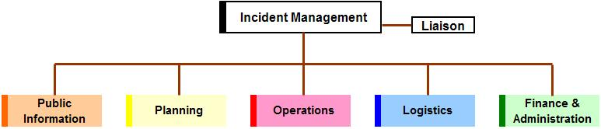

Figure 08. Incident management functions
3.2.3 Span of control relates to the number of groups or individuals which can be successfully supervised by one person. Where span of control is exceeded, the supervising officer should consider delegating responsibilities to others. Conversely, where the span of control is lower or tasks are fewer (for example in a de-escalating incident) the supervisor may resume responsibility or reorganise delegation to contract the structure to fit the tasks required.
During the response to biosecurity incidents, the environment in which supervision is required can rapidly change and become detrimental if not managed effectively. Under span of control, up to five reporting groups or individuals is considered to be desirable, as this maintains a supervisor’s ability to effectively task, monitor and evaluate performance.

3.3 The Incident Management Team
The Incident Management Team is established by the Incident Manager. The Incident Management Team works from its designated operations centre in order to achieve the objectives established for that centre.
Staff performing incident management functions should have the appropriate skills, knowledge and experience. Where this is not possible, appropriate training, coaching and/or mentoring should be provided until such time that staff are comfortable with the function/s for which they have responsibility.
The Incident Manager is responsible for identifying the staff required to perform the incident management functions. The Incident Manager may choose to undertake all functions or delegate them to other staff. As a response matures it is likely that the number of staff performing various functions will change.
The Incident Manager may choose to appoint staff to defined functions, or appoint staff to work within a section of the response, in which case the section manager will have responsibility for identifying the functions being performed by staff. The first approach provides certainty to staff about duties however can be inflexible, where-as the later approach provides more scope for flexibility and may rely on staff being multi-skilled across a range of functional roles.
The following diagram identifies the range of functions that may need to be established and their relationship to each other.
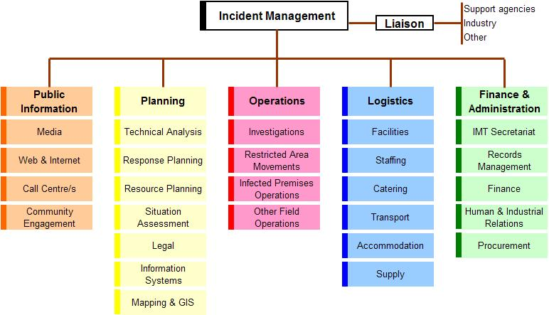
Figure 09. Incident management framework
Note: In this diagram, functions within the outlined boxes may be combined (e.g. in a Local Control Centre the Logistics function may combine with the Finance and Administration function to work as one section).
3.3.1 Incident Management Function
The Incident Management function is responsible for the overall management of activities within a particular geographic area of responsibility.
At a local level, this could apply to the ‘control’ or ‘restricted area’ assigned as the responsibility of a particular centre and only in relation to activities that have been assigned as the responsibility of that centre.
At a state level, this could apply to the activities across the state, however it is recognised that at a state and national level this function is more about coordination of support services and resources, rather than actually controlling activities.
In small scale incidents the incident management function may be performed by one person (i.e. the Incident Manager), however in larger scale or complex incidents it may be necessary to use a small team of people to perform this function. The following diagram illustrates roles that may need to be considered within the Incident Management function.
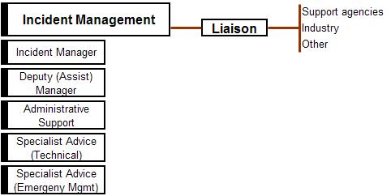
Figure 10. Incident Management function
Incident Manager
This role is the focal point for the management of all activities, within the operations centre’s area of responsibility. Specific responsibilities may include:
- appoint staff to perform functions within the Incident Management Team
- oversee activities performed by the relevant Incident Management Team
- ensure response activities are conducted in accordance with jurisdictional legislation and nationally agreed response arrangements
- report to the agency’s executive (through appropriate chain of command) on implementation and progress of planned response activities
- liaise with support agencies, industry and other organisations, through their designated Liaison Officer/s
- ensure a safe work environment is established and maintained. If necessary Safety Officer/s can be appointed who work across all functional areas of the organisation.
Deputy (or Assistant) Incident Manager
This role assists the Incident Manager to undertake specific responsibilities. Depending on the complexity of the incident it may be necessary to appoint more than one Deputy Incident Manager. When appointed this role may:
- relieve or stand in for the Incident Manager during periods of absence
- be assigned oversight responsibilities for specific functions within the response.
Administrative (or Executive) Support
This role provides administrative support to the Incident Manager. Specific responsibilities may include:
- coordinate routine correspondence and communication (verbal and electronic) on behalf of the Incident Manager
- manage the Incident Manager’s diaries and appointments
- other duties directed by the Incident Manager.
Specialist Advice (Technical)
This role provides guidance and advice to the Incident Manager on technical issues associated with the response. This may be performed by an individual specialist or may include the establishment of expert working groups to consider and advise on specific issues of a technical nature.
Specialist Advice (Emergency Management)
This role provides guidance and advice to the Incident Manager on emergency management policy, procedures and processes, including the implementation and application of the Biosecurity Incident Management System to the specific incident.
Liaison Function
The Liaison function creates the link between the Incident Management function and external agencies and organisations.
In a small scale response this function may be undertaken by the Incident Manager or Deputy Incident Manager. However in a large scale response it may be necessary to appoint dedicated staff to manage this function.
Using this approach means that external agencies and organisations are required to provide Liaison Officers who work through the Liaison function.
When appointed, agency or organisation Liaison Officers should come with:
- the ability to communicate with their own agency or organisation (i.e. radio, telephone, internet etc), and
- the authority to make decisions and commit resources on behalf of their agency or organisation.
In addition, Liaison Officers may need to perform a function within the Incident Management Team, that is relevant to their agency or organisation’s area of responsibility. For example a Liaison Officer, representing an affected industry, may need to assist with aspects of Community Engagement (within the Public Information section) and/or Situation Assessment (within the Planning section). In such an example one person can ‘wear many hats’ and needs to be mindful of the separation that exists between the functions and their specific responsibilities at a point in time.

3.3.2 Operations Function
The Operations function is responsible for the tasking and application of resources required to respond to the incident, in order to achieve the operational objectives set by the Incident Management function. The Operations function is responsible for monitoring and managing operational performance against the set objectives.
As the operational objectives will vary from one centre to the next, the composition of the Operations function will vary based on these objectives. For example a Local Control Centre’s objectives may be focused on surveillance and investigation of a pest or disease within a defined area, while at the National Coordination Centre’s objectives may be more focused on maintaining international markets and Australia’s favourable trade position.
The Operations function may be established within Local Control Centres, State Coordination Centres and/or the National Coordination Centre. Depending upon the size and complexity of the response, it may be necessary to establish several units to manage the range of operations activities for the incident. Where operational activities are focused on containment, treatment and or eradication of a pest or disease it is typical to establish the following:
- Investigations unit
- Restricted Area Movements unit
- Infected/Infested Premises Operations unit
- Other Field Operations unit
- Forward Command Posts.
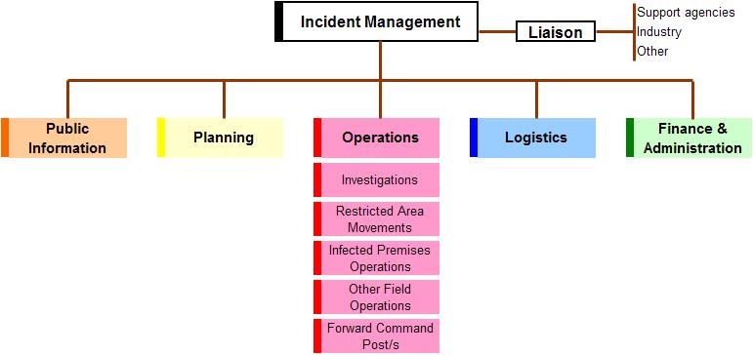
Figure 11. Operations function

Investigations is responsible for tracing, surveillance and sampling activities within the operations centre’s area of responsibility. These actions are focused on identifying the source and spread of the identified pest or disease and, where appropriate, proving freedom from the pest or disease.
In some cases it may be necessary to establish specific units to deal with:
- Tracing
- Surveillance
- Laboratory.
Restricted Area Movements is responsible for establishing control over the movement of animals, animal products, plants, plant products, vehicles, other things and people into, within and out of the restricted area/s, in order to limit the spread of the pest or disease.
In some cases it may be necessary to establish specific units to deal with:
- Permits
- Check Points
- Field Patrols
- Infected/Infested Premises Security.
Infected/Infested Premises Operations is responsible for all activities on infected/infested and dangerous contact premises, in order to contain and eradicate the pest or disease.
In some cases it may be necessary to establish specific units to deal with:
- Valuation
- Destruction
- Disposal
- Treatment (i.e. decontamination, disinfection, disinsection etc).
Other Field Operations may include, but are not limited to:
- Vector Control
- Trapping
- Vaccination
- Wild Animal Control.
Forward Command Post/s
The Operations function within a Local Control Centre has responsibility for the establishment and management of Forward Command Posts. If established, Forward Command Posts will report directly to the manager of the Operations function

Staff appointed to manage the Operations function will:
- interact with the Planning function to develop the operations portions of any plans (e.g. at a local level this may include the development of Incident Action Plans)
- request resources needed to implement planned operational activities
- supervise implementation of the planned operational activities.
The following diagram illustrates the expansion of the Operations function into the various units that may need to be considered, within a Local Control Centre, where operational activities will be the focus of the centre’s activities.
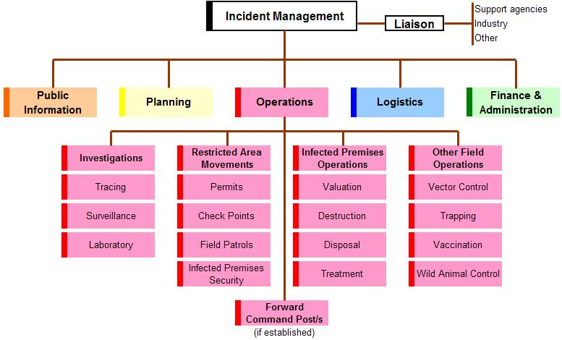
Figure 12. Operations function within a Local Control Centre
NOTE: The above diagram indicates the establishment of Forward Command Post/s. This may not always be required and can be omitted from the diagram.
In some cases the Operations function within a Local Control Centre may also have responsibility for air and/or water activities, in which case appropriately titled units may need to be established to manage these activities.

3.3.3 Planning Function
The Planning function is responsible for the collection, collation, analysis (or interpretation) and dissemination of information. It also includes the development of written plans for the response to the incident. The Planning function acts as an information centre, by providing information that contributes to the situational awareness of all staff involved in the response.
The Planning function may be established within Local Control Centres, State Coordination Centres and/or the National Coordination Centre. Depending upon the size and complexity of the response, it may be necessary to establish several units to manage the range of planning activities for the incident. These could include:
- Technical Analysis
- Response Planning
- Resource Planning
- Situation and Assessment
- Legal
- Information Systems
- Mapping and GIS
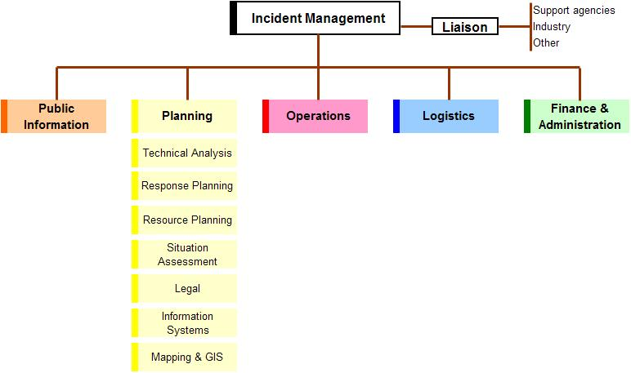
Figure 13. Planning function
Technical Analysis provides specialised knowledge and experience that may be necessary to support response activities.
This function collects technical data about the incident and undertakes analysis to anticipate rates of spread, impact etc, and predict the escalation or de-escalation of an incident. This may include the epidemiology and/or pathology of an incident.
The outputs from technical analysis include intelligence that assists with decision making and provides guidance for the planning of activities, such as movement restrictions, tracing, surveillance and vaccination.
Response Planning may include strategic and/or operational planning.
Strategic planning is usually performed at a state and/or national level.
At a state/territory level, strategic planning will look at state/territory wide activities and those issues that have relevance across the state/territory. The strategic planning function has primary responsibility for the compilation and maintenance of the state/territory’s incident specific response plan/s.
At a national level strategic planning may include the aggregation of state/territory outputs, to contribute to a nationally consistent approach to the management of the response.
Operational planning is most likely to occur at the Local Control Centre and will focus on activities within the local control centre’s area of responsibility. Operational planning may be undertaken at a state level if the State Coordination Centre has taken on responsibility for operational activities.
The Response Planning function will need to work closely with the Operations section and will have primary responsibility for the compilation and maintenance of the operations centre’s Incident Action Plan/s.
Resource Planning is responsible for projecting or forecasting the resource requirements such as facilities, equipment, human, financial and supporting resources and services required to achieve the objectives set for their operations centre’s area of responsibility. In a State Coordination Centre, resource planning will consider resource requirements across the state, where in a Local Control Centre, resource planning will consider resources requirements within the assigned area of responsibility.
This function needs to work closely with the Logistics Section to ensure that resource planning is realistic and achievable.
Situation and Assessment (may also include reporting) is primarily responsible for acquisition and maintenance of situational awareness and sharing of that ‘picture’ through visualisation and sharing systems (e.g. knowledge wall). This function collects and collates incident information. It produces and disseminates current information about the developing incident, including the production of regular Situation Reports for use within the operations centre and/or external distribution.
This function also has responsibility for the maintenance of visual displays within the operations centre, such as the incident’s status board.
Legal provides legal services and advice to ensure that response activities are conducted in accordance with appropriate state, territory and/or Commonwealth legislation. This may include but is not limited to:
- arranging proclamations, delegations and orders
- advising on the legality of proposed policy decisions and operational activities
- providing legal advice on specific issues, as they arise
- briefing staff on their responsibilities in regard to legal issues.
Information Systems includes responsibility for the management of electronic information management systems, such as BioSIRT or other information systems used within the jurisdiction and for the production of the required outputs from these systems.
NOTE: in some cases the information systems function may sit with other sections within the response organisation. If this is the case there needs to be close liaison with the Situation and Assessment function to ensure the appropriate management of all electronic and hardcopy information.
Mapping and GIS (Geographic Information Systems) works closely with the Situation and Assessment function and Information Management function to collate incident specific geographic information and data, to produce appropriate products and outputs (such as electronic and paper maps). These products may be required for inclusion in planning documents and will be used by other staff within the operations centre, as well as those deployed in the field.
Additional information on operational planning practices and processes that can be followed during the response to a biosecurity incident are included in the Biosecurity Emergency Management – Response Planning Guide.

3.3.4 Public Information Function
The Public Information function is responsible for the management of public information generated from and received by the operations centre. This includes the general public, affected individuals, businesses and the media.
The Public Information function may be established within Local Control Centres, State Coordination Centres and/or the National Coordination Centre. Depending upon the size and complexity of the response, it may be necessary to establish several units to manage the range of public information activities for the incident. These could include:
- Media
- Web and internet
- Call Centres
- Community Engagement
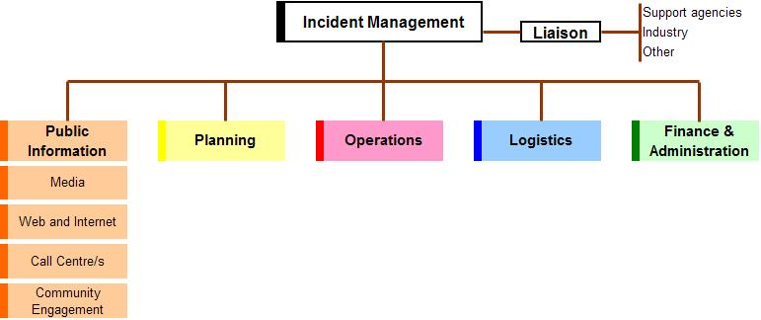
Figure 14. Public Communication function
Media function is likely to be performed at a local, state and national level. This function will have responsibility for:
- developing materials for use in media briefings
- obtaining the relevant approval for media releases
- informing media and conduct media briefings
- consider and oversee appropriate use of social media
- arranging for tours and other interviews or briefings as requested
- obtaining media information that can be useful to incident planning and management.

Web and Internet function is likely to be performed at a state and national level. This function is primarily responsibility for posting information relating to the incident onto agency and/or national websites, including the national pest and disease website (www.outbreak.gov.au), and other web based interfaces including social media.
This function may also have responsibility for managing the organisations internet infrastructure.
Call Centre/s function is likely to be performed at a state and national level. This function will have primary responsibility for supervising and facilitating the establishment and maintenance of a call centre facility, as a source for stakeholder information. Such call centres may be internally hosted (i.e. by the response agency) or outsourced to another organisation or commercial provider.
NOTE: The Australian Government Department of Agriculture, Fisheries and Forestry and a number of state/territory agencies have established arrangements with agencies such as Centrelink to provide call centre services during the response to biosecurity incidents.
Community Engagement relates to the affected community/ies. This may involve engaging with individuals either directly or indirectly affected, as well as affected industries and their member organisations.
This function is most applicable at a local and state level and may involve establishing community resource centres, to act as face to face meeting points for members of the affected communities, industries and government.
This function needs to liaise closely with relief and recovery agencies to ensure appropriate support is provided to affected communities.

3.3.5 Logistics Function
The Logistics function is responsible for the acquisition and provision of human and physical resources, facilities, services and materials required to support achievement of the objectives set by the Incident Management function.
The Logistics function may be established within Local Control Centres, State Coordination Centres and/or the National Coordination Centre. Depending upon the size and complexity of the response, it may be necessary to establish several units to manage the range of logistics activities for the incident. These could include:
- Facilities
- Staffing
- Catering
- Transport
- Accommodation
- Supply
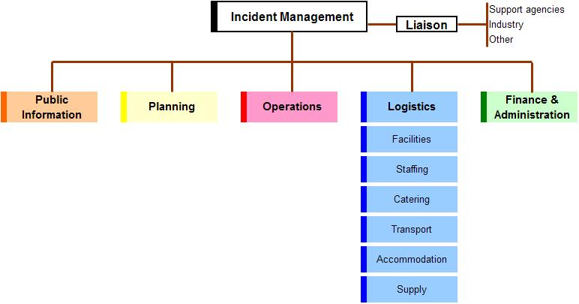
Figure 15. Logistics function
Facilities function may be required whenever an operations centre is established at local, state or national levels. This function will have primary responsibility for providing fixed facilities for the incident and may include:
- operations centre, forward command post/s and assembly area building/s, whether fixed or mobile (transportable buildings, tents etc)
- catering or feeding areas
- temporary sleeping facilities
- sanitary facilities
- etc.
Staffing is responsible for sourcing, acquiring, logging and tracking the human resources required for the response. Specific responsibilities may include coordinating incoming staff and briefing them on the nature of the disease, operation plans, current situation, structure of the operations centre, occupational health and safety arrangements and local conditions.
Catering function has primary responsibility for providing, or coordinating the provision of, meals and refreshments for response personnel, working in operations centres and in the field.
Where the provision of meals and refreshments is outsourced to another organisation or private contractor, this still needs to be coordinated from within the appropriate operations centre.
Care is required when staff are working extended or multiple shifts, to ensure their nutritional needs, commensurate with their shift and/or duties are met. The catering needs of staff working late or overnight shifts should not be overlooked by this function.
Transport function may be required where it is necessary to coordinate the transport of response personnel between centres, accommodation and/or field locations. If established, this function will have primary responsibility for:
- identifying the transport needs of response personnel
- identifying and source appropriate transport (hire-cars, taxis, buses, etc)
- scheduling available transport to suit the needs of response personnel
- communicating transport arrangement to response personnel.
Accommodation function may be required where it is necessary to accommodate response personnel. If established, this function will have primary responsibility for:
- identifying the accommodation needs of response personnel
- identifying and source appropriate accommodation (motels, hotels, etc). If portable accommodation is identified, sourcing should be coordinated with the Facilities function.
- scheduling available accommodation to suit the needs of response personnel
- communicating accommodation arrangement to response personnel.
Supply function may be required at local and state levels. This function will be primarily responsible for the acquisition and deployment of supporting equipment, consumables and services.

3.3.6 Finance and Administration Function
The Finance and Administration function is responsible for the management of records, information flow and miscellaneous items required to ensure the smooth and efficient running of an operations centre. It may also include the management of financial arrangements associated with the response.
The Finance and Administration function may be established within Local Control Centres, State Coordination Centres and/or the National Coordination Centre. Depending upon the size and complexity of the response, it may be necessary to establish several units to manage the range of finance and administration activities for the incident. These could include:
- Incident Management Team Secretariat
- Records Management
- Finance
- Human and Industrial Relations
- Procurement
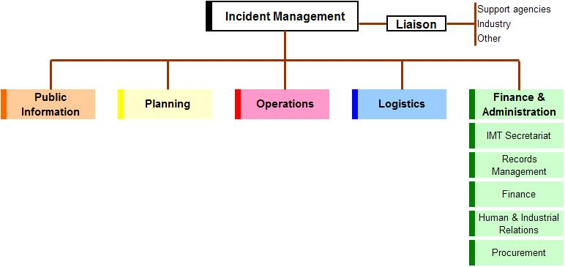
Figure 16. Finance and Administration function
Incident Management Team Secretariat will provide secretariat support to the whole Incident Management Team. Specific responsibilities include:
- organise meetings of the Incident Management Team, in accordance with the daily schedule of activities, or as advised by the Incident Manager
- create and maintain records (including minutes) of these meetings and distribute as appropriate.

Records Management is responsible for the overall management of all records (paper and electronic) received and generated by the Incident Management Team. This will include the establishment and management of processes for the collection, collation, storage and retrieval of these records.
Finance provides policy support to the Incident Manager, through provision of advice on financial issues such as cost sharing arrangements. This may also include the management of and accounting for all financial transactions (which may include claims for compensation).
Human and Industrial Relations provides policy support to the Incident Manager, through provision of advice on application of industrial relation rules. This may also include the management of human resource industrial issues and inequities that arise during the incident.
Additionally, this unit should ensure that all personnel time records are accurately completed and provided to home agencies, according to established policies.
Procurement provides policy support to the Incident Manager and Incident Management Team on procurement issues, such as contracts, leases and related negotiations. This may also include the preparation and management of contracts and leases during the incident.
Note: As many of the Finance and Administration functions are already performed as part of an organisations day to day business it is appropriate that existing systems, processes and staff be used to perform the functions described above.

Biosecurity Incident Management System

Glossary
The following terms have been used within this document and their definitions provided for ready reference.
A full list of biosecurity incident terminology can be found in the Biosecurity Emergency Management - Glossary
Biosecurity | Means mitigating the risks and impacts to the economy, the environment, social amenity or human health associated with pests and diseases.
Biosecurity Incident | An event which increase the likelihood of biosecurity risks being realised
Briefing | The process of advising personnel of the details of the incident or event with which they will be dealing
Command | The internal direction of the members and resources of an organisation in the performance of the organisation’s roles and tasks. Authority to command is established in legislation or by agreement with an organisation. Command relates to organisations and operates vertically within an organisation.
Control | The overall direction of activities in an emergency situation. Authority for control is established in legislation or in an emergency plan and carries with it the responsibility for tasking other organisations in accordance with the needs of the situation. Control relates to situations and operates horizontally across organisations.
Coordination | The bringing together of organisations and elements to ensure an effective response, primarily concerned with the systematic acquisition and application of resources (organisation, human and equipment) in accordance with the requirements imposed by the threat or impact of an emergency. Coordination relates primarily to resources and operates vertically within an organisation, as a function of the authority to command, and horizontally across organisations, as a function of the authority to control.
Debriefing | A meeting at the end of an operation with the purpose of assessing the conduct or result of an operation.
Forward Command Post | A field operations centre, subsidiary to a Local Disease Control Centre.
Incident | See – Biosecurity Incident
Incident Action Plan | A statement of objectives, actions, tasks and responsibilities to be undertaken to contain or resolve an incident or emergency. An IAP will generally have application for a single operational period.
Incident Management Team | Normally comprises the Controller [Incident Manager], the Operations Manager/Director, Planning Manager and Logistics Manager, however other specialists may be included when necessary such as a species expert and legal services unit representative.  They ensure that an incident or emergency is properly planned, adequately resourced, suitable implemented, effective and efficient.
Incident Manager | The individual responsible for incident activities, within their defined area of responsibility. An Incident Manager may be appointed at a local, state/territory and/or Australian Government level (may also be referred to as Incident Controller).
Liaison Officer | A representative from an agency [government or industry] involved in the incident response who works with the incident manger as part of the Incident Management Team and is in communication with the officer in charge of his or her respective agency. Liaison officers must have the authority to commit resources of the organisation they represent.
Local Control Centre | The operations centre from which all field operations aimed at containing and eradicating the pest or disease are managed.
National Coordination Centre | The centre established by DAFF to coordinate national and international activities and resource support to jurisdictions
Operational period | The period of time scheduled for execution of a given set of operational actions as specified in the Incident Action Plan
Operations Centre | Generic term referring to any one of the National Coordination Centre, State Coordination Centre, Local Control Centre or Forward Command Post.
State Coordination Centre | The emergency operations centre established at a state level, that coordinates the disease or pest control operations to be undertaken in that state or territory.

This page has been left blank

Biosecurity Incident Management System

Appendices
Appendix 1: Associated National Documents
Appendix 2: Relief and Recovery Application in a Biosecurity Response Context

This page has been left blank

Appendix 1: Associated National Documents
National Response and Cost Sharing Agreements
Title | National Sponsor / owner | Subject | Purpose and Scope
Government and Livestock Industry Cost Sharing Deed in Respect of Emergency Animal Disease Response (EADRA) | (National) Animal Health Committee – supported by Animal Health Australia and DAFF | Terrestrial animal disease incidents | The EADRA is a formal legally binding agreement between AHA, the Australian Government, all states and territory governments and national livestock industry body signatories. It covers the management and funding of responses to Emergency Animal Disease (EAD) Incidents, including the potential for reimbursement c. It also formalises the role of livestock industry signatories participating in decision making as well as their contribution towards the costs related to EAD responses.
Government and Plant Industry Cost Sharing Deed in Respect of Emergency Plant Pest Responses (EPPRD) | (National) Plant Health Committee – Supported by Plant Health Australia and DAFF | Plant pest and disease incidents | The EPPRD is a formal legally binding agreement between PHA, the Australian Government, all states and territory governments and national plant industry body signatories. It covers the management and funding of responses to Emergency Plant Pest (EPP) Incidents, including the potential for Owner Reimbursement Costs for growers. It also formalises the role of plant industry signatories participating in decision making as well as their contribution towards the costs related to EPP responses.
National Environmental and Biosecurity Response Agreement (NEBRA) | National Biosecurity Committee – Supported by DAFF | Biosecurity incidents, not covered by the EADRA or EPPRD | The purpose of the NEBRA is to establish national arrangements for response to nationally significant biosecurity where there are predominantly public benefits.  The scope of the NEBRA is to reduce the impacts of pests and diseases on Australia’s environment and social amenity. It establishes national response arrangements, including cost sharing, to be applied by agreement of the parties where there are no pre-existing arrangements

National (Sector-Specific) Biosecurity Plans

Title | National Sponsor / owner | Subject | Purpose and Scope
Australian Veterinary Emergency Plan (AUSVETPLAN) | Animal Health Australia | Terrestrial animal disease emergencies | AUSVETPLAN is a series of technical response manuals that describe the proposed Australian approach to an emergency animal disease incursion. The documents provide guidance based on sound analysis, linking policy, strategies, implementation, coordination and emergency management plans.  AUSVETPLAN includes a range of documentation to guide strategic and operational decision making. These include:  - A summary document  - Control centre management manuals  - Strategies for dealing with each disease covered by the plan  - Enterprise manuals that deal with risks associated with individual types of industry activity, e.g. saleyards  - Operational procedures, e.g. animal destruction, disposal and decontamination.
Australian Aquatic Animal Disease Veterinary Emergency Plan (AQUAVETPLAN) | Australian Government Department of Agriculture, Fisheries and Forestry (DAFF) | Aquatic Animal disease emergencies | AQUAVETPLAN is a series of manuals that describe the proposed Australian approach to an aquatic animal disease emergency. These manuals outline national emergency preparedness, response and control strategies for aquatic animal disease emergencies in Australia.
Australian Emergency Marine Pest Plan (EMPPlan) | Consultative Committee on Invasive Marine Pest Emergencies (CCIMPE), through DAFF | Incursions by introduced marine pests | The primary document is the EMPPlan Control Centre Management Manual that describes the intended generic response to a marine pest emergency within Australia.
Australian Emergency Plant Pest response Plan (PLANTPLAN) | Plant Health Australia | Plant pest and disease emergencies | PLANTPLAN is the generic emergency response plan for emergency plant pest and disease incursions and will be used by all plant industries and government agencies as a guide to management of emergency plant pest and disease incursions.  PLANTPLAN provides a description of the general procedures, management structure and information flow system for the handling of emergency plant pest incursions at the national, state/territory and district levels. This includes the operations of control centres, principles for chain of responsibilities, functions of sections within control centres and role descriptions.

Generic Operational Documents
Title | National Sponsor / owner | Subject | Purpose and Scope
Biosecurity Emergency Management – Biosecurity Incident Management System | BEPWG | Generic approach to the management of biosecurity incidents | This document provides guidance in contemporary practices for the management of biosecurity incident response and initial recovery in Australia. It is primarily focused at using the Biosecurity Incident Management System for managing the response to (which includes initial recovery from) biosecurity incidents.
Biosecurity Emergency Management – Response Planning Guidelines | BEPWG | Response planning | This document provides guidance on planning practices and processes that could be followed during the response to biosecurity incidents. It is intended that this document be used by staff within operations centres established at national, state/territory, local and field levels, during the response to all types of biosecurity incidents.
Biosecurity Emergency Management – Glossary | BEPWG | Glossary of biosecurity response terminology | This document provides a list of nationally agreed terminology, commonly used during the response to biosecurity incidents.
Nationally Agreed Standard Operating procedures (NASOPS) | Animal Health Committee (AHC) - for animal specific NASOPs  Biosecurity Emergency Preparedness Working Group (BEPWG) - for generic, non sector-specific NASOPs) | Various operational activities | NASOPs provide guidance to response personnel, performing operational activities in operations centres and in the field.
Biosecurity Emergency Management – Evaluation Guide | BEPWG | Evaluation of biosecurity preparedness and response activities | (currently under development)  This document describes evaluation procedures and processes and provides tools that can be used in the evaluation of biosecurity emergency management preparedness, response and initial recovery activities.
In addition to the above, jurisdictions maintain operational documentation relevant to their jurisdictional needs, legislation and emergency response arrangements. These include, but are not limited to; plans, manuals, operating procedures, works instructions etc.

Appendix 2: Relief and Recovery Roles in a Biosecurity Response Context
Impacts | Response Agency Roles | Other Agencies Roles
Families and individuals suffering loss or trauma as a result of:  - the destruction of stock or crops that may have been built up over an extended period and the consequent sudden loss of livelihood and sense of purpose  - personal trauma resulting from the destruction of pets  - possible changes in community perception of those whose stock/crops are affected by the disease/pest | Community information regarding the disease or pest incursion, response operations and likely consequences.  Provision of information and updates to affected families and businesses on the progress of response operations, their consequences and resolution.  Management of animal welfare issues arising from incursion and/or response operations. | Personal counselling and support services.  Temporary financial relief.  Rural counselling services may play a role in advising affected farmers on access to financial and other relevant services.  Translation and interpreting services where required.
Business and individuals, dependent on the affected industry. | Community information regarding the disease or pest incursion, response operations and likely consequences.  Provision of information and updates to affected families and businesses on the progress of response operations, their consequences and resolution.  Use of local capacity to support response operations wherever practicable. This may include purchasing goods and services from suppliers in affected areas and/or employing, for response tasks, displaced workers from affected enterprises. | Referral to relevant support services / financial relief providers.  Temporary financial relief.  Translation and interpreting providers.
Measures that support restocking / replanting and the return of an industry to pre-incident levels of activity. | Advice and referral to relevant support services. | State/territory community relief and recovery arrangements.  Rural counselling services may play a role in advising affected farmers on access to financial and other relevant services.
State/territory legislation may provide for compensation for the death of domestic animals in prescribed circumstance. Such compensation is covered by the relevant national cost sharing agreement where applicable. | Administration of claims.
Support for transition to alternate activities where an affected producer does not wish or is not able to recommence pre-incident activities | Advice and referral to relevant support services. | Support and advice coordinated through inter-agency cooperation.  Rural counselling services may play a role in advising affected farmers on access to financial and other relevant services.
Coordination of measures to enable re-establishment of trade. | Through national arrangements and/or in consultation with relevant state/territory agencies as appropriate. | State/territory economic/regional development agency – advisory and/or support services.
Measures to restore environmental values. | Through national arrangements and/or in consultation with relevant state/territory agencies as appropriate. | Agencies with significant land management responsibility to act in relation to their respective areas of responsibility.
Develop recovery plans for tourism. |  | State/territory tourism agencies.

The IGAB was endorsed by COAG on 12 January 2012, and is available at http://www.coag.gov.au/node/47.
National Environmental and Biosecurity Response Agreement, V.7 2011
Ibid.
The ‘response planning process’ is further described in the Biosecurity Emergency Management - Response Planning Guide.
Emergency Management Australia, Australian Emergency Management Glossary, 1998
Ibid.
Emergency Management Australia, Australian Emergency Management Glossary, 1998
Definition adapted from Australian Defence Force publication ADDP 5.0 Joint Planning (1 Jan 2006)
Ibid.
Ibid.
Definition adapted from AFAC, Australasian Inter- services Incident Management System, V. 1, (30 June 2004)
In the case of an animal health or plant health response, the incident specific response management plan will be documented in the form of either an Emergency Animal Disease Response Plan or Emergency Pant Pest Response Plan.
Definition adapted from AFAC, Australasian Inter- services Incident Management System, V. 1, (30 June 2004)
This function may also be referred to as ‘Incident Command’ or ‘Incident Control’.
Definition adapted from AFAC, Australasian Inter- services Incident Management System, V. 1, (30 June 2004)
The definitions provided herein are consistent with contemporary emergency management doctrine and as such may vary slightly to the way in which they are currently applied in a specific biosecurity sector.
In an emergency animal disease response this is equivalent to the ‘LCC Controller’ at local level or ‘SDCHQ Director’ at state level
In an emergency animal disease response, specific roles exist for Industry liaison Officer and Industry Liaison Coordinator. These are described in AUSVETPLAN.

