Biosecurity Emergency Management
Response Planning Guide
V1.1 – November 2012
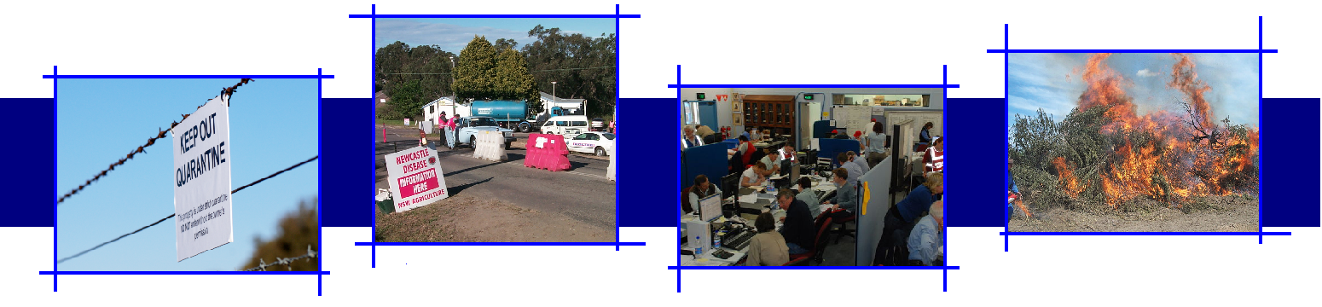

Version Control
Version | Date of issue | Author | Comments
V1.0 | 03/02/2010 | BEPWG – RPG Working Group | Endorsed by AHC and NBC
V1.1 | 20/11/2012 | BEPWG | Updated to reflect Biosecurity Incident Management System
Biosecurity Emergency Preparedness Working Group
BEPWG@daff.gov.au
C/- Australian Government Department of Agriculture, Fisheries and Forestry
PO Box 858
Canberra ACT 2600
Cover: photographs courtesy of New South Wales Department of Primary Industry and Fisheries and Australian Government Department of Agriculture, Fisheries and Forestry.

ACKNOWLEDGEMENTS
Significant contributions were made by organisations in the development of the Response Planning Guide. The Biosecurity Emergency Preparedness Working Group would like to acknowledge the following:
Australian Government Department of Agriculture, Fisheries and Forestry
New South Wales, Department of Primary Industries
Tasmania, Department of Primary Industries and Water
Animal Health Australia
EM Risk Pty Limited

CONTENTS
INTRODUCTION 1
1.1 Authority 1
1.2 Purpose 1
1.3 What is Response Planning? 1
1.4 Review 2
THE PLANNING PROCESS 3
2.1 Planning Principles 3
2.2 The Planning Cycle 3
2.3 Schedule of Planning Activities 5
PLANNING IN A RESPONSE 7
3.1 Levels of Planning 7
3.2 Planning Horizons 9
3.3 Planning Outputs 10
3.4 Planning Inputs 15
PLANNING SECTION 17
4.1 Role of the Planning Section 17
4.2 Structure of the Planning Section 17
4.3 Functions within the Planning Section 19
PLANNING TOOLS 23
APPENDIX 25
TEMPLATES 31

This page has been left blank
Response Planning Guide

INTRODUCTION

1.1 Authority
This document was initially prepared by a working group established by the Biosecurity Emergency Preparedness Working Group, and endorsed by the National Biosecurity Committee 03 February 2010.
The Response Planning Guide has since been updated to reflect contemporary incident management arrangements and the content and style of the Biosecurity Incident Management System, Version 1.0, endorsed by the National Biosecurity Committee.

1.2 Purpose
The purpose of this document is to provide guidance on contemporary response planning practices and processes that could be followed during the response to biosecurity incidents.
This document may be used as a training aid in preparation for the response to biosecurity incidents, as well as a reference document for staff working within operations centres at the national, state/territory, local and field levels, during the response to all types of biosecurity incidents.

1.3 What is Response Planning?
Response planning is the development and dissemination of the instructions required to achieve the response aims and objectives identified by incident managers.
Response planning involves the collection, collation, and interpretation of information, then developing this into operational plans and disseminating these plans to those that are required to know about or implement them.
Response planning does not occur in isolation. Within an operations centre, it is usually undertaken as a collaborative effort by the incident management team responsible for that centre. While the planning section will have primary responsibility for documenting and disseminating operational plans, all other sections within an operations centre need to be actively involved to ensure that the response aim and objectives can be achieved in a coordinated manner.

1.4 Review
This document will be reviewed regularly by the Biosecurity Emergency Preparedness Working Group.
Response Planning Guide

THE PLANNING PROCESS
The initial response to any incident is usually reactive in nature, in that available resources are dispatched to a site and upon arrival, decisions are made as to how resources are deployed and actions are adjusted based on available resources and situational awareness.
The response planning process is designed to move the initial reactive response to a well planned, proactive response that tailors incident resources to meet the response aim and objectives and allow for continual assessment of progress towards resolving the incident.

2.1 Planning Principles
The principles that should be observed when formulating any response plan are:
- Keep it simple (The best plans are simple, easy to prepare and are usually flexible enough to adapt. Complicated plans are difficult to prepare and can be difficult to change once activated).
- Ensure it relates directly to the response aim and objectives (If it does not relate to the stated aims and objectives they will not be achieved and the operation may be a failure).
- Ensure it is based on logical deductions.

2.2 The Planning Cycle
The response planning cycle describes the various steps or activities required to develop and implement workable response plans.
Before formal planning begins a number of actions will typically occur. These include:
- an incident or emergency is identified
- notification of the incident or emergency is made to an appropriate authority
- the authority undertakes an initial response and an assessment of the situation
- incident brief is provided to appropriate reporting point/s (BIMS 201 – Incident Briefing Form may be used for this purpose).
Based on the available information a decision is made whether further response action is required. If this is the case, an Incident Manager is appointed and an initial coordination/control meeting is conducted. The steps that are then taken make up the response planning cycle and include:
- incident managers develop/update the response aim and objectives
- Incident Management Team/s is established, members are briefed on the situation and appraised of the response aim and objectives
- planning meeting conducted
- Incident Action Plan prepared
- Incident Action Plan approved
- briefings conducted
- plan implemented
- planned actions are monitored and amended as necessary.
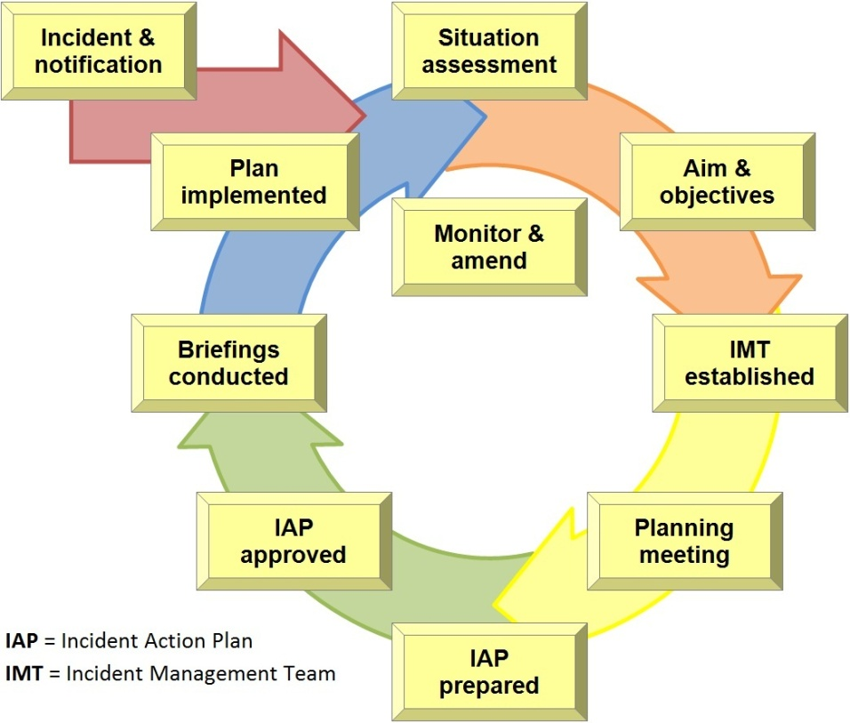
Figure 1. Response Planning Cycle at an operational and tactical level
By working through the response planning cycle the Incident Management Team will have methodically developed and implemented an Incident Action Plan. The Incident Action Plan is comprised of various components that together provide staff, within operations centres and in the field, with clear direction of what is to be achieved, how this will be done, resources required, communications protocols and any other information required to direct the response. The Incident Action Plan is described in more detail later in this document.

2.3 Schedule of Planning Activities
A regular pattern or schedule of planning activities should be established during a response. This is closely linked to the Planning Cycle and may include:
- planning meetings
- briefings and debriefs
- reporting.
Establishing a schedule of planning activities provides managers and responders with certainty about when activities need to be conducted or completed. This schedule assists with response planning by establishing timeframes for delivery of many of the planning outputs, such as Incident Action Plans and Situation Reports. The schedule should be communicated to all staff within a centre and those with responsibility for conducting activities identified within.
A typical schedule of activities that occurs in a local control centre is shown in Appendix A.
This page has been left blank
Response Planning Guide

PLANNING IN A RESPONSE

3.1 Levels of Planning
While planning will take place at all levels within a response, its scope and purpose varies according to the role of the unit undertaking the planning. There are three levels of planning, defined as: strategic, operational and tactical.
The strategic level is concerned with the practice and science of employing a national, state and/or territory capacity to resolve the incident. Strategic planning will inform operational planning by establishing strategic objectives. It is generally of a long term nature and is mindful of the impact that other factors may have on achieving the overall response objectives.
The operational level is concerned with the planning and conduct of response activities. It is at this level that strategy is implemented by assigning activities, tasks and resources to the response. Operational planning will focus, in detail, on the upcoming operational period, however will be mindful of the planning requirements for subsequent operational periods.
The tactical level is concerned with the planning and conduct of on-ground activities and is charactarised by the application of resources and actions to achieve a specific objective. Tactical planning will focus on the duration of the tasks at hand.

3.1.1 Strategic Plans
Strategic plans should precede and inform the other level of plans. Strategic plans may in fact be determined or influenced by strategies developed in advance of an actual incident or emergency, such as disease specific strategies found in AUSVETPLAN, or pest specific contingency plans, consistent with PLANTPLAN.
Depending on the nature and scale of the response to a biosecurity incident, strategic planning may be undertaken cooperatively between the National Coordination Centre, State Coordination Centre/s and affected industries and interest groups.
Strategic planning is generally focused on achieving long-term goals by proactively addressing potential risks and uncertainties. Typical outputs will include incident specific response plans, such as:
- Emergency Animal Disease Response Plans (or EADRP), for animal health responses
- Emergency Plant Pest Response Plans (or EPPRP), for emergency plant pest eradication responses
- Incident Specific Response Plan, for other response types.
3.1.2 Operational Plans
During the response to a biosecurity incident it is typical to assign responsibilities for the planning, resourcing and conduct of operational activities, within a defined geographic area, to a Local Control Centre. Such activities may include, but not limited to:
- gathering information through tracing and surveillance activities
- limiting pest/disease spread by enforcing movement controls
- eradicating the pest/disease by destroying infected or endangered plants/animals
- disposing of carcasses and infected materials
- disinfecting of assets (plant, equipment and buildings).
Operational plans address what is to be done within the defined area of responsibility. Operational planning is typically undertaken by the Local Control Centre and is promulgated in the form of an Incident Action Plan. The Incident Action Plan is informed by and gives effect to relevant parts of the national or state/territory incident specific response plan. In developing an Incident Action Plan the Local Control Centre should be mindful of:
- procedural guidance in relevant, established national plans
- jurisdictional policies and standard operating procedures
- intelligence developed through analysis of the information it has collected and collated.

3.1.3 Tactical Plans
To give effect to the intentions and objectives of an Incident Action Plan, actions and tasks are assigned to and carried out or coordinated by functional areas within the control centre. These functional areas may in turn assign responsibilities to Forward Command Posts, or functional groups/teams working in the field.
Tactical plans address how these responsibilities will be carried out. At this level plans would often be less formal than a documented Incident Action Plan and may not be documented in detail. In any case appropriate records and notes need to be made by the responsible staff.

3.2 Planning Horizons
Plans need to be developed and revised according to the demands of the specific response. A stable situation potentially enables longer planning timeframes whereas an unstable situation will require more frequent review of the appreciation and any plans.
The different levels of the response organisation may need to focus on different planning horizons:
- the strategic level needs to take the longest view and plan furthest ahead
- the operational level has an immediate and medium term focus, giving it a shorter planning time frame
- the tactical level is focused only on their current assignment.
For example:
Focus | Strategic | Operational | Tactical
Focus | National and State level | Local level | Field teams
Plan in detail | Up to 7 days | Operational period (1 day) | Task duration
Plan in outline | Up to 3 weeks | Up to 7 days
Plan in concept | Beyond 3 weeks | Greater than 7 days
Table 1. Comparison of Planning Horizons

3.3 Planning Outputs
Planning outputs may be presented in a range of formats, including electronic, paper and verbal. Some of these are described below.
Response Policy
Response policy will inform all levels of planning. A response policy may have been established prior to an incident and articulated in detail in a disease or industry specific response strategy. In addition to these an incident’s response policy will also be articulated in an incident specific response plan. For example, in the case of an emergency animal disease, this may appear in the Emergency Animal Disease Response Plan.
Incident Specific Response Plan
Incident specific response plans are strategic level plans, developed at a state/territory level. The incident specific response plan describes the overall aim and high level objectives to be achieved and response strategy to be employed in order to resolve the biosecurity incident. The incident specific response plan is used to obtain national agreement on the response strategy and actions being taken. They may also be a requirement of and inform decisions related to cost sharing arrangements.
In the case of animal health and plant health responses, the incident specific response plan will be documented in the form of either an Emergency Animal Disease Response Plan or Emergency Plant Pest Response Plan. Templates for these documents are provided in the respective response agreement or deed.
As a guide, incident specific response plans should include discussion on:
- current situation
- analysis of the situation, including:
  - risk Assessment
  - technical Feasibility Analysis
  - benefit:cost analysis
- response strategy
- actions and responsibilities
- proposed strategy to demonstrate proof of freedom
- budget and indicative costs
- review points.

In the event of a multi-jurisdictional response, the National Coordination Centre has a role to ensure consistency across all involved jurisdictions. In consultation with jurisdictions, and working through the normal National Management Group and consultative committee process, the National Coordination Centre may choose to develop a national response management plan for a biosecurity incident, in order to contribute to this consistency.

Incident Action Plan
Incident Action Plans are designed to move response operations from a reactive to proactive mode. It provides responders with direction on what to accomplish in a certain period of time (operational period) and the resources necessary to support the operations. While written Incident Action Plans are encouraged, during the early stages of a response the time or resources required may not be available to produce them, in which case verbal action plans can be delivered. In either case Incident Action Plans should be supported by written notes that support the decisions made to develop them.
An Incident Action Plan is a statement of objectives and the actions to be taken to contain or resolve an incident or emergency. An Incident Action Plan can take a number of formats, including:
Unwritten or oral for small incidents, where the Incident Manager can talk directly to all actively concerned in the incident (such an Incident Action Plan should be supported by written notes).
Written – abbreviated, for medium incident or where minimal detail is required. This will include a summary of current situation, incident objectives and actions taken. This level of Incident Action Plan is useful for briefing incoming personnel as well as contributing to situation reports.
Written – full, for large scale incidents or where more complete detail is required. In addition to information included in the abbreviated format the full Incident Action Plan should include the intentions and actions of the various sections and functional units involved in the response.
Incident Action Plans can also be supported by subordinate or task specific plans, which may include:
- Medical plan
- Communications plan
- Public Information plan
- Resource/Logistics plan
- Surveillance plan
- Vaccination plan
- Wild Animal Control plan
- Restricted Area Movements plan
- Infected Premises Operations plan
- Carcass Disposal plan
- Decontamination plan
- Transport plan
- Induction plan
Other documents that may contribute to or form part of the Incident Action Plan include:
- Incident Briefing Form (BIMS 201)
- Response Objectives (BIMS 202)
- Organisation Assignment List (BIMS 203)
- Communications Plan (BIMS 205)
- Medical Plan (BIMS 206)
- incident map/s.
Templates for many of these documents and an Incident Action Plan are included at the end of this document.
Situation Reports
A Situation Report (often referred to as a SITREP) is a brief report that is published, updated and distributed periodically during the response to an incident. It is issued as at a point in time during the response and outlines details of the incident, in particular; current situation, what is being done to resolve the incident, the outlook (or prognosis) and any issues that need to be resolved to achieve the incident objectives. When issued, new information can be included in BOLD as a quick reference to what may have changed from the previous Situation Report.
It should be noted that all Situation Reports must clearly identify the following:
- the operational period covered
- when the next Situation Report will be issued
- where to obtain further information.
Situation Reports should be factual and largely without interpretation or conjecture.
Situation Reports may be used for reporting to higher levels, informing involved agencies and other operations centres and as a basis for briefing staff within a centre or in the field.
A Situation Report template (BIMS 210) is included at the end of this document.

Visual Displays
Visual displays will take many forms within an operations centre, they can be either electronic or in hard copy and may include maps, whiteboards, charts etc.
Maps can be used to provide situational awareness to staff within an operations centre as well as a tool for briefings and debriefings to operations centre / section staff, visitors, media etc.
To be useful maps should be of a size that allows ready recognition of geography and identified features. Displayed maps should use symbology consistent with printed or published map products.
Whiteboards have a wide range of uses, for the whole operations centre or for sections within the operations centre. Uses for whiteboards are endless and may include:
- displaying operations centre or section ‘objectives’ and progress against these
- displaying the ‘Current Situation’
- displaying data relevant to the response such as field team composition, taskings and their status, outstanding issues etc.
Essentially any information that needs to be shared with others within the operations centre or section can be displayed on whiteboards in an abbreviated or tabulated format.
The value of whiteboards is that they can be easily and quickly modified and updated. However, the downside of this is that important information can easily be removed or modified. To ensure that information is not lost, whiteboards should be printed or photographed whenever changes are made.
Charts including graphs can be used to display progress against tasks, trends in pest/disease spread etc. As with whiteboards the types of charts used may be endless. The value of charts is that they provide information, using a pictorial representation of the data, which can be easily interpreted and understood by the reader.
Note: Any visual display must clearly identify its currency in the form of a notation along the lines of ‘Correct as at (date time group)’. Electronic displays, should be saved in appropriate directories for later reference.

Briefings
Briefings are usually provided orally at the beginning of an operational period and at the beginning of or change of shifts. Briefings should follow a recognised format. A commonly accepted format is SMEAC, an acronym for situation, mission, execution, administration (and logistics) and command (control and communications), with recent convention adding an additional ‘S’, for safety, at the end. This format is widely used by emergency management agencies and assists with ensuring that appropriate information is provided in an appropriate order.
A briefing template using the SMEAC approach is included at the end of this document.
Further guidance on briefings can be found in Nationally Agreed Standing Operating Procedure: Conducting briefings in a biosecurity response. (http://www.animalhealthaustralia.com.au/programs/emergency-animal-disease-preparedness/nasops/ )

3.4 Planning Inputs
There are many factors and influences that must be recognised, analysed and considered in response planning. A range of information sources, policies, perceptions and conditions are relevant, including:
- legislation and legal advice
- national policies and plans
- cost sharing arrangements
- state/territory policies and plans
- advice from other government agencies
- pest/disease characteristics and spread predictions
- tracing and surveillance reports
- analysis of the current incident situation
- identified consequences of events and proposed response actions
- health and safety of response personnel and any public health considerations
- new information gathered, e.g. from other jurisdictions’ or operations centres’ Situation Reports
- expectations of the Incident Management Team, Agency Executive, Consultative Committee and/or National Management Group
- advice and issues raised by specialists and industry representatives
- community perceptions and concerns
- resource availability
- progress of current operational activities.
When initiating the planning process for the response to a biosecurity incident or emergency, it should be remembered that there is likely to be many weeks of unknown history that needs to be discovered and considered along with other intelligence input.
Risk Assessments
Risk assessments are undertaken to analyse the impact that the incident may have.
Risk assessments could be expressed in terms of their social, technical, economic, environmental and/or political impacts.
Technical Feasibility Analysis
The technical feasibility analysis describes the feasibility of being able to contain, control and/or eradicate the cause of the incident or emergency and manage the impacts that it may have.
This analysis may look at the technical feasibility of several response options.

Benefit:Cost Analysis
Benefit:cost analysis should look at the benefit that will be achieved by undertaking certain response activities and analyse this against the costs associated with the impact and response options.
Appreciations
An appreciation of the extent of the problem being addressed, including an analysis of the factors that may affect the response should be undertaken to assist with decision making in relation to planning response actions.
The steps within the appreciation process are further described in Appendix 2.
Response Planning Guide

PLANNING SECTION

4.1 Role of the Planning Section
The Planning Section is responsible for the collection, collation, analysis and dissemination of incident information. It also includes the development of written plans for the response to the incident. The Planning Section acts as an information centre, by providing information that contributes to the situational awareness of all staff involved in the response.
The planning function is performed at all levels of response and certain aspects of planning are performed by other sections and functional groups within the response organisation. Dedicated planning sections may be established within the National Coordination Centre, State Coordination Centres and Local Control Centres.

4.2 Structure of the Planning Section
The Planning Section is a major section within the incident management framework of an operations centre. When established, the planning section will be the responsibility of the Planning Section Manager who is a member of the Incident Management Team. Depending upon the size of the response and responsibilities, the Planning Section Manager may undertake all planning functions or appoint staff to each of the required functions.

The functions generally performed within the Planning Section include:
- Technical Analysis
- Response Planning
- Resource Planning
- Situation and Assessment
- Legal
- Information Systems
- Mapping and GIS
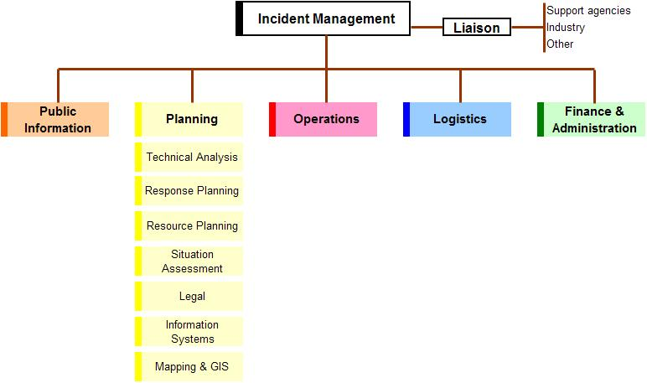
Figure 2. Functions within the Planning Section
The staff performing these functions are responsible to the Planning Manager, with these and other planning functions being added or removed as required.
In some circumstances it may be necessary to establish an intelligence function within the Planning Section. Should the intelligence function expand to an extent that it exceeds the Planning Managers span of control, it may be necessary to establish a separate Intelligence Section, however, this is not presently a common practice in biosecurity response.

The Planning Section is represented by the colour yellow within Incident Management Systems. Staff working within the Planning Section should wear appropriate identification. The Planning Manager is typically identified by a tabard, while staff will wear arm bands, name and/or identification cards.

4.3 Functions within the Planning Section
Technical Analysis
The Technical Analysis function provides specialised knowledge and experience that may be necessary to support response activities.
This function collects technical data about the incident and undertakes analysis to anticipate rates of spread, impact etc, and predict the escalation or de-escalation of an incident.
The outputs from technical analysis include intelligence that assists with decision making and provides guidance for the planning of activities, such as movement restrictions, tracing, surveillance, vaccination or other treatments.
Response Planning
Response Planning may include strategic and/or operational planning.
Strategic planning is usually performed at a state and/or national level.
At a state/territory level, strategic planning will look at state/territory wide activities and those issues that have relevance across the state/territory. The strategic planning function has primary responsibility for the compilation and maintenance of the state/territory’s incident specific response plan/s.
At a national level strategic planning may include the aggregation of state/territory outputs, to contribute to a nationally consistent approach to the management of the response.
Operational planning is most likely to occur at the Local Control Centre and will focus on activities within the local control centre’s area of responsibility. Operational planning may be undertaken at a state level if the State Coordination Centre has taken on responsibility for operational activities.
The Response Planning function will need to work closely with the Operations section and will have primary responsibility for the compilation and maintenance of the operations centre’s Incident Action Plan/s.

Resource Planning
The Resource Planning function responsible for projecting or forecasting the resource requirements such as facilities, equipment, human, financial and supporting resources and services required to achieve the objectives set for their operations centre’s area of responsibility. In a State Coordination Centre, resource planning will consider resource requirements across the state, where in a Local Control Centre, resource planning will consider resources requirements within the assigned area of responsibility.
This function needs to work closely with the Logistics Section to ensure that resource planning is realistic and achievable.
Situation and Assessment
The Situation, Assessment (which may also include reporting) function is primarily responsible for acquisition and maintenance of situational awareness and sharing of that ‘picture’ through visualisation and sharing systems (e.g. knowledge wall). This function collects and collates incident information. It produces and disseminates current information about the developing incident, including the production of regular Situation Reports for use within the operations centre and/or external distribution.
This function also has responsibility for the maintenance of visual displays within the operations centre, such as the incident’s status board.
Legal
The Legal function provides legal services and advice to ensure that response activities are conducted in accordance with appropriate state, territory and/or Commonwealth legislation. This may include but is not limited to:
- arranging proclamations, delegations and orders
- advising on the legality of proposed policy decisions and operational activities
- providing legal advice on specific issues, as they arise
- briefing staff on their responsibilities in regard to legal issues.
Information Systems
The Information Systems function i responsibility for the management of electronic information management systems, such as BioSIRT or other information systems used within the jurisdiction and for the production of the required outputs from these systems.
NOTE: in some cases the information systems function may sit with other sections within the response organisation. If this is the case there needs to be close liaison with the Situation and Assessment function to ensure the appropriate management of all electronic and hardcopy information.

Mapping and GIS (Geographic Information Systems)
The Mapping and GIS function works closely with the Situation and Assessment function and Information Management function to collate incident specific geographic information and data, to produce appropriate products and outputs (such as electronic and paper maps). These products may be required for inclusion in planning documents and will be used by other staff within the operations centre, as well as those deployed in the field.
This page has been left blank
Response Planning Guide

PLANNING TOOLS
The planning process can benefit from a range of tools, including those discussed below:
Information Collection Plan
Information is an essential input to planning. Therefore it is necessary to take a structured approach to identifying what information is required to inform the planning process, who holds that information and how it can be accessed or acquired. As a part of establishing a Planning Section an information collection plan should be developed to:
- identify information requirements, and
- identify sources of information, and
- plan for its acquisition, which implies a need to establish relationships with those information sources.
Information Management/Sharing Systems
There must be a focused, disciplined approach to the analysis, and use of the acquired information. The Planning Section should decide very early in a response on how it intends to manage and share information within the section, within the operations centre and with its external stakeholders.
Disciplined Information Analysis and Planning Process
A focused and disciplined approach to the task is vital to success in a response situation where conditions will be less than ideal.
Disease Spread Models, Epidemiological Curves, Time Lines, References
A disease spread model and other tools are developed by epidemiologists, as part of the Technical Analysis function, and contribute to an ability to stay ahead of the pest/disease. Many models have been developed by specialists in their fields, as part of preparing for a response, and can be used by populating them with incident specific information.

Resource Projection Model
An important element of planning is a projection of the resources required to undertake the planned operational activities. Resource requirements may be predicted three, seven and 21 days or longer ahead. Resource projections enable the logistics section to plan its activities in order to acquire the required resources or communicate resource limitations, so that operational plans can be amended to reflect any limitations.
Task Tracking System
Apart from its standing responsibilities to collect, collate, analyse and disseminate information, examine future needs and to plan for operational activities, the Planning Section will have many tasks in hand at any one time and they need to be prioritised, allocated and monitored in a systematic way. This could be as simple as a whiteboard dedicated to this purpose or dedicated software, designed specifically for this purpose.
Templates
Templates for many commonly used forms, plans and displays should be prepared in advance and a range of these are included at the end of this document. Examples include Operations Log, Situation Report and Incident Action Plan templates.
Risk Assessments
The Planning Section should identify risks to the operation and the organisation so that they can be factored into the planning process. Many of those risks could be identified in advance, where more time may be available and risk assessments could be prepared more carefully, ready for use in a response.
Appreciations
An appreciation of the extent of the problem being addressed, including an analysis of the factors that may affect the response is essential.
The appreciation process and its use as a decision making and planning tool are further described in Appendix 2.
Response Planning Guide

APPENDIX
Appendix 1 – Daily schedule – Local Control Centre
Appendix 2 – The Appreciation Process
Appendix 3 – Briefing (SMEAC format)
Appendix 1 – Daily Schedule – Local Control Centre
The following is not prescriptive and should only be used as a guide for establishing a regular schedule of activities within a Local Control Centre. Similar schedules should be established at national, state and field levels.
TIME | ACTIVITY | RESPONSIBILITY
0600 | IMT meeting – review and confirm Incident Action Plan | Incident Manager
0630 | Daily briefing of Local Control Centre staff | Section Mangers
0700 | Brief and deploy field teams | Functional Managers
0800 | am SITREP due | Planning Section
1200 | IMT meeting – review progress against Incident Action Plan and amend as required, consider objectives for next operational period | Incident Manager
As required | Brief incoming staff and debrief outgoing staff | Section Managers
1600 | pm SITREP due | Planning section
1600 | IMT meeting – review progress against Incident Action Plan and confirm/review objectives for subsequent operational periods | Incident Manager
As required | Redeploy and/or debrief field teams | Functional Managers
1700 | Daily debrief of Local Control Centre staff | Section Managers
1800 | Planning meeting for next operational period (Note: a preliminary meeting may occur earlier in the day to prepare for the next operational period) | Planning Manager
2000 | Draft Incident Action Plan provided to IMT for next operational period/s | Planning Section
Note: The schedule outlined above would require multiple shifts to undertake all activities.
Appendix 2 – The Appreciation Process
The purpose of the appreciation process is to assess a situation in a systematic way in order to identify the most appropriate course of action. It is therefore appropriate that the appreciation is documented in a way that will allow staff to support their decisions at a later time. While at the simplest level this may be supported by notes in an operations log or note pad, at a higher level this should be supported by recording in a more formal manner, utilising the Incident Appreciation template (BIMS 208).
- Determine the Aim (or end state to be achieved).
  - A clear succinct statement of the overall aim, which should include reference to a time frame, e.g.:
    - Contain the disease to the affected property by <<date>>
    - Eradicate the disease by stamping out, and restore normal operations by <<date>>.
- Identify Objectives.
  - List the important objectives that will be necessary to achieve the Aim
  - Objectives must be:
    - Specific
    - Measurable
    - Achievable
    - Realistic
    - Time framed.
- Identify Factors that may impact on achieving the identified Aim and Objectives.
  - List the important factors that affect or could affect the achievement of the aim. Factors may have a positive or negative impact. Random examples may include:
    - vectors
    - speed of spread
    - extent of spread
    - disease characteristics
    - topography
    - political expectations
    - community expectations
    - resource availability and capacity
    - weather
    - time
    - etc.
  - An alternative approach could be to group factors under the headings of:
    - social
    - technological
    - economical
    - environment
    - political.

- Draw Deductions from the identified factors.
  - This is a matter of identifying the effect that these factors may have on achieving the identified aims and objectives.
  - Factors should be weighted to rate them from highest to lowest risk (Different colours could be used to differentiate positive factors from negative).
- Identify Courses Open to control the pest/disease.
  - Identify the courses open to achieve the identified aim.
  - List worst first and best last.
  - Note: ‘Do nothing’ can sometimes be one of the options.
- Conducts a Risk Assessment on the courses open to assist inform the most appropriate course of action.

- Make a Recommendation on the proposed course of action.
  - Based on the foregoing appreciation, identify the course of action that should be adopted.
- Seek approval for course of action.
  - Within an operations centre, appreciations are often prepared by Planning staff and approved by the Planning Manager and/or Incident Manager.
- Disseminate as appropriate
  - The agreed course of action should then be represented at the appropriate level in:
    - Incident Specific Response Plan, Emergency Animal Disease Response Plan or Emergency Plant Pest Response Plan
    - Incident Action Plan
    - paper/s to inform decision making, and/or
    - briefings.
Appendix 3 – Briefings (SMEAC format)

Situation | Describes what has happened and perhaps what has been done.  Maps and other GIS products can be useful in describing the current situation.
Mission | Describes what is to be achieved. This may include the response objectives appropriate to the level at which the briefing is being delivered.
Execution | Describes how the response objectives are to be achieved. It will include instructing groups or individuals to undertake specific functions or tasks. A briefing will generally explain what needs to be done, not how to go about doing it.  Execution may be expressed in terms of :  - General Outline  - Groupings and tasks  - Coordination Instructions
Administration and Logistics | Describes the administrative and logistical arrangements required to undertake the allocated functions or tasks. At a higher level this may include transport, accommodation and catering arrangements for all involved, where at a lower level it may include details on how to obtain stationery or the forms required for a specific task.
Command and Communication | Describes clearly the chain of command and communication arrangements for the response. Organisational charts and diagrams can be useful to convey this information.
Safety (if included) | Describes the OHS, PPE, biosecurity requirements and safety hazards relevant to the level of briefing being conducted.
Questions | Conclude the briefing be seeking and answering questions from those being briefed.
This page has been left blank
Response Planning Guide

TEMPLATES
BIMS 201 (p.1) – Incident Briefing
BIMS 201 (p.2) – Summary of Current Actions
BIMS 201 (p.3) – Current Organisation
BIMS 201 (p.4) – Resource Summary
BIMS 202 – Incident Objectives
BIMS 203 – Organisation Assignment List
BIMS 205 – Incident Communications Plan
BIMS 206 – Medical Plan
BIMS 208 – Incident Appreciation
BIMS 209 – Incident Action Plan (IAP)
BIMS 210 – Situation Report (SITREP)
BIMS 214 – Operations Log
BIMS 215 – Issues Log
BIMS 230 – Daily Meeting Schedule
BIMS 231 – Meeting Summary
Incident Specific Response Plan

Template | BIMS 201 (p.1) – Incident Briefing
V 1.1 | Amended 20120824 – (adapted from ICS 201)

INCIDENT BRIEFING | 1. INCIDENT NAME | 2. DATE PREPARED | 3. TIME PREPARED

4. MAP SKETCH


BIMS 201  20120824 | PAGE 1 | 5. PREPARED BY (NAME AND POSITION)

Template | BIMS 201 (p.2) – Summary of Current Situation
V 1.0 | Created 20100203 – (adapted from ICS 201)

6. SUMMARY OF CURRENT SITUATION
7. OBJECTIVES
8. SUMMARY OF CURRENT ACTIONS
BIMS 201  20100203 | PAGE 2 | 9. PREPARED BY (NAME AND POSITION)

Template | BIMS 201 (p.3) – Current Organisation
V 1.1 | Amended 20120824 – (adapted from ICS 201)

10. CURRENT ORGANISATION – CONTROL CENTRE APPOINTMENTS
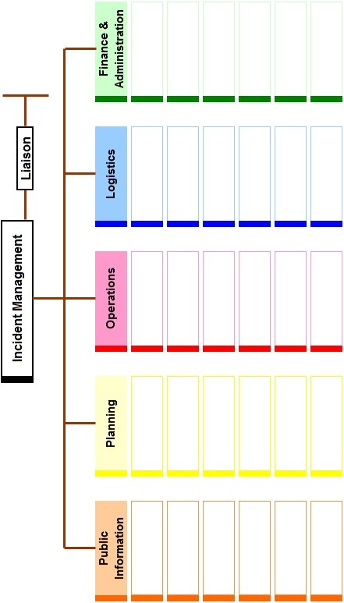
BIMS 201  20120824 | PAGE 3 | 11. PREPARED BY (NAME AND POSITION)

Template | BIMS 201 (p.4) – Resource Summary
V 1.0 | Created 20100203 – (adapted from ICS 201)

12. RESOURCE SUMMARY
RESOURCE |  | IDENTIFICATION | ETA | ON SITE | ASSIGNMENT
BIMS 201  20100302 | PAGE 4 | 13. PREPARED BY (NAME AND POSITION)

Template | BIMS 202 – Incident Objectives
V 1.0 | Created 20100203 – (adapted from ICS 202)

INCIDENT OBJECTIVES |  | 1. INCIDENT NAME |  |  | 2. DATE PREPARED |  | 3. TIME PREPARED
4. OPERATIONAL PERIOD (Date/Time)

5. OVERALL INCIDENT OBJECTIVE:

6. OBJECTIVES FOR THIS OPERATIONAL PERIOD:

7. WEATHER FORECAST FOR OPERATIONAL PERIOD:

8. GENERAL SAFETY MESSAGE:

9. ATTACHMENTS ( TICK IF ATTACHED)
- ORGANISATION LIST/CHART |  |  | - MEDICAL PLAN
- ASSIGNMENT LISTS |  |  | - INCIDENT MAP
- COMMUNICATIONS PLAN |  |  | - PUBLIC INFORMATION PLAN
BIMS 202  20100302 | 10. PREPARED BY (Planning Manager) |  |  | 11. APPROVED BY (Incident Manager)

Template | BIMS 203 – Organisation Assignment List
V 1.1 | Amended 20120824 – (adapted from ICS 203)

ORGANISATION ASSIGNMENT LIST |  |  | 1. INCIDENT NAME |  |  | 2. DATE PREPARED |  | 3. TIME PREPARED
4. OPERATIONAL PERIOD (Date/Time)

5. INCIDENT MANAGEMENT |  |  |  | 9. OPERATIONS SECTION
FUNCTION |  | NAME |  | FUNCTION |  |  | NAME
Manger |  |  |  | Manger
Deputy |  |  |  | Deputy
6. AGENCY REPRESENTATIVES
AGENCY |  | NAME
7. PUBLIC INFORMATION
FUNCTION |  | NAME
Manger
Deputy
8. PLANNING SECTION |  |  |  | 10. LOGISTICS SECTION
FUNCTION |  | NAME |  | FUNCTION |  |  | NAME
Manger |  |  |  | Manger
Deputy |  |  |  | Deputy
 |  |  |  | 11. FINANCE & ADMINISTRATION SECTION
 |  |  |  | FUNCTION |  |  | NAME
 |  |  |  | Manger
 |  |  |  | Deputy
BIMS 203  20120824 | 12. PREPARED BY |  |  |  | 13. APPROVED BY

Template | BIMS 205 – Incident Communications Plan
V 1.0 | Created 20100203 – (adapted from ICS 205)

INCIDENT COMMUNICATIONS |  |  | 1. INCIDENT NAME |  | 2. DATE PREPARED |  | 3. TIME PREPARED
4. OPERATIONAL PERIOD (Date/Time)

5. OVERALL INCIDENT OBJECTIVE:

SYSTEM | CHAN/FREQ/No. |  | FUNCTION | ASSIGNMENT |  | COMMENTS
BIMS 205  20100302 |  | 6. PREPARED BY (NAME AND POSITION)

Template | BIMS 206 – Medical Plan
V 1.0 | Created 20100203 – (adapted from ICS 206)

MEDICAL PLAN |  |  | 1. INCIDENT NAME |  |  | 2. DATE PREPARED |  |  | 3. TIME PREPARED
4. OPERATIONAL PERIOD (Date/Time)

5. MEDICAL AID STATIONS
STATION NAME |  | LOCATION |  |  |  |  | STAFFED BY |  |  | PARAMEDICS
 |  |  |  |  |  |  |  |  |  | Yes / No
6. TRANSPORTATION
A. AMBULANCE SERVICE
STATION NAME |  | ADDRESS |  |  |  |  | PHONE |  |  | PARAMEDICS
 |  |  |  |  |  |  |  |  |  | Yes / No
B. INCIDENT AMBULANCE
NAME |  | LOCATION |  |  |  |  | PHONE / RADIO |  |  | PARAMEDICS
 |  |  |  |  |  |  |  |  |  | Yes / No
7. HOSPITALS
NAME / ADDRESS / PHONE |  |  |  | SPECIALIST FACILITIES (if any) |  |  | TRAVEL TIME |  |  | HELIPAD  Yes / No
 |  |  |  |  |  |  | AIR | GRD |  | HELIPAD  Yes / No
8. MEDICAL EMERGENCY PROCEDURES
BIMS 206  20100302 | 9. PREPARED BY |  |  |  | 10. APPROVED BY

Template | BIMS 208 (p.1) – Incident Appreciation
V 1.0 | Created 20100203

INCIDENT APPRECIATION | 1. INCIDENT NAME | 2. DATE PREPARED | 3. TIME PREPARED
4. AIM:

5. OBJECTIVES:

6. FACTORS: | 7. DEDUCTIONS:

Template | BIMS 208 (p.2) – Incident Appreciation
V 1.0 | Created 20100203

8. COURSES OPEN:

9. RISK ASSESSMENT ON COURSES OPEN AND REFLECT BEST COURSE:

11. RECOMMENDATION:

BIMS 208  20100302 | 11. PREPARED BY (Planning Officer) | 12. APPROVED BY (Planning Manager)

Template | BIMS 209 – Incident Action Plan (IAP)
V 1.0 | Created 20100203 – (Courtesy NSW DPI)

INCIDENT ACTION PLAN | 1. INCIDENT NAME | 2. DATE PREPARED | 3. TIME PREPARED

LOCATION |  | CONTROL LEVEL | OPERATIONAL PERIOD (Date/Time)  From: To:
- SITUATION
Disease, community, environment  PROMPTS:  Weather, disease trends, Resources, Hazards & safety  REFERENCE:  Maps, weather reports, Sitreps, appreciation, warnings, alerts | CURRENT
 | PREDICTED
- OBJECTIVES (or MISSION)
PROMPTS:  Time & space  REFERENCE:  Appreciation – control options, courses open to disease | CURRENT
 | ALTERNATE
- EXECUTION (add safety information here or as part 6.0)
GENERAL OUTLINE
PROMPTS:
Strategies & tactics
(current/proposed/alternate)
REFERENCE:
Appreciation, Control Options
GROUPINGS
TASKS
Including PR & Media
COORDINATING INSTRUCTIONS
PROMPTS:
Timings, routes, assembly areas, staging areas

- ADMINISTRATION (Resources support)
PROMPTS: Unit names, locations, contact names, phone no’s, timings, duties/tasks, routes, suppliers, quantities, status (required, organised, stand by, enroute)
SUPPLY
WHO, WHAT, WHERE, WHEN of resources not readily available

GROUND SUPPORT
Transport of personnel, traffic mgt, refueling, mechanical repair/maintenance

COMMUNICATIONS
Installation, maintenance, technical advice

STAGING AREA / FCP
Setting up, communications, staffing

- ADMINISTRATION (Logistics Services)
PROMPTS: Unit names, locations, contact names, phone no’s, timings, duties/tasks, routes, suppliers, quantities, status (required, organised, stand by, enroute)
FACILITIES
Security, waste, cleaning

CATERING

OH&S / MEDICAL

FINANCE

TRAVEL

INDUCTION / TRAINING

ACCOMMODATION

6.0 CONTROL & COORDINATION
CONTROL & COORDINATION STRUCTURE
REFERENCE
Structural Chart
COORDINATION & LIAISON
Local knowledge, police, agency reps, emergency mgt reps
COMMUNICATIONS
PROMPTS
Communications structure, operational comm’s plan, information mgt
7.0 SAFETY
PROMPTS:
OHS, PPE, Biosecurity requirements, hazards

EXTRAS
Attachments
PROMPTS:
maps, weather, organisational charts, resources, comms diagram
Plan developers
PROMPTS:
PO, OO, Res Mgr, Controller

BIMS 209  20100302 | PREPARED BY (Planning Manager) | APPROVED BY (Incident Manager)

Template | BIMS 210 – Situation Report (SITREP)
V 1.0 | Created 20100203 – (Courtesy – Sub Committee for Emergency Animal Disease)
SITUATION REPORT (SITREP)
FROM: <<origin of Sitrep i.e. Local Control Centre, State or National Coordination Centre>>
TO: <<primary recipient/s of SITREP>>
SITUATION REPORT NUMBER: <<should be progressive, starting at 01>>
TIMEFRAME COVERED: <<date and time to date and time>>
ISSUED AT: <<date and time>>
TITLE <<e.g. Response to (pest/disease, state, year) >>
1.0 CURRENT SITUATION
Insert a brief description of the current situation. This could include general overview and then detail on new developments. Maps and graphs may be attached to illustrate key points or provide a visual representation of the current situation.
2.0 CURRENT ACTION
Insert a brief description of current action being undertaken to resolve the situation and actions that may be planned for the next operational period/s.
3.0 PREDICTED SITUATION
Insert a prognosis of the likely development of the incident over the next operational period and beyond, if known. This could include discussion of the situation in a bordering state/area that has potential for impact on the situation.
4.0 ISSUES
Discuss issues that need to be resolved to respond to the incident. Consider external issues that may impact on the response that need to be managed.
5.0 LOGISTICS and SUPPORT REQUIREMENTS
Identify any likely logistical and support required to resolve the incident. This will enable providers to prepare for requests, thus reducing response time. Formal requests for support should be made separately and not included in the situation report.
6.0 NEXT SITREP
The next SITREP will be issued at <<insert date/time>>.
Approved by <<Name / position>>
<<Date>>
Distribution
Identify groups or individuals the SITREP will be distributed to.
Contact details
<<Incident Management Point location/Contact details for more information>>

Template | BIMS 214 – Operations Log
V 1.0 | Created 20100203 – (courtesy DAFF)

OPERATIONS LOG |  | 1. INCIDENT NAME | 2. DATE PREPARED | 3. POSITION
TIME | COMMENT |  | ACTION
BIMS 214  20100302 | 4. PREPARED BY (NAME AND POSITION)

Template | BIMS 215 – Issues Log
V 1.0 | Created 20120824 – (courtesy DAFF)

ISSUES LOG |  | 1. INCIDENT NAME | 2. DATE PREPARED | 3. POSITION
TIME | COMMENT |  | ACTION
BIMS 215  20120824 | 4. PREPARED BY (NAME AND POSITION)

Template | BIMS 230 – Daily Meeting Schedule
V 1.0 | Created 20100203

DAILY MEETING SCHEDULE |  | 1. INCIDENT NAME |  |  | 2. DATE PREPARED | 3. TIME PREPARED
4. OPERATIONAL PERIOD (Date/Time)
From: To:
5. Meeting Schedule
Date/Time | Meeting Name |  | Purpose | Attendees |  | Location
BIMS 230  20100302 | 6. PREPARED BY: |  |  | 7. APPROVED BY:

Template | BIMS 231 – Meeting Summary
V 1.0 | Created 20100203

MEETING SUMMARY |  | 1. INCIDENT NAME |  | 2. MEETING DATE | 3. MEETING TIME
4. MEETING NAME:

5. MEETING LOCATION:

6. CHAIR / FACILITATOR:

7. ATTENDEES:

8. NOTES (with summary of decisions and action items)

BIMS 231  20100302 | 9. PREPARED BY: |  | 10. APPROVED BY:

Template | Incident Specific Response Plan
V 1.0 | Created 20100203
INCIDENT SPECIFIC RESPONSE PLAN
NOTE: During the response to animal or plant health incidents, covered by the EADRA or EPPRD, the template appearing in Schedule 4 of the respective deed/agreement is to be used.
FROM: <<origin i.e. State Coordination Centre…>>
TO: National Consultative Committee for <<insert details>>
ISSUED AT: <<date and time>>
TITLE <<e.g. Response to (pest/disease, state, year) >>
- CURRENT SITUATION
Insert a brief description of the current situation and an indication of future trends, if available. This could include general overview and then detail on new developments. Maps and graphs may be attached to illustrate key points or provide a visual representation of the current situation.
- ANALYSIS
  - Risk Assessment
  - Technical Feasibility Analysis
  - Benefit:Cost Analysis
- RESPONSE STRATEGY
Based on the analysis describe the proposed strategy for responding to this incident.
- ACTIONS & RESPONSIBILITIES
Discuss specific actions that will be taken and who has responsibility for implementing these actions.
- PROOF OF FREEDOM
Describe how proof of freedom will be achieved.
- BUDGET & INDICATIVE COSTS
Discuss the expected budget required and indicative costs of implementing the proposed response strategy.
- REVIEW POINTS
Identify at what points the response strategy needs to be reviewed. This may relate to a $ value or time frame.
Approved by <<Name / position>>
<<Date>>
Contact details
<<Incident Management Point location/Contact details for more information>>

Operational and tactical level planning are further described in section 3.1.
Definition adapted from Australian Defence Force publication ADDP 5.0 Joint Planning (1 Jan 2006)
Schedule 4.3. - Inter Governmental Agreement for Responding to Nationally Significant Biosecurity Incidents.
Response agreements include: Emergency Animal Disease Response Agreement (EADRA) and Emergency Plant Pest Response Deed (EPPRD)
The numbering system adopted for Biosecurity Incident Management System documentation is consistent with other national and international Incident Management Systems, i.e. ICS201, used in a fire incident will also be an ‘Incident Briefing Form’

