My submission to the Australian Standards for the Export of Live Animals – Review.

Monday, November 26, 2018

To whom it may concern,

I thank you for the opportunity to make this submission.

In 1984, the Senate Select Committee of Inquiry into Animal Welfare stated that the live export trade should be banned on animal cruelty grounds alone.

This was decades before the Indonesian, Egyptian, Vietnamese, Pakistani, etc…., exposés.

Thirty-four years, three reviews, ESCAS and various regulations later, and the only progress for the animals is thanks to whistle-blowers and animal charities.

This year, we’ve yet again seen the failure of the live export industry to protect Australian animals from abject cruelty on board ships.

We’ve seen animals subjected to cramped, filthy environments, bogged down in their own faeces and without clear access to food and water, giving birth, and cooking alive.

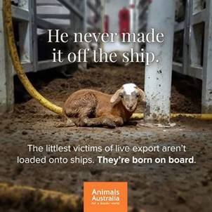

The Moss Review into the Department of Agriculture’s handling of our live export trade is most welcome, and predictably scathing (31.10.18).

[**'Beyond redemption': Renewed push to ban live exports following damning report**](https://l.facebook.com/l.php?u=https%3A%2F%2Fwww.smh.com.au%2Fpolitics%2Ffederal%2Fbeyond-redemption-renewed-push-to-ban-live-exports-following-damning-report-20181031-p50d5h.html%3Ffbclid%3DIwAR1aFW9PMq0Z2Ravn3frsKqxfFfHr08YguamfdAmcilQMcol9vgiEC2X_hk&h=AT0cu3h3DpW0FBqVGBdwEpaTgqGwfW5UJOhamOAMSRsp0gB6B-y8TzJNsx-m__YKj9aI_aosMfnQhJhf2hTyvy7dkf-sPD921-gyyp_Q5mHZE1en247q_0GxEZi44E9qJ5abclF73dVAQyCM2ENC4IbVZBSNohjzCAxn1t6Tck_w5aXOgRvRCcC01VOIwRPyaC5KNTO6FQWS5N_e-TotkfPI78d1YTvNhVLwdQLJoBrPx090KFisBoAw1DRkjnYYbsGIImlhEEkDhEVoGaU_WRsaQ6CzpxYLUtdSifpvQV7hVj0XlvqR67GWqcMkc0-eNmfB9iVNBgt9o9MIcER57rKf-e-BKvopbxlfnLyQ4sAvBvkinut9uNuK94ILwSFcJh7eJiCDYBk9USdXmFCXd9mQTgGtJI2jMnm6GsUd0aCaJvMR6ZkE4dqWU4JXsrNMw5qokA)- SMH, 31.10.18

<https://www.smh.com.au/politics/federal/beyond-redemption-renewed-push-to-ban-live-exports-following-damning-report-20181031-p50d5h.html?fbclid=IwAR1aFW9PMq0Z2Ravn3frsKqxfFfHr08YguamfdAmcilQMcol9vgiEC2X_hk>

And yet the ASEL review is actually proposing (among other non-progressive proposals) that the new standards:

-  will still not allow sheep to lie down at the same time;

-  will still not have ready access to food and water; 1/4

-  will allow the continuation of the horrendous, deadly furnace conditions of Northern summer shipments.

-  and have actually suggested that one stockperson is enough to monitor 30,000 sheep

For all the reviews this year, and tough talk from the government, very little if anything would change for animals.  It is ludicrous!

The proposed ASEL Standards must do better for animal welfare – Australians will not stand for the cruelty of this industry to continue unchecked,

and I’m writing to you to voice my concerns and my expectations for better treatment of animals within the new standards.

Below are the changes I am urging be made to the recommended Standards.  Detailed evidence to support these changes is provided in the submissions put forward by RSPCA Australia and the Australian Veterinary Association.

**Sourcing and preparation of animals**

*  No cattle should be exported from southern ports across the equator during the high-risk May to October period.

* The upper weight limit for all cattle being exported should be set at 500 kg, not at 650 kg, with no exemptions.

*  Sheep must be rested for at least two clear days after shearing and prior to loading, to overcome the cumulative stress of road transport, handling and shearing and to ensure all shearing wounds are healed.

*  No sheep, whatever the breed, should be allowed on board a ship with more than 25mm of wool or hair.

**Space allowance for sheep and cattle**

*  The space allowances proposed in the draft Standards are still far too small and will force animals to ‘time share’ their space.

Space allowances must be increased to ensure all animals in a group are able to lie down comfortably at the same time and easily access feed and water, whether they are in a registered premises or on-board ship.

**Heat stress risk assessment (HSRA)**

*  The heat stress risk assessment (HSRA) model should be applied to all voyages crossing the equator, at all times of year, from all ports.

**2/4**

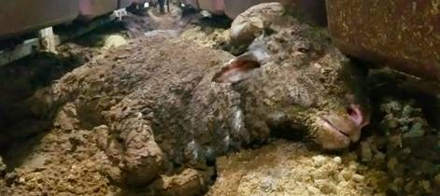

- He is still alive

**Voyage reporting**

*  Voyage reporting requirements should be increased to include more detailed daily welfare monitoring at the pen level, with monitored pens chosen independently of exporters to ensure transparency and accuracy.

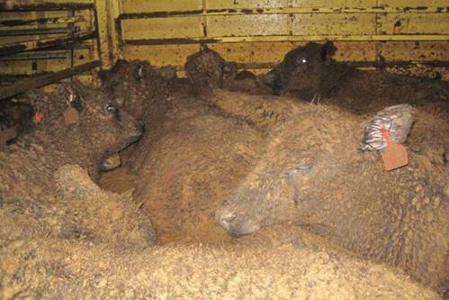

*  Voyage reports should be made publicly available to demonstrate that exporters have nothing to hide.

**Onboard management**

*  Ammonia levels must be tracked using ammonia meters, and action taken when they reach harmful levels.

3/4

**Onboard personnel**

*  There must be at least one accredited stockperson per 2,000 head of cattle and 8,000 head of sheep (not 3,000 cattle and 30,000 sheep), to allow effective monitoring of stock.

* A qualified Australian Government Accredited Veterinarian (AAV) must be on board every live export voyage, for supervision and monitoring, as well as an independent auditor with ultimate responsibility for reporting requirements.

**Species permitted to be exported**

* Live export of sheep to the Middle East during the May to October high risk period must cease immediately.

* The live export of feral buffalo should be prohibited, as they are unused to human contact and clearly do not tolerate handling and transport without serious welfare compromise.

* The export of feral goats, camels and deer should be prohibited, based on previous extreme mortality events and serious concerns over the handling and care of these species.

I’m joining the RSPCA in calling for these changes to be made, and Minister, I urge you to consider these in your review.

Finally, it is obviously critical to ensure public accountability and enforcement across all standards.

Please reply as soon as possible to advise how you will be addressing community expectations and animal welfare concerns in your review of the ASEL standards.

Yours faithfully,

Cheryl Forrest-Smith

4/4