Review of the Australian Standards for the Export of Livestock (ASEL)

27 November 2018

Contact: Jennifer Windsor
President, NSW Young Lawyers
Daniel Cung
Chair, NSW Young Lawyers Animal Law Committee
Contributors: Ashleigh Best, Devina Verma

The NSW Young Lawyers Animal Law Committee (Committee) makes the following submission in response to the Review of the ASEL (Review).

NSW Young Lawyers
NSW Young Lawyers is a division of The Law Society of New South Wales. NSW Young Lawyers supports practitioners in their professional and career development in numerous ways, including by encouraging active participation in its 15 separate committees, each dedicated to particular areas of practice. Membership is automatic for all NSW lawyers (solicitors and barristers) under 36 years and/or in their first five years of practice, as well as law students. NSW Young Lawyers currently has over 15,000 members.

The Committee comprises a group of over 400 members interested in animal welfare and laws regulating the treatment of animals. The Committee aims to raise awareness and provide education to the legal profession and wider community, while increasing understanding about the importance of protecting animals from abuse and neglect. A common theme amongst Committee members is a passion and desire to use their legal skills and the law to help improve the lives of animals.

Summary of Recommendations
The Committee submits that:
- The definition of ‘notifiable incident’ contained in the Draft Standards prepared in connection with the review should be clarified expressly to embrace incidents which are common or expected;
- Reports of notifiable incidents should include information about action taken to address the incident to which the report relates;
- The process of accrediting stockpersons and veterinarians should be amended to involve the Australian Veterinary Association and the RSPCA, in order to enhance independence and accountability;
- The regulatory approach should be amended to ensure that compliance is a strictly required and that failure to comply with standards is met with adequate penalties; and
- Although innovation by industry participants to enable them to meet and exceed standards should be encouraged, strategies developed through such innovation should not be considered to be valid alternatives to the satisfaction of baseline standards.
Discussion
Voyage reporting

In summary, Draft Standard 4F.1 establishes the following requirements in relation to export by sea:
- If a notifiable incident occurs at any time, a report must be provided to the relevant Australian Government agency by the Master of the vessel or on-board accredited veterinarian: Draft Standard 4F.1(a);
- The report must be made within twelve hours of the notifiable incident occurring: Draft Standard 4F.1(b); and
- If the notifiable incident involves a mortality rate or average daily mortality rate equal to or greater than the reportable level, a report must be provided that includes:
  - Details of the mortalities;
  - Potential causes;
  - The location and estimated time of arrival of the subject vessel: Draft Standard 4F.1(3).

A ‘notifiable incident’ is defined as one which ‘has the potential to cause serious harm to the health and welfare of animals.’ The mere fact of exporting animals live has the potential to cause serious harm to their health and welfare; in 1985, the Senate Select Committee on Animal Welfare described the practice as ‘inimical to good animal welfare’. Accordingly, the definition of ‘notifiable incident’ should be clarified to ensure that distress and injury occurring as inexorable consequences of export by sea cannot be dismissed. For example, any psychological stress experienced by livestock being exported by sea as a result of their confinement should be a ‘notifiable incident’, notwithstanding that it might be a common outcome of live export. The Committee recommends that the Draft Standards should instead define a ‘notifiable incident’ as one which ‘has the potential to cause serious harm to the health and welfare of animals, including incidents which are common or expected to occur.’

Additionally, it is unclear why reports of notifiable incidents involving a mortality rate or average daily mortality rate equal to or greater than the reportable level are not currently required to contain details of remedial action taken to abate the notifiable incident or further similar incidents. Draft Standard 4F.1(3) should be amended to include a requirement for the report to identify – with precision – the response of onboard personnel to the notifiable incident.

Onboard personnel
Draft Standard 3B.5 establishes the requirement that the ‘on-board management of livestock of sea must ensure the health and welfare of animals throughout the voyage’, and continues by setting out the roles of accredited veterinarians, accredited stockpersons and competent stock handlers.

The Definitions to the Draft Standards define:
- Accredited stockperson[s] as stockpersons who are accredited by LiveCorp for the shipboard husbandry of livestock; and
- An accredited veterinarian as a veterinarian who is accredited under section 4A.07 of the Export Control (Animals) Order 2004 to carry out duties in relation to the export of livestock. Otherwise known as an Australian Government Accredited Veterinarian.

These are the only roles carrying accreditation which the Draft Standards define. It is notable that the accrediting bodies, LiveCorp in the case of stockpersons and the Australian Government in the case of veterinarians, each have an economic interest in the live export industry. Further, the Committee notes that these entities do not have specific and exclusive expertise in the disciplines they accredit.
The Committee does not suggest that LiveCorp or the Australian Government should be excluded from the accreditation process entirely. However, in the interests of independence and transparency, entities with relevant expertise in animal management and veterinary science, such as the Australian Veterinary Association or the Royal Society for the Prevention of Cruelty to Animals should be involved in accrediting individuals for the purposes of employment on live export vessels.

Insofar as this would require an amendment to the Export Control (Animals) Order 2004, the Committee notes that the Order is delegated legislation and does not require the passage of an Act of Parliament to be amended.
Regulatory approach
The Stage 2: Draft Report states as follows:

The committee is mindful that the current ASEL is predominately an input based regulation model. It assumes that if the inputs are controlled then a satisfactory animal welfare outcome will follow.

However, best practice regulation is to focus on the outcomes desired and to promote compliance via incentive based mechanisms as well as input based processes. This encourages innovation in achieving the desired outcomes rather than simply ‘ticking the boxes’ to demonstrate compliance with the regulation.

An input based regulation model assumes that there is only one way – the regulated way – to achieve the desired outcomes. Achieving good animal welfare outcomes can be achieved by different combinations of factors and the proportion of each…

The committee accepts that there needs to be a minimum set of requirements and has outlined these in earlier chapters. Minimum standards and enforcement are essential if the public is to regain trust in the system. But it also believes that there should be scope for the Regulator to reward superior performance based on demonstrated outcomes. It has the data to identify those operators who consistently achieve better welfare outcomes including low mortality and other reportable incidents and those that do not. The AAVs—and now independent observers—are able to report on the results of innovative practices being used and their results, and how different combinations of inputs can achieve the same or better outcomes. This should be encouraged, not discouraged by limiting operators to just the requirements of the standard and not considering alternative, innovative ways in which to achieve the desired welfare outcomes.

The Committee is particularly concerned with this aspect of the Draft Report.

First, the suggestion of the second paragraph extracted above, being that best practice regulation involves a combination of input and incentive based regulation, overlooks the fact that participation in an industry such as the live animal export trade, given the impact upon those animals, is a privilege, not an entitlement. Strict compliance should be a baseline expectation, and violations should be met with substantial penalties to ensure a deterrence effect. If participants are not unconditionally prepared to comply with the standards, and instead require incentives to do so, they should no longer be permitted to participate in the industry.

Secondly, the Committee strongly opposes the inclusion of any scope within the regulatory framework for derogation from the baseline standards. Not only would such an approach complicate the administration of the legislative instruments regulating the industry, it would also represent a clear attempt to construct a mechanism by which participants can circumvent obligations to which they would otherwise be subject. The Committee encourages the development of innovative strategies for the improvement of animal welfare in the live export industry that ensure participants can meet or exceed baseline standards; however, the implementation of such strategies should not be relied on as a justification for departing from foundational standards.

Concluding Comments
NSW Young Lawyers and the Committee thank you for the opportunity to make this submission. If you have any queries or require further submissions please contact the undersigned at your convenience.

Contact:  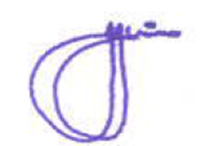  Jennifer Windsor  President  NSW Young Lawyers | Alternate Contact:  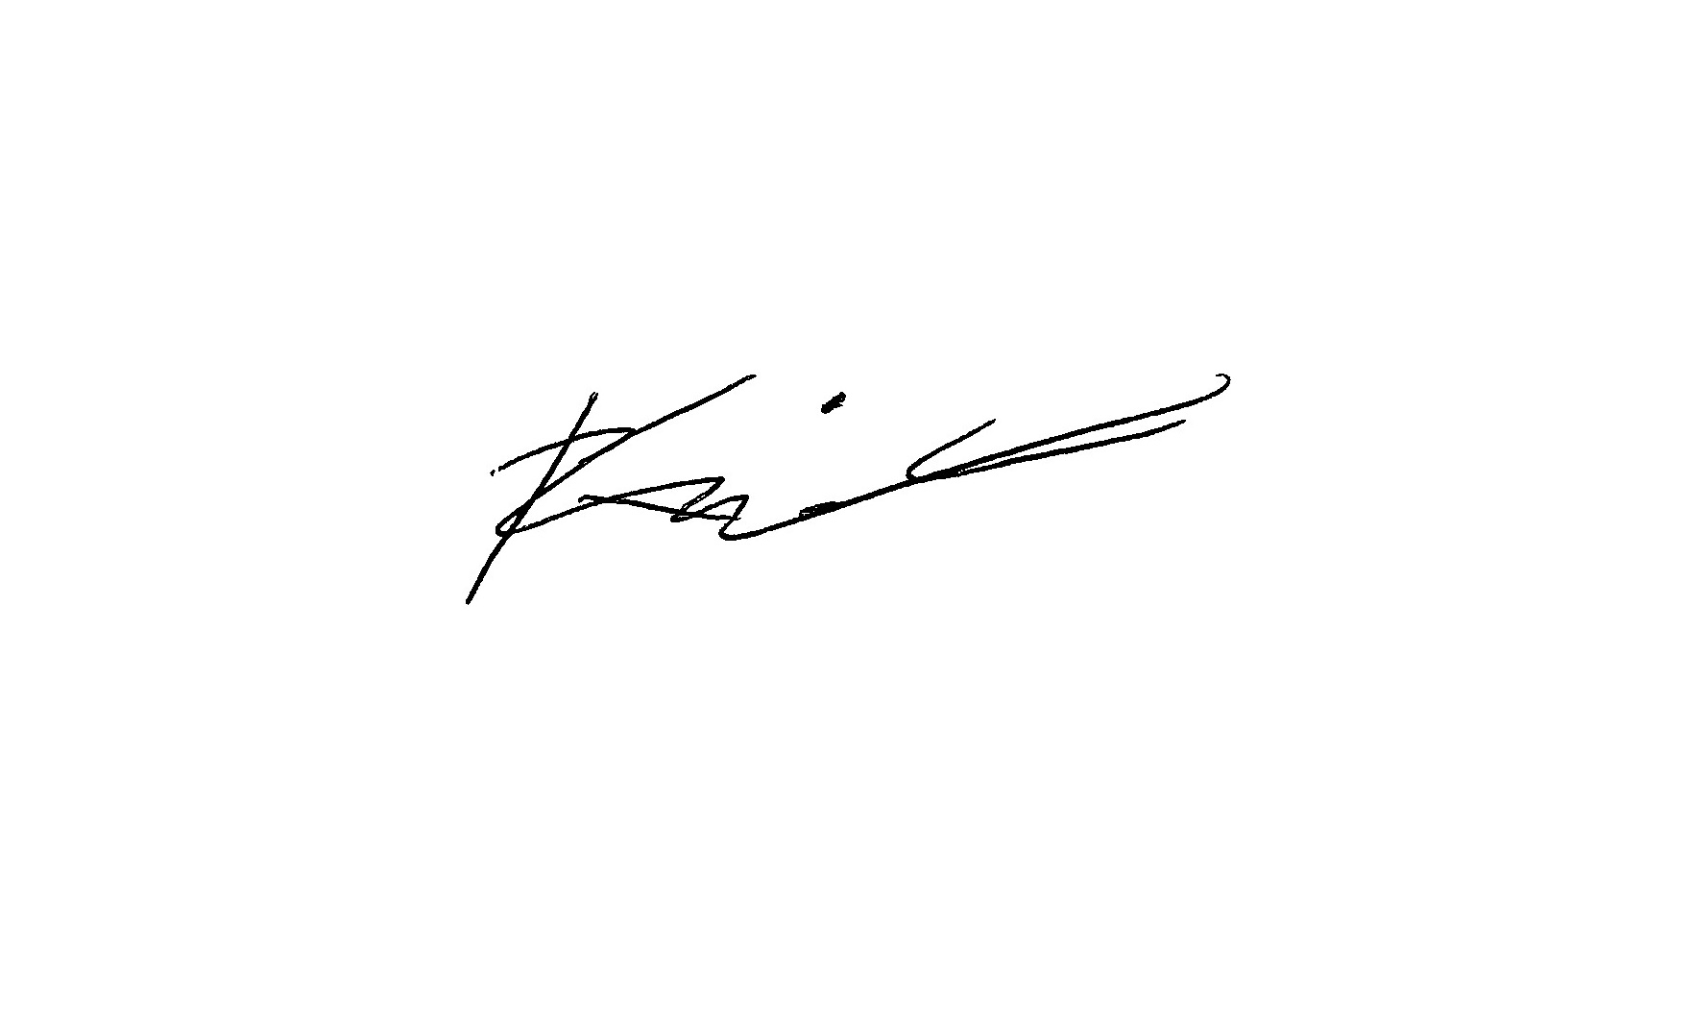  Daniel Cung  Chair  NSW Young Lawyers Animal Law Committee

Department of Agriculture and Water Resources - Review of the Australian Standards for the Export of Livestock –Technical Advisory Committee, Draft Standards (30 October 2018) 12.
Ibid 12.
Senate Select Committee on Animal Welfare, Report – Export of Live Sheep from Australia (1985) 185–186.
Department of Agriculture and Water Resources - Review of the Australian Standards for the Export of Livestock –Technical Advisory Committee, Stage 2: Draft Report (2018) 65-66.

