AQIS | AUSTRALIAN QUARANTINE AND INSPECTION SERVICE  DEPARTMENT OF AGRICULTURE, FISHERIES & FORESTRY

E-CERT

General User Manual

Last updated:
5 April 2005

Table of Contents

1. INTRODUCTION 1

1.1 What is E-cert? 1
1.2 E-cert Technology 1
1.3 Access 1
1.4 International Data Standards 1
1.5 Transmission 1
- Standard Operating Access Protocol (SOAP) 1
- Push Technology 1

2. E-CERT 2

2.1 WEBSITE 2

2.1.1 E-cert Home Page 2
2.1.2 Search 3
- Certificate List 3
- Certificate Display 4
2.1.3 Interactivity on the website 5
2.1.4 Password 5
2.1.5 Help 6
2.1.6 Logout 6

2.2 WEBSERVICE 6

    - Downloading from the website Search Results screen 6
    - Downloading from the website Certificate display screen 7

INTRODUCTION

1.1 What is E-cert?

E-cert is an electronic certification system for government to government sanitary and phytosanitary certificates issued for traded food and agricultural commodities.

1.2 E-cert Technology

E-cert is a web based system using Extensible Markup Language (XML) to transmit data. XML is a plain English text language most suitable for web based applications.

1.3 Access

Access to view or download E-cert data is restricted to parties identified by participating government authorities. The level of access will depend on agreed system use. For more information regarding access protocols, please refer to the Terms of Reference between AQIS and your organisation.

AQIS scheduled outages for the E-cert application take place every Tuesday between 19:00hrs and 00:00hrs (AEST) and every Sunday between 08:00hrs and 12:00hrs (AEST).

1.4 International Data Standards

United Nations Centre of Trade Facilitation and Electronic Commerce (UNCEFACT) will set a data standard for electronic certification. This process is under way with Australia and New Zealand leading the E-cert Project Team at UNCEFACT.

1.5 Transmission

The importing authority may either view the data on the web application and download from the site, pull the data from the AQIS application via interaction with the Standard Operating Access Protocol (SOAP) or have the data sent directly to their dedicated application.

Simple Object Access Protocol (SOAP)

The SOAP interface has been designed to allow semi-automated downloading. Users log on with a User Name and Password. Certificates are viewed and downloaded in XML. For further information on developing a SOAP application please contact the E-cert Administrator at ecertadministrator@daff.gov.au

Push Technology (SMTP)

The Push service has been developed to allow for automated secure system to system transmission of certificate data. Data is presented in XML format and is encrypted and transmitted using S/MIME protocols. For further information on utilising the Push service please contact the E-cert Administrator at ecertadministrator@daff.gov.au

E-CERT

  - WEBSITE

The E-cert website provides access to export certificate data via a secure website. The website exists as a Test environment which contains test data and is available for development, testing and training purposes, and the Production (or live) site which contains live data.

2.1.1 E-cert Home Page

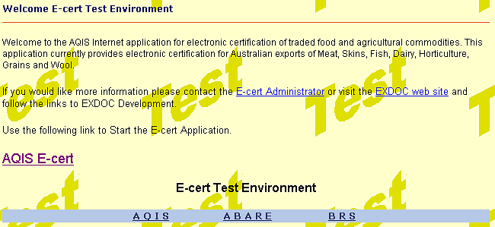

Click the link to access the login screen.

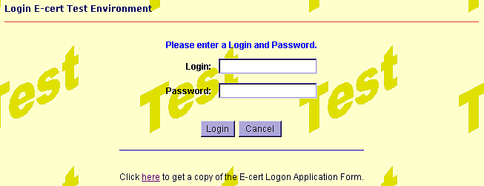

To log in, type in your login ID and Password. When logging on for the first time the system will ask you to change your password. Details of how to change your password are outlined at 2.1.3.

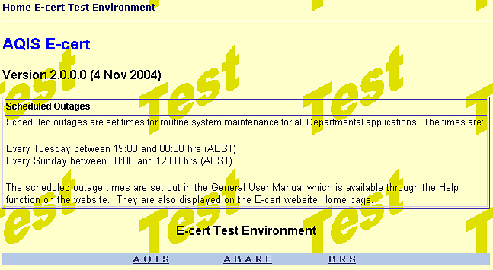

After successfully logging on the following menus can be accessed from the Home page by clicking on the tabs:

2.1.2 Search

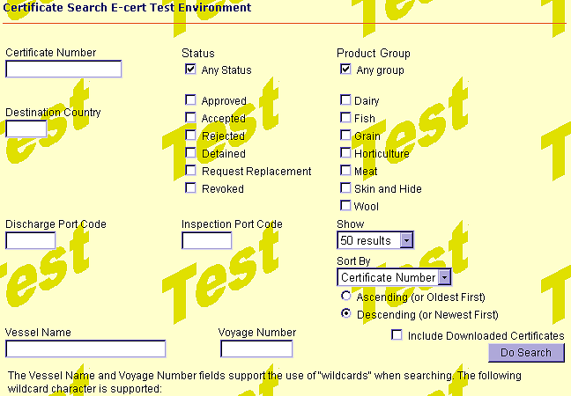
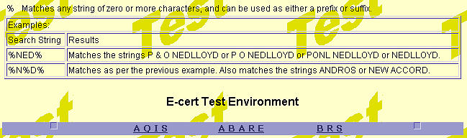

Certificates can be searched for in several ways, including Certificate Number, Discharge Port, Vessel Name, Voyage Number, Status and Product Group.

Any combination of product groups can be searched for by ticking the appropriate box . Results can be shown in groups of 50, 100, 200 or 500 and can be sorted by Certificate Number or Status in Ascending or Descending order.

Hit Enter or click the button to perform the search.

Certificate List (Search Results)

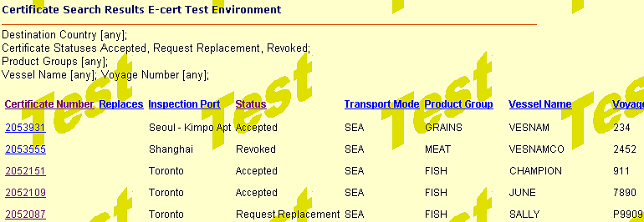

The Certificate Search Results screen displays the list of certificates returned from your search criteria. The list can be re-sorted by clicking on the heading of the column you wish to sort by, eg. click to sort alphabetically by the Inspection Port, or to sort alphabetically by vessel name. The list will only display current certificates.

Click on the Certificate Number () to display that certificate. Click the button to return to your original search request, or click the tab to return to a blank search screen.
Certificate Display

Certificate details can be accessed from the link on the certificate list page, or by entering the certificate number in the search screen:

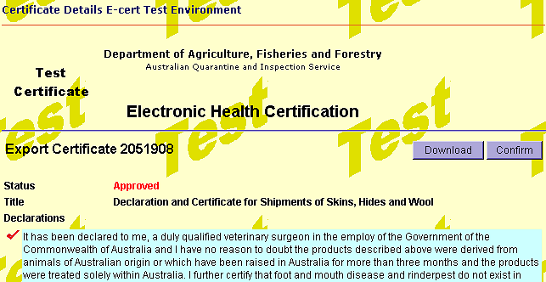
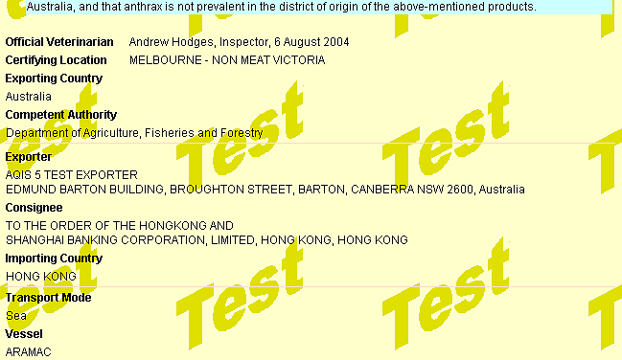
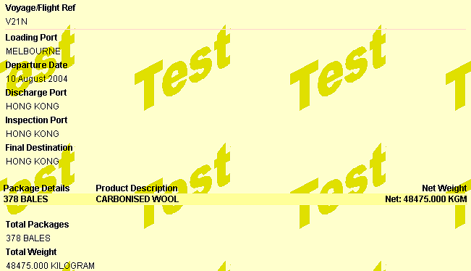
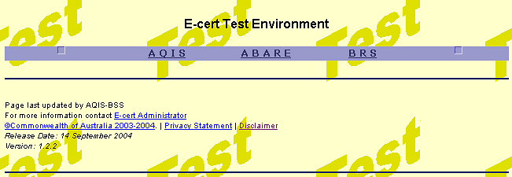
2.1.3 Interactivity on the website

Interactivity is the ability to update the status of a certificate. Only users with Standard or Admin permissions are able to use this functionality.

The status of a certificate at Approved may be updated to Accepted, Detained or Request Replacement. Notification of a change in status and a reason for the change (except in the case of Accepted status) must be sent to the E-cert Administrator.

The Update Certificate Status field is located at the bottom of the certificate.

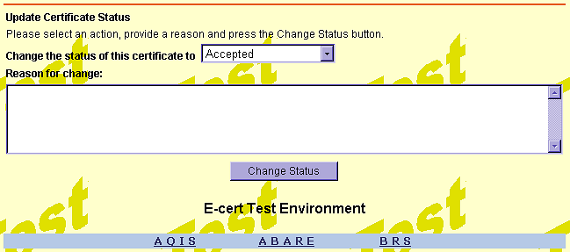
Certificates can be updated to Accepted, Detained or Request Replacement

Select the appropriate status from the drop down list, type the reason for change (in the case of Detained or Request Replacement) in the Reason for change field and click . The message is automatically sent to the E-cert Administrator.

2.1.4 Password

Passwords must contain at least one non-alpha character and be between seven and 15 characters.

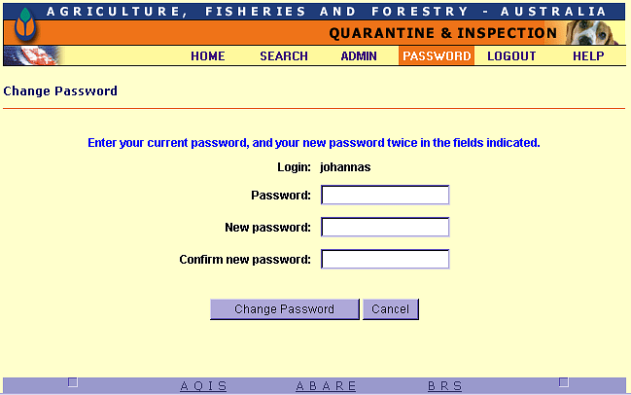

Users can change their password at any time through the Password screen. Enter your current password, then your new password twice. Click the button.

2.1.5 Help

The Help function links directly to the General User Manual. To exit, click .

2.1.6 Logout

Click the tab to log out. This will take you back to the Login page.

  - WEBSERVICE

Users can request a download of certificate data from the secure website. There are two methods of downloading: via the website or through the SOAP interface.

2.2.1 Downloading from the website Search Results screen

Access the website and perform your search. In the Search Results screen you will see the option to either ‘Select all’ or ‘Download’ (use the scroll bar at the bottom of the screen to scroll across to the last column ). Select All allows you to tick all the boxes on the screen, Download allows you to download the selected certificates.

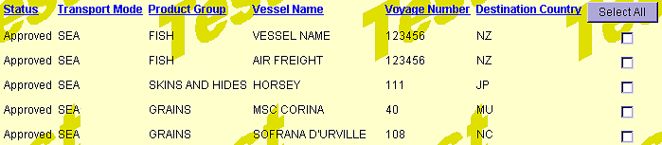

Once you have selected which certificates you wish to download, click the button. The following screen will appear asking to confirm the download:

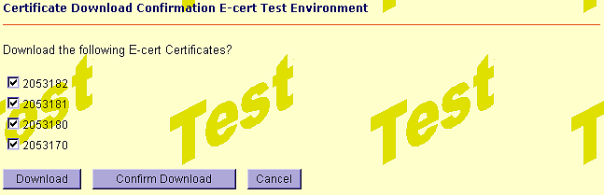

Click to proceed. To cancel click the button. Follow the prompts provided by your web browser to complete the download. The certificate will download in XML.

Once the certificate has downloaded, you may click the button to confirm that the download was completed successfully.

To include confirmed certificates in your search results tick the box located on the initial Search screen.

2.2.2 Downloading from the website Certificate display screen

Certificates may also be downloaded directly from the certificate screen. Access the website and perform your search.

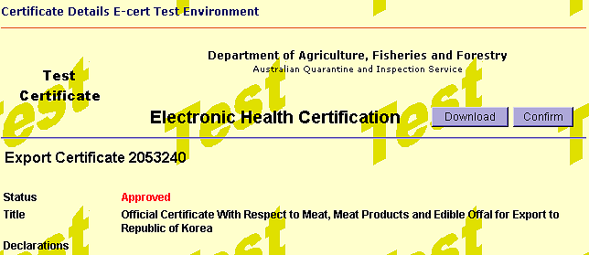

Click the button to proceed and follow the process outlined above.

