Volume 6 Part B: Pests and Diseases of Horticultural Commodities

Content

Introduction 2
Regulated Pests 2
Regulated Non–Quarantine Pests 2
Non – Quarantine pests 3
Method of collecting pests, diseases and contaminants 3
Contamination (inert and extraneous material) 4
Pests and diseases on fresh fruit and vegetable 7
Pests and Disease Symptoms found on Nursery Stock 8
Common Pests and Diseases on other plant and plant products 9
Quarantine Pests of Australia Found on Commonly Inspected Plant and Plant products 11
More Information 12
Relevant eLearning Modules 12
Questions 12

Introduction
Pest, disease and contaminants within plant export commodities are extensive and diverse and may be specific or general depending on the pest species and associated commodity.
This volume seeks to increase knowledge of pests, diseases and contaminants likely to be encountered by an authorised officer, however where uncertainty exists regarding an identification, the authorised officer must inform the exporter of their responsibility to seek professional identification.

For ease of finding information, this volume is specific to pests, diseases and contaminants applicable to plant and plant products excluding grain commodities.

For pests, diseases and contaminants applicable to grain commodities refer to the volume titled Pests, Diseases and Contaminants of Grain Commodities.

The information in this volume will assist authorised officers in the identification of pests, diseases and contaminants likely to be encountered within the commodity or associated with the flow path. Authorised officers are not expected to be able to identify all pests, diseases or contaminants herein.

Regulated Pests
Regulated pests are a pest of potential economic importance to the area endangered thereby and not yet present there, or present but not widely distributed and being officially controlled [FAO, 1990; revised FAO, 1995; IPPC, 1997]

Commonly noted regulated pests are fruit fly, mango seed weevil, light brown apple moth, bacterial black spot and orange fruit borer. The pests and diseases are located within different regions around Australia and the authorised officer needs to be aware of the pests and diseases that an importing country views as a regulated pest.

The authorised officer cannot determine whether a pest is a regulated pest. Official notification is found within the Manual of Importing Country Requirements (MICoR) database, the relevant work plan or the B-Lateral arrangement with the importing country.

Regulated Non–Quarantine Pests
Non – quarantine pests associated with Plant and Plant Products are snails and red back spiders. These pests are often not a pest of the commodity but are associated with the pathway. Importing countries can define them as of quarantine concern and must be treated in some manner.

Importantly an authorised officer will need to be aware of regulated non-quarantine pests, their economic and environmental significance and host commodities. These pests may not be located on the commodity but in the packaging or storage units like refrigerated containers.

The authorised officer cannot determine whether a pest is a regulated non –quarantine pest. Official notification is found within the MICoR database, the relevant work plan or the bilateral arrangement with the importing country.

Non – Quarantine pests
This may only apply where official notification has been received by AQIS from the NPPO of the importing country specifying official pest tolerances. They are pests that are not directly listed as a pest of the plant or plant product.

The authorised officer cannot determine whether a pest is a non –quarantine pest. Official notification is found within the MICoR database, the relevant work plan or the B-Lateral arrangement with the importing country. Some countries may have tolerances for non-quarantine pests.

Method of collecting pests, diseases and contaminants
Authorised officers should attempt to collect a representative sample of insects and not just the first specimen found. Try not to include substrate, soils and foliage with the specimens as this makes identification more difficult.

When live insects are found, an inspector should wet the brush with the 70% ethanol and then, with a rolling action, pick up the insect on the tip of the brush and transfer it to the sample tube.

For moths and other flying insects it may be necessary to place the wet brush over the wings to prevent flight. Often a moth will struggle from beneath the brush. Once it is wet, however, it may be readily picked up.

All specimens, except soft-bodied larvae (eg. caterpillars and maggots), should be collected into 70% ethanol. Do not use methylated spirits, it hardens the specimens and makes identification and long term storage very difficult. Caterpillars and fly maggots should be fixed in hot water (>70oC) (the Hydroboils or Miniboil in most lunch rooms are ideal) for a few minutes, then drain the water off and place the specimens into 70% ethanol.

Never leave them in water for an extended time as they will start to rot.

If specimens of dead insects (eg. Pupae and egg casings) are collected, they should be placed in tubes separate from any live ones and the labels marked accordingly. Live nematodes should be placed in tap water (not hot).

Plant material should be placed into zip lock bags. Place seed and weed contamination directly into the sample tube.

Equipment
Essential equipment that an authorised officer will find useful for the collection of pest, disease and contaminant specimens include:
- Sample tubes filled with 70% ethanol (ethyl alcohol) (approximately 3 parts alcohol:1 part water). Methylated spirits should only be used as a last resort
- small brush
- a good quality torch
- a scaper and or probe for recovering residues etc
- zip lock bag for plant material
- a pair of forceps (tweezers) suitable for collecting the larger species
- pencils for labelling tubes (pens aren't suitable as alcohol dissolves most ink).

Sample Collection
A nil tolerance for live pest infestation must be applied to all relevant goods presented for
inspection. It is advised that when authorised officers find insects within a consignment that
they collect samples for identification and reporting.

Labelling of samples
Samples should be labelled in pencil, so that they may be readily identified, using the multi-purpose self-adhesive labels supplied.

The label should include:
- the RFP number associated with the consignment
- Exporter details
- Commodity the pests or disease was located on
- the collectors name and the date collected
- There must be sufficient detail to trace the sample back to the consignment.

If the pest or disease needs to be identified it is the exporters responsibility to send the specimen to an entomologist or plant pathologist for identification. The exporter is then required to notify the authorised officer of the outcome.

Contamination (inert and extraneous material)

Inert Material
Import permits for the export of plant and plant products into a number of overseas countries have, on occasion, included an additional declaration requirement that the plant and plant products be free from inert material.

Authorised officers are advised that the definition of ‘inert material’ for phytosanitary certification purposes should be restricted to only sand and soil. Inspection for quality issues is not required.
An importing country authority may require a consignment to be free from inert material. AQIS will interpret this as a requirement that the consignment is practically free from sand and soil. If the import permit does not require an additional declaration of freedom from inert material, the AQIS visual inspection and generic endorsement on a phytosanitary certificate (section 19) is sufficient to verify this condition.

If the import permit requires freedom from inert material as an additional declaration, please refer the situation to the Regional Plant Exports Program Manager for further assessment on the phytosanitary risk.

Officers should avoid using the term inert material to reject a consignment. In instances where sand, soil or any other contaminants are clearly detectable, the individual contaminant should be recorded.

Extraneous Matter
Import permits may contain a requirement for AQIS to certify an additional declaration that the commodity be free from extraneous matter.

Extraneous matter may, or may not, be a phytosanitary issue and must therefore be considered carefully to ensure that phytosanitary matters are appropriately identified, compared to quality matters.

Extraneous is defined by the Macquarie Dictionary as not belonging to that thing of origin. Therefore, extraneous matter is defined for the purpose of export certification to be foreign plant debris coupled with sand and soil.

Extraneous matter does not include plant matter originating from the export commodity such as foliage connected to a strawberry.

AQIS provides certification for phytosanitary requirements, and does not certify quality parameters. Phytosanitary certificates should only include statements that relate to plant health and mitigate against valid phytosanitary risks.

AQIS cannot include additional declarations on phytosanitary certificates for freedom from extraneous matter to meet a quality condition. Demonstrating freedom from extraneous matter to meet a quality condition is the responsibility of the exporter, and freedom certification documents can be obtained from commercial organisations.

Weed seeds
Importing country authorities may specify that consignments be certified as free of specific weed seeds or require complete freedom from any weed seed contamination. The requirement for additional declarations declaring freedom from weed seeds will be stated either on the import permit or in the MICoR database.

Unless otherwise stated in the import permit, an authorised officer must satisfy the conditions outlined in the Legislation.

The Legislation notes that prescribed goods must:
- be free, in inspected samples, of pests, including any pest for which a declaration of freedom is required by a foreign country authority
- contain no contaminants above the relevant levels specified in these Orders
- not be loaded after inspection into containers or container system units unless they are clean and free from pests and contaminants
- not be loaded after inspection into containers or container system units with other goods that may cross-infest or cross-infect the prescribed goods.

The range of possible weed seed contamination in consignments will vary depending on the region the goods were harvested, where the goods were packed and the pathway the consignment travels up until inspection.

It is not possible to include a comprehensive list of weed species here; however a list of common weed seeds with images is available in the downloadable resource section.

Authorised officers can refer to range of reference material outlined in the ‘More Information’ section below.

Packing media
A very large proportion of all the commodities that are traded among countries is accompanied by packing wood. Probably as much as 70 % of all cargoes transported internationally by plane, ship, rail and road are supported in transit by wooden structures.

Solid wood packing material sourced from many countries associated with goods imported to Australia may range from highly processed, reconstituted or remanufactured wood through to sawn wooden slats or boards used individually or used in manufactured items such as pallets, crating, packaging blocks, cable drums, bulk heads, load boards, pallet collars and skids through to round log sections and whole round logs used to prevent movement of larger cargo items (IPPC 2002).

Potential pests may already be present in or on host material at the time of harvest, or they may colonise after harvest. Many species of bark beetles and wood borers are particularly attracted to recently cut wood.

In some countries of origin, wood packaging material (especially single use materials) are more likely to be constructed out of infested materials because of its general unsuitability for other uses. (USDA 2000.)

In recognition of the plant health risk associated with wood packaging material made from unprocessed raw wood, the International Plant Protection Convention (IPPC), as part of the
United Nations Food and Agricultural Organisation’s global program of policy and technical assistance in plant quarantine, published the International Standards for Phytosanitary
Measures Publication No. 15 Guidelines for Regulating Wood Packaging Material in
International Trade (ISPM 15) in March 2002

An authorised officer needs to be aware of the associated pest risk with timber packaging and ensure that all timber packaging being exported with a consignment to a country that supports ISPM 15 measures that that timber is compliant and has been treated appropriately.

Bare rooted plants may also be packaged with another plant material. Sphagnum moss or peat moss is known to be packaged with bare rooted plants to support the plant during transit.
The authorised officer will need to know the importing country requirements in the use of this type of packaging material prior to completing an inspection. Fungal disease and the risk of harbouring other pests may not meet importing country requirements.

Pests and diseases on fresh fruit and vegetable
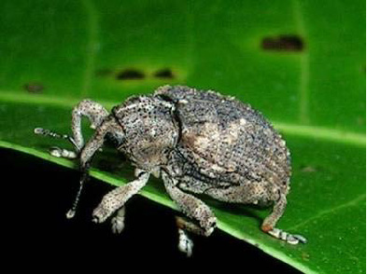
Mango Seed Weevil
Mango seed weevil is a pest only associated with mangoes. The seed is the host for the weevil until it is ready to exit the fruit. Countries that list mango seed weevil as a regulated pest require the fruit to be cut at inspection to identify whether mango seed weevil is present in the seed. Authorised officers will observe the fruit being cut and
then when it is safe to do so, inspect the seed for mango seed weevil

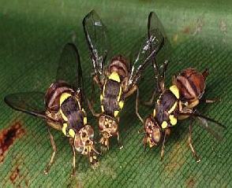
Fruit Fly
Fruit fly is a serious agricultural pest and importing countries strict rules for the import of fruit fly host material. The fruit fly lay their eggs in the plant material or just under the skin of fruit and vegetables. Characteristic sting marks can be observed where the eggs have been laid. Cutting the fruit or vegetable to investigate whether eggs or larvae is inside is a common method for identifying if the product has been infested.

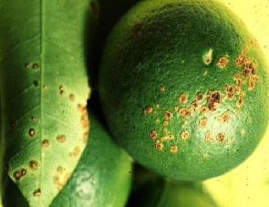
Citrus Canker
Citrus canker is a serious bacterial disease of citrus trees including grapefruit, lemons, limes and oranges. It reduces the growth of new fruit and spoils healthy fruit. Outbreaks of this disease have been eradicated from Queensland and the Northern Territory at great cost to industry and growers.

The disease attacks the leaves, twigs and fruit of citrus trees. It causes the leaves to drop and fruit to fall to the ground before it ripens. People may also contribute to disease spread by moving infected plants or plant parts.

Potato Cyst Nematode
Potato cyst nematodes are roundworms that live on the roots of plants. They reduce yield and ultimately damage the plant.

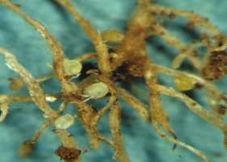
Authorised officers do not have the equipment to identify nematodes and will require a certificate that will meet the importing country requirements

Pests and Disease Symptoms found on Nursery Stock
The following images are examples of the various pests that may be found on nursery stock plants.

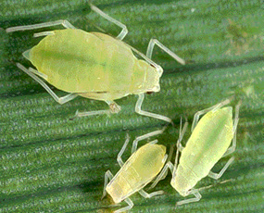
Aphids
Aphids are one of the most destructive insect pests on plants. They are soft bodied insects and their colours range from light green to pink. Aphids can be found on number of different nursery stock plants. Ants can also be found where there are aphids due to their symbiotic relationship

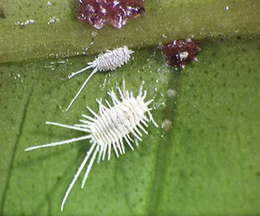
Mealy bugs
Mealy bugs are an insect that are considered a pest as they feed on plant juices from a variety of different plant species. They are also a known vector of several different diseases affecting plants. Mealy bugs appearance is distinctive with a white powdery view from above and a pink coloration viewed from beneath.
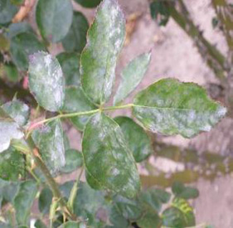
Powdery Mildew
Powdery Mildew is a fungal disease that affects a wide variety of plants. The symptoms can be observed on the leaves and the stems of the plants. It can visually be seen as a white powdery spots displaying the affected areas.

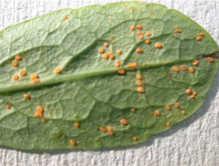
Rust
Rust is a fungal disease that affects a variety of different plants. Symptoms vary from lesions on the leaves, buckling of the leaves and the formation of bright yellow pustules (myrtle rust). In some cases the movement of plants interstate and to be exported have had restrictions put in place. An example of this is with plants from the Myrtaceae family being affected from Myrtle rust.

Common Pests and Diseases on other plant and plant products

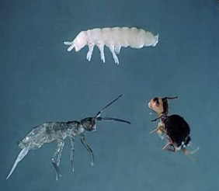
Springtails
Springtails are common agricultural pests found around the world. They are known to play a positive role in some agricultural sectors by controlling plant fungal diseases. At the inspection bench, springtails will more than likely be found on leafy vegetables such as cabbages, lettuce and celery.

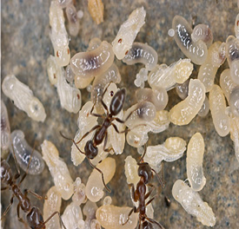
Ants
Ants are commonly found on advanced nursery stock and in pots that still contain soil and other media. The authorised officer will need to thoroughly inspect the plant and any packaging. Ants could also be located in the container which the plants will be transported in.

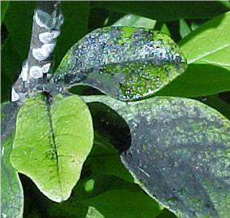
Sooty Mould
Sooty mould is a fungi from the excretion of sap sucking insects such as aphids and mealy bugs. The fungi mainly blocks sunlight to the plant though is a good indicator that there are other insects affecting the plants health.

Quarantine Pests of Australia Found on Commonly Inspected Plant and Plant products
Pest and Disease | Citrus | Apples & Pears | Leafy Veges | Root Veges | Grapes | Tomato  Cucurbits | Flowers N/Stock Foliage
Bactrocera tryoni  Queensland Fruit Fly | * | * |  |  | * | *
Ceratitis capitata  Mediterranean Fruit Fly | * | * |  |  | * | *
Epiphyas postvittana  Light brown apple moth | * | * |  |  | * | * | *
Atherigona orientalis  Muscid Fly | * | * |  |  | * | *
Planococcus pacificus  Citrus mealybug | * | *
Guignardia citricarpa  Citrus Black Spot | *
Conogethes punctiferalis  Yellow Peach Moth | * | * |  |  |  | *
Asynonychus cervinus  Fullers Rose Weevil | *
Lactrodectus hasselti  Redback spider |  |  |  |  | * |  | *
Lamprolonchaea brouniana  Green Metallic Tomato Fly |  |  |  |  |  | *
Rhadophous similis  Burrowing Nematode |  |  |  | *
Cydia pomonella  Codling moth | * | *
Ditylenchus dipsaci  Stem nematode |  |  | * | *
Potato cyst nematode (PCN) |  |  |  | *
Aphids – (some) | * | * | * |  |  | * | *
Snails – (some) | * | * | * | * | * | * | *
Aleurodicus dispersus  Spiralling white fly |  |  | * |  |  |  | *
Bemisia tabacci  Silver leaf white fly |  |  | * |  |  |  | *

More Information
- Pest and Disease Image Library: www.padil.gov.au
- A-Z list of significant pests and diseases: www.dpi.qld.gov.au
- Note. Most state department sites will have reference libraries on pests and diseases.

Relevant eLearning Modules
- Export Inspections: Product Identification, Pests and Diseases

Questions
- You can contact your Regional Plant Export Program Manager to clarify any aspects of this volume in the first instance.
- You can also direct a specific question or provide feedback to plantexporttraining@daff.gov.au

