Imported Food Inspection Data

Report for the period July to December 2010

Contents

Glossary of terms 3
Summary for July 2010 to December 2010 5
Commodity groups – July 2010 to December 2010 6
Country of origin – July 2010 to December 2010 7
Testing data – July 2010 to December 2010 9
Analytical testing data – July 2010 to December 2010 10
Other testing data – July 2010 to December 2010 13
Analytical testing data for China – July 2010 to December 2010 14
Analytical testing data for Thailand – July 2010 to December 2010 17
Analytical testing data for Italy – July 2010 to December 2010 20
Attachment 1: Guide to the types of analytical tests applied to food groups 23
Attachment 2: Guide to the tariff codes included in each food group 26
Attachment 3: Breakdown of inspections for all countries 27

Glossary of terms

AIMS | AQIS Import Management System, the AQIS computer system that processes entries for both Imported Foods and Quarantine purposes.
Analytical tests | These are analytical tests that are carried out by a laboratory on a sample of food taken during an inspection of imported food. They include microbiological, chemical, contaminant and food additive tests.
AQIS | Australian Quarantine and Inspection Service, an operating group within the Department of Agriculture, Fisheries and Forestry – Australia (DAFF). AQIS is responsible for a range of regulatory functions in areas such as quarantine, food imports and exports.
The Code | The Australia New Zealand Food Standards Code which contains food standards applicable to food for human consumption in Australia and available from the FSANZ website.
Entry | A Customs/Quarantine electronic document generated using the Australian Customs Service Integrated Cargo System. An entry may contain one or more lines / foods.
Food | Food includes:  (a) any substance or thing of a kind used or capable of being used as food or drink by human beings; or  (b) any substance or thing of a kind used or capable of being used as an ingredient or additive in, or substance used in the preparation of, a substance or thing referred to in paragraph (a); or  (c) any other substance or thing that is prescribed;  whether or not it is in a condition fit for human consumption, but does not include a therapeutic good within the meaning of the Therapeutic Goods Act 1989.
FSANZ | Food Standards Australia New Zealand, the agency responsible for developing food standards and administering the Australian New Zealand Food Standards Code.
Holding Order | A legal document provided for in the Imported Food Control Act 1992 (the Act). Use of a Holding Order increases the rate of inspection of a failing food until subsequent imports demonstrate compliance with the requirements of the Act. (Usually in force until 5 consecutive shipments pass inspection)
Imported Food Inspection Scheme | The Imported Food Inspection Scheme is administered by AQIS and inspects foods at various rates based upon the risk to human health and safety associated with that food. FSANZ conducts the food risk assessment and advises AQIS of those foods that pose a medium to high risk to human health and safety.  The legal basis for the inspection of imported food on arrival to Australia is the Imported Food Control Act 1992.
Inspection | This term includes inspection (visual and label assessment), or inspection and analysis (samples taken and sent for analysis), as the case requires.
Label assessment | AQIS will assess the labelling applied to imported food at each inspection. Labels are assessed against specific requirements in the Australia New Zealand Food Standards Code.
Line | When a broker lodges an import entry with the Australian Customs Service, they will list the items being imported on lines within the import entry. An import entry may consist of one line or many lines of products. As such it is not an indication of the number of import entries as an import entry may have multiple lines.
Lot | A quantity of a food prepared or packed under essentially the same conditions (ordinarily from a particular preparation or packing unit and during a particular time ordinarily not exceeding 24 hours).
Lot Code | Unique code which identifies a lot and can be used for recall purposes if necessary.
NATA | National Association of Testing Authorities
Other tests | These are tests of food that do not involve laboratory analysis. This term covers the visual assessment (but not label) of the food and an assessment of the government to government certification regarding the bovine spongiform encephalopathy status for the beef and beef product in the food.
Risk Category Food | Foods that have been assessed by FSANZ as representing a medium to high potential risk to consumer health.  Referred to AQIS by Customs for inspection at the rate of 100 % of imports.
Surveillance Category Foods | A general term for foods that are low risk foods under the Imported Food Inspection Scheme.
Trans Tasman Mutual Recognition Arrangement | The Trans Tasman Mutual Recognition Arrangement is an arrangement between the Commonwealth, State and Territory Governments of Australia and the Government of New Zealand.  It allows goods, including low risk foods, to be traded freely between New Zealand and Australia and enhances the freedom of individuals to work in both countries.

Summary for July 2010 to December 2010
The data contained in this report was obtained from imported food inspection data for the period 1 July 2010 to 31 December 2010 and has been extracted from the AQIS Import Management System (AIMS) database. The following is a summary of this information.
During this period:
- 8439 entries of imported food were referred to AQIS for inspection under the Imported Food Inspection Scheme
- 13 508 lines of imported foods were inspected
- 52 170 tests were applied, including label and visual checks and broken down as follows
- 18 415 label assessments were applied
- 15 668 analytical tests were applied
- 18 087 other tests were applied
More detailed analysis of data is provided based on the following:
- Commodity groups
- Country of origin
- Breakdown of inspection data into the tests applied and compliance rates

For more information about the terms used in this document, refer to the glossary of terms.
Brief explanation of the application of tests to imported food
The number of lines of food referred for inspection under the Imported Food Inspection Scheme and the number of tests applied to those lines of food may differ. This is because food subject to inspection is sampled and tested based on the following factors:
- The number of batches and number of lots within each batch of food on the line referred for inspection; and
- The number of tests to be applied to each sample of that food taken during the inspection process.
For example, one line of a cooked and processed meat product may be referred for inspection under the Imported Food Inspection Scheme. This line contains two batches of the product each with one lot. AQIS will take one sample from each batch (ie. Two samples from this one line of product) and apply the microbiological tests relevant to this food, these being E coli, standard plate count, coagulase positive Staphylococci, Listeria monocytogenes and Salmonella. As a result, this one line of imported food has had two samples taken and five microbiological tests applied to each sample.
This will be reported as – number of lines: 1
- number of tests applied: 10

Commodity groups – July 2010 to December 2010
The numbers of tests applied reflects those commodity groups with more risk foods and/or that are imported frequently as products imported frequently will have a higher representation under the inspection activity. It may also reflect where goods have previously failed and the inspection rate has increased to 100% until compliance has been demonstrated. Note: this data cannot be used to indicate volumes of trade.
Test data by broad commodity groups
- The single commodity that was subject to the most number of tests was seafood which accounted for 16.3% of tests applied (Chart 1) under the Imported Food Inspection Scheme. Captured under this category are products tariffed as fresh, chilled, frozen and processed seafood products.
- Horticulture was the next highest single commodity inspected and was subject to 14.8% of all tests applied to imported food under the Imported Food Inspection Scheme. This includes fresh and processed fruit and vegetables.
CHART 1: Percentage of tests applied - by commodity group
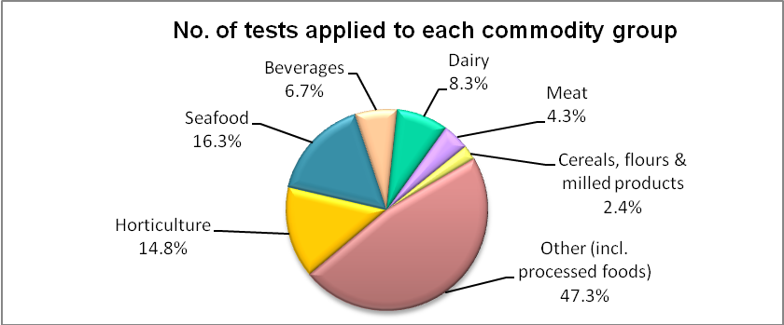
Attachment 1 provides an overview of the analytical tests applied to the commodity groups and Attachment 2 provides a list of the tariff codes associated with each commodity grouping used for this report.
TABLE 1: Inspection and test data by broad commodity group
Commodity | No. of tests applied | No. of compliant / non-compliant results | Compliance rate (%)
Horticulture | 7708 | 7517 / 191 | 97.5
Seafood | 8499 | 8406 / 93 | 98.9
Beverages | 3511 | 3378 / 133 | 96.2
Dairy | 4323 | 4245 / 78 | 98.2
Meat | 2229 | 2215 / 14 | 99.4
Cereals, flours & milled products | 1232 | 1212 / 20 | 98.4
Other (incl. processed foods) | 24 668 | 23 851 / 817 | 96.7
Totals | 52 170 | 50 824 / 1346 | 97.4

Country of origin – July 2010 to December 2010
Under the Imported Food Inspection Scheme, no country was uniquely targeted for routine inspection of its food. Food is targeted for inspection based on its risk and/or frequency of importation. The exception to this rule is where food has failed inspection and a holding order is raised which targets the specific food from the specific manufacturer in a specific country at a rate of 100% of consignments.
The numbers of inspections reflect those countries that export more risk foods and/or export more regularly to Australia. Countries exporting to Australia more frequently will have a higher representation in AQIS inspection activity for food safety. Note: this data cannot be used to indicate volumes of food imported into Australia.
Countries in descending order, based on the number of lines inspected
- The top three countries whose food was subject to the most inspections for the period July 2010 to December 2010 were China, Thailand and Italy.
- 62.1% of food inspections were on food from ten countries; the remaining 37.9% of food inspections were on food from 117 countries.
- The ‘Australian Food Statistics’ annual publication by the Department of Agriculture, Fisheries and Forestry indicates that a significant proportion of food imports are from New Zealand. However, under the Trans Tasman Mutual Recognition Arrangement (TTMRA), surveillance food from New Zealand is not subject to the Imported Food Control Act 1992 and only risk food is inspected and represented in this report.

TABLE 2: Number of inspections by country of origin
Country | No. of lines inspected | % of total lines inspected
China | 1403 | 10.4
Thailand | 1141 | 8.4
Italy | 995 | 7.4
United States | 994 | 7.4
Japan | 937 | 6.9
India | 748 | 5.5
France | 592 | 4.4
Korea, Republic of | 581 | 4.3
Taiwan | 502 | 3.7
Malaysia | 494 | 3.7
Other | 5121 | 37.9
Total 117 countries | 13 508 | 100

For a detailed breakdown of all countries, please refer to attachment 3.

CHART 2: Percentage of inspections by country of origin
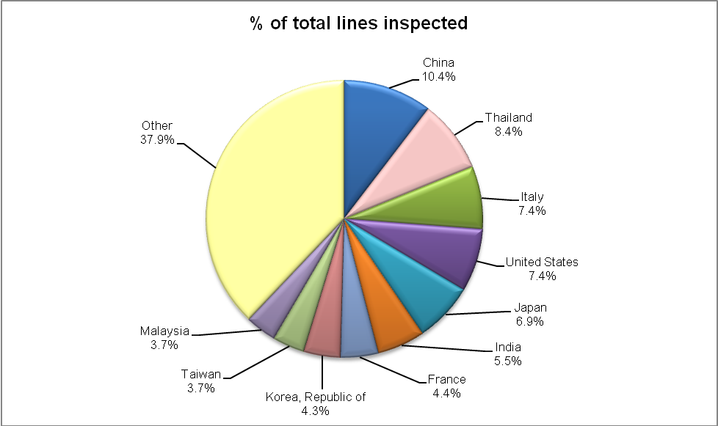

Further information about the top three countries is provided in the section outlining analytical test data.

Testing data – July 2010 to December 2010
Broad breakdown of inspection data for the period July 2010 – December 2010
- 97.4% of all tests applied to imported food samples under the Imported Food Inspection Scheme complied with Australian standards for these tests.
- Incorrect labelling accounts for the majority of non-compliances (ie. 74.1% of failures are for labelling).
- When labeling non-compliances are removed from testing data, there is a 99.3% compliance rate for the analytical and other tests applied to imported food.

TABLE 3: Level of compliance for imported food
Test | No. of tests applied | No. of compliant / non-compliant results | Compliance rate (%)
Analytical | 15 668 | 15 361 / 307 | 98.0
Labelling | 18 415 | 17 418 / 997 | 94.6
Other | 18 087 | 18 045 / 42 | 99.8
Total | 52 170 | 50 824 / 1346 | 97.4

The next pie chart provides a more detailed breakdown of the 1346 non-compliant tests, with breakdown to each specific test and the proportion that each test contributed to the total of the non-compliant results.
CHART 3: Breakdown of the 1346 non-compliant test results

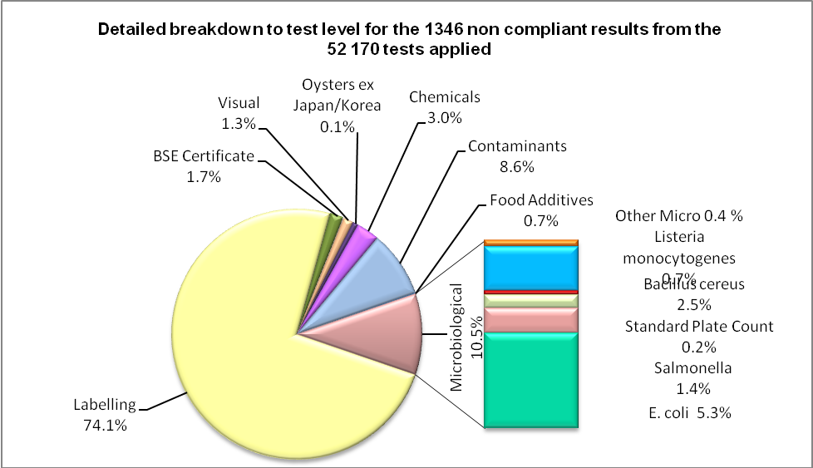

Analytical testing data – July 2010 to December 2010
Within the analytical test category, tests are grouped according to four main types: microbiological, chemical, contaminant and food additives. Each category is made up of several tests which are reported in detail in Tables 5, 6, 7 and 8.
Broad breakdown of analytical test data for the period July 2010 - December 2010
- Analytical tests results show there is a 98.0% compliance rate with the tests applied by AQIS under the Imported Food Inspection Scheme.
- 307 of the 15 668 tests applied, failed against the standards (ie. 2.0% of tests applied failed). This next section discusses these failed results.
TABLE 4: Summary of compliance for analytical testing
Analytical test type | No. of tests applied | No. of compliant / non-compliant results | Compliance rate (%)
Microbiological | 6838 | 6697 / 141 | 97.9
Chemicals | 4431 | 4391 / 40 | 99.1
Contaminants | 3940 | 3824 / 116 | 97.1
Food Additives | 459 | 449 / 10 | 97.8
Total | 15 668 | 15 361 / 307 | 98.0

TABLE 5: Summary of compliance for microbiological tests applied
Microbiological test | No. of tests applied | No. of compliant / non-compliant results | Compliance rate (%) | Types of food
E. coli | 1326 | 1255 / 71 | 94.6 | Processed meats, water based beverages and cheese
Salmonella | 2855 | 2836 / 19 | 99.3 | Processed meats, cooked prawns and dried coconut
Listeria monocytogenes | 1254 | 1244 / 10 | 99.2 | Smoked salmon, cheese and ham
Standard Plate Count | 279 | 276 / 3 | 98.9 | Cooked prawns
Bacillus cereus | 588 | 555 / 33 | 94.4 | Bean curd, tofu and pasta
Vibrio cholerae | 143 | 140 / 3 | 97.9 | Cooked prawns
Coagulase positive Staphylococcus | 392 | 390 / 2 | 99.5 | Processed meats and cooked prawns
pH | 1 | 1 / 0 | 100 | Fermented milk products
Total | 6838 | 6697 / 141 | 97.9

TABLE 6: Summary of compliance for chemical tests applied
Chemicals | No. of tests applied | No. of compliant / non-compliant results | Compliance rate (%) | Types of food
Pesticides | 3570 | 3552 / 18 | 99.5 | Fruit, vegetables and meat
Nitrofurans | 81 | 81 / 0 | 100 | Farmed prawns, honey
Ethylene Chlorohydrin | 399 | 382 / 17 | 95.7 | Herbs and spices
Malachite Green | 187 | 187 / 0 | 100 | Farmed fish
Fluoroquinolones | 140 | 136 / 4 | 97.1 | Farmed fish & prawns
Chloramphenicol | 8 | 7 / 1 | 87.5 | Honey
Streptomycin | 8 | 8 / 0 | 100 | Honey
Sulphonamides | 32 | 32 / 0 | 100 | Honey
Tetracycline | 6 | 6 / 0 | 100 | Honey
Total | 4431 | 4391 / 40 | 99.1

TABLE 7: Summary of compliance for contaminant tests applied
Contaminants | No. of tests applied | No. of compliant / non-compliant results | Compliance rate (%) | Types of food
Cadmium | 819 | 807 / 12 | 98.5 | Peanuts, leafy and tuber vegetables, wheat and rice
Aflatoxins | 732 | 702 / 30 | 95.9 | Nuts
Histamine | 1201 | 1185 / 16 | 98.7 | Fish
Lead | 4 | 4 / 0 | 100 | Dried dates and sultanas
Chloropropanols | 139  139 | 139 / 0 (DCP)  138 / 1 (3MCPD) | 100  99.3 | Soy and oyster sauce
Erucic Acid | 1 | 1 / 0 | 100 | Vegetable oils
Domoic Acid | 330 | 330 / 0 | 100 | Oysters
Hydrocyanic Acid | 19 | 9 / 10 | 47.4 | Cassava chips
Iodine* | 218 | 172 / 46 | 78.9 | Seaweed (brown algae)
Inorganic Arsenic | 10 | 10 / 0 | 100 | Hijiki seaweed
PSP Toxin | 315 | 315 / 0 | 100 | Bivalve molluscs
Melamine | 12 | 12/ 0 | 100 | Products for young children with minor dairy ingredients from China
Total | 3940 | 3824 / 116 | 97.1
*Iodine testing of seaweed as a risk category food was implemented in October 2010.

TABLE 8: Summary of compliance for food additive tests applied
Food Additives | No. of tests applied | No. of compliant / non-compliant results | Compliance rate (%) | Types of food
Sulphur Dioxide | 214 | 214 / 0 | 100 | Raw prawns, wine and preserved vegetables
Colours | 245 | 235 / 10 | 95.9 | Confectionery
Total | 459 | 449 / 10 | 97.8

Other testing data – July 2010 to December 2010
The types of tests that are included in the “other” category are visual inspections of the food and a check of the government to government certification for Bovine Spongiform Encephalopathy (BSE) free status for imports of beef and beef products.

TABLE 9: Summary of compliance for other testing of food
Other | No. of tests applied | No. of compliances / non-compliances | Compliance rate (%)
Oysters ex Japan / Korea | 2 | 1 / 1 | 50.0
Visual | 17 535 | 17 517 / 18 | 99.9
BSE Certificate | 550 | 527 / 23 | 95.8
Total | 18 087 | 18045 / 42 | 99.8

Analytical testing data for China – July 2010 to December 2010
Food from China had the highest number of inspections in comparison with other countries inspected under the Imported Food Inspection Scheme, at 10.4% of all food lines inspected. Further breakdown of these inspections by the types of tests applied are given in the following tables.
Summary of non-compliances for analytical testing
- Of the 1637 analytical tests applied to imported food from China, there were 32 non-compliances, giving a 98.1% compliance rate for tests applied.
- Chemical tests were the most frequently applied tests followed by tests for contaminants, microbiological and food additives.
TABLE 10: Summary of compliance for all types of analytical tests applied: China
Analytical test type | No. of tests applied | No. of compliant / non-compliant results | Compliance rate (%)
Microbiological | 486 | 471 / 15 | 96.9
Chemicals | 545 | 540 / 5 | 99.1
Contaminants | 513 | 499 / 14 | 97.3
Food Additives | 93 | 93 / 0 | 100
Total | 1637 | 1603 / 34 | 97.9

TABLE 11: Summary of compliance for microbiological testing: China
Microbiological test | No. of tests applied | No. of compliant / non-compliant results | Compliance rate (%)
E. coli | 33 | 31 / 2 | 93.9
Salmonella | 240 | 239 / 1 | 99.6
Listeria monocytogenes | 13 | 13 / 0 | 100
Standard Plate Count | 44 | 43 / 1 | 97.7
Bacillus cereus | 87 | 78 / 9 | 89.7
Vibrio cholerae | 34 | 32 / 2 | 94.1
Coagulase positive Staphylococcus | 35 | 35 / 0 | 100
Total | 486 | 471 /15 | 96.9

TABLE 12: Summary of compliance for chemical testing: China
Chemicals | No. of tests applied | No. of compliant / non-compliant results | Compliance rate (%)
Pesticides | 425 | 422 / 3 | 99.3
Nitrofurans | 27 | 27 / 0 | 100
Ethylene Chlorohydrin | 60 | 59 / 1 | 98.3
Malachite Green | 9 | 9 / 0 | 100
Fluoroquinolones | 14 | 14 / 0 | 100
Chloramphenicol | 3 | 2 / 1 | 66.7
Streptomycin | 3 | 3 / 0 | 100
Sulphonamides | 1 | 1 / 0 | 100
Tetracycline | 3 | 3 / 0 | 100
Total | 545 | 540 / 5 | 99.1

TABLE 13: Summary of compliance for contaminant testing: China
Contaminants | No. of tests applied | No. of compliant / non-compliant results | Compliance rate (%)
Cadmium | 95 | 95 / 0 | 100
Aflatoxins | 135 | 133 / 2 | 98.5
Histamine | 46 | 46 / 0 | 100
Lead | 1 | 0 / 1 | 0
Chloropropanols | 17  17 | 17 / 0 (DCP)  17 / 0 (3MCPD) | 100  100
Iodine | 46 | 35 / 11 | 76.1
Inorganic Arsenic | 3 | 3 / 0 | 100
Domoic Acid | 72 | 72 / 0 | 100
PSP Toxin | 70 | 70 / 0 | 100
Melamine | 11 | 11 / 0 | 100
Total | 513 | 499 / 14 | 97.3

TABLE 14: Summary of compliance for food additive testing: China
Food Additives | No. of tests applied | No. of compliant / non-compliant results | Compliance rate (%)
Sulphur Dioxide | 27 | 27 / 0 | 100
Colours | 66 | 66 / 0 | 100
Total | 93 | 93 / 0 | 100

TABLE 15: Summary of compliance for other testing of food: China
Other | No. of tests applied | No. of compliances / non-compliances | Compliance rate (%)
Visual | 1783 | 1779 / 4 | 99.8
BSE Certificate | 1 | 0 / 1 | 0
Total | 1784 | 1779 / 5 | 99.7

Analytical testing data for thailand – July 2010 to December 2010
In the period July 2010 to December 2010, food from Thailand had the second highest number of inspections in comparison with other countries inspected under the Imported Food Inspection Scheme, at 8.4% of all food lines inspected. Further breakdown of the types of tests applied are given in the following tables.
Summary of non-compliances for analytical testing
- Of the 1417 analytical tests applied to imported food from Thailand, there were 10 non-compliances, giving a 99.3% compliance rate for tests applied.
- Contaminant tests were the most frequently applied tests followed by tests for chemicals, microbiological and food additives.
TABLE 16: Summary of compliance for all types of analytical tests applied: Thailand
Analytical test type | No. of tests applied | No. of compliant / non-compliant results | Compliance rate (%)
Microbiological | 365 | 363 / 2 | 99.5
Chemicals | 474 | 472 / 2 | 99.6
Contaminants | 566 | 560 / 6 | 98.9
Food Additives | 18 | 18 / 0 | 100
Total | 1423 | 1413 / 10 | 99.3

TABLE 17: Summary of compliance for microbiological testing: Thailand
Microbiological test | No. of tests applied | No. of compliant / non-compliant results | Compliance rate (%)
E. coli | 11 | 10 / 1 | 90.9
Salmonella | 110 | 110 / 0 | 100
Listeria monocytogenes | 14 | 14 / 0 | 100
Standard Plate Count | 58 | 57 / 1 | 98.3
Bacillus cereus | 54 | 54 / 0 | 100
Vibrio cholerae | 56 | 56 / 0 | 100
Coagulase positive Staphylococcus | 62 | 62 / 0 | 100
pH | 0 | 0 | N/A
Total | 365 | 363 / 2 | 99.5

TABLE 18: Summary of compliance for chemical testing: Thailand
Chemicals | No. of tests applied | No. of compliant / non-compliant results | Compliance rate (%)
Pesticides | 402 | 401 / 1 | 99.8
Nitrofurans | 23 | 23 / 0 | 100
Ethylene Chlorohydrin | 28 | 28 / 0 | 100
Malachite Green | 11 | 11 / 0 | 100
Fluoroquinolones | 10 | 9 / 1 | 90.0
Chloramphenicol | 0 | 0 | N/A
Streptomycin | 0 | 0 | N/A
Sulphonamides | 0 | 0 | N/A
Tetracycline | 0 | 0 | N/A
Total | 474 | 472 / 2 | 99.6

TABLE 19: Summary of compliance for contaminant testing: Thailand
Contaminants | No. of tests applied | No. of compliant / non-compliant results | Compliance rate (%)
Cadmium | 110 | 110 / 0 | 100
Aflatoxins | 39 | 39 / 0 | 100
Histamine | 345 | 339 / 6 | 98.3
Lead | 0 | 0 | N/A
Chloropropanols | 20  20 | 20 / 0 (DCP)  20 / 0 (3MCPD) | 100  100
Erucic Acid | 0 | 0 | N/A
Hydrocyanic Acid | 2 | 2 / 0 | 100
Domoic Acid | 15 | 15 / 0 | 100
PSP Toxin | 15 | 15 / 0 | 100
Total | 566 | 560 / 6 | 98.9

TABLE 20: Summary of compliance for food additive testing: Thailand
Food Additives | No. of tests applied | No. of compliant / non-compliant results | Compliance rate (%)
Sulphur Dioxide | 8 | 8 / 0 | 100
Colours | 10 | 10 / 0 | 100
Total | 18 | 18 / 0 | 100

TABLE 21: Summary of compliance for other testing of food: Thailand
Other | No. of tests applied | No. of compliances / non-compliances | Compliance rate (%)
Visual | 1422 | 1419 / 3 | 99.8
BSE Certificate | 0 | 0 | N/A
Total | 1422 | 1419 / 3 | 99.8

Analytical testing data for italy – July 2010 to December 2010
In the period July 2010 to December 2010, food from Italy had the third highest number of inspections in comparison with other countries inspected under the Imported Food Inspection Scheme, at 7.4% of all food lines inspected. Further breakdown of the types of tests applied are given in the following tables.
Summary of non-compliances for analytical testing
- Of the 1609 analytical tests applied to imported food from Italy, there were 42 non-compliances, giving a 97.4% compliance rate for tests applied.
- Microbiological tests were the most frequently applied test followed by tests for chemicals, food additives and contaminants.
TABLE 22: Summary of compliance for all types of analytical tests applied: Italy
Analytical test type | No. of tests applied | No. of compliant / non-compliant results | Compliance rate (%)
Microbiological | 1113 | 1080 / 33 | 97.0
Chemicals | 282 | 277 / 5 | 98.2
Contaminants | 92 | 88 / 4 | 95.7
Food Additives | 122 | 122 / 0 | 100
Total | 1609 | 1567/ 42 | 97.4

Table 23: Summary of compliance for Microbiological testing: Italy
Microbiological test | No. of tests applied | No. of compliant / non-compliant results | Compliance rate (%)
E. coli | 356 | 330 / 26 | 92.7
Salmonella | 323 | 323 / 0 | 100
Listeria monocytogenes | 274 | 269 / 5 | 98.2
Standard Plate Count | 0 | 0 / 0 | N/A
Bacillus cereus | 127 | 125 / 2 | 100
Vibrio cholerae | 0 | 0 | N/A
Coagulase positive Staphylococcus | 33 | 33 / 0 | 100
pH | 0 | 0 | N/A
Total | 1113 | 1080 / 33 | 97.0

Table 24: Summary of compliance for chemical testing: Italy
Chemicals | No. of tests applied | No. of compliant / non-compliant results | Compliance rate (%)
Pesticides | 274 | 269 / 5 | 98.2
Nitrofurans | 0 | 0 | N/A
Ethylene Chlorohydrin | 8 | 8 / 0 | 100
Malachite Green | 0 | 0 | N/A
Fluoroquinolones | 0 | 0 | N/A
Chloramphenicol | 0 | 0 | N/A
Streptomycin | 0 | 0 | N/A
Sulphonamides | 0 | 0 | N/A
Tetracycline | 0 | 0 | N/A
Total | 282 | 277 / 5 | 98.2

Table 25: Summary of compliance for contaminant testing: Italy
Contaminants | No. of tests applied | No. of compliant / non-compliant results | Compliance rate (%)
Cadmium | 50 | 48 / 2 | 96.0
Aflatoxins | 21 | 19 / 2 | 90.5
Histamine | 19 | 19 / 0 | 100
Lead | 0 | 0 | N/A
Chloropropanols | 0  0 | 0 (DCP)  0 (3MCPD) | N/A  N/A
Erucic Acid | 0 | 0 | N/A
Domoic Acid | 2 | 2 / 0 | 100
PSP Toxin | 0 | 0 | N/A
Total | 92 | 88 / 4 | 95.7

Table 26: Summary of compliance for food additive testing: Italy
Food Additives | No. of tests applied | No. of compliant / non-compliant results | Compliance rate (%)
Sulphur Dioxide | 118 | 118 / 0 | 100
Colours | 4 | 4 / 0 | 100
Total | 122 | 122 / 0 | 100

TABLE 27: Summary of compliance for other testing of food: Italy
Other | No. of tests applied | No. of compliances / non-compliances | Compliance rate (%)
Visual | 1444 | 1440 / 4 | 99.7
BSE Certificate | 0 | 0 | N/A
Total | 1444 | 1440 / 4 | 99.7

Attachment 1: Guide to the types of analytical tests applied to food groups

Food group | Risk / Surveillance category test | Analytical test
Meat | Risk | BSE government certification  Coagulase positive Staph  E. coli  Listeria monocytogenes  Salmonella
Meat | Surveillance | Pesticide screen
Seafood | Risk | Histamine  Listeria monocytogenes  Coagulase positive Staph  E. coli  Salmonella  Standard plate count  Paralytic shellfish poison  Domoic acid
Seafood | Surveillance | Histamine  Malachite green  Nitrofurans  Fluoroquinolones  Sulphur dioxide
Vegetables | Risk | Salmonella (Sesame seeds)  Inorganic arsenic (Hijiki seaweed)  Iodine (Seaweed (brown algae))
Vegetables | Surveillance | Pesticide screen  Cadmium  Sulphur dioxide  Salmonella  Erucic acid (Canola oils)  B. cereus
Fruit | Surveillance | Pesticide screen  Lead  Sulphur dioxide
Nuts and nut products | Risk | Salmonella  Aflatoxin
Nuts and nut products | Surveillance | Aflatoxin
Herbs and spices | Risk | Salmonella
Herbs and spices | Surveillance | Salmonella  Ethylene chlorohydrins
Dairy foods | Risk | Listeria monocytogenes  Salmonella  E. coli  Melamine
Dairy foods | Surveillance | Pesticide screen  Salmonella  E. coli  pH test
Egg and egg products | Surveillance | Salmonella
Honey | Surveillance | Pesticide screen  Chloramphenicol  Nitrofurans  Streptomycin  Tetracycline  Sulphonamides
Fruit juices | Surveillance | Pesticide screen
Water | Surveillance | E. coli
Other beverages | Surveillance | Sulphur dioxide
Confectionery | Surveillance | Colour screen
Sauces | Surveillance | Chloropropanols (Soy sauces)

Attachment 2: Guide to the tariff codes included in each food group
The following table indicates those tariff codes which fall within each commodity grouping used for this report. For more information on tariff codes, please refer to the Australia Customs and Border Protection Service website at http://www.customs.gov.au/site/page.cfm?u=4273.

Commodity group | Tariff code | Commodity group | Tariff code
Meat | 0201 – 02120  0504  1601 - 1602 | Cereals | 1001 – 1008  1101 - 1109
Seafood | 0302 – 0307  1603 – 1605 | Horticulture | 0701 – 0714  0801 – 0814  0904 – 0910  1201 – 1208  1210 – 1212  1801 - 1802
Dairy | 0401 – 0406 | Other | 0410  0901 - 0903  1301 – 1302  1501 – 1504  1506 – 1517  1520 – 1521  1701 – 1704  1803 – 1806  1901 – 1905  2001 – 2008  2101 - 2106  2209  2501  3501 – 3503  3505  3507
Eggs | 0407 - 0408 | Other
Honey | 0409 | Other
Beverages | 2009  2201 - 2208 | Other

Attachment 3: Breakdown of inspections for all countries
Country | No. of unique lines inspected | Country | No. of unique lines inspected | Country | No. of unique lines inspected
China | 1403 | Iran Islamic Republic of | 41 | Oman | 3
Thailand | 1141 | Ireland | 41 | Jordan | 3
Italy | 995 | Bangladesh | 31 | Cuba | 3
United States | 994 | Austria | 30 | Tanzania United Republic Of | 3
Japan | 937 | Macedonia | 28 | Kenya | 3
India | 748 | Papua New Guinea | 26 | Zimbabwe | 3
France | 592 | Chile | 26 | Serbia and Montenegro | 2
Korea, Republic of | 582 | Russian Federation | 24 | Cote d’Ivoire | 2
Taiwan | 502 | Portugal | 22 | Estonia | 2
Malaysia | 494 | Egypt | 22 | Madagascar | 2
New Zealand | 435 | Norway | 21 | Nigeria | 2
United Kingdom | 380 | Bulgaria | 20 | Honduras | 2
Vietnam | 373 | Myanmar | 20 | Nepal | 2
Indonesia | 349 | United Arab Emirates | 19 | Finland | 2
Germany | 242 | Colombia | 16 | Belize | 2
Philippines | 223 | Serbia | 15 | Montenegro | 2
Netherlands | 219 | Saudi Arabia | 14 | Yemen | 2
Spain | 216 | Australia | 12 | Romania | 2
South Africa | 209 | Slovenia | 11 | Nicaragua | 2
Singapore | 197 | Guatemala | 10 | Swaziland | 2
Sri Lanka | 194 | Ukraine | 9 | Guinea | 1
Denmark | 150 | Cyprus | 9 | Guam | 1
Hong Kong | 148 | Czech Republic | 9 | Guyana | 1
Canada | 131 | Namibia | 8 | Lithuania | 1
Belgium | 111 | Bolivia | 8 | Barbados | 1
Greece | 101 | Ethiopia | 7 | Bosnia And Herzegowina | 1
Lebanon | 98 | Moldova, Republic of | 7 | Congo Democratic Republic of | 1
Turkey | 92 | Latvia | 7 | Maldives | 1
Fiji | 80 | Ghana | 6 | Timor-Leste | 1
Mexico | 64 | Tonga | 5 | Iceland | 1
Switzerland | 62 | El Salvador | 5 | Tokelau | 1
Pakistan | 60 | Syrian Arab Republic | 5 | Jamaica | 1
Poland | 55 | Hungry | 5 | French Guiana | 1
Argentina | 55 | Luxembourg | 5 | Vanuatu | 1
Israel | 53 | Trinidad And Tobago | 4 | Cambodia | 1
Peru | 53 | Ecuador | 4 | Samoa | 1
Brazil | 50 | Morocco | 4 | Tunisia | 1
Croatia (Hrvatska) | 47 | Costa Rica | 4 | Slovakia Slovak Republic | 1
Sweden | 44 | Uruguay | 4 | Uganda | 1

