
(A division of Kewagama Holdings Pty. Ltd.)
ACN 002101466
ABN 54002101466
70 Foxtail Rise, Noosa Valley
Queensland 4562 Australia
Phone: (07) 5471.1271
Fax: (07) 5471.1272
Email: kewagama@iprimus.com.au

NATIONAL SURVEY OF
BAIT AND BERLEY USE BY
RECREATIONAL FISHERS
Report to:
Biosecurity Australia,
AFFA
December 2002

SUMMARY

Data Needs and Objectives
In early 2001, Biosecurity Australia, AFFA identified specific information needs in relation to bait and berley usage by recreational fishers in Australia. This information was required to address a range of policy issues, including an imminent Import Risk Analysis for prawns. An understanding of usage patterns for other bait species was also required for future assessment work. Ten aquatic animal species groups (see Table A overleaf) were identified for detailed assessment – including the number of fishers, acquisition sources and estimated quantities used (for purchased bait). Disaggregation of these results was also required by purchase form (live, whole dead etc.), region, water body type and season. This information was required at a level of precision to enable ‘semi-quantitative’ analysis.

Survey Design Issues
Although some useful data could be obtained from the recent National Recreational Fishing Survey (NRFS – a major study of participation, catch, effort and expenditure conducted in 2000/01), the general absence of existing data meant that specific new research was required to meet these information needs.
In December 2001, Kewagama Research was commissioned to undertake this study. However, a number of factors impacting on survey design were identified from the outset. Timing constraints precluded the use of a diary survey method – a preferred approach to collect detailed information of this kind, where respondents are contacted regularly over time (e.g. a 12 month period, as for the NRFS). Yet, use of a conventional ‘recall’ survey (on a stand-alone basis) would almost certainly result in major data quality concerns, beyond acceptable limits of any ‘semi-quantitative’ analysis.
In recreational fishing surveys, ‘recall bias’ has been shown to result in significant over-estimates of fishing effort and catch, especially where longer recall periods are involved. Since fishing effort (days fished) was a likely basis on which bait usage would be assessed in the survey, the ultimate study design needed to measure and calibrate for these effects. Appropriate comparability ‘links’ were therefore established to a range of benchmark data from the NRFS (Diary Survey), Australian Bureau of Statistics (ABS, population estimates) and the Bait Supplier Survey (a specially-conducted study to establish pack sizes for common bait species across Australia).

Survey Implementation and Analysis
After extensive development and pilot-testing, the survey was conducted by telephone during May-August 2002, by 11 interviewers with direct experience in recreational fishing surveys. A stratified random sample of 8,000 private dwelling households across Australia was drawn from electronic ‘white pages’ listings. By design, non-private dwellings (hotels, nursing homes, gaols etc.) were excluded from the scope of the study, as were visitors from overseas.
Excellent response rates were achieved (85% overall). For each household (and person within, aged 5 years or more), participation in recreational fishing and ‘in-scope’ bait/berley usage were assessed for the previous 12 months (May 2001-April 2002). However, most substantive survey questions were asked of one (randomly-selected) bait/berley user in each household – principally, usage assessment for the 10 key bait types and estimated quantities for the previous 12 months. Whereas pilot-testing had shown that respondents could routinely ‘calculate’ bait usage on the basis of an ‘equation’ (e.g. 6 days by ½ small packet of prawns per day), it also revealed that many were unaware of the pack sizes involved. In these cases, information from the Bait Supplier Survey was used to estimate quantities, e.g. a ‘small’ packet of bait prawns was reported at 200g by all bait suppliers across Australia.
In the analysis phase, ‘raw’ survey data were expanded to population estimates, using integrated weights provided by ABS. Minor adjustments to these weightings were also applied to account for the effects of
non-response (based on follow-up surveys in the NRFS). However, significant calibrations were applied to reported bait quantities for the effects of recall bias, where over-estimation by a factor of 2.5 (overall) was assessed from NRFS Diary Survey data. This latter information became available in November 2002, enabling completion of the study in December.
Despite many complexities and constraints, excellent outcomes have been achieved for the study, with all objectives being met or exceeded.

Summary of Results
The following results have been compiled on a national basis, for the resident population (private dwelling basis), covering the period May 2001-April 2002. (Note: standard error calculations are contained in the Appendix, with detailed study definitions and methodologies in Sections 2 and 3).
- an estimated 1,602,618 households (21.7% of the population) did some kind of recreational fishing in the period, comprising 2,890,723 fishers, aged 5 years or more (16.4% of the population). Note: recreational fishing is defined as any attempted harvesting of aquatic animals for non-commercial purposes (including crabbing, prawning, diving for lobster etc.)
- the vast majority (2,479,043 – 86%) of all fishers, used at least some ‘in-scope’ bait/berley during the period - i.e. aquatic animals of any kind (including sharks/rays, worms, marine yabbies etc.)
- among these, nearly all (2,383,048 – or 82% of all fishers) used one or more of the 10 bait types in Table A below

Summary Table A: Acquisition Source of Bait/Berley Used by Recreational Fishers1 - 10 Key Bait ii Final Report
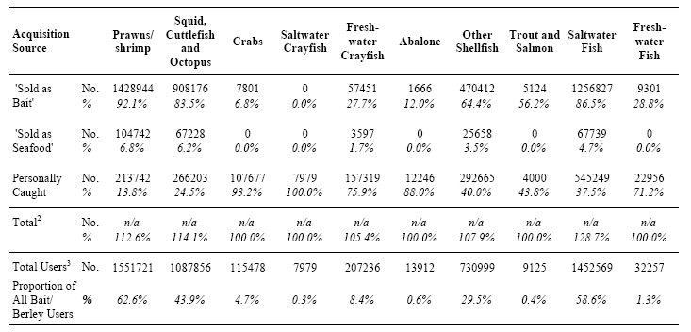
Notes:
¹ Table base: population estimate of recreational fishers using aquatic animals as bait/berley in the previous 12 months
² Percentages based on total users of each bait type. Due to multiple reporting, totals may add to more than 100%
³ Total users of each bait type. Percentages based on total users of any aquatic animal bait type (including sharks/rays, worms, marine nippers etc., not covered by the 10 key bait types)
By design, usage quantities were assessed in the survey for each of these 10 bait types, but only for ‘purchased’ bait, i.e. where the acquisition source was ‘Sold as Bait’ or ‘Sold as Seafood’. Due to the small sub-samples involved for several bait types (Crabs, Saltwater Crayfish, Abalone, Trout and Salmon, and Freshwater Fish), quantity estimates have not been included in Table B below.

Summary Table B: Purchase Source of Bait/Berley - Annual Quantities Used1 (Kgs) - 5 Key Bait Types
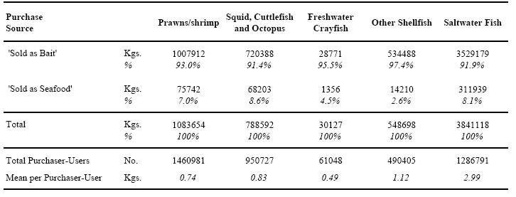
Notes:
¹ Table base: estimated total quantities of each bait type used by recreational fishers in the previous 12 months … from purchase sources only. By design, quantities for 'Personally Caught' bait were not assessed in the survey.
In Section 5 of the report, quantity estimates for the above bait types are further disaggregated for a range of variables including: purchase form (live, whole dead, etc), region, water body type and season. Other findings from the survey include:-
Reasons for Purchasing Bait from a Seafood Supplier were assessed for respondents reporting any bait usage for the acquisition source ‘Sold as Seafood’ (as opposed to ‘Sold as Bait’). For Prawns/shrimp, ‘Freshness/quality’ emerged as the predominant reason (the main reason for 46% of respondents), with ‘Convenience/access issues’ the next most popular (23%). These reasons/rankings also applied to two other bait types: Squid, Cuttlefish and Octopus (63% and 17% respectively); and Saltwater Fish (46% and 27% respectively). Note: small sub-samples prevent analysis of this issue for all other bait types
Methods Used to Bait the Hook during line fishing were assessed for two bait types only – and for respondents reporting any usage during the period. For Prawns/shrimp, ‘Whole (dead)’ emerged as the predominant method (the main method for 67% of respondents) and ‘With the head off (some shell and flesh used)’ the next most popular method (21%). For Freshwater Crayfish, 83% reported ‘Live’ as the main method, with ‘Whole (dead)’ the next most popular (13%).
Bait Size Preferences were also assessed for the above two bait types – on a ‘whole animal’ basis, but only for purchase forms where an effective choice of size might exist. For Prawns/shrimp, this assessment was confined to loose/unpackaged prawns, either ‘Sold as Bait’ or ‘Sold as Seafood’ (i.e. not pre-packaged bait prawns). For each purchase source, respondents were asked to assign proportions of reported quantities to four size ranges, with the following overall results: Less than 5cm (15%); 5-9cm (79%); 9-13cm (6%); and More than 13cm (0%). For Freshwater Crayfish, this assessment covered the purchase forms ‘live’ and ‘whole (dead)’ and two size ranges were employed, with the following overall results: Less than 8cm (64%); and More than 8cm (36%)
Sections 4 and 5 of the report contain a range of data tabulations for the survey. Subject to standard error tolerances, extensive further interrogation can be undertaken of the survey database, which has been provided as an output requirement of the project.

TABLE OF CONTENTS
1 INTRODUCTION 7
1.1 Background 7
1.2 Study Objectives 7
1.3 Report Format and Important Notes to the Reader 8
1.4 Acknowledgements 9
2 SURVEY SCOPE AND KEY DEFINITIONS 11
2.1 Preamble 11
2.2 Scope 11
2.2.1 Geographic Scope 11
2.2.2 Dwellings and Households in Scope 11
2.2.3 Persons in Scope 11
2.2.4 Temporal Scope 11
2.2.5 Fishing Activities in Scope 12
2.2.6 Bait Species in Scope 12
2.3 Other Key Survey Definitions 13
2.3.1 Acquisition Sources 13
2.3.2 Forms of Purchase and Usage 14
2.3.3 Quantities Used 15
2.3.4 Region, Water Body Type and Season of Usage 15
3 SURVEY METHODOLOGY 16
3.1 Survey Design 16
3.1.1 Overview of Survey 16
3.1.2 Recall Bias and Other Survey Design Issues 17
3.1.3 Output Specifications 18
3.1.4 Questionnaire Design and Pilot-Testing 19
3.2 Sampling 19
3.3 Enumeration and Response 21
3.4 Data Editing and Processing 23
3.5 Data Imputation 24
3.5.1 Bait Quantities – Numbers Reported 24
3.5.2 Bait Quantities – Pack Sizes Unknown 24
3.5.3 Bait Quantities – Usage by Region, Water Body Type and Season 26
3.6 Data Expansion and Adjustment 26
3.6.1 Population Benchmarks and Integrated Weighting 26
3.6.2 Adjustments for Non-response 27
3.6.3 Adjustments for Sub-sampling of Fishers within Households 28
3.6.4 Adjustments for Recall Bias 29
3.7 Analysis and Reporting 31
3.7.1 Analysis and Data Outputs 31
3.7.2 Error Estimation 32
3.8 Bait Supplier Survey 36
4 RESULTS RECREATIONAL FISHING AND BAIT USAGE 38
4.1 Recreational Fishing Participation 38
4.2 Bait Usage 39
5 RESULTS 10 SPECIFIC BAIT TYPES 41
5.1 Introduction 41
5.2 Prawns/Shrimp 41
5.2.1 Results on a Fisher Base 41
5.2.2 Quantities 45
5.3 Squid, Cuttlefish and Octopus 54
5.3.1 Results on a Fisher Base 54
5.3.2 Quantities 58
5.4 Crabs 65
5.5 Saltwater Crayfish 66
5.6 Freshwater Crayfish 67
5.6.1 Results on a Fisher Base 67
5.6.2 Quantities 70
5.7 Abalone 74
5.8 Other Shellfish 75
5.8.1 Results on a Fisher Base 75
5.9 Trout and Salmon 86
5.10 Saltwater Fish 87
5.10.1 Results on a Fisher Base 87
5.10.2 Quantities 91
5.11 Freshwater Fish 99
6 REFERENCES 101
APPENDIX: STANDARD ERROR TABLES 102

1 INTRODUCTION

1.1 Background
Until recently, little has been known about recreational fishing in Australia. Unlike commercial fisheries, where relatively small and accessible target audiences exist, the high costs of recreational fisheries research have resulted in a comparative dearth of information for this sector. While many studies have been conducted on a regional or fishery basis over the years, the recent National Recreational Fishing Survey (NRFS, in prep.) represents the first detailed assessment of recreational fishing on a national basis. The NRFS was conducted in 2000/01 and will provide a range of information on participation, catch, effort and expenditure.
In early 2001, Biosecurity Australia, AFFA identified specific information needs in relation to bait and berley usage by recreational fishers in Australia. This information was required to address a range of policy issues, including an imminent Import Risk Analysis for prawns. An understanding of usage patterns for other bait species was also required for future assessment work.
Although the NRFS provides some information of relevance (e.g. recreational harvest of bait species and expenditure on bait), specific new research was clearly required to meet these data needs.
In December 2001, Kewagama Research was commissioned to design and conduct this research. From the outset, it was evident that an innovative research design would be required to address the various objectives and constraints of the project. Timing constraints alone precluded the use of an ‘ideal’ data collection method (viz, a 12 month diary survey) and a multi-faceted ‘recall’ survey of the population was ultimately employed. By design, an integral component of the survey instrument involved the use of benchmark information from the NRFS, primarily to calibrate for non-response and recall bias. A detailed discussion of all survey design issues is contained in Section 3.1

1.2 Study Objectives
Initial survey objectives are summarised below:-
(i) to estimate the numbers/proportions of the resident population of Australia (aged 5 years or more) who went recreational fishing in the 12 months prior to the study, together with broad profiling information such as age, sex, ethnicity
(ii) to estimate the numbers/proportions of recreational fishers using ‘aquatic animals’ as bait/berley and for 10 identified bait types (see details in Section 2.2), to estimate the quantities used in the previous 12 months, for a range of key variables such as acquisition source, purchase form, location and season of usage
Note: data elements for the survey and detailed definitions are discussed in Section 2.
However, additional study objectives were identified later in the development process, in relation to a proposed public awareness campaign (FishSmart). Although a separate initiative, considerable efficiencies were identified in terms of research requirements for the campaign. Put simply, the inclusion of a few extra questions in the population screening component for the bait/berley survey totally obviated the need for a separate screening study for the awareness campaign. In summary, these objectives were:-
(iii) to estimate the numbers/proportions of the resident population in (other) target audiences of relevance to the FishSmart Campaign – namely, recreational divers (scuba/snorkelling etc), recreational boat owners and aquarium/fish pond owners
(iv) to identify a panel of such households/people (including recreational fishers) who would be willing to take part in a future benchmarking survey for the awareness campaign

1.3 Report Format and Important Notes to the Reader
The remainder of this report comprises a detailed discussion of study scope and definitions (Section 2), other methodological issues (Section 3), with substantive survey results in Sections 4 and 5. Importantly, this information refers only to the initial objectives of the study (items [i] and [ii] in 1.2 above). All information in relation to the FishSmart Awareness Campaign (items [iii] and [iv] above) has been reported separately. Other aspects for consideration by readers are:-
- in accordance with the agreed reporting structure, the survey results are presented without interpretation or commentary – unless such information refers to important definitions or methodological issues
- the study findings are presented as detailed tabulations of ‘expanded’ data – i.e. estimates of the total resident populations (households, persons, etc. based on latest Australian Bureau of Statistics [ABS] data) or estimated total quantities of bait used (kgs) by the populations concerned. In the footnotes below each table, the relevant ‘Table base’ is defined
- below each estimate, proportions are routinely expressed as column percentages (italicised)
- due to rounding, some row and column totals for population/quantity estimates may not add precisely (single integer differences only)
- as a general rule, data tabulations are disaggregated by state/territory, as the ‘column variable’ – with state/territory of residence routinely applied to household or person-based estimates and state/territory of usage for bait quantities. Note: in all analysis/reporting, NSW and ACT results have been combined in a single analysis cell. As the ACT is geographically contained within NSW, behavioural homogeneity has been assumed
- the ‘row variable’ represents the key analysis variable for the table. Unless otherwise stated, these results are routinely disaggregated for each answer category in the survey questionnaire. While this results in multiple rows of ‘zero data’ in several tables (e.g. un-
reported purchase forms for prawns in Table 14), this approach has been employed to clearly describe the classifications used in the survey
- in terms of ‘non-sample error’ (e.g. non-response and reporting biases), optimum data quality has been achieved through a range of measures/outcomes in the study. Although high response rates were obtained (85% nationally), minor calibration for non-response bias has been undertaken. On the other hand, substantial data calibration was required in relation to ‘recall bias’ (bait quantity estimation) and readers are referred to detailed discussion of these and other design issues in Section 3
- in any sample survey, estimate precision is also affected by ‘sample error’ – due to the fact that sampling was employed, as opposed to a total enumeration (or census) of the population concerned. To account for this, appropriate error tolerances have been calculated for all substantive data tabulations and presented as Relative Standard Errors (RSE) in the Appendix. Where small sub-samples exist, the error levels can be quite large. Readers should therefore refer to (and apply) this information when using the study results
- further to this, the levels of disaggregation in the data tabulations vary in accordance with the strength of the underlying data. For the more commonly reported bait types, quite extensive disaggregation/tabulations have been included (e.g. for prawns/shrimp – 17 tables). For the less common bait types, few tables are provided (e.g. saltwater crayfish – 1 table only) and in several such cases, the raw (i.e. un-expanded) survey data are discussed in the text of the report to provide a qualitative perspective
- also, ‘zero’ estimates commonly occur in the disaggregation cells of the data tables. Importantly, this is not to suggest that no such occurrence exists in the population overall – rather, that none was reported within the detection limits of the survey sample. Therefore, readers should routinely interpret such results as ‘nil or negligible’
- the information obtained through the survey conforms with stated output requirements. In several important areas, these requirements have been exceeded – for example, the need for data to enable “semi-quantitative” assessment of bait usage levels/quantities (see further discussion in Section 3). While a comprehensive range of data tabulations has been included in this report, additional information can be obtained from the survey database. The computer database is an output requirement of the study and subject to error tolerances, considerable further interrogation can be undertaken
Note: any enquiries regarding this report may be referred to the writer, Laurie West, Managing Director, Kewagama Research (contact details on title page).

1.4 Acknowledgements
Clearly, this study has been a most successful undertaking – and especially so, given the many complexities and constraints of the project. In achieving this outcome, the following contributions are acknowledged:-
- AFFA Liaison Staff: in particular, Dr. Robert Heard and Dr. Vanessa Findlay, for their subject-matter expertise, professionalism and support throughout the project – especially,
in enduring the complexity and tedium of the survey design process. This ‘tenacity’ has directly resulted in a survey design delivering optimum data quality and utility
- NRFS Project Staff (NSW Fisheries Research Institute): Gary Henry and Jeff Murphy for their assistance in providing vital benchmark data from the NRFS
- Consultant Staff (incl. sub-consultants): Cheryl Munro (Assist. Project Manager, Kewagama Research), Dr. Jeremy Lyle (Technical Consultant, Tasmanian Aquaculture and Fisheries Institute), Dennis Reid (Statistician, NSWFRI), Gerry Baerken (IT Consultant, GBS Software) – a skilled and effective team with the experience of many fisheries research projects together. Also, Edward Szoldra and Terry Hogan (ABS Statistical Consultants, Sydney) for providing population benchmark data and constructing ‘integrated weights’ for the study, within an extremely busy work schedule
- Survey Interviewers: a team of 11 skilled and experienced interviewers completed the 8,000 household survey – Irene Baerken, Wendy Barker, Paul Barker-Hudson, Robyn Cameron-Smith, Susan Collins, Pauline Kempton, Katherine Janssen, Shirley Munro, Robyn Parry, Marie Rampe and Elisabeth Ruthven. While interviewer performance can be measured in several ways (e.g. response rates), other less-tangible factors are equally important. The commitment of our interviewers to this quite complex project is very much appreciated
- Bait Suppliers: as an integral part of the study, the major bait suppliers around Australia were contacted to obtain information to assist in coding and analysis of the survey (principally to establish pack size information for key bait species – see further discussion in Section 3.8). Excellent co-operation was received from all 23 suppliers approached
- Finally, thanks are extended to the many thousands of people who responded to the population survey – in particular, the more avid recreational fishers for whom, the survey inherently required more of their time.

2 SURVEY SCOPE AND KEY DEFINITIONS

2.1 Preamble
In determining the scope and definitions for the survey, appropriate comparability/alignment was required in terms of key benchmarking sources – namely ABS and NRFS data. The information contained in this section addresses scope and definitions of broad relevance to the study. Definitions of a more isolated/issue-specific nature are discussed in relevant areas in the remainder of the report. Also, where appropriate, certain survey design and methodology issues are discussed in this section, although Section 3 primarily addresses these matters.

2.2 Scope

2.2.1 Geographic Scope
In terms of residency, the sampling universe was confined to the eight states and territories of Australia. External territories were excluded (e.g. Christmas and Cocos/Keeling Islands).
For fishing activity, geographic scope was defined as the Exclusive Economic Zone (EEZ).

2.2.2 Dwellings and Households in Scope
Private dwellings (ABS definition) were included. Non-private dwellings (NPD’s – e.g. hotels, nursing homes, gaols etc.) were excluded. Latest available ABS data indicate that around 98% of Australian residents reside in private dwellings (ABS 1996). Note: although comparatively rare, an individual ‘dwelling’ can contain more than one ‘household’ (see further discussion in Section 3.2).

2.2.3 Persons in Scope
Residency Status: Australian residents only were included (i.e. visitors from overseas were excluded – ABS definition).
Age Criteria: for general survey purposes (e.g. household size and demographic profiling), respondents of all ages were included. However, for substantive survey data (fishing activity, bait usage etc) an age criterion of 5 years or more at the time of interview was applied. In the NRFS and other surveys, this has been determined as the absolute minimum age at which a child might undertake effective recreational fishing activity.

2.2.4 Temporal Scope
For many purposes, a ‘time of interview’ definition was necessarily applied in the survey (e.g. age criterion, residency status).
However, for behavioural assessment (e.g. recreational fishing, bait usage), a reference period of ‘the previous 12 months’ was applied – 1 May 2001 to 30 April, 2002. This reference period was chosen to align with the Diary Survey from the NRFS (May 2000 to April 2001). It also facilitated respondent ‘recall’ for the study, by avoiding any fragmentation of peak fishing
seasons within the reference period. For example, in the southern states, the Easter period (April) represents the end of warmer/peak season fishing activity – and for many, the end of all fishing until the next summer.
Further to this, behavioural information was collected in the survey on the basis of two seasons – ‘winter’ (the colder months: May to October 01) and ‘summer’ (the warmer months: November 01 to April 02).

2.2.5 Fishing Activities in Scope
For purposes of survey objective (i) (Section 1.2 earlier), recreational fishing was defined as any capture or attempted capture of aquatic animals (finfish, crabs, prawns etc. – not amphibians, mammals, reptiles, insects etc ) in Australian waters (marine or freshwater) in the survey reference period – other than for commercial fishing purposes. Note: any recreational fishing activity by commercial fishers was included in the scope of the study. This definition also embraces the range of recreational harvesting methods, including line fishing, active or passive nets/traps, spear-fishing and diving/hand-collecting.
In terms of survey objective (ii) (Section 1.2 earlier), bait/berley usage was defined as any recreational fishing using uncooked* aquatic animals (or parts thereof) as bait or berley (an attractant). Other bait/berley types such as bread, meat, cheese were excluded. Therefore, recreational fishers only using ‘non-bait/berley’ methods (e.g. lures/fly fishing) or out-of-scope bait types in the reference period were excluded.
Note*: ‘uncooked’ was further defined as including smoked fish etc, on the basis that respondents could not reasonably be expected to delineate ‘cold vs. hot’ smoked products. Similarly, dried or salted products were defined as uncooked. On the other hand, all canned products were regarded as cooked and routinely excluded.

2.2.6 Bait Species in Scope
Further to the above definition of bait/berley usage, in-scope bait types were defined using a hierarchical description of 14 generic bait types of interest to the study. This approach was employed to minimise any respondent confusion in terms of taxonomic definitions – whereby the following 14 bait types were read out by the interviewer and further defined/clarified, where needed:-
Aquatic Animal Bait Type Further Definitions
1) Prawns or shrimp cherabin, pistol/snapping prawns etc
2) Squid, cuttlefish or octopus calamari
3) Crabs mud, sand, spanner, rock etc
4) Saltwater crayfish or lobster scampi, bugs
5) Freshwater crayfish yabbies, redclaw, marron etc
6) Abalone high value shellfish, gut used as bait
continued/………
7) Other shellfish like oysters, mussels or pippis cockles, scallops, clams
8) Trout or Salmon brown/rainbow trout; atlantic/ chinook salmon; not Australian salmon
9) Saltwater fish like pilchards, mullet, garfish or yellowtail also scad or yakka
10) Freshwater fish like perch, guppies, goldfish or carp _
11) Sharks or stingrays any kind
12) Worms beach, sand, blood – not garden worms
13) Saltwater yabbies or nippers bass yabbies, pink nippers – pump used
14) And our last category covers things like starfish, jelly fish, chitins, cunjevoi sea urchins and barnacles … and anything else aquatic snails,
sea cucumber, that lives in water
While the above 14 bait types were required for general assessment purposes and completeness, more detailed information (e.g. quantities used) was only collected for Bait Types 1-10.

2.3 Other Key Survey Definitions

2.3.1 Acquisition Sources
After extensive deliberation in the design phase, three acquisition sources were identified and routinely assessed for each of the 10 key bait types:-
(i) ‘Sold as Bait’: refers to any in-scope bait type which was presented/sold as bait. While conventional bait suppliers (e.g. tackle shops, service stations), do not (or may not) sell product other than bait, the supplier type was by no means the key determinant here. Many seafood suppliers sell bait, often from a separate ‘bait’ freezer, but also in the form of scraps/waste material from processing
(ii) ‘Sold as Seafood’: refers to any in-scope bait type which was presented/sold as seafood, i.e. for human consumption. Valid suppliers include seafood retailers, restaurants and supermarkets
(iii) ‘Personally Caught’: refers to any in-scope bait type that was caught by the respondent (or a friend, relative etc) and includes any by-product usage e.g. after filleting, fish frames used for berley or crab traps.
Also, for the three finfish bait types (Trout and Salmon [8], Saltwater Fish [9] and Freshwater Fish [10]), an additional acquisition source was assessed, namely ‘Sold as Other’. This category covers all other ‘sources’, but was primarily focused on pet food and aquarium suppliers.
The following definitions/procedures were also applied in relation to ‘Acquisition Sources’:-
- in a relatively small number of cases, respondents reported using bait supplied by a charter operator, but could not cite the original acquisition source. Most such cases referred to popular bait species (e.g. pilchards) and were routinely imputed as ‘Sold as Bait’. Others were imputed as ‘Personally Caught’ (e.g. reef fish scraps), on the assumption that the bait was captured by charter/recreational fishing. Note: all interviews reporting charter fishing have been ‘flagged’ in the ‘Comments’ field of the computer database – as have acquisitions from less conventional sources such as restaurants, commercial fishers etc.
- by design, quantities of bait used were only assessed in the survey for Acquisition Sources (i) and (ii) above. In relevant data tabulations, these are referred to as ‘Purchase Sources’, but also include any cases where no payment was made e.g. scraps provided free of charge
- to ensure that respondents clearly understood these definitions, considerable care was taken in the survey design, interviewer briefing and the interview itself, to avoid any ambiguity or misunderstanding. Importantly, this approach was consistently vindicated by interviewer feedback and data editing throughout the project.

2.3.2 Forms of Purchase and Usage
Specific classifications of purchase forms (e.g. live, whole dead etc) were developed for each of the 10 bait types and purchase sources within. Incidence and usage quantities for the previous 12 months were assessed on this basis. Each classification reflects the possible forms in which the particular bait type could be purchased or acquired. While certain purchase forms were considered unlikely to be reported for given bait types (and subsequently confirmed in the results), this approach ensured completeness and exclusivity in the data. The purchase forms employed for each of the bait types/purchase sources are detailed in relevant data tabulations in Section 5.
However, central to the design philosophy of the survey, is the concept that bait purchased in a particular form may or may not be used in that form. After extensive deliberation in the design phase, it was determined that (almost universally), the form purchased would be entirely used (or disposed of) in an aquatic environment. For example, even where whole prawns are purchased and routinely headed or peeled before baiting the hook, the waste material is invariably discarded into the water, with some anglers choosing to berley this way.
For product ‘Sold as Bait’, exceptions to this were considered rare (e.g. fish flesh used for pet food and heads/frames used for berley). Nevertheless, interviewers were alerted to this possibility. For product ‘Sold as Seafood’, such exceptions were considered more likely – resulting in the routine inclusion of an additional ‘purchase form’ in each case, e.g. in Table 15 for Prawns/Shrimp ‘Sold as Seafood’, the final purchase form is ‘Purchased whole/etc. but only heads/shells used’ (i.e. the flesh may have been eaten). In this case, any reported usage quantities refer to the waste material only.
Note: the foregoing is not to be confused with cases where a fisher might purchase (say) a quantity of whole prawns and use a proportion of them (whole) for fishing and the remainder (whole) for some other purpose. As the form did not alter between purchase and usage, quantity estimation is the only issue here and these cases were readily dealt with in the interview process.

2.3.3 Quantities Used
Estimates of quantities used (kgs.) for each of the 10 bait types, purchase sources etc. refer to personal use by fishers in the process of recreational fishing in the survey reference period (excluding ‘Personally Caught’ bait/berley). As discussed above, usage extends to include ‘disposal’ of bait/waste material in an aquatic environment. Note: reported bait usage quantities have been expanded and calibrated (for ‘recall’ bias), in accordance with procedures detailed in Section 3.6.

2.3.4 Region, Water Body Type and Season of Usage
The survey database has the capability to disaggregate estimated quantities purchased/used for each of the 10 bait types and purchase sources, by state/territory, water body type and season. For the more commonly reported bait types (e.g. prawns, squid etc), quite detailed disaggregation on this basis has been provided in Section 5 of the report. Procedures for deriving these estimates are addressed in Section 3.5.3. In terms of definitions, state/territory is discussed in Sections 1.3 and 2.2.1 and season (‘winter’ vs. ‘summer’), in Section 2.2.4.
In terms of water body type, ‘Freshwater’ was defined as all freshwater impoundments, rivers etc, including the upper reaches of rivers which ultimately drain to the sea. ‘Saltwater’ was defined as all offshore and coastal waters, estuaries and tidal rivers (including brackish water). In both cases, respondent perception was ultimately relied upon, with more objective delineation regarded as impractical.

3 SURVEY METHODOLOGY

3.1 Survey Design

3.1.1 Overview of Survey
As the primary research component, a confidential telephone survey was conducted in mid 2002, at a stratified random sample of 8,000 private dwelling households (telephone listings) in the study area. In early ‘screening’ questions, all in-scope residents of responding households were assessed in terms of recreational fishing, general ‘avidity’ (days fished) and in-scope bait/berley usage in the previous 12 months. Recreational boat ownership was also assessed for all households (including non-fishers), along with demographic profiling in terms of household size, age and sex of residents.
For households reporting no in-scope bait/berley usage, no further substantive questions were asked. For households, where one or more residents (aged 5 years or more) reported some such activity, the remainder of the survey was conducted with/on behalf of one fisher in each household (to minimise reporting burden). Where two or more bait/berley users existed, a random selection was made on the basis of the person with the birthday nearest to the day of interview. Personal interviews were routinely conducted (i.e. by speaking directly with the selected respondent), with ‘proxy’ interviews confined to appropriate cases only (e.g. a parent answering for a child).
The remaining questions for the survey are summarised below (in order of the questionnaire)-
(i) a detailed assessment of the number of days fished in the previous 12 months by state/ territory, water body type and season (defined in Section 2.3.4). Note: ‘recall’ bias inherent to this questioning is further discussed in Section 3.1.2
(ii) assessment of any usage in the previous 12 months of 14 ‘aquatic animal’ bait types (see Section 2.2.6) and for each of the 10 key bait types of interest to the study, a further assessment of usage by state/territory, water body type and season
More detailed information for each of the 10 bait types used by respondents in the previous 12 months, was then assessed in terms of:-
(iii) usage by Acquisition Source (‘Sold as Bait’, ‘Sold as Seafood’ and ‘Personally Caught’).
(iv) if ‘Sold as Seafood’ reported, reasons for purchase (as opposed to from a bait supplier)
(v) for each Purchase Source (i.e. ‘Sold as Bait’ and ‘Sold as Seafood’) and specific Purchase Forms within (e.g. live, whole dead etc), estimated quantities personally used in the previous 12 months. By design, quantities could be reported in kilograms, numbers or ‘packets’, but were ultimately coded as weights (see Section 3.5 for further details).
(vi) for two bait types only (‘Prawns/shrimp’ and ‘Freshwater crayfish’), additional questioning in terms of preferred methods for baiting the hook (e.g. whole vs. shelled etc) and important size range information for selected purchase forms
(vii) at the end of the interview, additional socio-demographic information was collected in terms of ‘labour forces status’ (e.g. full-time employment, student, retired/age pensioner etc) and ‘ethnicity’ (languages other than English, spoken at home). These conform to ABS/NRFS definitions and form discrete fields in the survey database, along with other demographic variables not analysed in this report
Importantly, the above survey structure was never intended as a stand-alone design. ABS data have been used to assess sample representation and provide correct weightings for expanded population estimates (see Section 3.6.1). Information from the NRFS has also been used to validate results and calibrate the survey data (namely, for ‘recall bias’ – see Sections 3.1.2 and 3.6.4). Furthermore, information from a specially-conducted survey of major bait suppliers has been used to assist in coding of the survey results (principally, for unknown bait pack sizes – see Sections 3.5 and 3.8)

3.1.2 Recall Bias and Other Survey Design Issues
Despite extensive work in the development phase, the above survey design aligns very closely with the structure detailed in this company’s original proposal for the project. At that time, ‘recall bias’ was identified as a major issue in terms of reporting precision for the survey, as demonstrated by the following extract from our proposal:-
“Recall or memory bias is an important factor in behavioural assessment generally. For recreational fishing surveys, it is a particularly complex issue that is not only influenced by the length of the recall period, but by the frequency of participation (Thompson and Hubert 1990, Fisher et al. 1991, Tarrant and Manfredo 1993, Tarrant et al. 1993, Connelly and Brown 1995). As a general rule, surveys with recall periods of two months or more produce significant over-estimates of fishing effort and catch and under-estimates of expenditure (Pollock et al. 1994). Importantly, from limited Australian research, over-estimates of fishing effort by a factor of double have consistently emerged (Lyle pers. comm.), including for less-avid fishers and even where a recall period of just one month has been employed (Coleman pers. comm.).
Since recalled fishing effort (e.g. number of days fished by each respondent) is a likely basis on which bait and berley usage might be calculated/reported during the interview (e.g. by applying mean usage rates per day for various fishery/bait types identified), significant over-estimation of such results is therefore likely.”
Recent results from the NRFS have now established the extent of this bias and significant over-estimates of fishing effort (days fished) have been assessed for the Bait/Berley Survey (see Section 3.6.4). Importantly, in a recent assessment of the recreational rock lobster fishery in Tasmania, recall and diary survey methods were directly compared (i.e. for the same season). Over-estimation of fishing effort and catch by factors of 1.5 and 1.6 (respectively) were assessed for the recall survey – a substantial amount, given the limited season and nature of the fishery (Forward and Lyle, 2002).
Other factors of importance to the survey design included:-
- a 12 month period was required for behavioural assessment, e.g. annual bait usage quantities
- timing constraints for the project precluded the use of a diary survey method, where data are collected on a ‘prospective’ basis from respondents, i.e. progressively throughout the 12 months. This method was employed in the NRFS and would normally be recommended for detailed data collection of this kind
- while the requirement for data to enable ‘semi-quantitative’ analysis provided some amelioration, this did not extend to the major uncertainties/over-estimation likely to arise from ‘recall bias’
It was therefore determined that a recall survey method could only be employed in the study, on the basis that these effects could be accounted for (i.e. measured and calibrated). Considerable care was therefore required in the design phase, to ensure that appropriate ‘comparability links’ were established between the survey and other calibration/benchmark data sources – again the NRFS, ABS and the Bait Supplier Survey. In some cases, the exact wording of survey questions was replicated from the NRFS to ensure this comparability.

3.1.3 Output Specifications
Although most research briefs identify study objectives in some detail, a routine practice of this company is to develop and prioritise quite detailed output specifications, in conjunction with client liaison staff. As an important first step in the design (and to avoid being ‘technique driven’), this process should ideally be completed before the survey methodology is determined. In some previous projects, this approach has resulted in a totally different methodology from initial expectations.
Despite the constraints of an established design, output specifications for the survey were developed to achieve optimum data quality and utility – within the obvious limits of a recall survey covering a 12 month period.
In this regard, respondent comprehension and burden were major considerations. While for non-fishers (and many less avid fishers), the survey would always be relatively brief and straight-forward, the more avid fishers were of particular concern. These fishers often undertake a variety of fishing activities (methods, bait types and areas fished) and although comprising a small proportion of all fishers, they also account for a disproportionately high component of the catch. Similar disproportions were assumed in terms of bait usage – and this has since been confirmed through the survey. In view of this, a critical design philosophy for the study was to minimise any burden or confusion for these respondents and therefore to seek data at a level of detail/resolution, that could consistently be provided by all respondents.
Output specifications for the project (covering all survey scope, data elements/definitions and disaggregation requirements) were detailed in a major document by AFFA staff (18 February, 2002). This information is primarily discussed in Section 2 earlier.

3.1.4 Questionnaire Design and Pilot-Testing
The above output specifications formed a ‘blue-print’ for survey questionnaire design by consultant staff. During March and April, 2002, a five-stage development process was employed (overleaf):-
(i) initial questionnaire design
(ii) review by AFFA staff, senior interviewers and a brief ‘skirmish’ testing (test interviews on purposively selected respondents)
(iii) subsequent refinement of the questionnaire
(iv) formal pilot-testing – primarily to test for respondent comprehension/reaction, ‘flow’ and duration of the interview. Experienced interviewers/consultant staff conducted 38 interviews with recreational fishers/bait-users, most of whom (27) were identified through a random population screening. As part of this process, many more non-fishing households (around 100) were interviewed in terms of the normal screening survey. The remaining fishers were purposively selected to provide coverage of specific fishing activities and high avidity levels
(v) after pilot test de-briefing, the questionnaire was finalised with only minor changes being required.
In terms of actual interview time, the ultimate questionnaire ranged from 1-2 minutes for non-fisher households to 25-30 minutes for the most avid fishers. Note: copies of the final questionnaire document have been provided to AFFA, along with appropriate briefing of liaison staff in terms of interviewing conventions, sequencing instructions etc. Interested readers requiring such information may contact the writer (Laurie West – contact details on title page).

3.2 Sampling
The sample design for the survey comprised a two-stage cluster sample, where the household represented the primary sampling unit and recreational fishers within the household, the secondary unit. Whereas, certain key survey data were collected for the household and all persons within, most substantive information for the survey was collected for one randomly selected fisher in each household (see Sections 3.1.1 and 3.6.3).
The sampling universe for the study was sourced from latest available electronic ‘white pages’ directories for the study area (Desktop Marketing Services - DTMS). These were used as a proxy for listings of private dwelling households. The use of directory lists, as opposed to other methods (e.g. random digit dialling) enabled obvious business numbers and multiple household listings to be filtered out and the sample population to be stratified by region, in accordance with ABS benchmark data.
Note: as research consultants to the NRFS, Kewagama Research was responsible for initial sample selection for the study. To minimise respondent burden and issues associated with ‘familiarity bias’, all telephone numbers randomly selected in the sample for the telephone screening survey component of the NRFS (some 44,000) were ‘flagged’ in the sampling
universe and excluded from potential selection in the present survey. As selections for the NRFS were made on a random basis (as described below), the sampling integrity of the study was not compromised by this procedure.
Following this preparatory work, over 6.1 million unique telephone listings remained in the DTMS ‘universe’ file. Comparable estimates from ABS ‘Estimated Resident Population’ (ERP) data show 7.3 million private dwelling households as at June, 2001 (ABS 2002). This translates to a nominal ‘coverage factor’ of 83%, with the balance referring to households with un-listed numbers, mobile telephones (only) or no telephone ownership. Note: demographic bias associated with this ‘coverage gap’ is accounted for in the Integrated Weighting process (Section 3.6.1).
A total of 14 strata were identified for the national sample, comprising the capital city component/SD (Statistical Division, ABS) and all other areas/SD’s in each of the seven state/ territory groupings shown in Table 1 below.
Sample sizes for each stratum were chosen to provide a careful balance in terms of reporting precision for key survey estimates nationally and in terms of state/territory disaggregation. To achieve this, assumed values of participation, bait/berley usage and response rates were used to model the effects of sample size on likely error tolerances for survey estimates.
Systematic random sampling was employed to select telephone numbers (and the households attached to these numbers) from the DTMS universe. A conventional ‘random start/sample interval’ method was employed to produce a probability sample of telephone numbers, i.e. where an equal probability of selection existed within each stratum. The sample size and distribution employed in the survey are shown in the following table.

Table 1: Sample Size and Distribution - Initial Gross Sample1 by State/Territory
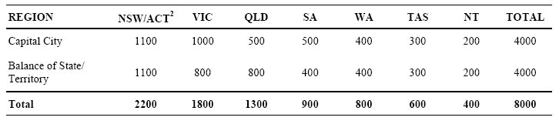
¹ Table base: total gross sample for the survey (i.e. selected households/telephone numbers)
² For sampling/analysis purposes, the entire ACT was included in the 'Balance of NSW' stratum
Also, detailed study definitions and methodologies are contained in Sections 2 and 3
Other interviewing procedures in relation to ‘selection chance’, double-counting etc. are discussed below:-
- most ‘private dwellings’ contain only one household. However, where multiple households occurred, all such households/residents were included – on the basis that each was primarily associated with the selected phone number (and no other)
- by contrast, some households have more than one phone number (including fax/modem lines etc) or more than one dwelling (e.g. holiday houses). Where such cases emerged, a definition of main phone number (or residence) was applied to include such households, i.e. ‘second’ lines/residences were excluded
- similar procedures were applied to any visitors at selected dwellings, determined as generally in-scope (i.e. Australian residents of private dwellings). Visitors expecting to return to their usual place of residence during the 8 week enumeration period for the survey were excluded, on the basis that their chance of selection existed there. The obverse applied to those not expecting to return ‘home’ in the period
- importantly, as a fundamental principle, no substitution of selected households (or persons within households) was permitted in the survey.

3.3 Enumeration and Response
A total of 11 interviewers conducted the survey. Located across Australia, all had previous experience in recreational fisheries surveys (including the NRFS). Interviewer training for the survey comprised one-to-one telephone briefing sessions, supplemented by detailed written instructions (scope, definitions etc) and several practice interviews (‘non-live’ samples).
Commencing in early May 2002, the vast majority of interviewing was completed by early July, with a small number being finalised in late July. Throughout the survey, completed interviews were progressively despatched to the survey office to aid with checking and data processing.
As discussed in Section 3.2, no substitution of selected households/persons was undertaken. Optimum response was therefore required to maximise representation from the survey sample and to achieve this, interviewer skill and persistence are important. While the survey was, of course, conducted on a voluntary basis, interviewers were instructed to ‘politely persist’ where respondents initially declined the survey – to explain the importance of their inclusion and to gain co-operation. The success of this approach is evidenced by the very low levels of ‘full refusals’ incurred – less than 2% of the overall sample (Table 2, overleaf). Also, substantial call-backs were made to minimise ‘non-contacts’, with a minimum requirement of 10 ‘effective’ calls over the assignment period (i.e. different times, days of week etc).
Whereas ‘non-response’ can be minimised in these ways (i.e. Items 2-5, and 8 in Table 2 below), other causes of incomplete interviews are un-avoidable, namely the ‘sample loss’ categories (Items 6, 7 and 9 in Table 2).
The ‘sample-take’ analysis in Table 2 overleaf is based on all response categories for the 8,000 household sample.

Table 2: Sample-Take Analysis - All Households in the Initial Gross Sample1 by State/Territory of Residence
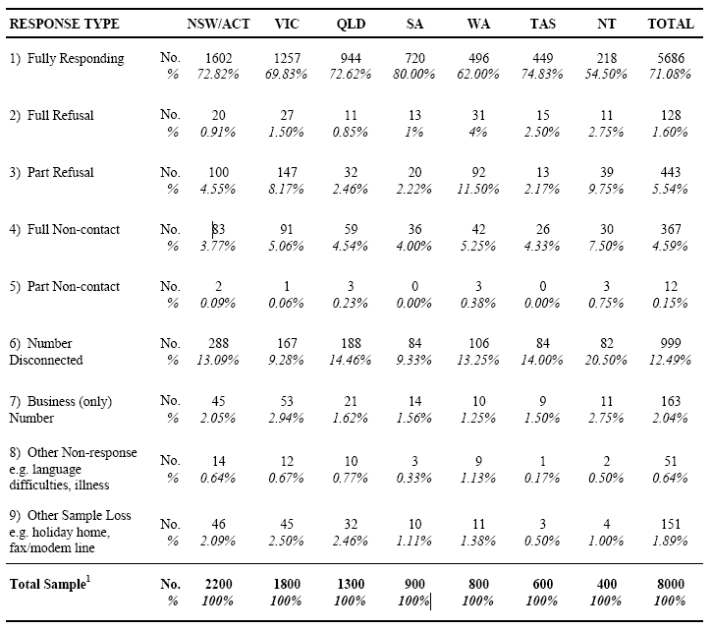
Notes:
¹ Table base: total gross sample for the survey (households/telephone numbers)
Also, detailed study definitions and methodologies are contained in Sections 2 and 3
However, for response rate assessment, the above results have been analysed to exclude all ‘sample loss’ categories (Items 6, 7 and 9). Accordingly, fully-responding households have been percentaged on total ‘eligible’ households, i.e. where a response could (or should) have been obtained, to reveal a national response rate of 85% (Table 3 overleaf).

Table 3: Response Analysis - Eligible Households in the Initial Gross Sample1 by State/Territory of Residence
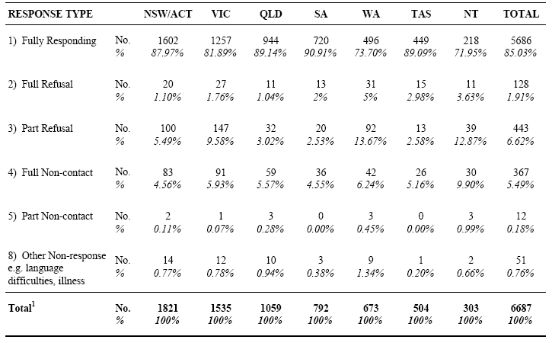
Notes:
¹ Table base: eligible households from the total gross sample for the survey (households/telephone numbers) i.e. excluding 'sample loss' categories from Table 2
Also, detailed study definitions and methodologies are contained in Sections 2 and 3
The survey results contained in this report have been based on 5,686 fully responding households nationally (Item 1 in Table 3). Information from partially responding households (Items 3 and 5) was only used in non-response analysis and adjustment (Section 3.6.2).

3.4 Data Editing and Processing
As a routine practice, completed survey questionnaires were subjected to several editing processes: clerical editing by interviewers and office staff; ‘input editing’ in data entry software; and detailed computer-based editing (incl. range and logic) prior to analysis. A key feature of this work concerns early detection of apparent errors/omissions to enable prompt resolution – especially in (albeit rare) cases, where a respondent needs to be re-contacted.
Data entry for the survey was completed by consultant office staff, using a customised data entry module, developed by our IT consultant. A copy of the software was provided to AFFA in June 2002. As mentioned above, the software included various ‘input editing’ functions, but also provided major efficiencies in terms of question sequencing (‘skips’) and was directly linked to the relational database for the study (MS Access).
Note: as an independent validation of the survey work and data entry, a random sample of completed questionnaires was checked against the results in the survey database, during a visit by AFFA liaison staff

3.5 Data Imputation
Cases where survey results were systematically imputed (i.e. where missing/unknown information was inferred) are discussed below. Although minor imputation was also required in terms of Acquisition Sources for charter fishing (Section 2.3.1), all other imputing was confined to minor omissions detected in editing – and only where the answer could be inferred with certainty.

3.5.1 Bait Quantities – Numbers Reported
By design, bait usage quantities could be reported in numbers (of species/group), as opposed to weights. Although this occurred infrequently and for particular species/forms (e.g. whole mullet), the questionnaire and database routinely accommodated such cases, through separate fields (for kgs. and no’s). All such cases were later converted to weights (with the original data retained in the database), using information obtained from a range of sources: the Bait Supplier Survey; length/weight data for prawns from NSWFRI; length/weight information for freshwater crayfish provided by AFFA staff (after consulting specialists in the field); and actual measurements by consultant staff at various retail outlets in NSW, QLD and SA (for prawns, squid, pippis/cockles and various fish species). Imputed weights for relevant species (whole animal basis) are shown below:-
Prawns: less than 5cm overall length – 1.4 grams (based on 4 cm mean): 5cm to 9cm – 3 grams (based on 7cm mean); 9 to 13 cm – 9 grams (based on 11cm mean); and although not ultimately required, > 13cm – 22 grams (based on 15 cm mean)
Squid: 60 grams
Freshwater crayfish: less than 8cm overall length – 25 grams (based on 6cm mean); and > 8cm – 45 grams (based on 10cm mean)
Pippis/cockles (and in a few cases, mussels): 8.75 grams
Saltwater fish species: pilchards – 50 grams; garfish – 50 grams; mullet (small) – 300 grams and (large) 450 grams.

3.5.2 Bait Quantities – Pack Sizes Unknown
Whereas quantities reported in numbers were infrequent, reporting of ‘packs’ (blocks etc) occurred quite commonly, with the pack size often unknown by the respondent. As an integral design component, the questionnaire allowed for general calculation/reporting of quantities in the form of an ‘equation’. In the following example … “6 days x 1 small pack/2 persons x 200g” the pack size was known and the total (600g) could be calculated. Where the pack size was unknown, the equation would be … “6 days x 1 small pack/2 persons x ?” and the total left blank. All such cases were ‘flagged’ in initial data entry and totals were later calculated using information from the Bait Supplier Survey (Section 3.8). High levels of consistency emerged
from this study, in terms of pack sizes by species across Australia and a largely standardised approach was employed in the coding work. Although minor state-specific exceptions were applied, the following refer to commonly imputed weights for key bait species and pack sizes, on a general/national basis:-
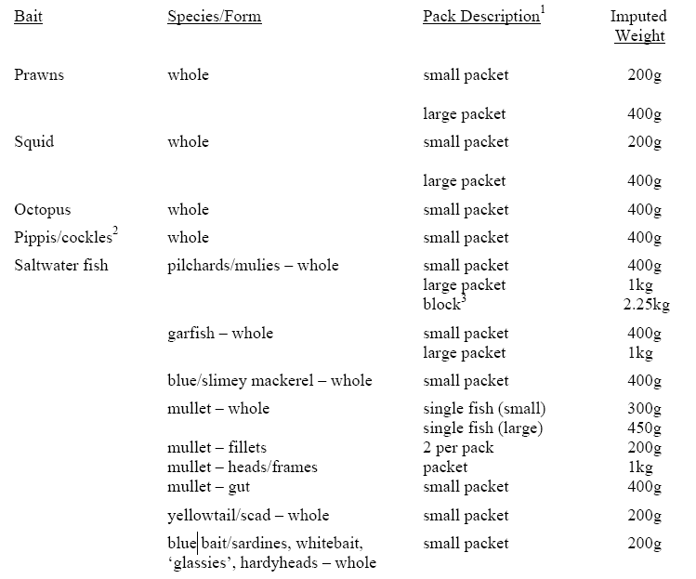
Notes:
1 Where respondents were unable to describe the pack size as ‘small’ or ‘large’, the small pack size was routinely imputed
2 in SA, pippis/cockles are commonly purchased in larger sizes – by the pint, gallon or ‘sack’. Mean weights for these were reliably established in field work by consultant staff
3 two main block sizes for pilchards were widely reported by bait suppliers (2kg and 2.5kg), along with a third, less common size (2.2kg). Accordingly, a mean of 2.25kg was applied.
Importantly, while the relatively high incidence of unknown pack sizes translated to a major coding task, it is not (we contend) an issue of concern to estimation precision. In this respect, a key design assumption was that most fishers have identifiable patterns of bait usage and could
quite reliably estimate their daily usage. Rather, the ‘number of days fished’ has always been the major concern, as a component of the standard reporting ‘equation’ (‘recall bias’ – see Section 3.6.4).

3.5.3 Bait Quantities – Usage by Region, Water Body Type and Season
As described in Section 3.1.1, usage quantities were assessed for each of the 10 bait types and the various acquisition sources and purchase forms within. This information was collected for each respondent on a national basis, covering all water body types and seasons for the previous 12 months. By design, specific questioning was included to enable disaggregation of quantities used in terms of time and space (Items [i] and [ii] in Section 3.1.1).
These question sequences produced a ‘28 cell’ usage assessment for each of the 10 bait types (7 states/territories x 2 water body types x 2 seasons) and a similar assessment for the number of days fished overall. The results from these two question sequences were combined to estimate usage proportions for the 28 cells within each bait type, reported by each respondent. That is, proportions were assigned to each ‘valid’ cell, based on the proportion of days fished in these cells.
For example, where a respondent’s only fishing in the period was in NSW saltwater, but in both ‘winter’ and ‘summer’ (say 1 and 4 days, respectively) and prawn usage was reported for both seasons, proportions would be assigned in the (prawns) database as follows … 20% (i.e. 1/5 days) to the cell for NSW_Saltwater_Winter and 80% (4/5 days) to NSW_Saltwater_Summer. On the other hand, the same respondent may have also reported using squid, but only in the summer period. In this case, 100% would be assigned to NSW_Saltwater_Summer in the squid database.
Always totalling 100% for each bait type/respondent, these proportions were then applied to reported bait quantities to estimate usage in time and space, i.e. in each of the 28 cells. In many cases, this process involved no imputation at all, i.e. where a bait type was used in only one state/territory, water body type and season (e.g. squid in the above example). Among the remainder, the vast majority referred to ‘two cell splits’ only (e.g. prawns in the above example). More complex ‘splits’ were quite uncommon and especially for ‘water body type’, where usage of a particular bait type in both freshwater and saltwater was extremely rare.

3.6 Data Expansion and Adjustment

3.6.1 Population Benchmarks and Integrated Weighting
As discussed in Section 3.2, population benchmarks for the survey were sourced from latest available Estimated Resident Population (ERP) data, as at June 2001 (ABS 2002). Benchmark data for private dwelling households were provided by stratum and household size (1, 2 or 3+ persons) – a total of 7,393,042 households nationally. For persons, the benchmarks were provided by stratum, sex and age group (less than 5 years, 5-14, 15-29, 30-44, 45-59 and 60 years or more) – a total of 18,863,130 residents nationally (and 17,581,317 – aged 5 years or more).
Using a method known as Integrated Weighting (Lemaitre and Dufour, 1987), ABS consultant staff provided expansion factors (weights) which, when applied to ‘raw’ survey data would
produce estimates conforming to the benchmark totals. Integrated weighting simultaneously considers characteristics for households (size) and persons (sex and age) and seeks to maximise convergence at all levels – namely, stratum, households by size and persons by sex/age. Through this approach, all persons in a given household and the household itself are assigned the same weight. The use of integrated weights (as opposed to independent weights for households and persons) is more consistent with cluster sampling, since the latter can result in different weights for each individual within a household (and the household itself).
Also, as an integral component of the weight construction process, the levels of demographic representation provided by the ‘sample-take’ for the survey were assessed by ABS staff. This assessment considered the upper/lower limits of ‘factors’ required to achieve benchmark convergence for each cell, i.e. where the factor represents the level of divergence from the original selection weight. The extent to which demographic cells needed to be collapsed (to facilitate convergence) was also assessed and in both respects, ABS reported acceptable outcomes (Hogan pers. comm.).

3.6.2 Adjustments for Non-response
Whereas the application of integrated weights provided demographic representation for the sample, the effects of non-response (refusals, non-contacts etc) have been shown to independently impact on the precision of behavioural assessments, e.g. recreational fishing participation (NRFS in prep.). Follow-up/calibration surveys conducted as part of the NRFS have assessed these impacts in some detail. Put simply, non-respondents have quite different levels of fishing participation from respondents, with ‘refusals’ having substantially lower participation and ‘non-contacts’ somewhat higher participation.
While low levels of non-response were achieved in the survey, adjustments for non-response bias were applied to maintain appropriate comparability with the NRFS. Adjustment factors were calculated using results from NRFS Follow-up Surveys, in combination with response profiling information from the Bait/Berley Survey. As for the NRFS, national adjustment factors were developed for fishing participation on a household basis (by size) in proportion to the types of non-response involved (i.e. different non-response profiles existed in the NRFS, where higher levels of refusal were incurred). As actual participation rates were available for all partially responding households in the present survey, these were directly employed in these calculations. For all other types of non-response (e.g. full refusals, non-contacts etc), participation ‘ratios’ were derived from the NRFS – resulting in the following general/national adjustment factors:-
Household Size Adjustment - Fisher Households
1 person 1.0111743*
2 persons 0.9692740
3 or more persons 0.9894910
Note*: this ‘upward’ adjustment is a direct result of the relatively high proportion of single-person households in the ‘non-contact’ group – where in turn, higher participation rates exist
The above adjustment factors were applied to the integrated weights for each fishing household (by size) in direct proportion to the level of non-response in each stratum, e.g. in a stratum with
half the national non-response level, the adjustment effect would be halved. For non-fishing households, appropriate counterpart adjustments were applied to maintain the benchmark populations, by stratum and household size.
Due to the low levels of non-response involved and to avoid divergence in adjusted integrated weights, the above adjustments were also applied at the person level (i.e. for those aged 5 years or more). In this process, adjustments to fishers/non-fishers also considered sex and age group within stratum to maintain the benchmark populations. This latter approach represents a departure from the non-response adjustment procedures employed in the NRFS, where specific person-based adjustments were developed and applied for participation and also in terms of ‘avidity’, for both households and persons. Analysis of these issues contra-indicated such adjustments for this survey – with very minor effects/benefits emerging, due to the low levels of non-response involved.
Note: expansion factors resulting from the above process (i.e. a product of the integrated weight and the non-response adjustment factor) have been applied in producing survey estimates in Tables 4-6, in Section 4

3.6.3 Adjustments for Sub-sampling of Fishers within Households
For most substantive questions, the survey was conducted with one randomly selected bait/berley user in each household. To account for differing ‘selection chances’ arising from this process and to maintain the benchmark populations for related survey estimates, a further adjustment factor was applied to the above expansion factor (i.e. adjusted integrated weight).
In developing these adjustments, relevant variables were analysed by stratum (e.g. sex, age group, ‘general avidity’ and the number of eligible household members) – initially to compare the profiles of all bait/berley users with those selected for the remainder of the interview. Due to the large number of cells involved, many small cell sizes emerged for selected fisher counts – translating to unacceptably large (potential) adjustment factors. To achieve an optimum balance in terms of benchmark alignment and the magnitude of these adjustments, further analysis was conducted whereby various cells were collapsed and different variable combinations assessed.
Ultimately, these adjustments were calculated on the basis of two variables within each stratum, namely sex and ‘general’ avidity (days fished: 1-4, 5-14, 15 or more) – as these were shown to be the most critical determinants of respondent behaviour (bait usage etc). Moreover, the exclusion of ‘age group’ from this process was shown to have quite minor effects on benchmark alignment.
Some 2,065 respondents were eligible for selection from the 1,123 households reporting any in-scope bait/berley usage in the survey. Consistent with this, the mean of all adjustment factors is 1.85. As would be expected, the vast majority of adjustment factors are clustered around the mean – although some larger factors emerged (the largest being 9.77). From an analysis of those with a value greater than 4, virtually all refer to females (one exception) in smaller avidity cells and strata. Under normal circumstances, the size and potential impact of such large adjustments would be reduced by appropriate cell collapsing. However, after further analysis this was shown to be unnecessary, due to the consistently low levels of fishing activity and bait usage reported in all such cases.
Note: expansion factors from the above process (i.e. a product of the adjusted integrated weight and the ‘selected fisher’ adjustment factor) have been applied in producing all fisher-based estimates for Table 7 onwards in the report (i.e. not quantity-based estimates – Section 3.6.4).

3.6.4 Adjustments for Recall Bias
Adjustment for the effects of ‘recall bias’ represents the most significant calibration of results for the survey. As discussed earlier in this report (primarily Section 3.1.2) ‘recall bias’ has been shown to result in significant over-estimation of fishing effort (days fished). Since ‘days fished’ was directly employed in calculating bait usage quantities for the vast majority of respondents (and perhaps indirectly for many others), it follows that bait quantities would also be over-estimated. To measure and calibrate for these effects, data from the NRFS Diary Survey have been used as benchmarks, on the basis that the diary method represents the most reliable assessment of such behaviour over time. These results were compared to data from the Bait/Berley Survey, in a detailed analysis discussed in (ii) below. However, before undertaking this analysis, important comparability issues were considered.
(i) Preliminary Analysis and Assumptions
Clearly, year-to-year variations can occur in fisher behaviour, as revealed by the lower fishing participation rates emerging from the Bait/Berley Survey (Tables 4 and 5, in Section 4). However, a comparison of broad avidity profiles (collected on a recall basis in both surveys) suggests that the distribution of fishing effort does not vary substantially on a year-to-year basis. The following analysis is based on expanded estimates of recreational fishers (including non-bait users) from the two datasets:-
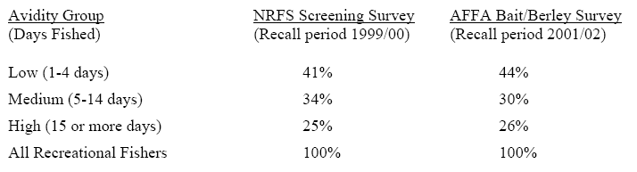
Note: due to the large sample size for the NRFS (44,000 households nationally), very low error tolerances apply to these estimates. For the AFFA survey, the standard errors are understandably larger, e.g. for the low avidity group estimate (44%), ‘95% confidence limits’ have been calculated at 42% – 46%. When all error tolerances are considered, very small differences emerge in the above comparisons.
Limited available information also indicates that mean fishing effort does not vary substantially from year-to-year. Time-series studies conducted in Queensland (on a recall basis) provide estimates of average days fished in Queensland, by resident recreational fishers: 18 days – 1996; 17 days – 1998; and 17 days in 2001 (QFMA 1997, Roy Morgan Research 1999, Higgs and McInnes, in press). Although based on bait/berley users only, estimates from the present survey for Queensland residents show a mean of 16 days fished in Queensland for the reference period.
(ii) Analysis and Adjustment
In the following analysis, optimum comparability was sought between the two datasets. For example, fishing effort estimates from the NRFS Diary Survey were confined to respondents reporting some bait/berley usage (of any kind) during the survey period. While this includes respondents who may only have used out-of-scope bait/berley (e.g. meat, bread) during the period, the impact of this is considered negligible, due to the presumably small numbers involved. Also, the NRFS data cover all fishing effort by bait/berley users (including e.g. lure fishing) on a ‘separate days fished’ basis – as do the results from the Bait/Berley Survey, which were derived from specific ‘recall’ questioning described in Item (i), Section 3.1.1.
For both datasets, the analysis was based on expanded estimates of fishers, classified by the number of days fished (in ascending order). These results were then dissected according to four ‘avidity comparison groups’, specifically developed for this purpose. In this classification, each dataset was dissected into comparable proportions, based on percentile rankings of fishers. For example, ‘the lowest 37%’ group for the NRFS refers to diarists reporting either 1 or 2 days fishing in the period (and more precisely, 37.25% of fishers). An equivalent proportion for the Bait/Berley Survey (37.39%) was obtained from cumulative estimates of those reporting 1-4 days fishing. In determining proportions for the other three groups, equivalent alignment precision was obtained (e.g. for ‘the next 29%’ group – 28.67% and 28.77%, respectively). Attempts to provide greater resolution in the analysis by creating more groups (or through modelling) were prevented by ‘spikes’ in the Bait/Berley Survey data – a characteristic of ‘recall bias’ (known as ‘digit bias’) where certain values attract higher levels of response (e.g. 10 days, not 9 or 11).
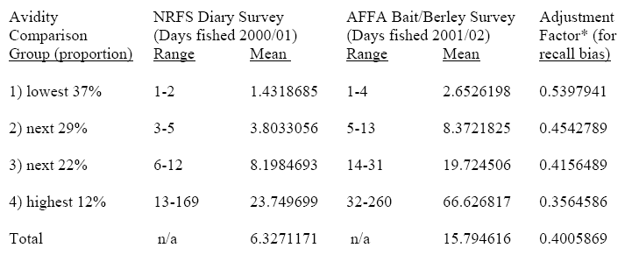
Note*: adjustment factors for each avidity group were calculated by dividing the mean (days fished) for the NRFS by the mean for the Bait/Berley Survey.
Based on assumptions (discussed in (i) above) in terms of year-to-year variations in fishing effort and the precision of the NRFS Diary Survey, significant over-estimation of fishing effort has been assessed for the Bait/Berley Survey – by a factor of around 2.5 overall (i.e. the inverse of 0.4005869) and with a clear trend towards higher levels of over-estimation, as fishing effort increases. In the extreme, this disparity is also evident from the maximum effort levels reported in the two datasets – 169 days for the NRFS, from a sample of some 11,000 diarists, yet in the Bait/Berley Survey, 10 respondents reported in excess of this amount (the highest being 260 days), from a sample of 1,123 respondents.
The above adjustment factors have been routinely applied to respondents in each of the four ‘avidity comparison groups’ – for purposes of bait quantity estimation only. All other assessments, including ‘incidence’ of bait usage, were considered to be unaffected by such bias. In the wholesale application of these adjustments, it is recognised that for some respondents, consequent reductions in bait quantities may be inappropriate (primarily, in the low avidity group). For example, a respondent reporting (say) one day’s fishing for the year and a ½ packet of prawns used, may have done so quite accurately. On the other hand, ‘telescoping’ effects could exist in this case, whereby the fishing day actually occurred prior to the reference period. While partitioning such cases was not possible, the potential effects of such ‘over-adjustment’ can be assessed. For example, in terms of prawns, the low avidity group (1-4 days fished) accounts for 41% of all purchaser-users, but only 11% of adjusted total quantities used (see discussion after Table 13, Section 5). Furthermore, prawn users reporting only one day’s fishing in the period, comprise 6% of all purchaser-users and only 1% of quantities used (a sub-sample of 80 respondents).
Clearly, this adjustment process represents the best available calibration for the effects of ‘recall bias’ and therefore provides optimum precision in bait quantity estimation for the project.
Note: expansion factors from the above process (i.e. a product of the [twice] adjusted integrated weight and the ‘recall bias’ adjustment factor) have been applied in producing all quantity-based estimates from Table 12 onwards in the report.

3.7 Analysis and Reporting

3.7.1 Analysis and Data Outputs
The structure and range of data tabulations presented in this report were determined in consultation with AFFA liaison staff. In accordance with the agreed reporting structure, these results have been presented without interpretation or commentary – one of several reporting conventions discussed in Section 1.3.
The survey database was also an output requirement of the project and copies of relevant databases have been provided to AFFA, along with detailed briefing of liaison staff. Note: for privacy reasons, all personal information for respondents (names, addresses, phone numbers etc) has been removed from databases provided to AFFA. However, this information (along with completed survey questionnaires) has been retained by our company to enable further research by AFFA (e.g. for the FishSmart Awareness Campaign) and more detailed disaggregation of survey results (see discussion below). Importantly, once these requirements have been met, all survey questionnaires will be ‘destroyed under supervision’ and any personal information permanently deleted from the databases.
All primary survey data are contained in a relational database (Microsoft Access), comprising separate ‘tables’ for the various bases involved (households, persons, fishers etc). The database has also been provided in Microsoft Excel format (in separate files for the various bases), to enable review of the data tabulations contained in this report and also to facilitate further interrogation of the database, where required.
In this regard, considerable potential exists within the database. However, for certain purposes, additional database ‘construction’ will be required – namely, to provide disaggregation of usage data for key bait species/groups within the 10 bait types covered by the survey. While the data entry system and database were designed to conform with output requirements, an unexpected by-product of the survey emerged after data editing and processing, whereby detailed usage information (incl. quantities purchased/used) can be reliably disaggregated for individual species/groups within three major bait types (‘Squid/cuttlefish/octopus’, ‘Other shellfish’ and ‘Saltwater fish’). For example, key ‘Saltwater fish’ species, such as pilchards, mullet, yellowtail and whitebait have been reported by relatively large numbers of respondents (see Table 69 in Section 5.10.1) and in all cases, individual ‘calculation equations’ are available in the survey questionnaires (where required).
Moreover, quite different ‘sourcing’ patterns exist for these and other species, based on observations in the processing work. For example, very large quantities of pilchards were reported and almost entirely refer to the acquisition source ‘Sold as Bait’. For mullet, quite large quantities were reported for ‘Sold as Bait’, but also to the extent of dominating quantities reported for ‘Sold as Seafood’ – together with significant reporting of ‘Personally Caught’. On the other hand, almost all usage of flathead was reported as ‘Personally Caught’ (and primarily by Tasmanian fishers).
As agreed, the work required to create these disaggregations is outside the scope and timing constraints of the present project. Accordingly, further information and discussion of this issue can be provided, as required.

3.7.2 Error Estimation
Standard error tables for all substantive survey results are contained in the Appendix – where data tabulations from the report have been replicated, showing relative standard errors (RSE) for each survey estimate. Application of the errors is also discussed in the introduction to the Appendix, e.g. calculation of confidence intervals.
Estimation of errors for the survey has been based on approximations which are considered more than adequate for purposes of the study, especially in terms of any ‘semi-quantitative’ analysis. Although 14 strata were employed in initial sampling (and construction of integrated weights), for practicality, all error estimates were derived on a state-basis and combined for the Australian total. This approach was shown to consistently produce only minor differences and slightly more conservative error levels, when compared to more detailed stratum-based calculations. Also, the error estimates are based on a cascading principle, where the estimate for a particular level is based on a sample proportion multiplied by an estimate of the population base calculated at the previous level.
Note: these error terms relate to ‘sample error’ only – any variability for components of ‘non-sample error’ (e.g. ‘recall bias’) has not been included. All variance estimators employed [var(X)] are defined in the remainder of this sub-section.
Relative standard error (RSE) is defined by:
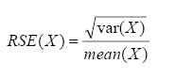
(i) ESTIMATION OF POPULATION-BASED VARIABLES (HOUSEHOLDS, PERSONS)
(a) Fisher Households
‘
The estimate of number of fisher households is derived by summing the expansion factors (i.e. adjusted integrated weights) for each fishing household in the sample, but is based on the binomial estimator:
NFH=NHH x nFH/nHH ...Eqn 1
The error on this estimate is the usual binomial variance estimator:
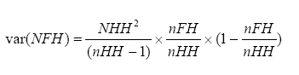 ...Eqn 2
where: NFH is the estimated number of fisher households in the population
NHH is the total number of households in the population
nHH is the number of households in the sample
nFH is the number of fisher households in the sample
(b) Fishers
The estimate of number of fishers (again derived by summing relevant expansion factors) is based on the binomial estimator:
NF=NP x nF/nP ...Eqn 3
where: NF is the estimated total number of fishers (> 4 years old) in the population
NP is the number persons (> 4 years old) in the population
nF is the number of fishers (> 4 years old) in the sample
nP is the number of persons (> 4 years old) in the sample
The error on this estimate is the usual binomial variance estimator:
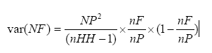 ...Eqn 4
Note: nHH is the number of households in the sample and is used in the denominator of the variance formula, rather than nP, as the latter would overestimate the true variance. As there was only one fisher selected from each household, the use of nHH is more appropriate to the provision of a variance estimate, as it less likely to underestimate the true variance.
(c) Bait Users
The estimate of number of bait-users (again derived by summing relevant expansion factors) is based on the product of the estimated number of fishers and the proportion of fishers using bait:
NFB=NF x Pr(B|F) ...Eqn 5
where: NFB is the estimated (expanded) total number of fishers (> 4 years old) using bait
NF is the estimated total number of fishers (> 4 years old) in the population
Pr(B|F) is the proportion of fishers in the sample who used bait and is defined by:
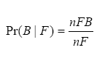
The error on this estimate is derived from the variance of the product of independent variables:
...Eqn 6
where var(Pr(B|F)) is given by the binomial variance estimator:
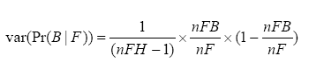
where: nFH is the number of fisher households in the sample
nFB is the number of fishers (> 4 years old) in the sample who used bait
var(NF) is given by Eqn 4.
(d) Number of Bait Users by Bait Type
The estimate of number of bait-users by bait type (again, derived by summing relevant expansion factors) is based on the product of the estimated number of bait-users and the proportion of bait-users by bait type. For example, the first bait category is prawns/shrimp (P):
...Eqn 7
where is the sample proportion of fishers using prawns/shrimps, given that the fisher used bait.
The error on this estimate is derived from the variance of the product of independent variables:
..Eqn 8
where var(Pr(P|B)) is given by the binomial variance estimator:
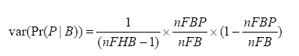
and var(NFB) is given by Eqn 6.
(e) Bait Type Usage Disaggregated by Other Variables
Disaggregation of bait type usage for other variables (e.g. method for baiting the hook) is again derived by summing expansion factors for relevant respondents, but is based on the product of the estimated number of bait-users for a particular bait type (e.g. prawns/shrimp) and the sample proportion for the variable concerned. For example, for fishers using prawns/shrimp (P) by method M:
NFBPM=NFBP x Pr(PM|P) = NFBP x nFBPM/nFBP ...Eqn 9
where Pr(PM|P) is the sample proportion of fishers using method M for prawns/shrimps, given that the fisher used prawns/shrimps as bait.
The error on this estimate is derived from the variance of the product of independent variables:
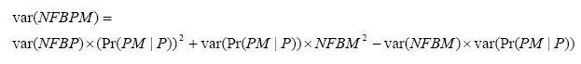 ...Eqn 10
where var(Pr(PM|P) is given by the binomial variance estimator:
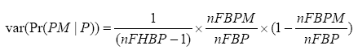
and var(NFBP) is given by Eqn 8.
(ii) ESTIMATION OF BAIT QUANTITIES
The estimates of quantity used for a given type of bait, e.g. prawns (QBP) are derived by summing the expanded estimates of quantities of prawns for each prawn purchaser-user, but are based on the product of the estimated total number of prawn purchaser-users (NFBP) and the weighted mean quantity of prawns used by these fishers (WMBP):
QBP= NFBP x WMBP ...Eqn 11
The error on this estimate is derived from the variance of the product of independent variables:
...Eqn 12
where: var(NFBP) is given by Eqn 8.
var(WMBP), the variance of the weighted mean quantity of prawns used over all
prawn purchaser-users, is given by:
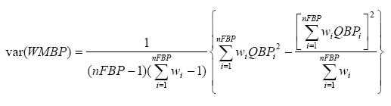
wi is the weighting (expansion factor) for person/household i
nFBP is the number of persons/households in the sample using prawns
QBPi is the quantity of prawns reported for person/household i
Similarly, for the estimate of quantity of a particular bait type (e.g. prawns (P)) for a particular method M:
where: var(NFBPM) is given in Eqn 10.
var(WMBPM), the variance of the weighted mean quantity of bait used, is given by:
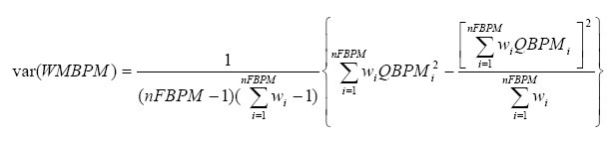
where: wi is the weighting (expansion factor) for the person/household i
nFBPM is the number of persons/households in the sample using prawns by method M
QBPMi is the quantity of prawns by method M reported for person/household i

3.8 Bait Supplier Survey
The primary objective of the Bait Supplier Survey was to establish pack size information (weights) for key bait species sold around Australia. As discussed in Section 3.5.2, this information was directly employed in the imputation process for unknown pack sizes in the Bait/Berley Survey. Although by no means a large study, key design features/outcomes were:-
- optimum coverage of the major bait suppliers and wholesalers was sought to maximise the utility of the results. Excellent co-operation and complete survey information were provided by all 23 suppliers approached
- although initial sampling was sourced from electronic ‘yellow pages’ directories, other information was employed to identify and ‘rank’ the major operators by state etc. (including through the interview itself)
- the survey was conducted by telephone interview, on a voluntary basis with key staff from the companies concerned. Initial interviews were conducted by a senior interviewer of our
company, with some follow-up contact by consultant staff (primarily in terms of species identification issues – different local names)
- in many cases, data were supplied by fax/email in the form of product listings/order forms. Although much of the information collected is generally available to the public, individual results from the survey are to be treated in the strictest confidence
- in several cases, different pack sizes were reported for particular bait types and where appropriate, these were applied in the coding for the states concerned. However, substantial consistency emerged for the vast majority of cases, e.g. for prawns, a 200g ‘small’ pack was reported by all bait suppliers
- this consistency not only facilitated the coding process for the Bait/Berley Survey, but also provides enhanced data quality overall. It also obviated more detailed questioning of bait suppliers, e.g. to quantify sales volumes across/within states, where differing pack sizes were reported.
Detailed results from this survey were provided to AFFA liaison staff on a confidential basis in August 2002.

4 RESULTS RECREATIONAL FISHING AND BAIT USAGE

4.1 Recreational Fishing Participation
The results in this section assess participation in recreational fishing by the resident population during the period May 2001 to April 2002 – on a household basis (Table 4) and for persons aged 5 years or more (Table 5).

Table 4: Any Recreational Fishing1 in the Previous 12 Months - Households2 by State/Territory of Residence
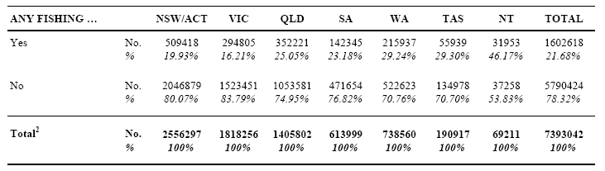
Notes:
¹ Recreational fishing is defined as any attempted harvesting of aquatic organisms for non-commercial purposes
² Table base: population estimate of resident households ('Private Dwellings' basis only)
Also, standard error estimates are contained in Appendix A, with detailed study definitions and methodologies in Sections 2and 3

Table 5: Any Recreational Fishing1 in the Previous 12 Months - Persons (aged 5 years or more)2 by State/Territory of Residence
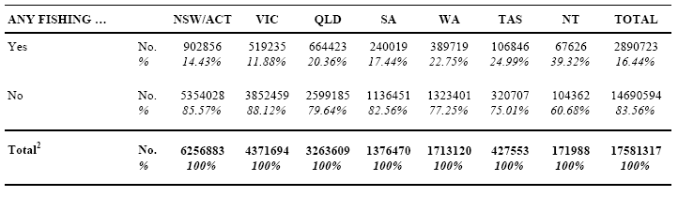
Notes:
¹ Recreational fishing is defined as any attempted harvesting of aquatic organisms for non-commercial purposes
² Table base: population estimate of residents aged 5 years or more ('Private Dwelling' basis only)
Also, standard error estimates are contained in Appendix A, with detailed study definitions and methodologies in Sections 2and 3
When the above results are compared with equivalent data from the NRFS (reference period 1999/00), it emerges that national participation rates* have declined between the two studies. On a household basis, 95% confidence limits for NRFS participation rates are 24.0% – 25.0%, compared with 20.6% – 22.7% for the Bait/Berley Survey. For residents (aged 5 years or more), equivalent results are 18.9% – 20.1% (NRFS) and 15.5% – 17.4% (Bait/Berley Survey). Also,
regional analysis of participation reveals a general decline across all states/territories, with the exception of the Northern Territory. Declining participation rates have also been observed in a recent Queensland study and related time-series information (Higgs and McInnes, in press).
As a more stable variable, comparisons of boat ownership levels provide an important validation of the above findings (note: relevant boat ownership questioning from the NRFS was replicated in the Bait/Berley Survey). In the NRFS, some 789,000 households in Australia (10.9% of the population) were estimated to own a boat of any kind (including canoes, jet skis etc). Equivalent results for the Bait/Berley Survey are 775,000 households and 10.5%, respectively. Boat ownership among fishing households was also assessed – for the NRFS: 573,000 households (7.9% of all households) and for the Bait/Berley Survey: 554,000 (7.5% of all households). When error tolerances are considered, no significant differences exist between the results in these comparisons
Note*: participation rates are routinely expressed as a percentage of population estimates at the time. Due to population growth, somewhat lower levels of decline emerge for analyses based on numbers of recreational fishers.

4.2 Bait Usage
All respondents (aged 5 years or more) reporting any recreational fishing activity in the previous 12 months (Table 5) were then assessed in terms of ‘in-scope’ bait/berley usage (i.e. aquatic animals) during that time, the results to which appear in the following table.

Table 6: Any Bait/Berley Usage1 in Previous 12 Months - Recreational Fishers2 by State/Territory of Residence
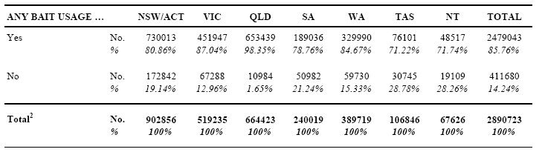
Notes:
¹ Bait/berley is defined as any kind of aquatic animal (i.e. plants and terrestrial animals are excluded)
² Table base: population estimate of recreational fishers (aged 5 years or more)
Also, standard error estimates are contained in Appendix A, with detailed study definitions and methodologies in Sections 2and 3
After assessing bait/berley usage for all fishers in the household, a random selection process identified one fisher in each household (1,123 in the sample) for remaining survey questions. Accordingly, all results in the remainder of this report have been based on expanded estimates of ‘selected fishers’ – i.e. expanded to the estimated population of bait/berley users (Table 6 above). The first of these question sequences assessed usage in the previous 12 months, in terms of 14 specific bait types (Table 7 overleaf).

Table 7: Bait Types Used in Previous 12 Months - Recreational Fishers1 by State/Territory of Residence
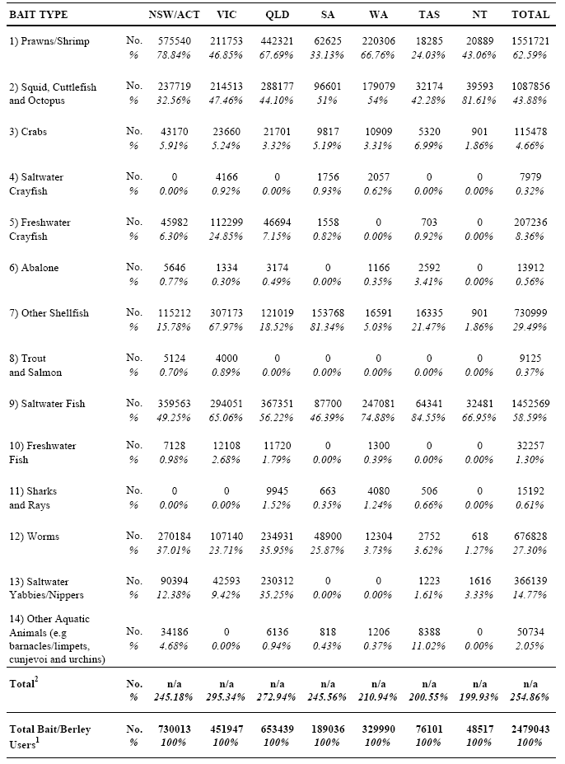
Notes:
¹ Table base: population estimate of recreational fishers using aquatic animals as bait/berley in the previous 12 months
² Due to multiple reporting, totals add to more than 100%
Also, standard error estimates are contained in the Appendix, with detailed study definitions and methodologies in Sections 2 and 32)

5 RESULTS 10 SPECIFIC BAIT TYPES

5.1 Introduction
The remaining questions in the survey collected detailed usage information for 10 specific bait types of interest to the study, i.e. Bait Types 1-10 (from Table 7). Whereas, the vast majority of respondents (1,093 of 1,123 – or 2,383,048 of 2,479,043 on a population base) reported some such usage in the period, no further bait usage questions were asked of those reporting Bait Types 11-14 only (30 respondents). Also, in Section 1.3, various reporting conventions are discussed – including that varying levels of detail have been provided for each of the 10 Bait Types in this section. As this is dependent on the strength of the underlying data, the number of respondents reporting usage of each Bait Type has been included (as a guide) in Sections 5.2 to 5.11 below. Also, for the more commonly reported bait types, all fisher-based results are firstly reported in a separate sub-section (e.g. 5.2.1 for prawns/shrimp) from quantity-based estimates (e.g. 5.2.2 for prawns/shrimp).

5.2 Prawns/Shrimp

5.2.1 Results on a Fisher Base
As a major bait type, some 641 respondents reported using prawns/shrimp as bait/berley in the previous 12 months. For each respondent, usage was firstly assessed in terms of three acquisition sources (Table 8 below).

Table 8: Acquisition Source of Prawns/Shrimp Used as Bait/Berley - Recreational Fishers1 by State/Territory of Residence
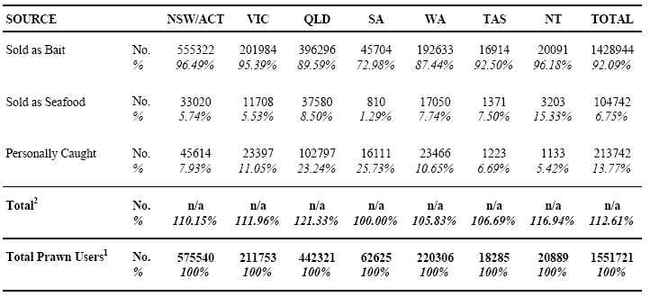
Notes:
¹ Table base: population estimate of recreational fishers using prawns/shrimp as bait/berley in the previous 12 months
² Due to multiple reporting, totals may add to more than 100%
Also, standard error estimates are contained in the Appendix, with detailed study definitions and methodologies in Sections 2 and 3
Respondents reporting any usage of prawns/shrimp for the acquisition source ‘Sold as Seafood’ were subsequently questioned to establish their main (and any other) reasons for doing so. In Table 9 (below), the results are presented on a national basis – with three un-reported answer categories from the survey questionnaire included in ‘Other’ (namely, choice of species, choice of form and choice of quantity).

Table 9: Reasons for Purchasing Prawns/Shrimp from a 'Seafood Supplier' (vs. Bait Supplier) - Recreational Fishers1 (All States/Territories)
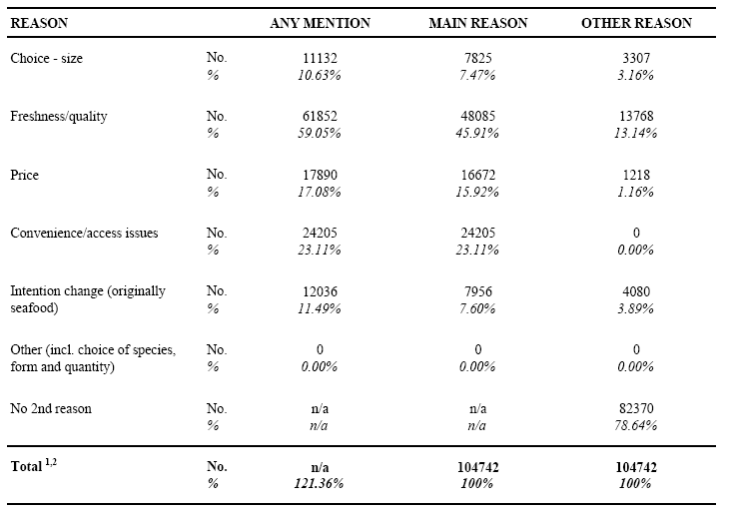
Notes
1 Table base: population estimate of recreational fishers using prawns/shrimp that were 'Sold as Seafood', as bait/berley in the previous 12 months
2 Due to multiple reporting in the 'ANY MENTION' column, the total adds to more than 100%
Also, standard error estimates are contained in the Appendix, with detailed study definitions and methodologies in Sections 2 and 3
The results in Table 10 (below) assess usage preferences in terms of main (and any other) methods used to bait the hook in line fishing with prawns/shrimp – for all users, aggregated on a national basis.

Table 10: Methods Used to Bait Hook with Prawns/Shrimp - Recreational Fishers1 (All States/Territories)
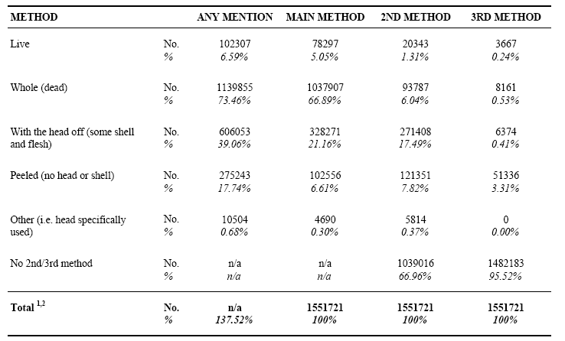
Notes:
¹ Table base: population estimate of recreational fishers using prawns/shrimp as bait/berley in the previous 12 months
² Due to multiple reporting in the 'ANY MENTION' column, the total adds to more than 100%
Also, standard error estimates are contained in the Appendix, with detailed study definitions and methodologies in Sections 2 and 3
The results in Table 11 (below) assess the extent to which residents of each state/territory used prawns/shrimp locally, as opposed to other regions of Australia. To assist in this regard, the table cells conforming to ‘home’ state/territory usage have been highlighted.

Table 11: State/Territory of Usage of Prawns/Shrimp as Bait/Berley - Recreational Fishers1 by State/Territory of Residence
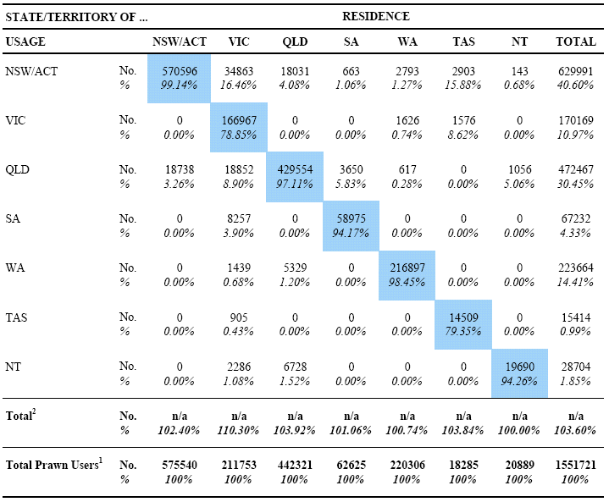
Notes:
¹ Table base: population estimate of recreational fishers using prawns/shrimp as bait/berley in the previous 12 months
² Due to multiple reporting, totals may add to more than 100%
Also, standard error estimates are contained in the Appendix, with detailed study definitions and methodologies in Sections 2 and 3

5.2.2 Quantities
All results in this sub-section refer to estimates of total quantities of prawns/shrimp used in the previous 12 months from ‘purchase sources’ only, i.e. quantities used were not assessed for ‘Personally Caught’ prawns/shrimp. In Tables 12 and 13 (below), quantities for each purchase source are assessed by state/territory of residence and usage (respectively).

Table 12: Purchase Source of Prawns/Shrimp Used as Bait/Berley - Annual Quantities Used1 (Kgs) by State/Territory of Residence
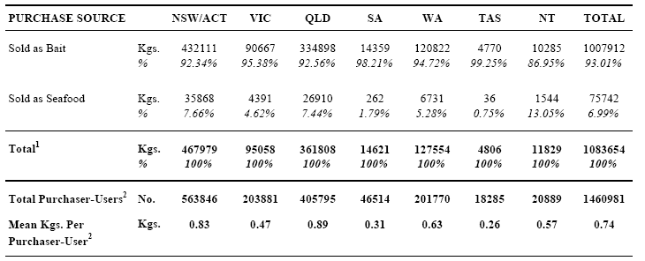
Notes:
¹ Table base: estimated total quantity of prawns/shrimp used by recreational fishers as bait/berley in the previous 12 months ... from 'purchase sources' only
² Excludes those who only used prawns/shrimp that were 'Personally Caught'
Also, standard error estimates are contained in the Appendix, with detailed study definitions and methodologies in Sections 2 and 3

Table 13: Purchase Source of Prawns/Shrimp Used as Bait/Berley - Annual Quantities Used1 (Kgs) by State/Territory of Usage
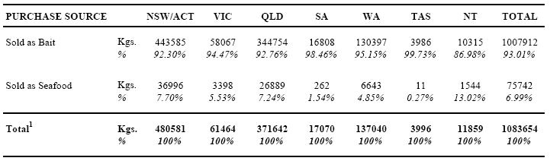
Notes:
¹ Table base: estimated total quantity of prawns/shrimp used by recreational fishers as bait/berley in the previous 12 months … from 'purchase sources' only. By design, quantities for 'Personally Caught' prawns/shrimp were not assessed in the survey
Also, standard error estimates are contained in the Appendix, with detailed study definitions and methodologies in Sections 2 and 3
Also, when national usage quantities are analysed in terms of general fishing ‘avidity’ (days fished), it emerges that the low avidity group (1-4 days fished) accounts for some 41% of all purchaser-users of prawns/shrimp, but only 11% of the estimated total quantities used. Corresponding results for the medium avidity group (5-14 days fished) are 29% and 21% respectively and for the high avidity group (15 or more days fished), 30% and 67% respectively.
The results in Table 14 (below) show estimated total quantities used for prawns/shrimp ‘Sold as Bait’ (per Table 13) disaggregated for each specific ‘purchase form’ contained on the survey questionnaire.

Table 14: Form Purchased of Prawns/Shrimp 'Sold as Bait' - Annual Quantities Used1 (Kgs) by State/Territory of Usage
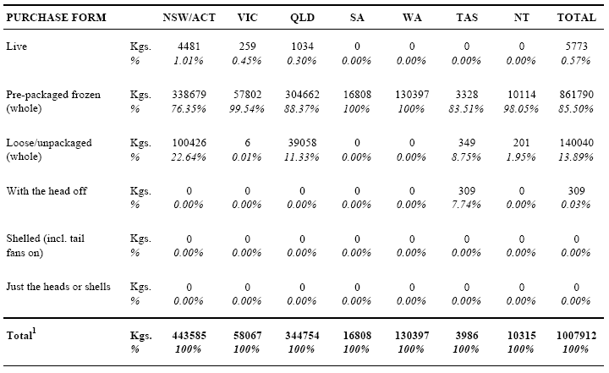
Notes:
¹ Table base: estimated total prawns/shrimp used by recreational fishers as bait/berley in the previous 12 months - where the purchase source was 'Sold as Bait'
Also, standard error estimates are contained in the Appendix, with detailed study definitions and methodologies in Sections 2 and 3

The results in Table 15 (below) show estimated total quantities used for prawns/shrimp ‘Sold as Seafood’ (per Table 13) disaggregated for each specific ‘purchase form’ contained on the survey questionnaire.

Table 15: Form Purchased of Prawns/Shrimp 'Sold as Seafood' - Annual Quantities Used1 (Kgs) by State/Territory of Usage
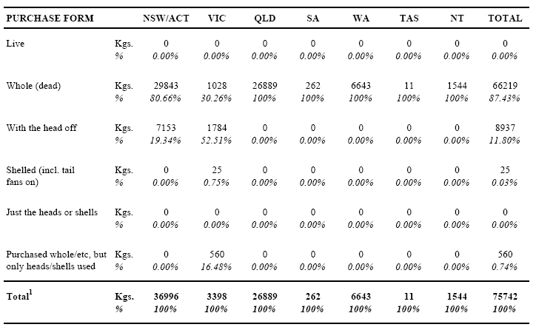
Notes:
¹ Table base: estimated total prawns/shrimp used by recreational fishers as bait/berley in the previous 12 months - where the purchase source was 'Sold as Seafood'
Also, standard error estimates are contained in the Appendix, with detailed study definitions and methodologies in Sections 2 and 3
The results in Table 16 (below) estimate quantities of whole prawns/shrimp used (for selected purchase forms), in terms of four size groups (total body length basis). This assessment was confined to certain purchase forms, on the basis that they represent the main situations where an effective choice of size might exist, i.e. any loose/unpackaged prawns (as opposed to pre-packaged frozen prawns from bait suppliers).
In this question sequence, respondents were asked to assign proportions of reported quantities to each of the four size groups. However, in developing and testing this approach, it was recognised that many respondents would be unable to accurately assess prawn sizes, to the extent that misreporting by one size group (up or down) could reasonably be expected – especially for prawn sizes close to the limits of adjoining groups. The significant minority of quantities assigned to the smallest group (‘less than 5cm or 2 inches’) is considered at least partly attributable to this imprecision – namely, where respondents wishing to report quite small prawns, may have inappropriately opted for the smallest group. On the other hand, misreporting by two size groups was considered highly unlikely. For example, where a respondent used (say) 14cm prawns, substantial under-estimation would be required (by at least 5cm) for the quantity to be assigned to the 5–9cm group.
In the context of ‘semi-quantitative’ analysis, this assessment has clearly achieved its objectives – namely, to gain an understanding of fisher preferences/usage in relation to prawn size and more specifically, the extent to which large prawns (>13cm) might be sourced from seafood suppliers. In terms of the latter, the impacts of any reporting imprecision in the 9-13cm group can only be minimal – due to the small numbers involved and the likely ‘distribution skew’ towards the lower end of the 9-13cm range.

Table 16: Estimated Size of Whole Prawns/Shrimp - Annual Quantities Used1 (Kgs) by Selected Source/ Purchase Forms (All States/Territories)

Notes:
¹ Table base: estimated total quantity of prawns/shrimp used by recreational fishers as bait/berley in the previous 12 months ... Purchased 'Whole (dead)' and either 'Sold as Bait' (but excluding pre-packaged frozen) or 'Sold as Seafood'
Also, standard error estimates are contained in the Appendix, with detailed study definitions and methodologies in Sections 2 and 3
The results in Table 17 (below) estimate national usage of prawns/shrimp by water body type, season and purchase source.

Table 17: Usage of Prawns/Shrimp by Water Body Type and Season - Annual Quantities Used1 (Kgs) by Purchase Source (All States/Territories)
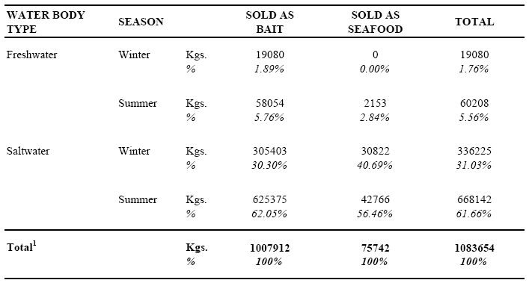
Notes:
1 Table base: estimated total quantity of prawns/shrimp used (in any State/Territory) by recreational fishers as bait/berley in the previous 12 months ... from 'purchase sources' only. By design, quantities for 'Personally Caught' prawns/shrimp were not assessed in the survey
Also, standard error estimates are contained in the Appendix, with detailed study definitions and methodologies in Sections 2 and 3
The remaining tables in this sub-section (Tables 18-24) comprise a disaggregation of the results in Table 17 above, for each state/territory. In several cases, relatively large sub-samples of prawn users exist (e.g. NSW/ACT). However, others are based on quite small numbers of respondents (e.g. Tasmania) and have been included for completeness.

Table 18: Usage of Prawns/Shrimp by Water Body Type and Season - Annual Quantities Used1 (Kgs) by Purchase Source (NSW/ACT)
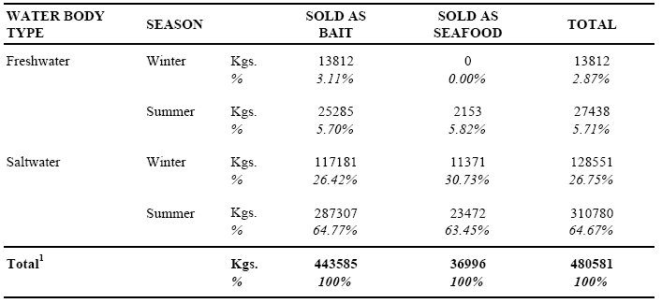
Notes:
¹ Table base: estimated total quantity of prawns/shrimp used in NSW/ACT by recreational fishers as bait/berley in the previous 12 months ... from 'purchase sources' only. By design, quantities for 'Personally Caught' prawns/shrimp were not assessed in the survey
Also, standard error estimates are contained in the Appendix, with detailed study definitions and methodologies in Sections 2 and 3

Table 19: Usage of Prawns/Shrimp by Water Body Type and Season - Annual Quantities Used1 (Kgs) by Purchase Source (VICTORIA)
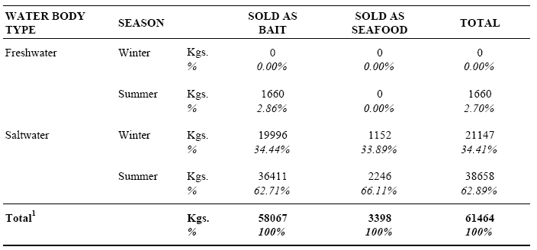
Notes:
¹ Table base: estimated total quantity of prawns/shrimp used in Victoria by recreational fishers as bait/berley in the previous 12 months ... from 'purchase sources' only. By design, quantities for 'Personally Caught' prawns/shrimp were not assessed in the survey
Also, standard error estimates are contained in the Appendix, with detailed study definitions and methodologies in Sections 2 and 3

Table 20: Usage of Prawns/Shrimp by Water Body Type and Season - Annual Quantities Used1 (Kgs) by Purchase Source (QUEENSLAND)
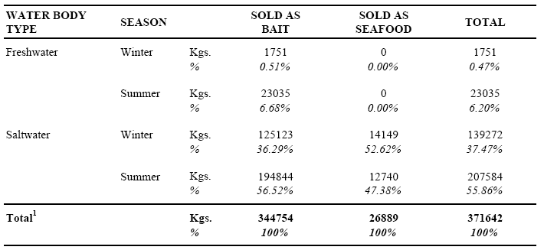
Notes:
¹ Table base: estimated total quantity of prawns/shrimp used in Queensland by recreational fishers as bait/berley in the previous 12 months ... from 'purchase sources' only. By design, quantities for 'Personally Caught' prawns/shrimp were not assessed in the survey
Also, standard error estimates are contained in the Appendix, with detailed study definitions andmethodologies in Sections 2 and 3

Table 21: Usage of Prawns/Shrimp by Water Body Type and Season - Annual Quantities Used1 (Kgs) by Purchase Source (SOUTH AUSTRALIA)
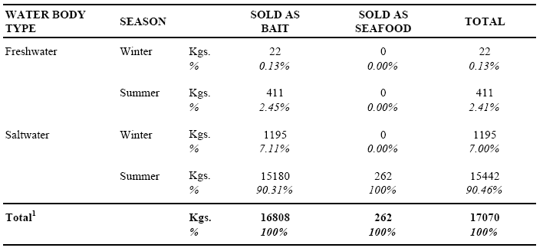
Notes:
¹ Table base: estimated total quantity of prawns/shrimp used in South Australia by recreational fishers as bait/berley in the previous 12 months ... from 'purchase sources' only. By design, quantities for 'Personally Caught' prawns/shrimp were not assessed in the survey
Also, standard error estimates are contained in the Appendix, with detailed study definitions andmethodologies in Sections 2 and 3

Table 22: Usage of Prawns/Shrimp by Water Body Type and Season - Annual Quantities Used1 (Kgs) by Purchase Source (WESTERN AUSTRALIA)
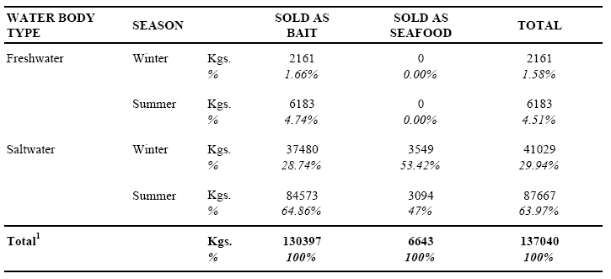
Notes:
¹ Table base: estimated total quantity of prawns/shrimp used in Western Australia by recreational fishers as bait/berley in the previous 12 months ... from 'purchase sources' only. By design, quantities for 'Personally Caught' prawns/shrimp were not assessed in the survey
Also, standard error estimates are contained in the Appendix, with detailed study definitions andmethodologies in Sections 2 and 3

Table 23: Usage of Prawns/Shrimp by Water Body Type and Season - Annual Quantities Used1 (Kgs) by Purchase Source (TASMANIA)
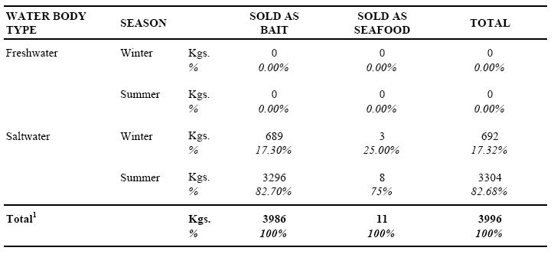
Notes:
¹ Table base: estimated total quantity of prawns/shrimp used in Tasmania by recreational fishers as bait/berley in the previous 12 months ... from 'purchase sources' only. By design, quantities for 'Personally Caught' prawns/shrimp were not assessed in the survey
Also, standard error estimates are contained in the Appendix, with detailed study definitions andmethodologies in Sections 2 and 3

Table 24: Usage of Prawns/Shrimp by Water Body Type and Season - Annual Quantities Used1 (Kgs) by Purchase Source (NORTHERN TERRITORY)
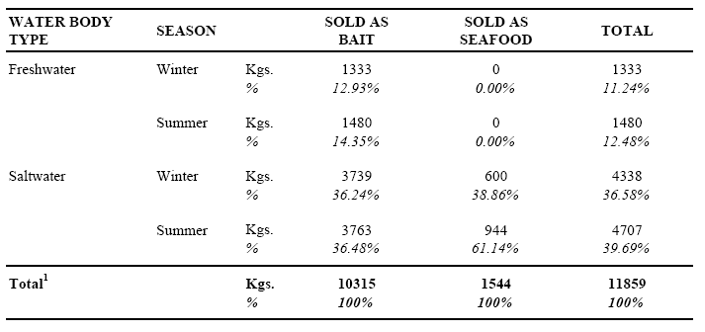
Notes:
¹ Table base: estimated total quantity of prawns/shrimp used in Northern Territory by recreational fishers as bait/berley in the previous 12 months ... from 'purchase sources' only. By design, quantities for 'Personally Caught' prawns/shrimp were not assessed in the survey
Also, standard error estimates are contained in the Appendix, with detailed study definitions andmethodologies in Sections 2 and 3

5.3 Squid, Cuttlefish and Octopus

5.3.1 Results on a Fisher Base
A total of 557 respondents reported using cephalopods as bait/berley in the previous 12 months. For each respondent, usage was firstly assessed in terms of three generic species groups (Table 25 below). Following this, all other assessments in the survey referred to aggregated data for the three groups (see discussion regarding potential disaggregation in Section 3.7.1).

Table 25: Usage of Any Squid, Cuttlefish or Octopus as Bait/Berley - Recreational Fishers1 by State/Territory of Residence
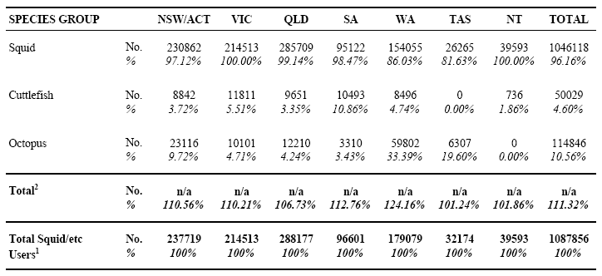
Notes:
¹ Table base: population estimate of recreational fishers using squid/cuttlefish/octopus as bait/berley in the previous 12 months
² Due to multiple reporting, totals add to more than 100%
Also, standard error estimates are contained in the Appendix, with detailed study definitions and methodologies in Sections 2 and 3
Usage in the previous 12 months was then assessed in terms of three acquisition sources (Table 26 below).

Table 26: Acquisition Source of Squid/Cuttlefish/Octopus Used as Bait/Berley - Recreational Fishers1 by State/Territory of Residence
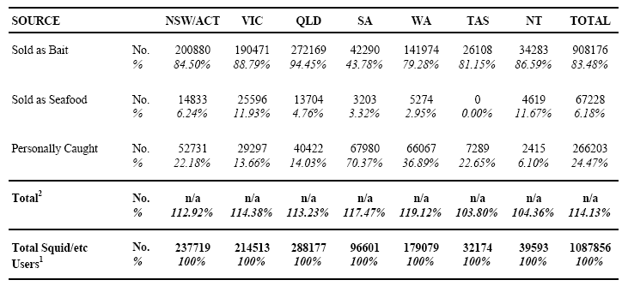
Notes:
¹ Table base: population estimate of recreational fishers using squid/cutllefish/octopus as bait/berley in the previous 12 months
² Due to multiple reporting, totals add to more than 100%
Also, standard error estimates are contained in the Appendix, with detailed study definitions and methodologies in Sections 2 and 3
Respondents reporting any usage of squid/cuttlefish/octopus for the acquisition source ‘Sold as Seafood’ were subsequently questioned to establish their main (and any other) reasons for doing so. In Table 27 (below), the results are presented on a national basis – with two un-reported answer categories from the survey questionnaire included in ‘Other’ (namely, choice of species and choice of form).

Table 27: Reasons for Purchasing Squid/Cuttlefish/Octopus from a 'Seafood Supplier' (vs. Bait Supplier) - Recreational Fishers1 (All States/Territories)
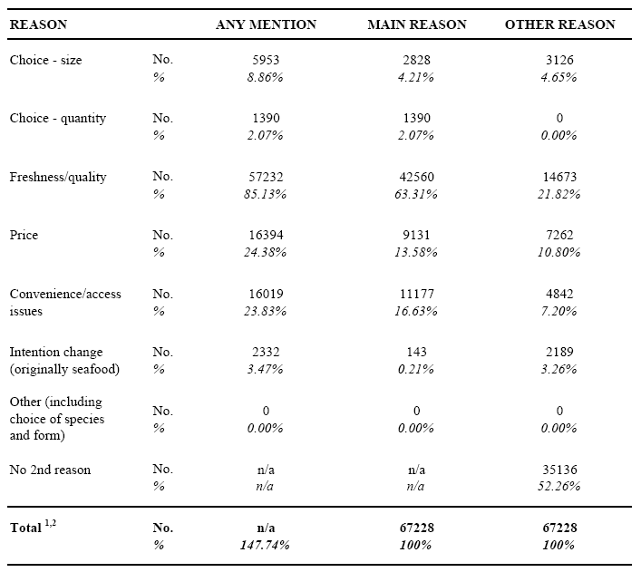
Notes:
¹ Table base: population estimate of recreational fishers using squid/cuttlefish/octopus that were Sold as Seafood, as bait/berley in the previous 12 months
² Due to multiple reporting in the 'ANY MENTION' column, the total adds to more than 100%
Also, standard error estimates are contained in the Appendix, with detailed study definitions and methodologies in Sections 2 and 3
The results in Table 28 (below) assess the extent to which residents of each state/territory used squid/cuttlefish/octopus locally, as opposed to other regions of Australia. To assist in this regard, the table cells conforming to ‘home’ state/territory usage have been highlighted.

Table 28: State/Territory of Usage of Squid/Cuttlefish/Octopus as Bait/Berley - Recreational Fishers1 by State/Territory of Residence
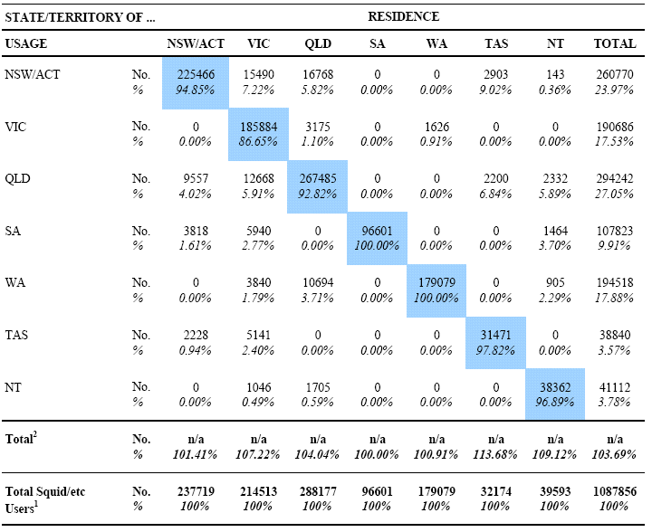
Notes:
¹ Table base: population estimate of recreational fishers using squid/cuttlefish/octopus as bait/berley in the previous 12 months
² Due to multiple reporting, totals may add to more than 100%
Also, standard error estimates are contained in the Appendix, with detailed study definitions and methodologies in Sections 2 and 3

5.3.2 Quantities
All results in this sub-section refer to estimates of total quantities of squid/cuttlefish/octopus used in the previous 12 months from ‘purchase sources’ only, i.e. quantities used were not assessed for ‘Personally Caught’ cephalopods. In Tables 29 and 30 (below), quantities for each purchase source are assessed by state/territory of residence and usage (respectively).

Table 29: Purchase Source of Squid/Cuttlefish/Octopus Used as Bait/Berley - Annual Quantities Used1 (Kgs) by State/Territory of Residence
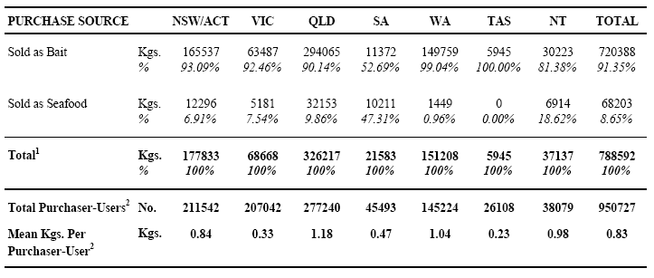
Notes:
¹ Table base: estimated total quantity of squid/cuttlefish/octopus used by recreational fishers as bait/berley in the previous 12 months …. from 'purchase sources' only
² Excludes those who only used squid/etc that were 'Personally Caught'
Also, standard error estimates are contained in the Appendix, with detailed study definitions and methodologies in Sections 2 and 3

Table 30: Purchase Source of Squid/Cuttlefish/Octopus Used as Bait/Berley - Annual Quantities Used1 (Kgs) by State/Territory of Usage
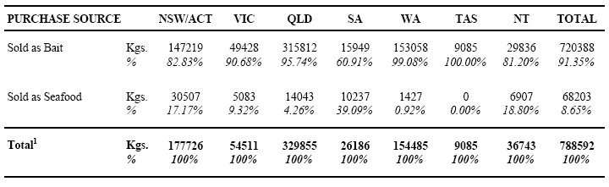
Notes:
¹ Table base: estimated total quantity of squid/cuttlefish/octopus used by recreational fishers as bait/berley in the previous 12 months …. from 'purchase sources' only. By design, quantities for 'Personally Caught' squid/etc were not assessed in the survey
Also, standard error estimates are contained in the Appendix, with detailed study definitions and methodologies in Sections 2 and 3
Also, when national usage quantities are analysed in terms of general fishing ‘avidity’ (days fished), it emerges that the low avidity group (1-4 days fished) accounts for some 31% of all purchaser-users of squid/cuttlefish/octopus, but only 9% of the estimated total quantities used. Corresponding results for the medium avidity group (5-14 days fished) are 32% and 17% respectively and for the high avidity group (15 or more days fished), 37% and 74% respectively.
The results in Table 31 (below) show estimated total quantities used for squid/cuttlefish/octopus ‘Sold as Bait’ (per Table 30) disaggregated for the two ‘purchase forms’ contained on the survey questionnaire. Table 32 shows equivalent results for the acquisition source ‘Sold as Seafood’.

Table 31: Form Purchased of Squid/Cuttlefish/Octopus 'Sold as Bait' - Annual Quantities Used1 (Kgs) by State/Territory of Usage
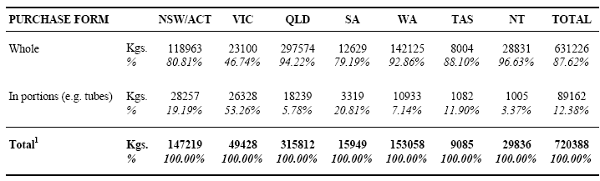
Notes:
¹ Table base: estimated total quantity of squid/cuttlefish/octopus used by recreational fishers as bait/berley in the previous 12 months - where the purchase source was 'Sold as Bait'
Also, standard error estimates are contained in the Appendix, with detailed study definitions and methodologies in Sections 2 and 3

Table 32: Form Purchased of Squid/Cuttlefish/Octopus 'Sold as Seafood' - Annual Quantities Used1 (Kgs) by State/Territory of Usage
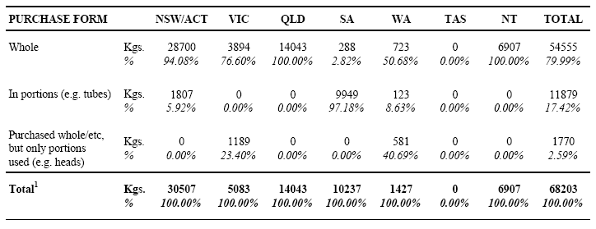
Notes:
¹ Table base: estimated total quantity of squid/cuttlefish/octopus used by recreational fishers as bait/berley in the previous 12 months - where the purchase source was 'Sold as Seafood'
Also, standard error estimates are contained in the Appendix, with detailed study definitions and methodologies in Sections 2 and 3Purchased
The results in Table 33 (below) estimate national usage of squid/cuttlefish/octopus by water body type, season and purchase source.

Table 33: Usage of Squid/Cuttlefish/Octopus by Water Body Type and Season - Annual Quantities Used1 (Kgs) by Purchase Source (All States/Territories)
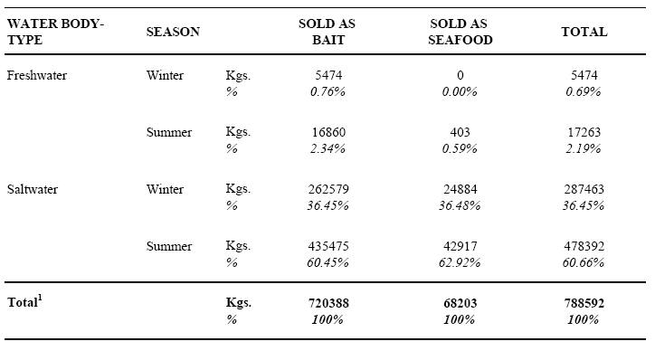
Notes:
¹ Table base: estimated total quantity of squid/cuttlefish/octopus used (in any State/Territory) by recreational fishers as bait/berley in the previous 12 months … from 'purchase sources' only. By design, quantities for 'Personally Caught' squid/etc were not assessed in the survey
Also, standard error estimates are contained in the Appendix, with detailed study definitions and methodologies in Sections 2 and 3
The remaining tables in this sub-section (Tables 34-40) comprise a disaggregation of the results in Table 33 above, for each state/territory. In several cases, relatively large sub-samples of cephalopod users exist (e.g. NSW/ACT). However, others are based on quite small numbers of respondents (e.g. Tasmania) and have been included for completeness.

Table 34: Usage of Squid/Cuttlefish/Octopus by Water Body Type and Season - Annual Quantities Used1 (Kgs) by Purchase Source (NSW/ACT)
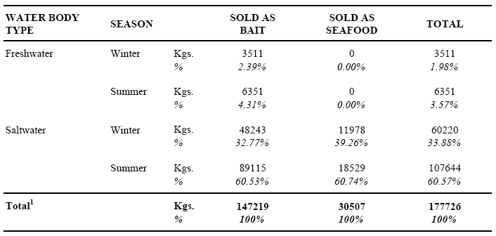
Notes:
¹ Table base: estimated total quantity of squid/cuttlefish/octopus used in NSW/ACT by recreational fishers as bait/berley in the previous 12 months ... from 'purchase sources' only. By design, quantities for 'Personally Caught' squid/etc were not assessed in the survey
Also, standard error estimates are contained in the Appendix, with detailed study definitions and methodologies in Sections 2 and 3

Table 35: Usage of Squid/Cuttlefish/Octopus by Water Body Type and Season - Annual Quantities Used1 (Kgs) by Purchase Source (VICTORIA)
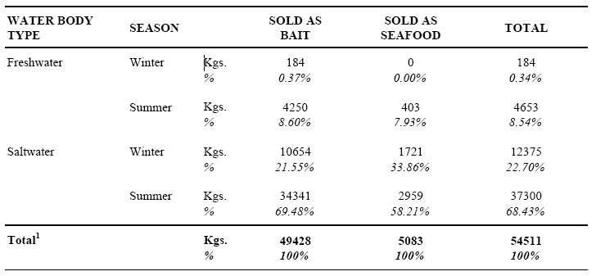
Notes:
¹ Table base: estimated total quantity of squid/cuttlefish/octopus used in Victoria by recreational fishers as bait/berley in the previous 12 months ... from 'purchase sources' only. By design, quantities for 'Personally Caught' squid/etc were not assessed in the survey
Also, standard error estimates are contained in the Appendix, with detailed study definitions andmethodologies in Sections 2 and 3

Table 36: Usage of Squid/Cuttlefish/Octopus by Water Body Type and Season - Annual Quantities Used1 (Kgs) by Purchase Source (QUEENSLAND)
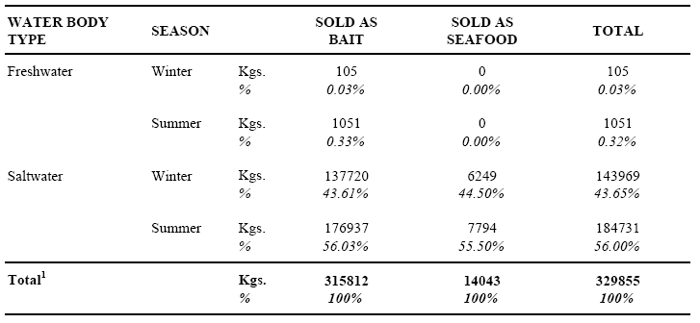
Notes:
¹ Table base: estimated total quantity of squid/cuttlefish/octopus used in Queensland by recreational fishers as bait/berley in the previous 12 months ... from 'purchase sources' only. By design, quantities for 'Personally Caught' squid/etc were not assessed in the survey
Also, standard error estimates are contained in the Appendix, with detailed study definitions andmethodologies in Sections 2 and 3

Table 37: Usage of Squid/Cuttlefish/Octopus by Water Body Type and Season - Annual Quantities Used1 (Kgs) by Purchase Source (SOUTH AUSTRALIA)
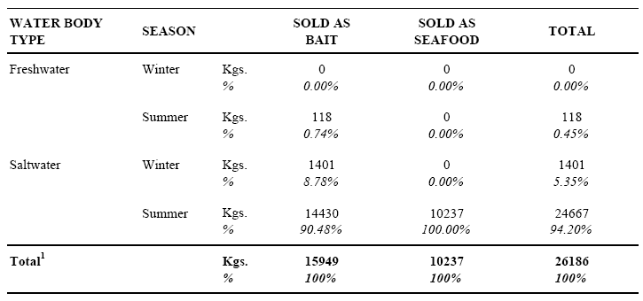
Notes:
¹ Table base: estimated total quantity of squid/cuttlefish/octopus used in South Australia by recreational fishers as bait/berley in the previous 12 months ... from 'purchase sources' only. By design, quantities for 'Personally Caught' squid/etc were not assessed in the survey
Also, standard error estimates are contained in the Appendix, with detailed study definitions andmethodologies in Sections 2 and 3

Table 38: Usage of Squid/Cuttlefish/Octopus by Water Body Type and Season - Annual Quantities Used1 (Kgs) by Purchase Source (WESTERN AUSTRALIA)
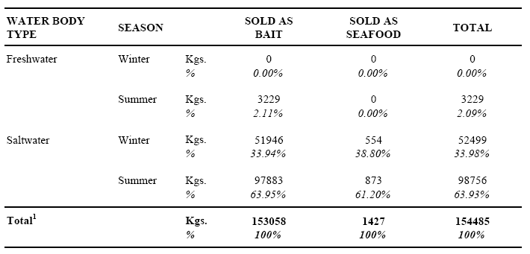
Notes:
¹ Table base: estimated total quantity of squid/cuttlefish/octopus used in Western Australia by recreational fishers as bait/berley in the previous 12 months ... from 'purchase sources' only. By design, quantities for 'Personally Caught' squid/etc were not assessed in the survey
Also, standard error estimates are contained in the Appendix, with detailed study definitions andmethodologies in Sections 2 and 3

Table 39: Usage of Squid/Cuttlefish/Octopus by Water Body Type and Season - Annual Quantities Used1 (Kgs) by Purchase Source (TASMANIA)
Notes:
¹ Table base: estimated total quantity of squid/cuttlefish/octopus used in Tasmania by recreational fishers as bait/berley in the previous 12 months ... from 'purchase sources' only. By design, quantities for 'Personally Caught' squid/etc were not assessed in the survey
Also, standard error estimates are contained in the Appendix, with detailed study definitions andmethodologies in Sections 2 and 3

Table 40: Usage of Squid/Cuttlefish/Octopus by Water Body Type and Season - Annual Quantities Used1 (Kgs) by Purchase Source (NORTHERN TERRITORY)
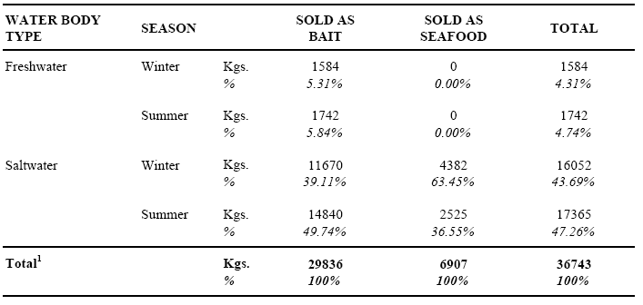
Notes:
¹ Table base: estimated total quantity of squid/cuttlefish/octopus used in Northern Territory by recreational fishers as bait/berley in the previous 12 months ... from 'purchase sources' only. By design, quantities for 'Personally Caught' squid/etc were not assessed in the survey
Also, standard error estimates are contained in the Appendix, with detailed study definitions andmethodologies in Sections 2 and 3

5.4 Crabs
A total of 61 respondents reported using crabs as bait/berley in the previous 12 months. For each respondent, usage was assessed in terms of three acquisition sources (Table 41 below). As only 4 respondents reported any purchase of crabs, further analysis for this bait type has been limited to Table 42 (below) – which has been included for illustrative purposes only.

Table 41: Acquisition Source of Crabs Used as Bait/Berley - Recreational Fishers1 by State/Territory of Residence
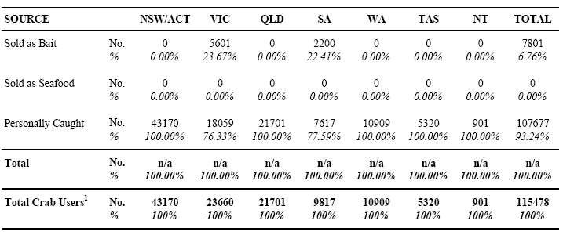
Notes:
¹ Table base: population estimate of recreational fishers using crabs as bait/berley in the previous 12 months
Also, standard error estimates are contained in the Appendix, with detailed study definitions and methodologies in Sections 2 and 3

Table 42: Form Purchased of Crabs 'Sold as Bait' - Annual Quantities Used1 (Kgs) by State/Territory of Usage
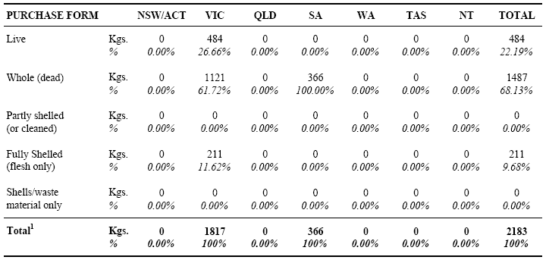
Notes:
¹ Table base: estimated total crabs used by recreational fishers as bait/berley in the previous 12 months - where the purchase source was 'Sold as Bait'
Also, standard error estimates are contained in the Appendix, with detailed study definitions and methodologies in Sections 2 and 3

5.5 Saltwater Crayfish
A total of 5 respondents reported using saltwater crayfish (rock lobster etc) as bait/berley in the previous 12 months. For each respondent, usage was assessed in terms of three acquisition sources (Table 43 below). As all respondents reported ‘Personally Caught’ as their only acquisition source, no further analysis for this bait type has been undertaken.

Table 43: Acquisition Source of Saltwater Crayfish Used as Bait/Berley - Recreational Fishers1 by State/Territory of Residence
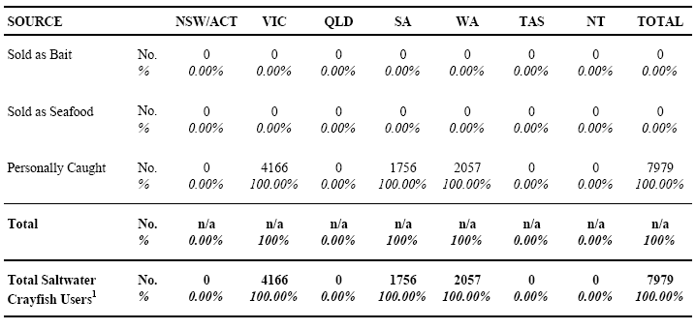
Notes:
¹ Table base: population estimate of recreational fishers using saltwater crayfish as bait/berley in the previous 12 months
Also, standard error estimates are contained in the Appendix, with detailed study definitions and methodologies in Sections 2 and 3

5.6 Freshwater Crayfish

5.6.1 Results on a Fisher Base
A total of 100 respondents reported using freshwater crayfish (yabbies etc) as bait/berley in the previous 12 months. For each respondent, usage was assessed in terms of three acquisition sources (Table 44 below).

Table 44: Acquisition Source of Freshwater Crayfish Used as Bait/Berley - Recreational Fishers1 by State/Territory of Residence
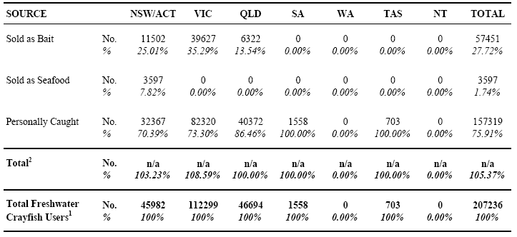
Notes:
¹ Table base: population estimate of recreational fishers using freshwater crayfish as bait/berley in the previous 12 months2 Due to multiple reporting, totals may add to more than 100%
Also, standard error estimates are contained in the Appendix, with detailed study definitions and methodologies in Sections 2 and 3
As only one respondent reported usage of freshwater crayfish for the acquisition source ‘Sold as Seafood’, no table has been included in terms of main/other reasons for doing so (for the record, ‘freshness/quality’ was cited as the only reason by this respondent).
The results in Table 45 (below) assess usage preferences in terms of main (and any other) methods used to bait the hook in line fishing with freshwater crayfish – for all users, aggregated on a national basis.

Table 45: Methods Used to Bait Hook with Freshwater Crayfish - Recreational Fishers1 (All States/ Territories)
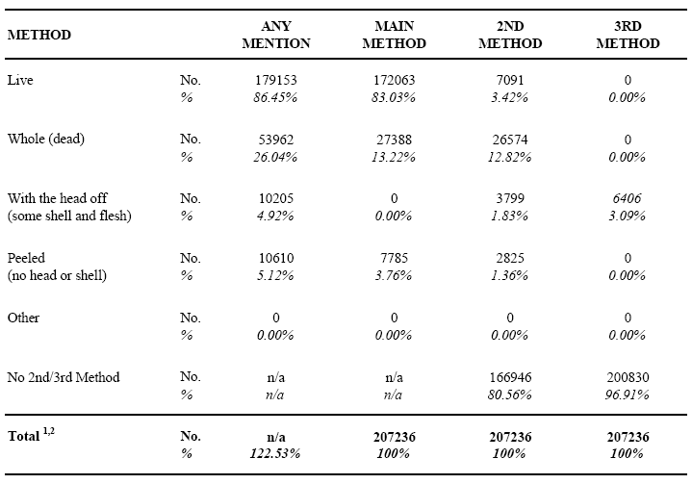
Notes:
¹ Table base: population estimate of recreational fishers using freshwater crayfish as bait/berley in the previous 12 months
² Due to multiple reporting in the 'ANY MENTION' column, the total adds to more than 100%Also, standard error estimates are contained in the Appendix, with detailed study definitions and methodologies in Sections 2 and 3
The results in Table 46 (below) assess the extent to which residents of each state/territory used freshwater crayfish locally, as opposed to other regions of Australia. To assist in this regard, the table cells conforming to ‘home’ state/territory usage have been highlighted. Note: the significant minority of Victorian residents reporting usage in NSW/ACT is at least partly attributable to the Murray River being regarded as NSW waters (where it borders Victoria). Interviewers were aware of this definition and advised respondents accordingly.

Table 46: State/Territory of Usage of Freshwater Crayfish as Bait/Berley - Recreational Fishers1 by State/Territory of Residence
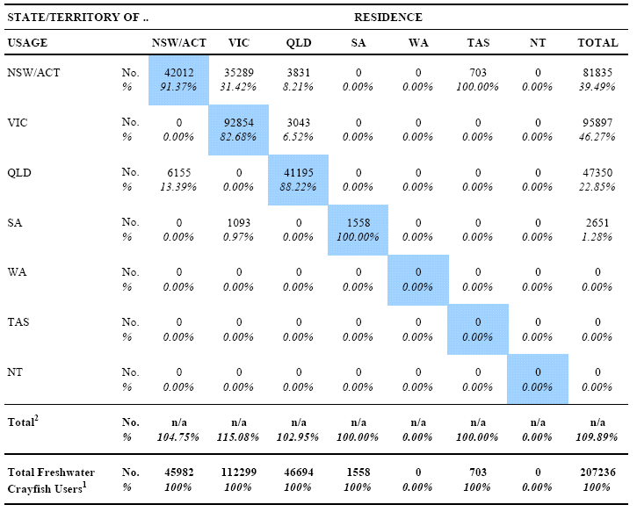
Notes:
¹ Table base: population estimate of recreational fishers using freshwater crayfish as bait/berley in the previous 12 months2 Due to multiple reporting, totals may add to more than 100%
Also, standard error estimates are contained in the Appendix, with detailed study definitions and methodologies in Sections 2 and 3

5.6.2 Quantities
All results in this sub-section refer to estimates of total quantities of freshwater crayfish used in the previous 12 months from ‘purchase sources’ only, i.e. quantities used were not assessed for ‘Personally Caught’ crayfish. In Tables 47 and 48 (below), quantities for each purchase source are assessed by state/territory of residence and usage (respectively).

Table 47: Purchase Source of Freshwater Crayfish Used as Bait/Berley - Annual Quantities Used1 (Kgs) by State/ Territory of Residence
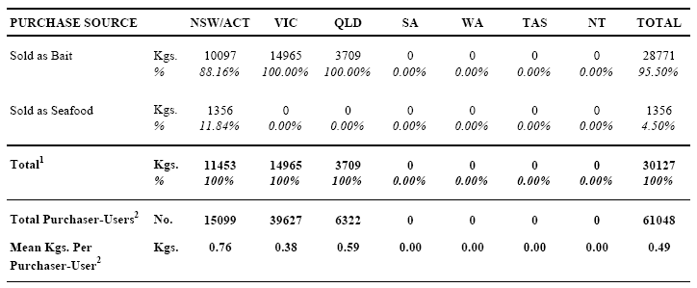
Notes:
¹ Table base: estimated total quantity of freshwater crayfish used by recreational fishers as bait/berley in the previous 12 months ... from 'purchase sources' only 2 Excludes those who only used freshwater crayfish that were 'Personally Caught'
Also, standard error estimates are contained in the Appendix, with detailed study definitions and methodologies in Sections 2 and 3

Table 48: Purchase Source of Freshwater Crayfish Used as Bait/Berley - Annual Quantities Used1 (Kgs) by State/ Territory of UsageAlso,
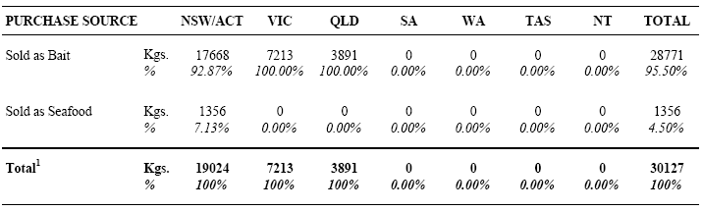
Notes:
¹ Table base: estimated total quantity of freshwater crayfish used by recreational fishers as bait/berley in the previous 12 months … from 'purchase sources' only. By design, quantities for 'Personally Caught' freshwater crayfish were not assessed in the survey
Also, standard error estimates are contained in the Appendix, with detailed study definitions and methodologies in Sections 2 and 3

The results in Table 49 (below) show estimated total quantities used for freshwater crayfish ‘Sold as Bait’ (per Table 48) disaggregated for the specific ‘purchase forms’ contained on the survey questionnaire.

Table 49: Form Purchased of Freshwater Crayfish 'Sold as Bait' - Annual Quantities Used1 (Kgs) by State/Territory of Usage
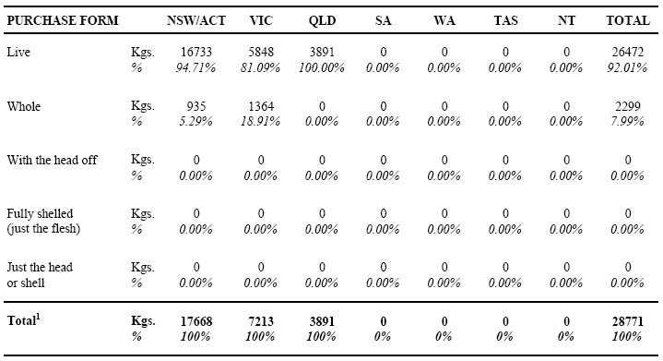
Notes:
¹ Table base: estimated total freshwater crayfish used by recreational fishers as bait/berley in the previous 12 months - where the purchase source was 'Sold as Bait'
Also, standard error estimates are contained in the Appendix, with detailed study definitions and methodologies in Sections 2 and 3
As only one respondent reported usage of freshwater crayfish for the acquisition source ‘Sold as Seafood’, no table has been included for ‘purchase form’ (for the record, all were purchased live).
The results in Table 50 (below) estimate quantities of whole freshwater crayfish used (by purchase source), in terms of two size groups (total body length basis). Note: issues of concern to a similar assessment for prawns/shrimp are discussed prior to Table 16, Section 5.2.2.

Table 50: Estimated Size of Freshwater Crayfish - Annual Quantities Used1 (Kgs) by Selected Source/Purchase Forms (All States/Territories)
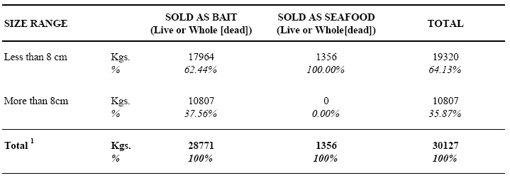
Notes:
¹ Table base: estimated total quantity of freshwater crayfish used by recreational fishers as bait/berley in the previous 12 months … purchased 'Live' or 'Whole (dead)' and either 'Sold as Bait' or 'Sold as Seafood'
Also, standard error estimates are contained in the Appendix, with detailed study definitions and methodologies in Sections 2 and 3
The results in Table 51 (below) estimate national usage of freshwater crayfish by water body type, season and purchase source. Note: as only 25 respondents reported such usage, further disaggregation of these results by state/territory has not been undertaken.

Table 51: Usage of Freshwater Crayfish by Water Body Type and Season - Annual Quantities Used1 (Kgs) by Purchase Source (All States/Territories)
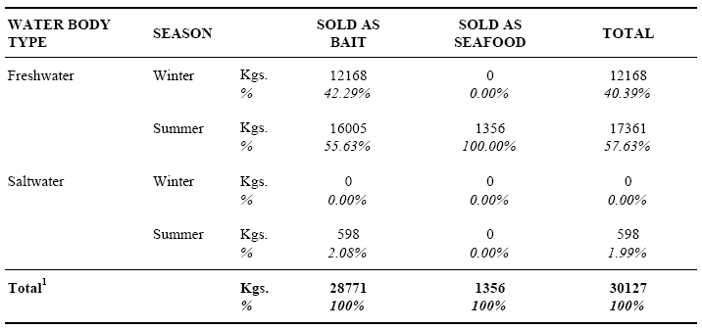
Notes:
¹ Table base: estimated total quantity of freshwater crayfish used (in any State/Territory) by recreational fishers as bait/berley in the previous 12 months ... from 'purchase sources' only. By design, quantities for 'Personally Caught' freshwater crayfish were not assessed in the survey
Also, standard error estimates are contained in the Appendix, with detailed study definitions and methodologies in Sections 2 and 3

5.7 Abalone
A total of 8 respondents reported using abalone as bait/berley in the previous 12 months. For each respondent, usage was assessed in terms of three acquisition sources (Table 52 below). As only one respondent reported any acquisition source other than ‘Personally Caught’, (‘Sold as Bait’ – abalone gut purchased), no further analysis has been undertaken for this bait type.

Table 52: Acquisition Source of Abalone Used as Bait/Berley - Recreational Fishers1 by State/Territory of Residence
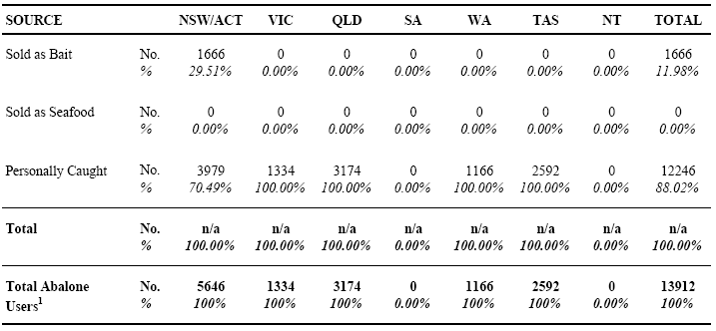
Notes:
¹ Table base: population estimate of recreational fishers using abalone as bait/berley in the previous 12 months
Also, standard error estimates are contained in the Appendix, with detailed study definitions and methodologies in Sections 2 and 3

5.8 Other Shellfish

5.8.1 Results on a Fisher Base
A total of 358 respondents reported using ‘other shellfish’ (bi-valve molluscs) as bait/berley in the previous 12 months. For each respondent, usage was firstly assessed in terms of five generic species groups (Table 25 below). In this classification, pippis and cockles have been combined in the one group. This became necessary due to differences in local names used for these species. In South Australia, pippis are almost universally known as cockles (or Goolwa cockles) and are a very popular bait. While true/other cockles also exist there (e.g. mud cockles) and are used in other states, delineation of these was considered inappropriate. However, an analysis of results for other states/territories suggests that low levels of usage exist for true cockles, with just 10 respondents reporting any usage from four states.
Following this questioning, all other assessments in the survey referred to aggregated data for the five groups (see discussion regarding potential disaggregation in Section 3.7.1).

Table 53: Usage of 'Other Shellfish' as Bait/Berley - Recreational Fishers1 by State/Territory of Residence
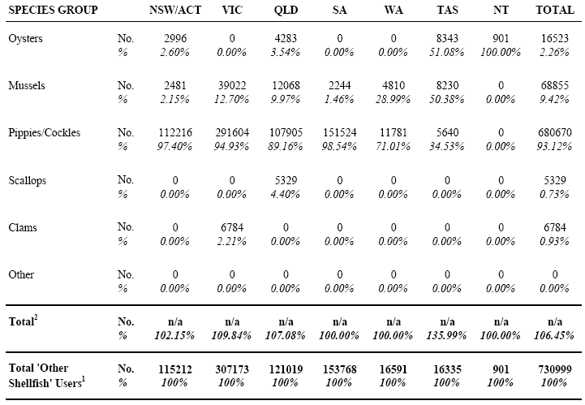
Notes:
¹ Table base: population estimate of recreational fishers using 'other shellfish' as bait/berley in the previous 12 months2 Due to multiple reporting, totals may add to more than 100%
Also, standard error estimates are contained in the Appendix, with detailed study definitions and methodologies in Sections 2 and 3
Usage in the previous 12 months was then assessed in terms of three acquisition sources (Table 54 below).

Table 54: Acquisition Source of 'Other Shellfish' Used as Bait/Berley - Recreational Fishers1 by State/Territory of Residence
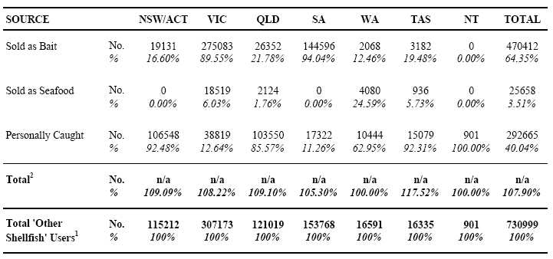
Notes:
¹ Table base: population estimate of recreational fishers using 'other shellfish' as bait/berley in the previous 12 months2 Due to multiple reporting, totals may add to more than 100%
Also, standard error estimates are contained in the Appendix, with detailed study definitions and methodologies in Sections 2 and 3
As only 8 respondents reported any usage of ‘other shellfish’ for the acquisition source ‘Sold as Seafood’, Table 55 (below) has been included for illustrative purposes only.

Table 55: Reasons for Purchasing 'Other Shellfish' from a 'Seafood Supplier' (vs. Bait Supplier) - Recreational Fishers1 (All States/Territories)
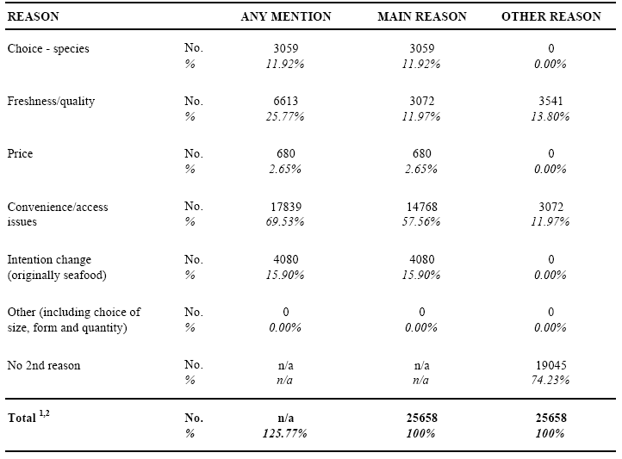
Notes:
¹ Table base: population estimate of recreational fishers using 'other shellfish' that were Sold as Seafood, as bait/berley in the previous 12 months
² Due to multiple reporting in the 'ANY MENTION' column, the total adds to more than 100%
Also, standard error estimates are contained in the Appendix, with detailed study definitions and methodologies in Sections 2 and 3
The results in Table 56 (below) assess the extent to which residents of each state/territory used ‘other shellfish’ locally, as opposed to other regions of Australia. To assist in this regard, the table cells conforming to ‘home’ state/territory usage have been highlighted.

Table 56: State/Territory of Usage of 'Other Shellfish' as Bait/Berley - Recreational Fishers1 by State/Territory of Residence
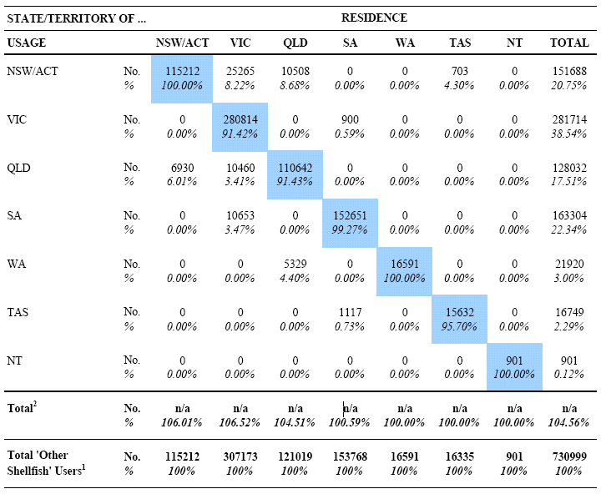
Notes:
¹ Table base: population estimate of recreational fishers using 'other shellfish' as bait/berley in the previous 12 months
² Due to multiple reporting, totals may add to more than 100%
Also, standard error estimates are contained in the Appendix, with detailed study definitions and methodologies in Sections 2 and 3
5.8.2 Quantities
All results in this sub-section refer to estimates of total quantities of ‘other shellfish’ used in the previous 12 months from ‘purchase sources’ only, i.e. quantities used were not assessed for ‘Personally Caught’ shellfish. In Tables 57 and 58 (below), quantities for each purchase source are assessed by state/territory of residence and usage (respectively).

Table 57: Purchase Source of 'Other Shellfish' Used as Bait/Berley - Annual Quantities Used1 (Kgs) by State/Territory of Residence
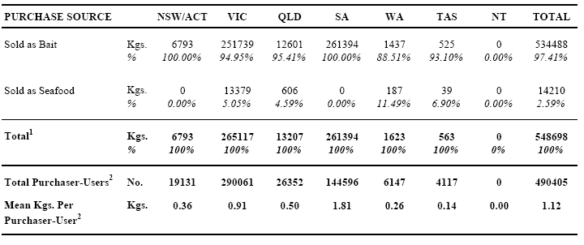
Notes:
¹ Table base: estimated total quantity of 'other shellfish' used by recreational fishers as bait/berley in the previous 12 months …. from 'purchase sources' only.
² Excludes those who only used 'other shellfish' that were 'Personally Caught'
Also, standard error estimates are contained in the Appendix, with detailed study definitions and methodologies in Sections 2 and 3

Table 58: Purchase Source of 'Other Shellfish' Used as Bait/Berley - Annual Quantities Used1 (Kgs) by State/Territory of Usage
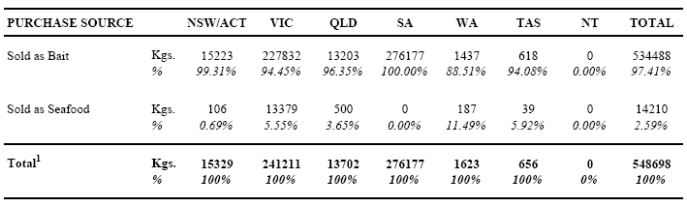
Notes:
¹ Table base: estimated total quantity of 'other shellfish' used by recreational fishers as bait/berley in the previous 12 months … from 'purchase sources' only. By design, quantities for personally caught 'other shellfish' were not assessed in the survey
Also, standard error estimates are contained in the Appendix, with detailed study definitions and methodologies in Sections 2 and 3
Also, when national usage quantities are analysed in terms of general fishing ‘avidity’ (days fished), it emerges that the low avidity group (1-4 days fished) accounts for some 33% of all purchaser-users of ‘other shellfish’, but only 8% of estimated total quantities used. Corresponding results for the medium avidity group (5-14 days fished) are 31% and 26% respectively and for the high avidity group (15 or more days fished), 36% and 66% respectively.
The results in Table 59 (below) show estimated total quantities used for ‘other shellfish’ reported as ‘Sold as Bait’ (per Table 58) disaggregated for each specific ‘purchase form’ contained on the survey questionnaire.

Table 59: Form Purchased of 'Other Shellfish' Sold as Bait - Annual Quantities Used1 (Kgs) by State/Territory of Usage
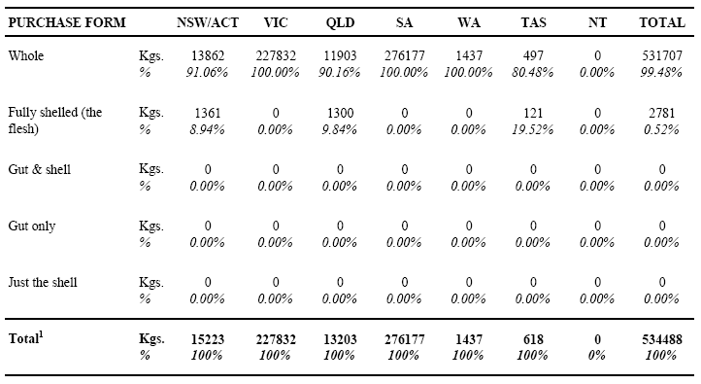
Notes:
¹ Table base: estimated total quantity of 'other shellfish' used by recreational fishers as bait/berley in the previous 12 months - where the purchase source was Sold as Bait
Also, standard error estimates are contained in the Appendix, with detailed study definitions and methodologies in Sections 2 and 3
The results in Table 60 (below) show estimated total quantities used for ‘other shellfish’ reported as ‘Sold as Seafood’ (per Table 58) disaggregated for each specific ‘purchase form’ contained on the survey questionnaire.

Table 60: Form Purchased of 'Other Shellfish' Sold as Seafood - Annual Quantities Used1 (Kgs) by State/Territory of Usage
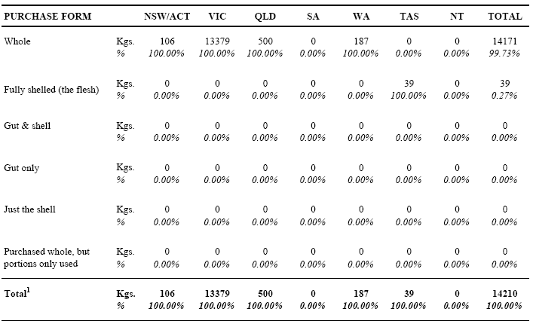
Notes:
¹ Table base: estimated total quantity of 'other shellfish' used by recreational fishers as bait/berley in the previous 12 months - where the purchase source was 'sold as seafood'
Also, standard error estimates are contained in the Appendix, with detailed study definitions and methodologies in Sections 2 and 3
The results in Table 61 (below) estimate national usage of ‘other shellfish’ by water body type, season and purchase source.

Table 61: Usage of 'Other Shellfish' by Water Body Type and Season - Annual Quantities Used1 (Kgs) by Purchase Source (All States/Territories)
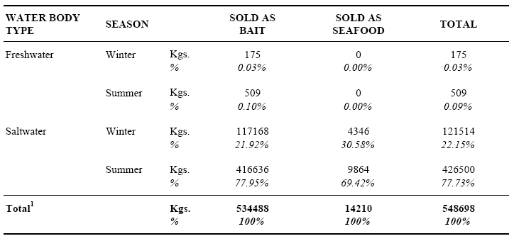
Notes:
¹ Table base: estimated total quantity of 'other shellfish' used (in any State/Territory) by recreational fishers as bait/berley in the previous 12 months … from 'purchase sources' only. By design, quantities for personally caught 'other shellfish' were not assessed in the survey
Also, standard error estimates are contained in the Appendix, with detailed study definitions and methodologies in Sections 2 and 3
The remaining tables in this sub-section (Tables 62-67) comprise a disaggregation of the results in Table 61 above, for each state/territory. In several cases, relatively large sub-samples of ‘other shellfish’ users exist (e.g. Victoria). Others are based on quite small numbers of respondents (e.g. Tasmania) and have been included for completeness. However, no table has been included for the Northern Territory, as no respondents reported any such activity.

Table 62: Usage of 'Other Shellfish' by Water Body Type and Season - Annual Quantities Used1 (Kgs) by Purchase Source (NSW/ACT)
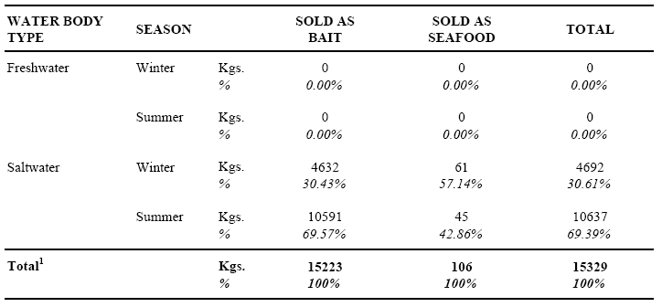
Notes:
¹ Table base: estimated total quantity of 'other shellfish' used in NSW/ACT by recreational fishers as bait/berley in the previous 12 months ... from 'purchase sources' only. By design, quantities for personally caught 'other shellfish' were not assessed in the survey
Also, standard error estimates are contained in the Appendix, with detailed study definitions and methodologies in Sections 2 and 3

Table 63: Usage of 'Other Shellfish' by Water Body Type and Season - Annual Quantities Used1 (Kgs) by Purchase Source (VICTORIA)
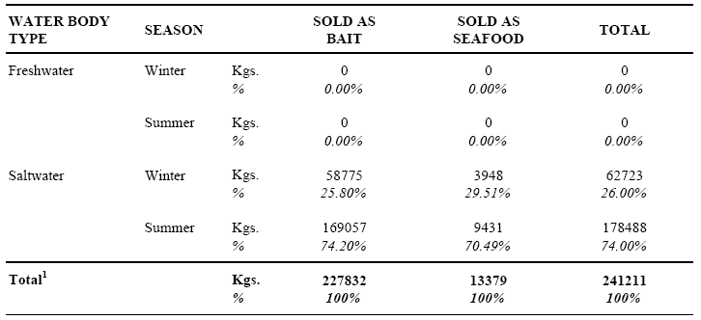
Notes:
¹ Table base: estimated total quantity of 'other shellfish' used in Victoria by recreational fishers as bait/berley in the previous 12 months ... from 'purchase sources' only. By design, quantities for personally caught 'other shellfish' were not assessed in the survey
Also, standard error estimates are contained in the Appendix, with detailed study definitions and methodologies in Sections 2 and 3

Table 64: Usage of 'Other Shellfish' by Water Body Type and Season - Annual Quantities Used1 (Kgs) by Purchase Source (QUEENSLAND)
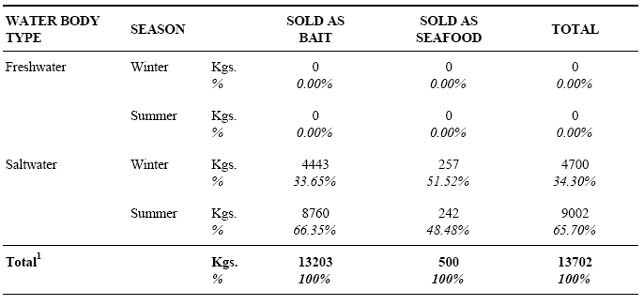
Notes:
¹ Table base: estimated total quantity of 'other shellfish' used in Queensland by recreational fishers as bait/berley in the previous 12 months ... from 'purchase sources' only. By design, quantities for personally caught 'other shellfish' were not assessed in the survey
Also, standard error estimates are contained in the Appendix, with detailed study definitions and methodologies in Sections 2 and 3

Table 65: Usage of 'Other Shellfish' by Water Body Type and Season - Annual Quantities Used1 (Kgs) by Purchase Source (SOUTH AUSTRALIA)
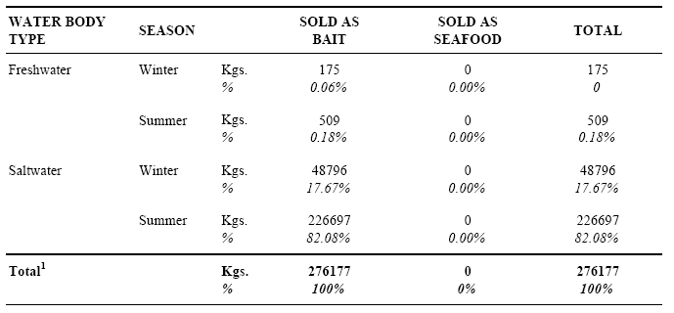
Notes:
¹ Table base: estimated total quantity of 'other shellfish' used in South Australia by recreational fishers as bait/berley in the previous 12 months ... from 'purchase sources' only. By design, quantities for personally caught 'other shellfish' were not assessed in the survey
Also, standard error estimates are contained in the Appendix, with detailed study definitions and methodologies in Sections 2 and 3

Table 66: Usage of 'Other Shellfish' by Water Body Type and Season - Annual Quantities Used1 (Kgs) by Purchase Source (WESTERN AUSTRALIA)
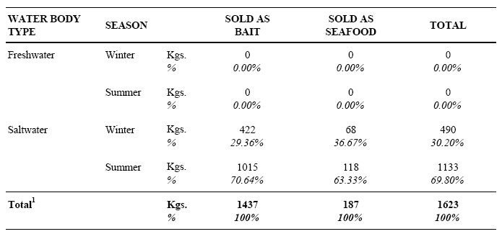
Notes:
¹ Table base: estimated total quantity of 'other shellfish' used in Western Australia by recreational fishers as bait/berley in the previous 12 months ... from 'purchase sources' only. By design, quantities for personally caught 'other shellfish' were not assessed in the survey
Also, standard error estimates are contained in the Appendix, with detailed study definitions and methodologies in Sections 2 and 3

Table 67: Usage of 'Other Shellfish' by Water Body Type and Season - Annual Quantities Used1 (Kgs) by Purchase Source (TASMANIA)
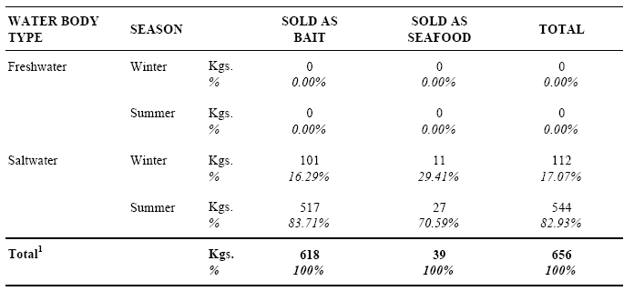
Notes:
¹ Table base: estimated total quantity of 'other shellfish' used in Tasmania by recreational fishers as bait/berley in the previous 12 months ... from 'purchase sources' only. By design, quantities for personally caught 'other shellfish' were not assessed in the survey
Also, standard error estimates are contained in the Appendix, with detailed study definitions and methodologies in Sections 2 and 3

5.9 Trout and Salmon
A total of 3 respondents reported using trout or salmon (i.e. salmonid species) as bait/berley in the previous 12 months. For each respondent, usage was assessed in terms of four acquisition sources (Table 68 below). As only one respondent reported usage for the acquisition source ‘Sold as Bait’ (trout off-cuts used at a commercial sport-fishing facility), no further analysis has been undertaken for this bait type.

Table 68: Acquisition Source of Trout and Salmon Used as Bait/Berley - Recreational Fishers1 by State/Territory of Residence
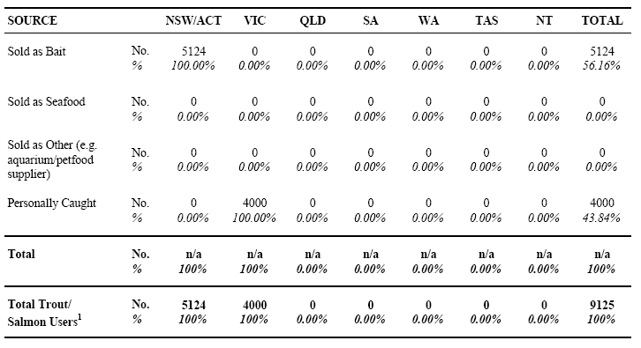
Notes:
¹ Table base: population estimate of recreational fishers using trout or salmon (not Australian Salmon) as bait/berley in previous 12 months
Also, standard error estimates are contained in the Appendix, with detailed study definitions and methodologies in Sections 2 and 3

5.10 Saltwater Fish

5.10.1 Results on a Fisher Base
A total of 718 respondents reported using saltwater fish species as bait/berley in the previous 12 months. For each respondent, usage was firstly assessed in terms of a number of species/groups – for which, responses have been ranked in Table 69 (below). Following this, all other assessments in the survey referred to aggregated data for all species/groups (see discussion regarding potential disaggregation in Section 3.7.1).

Table 69: Usage of Any Saltwater Fish as Bait/Berley - Recreational Fishers1 by State/Territory of Residence
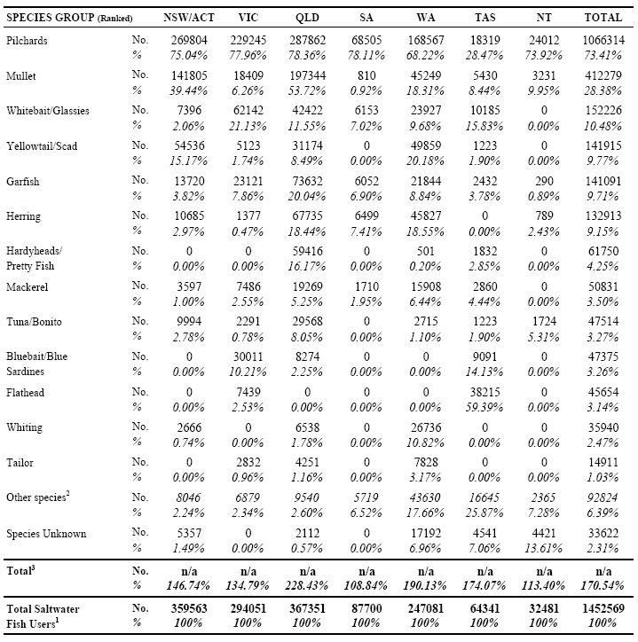
Notes:
¹ Table base: population estimate of recreational fishers using saltwater fish as bait/berley in the previous 12 months
² Includes a number of individual species - none greater than the 1% level nationally3 Due to multiple reporting, totals add to more than 100%
Also, standard error estimates are contained in the Appendix, with detailed study definitions and methodologies in Sections 2 and 3
Usage in the previous 12 months was then assessed in terms of four acquisition sources (Table 70 below).

Table 70: Acquisition Source of Saltwater Fish Used as Bait/Berley - Recreational Fishers1 by State/Territory of Residence
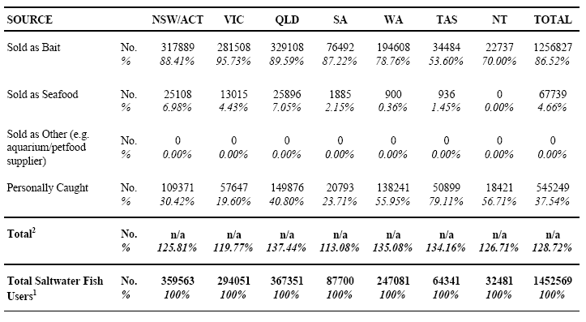
Notes:
¹ Table base: population estimate of recreational fishers using saltwater fish as bait/berley in the previous 12 months
² Due to multiple reporting, totals add to more than 100%
Also, standard error estimates are contained in the Appendix, with detailed study definitions and methodologies in Sections 2 and 3Sold
Respondents reporting any usage of saltwater fish for the acquisition source ‘Sold as Seafood’ were subsequently questioned to establish their main (and any other) reasons for doing so. In Table 71 (below), the results are presented on a national basis – with two un-reported answer categories from the survey questionnaire included in ‘Other’ (namely, choice of size and choice of quantity).

Table 71: Reasons for Purchasing Saltwater Fish from a 'Seafood Supplier' (vs. Bait Supplier) - Recreational Fishers1 (All States/Territories)
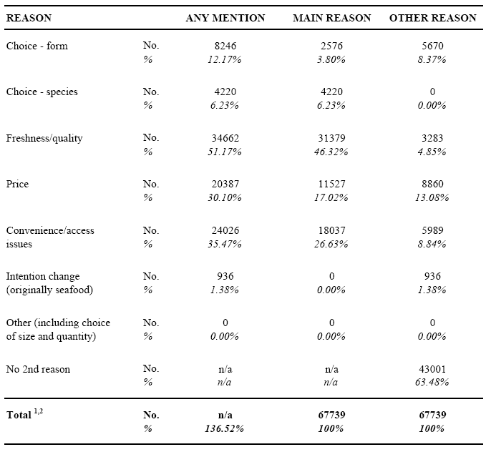
Notes:
¹ Table base: population estimate of recreational fishers using saltwater fish that were 'Sold as Seafood', as bait/berley in the previous 12 months
² Due to multiple reporting in the 'ANY MENTION' column, total adds to more than 100%
Also, standard error estimates are contained in the Appendix, with detailed study definitions and methodologies in Sections 2 and 3
The results in Table 72 (below) assess the extent to which residents of each state/territory used saltwater fish locally, as opposed to other regions of Australia. To assist in this regard, the table cells conforming to ‘home’ state/territory usage have been highlighted.

Table 72: State/Territory of Usage of Saltwater Fish as Bait/Berley - Recreational Fishers1 by State/Territory of Residence
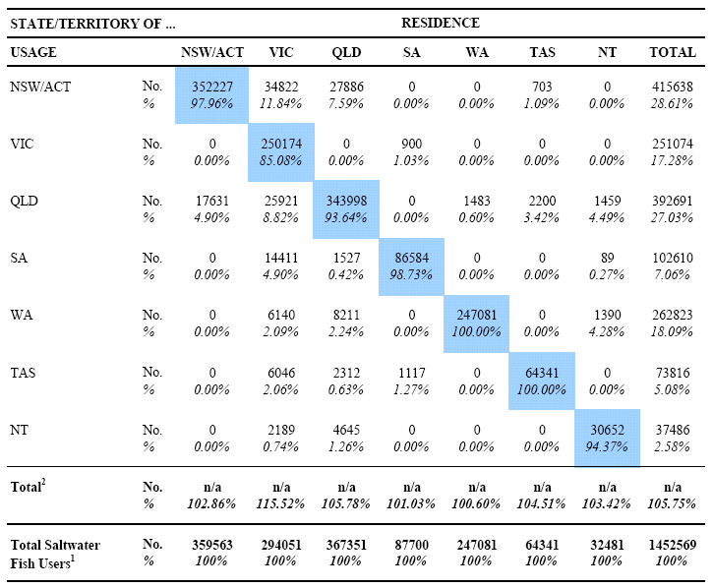
Notes:
¹ Table base: population estimate of recreational fishers using saltwater fish as bait/berley in the previous 12 months
² Due to multiple reporting, totals add to more than 100%
Also, standard error estimates are contained in the Appendix, with detailed study definitions and methodologies in Sections 2 and 3

5.10.2 Quantities
All results in this sub-section refer to estimates of total quantities of saltwater fish used in the previous 12 months from ‘purchase sources’ only, i.e. quantities used were not assessed for ‘Personally Caught’ fish. In Tables 73 and 74 (below), quantities for each purchase source are assessed by state/territory of residence and usage (respectively).

Table 73: Purchase Source of Saltwater Fish Used as Bait/Berley - Annual Quantities Used1 (Kgs) by State/Territory of ResidenceAlso,
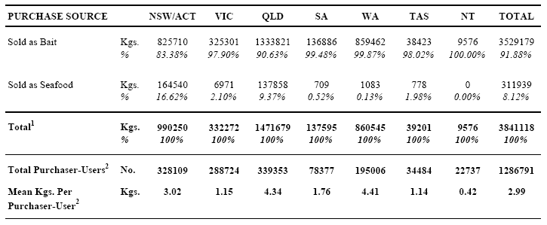
Notes:
¹ Table base: estimated total quantity of saltwater fish used by recreational fishers as bait/berley in the previous 12 months …. from 'purchase sources' only
² Excludes those who only used saltwater fish that were 'Personally Caught'
Also, standard error estimates are contained in the Appendix, with detailed study definitions and methodologies in Sections 2 and 3

Table 74: Purchase Source of Saltwater Fish Used as Bait/Berley - Annual Quantities Used1 (Kgs) by State/Territory of Usage
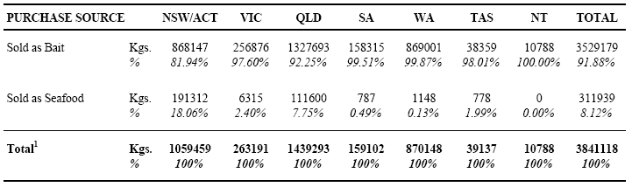
Notes:
¹ Table base: estimated total quantity of saltwater fish used by recreational fishers as bait/berley in the previous 12 months …. from 'purchase sources' only. By design, quantities for 'Personally Caught' saltwater fish were not assessed in the survey
Also, standard error estimates are contained in the Appendix, with detailed study definitions and methodologies in Sections 2 and 3
Also, when national usage quantities are analysed in terms of general fishing ‘avidity’ (days fished), it emerges that the low avidity group (1-4 days fished) accounts for some 30% of all purchaser-users of saltwater fish, but only 4% of estimated total quantities used. Corresponding results for the medium avidity group (5-14 days fished) are 32% and 13% respectively and for the high avidity group (15 or more days fished), 38% and 83% respectively.
The results in Table 75 (below) show estimated total quantities used for saltwater fish species reported as ‘Sold as Bait’ (per Table 74) disaggregated for each specific ‘purchase form’ contained on the survey questionnaire.

Table 75: Form Purchased of Saltwater Fish 'Sold as Bait' - Annual Quantities Used1 (Kgs) by State/Territory of Usage
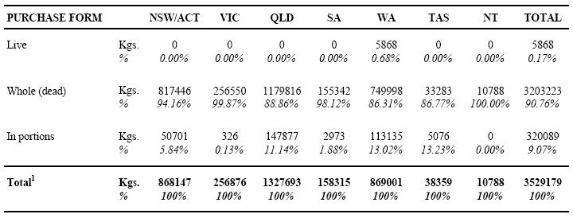
Notes:
¹ Table base: estimated total quantity of saltwater fish used by recreational fishers as bait/berley in the previous 12 months - where the purchase source was 'Sold as Bait'
Also, standard error estimates are contained in the Appendix, with detailed study definitions and methodologies in Sections 2 and 3
The results in Table 76 (below) show estimated total quantities used for saltwater fish species reported as ‘Sold as Seafood’ (per Table 74) disaggregated for each specific ‘purchase form’ contained on the survey questionnaire.

Table 76: Form Purchased of Saltwater Fish 'Sold as Seafood' - Annual Quantities Used1 (Kgs) by State/Territory of Usage
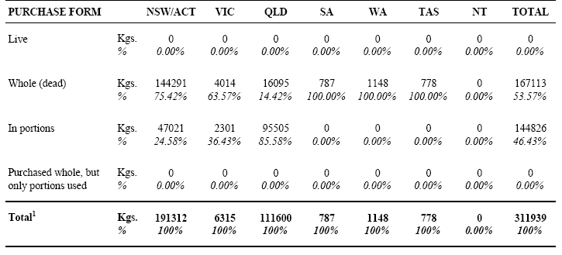
Notes:
¹ Table base: estimated total quantity of saltwater fish used by recreational fishers as bait/berley in the previous 12 months - where the purchase source was 'Sold as Seafood'
Also, standard error estimates are contained in the Appendix, with detailed study definitions and methodologies in Sections 2 and 3Purchased
The results in Table 77 (below) estimate national usage of saltwater fish by water body type, season and purchase source.

Table 76: Form Purchased of Saltwater Fish 'Sold as Seafood' - Annual Quantities Used1 (Kgs) by State/Territory of Usage
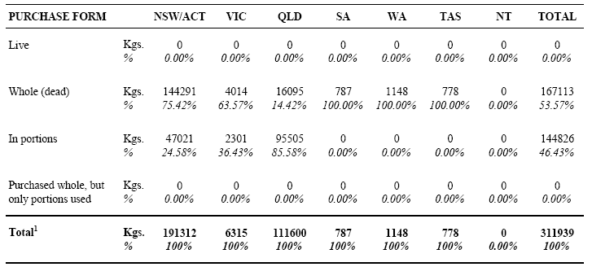
Notes:
¹ Table base: estimated total quantity of saltwater fish used by recreational fishers as bait/berley in the previous 12 months - where the purchase source was 'Sold as Seafood'
Also, standard error estimates are contained in the Appendix, with detailed study definitions and methodologies in Sections 2 and 3
The results in Table 77 (below) estimate national usage of saltwater fish by water body type, season and purchase source.

Table 77: Usage of Saltwater Fish by Water Body Type and Season - Annual Quantities Used1 (Kgs) by Purchase Source (All States/Territories)
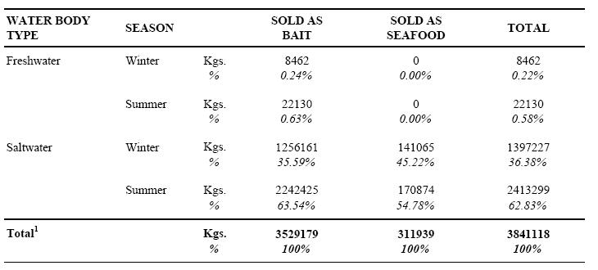
Notes:
¹ Table base: estimated total quantity of saltwater fish used (in any State/Territory) by recreational fishers as bait/berley in the previous 12 months … from 'purchase sources' only. By design, quantities for 'Personally Caught' saltwater fish were not assessed in the survey
Also, standard error estimates are contained in the Appendix, with detailed study definitions and methodologies in Sections 2 and 3
The remaining tables in this sub-section (Tables 78-84) comprise a disaggregation of the results in Table 77 above, for each state/territory.

Table 78: Usage of Saltwater Fish by Water Body Type and Season - Annual Quantities Used1 (Kgs) by Purchase Source (NSW/ACT)
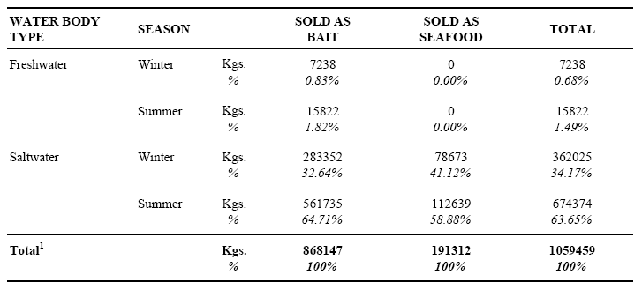
Notes:
¹ Table base: estimated total quantity of saltwater fish used in NSW/ACT by recreational fishers as bait/berley in the previous 12 months ... from 'purchase sources' only. By design, quantities for 'Personally Caught' saltwater fish were not assessed in the survey
Also, standard error estimates are contained in the Appendix, with detailed study definitions and methodologies in Sections 2 and 3

Table 79: Usage of Saltwater Fish by Water Body Type and Season - Annual Quantities Used1 (Kgs) by Purchase Source (VICTORIA)
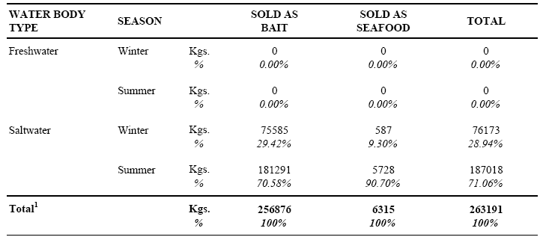
Notes:
¹ Table base: estimated total quantity of saltwater fish used in Victoria by recreational fishers as bait/berley in the previous 12 months ... from 'purchase sources' only. By design, quantities for 'Personally Caught' saltwater fish were not assessed in the survey
Also, standard error estimates are contained in the Appendix, with detailed study definitions and methodologies in Sections 2 and 3

Table 80: Usage of Saltwater Fish by Water Body Type and Season - Annual Quantities Used1 (Kgs) by Purchase Source (QUEENSLAND)
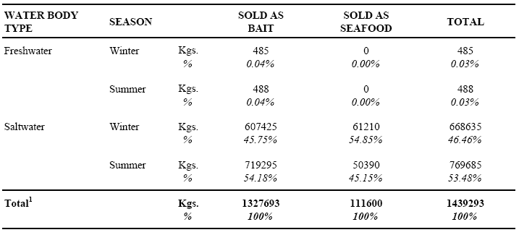
Notes:
¹ Table base: estimated total quantity of saltwater fish used in Queensland by recreational fishers as bait/berley in the previous 12 months ... from 'purchase sources' only. By design, quantities for 'Personally Caught' saltwater fish were not assessed in the survey
Also, standard error estimates are contained in the Appendix, with detailed study definitions and methodologies in Sections 2 and 3

Table 81: Usage of Saltwater Fish by Water Body Type and Season - Annual Quantities Used1 (Kgs) by Purchase Source (SOUTH AUSTRALIA)
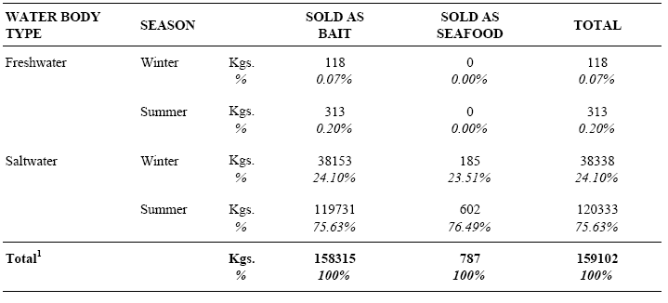
Notes:
¹ Table base: estimated total quantity of saltwater fish used in South Australia by recreational fishers as bait/berley in the previous 12 months ... from 'purchase sources' only. By design, quantities for 'Personally Caught' saltwater fish were not assessed in the survey
Also, standard error estimates are contained in the Appendix, with detailed study definitions and methodologies in Sections 2 and 3

Table 82: Usage of Saltwater Fish by Water Body Type and Season - Annual Quantities Used1 (Kgs) by Purchase Source (WESTERN AUSTRALIA)
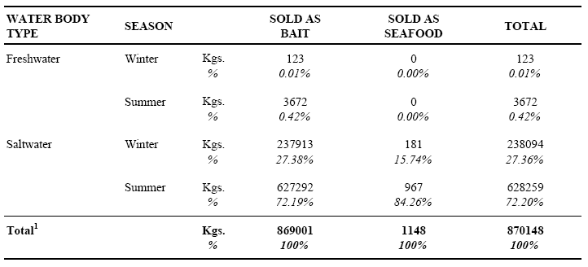
Notes:
¹ Table base: estimated total quantity of saltwater fish used in Western Australia by recreational fishers as bait/berley in the previous 12 months ... from 'purchase sources' only. By design, quantities for 'Personally Caught' saltwater fish were not assessed in the survey
Also, standard error estimates are contained in the Appendix, with detailed study definitions and methodologies in Sections 2 and 3

Table 83: Usage of Saltwater Fish by Water Body Type and Season - Annual Quantities Used1 (Kgs) by Purchase Source (TASMANIA)
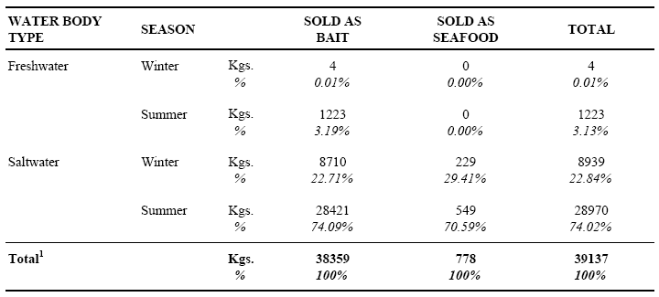
Notes:
¹ Table base: estimated total quantity of saltwater fish used in Tasmania by recreational fishers as bait/berley in the previous 12 months ... from 'purchase sources' only. By design, quantities for 'Personally Caught' saltwater fish were not assessed in the survey
Also, standard error estimates are contained in the Appendix, with detailed study definitions and methodologies in Sections 2 and 3

5.11 Freshwater Fish
A total of 14 respondents reported using freshwater fish species as bait/berley in the previous 12 months. For each respondent, usage was assessed in terms of a number of species/groups. However, due to the small sub-samples involved, Table 85 (below) has been included for illustrative purposes only.

Table 85: Usage of Any Freshwater Fish as Bait/Berley - Recreational Fishers1 by State/Territory of Residence
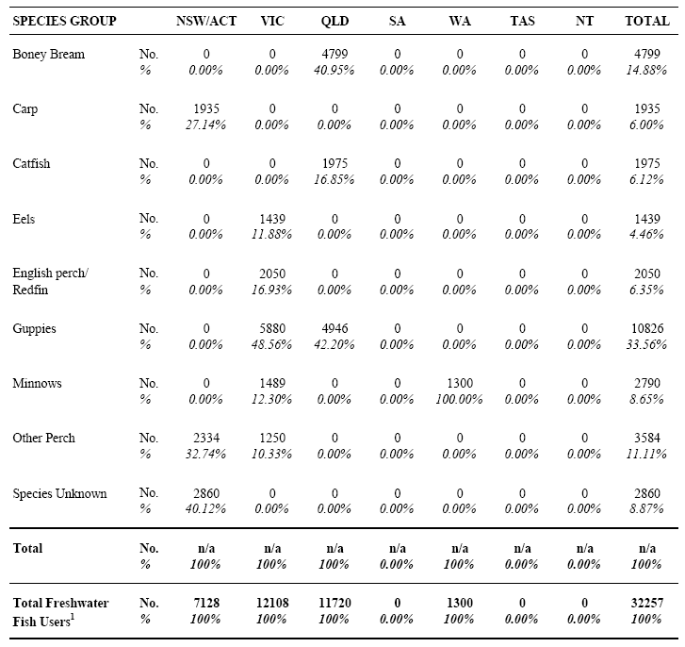
Notes:
¹ Table base: population estimate of recreational fishers using freshwater fish as bait/berley in previous 12 monthsAlso, standard error estimates are contained in the Appendix, with detailed study definitions and methodologies in Sections 2 and 3
Usage in the previous 12 months was then assessed in terms of four acquisition sources (Table 86 below) again, due to the small sub-samples involved, no further analysis for this bait type has been undertaken. For the record, 3 respondents reported usage for the acquisition source ‘Sold as Bait’ – with 2 reporting guppies and the other, catfish.

Table 86: Usage of Any Freshwater Fish as Bait/Berley - Recreational Fishers1 by State/Territory of Residence
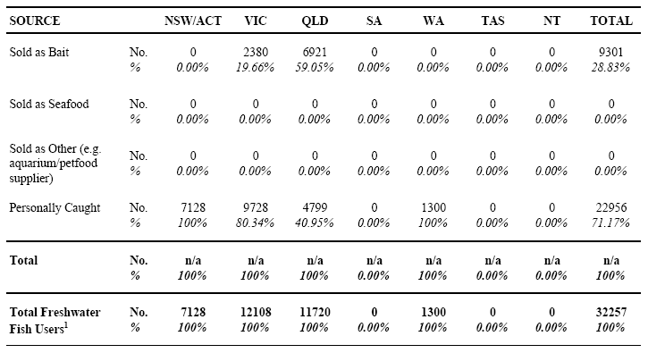
Notes:
¹ Table base: population estimate of recreational fishers using freshwater fish as bait/berley in previous 12 months
Also, standard error estimates are contained in the Appendix, with detailed study definitions and methodologies in Sections 2 and 3

6 REFERENCES
ABS (1996) Australian Bureau of Statistics, 1996 Census of Population and Housing, Basic Community Profiles (CDATA) and Estimated Resident Populations (June 1996), Catalogue No: 3210.1.
ABS (2002) Australian Bureau of Statistics, Estimated Resident Populations (June 2001), Catalogue No: 3210.1 and unpublished data.
Connelly, N.A. and Brown, T.L. (1995) Use of angler diaries to examine biases associated with 12-month recall on mail questionnaires. Transactions of the American Fisheries Society 124.
Forward, J. and Lyle, J.M. (2002) A survey of the 2000/01 Tasmanian recreational rock lobster fishery and options for future assessment. Final Report to Marine Recreational Fishery Council. Tasmanian Aquaculture and Fisheries Institute, University of Tasmania.
Fisher, W.L., Grambsch, A.E., Eisenhower, D.L. and Morganstein, D.R. (1991) Length of recall and accuracy of estimates from the National Survey of Fishing, Hunting, and Wildlife-Associated Recreation. American Fisheries Society Symposium 12.
Higgs, J. and McInnes, K. (in press) 2001 Biennial Recreational Fishing Survey of Queensland Residents, Queensland Fisheries Management Authority.
Lemaitre, G. and Dufour, J. (1987) An Integrated Method for Weighting Persons and Families, in Survey Methodology December 1987 Vol. 13 No.2 pp 199-207 Statistics Canada.
NRFS (in prep.) Recreational fishing component of The National Recreational and Indigenous Fishing Survey (NRIFS). Final report to the Fisheries Research and Development Corporation. Project No. 99/158.
Pollock, K.H., Jones, C.M. and Brown, T.L. (1994) Angler Survey Methods and Their Implications in Fisheries Management. American Fisheries Society Special Publication 25.
QFMA (1997) Unpublished data. Recreational Fishing in Queensland – A Survey of Queensland Residents (1996), Queensland Fisheries Management Authority.
Roy Morgan Research (1999). Recreational Fishing in Queensland – A Survey of Queensland Residents (1998), Report to Queensland Fisheries Management Authority, Roy Morgan Research
Tarrant, M.A. and Manfredo, M.J. (1993) Digit preference, recall bias, and non-response bias in self-reports of angling participation. Leisure Sciences 15.
Tarrant, M.A., Manfredo, M.J., Bayley, P.B. and Hess, R. (1993) Effects of recall bias and non-response bias on self-report estimates of angling participation. North American Journal of Fisheries Management 13.
Thompson, T. and Hubert, W.A. (1990) Influence of survey method on estimates of statewide fishing activity. North American Journal of Fisheries Management 10.
Final Report – Page 95
National Survey of Bait and Berley Use by Recreational Fishers

APPENDIX: STANDARD ERROR TABLES
Information in this appendix refers to standard error calculations for survey estimates contained in this report. Commencing with Summary Table A, each substantive data tabulation has been replicated from the body of the report to show the survey estimate and the ‘relative standard error’ (RSE) for each cell within the table. As a general rule, RSE estimates for column totals (i.e. the total ‘row’) have only been included where the information is not available in an earlier (higher level) table. Also, the original table numbering has been retained, prefixed by ‘Error’.
Expressed as a percentage, the RSE refers to the relative amount (+ or -) by which the estimate might vary due to ‘sample error’ (see discussion of confidence intervals below). Procedures employed in developing the error terms are discussed in some detail in Section 3.7.2.
In all cases where a survey estimate of zero occurs, the RSE is shown as n/a. As discussed in Section 1.3, this is not to suggest that no such occurrence exists in the population overall – rather, that none was reported within the detection limits of the survey sample. Zero estimates should therefore be interpreted as ‘nil or negligible’.
Also, for estimates based on very small sub-samples (less than 5 respondents), the RSE is shown as n/a. Below this level, the influences of differing stratum weights can result in misleading error estimation. Although these survey estimates invariably refer to quite small proportions of the population or quantity estimates, where necessary, it is recommended that a 50% RSE be generally applied for conservative analysis purposes. On this basis, 95% confidence limits would approximate (+/-) 100% (see discussion below). If required, even higher upper limits may of course be applied.
To calculate 95% confidence intervals for a given survey estimate, the RSE is multiplied by 1.96 then applied to the estimate. For example, in Summary Table A (below), the estimate for Prawns/shrimp ‘Sold as Bait’ is 1,428,944 fishers and the RSE is 4.1%. The 95% confidence interval for this estimate is 1,314,114 – 1,543,774 with the lower limit calculated by 1,428,944 x 0.91964 (i.e. 100% - [1.96 x 4.1%]) and the upper limit by 1,428,944 x 1.08036 (i.e. 100% + [1.96 x 4.1%]).

Error Summary Table A: Acquisition Source of Bait/Berley Used by Recreational Fishers - 10 Key Bait Types
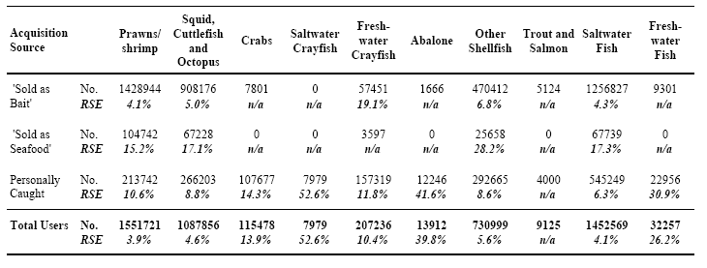

Error Summary Table B: Purchase Source of Bait/Berley - Annual Quantities Used (Kgs) for 5 Key Bait Types
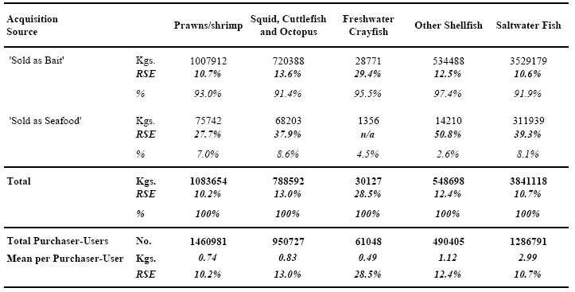

Error Table 4: Any Recreational Fishing in the Previous 12 Months - Households by State/Territory of Residence
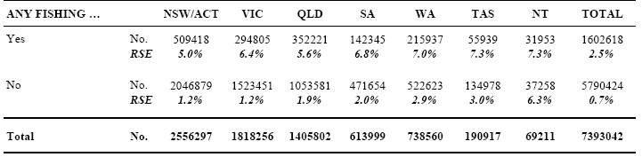

Error Table 5: Any Recreational Fishing in the Previous 12 Months - Persons (aged 5 years or more) by State/Territory of Residence
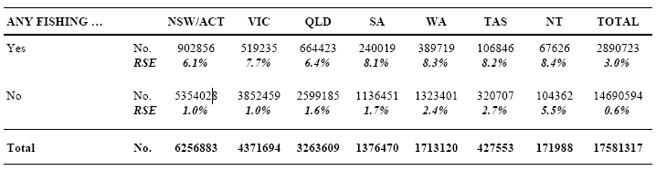

Error Table 6: Any Bait/Berley Usage in Previous 12 Months - Recreational Fishers by State/Territory of Residence
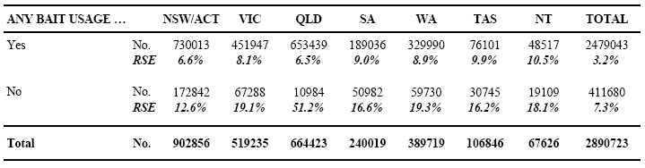

Error Table 7: Bait Types Used in Previous 12 Months - Recreational Fishers by State/Territory of Residence
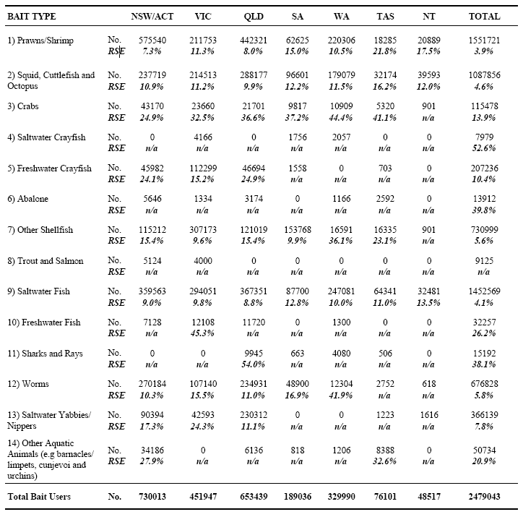

Error Table 8: Acquisition Source of Prawns/Shrimp Used as Bait/Berley - Recreational Fishers by State/Territory of Residence
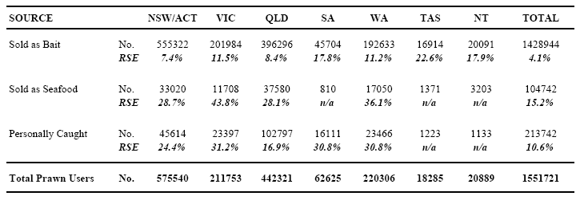

Error Table 9: Reasons for Purchasing Prawns/Shrimp from a 'Seafood Supplier' (vs. Bait Supplier) - Recreational Fishers (All States/Territories)
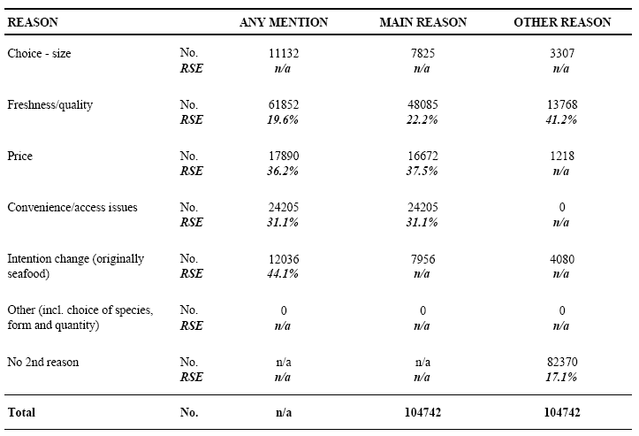

Error Table 10: Methods Used to Bait Hook with Prawns/Shrimp - Recreational Fishers (All States/Territories)
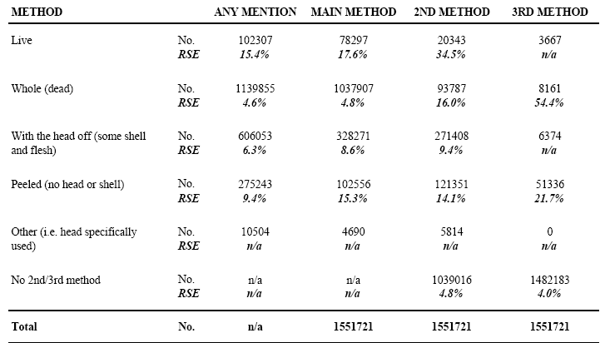

Error Table 11: State/Territory of Usage of Prawns/Shrimp as Bait/Berley - Recreational Fishers by State/Territory of Residence
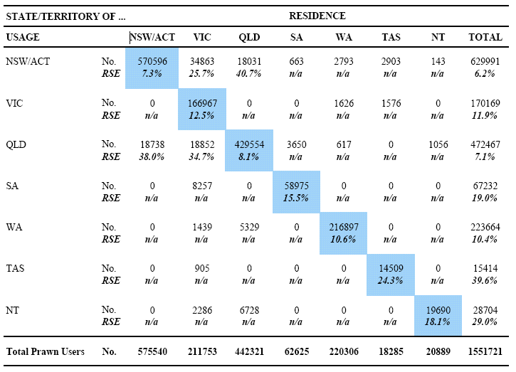

Error Table 12: Purchase Source of Prawns/Shrimp Used as Bait/Berley - Annual Quantities Used (Kgs) by State/Territory of Residence
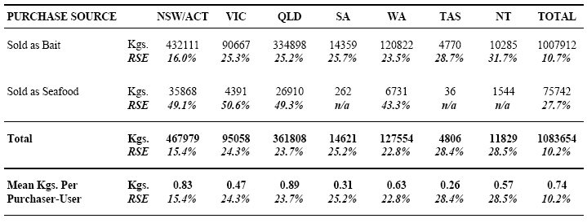

Error Table 13: Purchase Source of Prawns/Shrimp Used as Bait/Berley - Annual Quantities Used (Kgs) by State/Territory of Usage
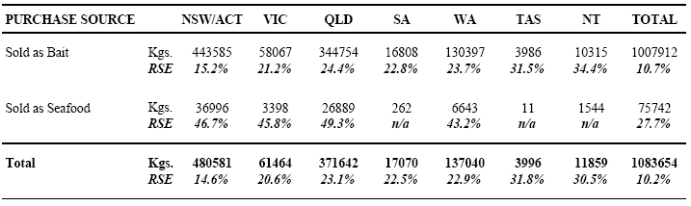

Error Table 14: Form Purchased of Prawns/Shrimp 'Sold as Bait' - Annual Quantities Used (Kgs) by State/Territory of Usage
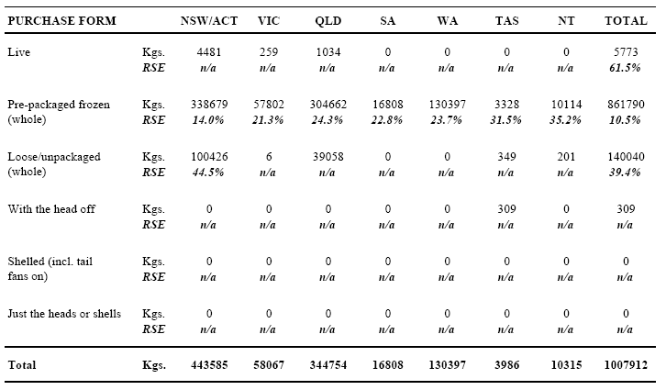

Error Table 15: Form Purchased of Prawns/Shrimp 'Sold as Seafood' - Annual Quantities Used (Kgs) by State/Territory of Usage
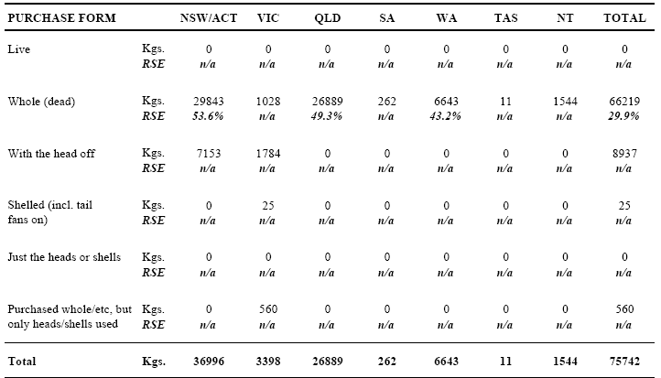

Error Table 16: Estimated Size of Whole Prawns/Shrimp - Annual Quantities Used (Kgs) by Selected Source/Purchase Forms (All States/Territories)
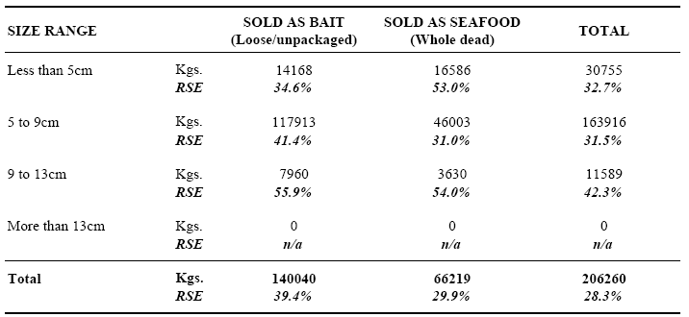

Error Table 17: Usage of Prawns/Shrimp by Water Body Type and Season - Annual Quantities Used (Kgs) by Purchase Source (All States/Territories)
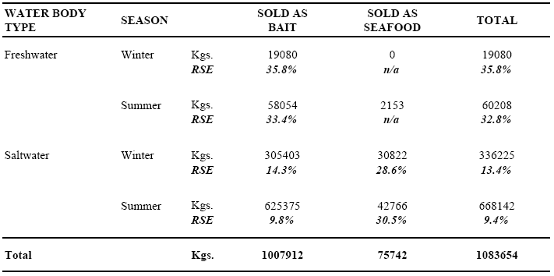

Error Table 18: Usage of Prawns/Shrimp by Water Body Type and Season - Annual Quantities Used (Kgs) by Purchase Source (NSW/ACT)
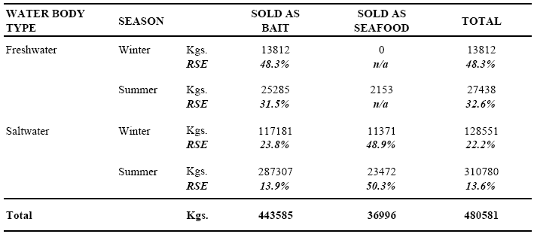

Error Table 19: Usage of Prawns/Shrimp by Water Body Type and Season - Annual Quantities Used (Kgs) by Purchase Source (VICTORIA)
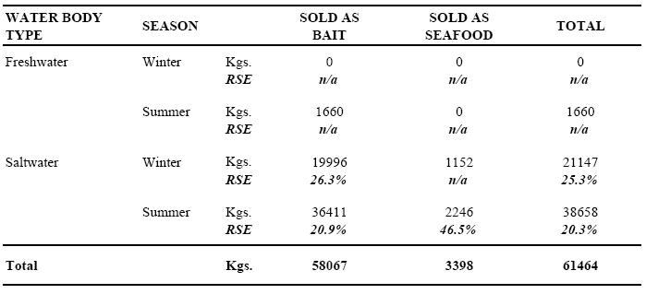

Error Table 20: Usage of Prawns/Shrimp by Water Body Type and Season - Annual Quantities Used (Kgs) by Purchase Source (QUEENSLAND)
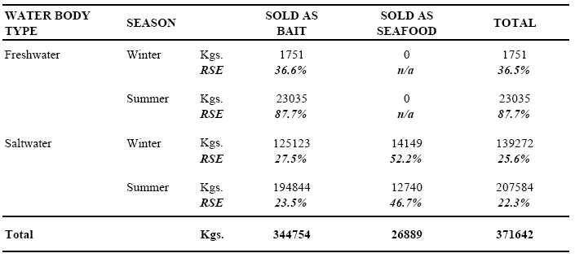

Error Table 21: Usage of Prawns/Shrimp by Water Body Type and Season - Annual Quantities Used (Kgs) by Purchase Source (SOUTH AUSTRALIA)
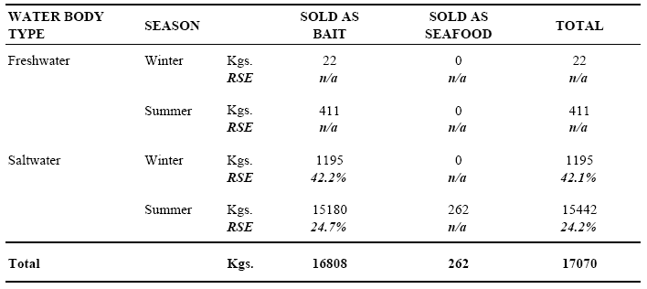

Error Table 22: Usage of Prawns/Shrimp by Water Body Type and Season - Annual Quantities Used (Kgs) by Purchase Source (WESTERN AUSTRALIA)
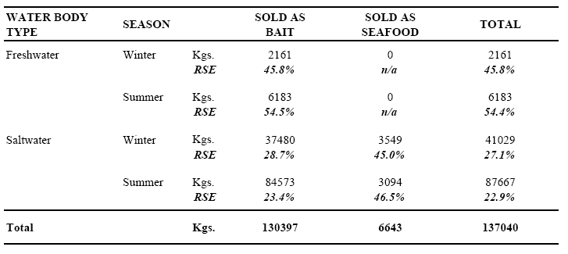

Error Table 23: Usage of Prawns/Shrimp by Water Body Type and Season - Annual Quantities Used (Kgs) by Purchase Source (TASMANIA)
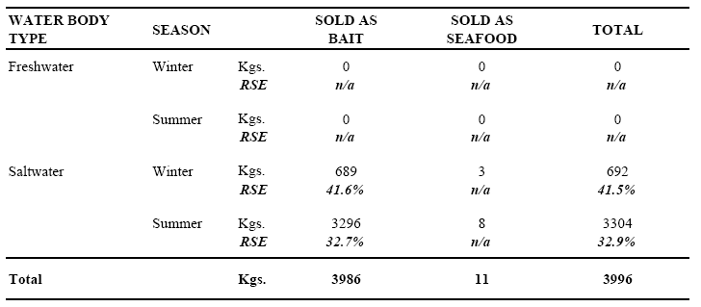

Error Table 24: Usage of Prawns/Shrimp by Water Body Type and Season - Annual Quantities Used (Kgs) by Purchase Source (NORTHERN TERRITORY)
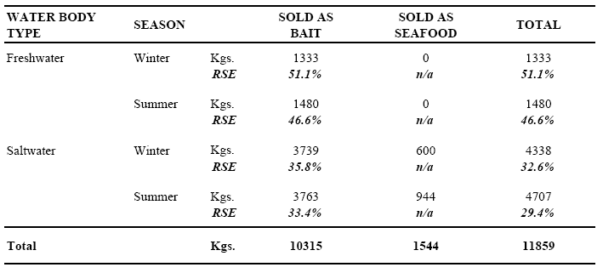

Error Table 25: Usage of Any Squid, Cuttlefish or Octopus as Bait/Berley - Recreational Fishers by State/Territory of Residence
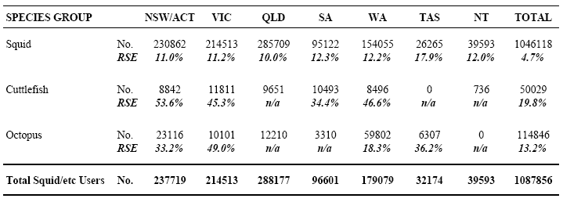

Error Table 26: Acquisition Source of Squid/Cuttlefish/Octopus Used as Bait/Berley - Recreational Fishers by State/Territory of Residence
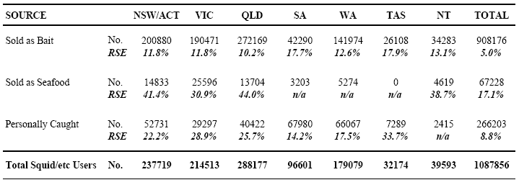

Error Table 27: Reasons for Purchasing Squid/Cuttlefish/Octopus from a 'Seafood Supplier' (vs. Bait Supplier) - Recreational Fishers (All States/Territories)
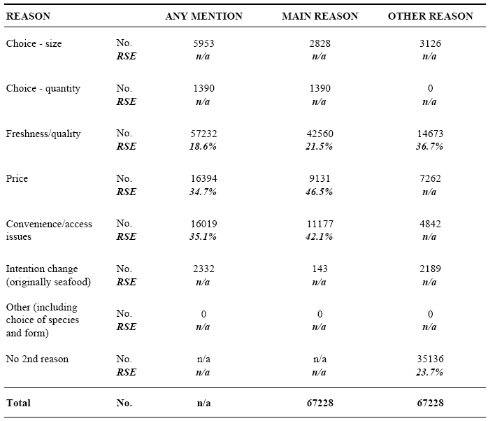

Error Table 28: State/Territory of Usage of Squid/Cuttlefish/Octopus as Bait/Berley - Recreational Fishers by State/Territory of Residence
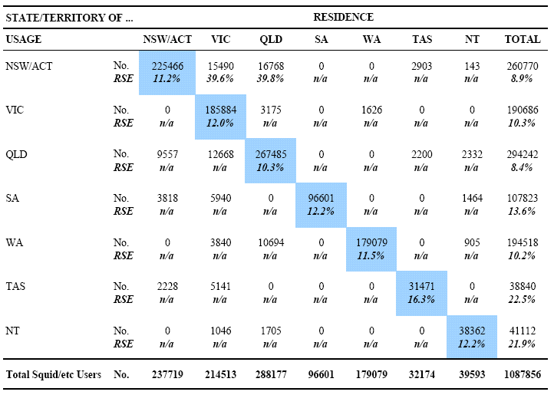

Error Table 29: Purchase Source of Squid/Cuttlefish/Octopus Used as Bait/Berley - Annual Quantities Used (Kgs) by State/Territory of Residence
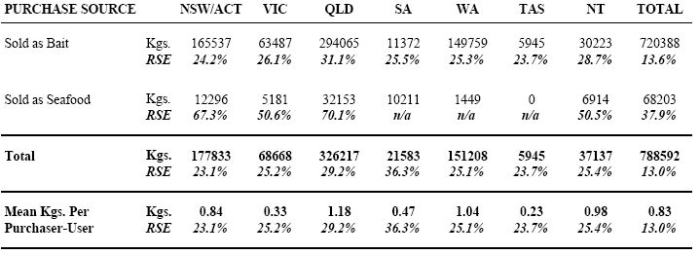

Error Table 30: Purchase Source of Squid/Cuttlefish/Octopus Used as Bait/Berley - Annual Quantities Used (Kgs) by State/Territory of Usage
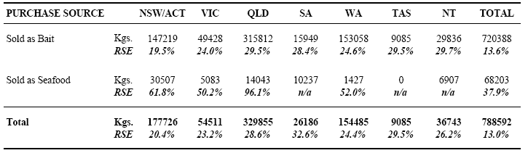

Error Table 31: Form Purchased of Squid/Cuttlefish/Octopus 'Sold as Bait' - Annual Quantities Used (Kgs) by State/Territory of Usage
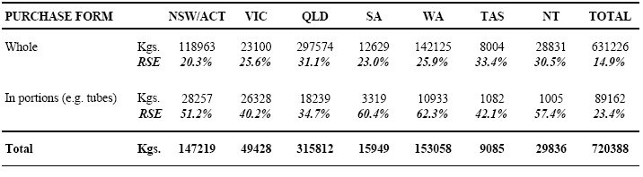

Error Table 32: Form Purchased of Squid/Cuttlefish/Octopus 'Sold as Seafood' - Annual Quantities Used (Kgs) by State/Territory of Usage
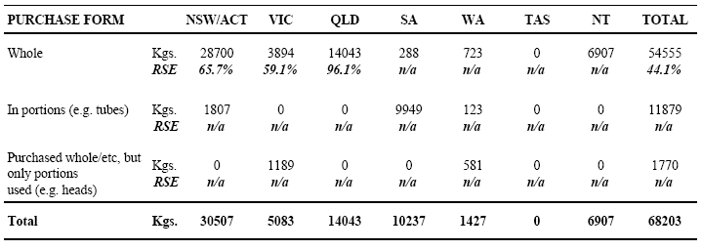

Error Table 33: Usage of Squid/Cuttlefish/Octopus by Water Body Type and Season - Annual Quantities Used (Kgs) by Purchase Source (All States/Territories)
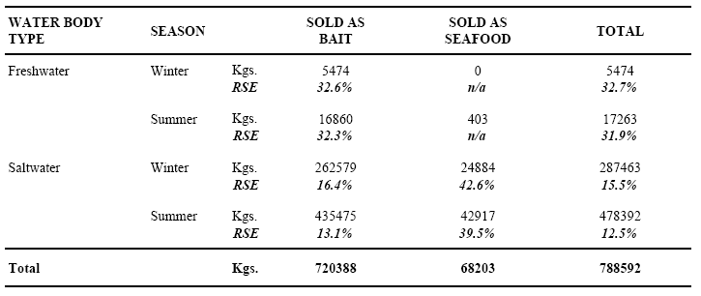

Error Table 34: Usage of Squid/Cuttlefish/Octopus by Water Body Type and Season - Annual Quantities Used (Kgs) by Purchase Source (NSW/ACT)
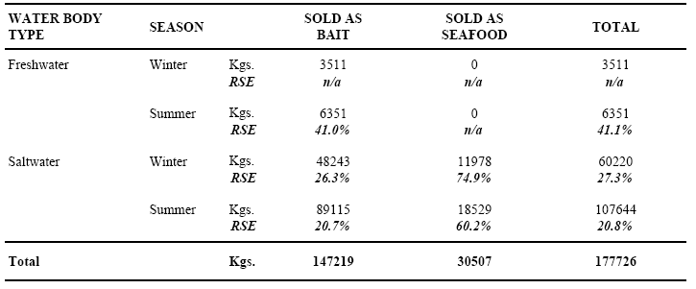

Error Table 35: Usage of Squid/Cuttlefish/Octopus by Water Body Type and Season - Annual Quantities Used (Kgs) by Purchase Source (VICTORIA)
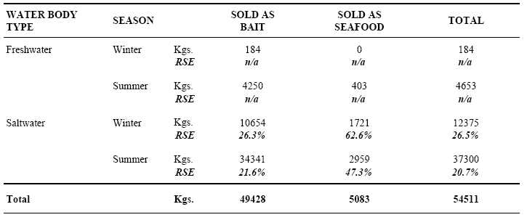

Error Table 36: Usage of Squid/Cuttlefish/Octopus by Water Body Type and Season - Annual Quantities Used (Kgs) by Purchase Source (QUEENSLAND)
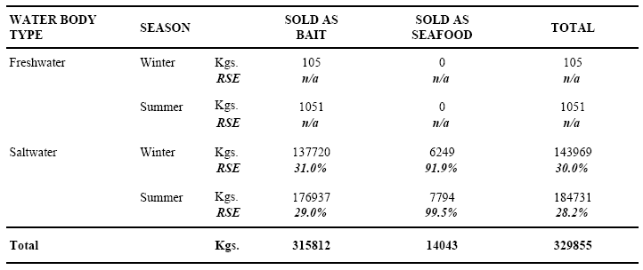

Error Table 37: Usage of Squid/Cuttlefish/Octopus by Water Body Type and Season - Annual Quantities Used (Kgs) by Purchase Source (SOUTH AUSTRALIA)
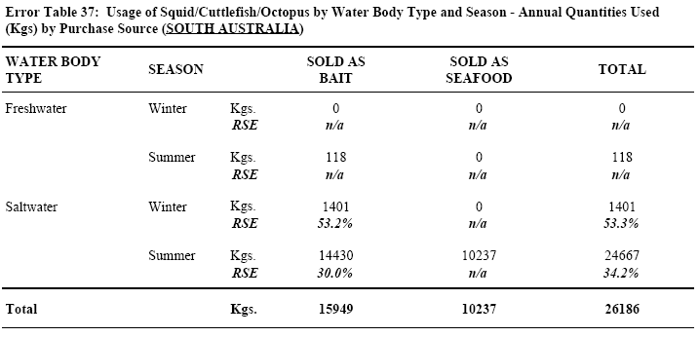

Error Table 38: Usage of Squid/Cuttlefish/Octopus by Water Body Type and Season - Annual Quantities Used (Kgs) by Purchase Source (WESTERN AUSTRALIA)
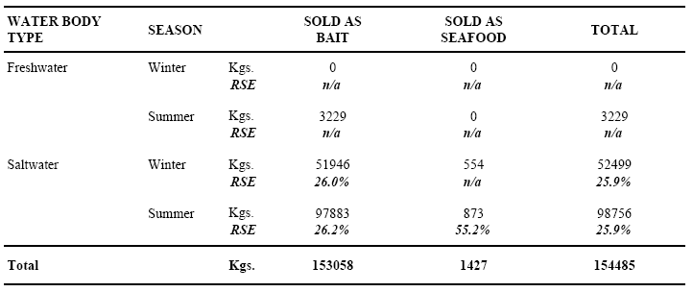

Error Table 39: Usage of Squid/Cuttlefish/Octopus by Water Body Type and Season - Annual Quantities Used (Kgs) by Purchase Source (TASMANIA)
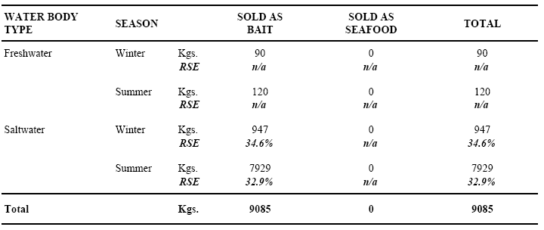

Error Table 40: Usage of Squid/Cuttlefish/Octopus by Water Body Type and Season - Annual Quantities Used (Kgs) by Purchase Source (NORTHERN TERRITORY)
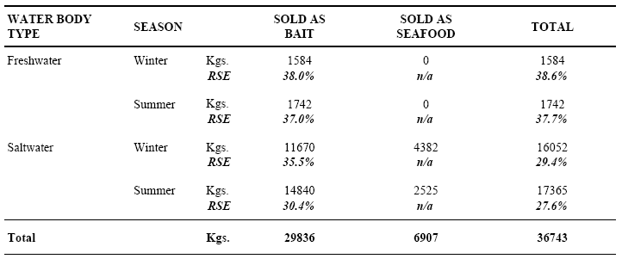

Error Table 41: Acquisition Source of Crabs Used as Bait/Berley - Recreational Fishers by State/Territory of Residence
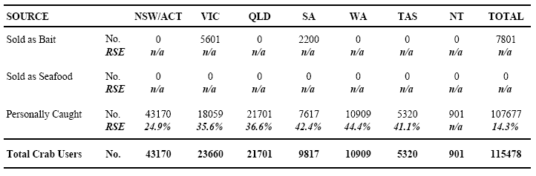

Error Table 42: Form Purchased of Crabs 'Sold as Bait ' - Annual Quantities Used (Kgs) by State/Territory of Usage
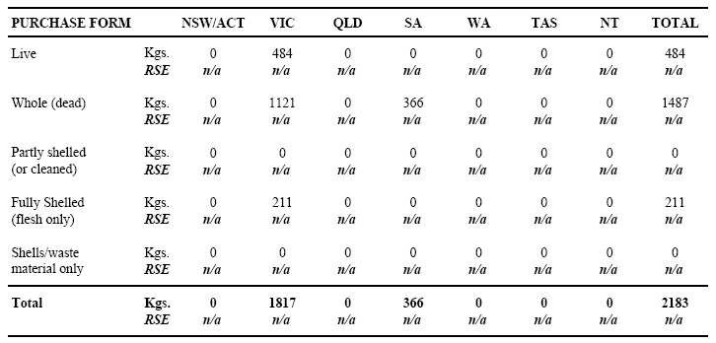

Error Table 43: Acquisition Source of Saltwater Crayfish Used as Bait/Berley - Recreational Fishers by State/Territory of Residence
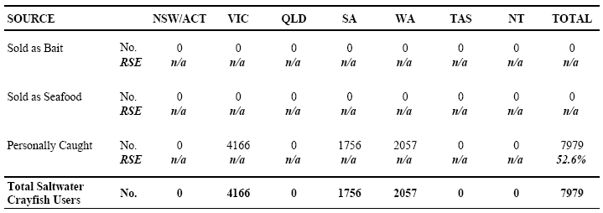

Error Table 44: Acquisition Source of Freshwater Crayfish Used as Bait/Berley - Recreational Fishers by State/Territory of Residence
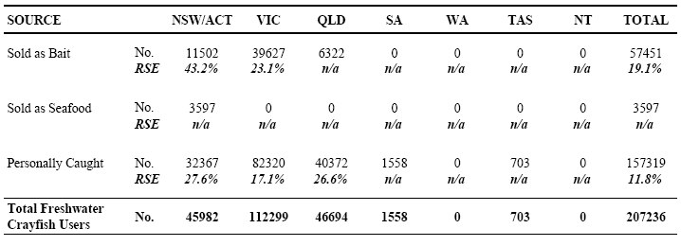

Error Table 45: Methods Used to Bait Hook with Freshwater Crayfish - Recreational Fishers (All States/ Territories)
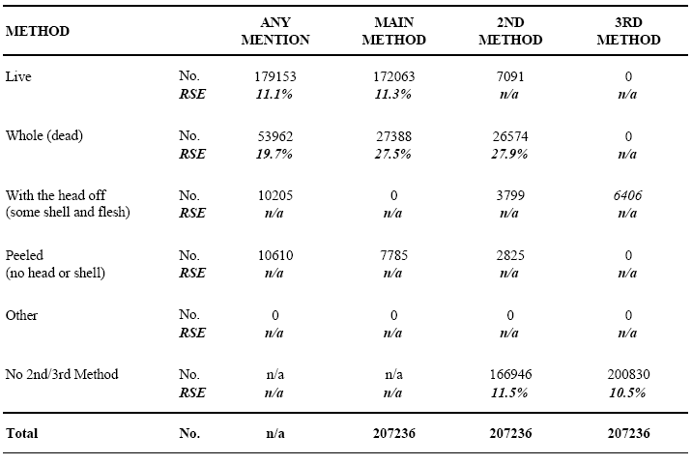

Error Table 46: State/Territory of Usage of Freshwater Crayfish as Bait/Berley - Recreational Fishers by State/Territory of Residence
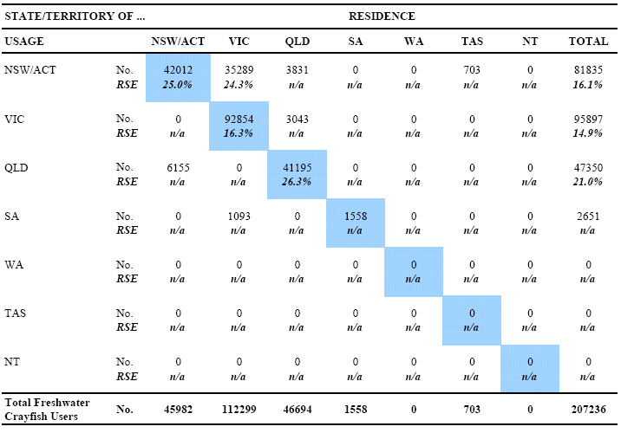

Error Table 47: Purchase Source of Freshwater Crayfish Used as Bait/Berley - Annual Quantities Used (Kgs) by State/ Territory of Residence
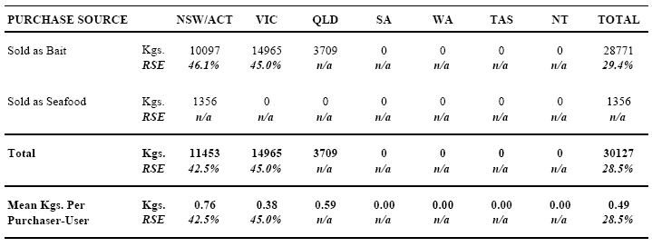

Error Table 48: Purchase Source of Freshwater Crayfish Used as Bait/Berley - Annual Quantities Used (Kgs) by State/ Territory of Usage
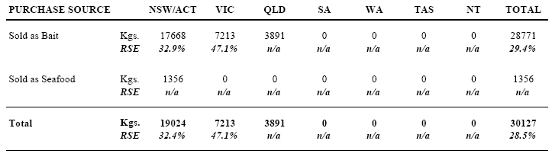

Error Table 49: Form Purchased of Freshwater Crayfish 'Sold as Bait ' - Annual Quantities Used (Kgs) by State/Territory of UsageFully 21
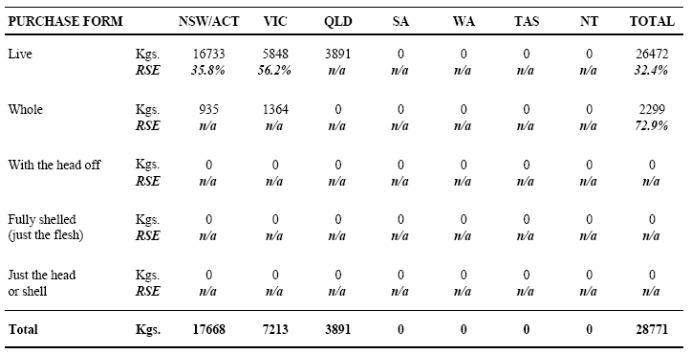

Error Table 50: Estimated Size of Freshwater Crayfish - Annual Quantities Used (Kgs) by Selected Source/Purchase Forms (All States/Territories)
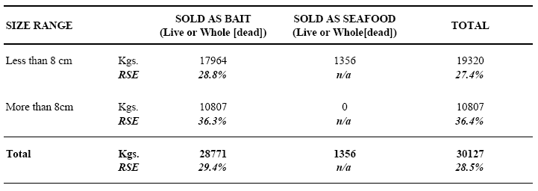

Error Table 51: Usage of Freshwater Crayfish by Water Body Type and Season - Annual Quantities Used (Kgs) by Purchase Source (All States/Territories)
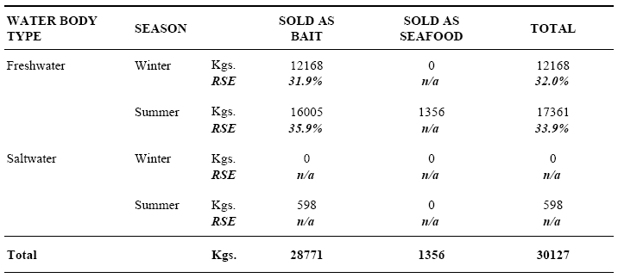

Error Table 52: Acquisition Source of Abalone Used as Bait/Berley - Recreational Fishers by State/Territory of Residence
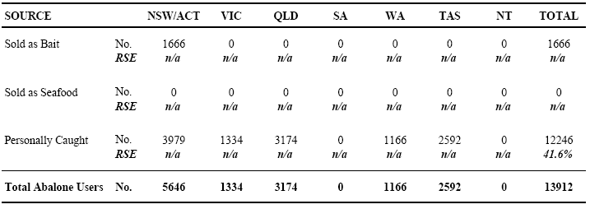

Error Table 53: Usage of 'Other Shellfish' as Bait/Berley - Recreational Fishers by State/Territory of Residence
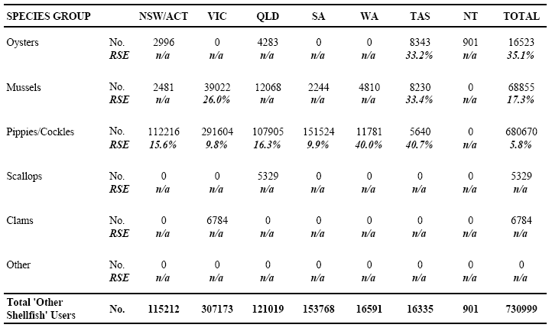

Error Table 54: Acquisition Source of 'Other Shellfish' Used as Bait/Berley - Recreational Fishers by State/Territory of Residence
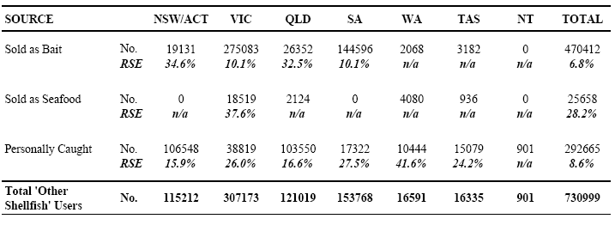

Error Table 55: Reasons for Purchasing 'Other Shellfish' from a 'Seafood Supplier' (vs. Bait Supplier) - Recreational Fishers (All States/Territories)
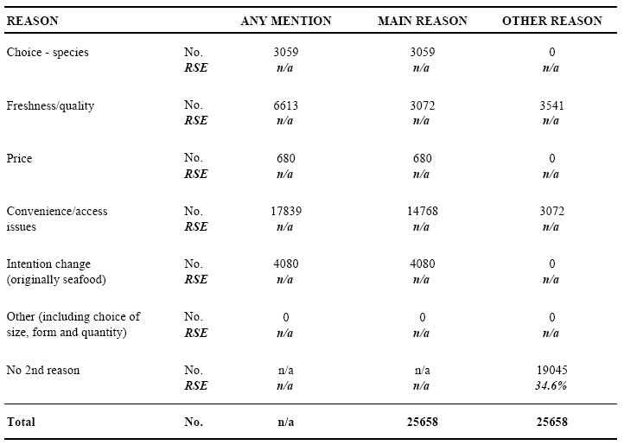

Error Table 56: State/Territory of Usage of 'Other Shellfish' as Bait/Berley - Recreational Fishers by State/Territory of Residence
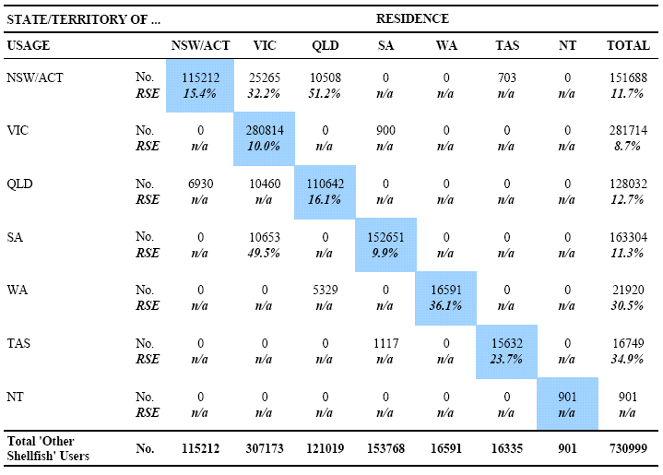

Error Table 57: Purchase Source of 'Other Shellfish' Used as Bait/Berley - Annual Quantities Used (Kgs) by State/Territory of Residence
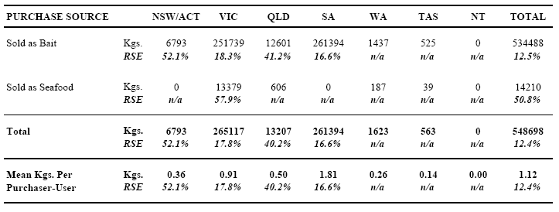

Error Table 58: Purchase Source of 'Other Shellfish' Used as Bait/Berley - Annual Quantities Used (Kgs) by State/Territory of Usage
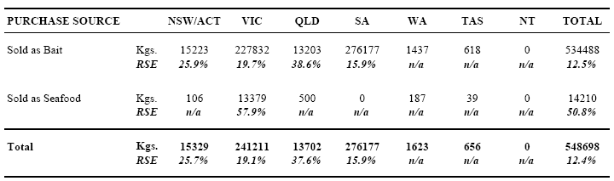

Error Table 59: Form Purchased of 'Other Shellfish' Sold as Bait - Annual Quantities Used (Kgs) by State/Territory of Usage
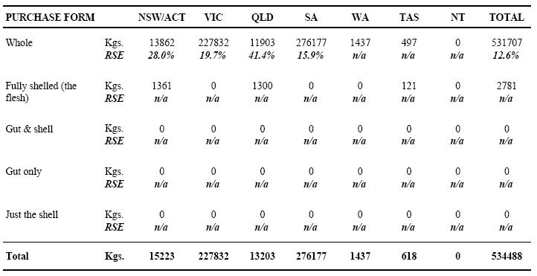

Error Table 60: Form Purchased of 'Other Shellfish' Sold as Seafood - Annual Quantities Used (Kgs) by State/Territory of Usage
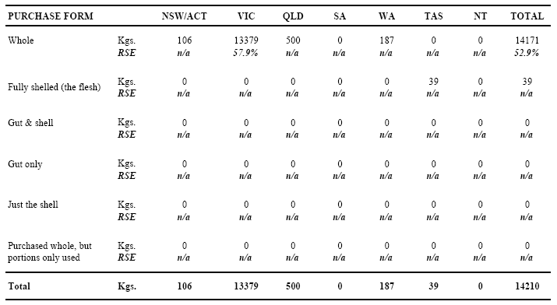

Error Table 61: Usage of 'Other Shellfish' by Water Body Type and Season - Annual Quantities Used (Kgs) by Purchase Source (All States/Territories)
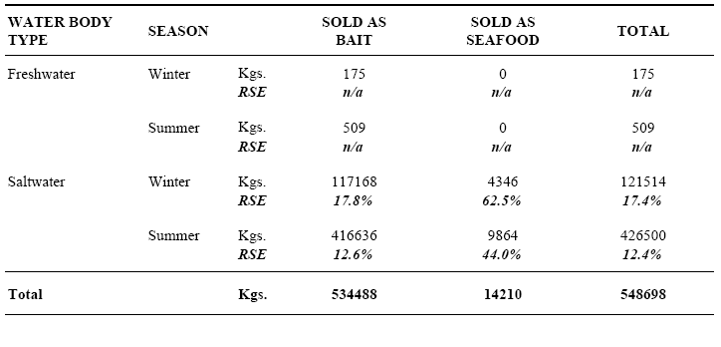

Error Table 62: Usage of 'Other Shellfish' by Water Body Type and Season - Annual Quantities Used(Kgs) by Purchase Source (NSW/ACT)
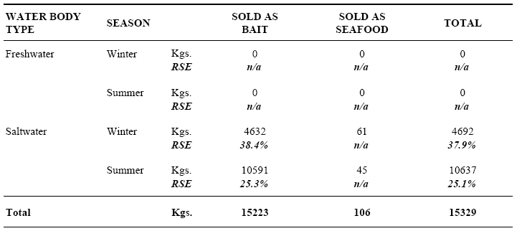

Error Table 63: Usage of 'Other Shellfish' by Water Body Type and Season - Annual Quantities Used (Kgs) by Purchase Source (VICTORIA)
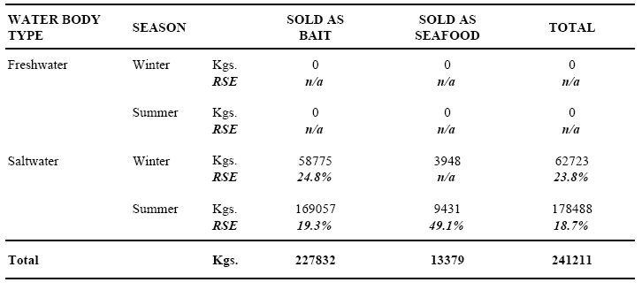

Error Table 64: Usage of 'Other Shellfish' by Water Body Type and Season - Annual Quantities Used (Kgs) by Purchase Source (QUEENSLAND)
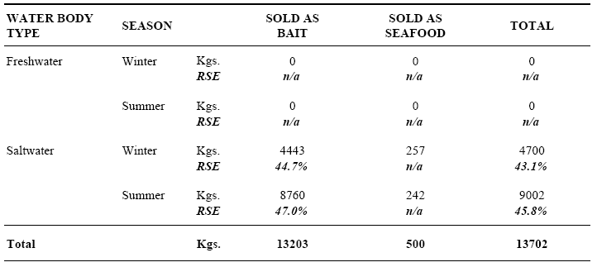

Error Table 65: Usage of 'Other Shellfish' by Water Body Type and Season - Annual Quantities Used (Kgs) by Purchase Source (SOUTH AUSTRALIA)
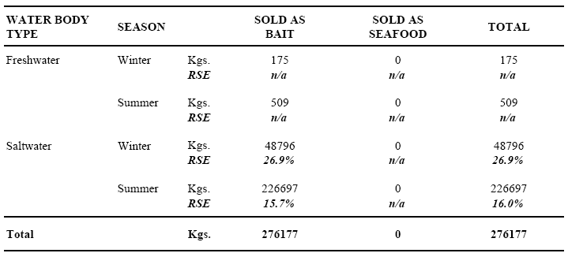

Error Table 66: Usage of 'Other Shellfish' by Water Body Type and Season - Annual Quantities Used (Kgs) by Purchase Source (WESTERN AUSTRALIA)
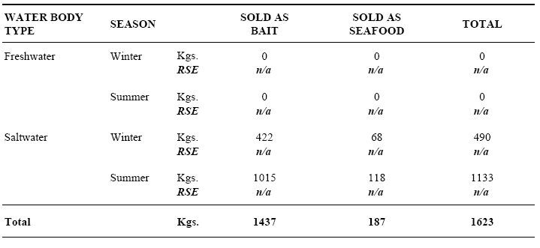

Error Table 67: Usage of 'Other Shellfish' by Water Body Type and Season - Annual Quantities Used (Kgs) by Purchase Source (TASMANIA)
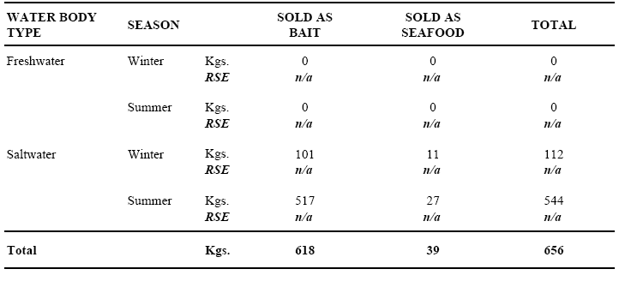

Error Table 68: Acquisition Source of Trout and Salmon Used as Bait/Berley - Recreational Fishers by State/Territory of Residence
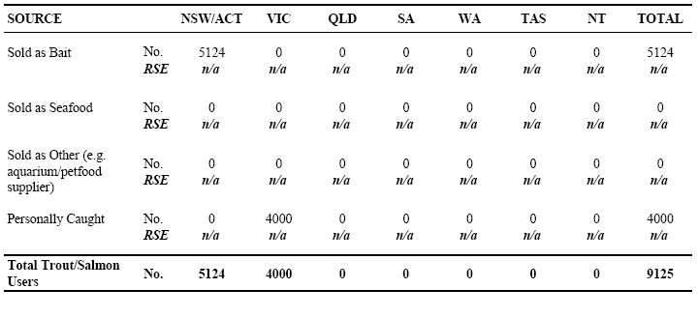

Error Table 69: Usage of Any Saltwater Fish as Bait/Berley - Recreational Fishers by State/Territory of Residence
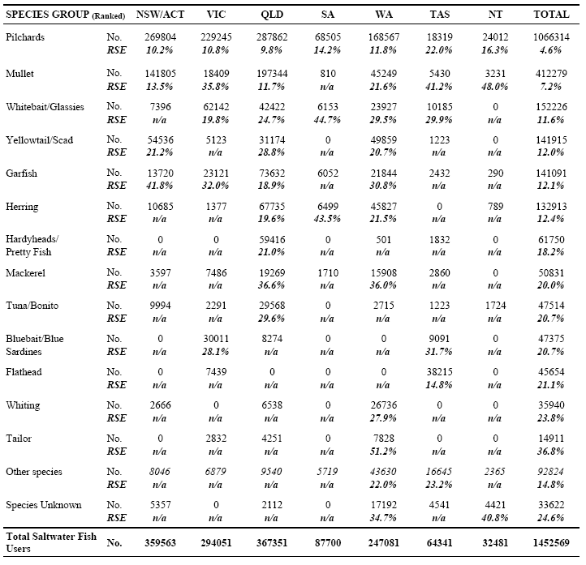

Error Table 70: Acquisition Source of Saltwater Fish Used as Bait/Berley - Recreational Fishers by State/Territory of Residence
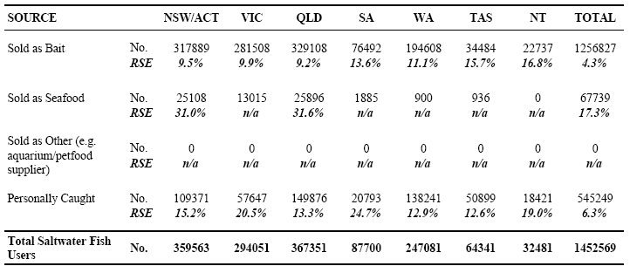

Error Table 71: Reasons for Purchasing Saltwater Fish from a 'Seafood Supplier' (vs. Bait Supplier) -Recreational Fishers (All States/Territories)
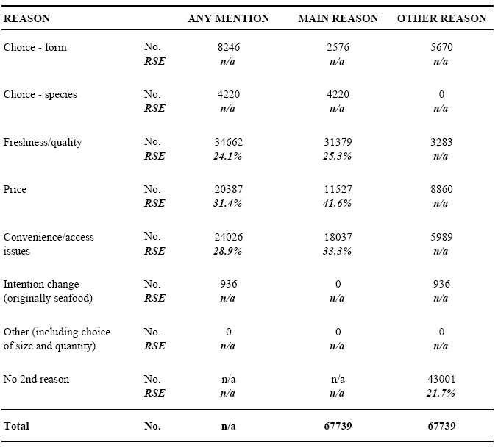

Error Table 72: State/Territory of Usage of Saltwater Fish as Bait/Berley - Recreational Fishers by State/Territory of Residence
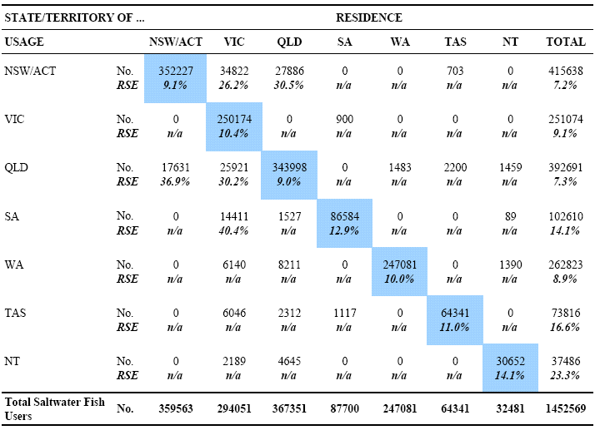

Error Table 73: Purchase Source of Saltwater Fish Used as Bait/Berley - Annual Quantities Used (Kgs) by State/Territory of Residence
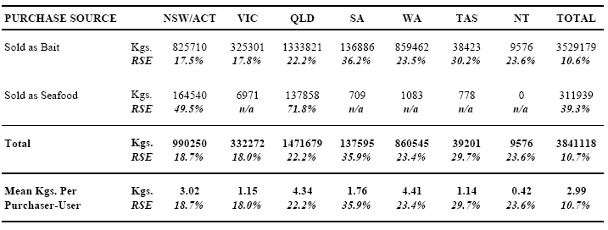

Error Table 74: Purchase Source of Saltwater Fish Used as Bait/Berley - Annual Quantities Used (Kgs) by State/Territory of Usage
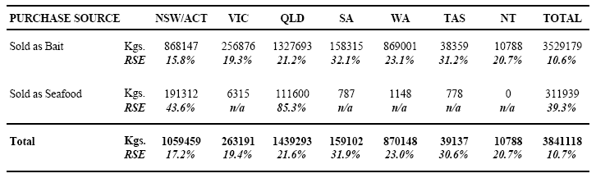

Error Table 75: Form Purchased of Saltwater Fish 'Sold as Bait' - Annual Quantities Used (Kgs) by State/Territory of Usage
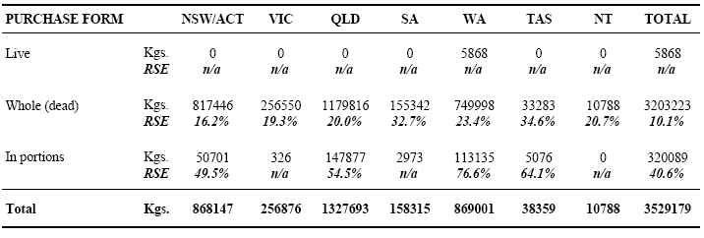

Error Table 76: Form Purchased of Saltwater Fish 'Sold as Seafood' - Annual Quantities Used (Kgs) by State/Territory of Usage
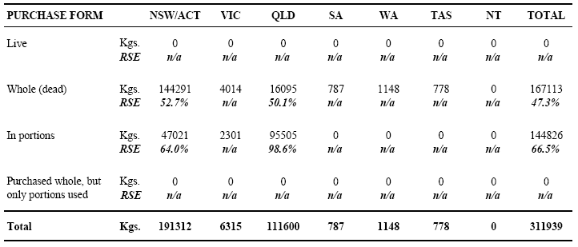

Error Table 77: Usage of Saltwater Fish by Water Body Type and Season - Annual Quantities Used (Kgs) by Purchase Source (All States/Territories)
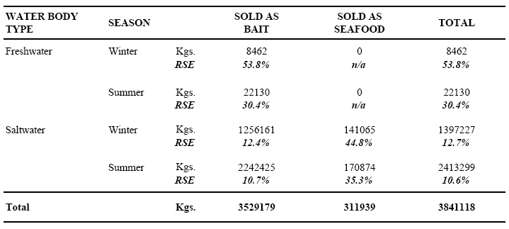

Error Table 78: Usage of Saltwater Fish by Water Body Type and Season - Annual Quantities Used (Kgs) by Purchase Source (NSW/ACT)
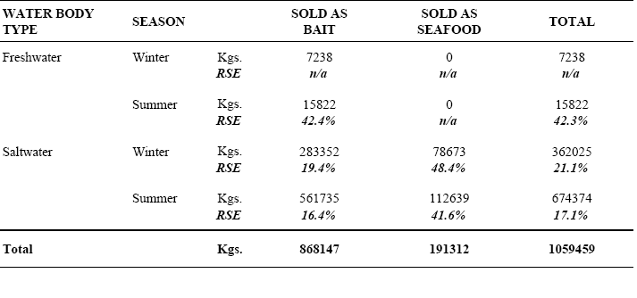

Error Table 79: Usage of Saltwater Fish by Water Body Type and Season - Annual Quantities Used (Kgs) by Purchase Source (VICTORIA)
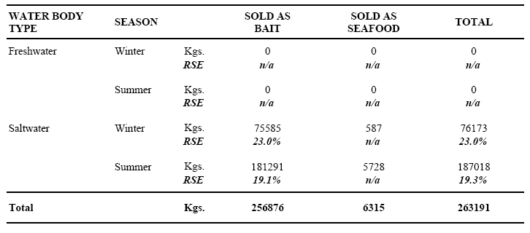

Error Table 80: Usage of Saltwater Fish by Water Body Type and Season - Annual Quantities Used (Kgs) by Purchase Source (QUEENSLAND)
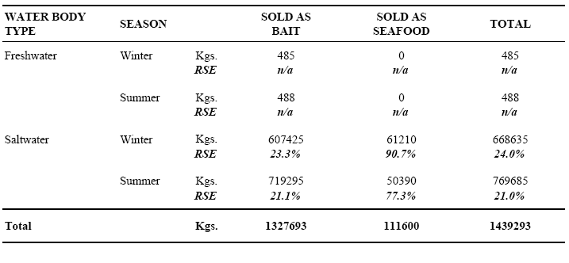

Error Table 81: Usage of Saltwater Fish by Water Body Type and Season - Annual Quantities Used (Kgs) by Purchase Source (SOUTH AUSTRALIA)
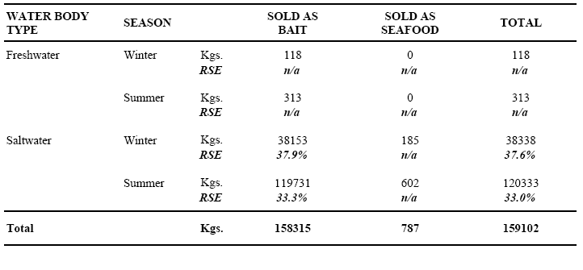

Error Table 82: Usage of Saltwater Fish by Water Body Type and Season - Annual Quantities Used (Kgs) by Purchase Source (WESTERN AUSTRALIA)
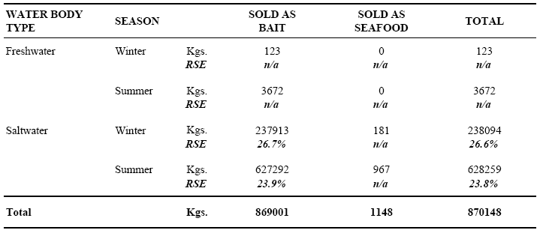

Error Table 83: Usage of Saltwater Fish by Water Body Type and Season - Annual Quantities Used (Kgs) by Purchase Source (TASMANIA)
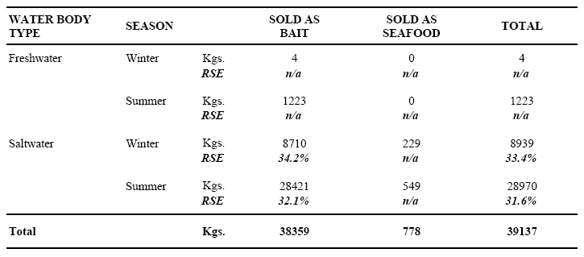

Error Table 84: Usage of Saltwater Fish by Water Body Type and Season - Annual Quantities Used (Kgs) by Purchase Source (NORTHERN TERRITORY)
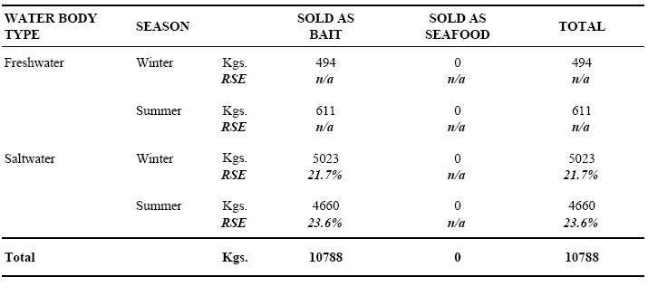

Error Table 85: Usage of Any Freshwater Fish as Bait/Berley - Recreational Fishers by State/Territory of Residence
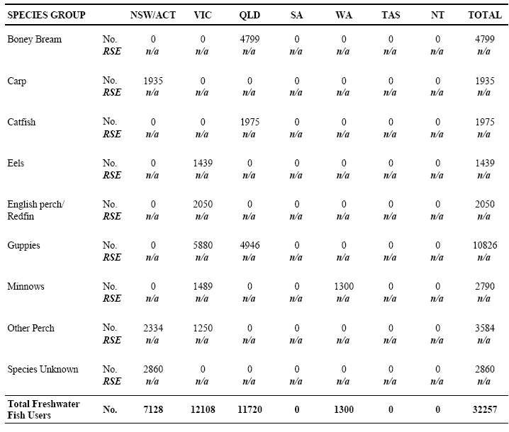

Error Table 86: Usage of Any Freshwater Fish as Bait/Berley - Recreational Fishers by State/Territory of Residence
