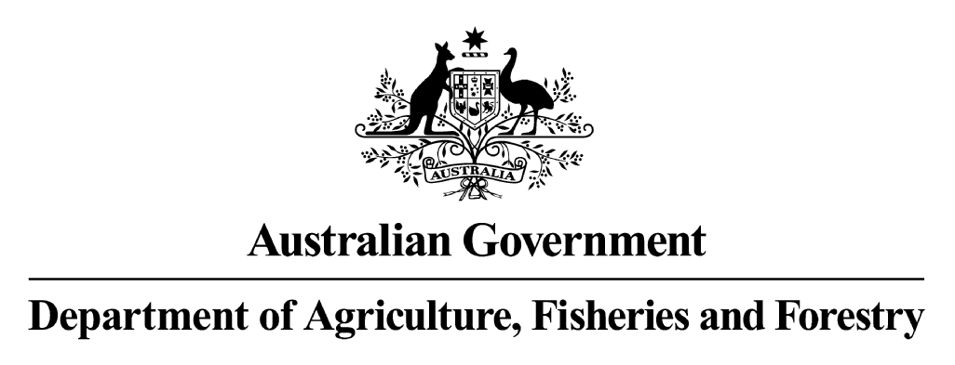

biosecurity POLICY DETERMINATION

on the IMPORTATION OF pig meat

This is my final determination relating to the biosecurity policy for the importation of pig meat.

I am satisfied that the import risk analysis has been completed following the administrative process set out in Biosecurity Australia’s Import Risk Analysis Handbook 2003.

Importation of pig meat will be subject to the Quarantine Act 1908 and the application of measures as specified in the section on Quarantine Requirements in the Final Import Risk Analysis (IRA) Report for Pig Meat (February 2004). These measures are designed to limit quarantine risk to a level that is acceptably low.

This policy is to be taken into account by decision makers in accordance with the Quarantine Act 1908 and Quarantine Proclamation 1998 as amended.

Michael Taylor
Director of Animal and Plant Quarantine
Department of Agriculture, Fisheries and Forestry
CANBERRA, ACT
AUSTRALIA

May 2004

