4 December 2008

BIOSECURITY AUSTRALIA ADVICE 2008/35
REVISED EMERGENCY MEASURES FOR THE IMPORTATION OF
TOMATO AND CAPSICUM FRUIT FROM NEW ZEALAND

This Biosecurity Australia Advice notifies stakeholders that the emergency measures for the importation of tomato and capsicum from New Zealand are to be revised.
The revised emergency quarantine measures will allow imports of tomatoes and capsicums to recommence, subject to demonstrated control of the psyllid population in production sites (glasshouses) and mandatory methyl bromide fumigation.
A draft pest risk analysis report for Candidatus Liberibacter sp. affecting solanaceous crops is being developed. Until this PRA is finalised, the revised emergency measures will remain in place.
The revised emergency measures will commence on 10 December 2008.

Following the detection of a new bacterium, Candidatus Liberibacter psyllaurous, in New Zealand, Australia put emergency quarantine measures in place on 6 June 2008, prohibiting the importation of a number of solanaceous crops, such as tomatoes and capsicums, from New Zealand.
Consistent with international obligations, Biosecurity Australia commenced a risk analysis for the bacterium to characterise the risks posed by the importation of host commodities including tomatoes, capsicum, eggplant and tamarillo.
As a result of work undertaken by New Zealand to better understand the disease and its vectors and a series of site visits conducted by BA representatives, BA has revised the emergency measures to allow trade to recommence, while the risk analysis is being finalised.
The revised emergency quarantine measures will allow importations of tomatoes and capsicums, subject to demonstrated control of the psyllid population in production sites (greenhouses) and mandatory methyl bromide fumigation. Other solanaceous crops from New Zealand will remain prohibited.
Confidentiality
Stakeholders are advised that, subject to the Freedom of Information Act 1982 and the Privacy Act 1988, all submissions received in response to Biosecurity Australia Advices will be publicly available and may be listed or referred to in any papers or reports prepared on the subject matter.
The Commonwealth of Australia reserves the right to reveal the identity of a respondent unless a request for anonymity accompanies the submission. Where a request for anonymity does not accompany the submission the respondent will be taken to have consented to the disclosure of his or her identity for the purposes of Information Privacy Principle 11 of the Privacy Act 1988.
The contents of the submission will only be treated as confidential if they are marked ‘confidential’ and they can be classified as such in accordance with the Freedom of Information Act 1982.
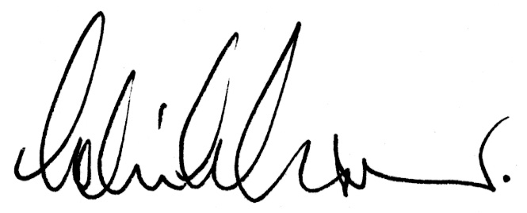
Colin Grant
Chief Executive

