18 December 2008

BIOSECURITY AUSTRALIA ADVICE 2008/36

DRAFT IMPORT RISK ANALYSIS REPORT FOR
FRESH APPLE FRUIT FROM THE PEOPLE’S REPUBLIC OF CHINA

This Biosecurity Australia Advice notifies stakeholders that the Draft import risk analysis report for fresh apple fruit from the People’s Republic of China will be issued for stakeholder consultation in late January 2009.

Biosecurity Australia released the Issues paper for the import risk analysis for fresh apple fruit from the People's Republic of China for consultation on 8 July 2008 (Biosecurity Australia Advice 2008/21). Stakeholders provided 11 submissions, which are available on the Biosecurity Australia website, www.biosecurityaustralia.gov.au.

Stakeholders were advised in Biosecurity Australia Advice 2008/05 (17 March 2008) that Biosecurity Australia expected to complete a draft import risk analysis (IRA) report in 2008. However, given the consideration of issues raised in stakeholders’ submissions and the seasonal holiday period, the draft IRA report is now expected to be issued towards the end of January 2009.
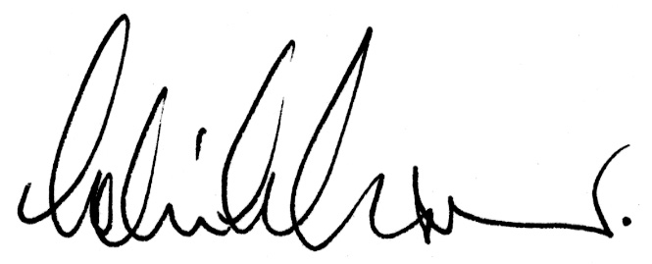
Dr Colin Grant
Chief Executive

Contact: Louise van Meurs
Tel: +61 2 6272 4042
Fax: +61 2 6272 3307

