30 June 2009
BIOSECURITY AUSTRALIA ADVICE 2009/14
UPDATE TO THE IMPORT RISK ANALYSIS HANDBOOK 2007

This Biosecurity Australia Advice notifies stakeholders that the Import Risk Analysis Handbook 2007 has been updated to reflect interim arrangements as part of improvements to the coordination and delivery of Australia’s quarantine and biosecurity services.

The interim arrangements, which come into effect from 1 July 2009, will result in minimal changes to Australia’s biosecurity service delivery. The interim arrangements will not change the regulated import risk analysis process.

The Australian Government commissioned a comprehensive, independent review of Australia’s quarantine and biosecurity system, chaired by Roger Beale AO, in February 2008. The review panel’s report, One Biosecurity: a working partnership, and the government’s preliminary response were issued on 18 December 2008. In its preliminary response, the government agreed in-principle to the review panel’s 84 recommendations. Changes proposed by the panel are extensive and wide-ranging. A number of activities are underway; however the government’s response will take time and will be subject to normal budgetary processes.

Interim arrangements are being implemented in anticipation of longer term changes to Australia’s biosecurity arrangements. These interim arrangements will not change the regulated import risk analysis (IRA) process.

The interim arrangements include:
• consolidating the Department of Agriculture, Fisheries and Forestry’s biosecurity functions into a new Biosecurity Services Group within the department from 1 July 2009
• appointing an interim Inspector General of Biosecurity to audit Australia’s biosecurity systems
• enhancing the Eminent Scientists Group with the appointment of an economist
• establishing a Biosecurity Advisory Council to replace the Quarantine and Export Advisory Council.

The interim arrangements are outlined below.

Biosecurity Services Group
One Biosecurity: a working partnership recommended the consolidation of the department’s biosecurity activities into a new statutory authority. As an interim step, the current pre-border, border and post-border biosecurity functions of the Department of Agriculture, Fisheries and Forestry have been consolidated into a new business unit: the Biosecurity Services Group.

The Biosecurity Services Group will deliver the functions of the Australian Quarantine and Inspection Service, Biosecurity Australia and parts of the Product Integrity, Animal and Plant Health Division. Biosecurity Australia will continue to exist as an administrative unit within the Biosecurity Services Group and IRAs will continue to be conducted according to the regulated IRA process.

Current import clearance and export certification processes operated by the Australian Quarantine and Inspection Service will not change.

Inspector General of Biosecurity
An interim Inspector General of Biosecurity will be appointed from 1 July 2009 to conduct independent audits of Australia’s biosecurity systems, subsuming the role of the of the interim Inspector General of Horse Importation. Dr Kevin Dunn, the current interim Inspector General of Horse Importation, will be appointed as interim Inspector General of Biosecurity. Dr Dunn will have a broad role to inquire into and report on the range of risk management systems across the biosecurity continuum, and will continue to oversee the systems for horses.

The following information relates to the process set out in the Import Risk Analysis Handbook 2007.

Eminent Scientists Group
The Eminent Scientists Group (ESG), which provides independent, scientific review of Australia’s import risk analyses, will be enhanced to include an economist to ensure that all relevant matters relating to the likely economic consequences of a pest or disease incursion have been properly considered. Mr Roger Rose, former Chief Economist at the Australian Bureau of Agricultural and Resource Economics, will be appointed to the ESG from 1 July 2009.

Biosecurity Advisory Council
A Biosecurity Advisory Council will be established to provide independent advice to the Minister for Agriculture, Fisheries and Forestry on matters ranging across the biosecurity continuum. It will replace the Quarantine and Exports Advisory Council (QEAC). This is relevant to the membership of the appeals process, which is independent of Biosecurity Australia.

Import Risk Analysis Appeals Panel
The independent Import Risk Analysis Appeals Panel (IRAAP) will continue to consider appeals submitted in response to provisional final IRA reports and will continue to operate as outlined in the Import Risk Analysis Handbook 2007. The chairman of the Biosecurity Advisory Council will chair the IRAAP and will nominate another council member to serve on the panels.

Appeal periods that opened before the commencement of the update to the handbook, or before the cessation of QEAC, will be considered under the existing QEAC membership arrangements for the IRAAP.

Import Market Access Advisory Group
The Import Market Access Advisory Group (IMAAG), responsible for assigning priority to import proposals and monitoring progress of Biosecurity Australia’s work program, will continue to operate as outlined in the Import Risk Analysis Handbook 2007. Membership of IMAAG will change slightly to reflect the consolidation of the department’s biosecurity functions into the Biosecurity Services Group.

Updated Import Risk Analysis Handbook 2007
The Import Risk Analysis Handbook 2007 has been updated to reflect the interim arrangements. Details of the changes are attached. An electronic version of the updated handbook is available at www.daff.gov.au/irahandbook.
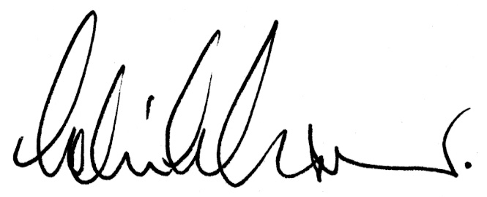
Dr Colin J Grant
Chief Executive

